Module code: ECAD6008
Module name:
Professional and Pedagogic Studies: Leading the Learning: what, how and why am I teaching?
Assignment Title:
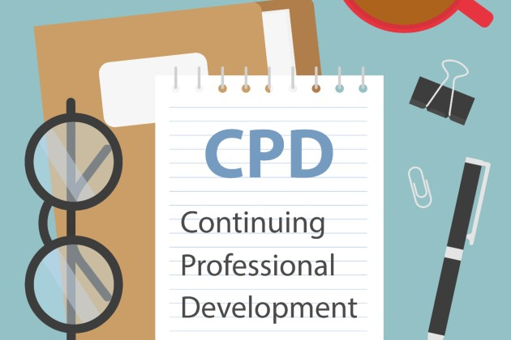
Critically reflect on your progress in planning, preparing, and teaching lessons that incorporate specific pedagogical principles. (This evidence should be taken from you Professional Learning Passport –PLP.) Identify up to three of these pedagogical principles as an area for development and justify the next steps in your development.

(Royal College of Nursing, 2022)

BA Primary Education with QTS
Level 6
Student: Emily Brown (1900471)

Targets

Target | Development
Revise in-text referencing techniques https://uwtsd.ac.uk/media/uwtsd-website/content-assets/documents/library-and-learning-resources/infoskills/Harvard-eng_v.1.2.pdf | I have referred closely to the Harvard referencing guide to ensure my in-text referencing is correct.
Some paragraphs are very long. Consider introducing more paragraphs in your work to group ideas | I have carefully read my assignment, ensuring it is appropriately structured.

Part 1
ECAD6008 Assignment: Part 1
Professional Experience Template 1
Pedagogy Standard | Assessment for learning (AfL)
What did you do and why? | Questioning  I used regular questioning to ensure learners understood what was expected of them. I used questioning to assess the children’s prior knowledge, for example in ‘Chinese New Year’, I asked if they have ever learnt about or celebrated it in school meaning I could assess the children’s prior knowledge, and misconceptions. I learnt that twins in my class had previously witnessed Chinese New Year celebrations whilst living in Malaysia. Following the introduction, I asked the children to explain the task in their own words. I asked questions regarding key vocabulary and information to ensure these elements have been understood and attained.  Questioning influenced my planning and plenaries. When introducing the class topic, I asked the children what they wanted to learn. For ‘The Great Fire of London’, the children wondered if the fire was started on purpose. As a class we compiled a list of questions for the EPIC - Everyone Plans in Class, board. These questions then informed my planning. I found the EPIC board useful because it showed the curiosity of the learners and indicated their prior knowledge. Using these questions when planning ensured the children remain autonomous – something being implemented in Curriculum 2022 and therefore maintained the children’s engagement. When the children asked questions during the lesson, I made a note and provide an answer in the plenary. This also had a positive effect on learning and behaviour as the children were being listened too.  Success-criteria  Lessons were differentiated meaning the children had different success criteria. In lesson introductions, I showed the children each differentiated sheet and what needed to be done. I then asked each group for any questions about the task to ensure misconceptions were eliminated. In independent lessons like storyboard writing, I ensured to model the task on the board to enable understanding. One lesson required the children to write the ending of our class story. At the beginning of the previous day, I read the beginning of our class story and then asked the children to predict the next bit. The following lesson we wrote a middle of the story as a whole class. I used prompt questions to ensure the children achieved the shared success criteria and stayed on task. I then shared another success criteria with the learners and asked them to write an ending showing progression. This ensured all learners had the same learning expectations.  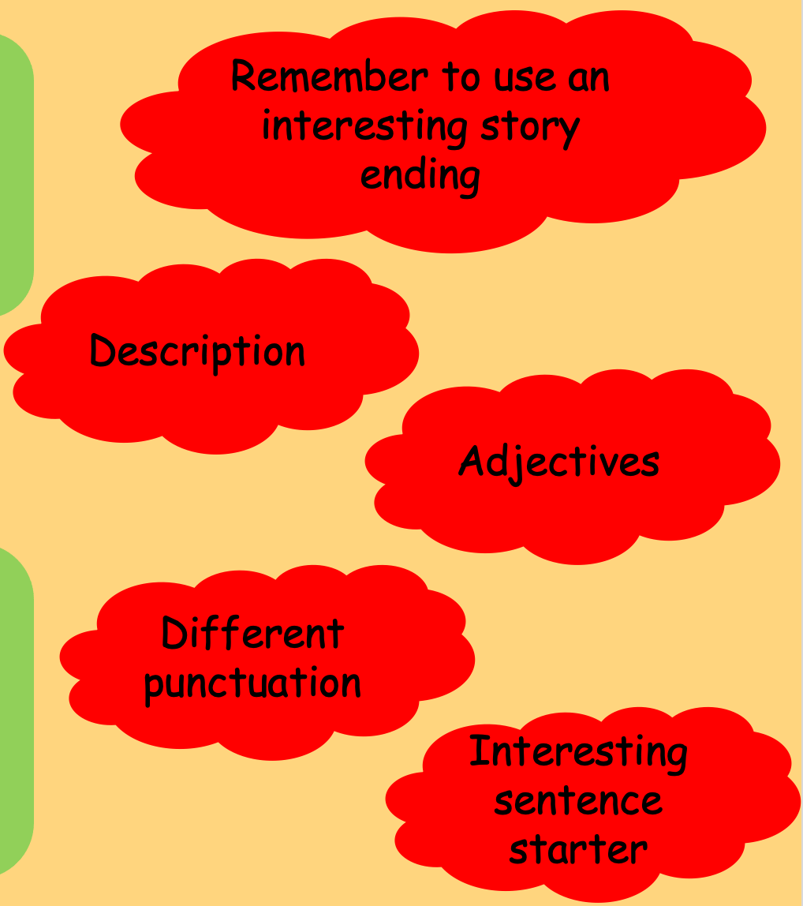  Self and peer-assessment  My placement school were enthusiastic about self and peer-assessment therefore each teacher was supplied with a traffic-light stamp which was used on all children’s work. The children had to honestly self, and peer assess work using green, yellow/orange, and red to indicate how they found the lesson – easy, okay, or difficult. The children were able to honestly self-assess but were unaware of peer assessment. The children were asking their friends to peer-assess their work, often green and not reading each other’s work to ensure the success criteria had been met. Following observation, I created a success criteria table:  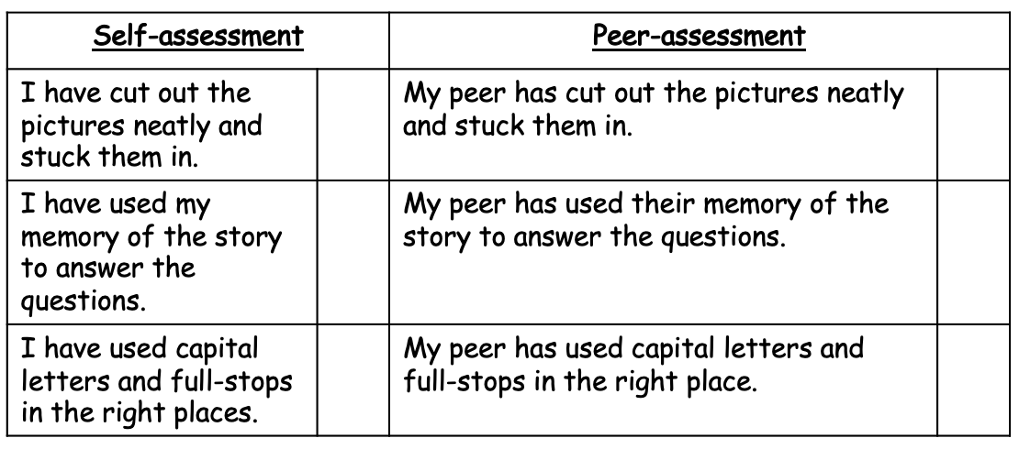  After a task, I read the success criteria and asked the children to put a tick or dot to indicate if they felt the success criteria had been met. This required the children to read their work thoroughly and honestly assess their work. Peer assessment proved to be more difficult, however, I paired the children up which was effective as there was no conflict of interest with close friendships.  Feedback  Oral feedback was given through praise, encouragement and questioning to ensuring the children were on track. For example, in Maths I would ask why they wrote that answer, to ensure the children understood the method and were not copying from their peers. I marked work during the lesson to provide reassurance. I used the school’s marking policy and provided the learners with a green tick or dot to show their success and the opportunity to correct their work either independently or with support. The schools marking policy encouraged writing the correct spellings of words under the learner’s work. Learners then had to write this 3 times. I used a target stamp to write learners target for learning for example ‘to use capital letters at the beginning of sentences’ and shared this orally.
What have you learned? | The use of real-time verbal and written feedback allowed me to have personalised discussions with each learner. I enjoyed listening to the children’s questions and using these to influence my planning which positively affected learning and behaviour.  Success criteria ensured learners were aware of the lessons aims and objectives. Furthermore, this helped the learners stay on track. I ensured that learners checked their work against the success criteria before marking it. I have learnt the importance of modelling continuously. As success criteria was a new concept to the learners I modelled and monitored this daily before allowing them independence. I quickly learnt that the learners need to peer assess with a peer they are not close friends with to avoid conflict however the opportunity to read and assess another peer’s work provided the learners with the opportunity to see the work of higher achieving learners and support those lower attaining children.
What next? | I will continue with all methods of AfL to ascertain the children’s feelings towards a lesson.  Questioning was helpful to inform my planning as well as provide the learners with autonomy. Furthermore, questioning allowed me to eliminate misconceptions about a lesson and understand the learners’ interests. For example, the use of EPIC planning was accessible to all as everyone’s curiosities were considered.  Real-time oral and verbal feedback will be continued throughout my career as I find this effective in ensuring learners are on track. Discussion throughout a task will ensure that learners maintain their understanding.  Regarding peer and self-assessment, I will ensure all learners are familiar with and understand the success criteria. I will continue with assessment tables to ensure learners are aware of assessment in an in-depth way rather than just a colouring exercise.  I will also remain up to date with new AfL research to inform my practice.

Professional Experience Template 2
Pedagogy Standard | Blended learning experiences
What did you do and why? | I planned 12 missions to be competed independently by the children all linked to the class topic, by developing learning, and understanding and included ICT, investigation, and role play. Missions consolidated prior learning or introduced new learning allowing the children to learn independently. Furthermore, the children were able to work outside of their ability group which allowed for collaborative learning. These hands-on learning experiences follow the new curriculum’s ethos. For World Book Day, I wrote differentiated letters to the children from various objects following the book ‘The Day the Crayons Quit’. The children had to write a persuasive response to their object.  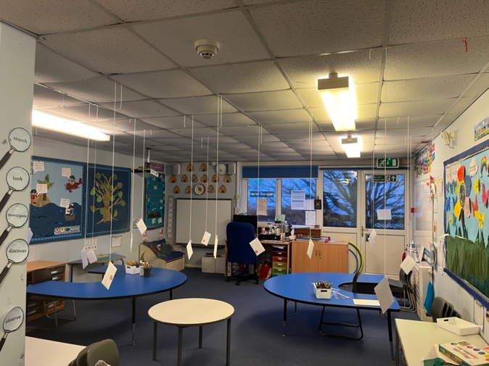  Regarding outdoor learning experiences, for example, in morning multisensory time, would take a group outside to practice handwriting techniques. On bird watching weekend, the children went bird watching and made tally charts before coming back to class to transfer their findings into a graph. With clocks, I took the class outside to make clocks using sticks and a hoola-hoop. Being outside to learn excited the children which was evident in their behaviour and participation.  I used a whole class approach to teaching lessons such as Science - planning an investigation. As the children were unfamiliar with this, I created differentiated planning sheets and went through every stage as a whole class. I asked children questions such as ‘what are we investigating?’ and wrote it on the board. Overtime, the children became used to whole class teaching and responded well.  Following half-term, learners were unsure of fractions, so I complied a test. This meant that moving onto a different Maths topic was postponed however the test was informative about the areas the children were unsure of. I then planned work based on the test results. I planned this in blended ways and ensured that questions were reversed to assess attainment and understanding. This test showed me that the children hadn’t understood or remembered as much as anticipated.  In Literacy and Maths, sequence of lessons was vital. In Literacy, I planned the examination of Great Fire of London diary entries – who wrote it? And how do we know? Then identify the thoughts and feeling of Pepys, before setting the children a success criteria and asking them to write a recount of the first day of the fire as if they were there. The build-up lessons allowed the children to experience Pepys diaries and become familiar with the fire and therefore implementing these techniques in their writing.
What have you learned? | I was keen to use blended approaches when introducing and consolidating lessons to maintain learner’s engagement. I have learnt about different ways the learners can learn as a group or individually for example, through missions the learners were able to explore and investigate their class theme further. The opportunity to plan for these missions allowed me to explore different strategies. For example, the Welsh station housed an independent Welsh activity about our class theme. I prepared a word mat to go with this to assist their learning. I have learnt to consider the children’s learning on an independent level.  I have learnt about green screen technology and the importance of encouraging learners to display their work. This lifted self-esteem and allowed the children to reflect on learning in mixed-ability groups.  Planning for progression allowed me to follow the curriculums progression steps. This allowed me to plan and teach a series of lesson building to a common goal. I have learnt that prior learning needs to be implemented and consolidated into new lessons.  I have learnt that outdoor learning engages learners. The learners can explore, investigate, and participate in learning outdoors using familiar materials such as stones and sticks. This increases the learners understanding that learning can be done anywhere, not just the classroom.
What next? | I will ensure that learners have regular opportunities to learn in blended ways. I will continue to develop my knowledge of digital skills to enhance blended learning opportunities. Furthermore, I will continue to follow Curriculum 2022 and the progression steps to maintain effective planning and follow guidance to ensure this is achievable.

Professional Experience Template 3
Pedagogy Standard | Real life authentic contexts
What did you do and why? | I ensured to implement this as much as possible in my lessons. For example, when teaching clocks, I ensured to tell the children the corresponding routine in the day – lunchtime etc. I then asked them throughout the day to remind me when it was for example; 11:50 – tidy-up time. This gave the children ownership of their learning and made them enthusiastic and keen to share their learning. Furthermore, in both fractions and clocks lessons, I ensured to provide worded questions to provide real-life context.  On Saint David’s Day/Shrove Tuesday, I provided the children with the corresponding stories, and linked learning opportunities. For example, I made bara brith and Welsh cakes for the children to try and evaluate. This provided them with real-life context as we learnt about the baking methods and the importance of these foods.  When testing waterproof materials, I asked the children to compile a list of materials to test. The children gathered round the equipment as I poured water over the materials. They then recorded their results.
What have you learned? | Real-life experiences are key to consolidation. I have learnt that involving children in their learning also has a positive effect on achievement and behaviour. For example, linking clocks to the schools routine has allowed the children to become aware of their daily routine.  Real-life opportunities has reinforced the children’s learning and maintained their interest.
What next? | I will include accessible real-life experiences in my teaching. I will endeavour to seek advice and support from other practitioners to collate ideas regarding implementation. Furthermore, this strategy allows learners to achieve the Curriculums four purposes and receive independence in learning.

Professional Experience Template 4
Pedagogy Standard | Cross-curricular themes
What did you do and why? | On Shrove Tuesday, I made pancakes with the children incorporating PE. The children had learnt about Pancake Day traditions and were keen to try pancake flipping. I divided the class, they flipped pancakes, and the succeeding group had to answer a question about Shrove Tuesday to win.  Humanities subjects were often cross-curricular, eg: Saint David’s Day, the children learnt about the location, History of Saint David and religious aspect. All 3 subjects were vital in lessons to aid pupil understanding.  Art and DCF – for example, in the Great Fire of London topic, the children were asked to use familiar computer software to draw a fire scene and transferred using oil pastels.  Making dragons displaying force in Science, required expressive arts elements to create and design the dragon. The children presented their dragon using green screen to animate the background. The children planned and discussed making of their dragon. The children and I were new to green screen technology, so this learning was collaborative.  My final lesson encompassed expressive arts and health and well-being. The children had to print their handprint to create a class rainbow and then write an affirmation on a raindrop. I taught the children about affirmations and their meaning before creating their own.
What have you learned? | I have learnt the importance of varying the subject and skills taught in all lessons to ensure the children receive a wholesome curriculum. Furthermore, ensuring children awareness of the subjects they are learning.
What next? | I aim to differ the cross-curricular learning experiences in my lessons. For example, teaching Maths and PE together as this is a lesser-known collaboration. I will seek advice and support from fellow practitioners and will turn to research and CDP opportunities to develop my knowledge.

Part 2
This assignment will look at the transformation of professional practice in relation to planning, teaching and assessment. Areas of transformation will refer to the pedagogical principles as underpinned by Curriculum for Wales (UWTSD, 2022). Transformation focusses on learners adjusting their thinking based on new findings (Mezirow, 1978). A discussion about my professional development will also be included in reference to the principles. ‘Creating authentic contexts for learning’ and ‘using assessment for learning to accelerate progress’ are the two pedagogical principles I will be exploring throughout this assignment.

Assessment for Learning (AfL) refers to feedback shared with learners to improve their learning outcomes. AfL strives to reduce the gap between the learner’s current academic stance, their academic goal and how to achieve it. In this assignment, emphasis will surround informative formative assessment (questioning, feedback, peer/self-assessment) with reference to formal summative assessment (tests) (Cambridge Assessment International Education, 2021). I have chosen AfL because I observed the class peer assessing work green without consideration. My placement school places a large emphasis on formative self and peer assessment to ascertain pupils’ feelings towards a lesson. The school’s assessment policy states that learners play an active role in the assessment of their own work using a range of strategies therefore I implemented a new strategy with the hope that learners would understand the importance of effective peer assessment.

Authentic contexts encourage learners to explore, discuss and meaningfully construct concepts and links in contexts that include real-life problems, relevant to the learners (Donovan et al, 1999) (Boogaard, K 2021). Additionally, I will focus on real-life contexts as this is something I developed during placement. This refers to learning designed to reflect tasks in the real world (Karweit, 1993). Furthermore, I will explore the link between these areas.

Authentic learning opportunities refer to numerous aspects of learning. Atlas (2021) refers to learning as an ‘active process’ meaning learners lead the learning through exploration. Authentic learning illustrates learning activities that are carried out in real-world contexts or are transferable to real-world settings (Stein et al, 2004). In theory, learners should be able to transfer new learning to experiences beyond the classroom. This is echoed by constructivists theorists such as Piaget who believes learning should be child-led. Tochon, F (2000) alludes to a contradiction in ‘planning to be authentic’ as practitioners are advised to prepare for learning however should also be flexible to following learners’ interests. Mayo (2010) reinforced this by illustrating how practitioners must be adaptable regarding their role in the classroom. Practitioners must facilitate learning (Harvard University, 2022).

Another aspect is one I have witnessed on placement. Everyone Plans in Class (EPIC) is an example of self-directed inquiry. Meaning that learning in the classroom is led by learners’ interests and curiosities. On placement, I used EPIC to introduce a new topic to the class and collate their questions about the topic. I used the children’s questions to influence my planning which provided the learners with autonomy. Curriculum 2022 refers to ‘ambitious, capable learners’ and ‘healthy, confident individuals’, to implement this, leaners need opportunities to solve problems in relation to problems they may be witnessing or will come across in their lives. These curriculum aims aspire to prepare learners to become ‘valued members of society’ and the wider world.

An interesting insight comes from a 2014 blog post. The author refers to teachers planning for lessons with a real-life element such as responding to a letter from the council. However, these letters a very often, fabricated by the teacher thus making the real-life context a pretence. The old curriculum forced teachers to teach the familiar topics and therefore make real-life contexts fit to the theme. Curriculum for Wales, allows learners and teachers the autonomy to choose the class theme, therefore making real-life contexts more implementable. For example, making historical themes such as Celts - apart from a trip to ‘Castell Henllys’ - a real-life purpose may provide difficult however Curriculum for Wales encourages learners being ‘ethical, informed citizens of Wales and the world’ therefore allowing teachers to link learning to learners’ local area. Creating authentic contexts for learning gives learning a purpose.

Limitations of authentic experiences in education could include lack of time and resources. Authentic experiences often take forward-planning, although this allows for following the new Curriculum and its progression steps this can prove to be very time consuming. Linking to the previous example of fabricated letters, with careful planning, learners would be able to learn about letter writing, write their letters and examine and respond to the letters. This would provide learners with valuable experiences and progressive learning opportunities. In contrast, authentic experiences allow for further connections with the community. For example, learners and the school will be able to form relationships through these experiences by asking community members to share their expertise with learners. Numerous studies have concluded that parental engagement is a critical element of learner’s success. Teachers, parents/guardians, and the community are the key ingredients to learners’ success with Henderson and Mapp (2002) identifying the significantly positive correlation between these elements and learner’s achievements.

On placement, regarding inclusion of authentic learning contexts I was able to plan for progressions using the new Curriculum for Wales 2022. I was keen to implement this pedagogical principle on Saint David’s Day - we participated in a whole school Eisteddfod after learning about traditions of the day. To consolidate this learning, I made Welsh cakes and Bara brith and taught the children about the tradition behind it and the baking process. The children then predicted their responses to the foods, tasted them and documented their assessment. This experience allowed the children hands-on learning opportunities which has been identified by Middendorf as an effective way to stimulate growth on both side of the brain due to the requirement of multiple skills (2018). Furthermore, I enjoyed implementing this principle in Mathematics when teaching time. I ensured to correspond time to routines in the children’s day. For example, when teaching o’clock, I informed the children that 12 o’clock is lunchtime. I asked different children throughout the day, to tell me when it reached a time which corresponded to their daily routine. This gave the learning an authentic context and gave the learners ownership. Mcclaskey, K (2018) identified ownership to learning as meaning that learners are motivated and engaged. This links to AfL as ownership meaning learners can assess their own learning and monitor progression. Furthermore, learners can use these skills to complete independent learning experiences.

Prior to Curriculum for Wales, the Welsh Government acknowledged a weakness in its assessment framework and understood that Assessment for Learning (AfL) approached were not understood. Evaluations found a need to provide high quality feedback originating from formative assessment – the assessment of learning to provide continuous feedback - to improve the academic achievements of learners. OECD (2014) indicated that Curriculum for Wales must ensure that assessment supports learning. The HMCI found assessment to be a common recommendation with 40% of schools receiving this as a key area for development. To ensure effective assessment in education, it is vital that learners understand the reason for assessment, practitioners plan for the implementation of assessment results, a range of assessment techniques are used and that students are engaged in assessment (Welsh Government, 2018). Black and Wiliam (1998) found that formative assessment lies at the core of effective teaching and has a positive effect on achievement. The result of this research has put AfL at the forefront of strategies to improve learning. AfL is underpinned by the premise that every learner can improve, putting effective communication at the forefront of successful AfL implementation. Dobbs and Arnold (2009) established that communication with learners can affect their perception of education, their ability and motivation. Therefore, making it vital that practitioners communicate assessment to learners in an encouraging manner thus making it important that learners understand the process and reasoning of assessment. Lambros, N (2016) wrote that practitioners must provide an environment that allows all learners to experience success by setting achievable goals – success criteria. Additionally, practitioners must facilitate a positive learning mindset for learning by demonstrating mistakes as learning opportunities. This ‘Growth Mindset’ improves resilience, perseverance, and academic achievement. This initiative has resulted increased self-regulation in learners, equipping them to cope better with transitions (Innerdrive, 2022).

A key strategy for assessment comes from the acronym ‘SMART’ – ‘Specific, Measurable, Achievable, Relevant and Time’, giving learners clear lesson objectives and success criteria within an achievable timeframe which relates to success criteria. Clarke, S (2022) outlines a six-step process for success criteria. Firstly, learners need to understand the focus of the lesson and have the opportunity to clarify their understanding. This can be achieved through questioning – another AfL strategy. I use regular questioning to ensure learners understand what is expected of them. For example, when setting a task, I ask the children if they have any questions, and have them repeat the task to me to ensure understanding. Questioning can also consolidate key vocabulary. I also conduct mini-plenaries throughout the lesson by posing questions to the learners to ensure the success criteria is being achieved. Clarke identified the importance of allowing learners to identify success for themselves. Upon experience, learners are aware of what success looks like, for example; full-stops to finish a sentence. Encouraging learners to be a part in setting their own success criteria makes learners more likely to remember the criteria and has a positive influence on peer and self-assessment. Questioning also helps practitioners to understand the children’s misconceptions in learning. This could be demonstrated using a ‘WABOLL’ and through questioning. In conjunction to this, a discussion of each criteria will help learners understand areas of improvement and how to achieve it. Finally, Clarke expresses the importance of allowing children the opportunity to monitor their own progress. In a literacy lesson, the children were asked to imagine they were in the Great Fire of London and write a recount. I stopped the children every ten-minutes to encourage reflection and self-assessment. On placement, I was presented with the opportunity to overhaul the learners understanding of self and peer-assessment. Initially learners were self and peer-assessing using a traffic-light system. Although self-assessment appeared to be completed honestly, evidently, they struggled with peer-assessment. Learners often sought out their friend for peer-assessment and not a member of their learning group. Furthermore, peers were often copying the colour code of the learner without consideration. From this experience I ensured to explain the process of peer-assessment and instil the benefits of peer-assessment – equips learners with the skills to assess their own work. I also explained the emotional aspect of peer-assessment and the importance of honestly and explanation. It was clear that learners were worried about peer-assessment upsetting their peers, however as a class we discussed honesty and appropriate responses. I modelled this process with my Teaching Assistant to reinforce this. Modelling provides learners with visual success criteria. Alesandrini, K (1981) found that learners were more able to recall more conceptual information after experiencing and discussing modelling. Bandura, A (1977) concurred stating that behaviour is learnt through observing others. I used a tabular success criteria displaying lesson aims which was commended in my observation. Additionally, I ensured to pair-up the children to encourage learning from each other and reduce relationship issues.

Another aspect of assessment relates to feedback. Oral feedback was given through encouragement and praise throughout all lessons. Questioning was further included in this area as I endeavoured to ask learners for the thought process of their answer. This ensured the learners had a conceptualised understanding of the lesson and were not reliant on their peers. I discovered that ‘live marking’ was a successful feedback strategy as it provided learners with individualised, visual feedback and provided discussion opportunities. This drew the learner’s attention to a mistake and allowed them time to reconsider their response. I ensured to check on that child’s progress soon after to ensure they had adjusted their response. If the learner was unsure, I would engage in a discussion to encourage the learner to realise the correct answer. For example, when teaching fractions, learners were often making small Mathematical errors, I would draw a dot near the learners answer and then if needed encourage the learners to recall their times tables to reach the correct answer. According to ‘Teacher Toolkit’ (2021) ‘live marking’ provided learners with concise feedback and the immediate opportunity to improve learning in addition to reducing teachers marking workload outside of teaching hours. A limitation is identified as suffering curriculum coverage if learners were spending too much time acting on feedback. However, I would argue that misconceptions need to be targeted in real-time to reduce the impact on further learning. With progressive learners, learners need to master strategies to progress. Therefore, misconceptions must be understood and worked upon as they arise. As a teacher, identifying misconceptions allows me to conduct a mini-plenary to ensure other learners are not making the same mistake. This allows for assessment and feedback of my teaching an provides opportunities to reflect and develop. The education Endowment Foundation (EEF) found that feedback is a well-evidenced strategy with a positive influence on learning outcomes. Additionally, different methods of feedback can be effective and should not be restricted to written marking. studies show that verbal feedback show marginally higher (7 month) impact on learning progression however written feedback also plays a key part. The EEF emphasises the importance of giving feedback when work is correct as well as incorrect to increase learners’ confidence and self-esteem. Nichol and Dick (2006) compare summative and formal assessment saying that formative assessment – questioning, success criteria, feedback, and peer/self-assessment – provides both the learner and practitioner with the knowledge of their achievement and their steps for progression therefore aiding development whereas summative assessment – tests – focusses on success or failure and the comparisons of learners with their peers. However, I understand that summative assessments are often necessary especially in higher education. I would argue that learners should partake in summative assessment regularly to reduce anxiety. ASPAM Scottish writes that most learners fear examinations due to lack of preparation and low self-esteem. Therefore, it is vital that learner’s self-esteem is maintained, and learning is praised and encourages.

AfL can also provide practitioners with feedback to further professional development. To conclude lessons, I asked the children to name one thing they have learnt and something they would like to know. This helped me to comprehend the learners understanding from the lesson in addition to their curiosities to influence future lessons. This also allowed me to identify areas that required consolidation. I often provided consolidation at the end of the day through interactive games.

________________________________________________________________

To conclude, the teaching and learning of authentic contexts and of Assessment for learning must both be central to education as both are vital to learners being ‘ambitious, capable learners’ who strive to achieve high standards and enjoy challenge and enjoy questioning and problem solving as outlines in Curriculum for Wales 2022.
Personally, the opportunity to improve the implementation of these pedagogical principles will be something I seek to achieve. To accomplish this, I will turn to literature and the experience of my colleagues. This links to the Welsh Governments model of professional learning provision. It states that professionals should seek collaborative opportunities to develop their own practice. In a recent assignment, I conducted a research study to determine the effectiveness of Bandura’s theory of recall. Opportunities like this. Practitioners also benefit significantly from the pedagogical principles ‘Creating authentic contexts for learning’ and ‘using assessment for learning to accelerate progress’. Practitioners need to implement a learnt strategy to evaluate it. Similarly, practitioners must grasp both self and peer assessment opportunities to develop professionally.

Regarding Qualified Teacher Status, I believe I have demonstrated a good understanding of the use of real-life contexts for learning being a part of the natural teaching process. I will continue to develop this standard as new research is published. I understand that authentic contexts expand a learner’s academic experiences in all Areas of Learning and Experiences (AoLEs) and will equip learners to be active participants in Wales and the wider community, a key element in the success of Curriculum for Wales 2022.

AfL is reflected in the standard, ‘assessment’ and ‘challenge and expectations’. Currently I am ‘on track’ and displaying a good understanding of assessment. In conjunction to this, providing learners with an appropriate level of challenge and a high level of expectations will motivate learners to succeed. This is echoed in the purpose ‘ambitious, capable learners’ able to set themselves high standards in learning. From my assignment, there is a clear link between assessment and authentic contexts. These are both areas I will continue to develop in my professional practice.

Reference List:

2-minute classroom (2020) ‘How to set SMART goals’ [video]
Available at: https://www.youtube.com/watch?v=i0QfCZjASX8
(Accessed: 28th March 2022).

ASPAM Scottish School (2022) ‘Five Common Reasons Students Fear Examination’
Available at: https://aspamscottish.com/five-common-reasons-students-fear-examination/
(Accessed: 29th March 2022).

Atlas (2021) ‘What is Authentic Learning and How Do I Use It?’
Available at: https://www.onatlas.com/blog/what-is-authentic-learning-and-how-do-i-use-it
(Accessed: 28th March 2022).

Available at: http://d6vsczyu1rky0.cloudfront.net/34856_b/wp-content/uploads/2021/05/Assessment-Policy-2020-21-1.pdf
(Accessed: 17th March 2022).

Boogaard, K (2021) ‘Write SMART goals’
Available at: https://www.atlassian.com/blog/productivity/how-to-write-smart-goals
(Accessed: 28th March 2022).

British Council (2022) ‘Assessment for Learning’
Available at: https://www.teachingenglish.org.uk/article/assessment-learning
(Accessed on 10th March 2022).

Cambridge Assessment International Education (2022) ‘Getting started with assessment for learning’
Available at: https://cambridge-community.org.uk/professional-development/gswafl/index.html
(Accessed: 18th March 2022).

Carnegie Mellon Center (2022) ‘What is the difference between formative and summative assessment?’
Available at: https://www.cmu.edu/teaching/assessment/basics/formative-summative.html
(Accessed: 18th March 2022)

Clarke, S (2022) ‘Formative Assessment: a summary’
Available at: https://www.shirleyclarke-education.org/what-is-formative-assessment/
(Accessed: 29th March 2022).

Communication Theory (2014) ‘Communication Theory’.
Available at: https://www.communicationtheory.org/modelling-theory/
(Accessed: 15th March 2022).

Donaldson, G (2015) ‘Successful Futures - Independent Review of Curriculum and Assessment Arrangements in Wales’
Available at: https://gov.wales/sites/default/files/publications/2018-03/successful-futures.pdf
(Accessed: 18th March 2022).

Drew, C (2021) ‘Active Learning – Advantages & Disadvantages’
Available at: https://helpfulprofessor.com/active-learning-pros-cons/
(Accessed: 21st March 2022).

Dyer, K (2018) ‘What you need to know when establishing success criteria in the classroom’
Available at: https://www.nwea.org/blog/2018/what-you-need-to-know-when-establishing-success-criteria-in-the-classroom/
(Accessed: 30th March 2022).

Galindo, J (2019) ‘Authentic Learning’
Available at: https://ablconnect.harvard.edu/authentic-learning
(Accessed: 19th March 2022).

Goodwin University (2018) ‘How hands-on learning benefits children of all ages’
Available at: https://www.goodwin.edu/enews/benefits-of-hands-on-learning/
(Accessed: 19th March 2022).

Hendrefoilan Primary School ‘Assessment Policy’ (2021-2022)
Available at: http://d6vsczyu1rky0.cloudfront.net/34856_b/wp-content/uploads/2021/05/Assessment-Policy-2020-21-1.pdf
(Accessed: 6th January 2022)

Ismail, N (2013) ‘Real world context’
Available at: https://prezi.com/nmt0tozw8rg8/real-world-context/
(Accessed: 20th March 2022).

Lambros, N (2016) ‘Five tips to help your students believe in themselves’
Available at: https://www.gl-education.com/news-hub/blogs/five-tips-to-help-your-students-believe-in-themselves/
(Accessed: 30th March 2022).

Leave no trace (2022) ‘A lack of real-world experience is putting Children – and the planet – at risk’
Available at: https://www.leavenotraceireland.org/a-lack-of-real-world-experience-is-putting-children-and-the-planet-at-risk/
(Accessed: 20th March 2022).

Mcclaskey, K (2018) ‘Ownership to Learning: What does that really mean?’
Available at: https://kathleenmcclaskey.com/2018/11/18/ownership-to-learning-what-does-it-really-mean/
(Accessed: 19th March 2022).

Mrs P Teach (2014) ‘using real-life contexts for learning’
Available at: http://www.mrspteach.com/2014/03/using-real-life-contexts-for-learning.html
(Accessed: 19th March 2022).

Rahman, I (2016) ‘The value and Effectiveness of Feedback in Improving Student’s Learning and Professionalizing Teaching in Higher Education’. Volume 7. Number 16.
Available at: https://files.eric.ed.gov/fulltext/EJ1105282.pdf
(Accessed: 25th March 2022).

Royal College of Nursing (2021) ‘Accessing CPD funding’ [image]
Available at: https://www.rcn.org.uk/magazines/career/2022/jan/accessing-cpd-funding
(Accessed 31st March 2022).

Salisu, A and Ransom, E (2014) ‘The role of modelling towards impacting quality education’
Available at: https://www.scipress.com/ILSHS.32.54.pdf
(Accessed: 21st March 2022).

Single Steps Learning Project (2022) ‘Curriculum for Wales’
Available at: https://singlestepslearningproject2.weebly.com/curriculum-for-wales.html
(Accessed: 29th March 2022).

Sword, R (2020) ‘Effective Communication in the Classroom: Skills for Teachers’
Available at: https://www.highspeedtraining.co.uk/hub/communication-skills-for-teachers/
(Accessed: 27th March 2022).

Teacher Toolkit (2017) ‘live marking’.
Available at: https://www.teachertoolkit.co.uk/2017/11/19/live-marking/
(Accessed: 26th March 2022).

Teacher Toolkit (2018) ‘The pros and cons for live marking’
Available at: https://www.teachertoolkit.co.uk/2018/03/04/live-marking-2/
(Accessed on 26th March 2022).

Western Governors University ‘What is the transformative learning theory?’
Available at: https://www.wgu.edu/blog/what-transformative-learning-theory2007.html#close
(Accessed: 17th March 2022).

