

Kieran Howells

Safety & Hazard Assessment

University of Wales Trinity Saint David
OME

Austin Clark
July 2026

Table of Contents
List of Figures iii
List of Abbreviations iv
1 Introduction 1
2 Risk Assessment 2
3 ALARP Justification 13
3.1 Purpose & Scope 13
3.2 Assessment of In-bore detonation 13
3.2 Assessment of contact with hot barrel 15
3.3 Fatigue due to heat 15
3.4 Cost Benefit Analysis 16
3.5 Legislation 17
3.6 ALARP Statement 17
4 References 19
Appendices 20
Appendix A Hazard Identification Checklist 20

List of Figures
Figure 1 Hierarchy of control [2] 14
Figure 2 Unit costs to employers [4] 16

List of Abbreviations
ISS | In service surveillance
SQEP | Suitably Qualified and Experience Personnel
SOP | Standard Operating Procedures

Introduction
This document contains a risk assessment of an AJAX firing trial. The hazard identification and assessment are included alongside the reduction of theses risks. An ALARP statement follows justifying all risks meet the statement.

Risk Assessment
General Risk Assessment Form
PART 1: Description
Site: Trial Site | Work Area: Range |  | Bldg. No: N/A
Related Risk Assessments: Risk Assessment Checklist |  | Related Instructions (e.g. SOPs): Trial SOP and Specification
Description of Task/Process: Fire Control System calibration trial – Varied firing of HE rounds from CT40 cannon mounted to Ajax platform to calibrate FCS.
Mobile firing to be included.

PART 4: Sign Off
When all additional controls are in place, the risk levels will be as low as is reasonably practicable.
Assessor’s Signature: Kieran Howells, Eryn Legg, Elias James, Rory Bowen, Bethan Davies-Jones |  |  | Date: 17/06/2026

PART 2: Risk Assessment
Identified Hazard | Persons at Risk | Effects | Severity | Probability | Existing Risk Level | Additional Controls & Mitigations | Severity |  | Probability |  | Final Risk Level
- Fire and explosion
Heat induced Risks
- Heat, deflagration, detonation | Those in contact with barrel/case  Munition  People around vehicle | In-bore detonation due to excess heat | 5 | 2 | 10 | Controls:  - SOP & Firing manual in place to instruct use of weapon system that limits heat build up  - Regular temperature checks after each firing  Mitigations:  - Personnel to be clear of vehicle when firing unless necessary for operation.  - Range control limiting access during firing | 4 |  | 1 |  | 4
- Heat, deflagration, detonation | Those in contact with barrel/case | Contact with metal case / hot barrel causing burns | 2 | 4 | 8 | Controls:  - SOP in place detailing cooling period for the barrel may be approached.  - Range control limiting access during firing.  - PPE for handling hot materials  Mitigations  - Range first aid procedures and trained staff on site in the case of minor injury  - Emergency procedures in place for serious injury | 2 |  | 2 |  | 4
- Heat, deflagration, detonation | Tank Crew | Heat build up from continuous firing slowly increase cabin temperature. Introduces fatigue to crew members | 2 | 4 | 8 | Controls:  - Trial Specification detailing firing timetable with breaks allowing for cooling of cabin.  Mitigations  - Human Factors accounted for in risk assessment.  - Regular break allocated  - Medical procedures in place for fatigue and heat | 1 |  | 3 |  | 3
Physical Hazards
Falling objects | Those surrounding vehicle | Cart case ejection impacting personnel surrounding vehicle | 2 | 4 | 8 | Controls:  - SOP in place detailing area that shell ejection takes place  - Range control limiting access during firing.  Mitigations:  - Range first aid procedures and trained staff on site in the case of minor injury  - Emergency procedures in place for serious injury |  | 2 |  | 2 |  | 4
Falling objects | Those surrounding vehicle | Rounds dropped during the loading of the tank. Impacting those bellow or causing shock to detonation | 4 | 2 | 8 | Controls:  - SOP and Trial Specification in place detailing how to load vehicle  - Access to vehicle via mobile steps rather than vehicle ladder. Removes need to pass round up  Mitigations:  - IM Material used as an energetic fill meaning that it wont detonate upon impact with floor  - Range first aid procedures and trained staff on site in the case of minor injury  - Emergency procedures in place for serious injury |  | 2 |  | 2 |  | 4
Falling objects | Personnel on top of vehicle | People falling off vehicle sustaining injuries to head (2.7m fall) | 3 | 3 | 9 | Controls:  - Vehicle clear of any trips hazards with clear marked out walking areas  Mitigations:  - Range first aid procedures and trained staff on site in the case of minor injury  - Emergency procedures in place for serious injury  - Vehicle operators are to wear PPE including a helmet when moving on vehicle |  | 2 |  | 2 |  | 4
Munition storage and quality
Munition quality | Personnel present | Poor munition quality from manufacturer meaning munitions containing large voids withing HE  Munition causes barrel to detonate upon firing | 5 | 2 | 10 | Controls:  - Agreed QA & QC regimes in place with CofC provided with batch.  Mitigations:  - Personnel to be clear of vehicle when firing unless necessary for operation.  - Range control limiting access during firing | 4 |  | 1 |  | 4
Munition storage | Personnel present | Degradation of munition due to poor storage (NC prop)  Inadvertent miss fire occurs (round initiates prematurely causing harm to surrounding personnel. (goes off in magazine or during handling or prior to range being clear) | 5 | 2 | 10 | Controls:  - ISS of munition batches conducted before use of them in trial  - Storage facilities upkept and appropriate for storing that munition  Mitigations:  - Personnel to be clear of vehicle when firing unless necessary for operation.  - Range control limiting access during firing | 4 |  | 1 |  | 4
Munition storage |  | Diurnal cycling of fill causing in bore detonation | 5 | 2 | 10 | Mitigations:  - Personnel to be clear of vehicle when firing unless necessary for operation.  - Range control limiting access during firing | 4 |  | 1 |  | 4
 | Personnel present | Shock and impact from vehicle and handling causing cracking of HE fill leading to adiabatic heating on firing leading to in bore explosion | 5 | 2 | 10 | Controls:  - SOP & Trial specification detail how to handle munition.  - All personnel to handle the munition are suitably SQEP  - Any shell that is dropped is to be marked as a reject and quarantined for disposal.  Mitigations:  - Robust full used in munition allowing for a degree of rough handling  - Personnel to be clear of vehicle when firing unless necessary for operation.  - Range control limiting access during firing | 4 |  | 1 |  | 4
Chemical
- Toxicity | Tank crew and people within immediate vicinity | Inhale hot toxic after firing leading to burning lungs and toxics effects potentially including cancer | 3 | 3 | 9 | Controls:  - Weapons system employs a rotating chamber that pushes toxic gases out to the side of the vehicle meaning limit amounts enter the vehicle cabin  - Vehicle cabin contains air filters to remove toxic gases from the air  - Clear area marked out by range staff as to where to keep clear for that is where build up is most likely  Mitigations:  - Range first aid procedures and trained staff on site in the case of minor injury  - Emergency procedures in place for serious injury | 2 |  | 1 |  | 2
- Toxicity | Tank crew/ range staff | Inhale/absorb/ingest when cleaning the barrel causing toxic effects to personnel | 3 | 4 | 12 | Controls:  - PPE & Cleaning tooling provided to prevent direct contact with these materials  - SOP & Trial specification detail how to handle munition.  - All personnel to handle the munition are suitably SQEP  Mitigations:  - Range first aid procedures and trained staff on site in the case of minor injury  - Emergency procedures in place for serious injury  - COSHH assessments & SDS available detailing first aid measures for exposure | 2 |  | 2 |  | 4
- Toxicity | People within immediate vicinity | Munition leaking fill due to age & degradation over time causing illness upon contact with explosive mateiral | 3 | 2 | 6 | Controls:  - ISS of munition batches conducted before use of them in trial  - Storage facilities upkept and appropriate for storing that munition.  - Munition to be handled with appropriate gloves and PPE  Mitigations:  - Range first aid procedures and trained staff on site in the case of minor injury  - Emergency procedures in place for serious injury  COSHH assessments & SDS available detailing first aid measures for exposure | 2 |  | 1 |  | 2
Vibration/Noise
Vibration |  | Heavy Vibration causing physical deformation to CTA Shell resulting in no obturation leading to hang fire. Next shell is fired into hang fire causing barrel detonation. | 5 | 3 | 15 | Controls:  - FCS prevents firing of a second shell  - Miss and hang fire procedures in place at trial site  - Robust shell used to protect from physical damage from vehicle induced conditions.  Mitigations:  - Range first aid procedures and trained staff on site in the case of minor injury  - Emergency procedures in place for serious injury  - Personnel to be clear of vehicle when firing unless necessary for operation.  - Range control limiting access during firing | 3 |  | 1 |  | 3
Vibration |  | Excess vibration leading to damaged electrical wires that can result in shock/electrocution. | 3 | 3 | 9 | Controls:  - Robust electrical wiring & protective shielding preventing them from contacting areas that could wear through  - Maintenance schedule in place & regular checks during start up for damage  Mitigations:  - Range first aid procedures and trained staff on site in the case of minor injury  - Emergency procedures in place for serious injury | 2 |  | 2 |  | 4
Vibration |  | Vibration causing damage to exhaust seals leading to monoxide build up in cabin. | 2 | 4 | 8 | Controls:  - Ventilation system in cabin to reduce toxic gas build up  - Maintenance schedule in place & regular checks during start up for damage  Mitigations:  - Regular breaks in firing with vehicle hatches all open to vent heat and gases  - Range first aid procedures and trained staff on site in the case of minor injury  - Emergency procedures in place for serious injury | 2 |  | 2 |  | 4
Noise |  | Noise – hearing loss  Extreme noise from both normal and abnormal operation leading to hearing loss | 4 | 3 | 12 | Controls:  - PPE provided with correct grade hearing protection  Mitigations:  - Crew receive regular checks from occupational nurse to assess hearing | 2 |  | 2 |  | 4

Part 3: Risk Assessment Matrix
Risk Matrix
Severity | Multiple fatalities >5 | 5 | 5 | 10 | 15 | 20 | 25
Severity | Fatalities <5 | 4 | 4 | 8 | 12 | 16 | 20
Severity | Severe life threatening injuries requiring immediate hospitalisation | 3 | 3 | 6 | 9 | 12 | 15
Severity | Serious non-life threatening injuries requiring medical treatment | 2 | 2 | 4 | 6 | 8 | 10
Severity | Minor injuries requiring first aid treatment | 1 | 1 | 2 | 3 | 4 | 5
Frequency |  |  | 1 | 2 | 3 | 4 | 5
 |  |  | Remote | Unlikely | Occasional | Likely | Frequent

Assessment to evaluate the suitability of control measures.
Key | Risk = Severity x Frequency
 | 12 - 25 Intolerable | The risk is too high, the activity should cease until control measures are improved.
 | 4 - 10 Tolerable if ALARP | The level of protection from the activity is only acceptable when the risks are ALARP
 | 1 - 4 Broadly Acceptable | The level of protection for the activity is considered acceptable

Frequency Rating For Risk Matrix
Frequency | Frequency Rating | Occurrence During Operational Life | Frequency P/A
Frequent | 5 | Likely to occur a number of times a year | F > 10
Likely | 4 | Likely to occur a few times in the plant lifetime | 10 > F > 10⁻¹
Occasional | 3 | Could occur in the plant lifetime | 10⁻¹ > F > 10⁻³
Unlikely | 2 | Unlikely to occur | 10⁻³ > F > 10⁻⁵
Remote | 1 | Highly unlikely but may exceptionally occur | 10⁻⁵ > F > 10⁻⁷

ALARP Justification

Purpose & Scope
The purpose of this ALARP Justification is to detail the measures taken in the risk assessment above and to justify that these measures bring the risks to as low as reasonably practicable. This justification will focus on the specifics of the heat induced risks and the controls and mitigations used to reduce the risk. In order to fully assess the risks a hazard identification checklist was used to capture all the associated risks no matter how minor. This method is used commonly in industry as it allows for non-safety personnel to look for areas of risk prior to consulting the safety department for an in depth assessment [1]. Please see annex A for the completed checklist.

3.2 Assessment of In-bore detonation
Several control measures were used but more were assessed prior to being ruled out. Starting with the highest severity the in bore detonation of the barrel due to firing past operational limits. The control measures that are used most include SOPs, specifications and PPE as in many cases its not possible to eliminate or substitute the cause of the risk. As this platform allows for the bypass of the operational limit due to requirements that could appear in combat locking the FCS is not possible despite this reducing the likelihood to a 1 rating. The cost of reprogramming the fire control system would also be more than is practicable to reduce the risk as this would require the recall of all current produced weapon systems along with the time to the reprogramme. It is for this reason that relying on the training and experience of individuals is a method employed as this is a lower cost solution but does not reduce the likelihood as much as other methods. The other control used was temperature checks of the weapon system components as it would be up to the discretion of the trial lead if they wanted to continue firing despite getting close to the temperature limit. By training all the crew they can challenge and refuse at any time so long as the are aware of the risks. Safety is the responsibility of everyone [1].
The mitigations used were to reduce the effect of the event if it occurred. An In bore detonation is likely to send fragmentation out in the surrounding area of the vehicle which is why this area is to be controlled by the range staff along with the area that is being fired into. Should any personnel of civilian be in this area there should be no rounds fired. This is a cost-efficient method of reducing the severity of a risk by removing the person in the way of harm.
An in bore is a dangerous event for the crew on the inside of the vehicle. A way of removing the risk is to use a remote system to initiate the weapon system removing the need for the crew to be present. This was decided against as this trial included mobile firing meaning that both the driving and weapon system activation would have to be remote. This would be a significant cost compared to having the 2-3 crew members on board. All of the above controls and mitigations had the hierarchy of control applied to them.
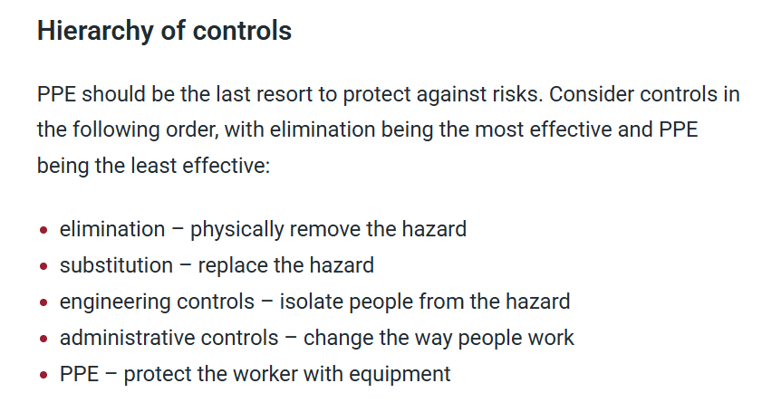
Figure 1 Hierarchy of control [2]
Figure 1 shows the hierarchy of control. In many cases it is difficult to remove the hazard especially with munition as in their design the cause harm. For that reason, there needs to be additional controls to prevent the munition activating.

Assessment of contact with hot barrel
The hazard checklist highlighted the potential for physical burns due to coming into contact with the barrel after a period of firing. The barrel temperature can reach in excess of 600°C which can cause serious burns. Applying water may cool the barrel but this would also cause damage and in most cases its best to let it cool over time. As this is the case there is a chance that someone may come into contact with this during the cooling period. Again, looking to the hierarchy of control in figure 1 we cannot eliminate the head nor substitute it. The best case is to isolate and protect those who are working around it. By having a cooling period before anyone can approach the barrel this reduces the risk of someone receiving a major burn. Then PPE is in place as a method to protect those from having direct contact with the heat source. Both of these methods are again a cost effective solution that when applied correct protect the personnel from harm.
The mitigations in this case are to remedy the injury and apply immediate medical attention to those who may be burned. Medical procedures on trial sites often are basic which is why emergency procedures are also in place with local authorities to have a priority response to emergencies. While in the case of a burn there may not be the need for a priority response in the cases of detonation it is common for the authorities to respond quickly.

Fatigue due to heat
Tanks are confined spaces and as mentioned in 3.2 there are temperatures in excess of 600 °C which can start to increase the temperature inside the cabin. This puts the crew of the vehicle under a degree of fatigue and stress as they are working in a confined space with PPE and in high temperatures. This is a hazard for many reasons as these conditions promote an increase in human error along with the general health risks to the crew. An error in this case could be firing at the incorrect time or at the wrong target. While these would be captured more in a stand-alone human factors assessment its important for a general risk assessment to highlight the human factor risks involved. Specifically with the trial firing the build up of heat can be controlled by having regular break intervals within the firing schedule. This reduces the heat build up and allows for it to dissipate. Another option that was considered was the implementation of an air conditioning unit to the inside of the vehicle. This was ruled out for several reasons including cost, space and weight. Instead, regular breaks were chosen where the crew can leave the vehicle and cool down whilst the vehicle cools. This reduces the fatigue of the firing crew and allows them to remain focused preventing any other hazards forming from fatigue.

Cost Benefit Analysis
Looking purely from a business perspective there is a financial cost to reducing these risks. When reducing risk this is compared to the unit costs of the injury. The HSE guidance shows the approximate costs to different injuries.
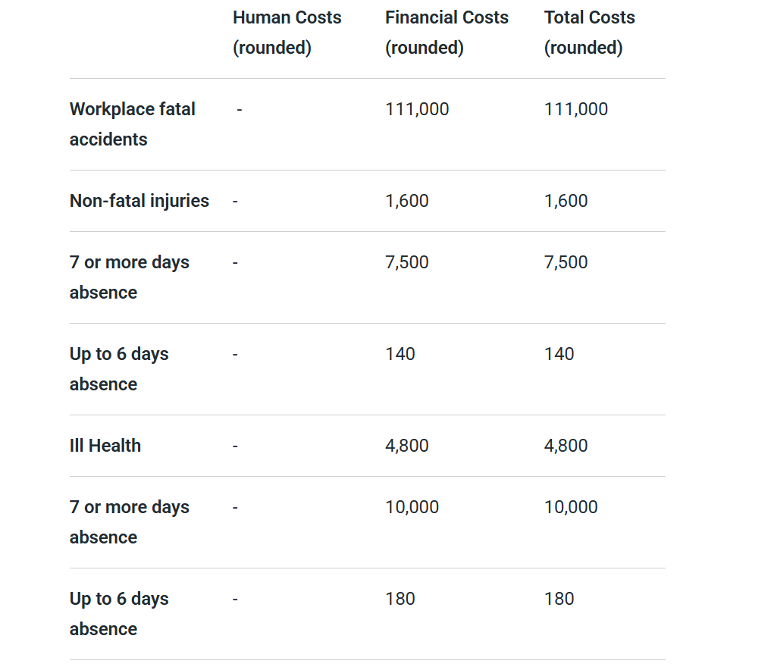
Figure 2 Unit costs to employers [4]
All values are in pounds in figure 2. This shows the incentive, other than the law, to reduce the risks of fatal accidents as the cost is higher than most to the company. These accidents can cost businesses large amounts of money especially if it was something that should have been captured and reduced after a risk assessment. In the case of this trial all risks captured have been reduced to an acceptable level from a reasonably practicable investment.

Legislation
The legislation in place requires several documents be in place prior to the trial starting. These being PUWER, COSHH, general risk assessments and more. This legislation has been followed in the case of this trial with additional controls going beyond the recommended actions detailed in these laws and guidance from the HSE [1]. The health and safety at work act 1974 along with the management of health and safety at work regulations 1999 dictate that risks assessments are required by businesses and the risk assessment completed above meets the guidelines of these regulations.

ALARP Statement
Overall, this risk assessment has found and reduced many risks to the firing trial. This has been done by implementing a variety of physical, legislative and training measures to reduce the hazards. However, this should be revisited should any detail about the trial change.
Additionally, several of these factors such as training and SQEP personnel relies on experienced people who may leave the business. As this is the case it should be reviewed in tandem with the training and SQEP justification/statements to assess the levels of knowledge with the equipment. Also, as AJAX is in development this assessment has been given a shortened validity period as changes are likely to occur and this assessment should be completed again for any change to the build standard.
This assessment has found the controls and mitigations to the identified risks and hazards to be appropriate and ALARP. Guidance from the HSE and legislation has been considered along with investment into control measures within a reasonable expenditure. This assessment should be completed again after six months or if any changes are made to the build standard.

References

[1] | E. I. GROUP, PROTECTIVE Measures A guide on measures other than personal, London: CBI, 2003.
[2] | U. Gov, “Health and Safety at Work etc. Act 1974,” UK Gov, [Online]. Available: https://www.legislation.gov.uk/ukpga/1974/37/contents. [Accessed 16 07 2026].
[3] | HSE, “Using personal protective equipment (PPE) to control risks at work,” HSE, [Online]. Available: http://hse.gov.uk/ppe/managing-risk-using-ppe.htm. [Accessed 16 07 2026].
[4] | HSE, “Appraisal values or 'unit costs',” HSE, [Online]. Available: https://www.hse.gov.uk/statistics/economics/eauappraisal.htm. [Accessed 16 07 2026].

Appendices

Hazard Identification Checklist
Hazard Check List

This form is to assist in the identification of hazards.
Determine which sections apply and tick the yes/no boxes for each section heading.
Then, for each section that applies, tick the yes/no boxes for each entry and add any comments (if appropriate) to those ticked ‘yes’.
HAZARD |  | Applies?
Primary | Secondary | Yes | No | Comments
1. Explosion
Detonation/ Deflagration# (#Delete that which is not applicable). | Friction (with external materials)
 | Friction (internal-crystal to crystal, shear heating, detonation traps, etc.)
 | Impact
 | Internal heat
 | External heat | Y |  | Over use of barrel causing barrel heat to transfer to round igniting propellant – potential for inbore if HE shell
 | Static
 | Electrical
 | Wave energy
 | Increased sensitiveness*
 | Confinement* | Y |  | Confined within breach – if unplanned ignition of propellant occurs no release for gases
Vapour or flammable liquid ignition | Friction
Vapour or flammable liquid ignition | Impact
Vapour or flammable liquid ignition | Internal heat | Y |  | Engine overheat
Vapour or flammable liquid ignition | External heat | Y |  | Heat from engine deck causing ignition of spilled fuel from fuelling
Vapour or flammable liquid ignition | Static | Y |  | Static ignition of fuel from leaking tank/spill from fuelling
Vapour or flammable liquid ignition | Electrical
Vapour or flammable liquid ignition | Wave energy
Vapour or flammable liquid ignition | Auto-ignition
Vapour or flammable liquid ignition | Flammability limits*
Vapour or flammable liquid ignition | Vapour pressure (pure and mixed)*
Vapour or flammable liquid ignition | Oxygen enrichment*
Powder and solids ignition | Friction
Powder and solids ignition | Impact
Powder and solids ignition | Internal heat
Powder and solids ignition | External heat |  |  | Over use of barrel causing barrel heat to transfer to round igniting propellant – potential for inbore if HE shell
Powder and solids ignition | Static
Powder and solids ignition | Electrical
Powder and solids ignition | Wave energy
Powder and solids ignition | Auto-ignition | Y |  | Gas reignition upon leaving barrel from new oxygen present
Powder and solids ignition cont’d | Increased sensitiveness*
Powder and solids ignition cont’d | Oxygen enrichment* | Y |  | Gas reignition upon leaving barrel from new oxygen present
Event transmission and enhancement (domino effects) | Confinement (leading to enhancement of effects)
Event transmission and enhancement (domino effects) | Blast/overpressure/shock
Event transmission and enhancement (domino effects) | Debris/fragmentation
Event transmission and enhancement (domino effects) | Flame/ thermal radiation effects
Event transmission and enhancement (domino effects) | Personnel exposures
Event transmission and enhancement (domino effects) | Substances/Articles exposures
2. Chemical
Toxicity | Inhalation | Y |  | Seals breaking on exhaust system due to vibration introducing CO into interior compartment  Gases released from propellant entering vehicle
Toxicity | Absorption (skin)
Toxicity | Ingestion
Contact | Burn |  |  | Contact with hot gases released from propellant
Contact | Skin sensitisation
Contamination | Reaction
Contamination | Increased sensitiveness
Corrosion | Strength |  |  | Barrel corrosion causing misfire/shot inaccuracy
Stability
Compatibility
Oxygen | Enrichment
Oxygen | Deficiency | Y |  | Seals breaking on exhaust system due to vibration introducing CO into interior compartment
3. Physical
Heat - contact | Burn | Y |  | Hot case ejection, barrel heat
Heat - contact | Scald
Heat - environment | Fatigue/exhaustion/stroke
Cold - contact | Burn
Cold - environment | Hypothermia/Frostbite
Humidity
Lighting
Dust | Inhalation
 | Ingestion
Noise |  | Y
Vibration |  | Y |  | Extreme vibration causing crew illness
Repetitive action/force
Stability
Radiation | Ionising
Radiation | Non-Ionising (UV, IR, Laser)
Radiation | Arc eye
Radiation | Electromagnetic fields
Electricity | Electrocution/shock
 | Burns/fire
 | Ignition of flammables/explosives
Pressure | Unexpected pressure release | Y |  | Pressure release from breach
 | Over-pressure – explosion |  |  | Inbore?
Static
Biological
Weather | Inclement weather – sun bending barrel | Y |  | Inaccuracy of round in close fire support
4. General
Contact | Falling objects | Y |  | Hot Case
Contact | Stationary objects
Contact | Falling | Y |  | Falling from Moving vehicle
Contact | Tripping | Y |  | Tripping over objects on top of chassis
Contact | Moving parts | Y |  | Rotating turret
Contact | Ejected parts and fragments | Y |  | Ejecting case
Stored Energy | Strain
Stored Energy | Pressure | Y |  | Recoil system
Stored Energy | Potential
Stored Energy | Electrical charge
Entrapment | Parts of the body | Y |  | Closing doors, rotating breach
Entrapment | Clothing/hand tools | Y |  | Maintenance tools
Entrapment | Restricted escape route | Y |  | Hatched vehicle, one escape route per position
Entrapment | No escape route
Manual handling | Excessive weight
Manual handling | Excessive lever action
Traffic | People
Traffic | Powered vehicles / mobile plant | Y |  | Moving vehicle
Traffic | Overhead movements | Y |  | Cannon moves overhead of driver position
5. Additional Factors / Conditions
Organisational Factors | Roles & responsibilities | Y |  | Commander
Organisational Factors | Resources (numbers, skills, competence, etc) | Y |  | New platform, new crew training
Organisational Factors | Work pattern (shifts, etc) | Y |  | Short shifts due to health issues
Ergonomics | Posture & position | Y |  | Enclosed work area
Ergonomics | Interface with work place & equipment | Y
Human Factors | Human Error | Y |  | New crew  People on range
Human Factors | Fatigue | Y |  | -
Human Factors | Training | Y |  | New platform
Human Factors cont’d: | Clarity of Information | Y |  | New platform  Range signs not present
Human Factors cont’d: | Decision Making | Y |  | Commander
Human Factors cont’d: | Supervision | Y |  | Training Exercises
Human Factors cont’d: | Health surveillance | Y |  | Crew getting ill
Process conditions: | Temperature
Process conditions: | Pressure
Process conditions: | Flow
Process conditions: | Composition
Process conditions: | Flash Point
Process conditions: | Rate of additions
Process conditions: | Exotherms
Process conditions: | Reaction cooling/heating
Process conditions: | Start up
Process conditions: | Routine Operation
Process conditions: | Abnormal Operation | Y |  | New platform – no set operation
Process conditions: | Emergency shutdown | Y
Process conditions: | Planned shutdown
Process conditions: | Bldg electrical standard
Process conditions: | Interlocks
Process conditions: | Trips or Alarms
Process conditions: | Lightning protection
Process conditions: | Rate of corrosion or erosion
Process conditions: | Particle size
Process conditions: | Viscosity
Process conditions: | Melting point or boiling point
Process conditions: | Vapour pressure
Process conditions: | Bulk handling or packaging
Process conditions: | Storage | Y
Process conditions: | Transportation | Y |  | Own movement system  Moved on armour vehicle carrier otherwise
6. Maintenance
General: | Trip or Alarm testing | Y |  | Internal warning systems for fire or gas build up  Vehicle toolkit inside vehicle  Maintenance schedule in place (I hope)  Pipework -Exhaust seals breaking due to vibration  Engine maintenance  Internal fire extinguishes  No handrails – fall off vehicle  Ladders to climb on vehicle  Marked platforms for standing  No walkways  Tripping hazards all over top of chassis
General: | Portable Equipment | Y
General: | Maintenance Procedures | Y
General: | Pipework or Supports or Bellows | Y
General: | Valves or Slip Plates or Filters | Y
General: | Fire Protection of Cables | Y
General: | Isolations for Maintenance
General: | Handrails | Y
General: | Ladders | Y
General: | Platforms | Y
General: | Walkways
General: | Tripping Hazards | Y
Access and Egress: | Operation
Access and Egress: | Maintenance
Access and Egress: | Vehicles
Access and Egress: | Plant
Access and Egress: | Fire Fighting
Access and Egress: | Work at heights
Access and Egress: | Entry into confined spaces
Access and Egress: | Floor surfaces
Access and Egress: | Housekeeping
Services & Equipment: | Underground
Services & Equipment: | Overground
7. Statutory Inspections and Regulations
 | Local Exhaust Ventilation | Y |  | Inadaquate internal ventilation for carbon monoxide
 | Pressure Test / Pressure System
 | Lifting Equipment
 | Legionella
 | Fire Detection System | Y |  | Internal fire detection system – engine
 | Drench Testing |  |  | N/A
 | Planned Maintenance Schedules | Y |  | I hope
 | Fire Extinguishers | Y |  | Both hand and internal engine compartment
 | Fire Alarms | Y |  | Fire warning system
 | Communications with Emergency Control Centre | Y |  | Radio communications
 | Change of Use for building |  | N
 | Change to number of occupants | Y |  | Troop carried on exterior of vehicle
8. Explosive Licence Conditions
 | Type Of Explosive | Y |  | HE and propellant  Maximum storage of CTA ammunition  Internal crew limit – no external limit
 | Total Quantity of Explosive | Y
 | Man Limit | Y
 | Licence Distances
9. Environmental Conditions
 | Liquid Effluent
 | Solid Effluent
 | Gaseous Effluent
 | Noise
 | Waste Management
 | Significant Energy Users* See EnMs Rep
 | Wasted Energy
 | BS.EN.ISO 14001
 | B.S.ISO.50001
 | BS.EN.ISO 9001
10. Engineering Hardware & Design
General: | Plant Layout
General: | Materials of Construction
General: | Building Design or Layout
Loads on or Strengths of: | Foundations
Loads on or Strengths of: | Structure
Loads on or Strengths of: | Vessels
11. COMAH
Major Accident Hazards: | There are additional Major Accident Hazards to those identified in the Site Safety Report for this process.
Inventory: | There is a significant change to the quantity and/or type of dangerous substance in the above Report.
Prevention of Major  Accident: | The controls specified in the above Safety report need to be enhanced / improved.
12. Zoonoses
Contact with contaminated environment | Broken skin – contact with infected environment (urine from infected rats). Inhalation of contaminated substances (dust or droplets)
Direct contact with animals | Bites or scratches (rabies)
Outdoor Pursuits | Vectors biting insects ( Ticks – Lyme disease)
13. Other

Suggested Criteria for the Review of Risk Assessments.

People:
New personnel.
Medical changes (work related).
Medical changes (non-work related).
Change in Shift Pattern.
Campaign Production Runs.

Plant (Equipment):
Plant design changes.
Maintenance condition.
Supplier technical advice.
General technical advice.
Operational experience.
Intermittent use.
Non-standard operating conditions.
New or revised Regulations.

Place (Building and Location):
Design Changes.
New or revised Regulations.
New guidance.
Natural and manmade Condition and Deterioration.
Change of Use.

Material (Substance or Article):
Change in process method.
Change of substrate, form, or component.
Break in production.
Old stock.
New material, substance or article.
New or revised technical advice.
Operational experience.
Change of supplier, supplier’s process or specification.
Break in supply

Environment:
Change in Shift Pattern.
New material, substance or article.
Change in Regulation or Guidance.
New or revised technical advice.
Operational experience.
Plant or equipment condition.

These lists are not exhaustive. They are intended for guidance only.

The competent person(s) undertaking the risk assessment and/or supervising the activity should consider other possible criteria applicable to the exact circumstances in the workplace.

