Title Page

Module Name – Employability and Career Development
Module Code - LCLM4005_LON
Student Name: Isabella Guthier
Student Number: 2516266
Lecture name: Rejwan Bin Sulaiman

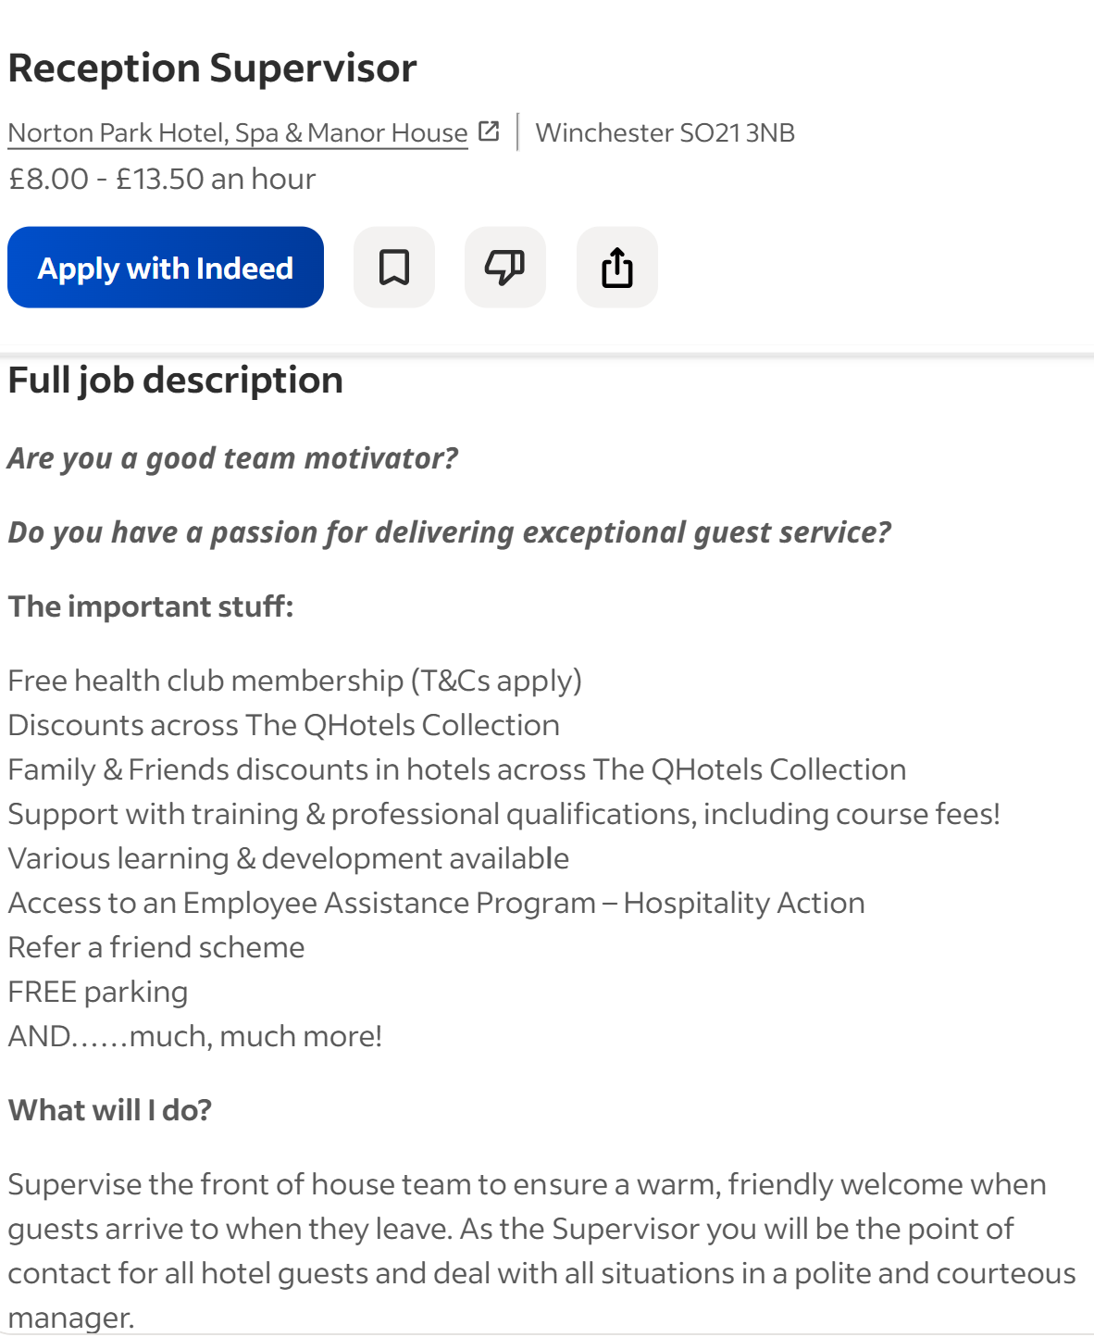

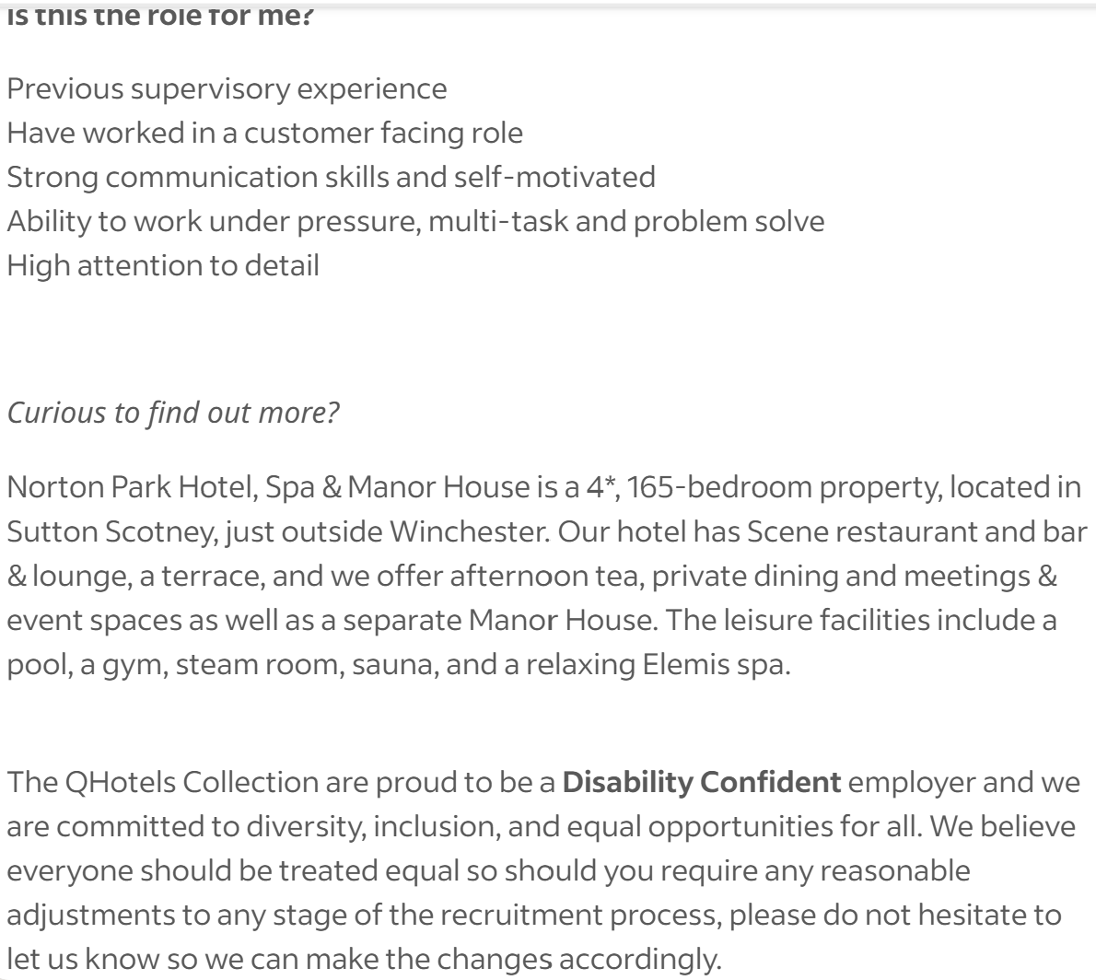

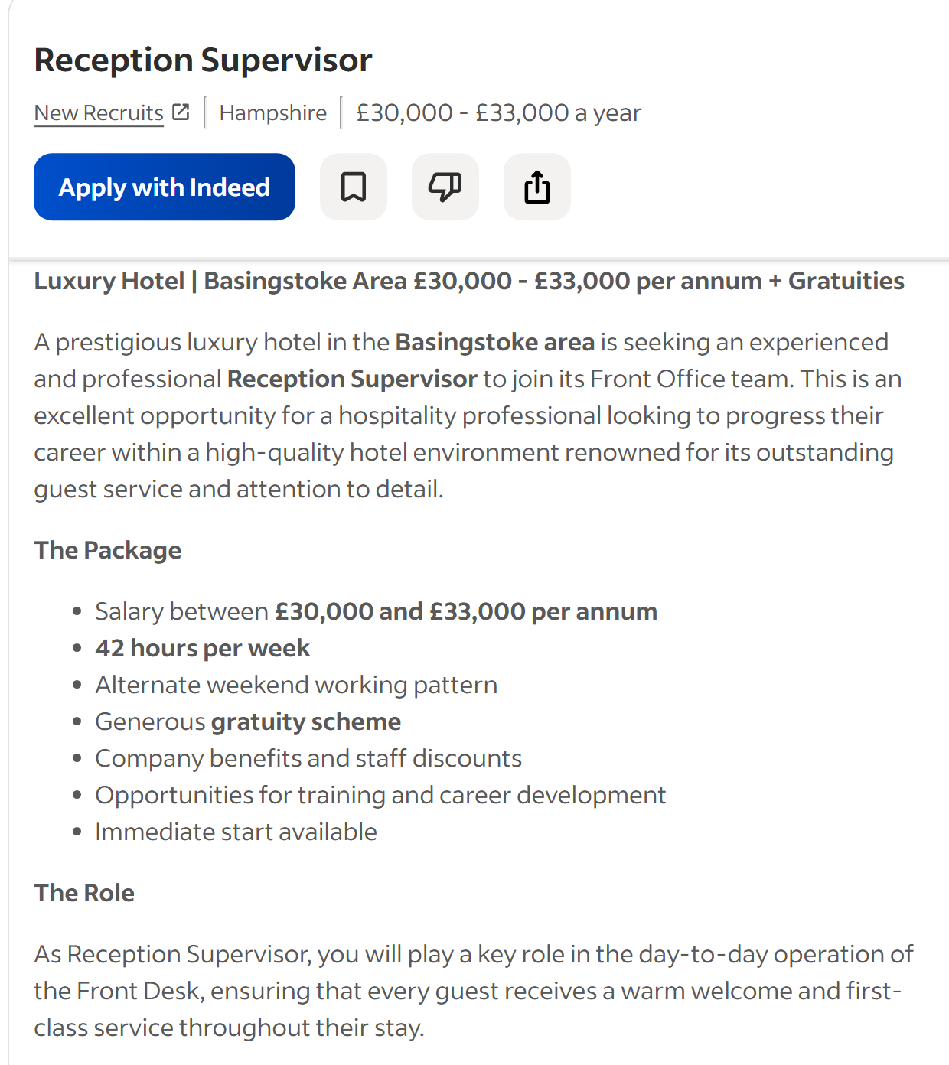
JOB 2

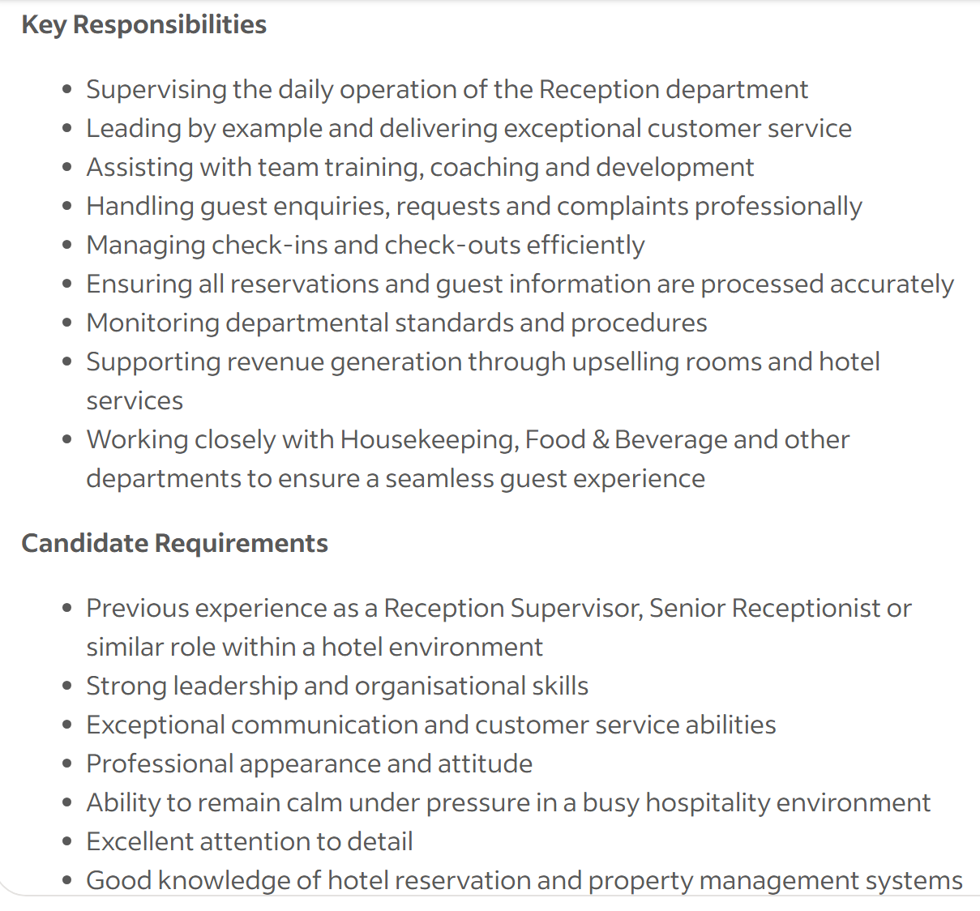

Task 1 -
Task 1
Job adverts
For this task I looked at two Reception Supervisor adverts, both in Hampshire. The first is for a luxury hotel near Basingstoke, paying £30,000-£33,000 a year. The second is for Norton Park Hotel, Spa & Manor House in Winchester, paying £8.00-£13.50 an hour.
Key skills and knowledge
Both adverts want someone good at guest service. The Basingstoke job says the supervisor needs to make sure "every guest receives a warm welcome and first-class service throughout their stay." Norton Park is also a hospitality/spa hotel, so guest care is clearly a big part of the job there too.
Leadership comes up in both as well. The Basingstoke advert says the supervisor will "support the Front Office Manager in leading and motivating the reception team" and help with training and coaching new staff. Norton Park's supervisor role would also involve overseeing the reception team and being in charge when the manager isn't around.
Communication skills are needed in both jobs too — dealing with guest questions, complaints, and requests, plus talking to other departments like housekeeping.
Both adverts also want someone who knows how to use hotel booking systems. Basingstoke specifically asks for "good knowledge of hotel reservation and property management systems," and this would be needed at Norton Park too for check-ins and check-outs.
Lastly, both mention staying calm under pressure, since reception can get really busy, especially with the Basingstoke role saying they need "ability to remain calm under pressure in a busy hospitality environment."
Skills in common
- Guest service/customer care
- Leading and coaching a team
- Communication skills
- Knowledge of booking/PMS systems
The skill I think I'd use most is leading and coaching my team. As a supervisor I'd probably have to train newer receptionists and help them when things get busy. If I stay calm, explain things clearly, and lead by example instead of just telling people what to do, it should help the whole team work better together and keep guests happy

Task 2

self-Assessment
For this task I used a SWOT analysis to look at my strengths weaknesses opportunities and threats. This helps me understand what I am good at and what I need to improve. My career goal is to become a Front Office Manager in the future.

- Strength -
One of my main strengths is customer service. I work as a Front Office Receptionist at Leonardo Royal Grand Harbour Southampton. I welcome guests and help them with their needs. I deal with check-ins check-outs reservations and guest questions. I always try to make guests feel welcome.
Another strength is communication. I speak to guests and staff every day. I also work with other departments such as housekeeping and food and beverage. Good communication helps me work well with other people.
I am also good at teamwork. Working in a hotel means working with many people. I help my colleagues when the hotel is busy. I also try to support my team when they need help.
Another strength is using Opera and Opera Cloud. I use these systems at work for reservations check-ins check-outs and payments. This is useful knowledge for my future career.

- Weaknesses -
One weakness is that I do not have much management experience yet. I have worked in hotels for some time but I have not been a manager. I need to learn more about leading a team and making important decisions.
I can improve this by asking my managers for feedback. I can also help new staff and take more responsibility when I am at work. This will help me become more confident.
Another weakness is that I can sometimes lack confidence when dealing with difficult situations. I can deal with guest complain but s I sometimes worry about making the wrong decision. I need to become more confident and learn from my managers.
- Opportunity -
I have many opportunities to improve my career. One of these is my Business studies. I am currently studying Business at the University of Wales Trinity Saint David. My course is helping me learn about business and management.
My current job is also a good opportunity. I work in a busy hotel and I can learn from managers and other experienced staff. I can ask questions and learn more about what managers do.
I also have experience from different hotels. I have worked at Leonardo Royal Grand Harbour Southampton and Holiday Inn in Basingstoke. This has helped me learn how different hotels work.

- Threats -
One threat is competition for management jobs. There may be many people who want the same job. Some people may have more management experience than me. I need to keep learning and improving my skills.
Another threat is the pressure of working in hotels. Hotels can be very busy and managers can have a lot of work. They may also have to deal with unhappy guests or problems with staff. I need to keep improving my time management and problem solving skills.

Evidence of Readiness
I believe I am ready to develop my career because I already have good hotel experience. My current job has given me experience with guests reservations check-ins check-outs and hotel systems.
My previous job at Holiday Inn also helped me improve my customer service and communication skills. I also had work experience at Deutsche Jugendherbergen in Munich ( German Hotel chain). This gave me experience working in a different country and meeting different people.
My Business studies are also important. They are helping me learn skills that I can use in a future management job.
I can also speak English German and Romanian fluently. I have basic French too. This is useful in the hotel industry because hotels have guests from many different countries.
Overall my SWOT analysis shows that I have good skills and experience for my future career. I am good at customer service communication and teamwork. I still need to improve my management skills and confidence. I believe that my work experience and Business studies will help me become a good Front Office Manager in the future.

Task 3

Weakness | Short-Term Goal | Mid-Term Goal | Long-Term Goal | Action | Reason | Measure |  | Measure
Lack of confidence | Become more confident when  dealing with guests | Handle difficult guest situations independently | Be confident enough to take on a management role. | Practise handling complaints and ask managers for advice. | To improve my communication and confidence at work. | Manager feedback and number of situations handled independently. |  | Manager feedback and number of situations handled independently.
Decision-making | Take responsibility for more front office tasks. | Develop strong decision-making skills for management. | Take on extra responsibilities and learn from experienced staff. | To become more independent and prepare for management. | Review my progress with my manager each month.
Leadership skills | Support colleagues and new staff. | Take more responsibility during busy periods | Become a Front Office Manager or Hotel Manager. | Help new staff and support the team when needed. | To develop my leadership and teamwork skills. | Feedback from my manager and colleagues. |  | Feedback from my manager and colleagues.
Limited management experience | Learn more about hotel management. | Gain experience with management tasks. | Progress into a hotel management position within 2–4 years. | Ask my manager about management responsibilities and apply knowledge from my business studies. | To build the knowledge and experience needed for promotion. | Review my development every 3 months. |  | Review my development every 3 months.

