3/24/2025
University of Wales Trinity Saint David
London campus
E-Portfolio Link: Home | E Portfolio Hub
Module Name: Learning In the Digital Era
Module Code: ACCA 4025

Student Name: PA ABDULLAH
Student ID:2538569
Group: 2

Lecturer’s Name: FERNANDO

LDE Assignment 1
E-Portfolio
Table of Contents
Introduction 2
Main Body 2
Task 1: Essential Academic and Employment Skills for the future career Path 2
Task 1 (a): Report on Essential Academic and Employment Skills 2
Task 1 (b): Evaluation of Task 1 (a) based on Similarity report 2
Task 2: Collaborative Mind Map and Individual Poster 2
Mind Map (Collaborative) 2
Poster (Individual) 2
Task 3: Virtual Collaboration and RefWorks 2
Report on Virtual Collaboration 2
Step-by-step process of using RefWorks with visuals 2
Task 4: E-Portfolio Creation and Evaluation 2
Task 4 (a): E-Portfolio Creation 2
Task 4 (b): Illustrative Review of E-Portfolio tool Selection 2
Conclusion 2
References 2
Task 1 References: 2
Task 3 References: 2

Introduction

Main Body

Task 1: Essential Academic and Employment Skills for the future career Path

Task 1 (a): Report on Essential Academic and Employment Skills

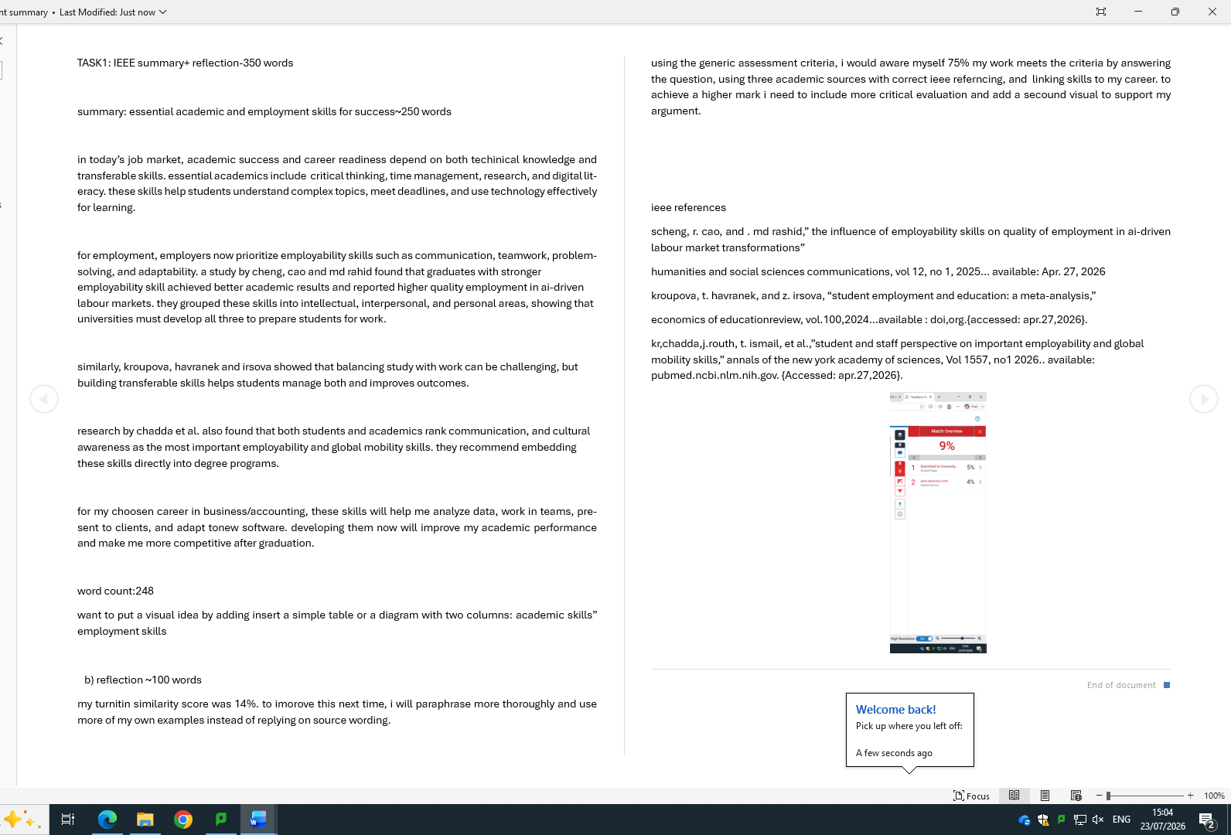

Task 1 (b): Evaluation of Task 1 (a) based on Similarity report

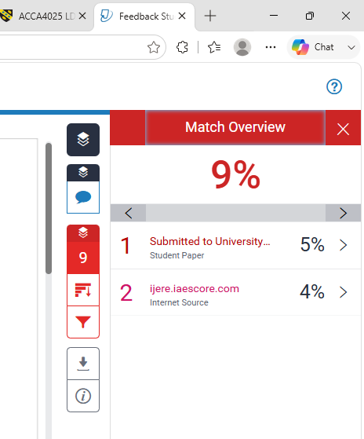

Task 2: Collaborative Mind Map and Individual Poster

Mind Map (Collaborative)

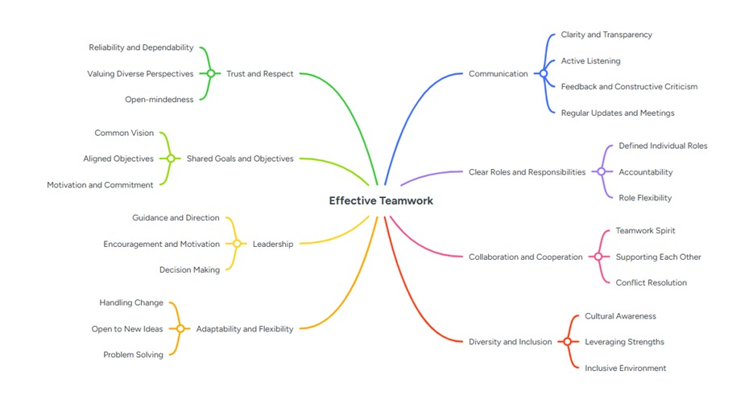

Poster (Individual)

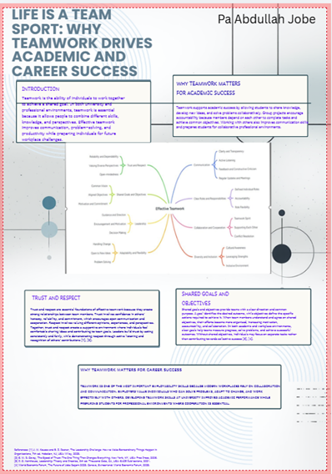

Task 3: Virtual Collaboration and RefWorks

Report on Virtual Collaboration
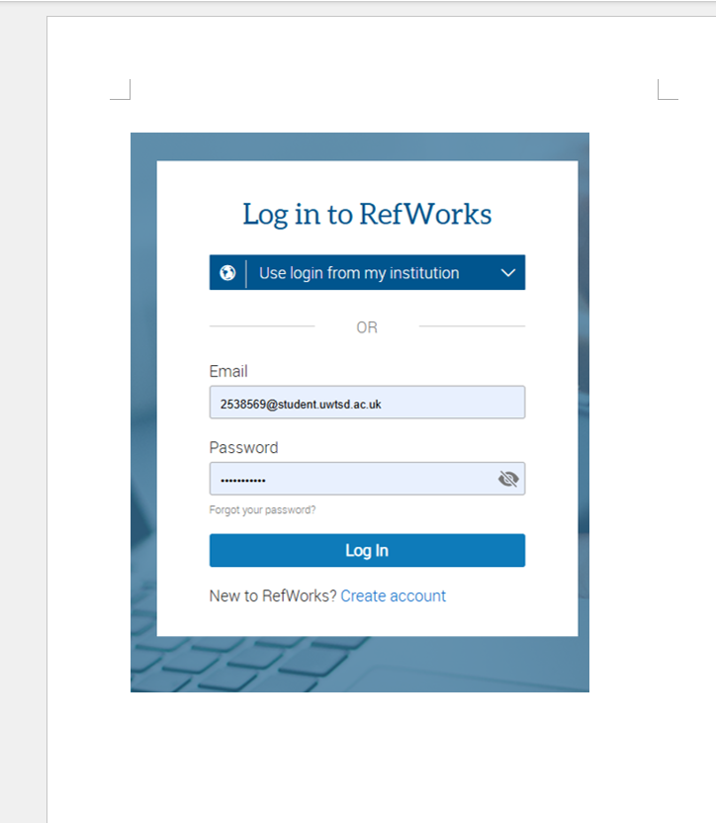

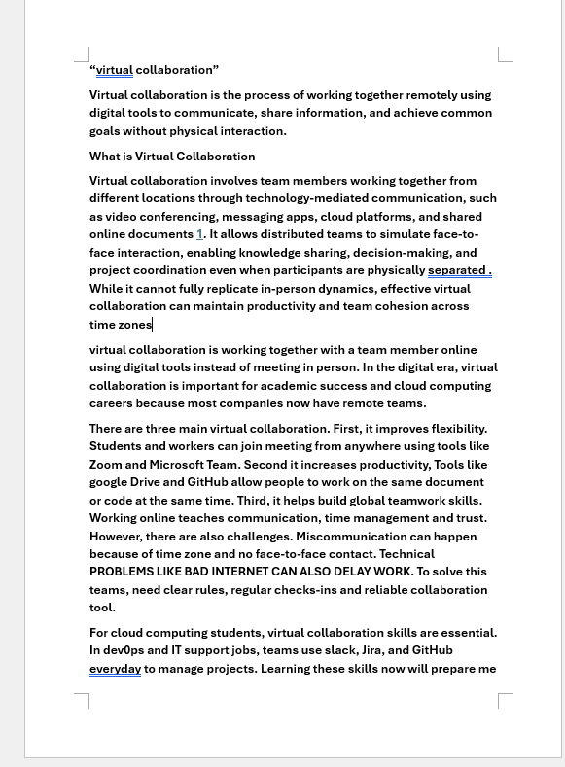
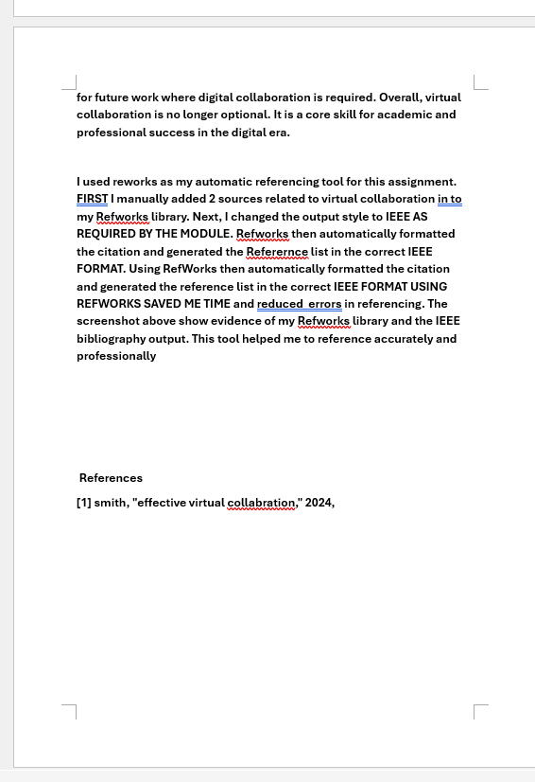

Step-by-step process of using RefWorks with visuals

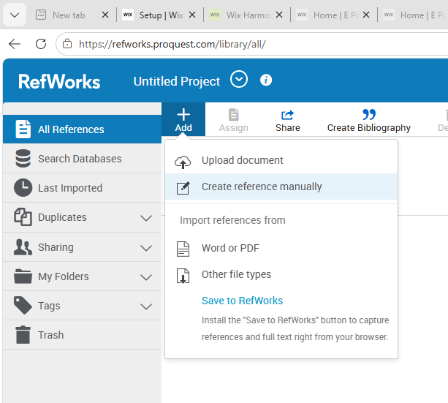
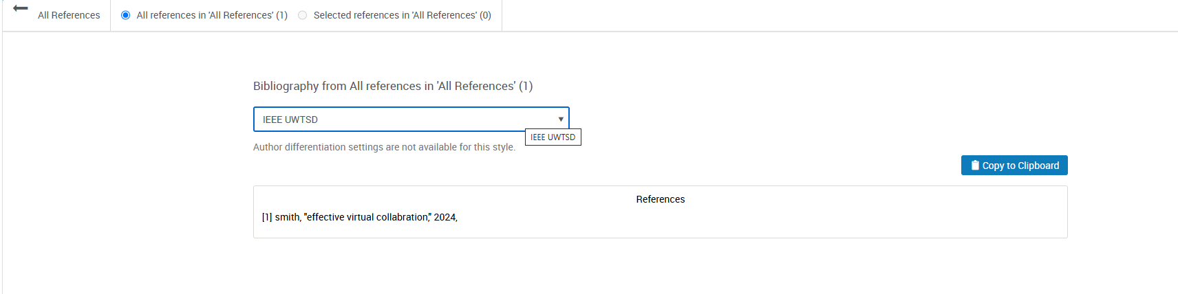

Task 4: E-Portfolio Creation and Evaluation

Task 4 (a): E-Portfolio Creation

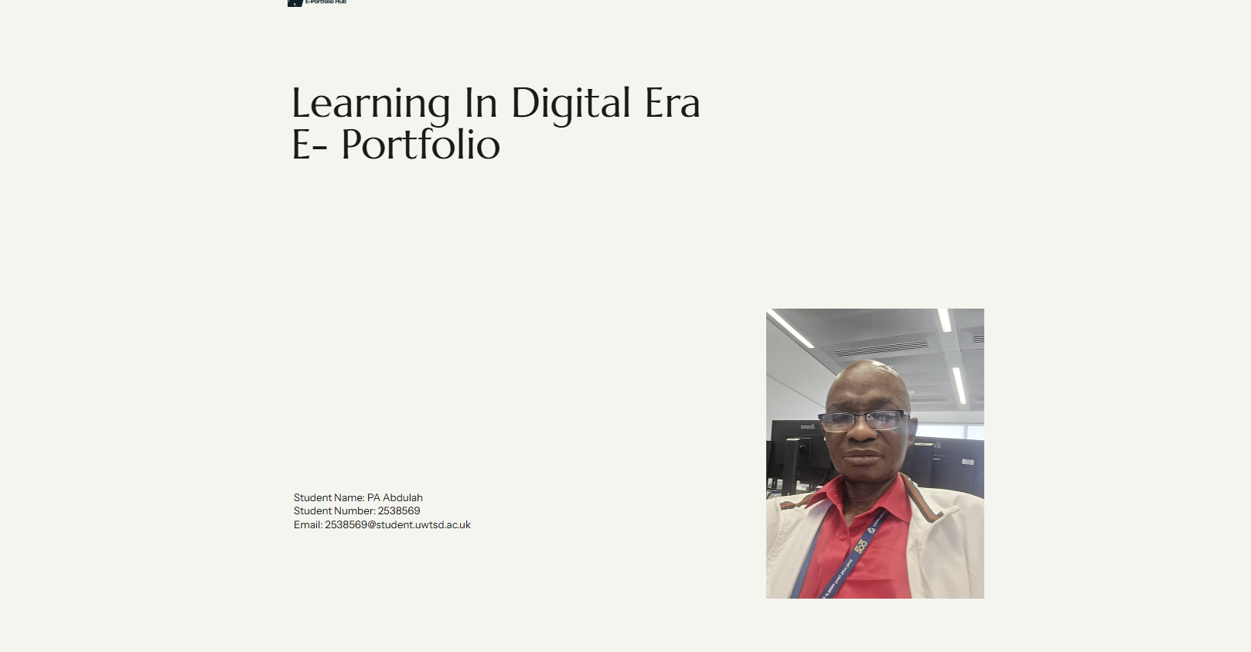

Task 4 (b): Illustrative Review of E-Portfolio tool Selection

THE TOOLES WE USE ADD ELEMINTS SO WE CAN ADD (PIC , TEXT,LIST AND MORE.
THEN WE USE ADD SECTIONS WITCH WE CAN ADD ABOUT PORTFOLIO AND EVENTS .
THEN WE CAN USE ADD PAGES WHIYCH WE CAN ADD AND MANGE PAGES
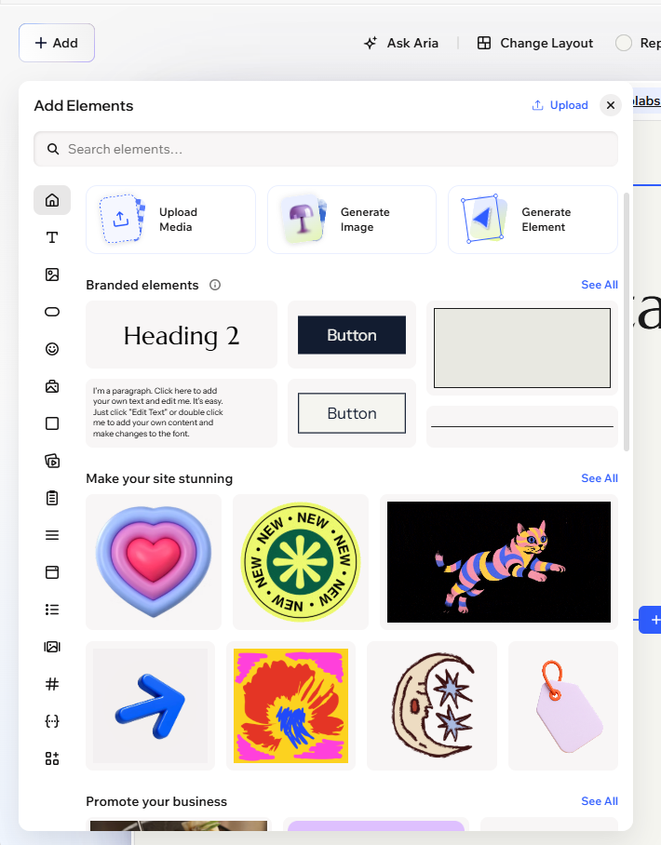

Conclusion

WE STUDY THUI

References

Task 1 References:

scheng, r. cao, and . md rashid,” the influence of employability skills on quality of employment in ai-driven labour market transformations”
humanities and social sciences communications, vol 12, no 1, 2025… available: Apr. 27, 2026
kroupova, t. havranek, and z. irsova, “student employment and education: a meta-analysis,”
economics of educationreview, vol.100,2024…available : doi,org.{accessed: apr.27,2026}.
kr,chadda,j.routh, t. ismail, et al.,”student and staff perspective on important employability and global mobility skills,” annals of the new york academy of sciences, Vol 1557, no1 2026.. available: pubmed.ncbi.nlm.nih.gov. {Accessed: apr.27,2026}.

Task 3 References:

[1] smith, "effective virtual collabration," 2024,

