Outsourcing and Insourcing Housekeeping at Marriot Hotel: A Critical Analysis
Name: Oluwatosin Osoba
Student ID: 2013493
Module Title: Financial Management for the Hotel Industry
Module Code: (BMIH5007)
Lecturer's Name: Chris Wilkins

Contents

Title page 1
Contents 2
Introduction 3
About Marriott Hotel 4
Comparison of insourced Housekeeping team Vs Outsourcing Housekeeping 4
Abilities of those employed 4
Cost implications 5
Results 5
Sustainability 6
Consistency 6
Guest experience 7
Conclusion 7
Reference 8

Introduction
The housekeeping department in an organization is saddled with the responsibility of ensuring cleanliness, orderliness, and hygiene within the organization. It is an important sector of the organization, especially the hospitality sector. Their services include cleaning and sanitizing, waste management, surface and equipment maintenance, Linen and laundry management, stocking and Inventory, specialized cleaning, safety, and compliance. Organizations can take up this responsibility or contract it out to other organizations.
Dixit (2023) stated that, after the pandemic, many hospitality sectors have adopted and modified most of their operations and processes. They are driven towards cost management by reducing labor costs, which seems to account for a larger part of their expenditure. One of these kinds of responses is the recent trend of outsourcing housekeeping. Several employees have been laid off as a means of getting the organization back on its feet after the effect of the pandemic. Goswami (2022) stated that the choice of the method adopted by any hospitality organization largely depends on several conditions and requirements.
There are several reasons why organizations choose to outsource their housekeeping department. They include the need for, expertise and specialization, cost saving, flexibility, scalability, and quality assurance, among others. Outsourcing the housekeeping department can offer several benefits to an organization if well managed. Otherwise, it can be a bad decision. However, organizations, especially the hospitality industry, have specific cultures and brand images they portray to their customers and the public at large; this may not be effectively communicated using outsourced housekeepers. This report examines the insourced housekeeping and outsourced housekeeping for hotels, with a bid to justify the best approach for hotels.
Insource/internal housekeeping describes the process of managing housekeeping in an organization by directly employing in-house staff to handle cleaning and maintenance tasks. This simply means that Marriot Hotel has a department that deals with housekeeping and room cleaning. They are saddled with the task of planning and implementing the cleaning process. The Marriott Hotel operates majorly during the day, so the cleaning takes place either in the evening or the night. Bovaird (2015 ) stated that this is one of the major advantages of internal housekeeping over outsourcing, outsourced housekeeping comes at a scheduled period, and this may interrupt the operational order of the hotel. The order of operating of the hotel will not be interrupted in the case of insourcing as the cleaning process is scheduled with the daily activity. This also avoids selective cleaning, as is the case with outsourcing. Also, housekeepers, in this case, can serve as the eyes and ears of the hotel, as they frequently go in and out of the rooms on daily bases, maintenance at Marriot Hotel will be timely and effective, as housekeepers can work closely with engineers and other maintenance departments.
Outsource housekeeping, on the other hand, contract an external service provider or company to handle the housekeeping task. The outsourcing company works in partnership with Marriot Hotel to determine the scope of the housekeeping duty. They work based on agreement, which majorly includes the details of what is used in the cleaning and the number of rooms that were cleaned; extra work cannot be done without the consent and approval of the hotel representative. Extra services in insource housekeeping may not attract extra charges as housekeeping staff are also hotel employees. One of the bright sides of outsourcing to Marriot Hotel is to manage costs and be selective in their cleaning process.

About Marriott Hotel
Marriott Hotels is a renowned hospitality brand recognized globally for its commitment to exceptional service and luxurious accommodations. With a portfolio of hotels and resorts in prime locations worldwide, Marriott offers guests a seamless blend of comfort, style, and innovation. From sophisticated rooms and amenities to personalized experiences, Marriott Hotels strive to create memorable stays for business and leisure travelers alike. With a rich heritage and a focus on guest satisfaction, Marriott continues to set the standard for excellence in the hospitality industry (Andreani et al., 2012)
At Marriot Hotel, the housekeeping department is headed, but the human resources manager and the approach adopted by this organization is the insourcing approach as seen (BCHG, 2023); the employment opportunity offered to housekeepers is permanent in terms of contract type, outsourcing housekeeping always have the contract on conditional base. They work together as a team. However, there is a need to justify which of the approach is best for Marriot as an organization.
Marriot Hotel operates as a hotel chain, which is the major reason why they exist in several countries; it is, therefore, important that the housekeeping system must be unique and fit for a system of hotels operated by the system (Pine and Qi, 2004). Ivanova et al. (2016) stated that the hotel chain operates as a franchise, and this has been the secret of their global expansion. Therefore, the characteristics of the housekeeping approach to be adopted must be fitted into this system.

Comparison of insourced housekeeping team Vs. Outsourcing Housekeeping
Every organization has brand values and culture they represent and communicate with their guests and the entire public. Internalizing Housekeeping will allow the hired staff to be trained and instructed in this regard. One of the competitive edges of the hospitality industry is its ability to create uniqueness in brand and culture. Outsourced housekeeping may be professional in their approach, but because they do not belong to the system and the organization at large, representing the brand of the organization may not be effective.

Abilities of those employed.
Insourcing housekeeping gives a sense of belonging to the employees working in this department and reduces the employee turnover rate. The task carried out by these staff at Marriot Hotel is more effective than that of the outsource because they understand that failure in their duties could cost them their job, so they tend to be more professional and accurate in their approach. The outsourced housekeeping may only have their contract at stake in this case, and such cases are only associated with very severe cases, which are always rare. Anthony et al. (2004) stated that guests in the organization take notes of little things and events in the hotels, so this may be a downside in terms of services employed during the outsourced housekeeping process. Since employees have a sense of belonging, they take note of guest complaints and complement and relay the information to the organization. For outsourcing services, training employees to reflect the organization's culture and brand may not be possible; consistency and dedication can only be derived from insourcing housekeeping.

Cost implications
Zhang and Ma (2017) stated that the use of outsourced housekeepers has kept increasing in the hospitality industry over the years. The hospitality industry is faced with the choice of incurring the high cost of the initial investment in buying machines and products that can enable insources housekeeping or choosing outsourcing housekeeping services that allow them to carry out housekeeping services based on contract. This allows selective housekeeping and also minimizes cost. Marriot Hotel is a big organization and may not have a challenge incurring the initial capital investment, but will this be the case for the chains and brands of hotels they have across the globe? Outsource Housekeeping has proven to be more cost-effective, ( ) describe it as a profitable business. Personen (200) stated that during economic issues or pandemics, Marriot might be forced to lay off staff, and outsourcing housekeeping bears the burden of this layoff, thereby leaving the hotel out of the effect.
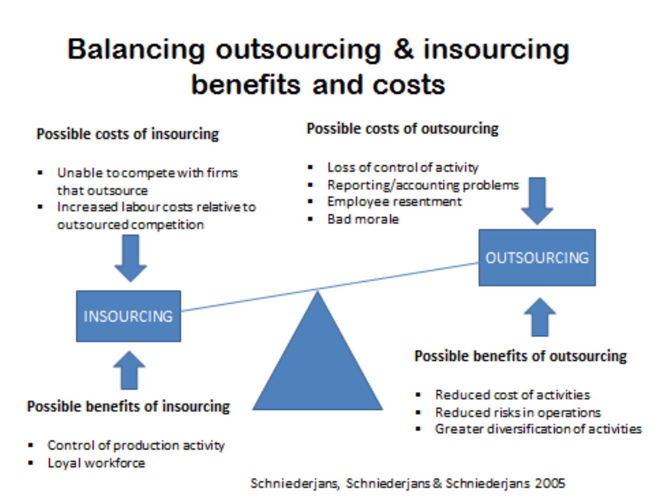
Figure 1: Benefit and Cost balancing for Outsourcing and Insourcing (Schniederjans et al., 2005)

Results
The result of bringing outsourced housekeeping into the system often brings disruption in the order and the way things are done in an organization. The result of outsourcing is largely seen in terms of profitability. The hotel can then focus on its hospitality services while the outsourced housekeeping focuses on general cleaning. A description of the result of both housekeeping services in terms of benefits and challenges is shown in Figure 2. Internal housekeeping offers more benefits and fewer challenges than outsourced housekeeping.
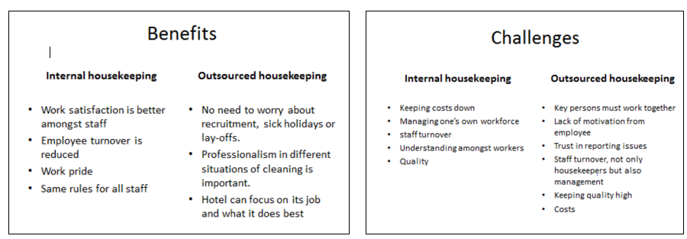
Figure 2: Benefits and Challenges Associated with Internal and Outsourced Housekeeping (Personen, 2015)

Sustainability
Sustainability is largely related to culture and the corporate social responsibility of an organization to both the environment, the customers, and the continuous operation of the organization (Martinezz-Martinez et al., 2019). Outsourcing housekeeping in hotels can positively impact sustainability. By partnering with professional cleaning companies, hotels can benefit from their expertise in implementing sustainable practices. These practices may include using environmentally friendly cleaning products, adopting energy-efficient equipment, and implementing waste management strategies. Outsourcing housekeeping allows hotels to leverage the knowledge and resources of specialized firms to promote sustainability and reduce their environmental footprint. However, Molina-Collado et al. (2022) stated that insourcing Housekeeping in hotels can also influence sustainability positively. By directly managing the housekeeping operations, hotels have more control over implementing sustainable practices. This includes training staff on eco-friendly cleaning methods, utilizing energy-efficient equipment, and implementing waste reduction strategies. Insourcing allows hotels to have a direct impact on sustainability initiatives and ensures greater adherence to their specific sustainability goals and standards

Consistency
Consistency describes the ability to continuously engage in an activity at virtually the same standard and condition. Marriot Hotel has been known for consistency in the high quality of guest experience and services they offer across the globe (Li et al., 2020). Outsourcing housekeeping ensures consistency by relying on specialized service providers who have standardized processes and training programs. This helps maintain a consistent level of service quality and ensures that cleaning standards and procedures are consistently followed across different properties or locations. However, Insourcing Housekeeping allows for better control and supervision of staff, resulting in increased consistency in cleaning standards and procedures. Ramphal and Nicolaides (2018) stated that direct oversight and training by the hotel management ensures adherence to specific guidelines and maintain a consistent level of service quality.

Guest experience
Guest experience is heightened more in insourcing housekeeping than outsourcing housekeeping (Mahas and Tukamushaba, 2015). The guest experience is a combination of proper communication of culture, brands, services, and hospitality to the customers during their stay. Culture and effective brand communication are the salient characteristics of insourcing housekeeping since employees have a sense of belonging to the organization. Yoruk et al. (2023) stated that insourcing housekeeping ensures direct management oversight, leading to better quality control and personalized service, ultimately enhancing the guest experience. Outsourcing housekeeping can negatively impact the guest experience due to potential inconsistencies in service quality and lack of familiarity with the hotel's standards.

Conclusion
Marriot Hotel, as a hospitality organization, is faced with two important choices, which are relatively associated with insourcing and outsourcing of housekeeping, the challenge of profitability, and brand reputation. Using outsourced housekeeping offers an advantage of maximizing cost and increasing profitability, while insource housekeeping offers a greater advantage in terms of improving guest experience and also the brand and culture of the organization. Outsourcing hotel facilities brings benefits like improved efficiency, effectiveness, and cost savings. To enhance housekeeping operations, Marriott Hotel should focus on recruiting and training the right employees. Providing adequate training and cross-training opportunities can boost housekeeping performance, maximize efficiency, and increase productivity.

Reference
Andreani F., Sumargo Y. and Lie C. (2012) The Influence of Customer Relationship Management (CRM) on Customer Loyalty in JW Marriot Hotel Surabaya Journal of Management and Entrepreneurship 14(2):34-46
Anthonisz A. (2014) Assessing the future of housekeeping operations in Dubai's five-star hotel industry – room for innovation Worldwide Hospitality and Tourism Themes 6(4): 352-361
Anthony J., Anthony F. J.and Ghosh S. (2004) Evaluating service quality in a UK hotel chain: a case study International Journal of Contemporary Hospitality Management 16(6): pp. 380 -384 Available at: https://www.emerald.com/insight/content/doi/10.1108/09596110410550833/full/html Accessed on: 09 June 2023
BCHG92023) Housekeeping Assistant & Runners – Marriott Hotel [online] Available at: https://bchg-career.talent-soft.com/job/job-housekeeping-assistants-runners-marriott-hotel_483.aspx Accessed on: 09 June 2023
Bovaird T.(2015) The ins and outs of outsourcing and insourcing: what we learned from the past 30 years Public Money & Management 36(1): 67-74
Dixit S. (2023) Internal Housekeeping Versus Outsourced Housekeeping – Both Sides of the Coin Explained [online] Available at: https://www.raregrp.com/internal-housekeeping-versus-outsourced-housekeeping-both-sides-of-the-coin-explained/ Accessed on: 07 June 2023
Ivanova M., Ivanov S. and Magnini V. P.(2016) The Routledge Handbook of Hotel Chain Management Routledge Taylor & Francis Group, London and New York
Li Y., Huang S. and Song L. (2020) Opportunity and necessity entrepreneurship in the hospitality sector: Examining the institutional environment influence Tourism Management Perspectives 34:pp. 45-78
Manhas P. S. and Tukamushaba E. K. (2015) Understanding services experience and its impact on brand image in hospitality sector International Journal of Hospitality Management 45: pp. 77-87
Martinez-Martinez A., Cegarra-Navarro J., Garcia-Perez A. and Wensley A. (2019) Knowledge agents as drivers of environmental sustainability and business performance in the hospitality sector Tourism Management 70: pp 381-389 https://doi.org/10.1016/j.tmp.2020.100665
Molina-Collado, A., Santos-Vijande, M.L., Gómez-Rico, M. and Madera, J.M. (2022), Sustainability in hospitality and tourism: a review of key research topics from 1994 to 2020 International Journal of Contemporary Hospitality Management 34(8), pp. 3029-3064. https://doi.org/10.1108/IJCHM-10-2021-1305
Prashanti J. (2020) The Triumphs & Challenges in the Path of Green Hotel Housekeeping Journal of Services Research 20(1): 21-37
Pesonen J. (2015) Internal Housekeeping Versus Outsourced Housekeeping Master Thesis Saima University of Applied Science
Pine R. and Qi P. (2004) Barriers to hotel chain development in China International Journal of Contemporary Hospitality Management 16(1): pp. 37-44
Ramphal R. R. and Nicolaides A. (2018) Intelligent consistency- Ethical practices of Lean Six Sigma in quality service provision in the hospitiality industry African Journal of Hospitality, Tourism and Leisure 7(3): pp. 1-15
Schniederjans M. J., Schniedeerjans A. M. and Schniederjans D. G. (2005) Outsourcing & Insourcing in an international context U.S.A: M.E. Sharpe, Inc.
Zhang Y. and Ma E. (2017) Transaction Cost and resources Based Views on Hotels' Outsourcing Mechanism: An empirical study in China Journal of Hospitality Marketing & Management 27(5): pp. 34 – 45 Available at: https://www.tandfonline.com/doi/abs/10.1080/19368623.2018.1406834 Accessed on: 09 June 2023
Yörük, T., Akar, N. and Özmen, N.V. (2023), "Research trends on guest experience with service robots in the hospitality industry: a bibliometric analysis", European Journal of Innovation Management, Vol. ahead-of-print No. ahead-of-print. https://doi.org/10.1108/EJIM-09-2022-0530

