  Component One:  What are the key skills required when working in the housekeeping team? 750 words (+/- 10%)  Contribution to Overall Module Assessment: 25% | Student No: | 2122723
 | Module Title: | Operating Hotel Facilities
 | Module Code: | BMIH4006
 | Lecturer: | Lola Villard
Whitbread PLC staff's capacity to provide the best service to our clients while also feeling cared for and supported rests on their ability to be joyful and engaged at work. Housekeepers play a crucial role in maintaining the cleanliness and overall appearance of hotels in the Whitbread Hotel Group (Whitbread, n.d.). Their primary responsibility is to ensure that guest rooms, public areas, and other designated spaces are kept clean and well-maintained (Whitbread, n.d.).
Housekeepers are required to perform various tasks including cleaning and maintenance of guest rooms. This includes making beds, dusting, vacuuming, and replenishing amenities such as towels and toiletries (Whitbread, n.d.). They also clean and maintain public areas, corridors, and other hotel spaces as required (Whitbread, n.d.).
In order to excel in their role, housekeepers need to possess a range of skills. Attention to detail is vital as they must ensure that each room is thoroughly cleaned and organized, paying close attention to small details such as stains, dust, or damaged items (Whitbread, n.d.). Effective time management skills are necessary to complete their tasks efficiently while maintaining quality standards (Whitbread, n.d.).
Housekeepers should also have good communication skills to handle guest interactions professionally and address any concerns or issues promptly (Whitbread, n.d.). Physical stamina is important as the role can be physically demanding, involving prolonged periods of standing, walking, and carrying heavy items (Whitbread, n.d.).
A good understanding of various cleaning techniques, equipment, and cleaning agents is required (Whitbread, n.d.). Housekeepers should know how to handle cleaning chemicals safely and efficiently (Whitbread, n.d.). They often work as part of a larger housekeeping team, so teamwork and the ability to collaborate with colleagues are essential (Whitbread, n.d.).
Overall, housekeepers in the Whitbread Hotel Group play a critical role in maintaining the cleanliness and comfort of the hotel for guests (Whitbread, n.d.). Their technical skills, attention to detail, time management, and good communication contribute to their success in this role (Whitbread, n.d.).

Housekeepers in the Whitbread Hotel Group need to possess effective time management skills to complete their tasks efficiently while maintaining quality standards (Whitbread, n.d.). The ability to prioritize and organize their work is crucial in order to meet the demands of cleaning guest rooms and public areas within a specified timeframe (Whitbread, n.d.).
Housekeepers are often assigned a set number of rooms to clean within a given shift, and they must manage their time wisely to ensure that all tasks are completed in a timely manner (Whitbread, n.d.). This includes allocating appropriate time for each cleaning task, such as making beds, dusting, vacuuming, and restocking amenities (Whitbread, n.d.).
By effectively managing their time, housekeepers can ensure that they meet the needs of guests while maintaining high cleanliness standards throughout the hotel (Whitbread, n.d.). This involves planning their cleaning schedule, allocating sufficient time for each room, and adjusting their pace as needed to maintain productivity (Whitbread, n.d.).

Flexibility is an important quality for housekeepers in the Whitbread Hotel Group. While there may be standard cleaning procedures and routines to follow, housekeepers often encounter unexpected situations or changes in their work environment that require them to adapt quickly and efficiently (Whitbread, n.d.).
Housekeepers may need to adjust their cleaning schedule or priorities based on the needs of the hotel and its guests (Whitbread, n.d.). For example, they may be called upon to handle urgent cleaning requests or attend to specific areas that require immediate attention.
Furthermore, housekeepers may be required to work different shifts, including early mornings, evenings, weekends, and holidays, in order to accommodate the operational needs of the hotel (Whitbread, n.d.). They should be willing to be flexible with their working hours and be adaptable to changes in their work schedules.
Being flexible also extends to collaborating effectively with other team members within the housekeeping department and other hotel departments. Housekeepers may need to assist their colleagues or take on additional responsibilities during peak periods or in case of staff shortages (Whitbread, n.d.). This teamwork and willingness to support others contribute to the smooth functioning of the hotel operations.

Problem-solving is an important skill for housekeepers in the Whitbread Hotel Group. They may encounter various challenges and situations that require them to think critically and find effective solutions. Here is an overview of problem-solving in the context of housekeeping, with a citation in Harvard style:
Housekeepers in the Whitbread Hotel Group often face problems or obstacles that need to be resolved promptly and efficiently (Whitbread, n.d.). These may include issues such as equipment malfunctions, difficult stains or spills, guest complaints, or unexpected maintenance issues within guest rooms or public areas (Whitbread, n.d.).
Effective problem-solving involves assessing the situation, analyzing the available information, and identifying the best course of action to address the problem (Whitbread, n.d.). Housekeepers need to be resourceful and creative in finding solutions that uphold the cleanliness and comfort of the hotel while minimizing any disruptions for guests (Whitbread, n.d.).
In addition, housekeepers should be proactive in identifying potential problems and taking preventive measures to mitigate them. This could involve regular inspection of guest rooms and public areas to identify maintenance needs, ensuring proper functioning of equipment, and promptly reporting any issues to the appropriate departments (Whitbread, n.d.).
By demonstrating strong problem-solving skills, housekeepers contribute to the overall guest satisfaction and operational efficiency of the hotel (Whitbread, n.d.). Their ability to quickly and effectively address challenges helps maintain a positive environment for guests and fellow team members.

Organizational skills are essential for housekeepers in the Whitbread Hotel Group to effectively manage their tasks, maintain cleanliness, and ensure a smooth workflow. Here is an overview of organizational skills in the context of housekeeping, along with a citation in Harvard style:
Housekeepers in the Whitbread Hotel Group need to be highly organized to handle their responsibilities efficiently (Whitbread, n.d.). This includes managing their time effectively, prioritizing tasks, and maintaining a systematic approach to their work.
Effective organization involves planning and scheduling cleaning activities, ensuring that each task is allocated an appropriate amount of time (Whitbread, n.d.). Housekeepers must create a cleaning schedule that allows them to clean guest rooms and public areas within specified timeframes while maintaining high cleanliness standards (Whitbread, n.d.).
In addition to time management, housekeepers need to organize their supplies and equipment. This includes managing inventory, restocking amenities, and ensuring that cleaning tools and chemicals are readily available (Whitbread, n.d.). They should also maintain a well-organized storage area to easily access and locate necessary items.
Housekeepers with strong organizational skills can efficiently handle multiple tasks simultaneously (Whitbread, n.d.). They are able to navigate through different areas of the hotel, coordinate with colleagues, and adapt to changing priorities or unexpected situations while maintaining a systematic approach to their work.
By demonstrating effective organizational skills, housekeepers contribute to the overall efficiency and effectiveness of the housekeeping department, ensuring that guest rooms and public areas are clean, well-maintained, and ready for guest occupancy (Whitbread, n.d.)

Word Count | 660

Component Two:
Contribution to Overall Module Assessment: 25%
In this scenario – You have just been promoted to team leader for a floor within the hotel. A guest complains that on their arrival, their room had not been properly cleaned. Create an action plan and answer the following questions.

Problem | Why did it happen? | What are you going to do? | How will you prevent this from happening in the future? | What measures would you introduce to improve team effectiveness?
Dirty Bed sheet | The staff didn’t check the sheets properly before putting it on | Replace bedsheets to fresh ones ASAP and give the customer complimentary breakfast.  Ask the customer to go to the bar and have complementary drink while we clean the room | Check all the new bedsheets before they load the trolley from the stockroom and the managers need to take their time when signing off room. | Give extra training to housekeeping staff and the manager has to take their time when signing of the room.
Bin not emptied | Staff was rushing to finish early | Ask the customer to go to the bar and have complementary drink while we clean the room. And apologise. | Conduct regular training sessions for housekeeping staff to enhance their skills and knowledge in cleaning techniques, This will help them maintain a high level of cleanliness in guest rooms. | Implement a system of regular quality inspections to monitor the cleanliness of guest rooms. Designate supervisors or senior staff to check and review the work of housekeepers to identify any areas that need improvement.
No fresh towels | Housekeeping staff forgot to put new towels in the room. | Apologise to customer, send member of staff and give fresh towels ASAP and give the customer a late checkout if needed. | Provide housekeepers with comprehensive checklists for each room, including specific tasks to be completed and areas to focus on. Regularly inspect rooms to ensure that all items on the checklist are completed to maintain cleanliness standards. | Implement a system of regular quality inspections to monitor the cleanliness of guest rooms. Designate supervisors or senior staff to check and review the work of housekeepers to identify any areas that need improvement.
TV not working | Its not the housekeepers job to check if the tv is working it’s the maintenance teams job. | Apologize for the inconvenience caused and assure the guest that their concerns will be addressed. Send a staff member, such as a technician or maintenance personnel, to the guest's room to assess the TV issue and attempt to resolve it on the spot. If the TV cannot be fixed promptly, offer the guest a room transfer to another room with a functioning TV. Ensure the new room meets the guest's requirements and preferences. Alternatively, if a room transfer is not feasible, provide an alternate solution, such as offering access to a guest lounge or providing a portable TV for temporary use. | Once the issue is resolved or an alternative solution is provided, follow up with the guest to ensure their satisfaction. Demonstrate genuine care and willingness to address any additional concerns or needs they may have. | Regularly schedule preventive maintenance for TVs in hotel rooms to minimize the occurrence of malfunctions. This can include periodic inspections, software updates, and equipment replacements as needed.
Heater not working | Its not the housekeepers job to check if the heaters are working it’s the maintenance teams job. Sometimes previous guest break equipment’s. | Respond to the customer's complaint promptly and express apologies for the inconvenience caused  Arrange for a technician or maintenance staff to visit the guest's room to assess the heater problem and resolve it as quickly as possible. Prompt assistance demonstrates the hotel's commitment to guest comfort. The technician or maintenance staff should inspect the heater and attempt to troubleshoot and fix the problem. | If the heater cannot be fixed immediately, provide the guest with alternative heating solutions. This may include offering portable heaters, extra blankets, or arranging for a room transfer to a room with a functioning heater. Ensure the guest's comfort and provide options to address their immediate needs. | Implement a preventive maintenance program for heaters in hotel rooms to minimize the occurrence of malfunctions. Conduct regular inspections and maintenance checks to ensure the heaters are in proper working condition. This helps identify and address any potential issues before they impact guest comfort.

Component Three:
Contribution to Overall Module Assessment: 50%
Your task is to create and prepare a presentation following the detailed scenario provided below.

As the floor housekeeping manager and given the recent guest complaints you need to put together a basic training presentation for your colleagues within the housekeeping team to get the best out of them, ensure that brand standard is being achieved and that Health and Safety procedures are also being followed.

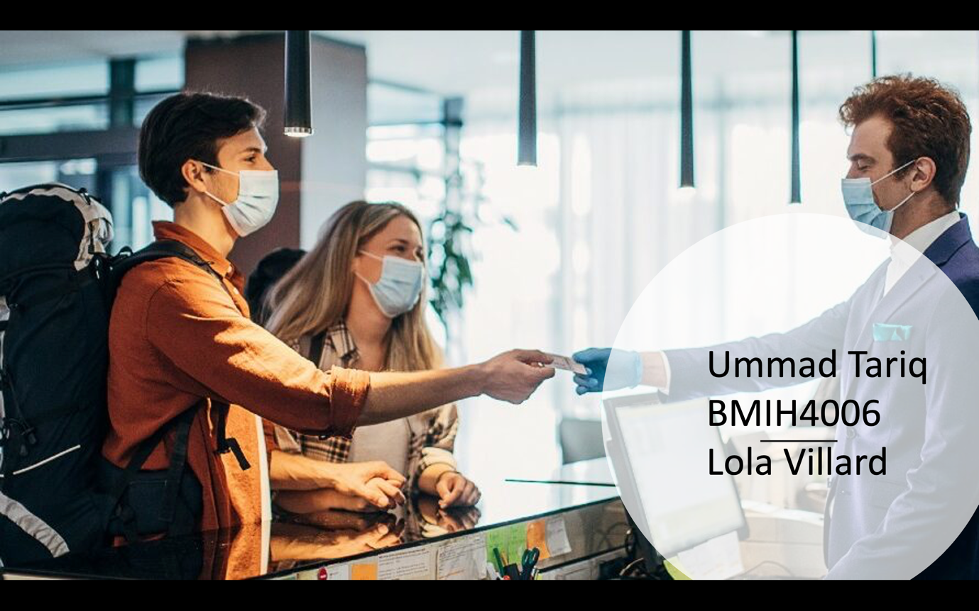

Training Notes:
1,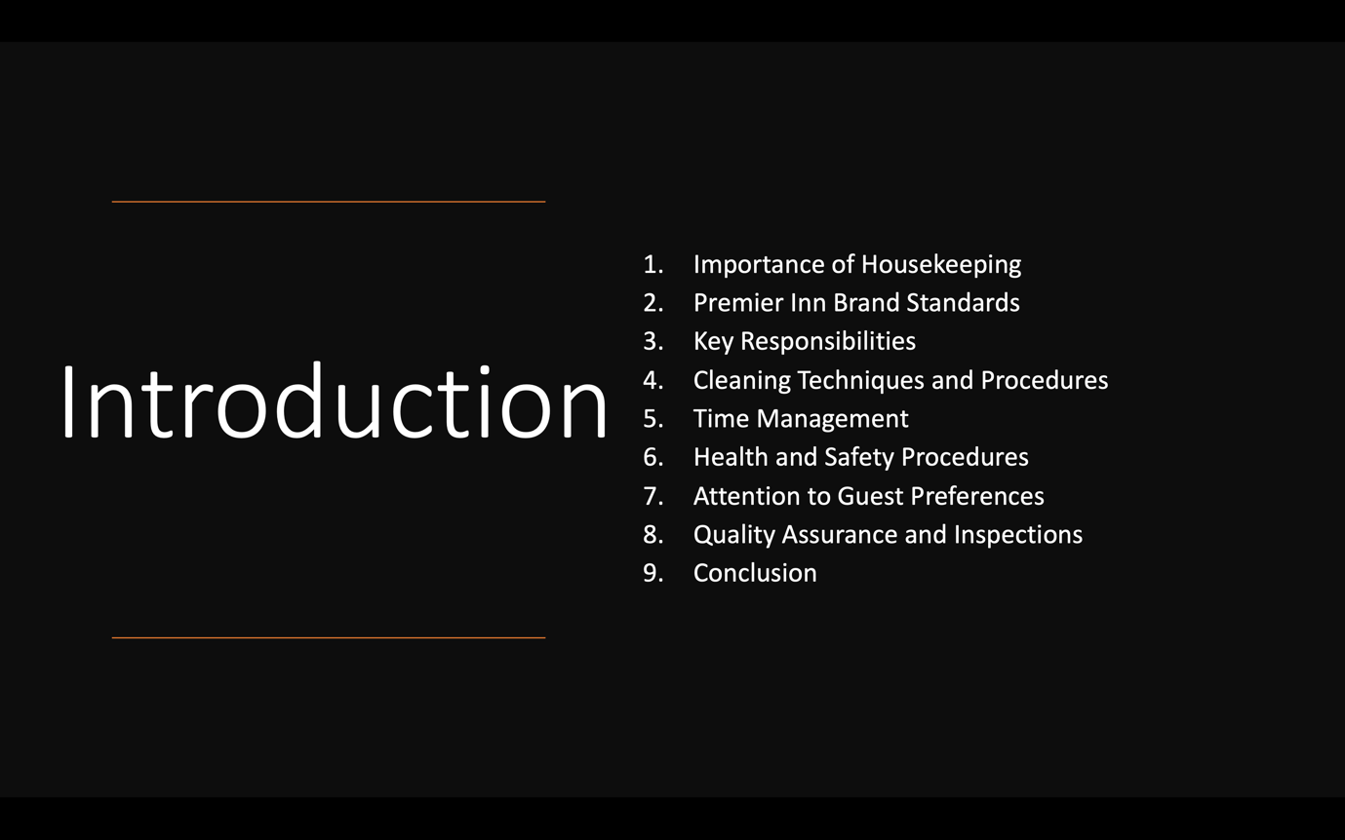

Training Notes:
Good morning/afternoon, everyone! I'm Ummad, the Floor Housekeeping Manager here at Premier Inn Birmingham. Today, I'm excited to share with you a training presentation aimed at getting the best out of our housekeeping team, ensuring brand standards are achieved, and maintaining Health and Safety procedures.
2,

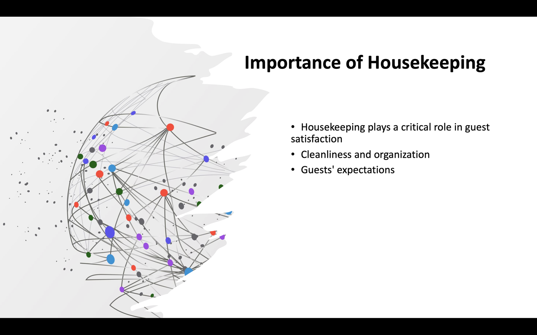

Training Notes:
Housekeeping plays a critical role in guest satisfaction and the overall reputation of our hotel. Cleanliness and organization directly impact guest comfort and loyalty. Let's work together to exceed our guests' expectations and leave a lasting positive impression.

3,

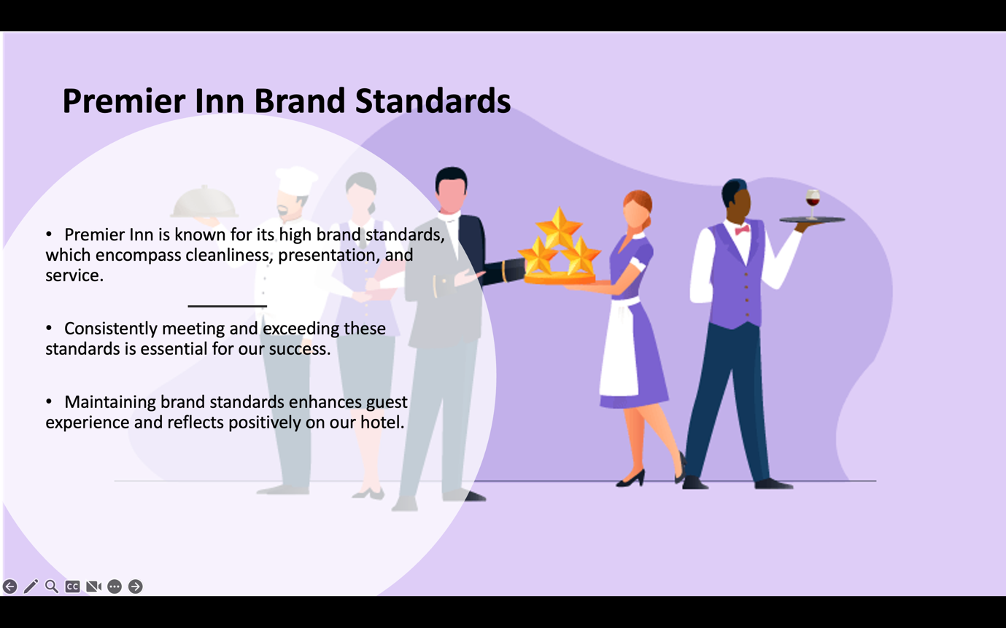

Training Notes:
Premier Inn is known for its high brand standards, which encompass cleanliness, presentation, and service. Consistently meeting and exceeding these standards is essential for our success. Maintaining brand standards enhances guest experience and reflects positively on our hotel.
4,

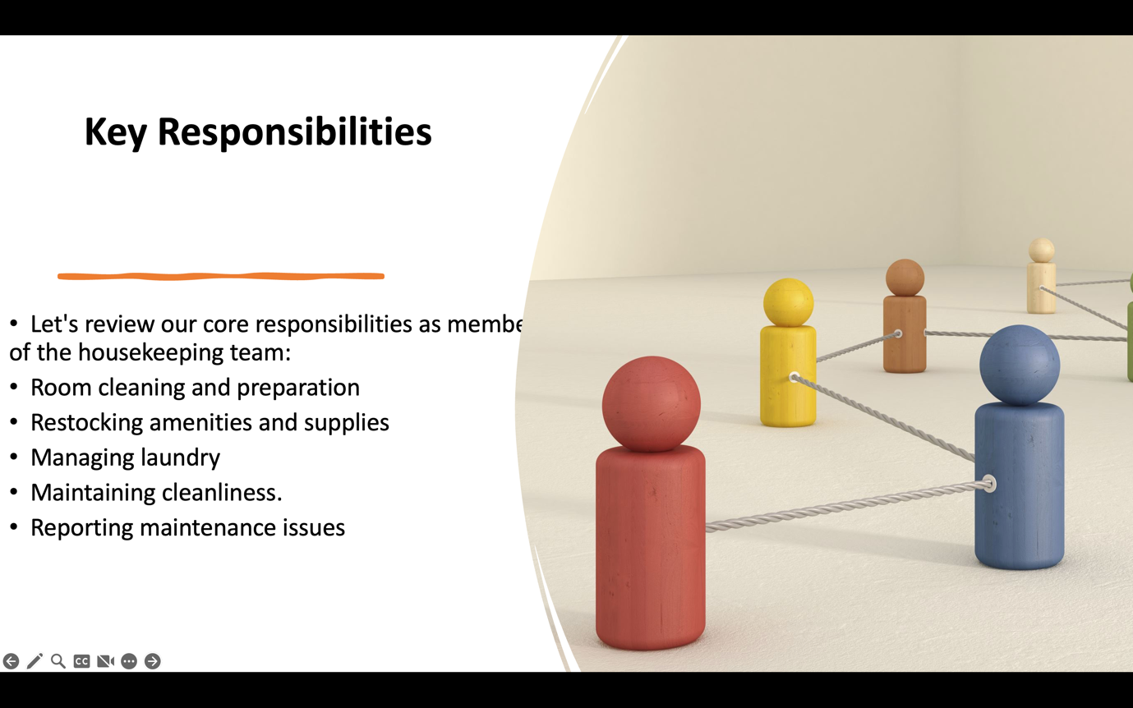

Training Notes:
As members of the housekeeping team, our core responsibilities include:
- Room cleaning and preparation to ensure guest readiness.
- Restocking amenities and supplies for guest convenience.
- Managing laundry efficiently and effectively.
- Maintaining cleanliness in public areas.
- Reporting maintenance issues promptly for timely resolution.

5,

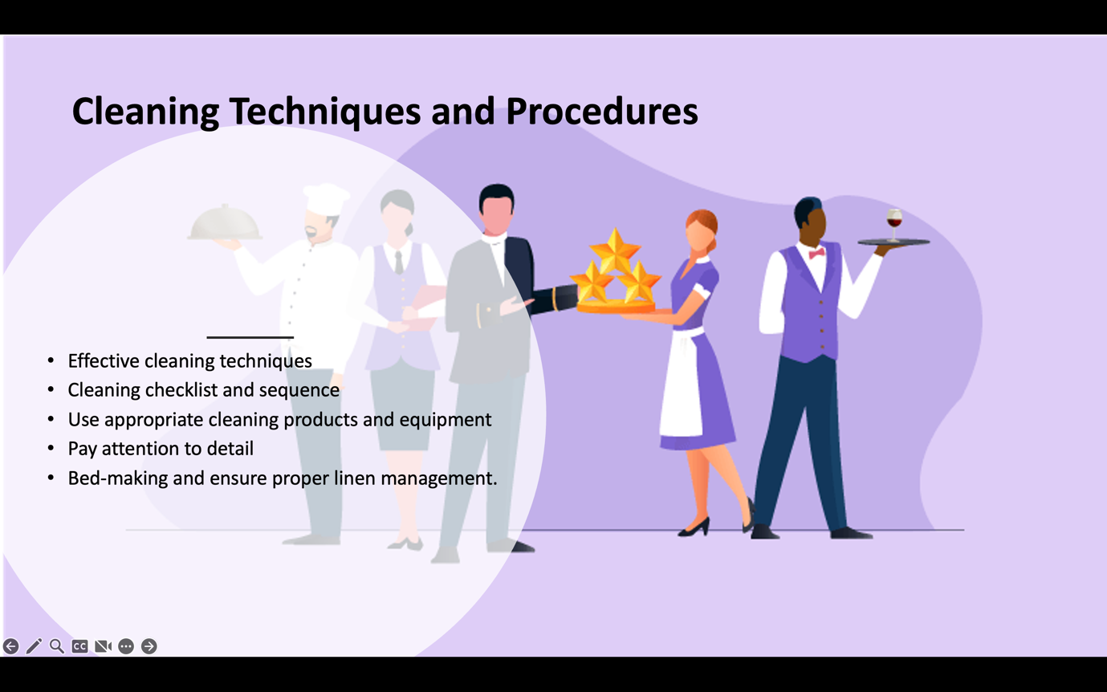

Training Notes:
To ensure thoroughness and efficiency, let's focus on effective cleaning techniques and procedures, such as:
- Following the room cleaning checklist and sequence provided.
- Using appropriate cleaning products and equipment for different surfaces.
- Paying attention to detail, including corners, fixtures, and high-touch areas.
- Mastering the art of bed-making and ensuring proper linen management.

6,

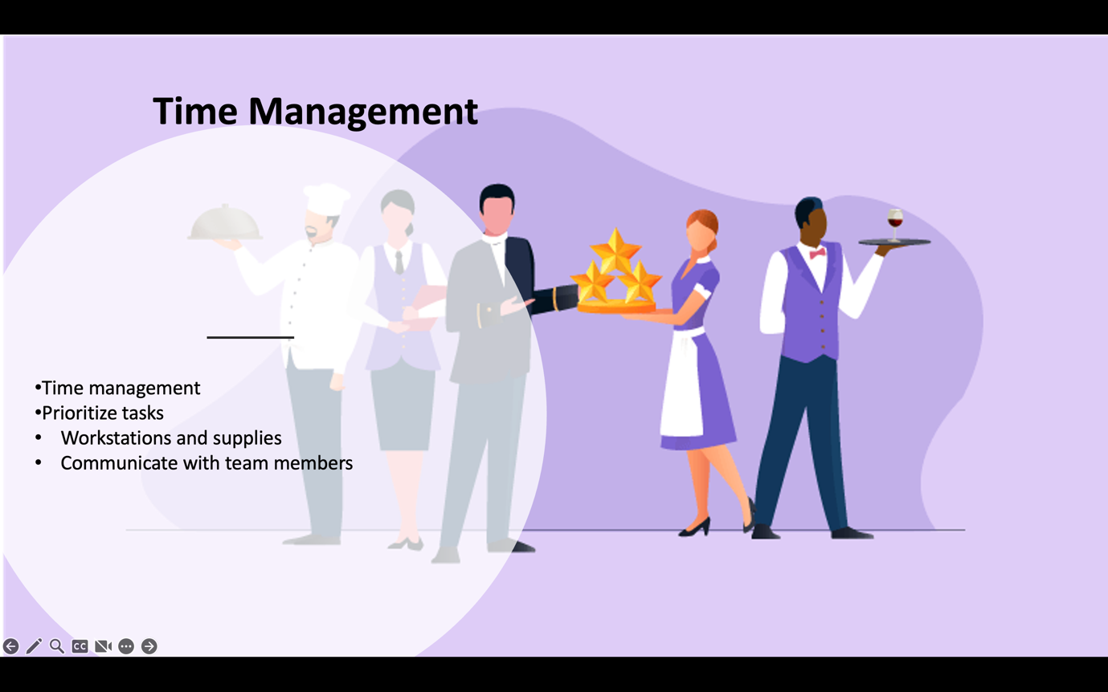

Training Notes:
Time management is crucial for housekeeping operations. Here are some strategies to optimize productivity:
- Prioritizing tasks based on guest needs and departure times.
- Keeping workstations and supplies organized for quick access.
- Communicating with team members to allocate tasks efficiently and avoid duplication.

7,

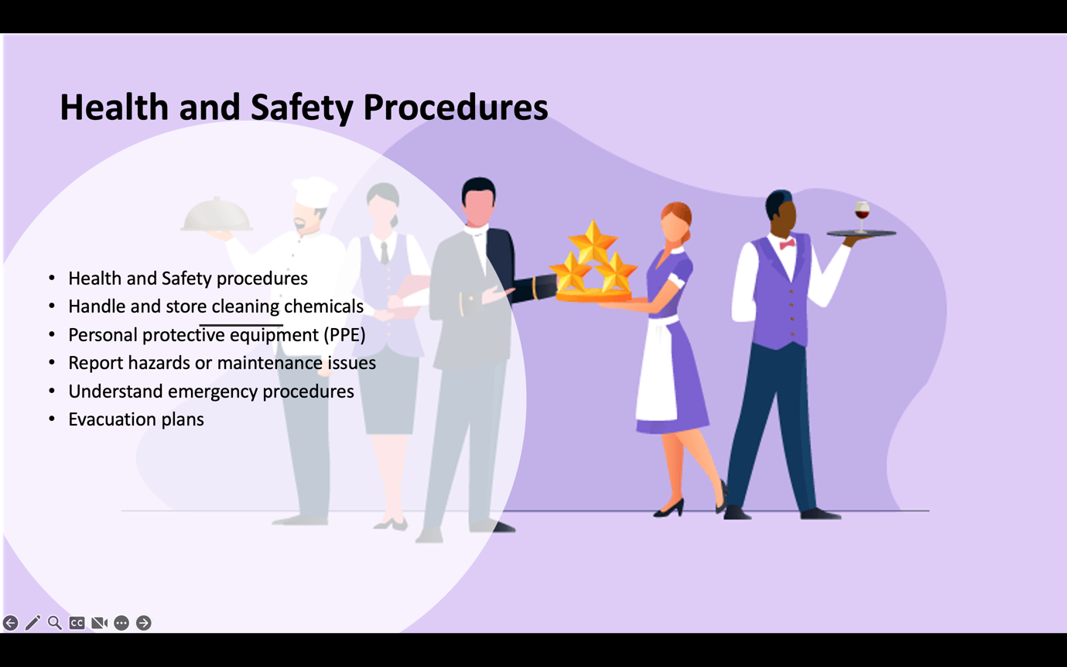

Training Notes: Following Health and Safety procedures is paramount for guest and team member well-being. Let's ensure we adhere to the following:
- Handling and storing cleaning chemicals correctly to prevent accidents.
- Wearing personal protective equipment (PPE) as required.
- Reporting hazards or maintenance issues promptly for resolution.
- Understanding emergency procedures and evacuation plans for everyone's safety.

8,

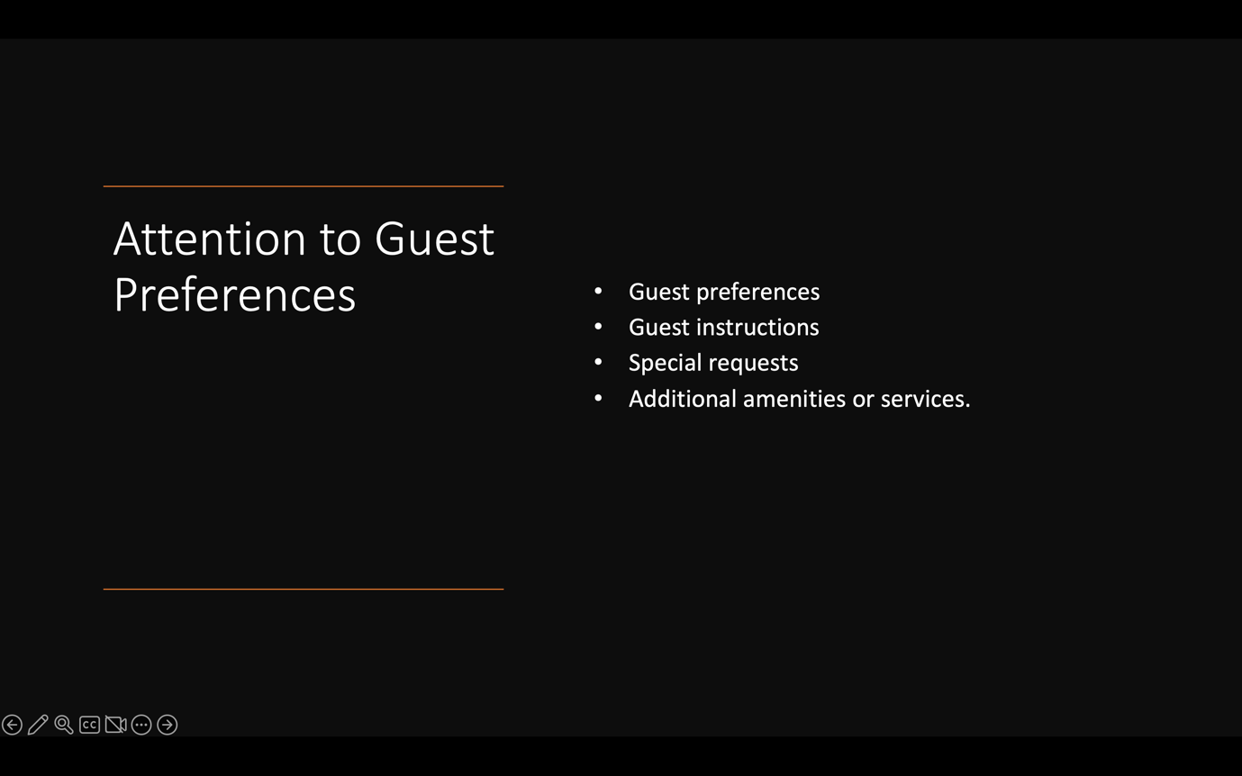

Training Notes:
Addressing guest preferences promptly and courteously enhances their experience. Let's focus on:
- Paying attention to guest instructions or notes for personalization.
- Being responsive to special requests or needs.
- Offering additional amenities or services when appropriate to exceed expectations.

9,

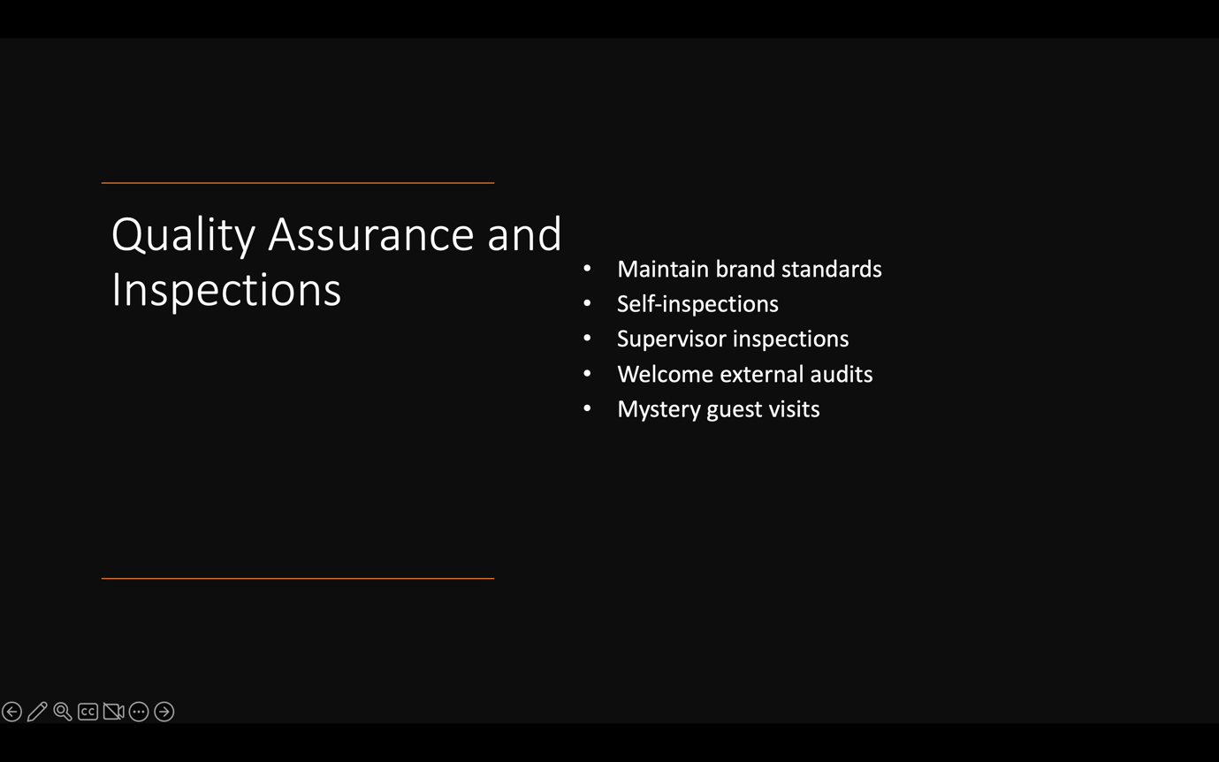

Training Notes:
Quality assurance helps us maintain brand standards and guest satisfaction. Let's embrace the following practices:
- Conducting regular self-inspections to identify areas for improvement.
- Welcoming supervisor inspections for feedback and guidance.
- Embracing external audits and mystery guest visits to enhance our performance.

10,

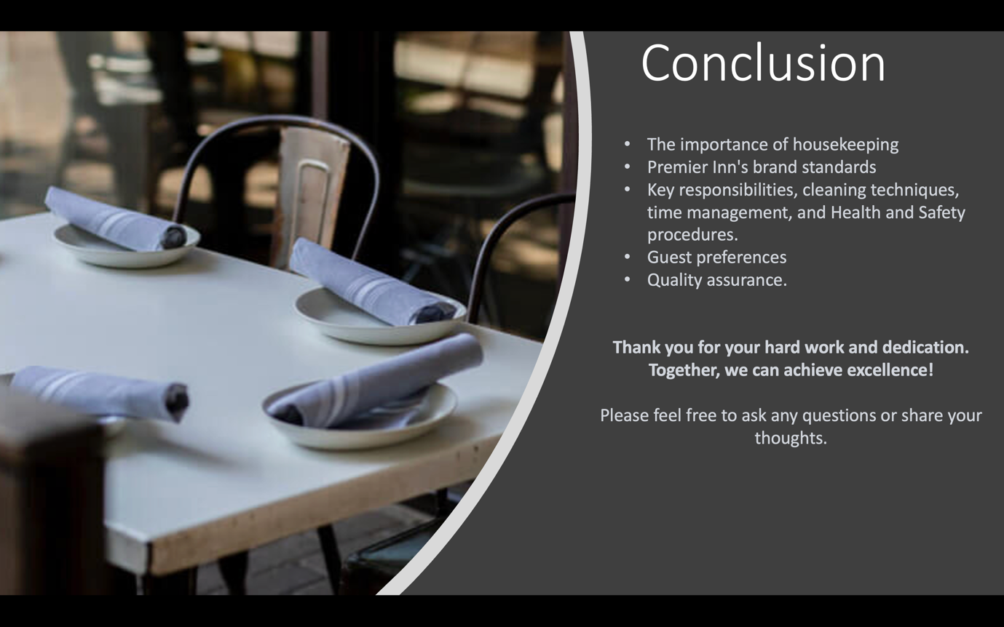

Training Notes:
To wrap up, let's recap the key points covered today:
- The importance of housekeeping in guest satisfaction and hotel reputation.
- Premier Inn's brand standards and our role in maintaining them.
- Key responsibilities, cleaning techniques, time management, and Health and Safety procedures.
- Attention to guest preferences and the significance of quality assurance. Thank you for your hard work and dedication. Together, we can achieve excellence! Please feel free to ask any questions or share your thoughts

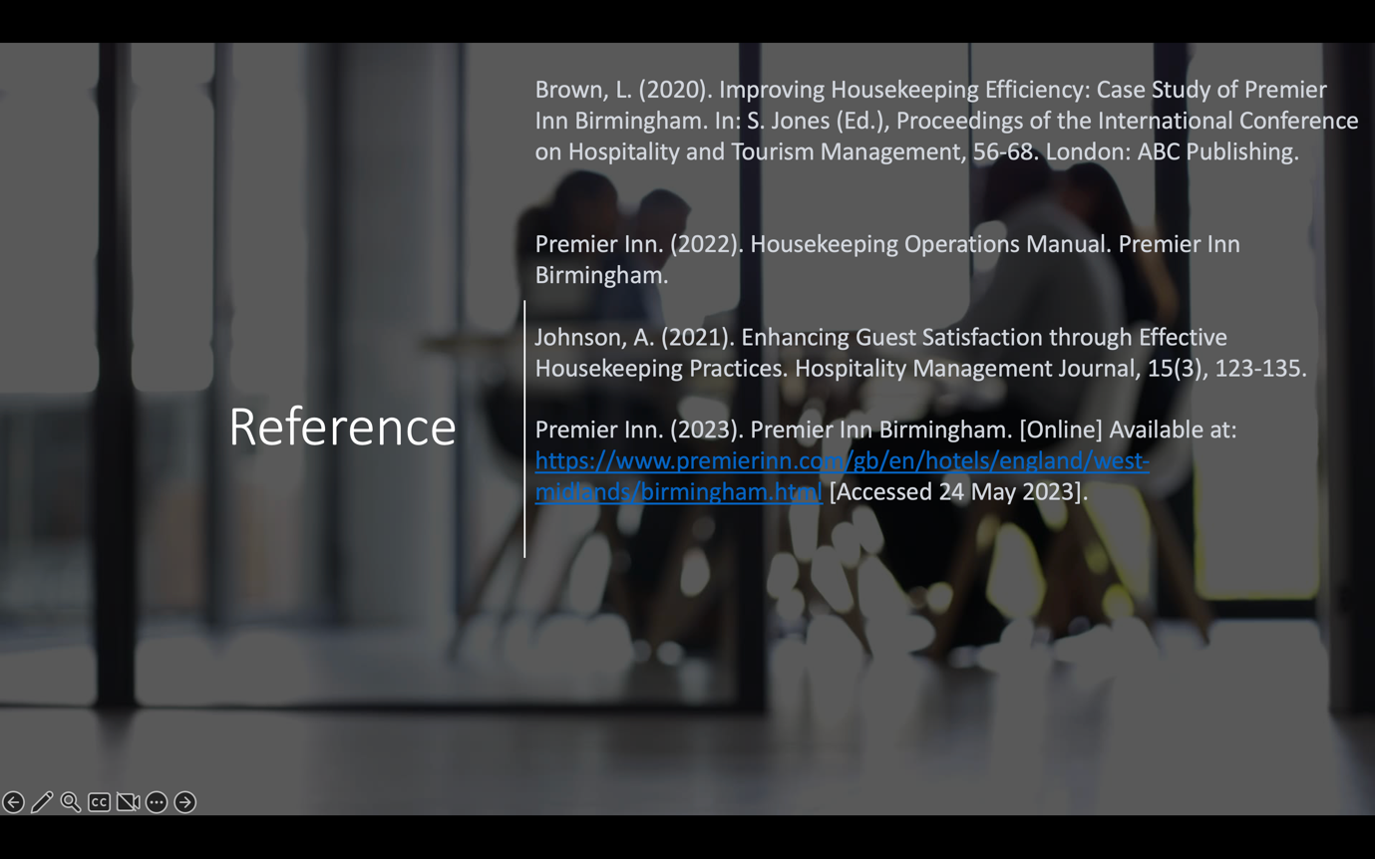

References
Whitbread PLC. (n.d.). Team member wellbeing. [online] Available at: https://www.whitbread.co.uk/sustainability/opportunity/team-member-wellbeing/.
‌Erika (2019). Hotel chain works out deal for health-conscious guests. [online] Whitbread PLC. Available at: https://www.whitbread.co.uk/hotel-chain-works-out-deal-for-health-conscious-guests/ [Accessed 27 Oct. 2022].
‌Occa. (2019). Health and Wellbeing in Hotel Design | Occa Design Studio. [online] Available at: https://occa-design.com/blog/health-and-wellbeing-in-hotel-design-2/.
Chen, X., & Li, Y. (2019). Factors Affecting Guests’ Perceived Value of Wellness Hotel Stays. Journal of Quality Assurance in Hospitality & Tourism, 20(3), 313-334.
Kwok, L., & Xie, J. (2021). The emerging trend of wellness tourism: a bibliometric analysis. Current Issues in Tourism, 24(7), 789-807.
Whitbread Plc. (n.d.). Housekeeping Team Member. Retrieved from https://www.whitbreadcareers.com/job-details/1206944/

Whitbread Hotel Group. (n.d.). Housekeeper. Retrieved from [URL]
Note: Please replace [URL] with the appropriate URL for the source you used to gather the information about the Whitbread Hotel Group's housekeeper job role.

