Nathan Doyle (P151450)
Ndoyle.151450@student.uwtsd.ac.uk
ADVANCED cOMPUTATIONAL METHODS
M6X00408 ASSIGNMENT 2

Contents
Table of Figures and Tables 1
Abstract 2
1. Introduction 3
2. Research of Design and Loading Conditions 4
2.1 Design 5
2.2 Manufacturing Process, Material and Loading conditions 7
2.3 Mesh 11
2.3.1 Mesh Size and Density 11
2.3.2 Mesh control 13
2.3.3 Mesh Quality 16
3. Topology Optimisation of Component 18
4. Interpretation of Topology results 21
5. Conclusion 23
References 24

Table of Figures and Tables

Figure 1, Initial bracket design (Solidworks, 2020). 5
Figure 2, Front view and position of four bolts used in fastening to the rocket (Solidworks, 2020). 5
Figure 3, Location of bracket on Atlas rocket (Sevcik, et al., 2016) 6
Figure 4, Holes used to fasten the working platform to the bracket (Solidworks, 2020) 6
Figure 5, Image demonstrating fused deposition modelling (Gibson, 2016) 7
Figure 6, Force in Z direction (Solidworks, 2020). 9
Figure 7, Reducing the weight reduction by 90% on the topology software (Solidworks, 2020) 10
Figure 8, Graph to show maximum stress size with mesh size decrease (Doyle, 2020). 11
Figure 9, Graph comparing mesh size with time taken (Doyle, 2020). 12
Figure 10, 3mm mesh with no mesh control 13
Figure 11, FEA stress analysis with no mesh control 13
Figure 12, 1mm mesh control applied to high stress areas 14
Figure 13, FEA stress analysis with mesh control 14
Figure 14, Aspect ratio of the elements used on the support bracket (Solidworks, 2020). 16
Figure 15, Illustration of Aspect ratio on support bracket (Solidworks, 2020). 16
Figure 16, Trueform topology of Bracket (Trueform, 2020) 18
Figure 17, Solidworks Topology study of Bracket (Solidworks, 2020) 18
Figure 18, Design Studio topology of bracket (Studio, 2020) 19
Figure 19, Graphs showing design cycle and constraint violations for part (Studio, 2020) 19
Figure 20, Smooth component created by solidworks and justification of new design (Solidworks, 2020) 21
Figure 21, Similarities to the winning design (Grabcad, 2016) 22

Table 1, Loading conditions converted from imperial to metric (Doyle, 2020). 8
Table 2, Table to display time taken at different mesh sizes, with maximum stress 10
Table 3, percentage changes of high stress and time taken with change in mesh size. 11

Abstract

During the take-off of the Atlas V rocket, the weight of all components has a first order effect on the performance and efficiency of the system, therefore, the current Boattail support bracket is analysed to potentially redesign the component. It is observed using three different topology software tools, that a large amount of the component experiences little or no stress change when all additional forces have been applied. Even though the different software has displayed possible better designs, research has suggested that using different topology tools can produce slight variance in the results. This can be as the result of different software tools containing different design features and applications. It has also been observed that the mesh quality and size can significantly improve the accuracy of results from areas of high stress concentrations. Included in this, is the technique of applying greater mesh density around elements that may experience huge stress changes. The findings of this report demonstrate the need for a redesign of the support bracket as well as providing recommendations for further study and research into CAD packages for this application.

Introduction

Topology optimisation is a method of optimising a components material under a certain load, with the aim of reducing weight, decreasing the cost to manufacture and increasing its performance. Regarding the aerospace industry, it is crucial that topology optimisation is integrated correctly within a CAD package, as any misinterpretation or incorrect data, can lead to costly and devastating consequences. In terms of the support bracket, its function is only required whilst the rocket is stationary on the launch platform, therefore, its topology optimisation should be thoroughly analysed so that it does not alter the performance of the rocket.
The purpose of their report is to create a topology optimisation of the Boattail bracket to be used on the using NASAs Atlas V rocket. It requires an effective analysis, prior to the topology optimisation, of a variety of factors such as mesh size, density and quality that may affect the reliability of the data gathered. This can have a profound effect on the support bracket. Even though the bracket should be optimised effectively, the report also demonstrates the need for thought on the type and ease of the manufacturing process, as any difficulty can result in delay and financial penalties. Loading conditions are vital to the topology of the part, as this can determine the stress gradient across the mesh elements, therefore, all forces and constraints need to be certain, prior to the start of the process.

Research of Design and Loading Conditions

Before manufacturing a product, it can be useful for engineers to determine that the mechanical processes the component is designed for, are satisfied (Mejia, et al., 2018). Frederic, (2014 ) suggests that a topology study, aims to reduce the mass or maximum displacement of a product without sacrificing its intended purpose. Joshi, et al., (2016) go further, by explaining that topology is used to achieve specific goals such as heat conduction through a component, mechanical synthesis or mechanical compliance.

Design
As part the ambition of increasing safety in space and a greater exploration of the universe, ULAs are looking to improve their design of an internal boat-tail support bracket for the use on their Atlas V rocket. The analysis is being done, as according to Turner, (2005) conditions within earths lower atmopshere and in the vaccum of space are completey different. Atmospheric drag and pressure is extremely important during take off,therefore, any additional weight, requires more fuel and thrust. The initial part and four holes used to fasten the bracket to the rocket are illustrated in figures 1 and 2.
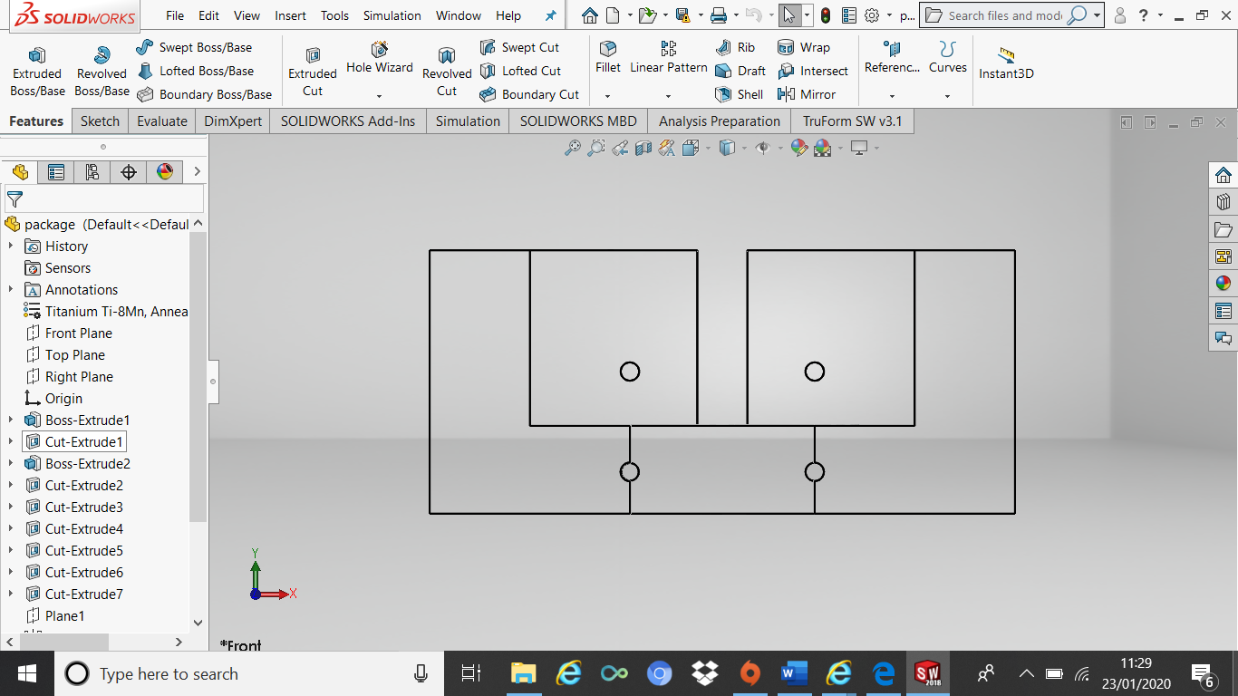
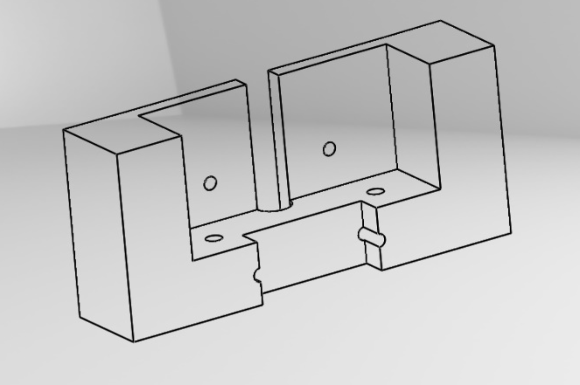

Figure 1, Initial bracket design (Solidworks, 2020). Figure 2, position of four bolts (Solidworks, 2020).

The bracket will be used on the base of the Atlas payload fairing, acting as a support for the crew and work platforms near the launch date. The part will be fastened to the rocket, via four bolts, in the location shown in Figure 3.
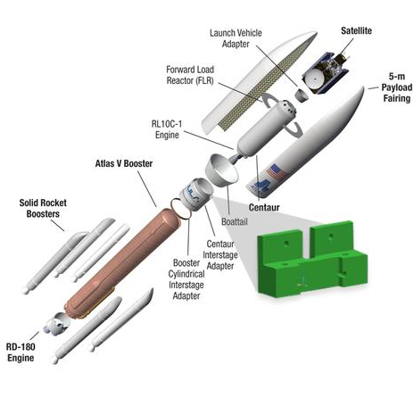

Figure 3, Location of bracket on Atlas rocket (Sevcik, et al., 2016)
The part is also required to be fastened to the work platform via 2 holes shown in figure 4. A minimum distance of two times the diameter around the holes is required to be designed around all holes.
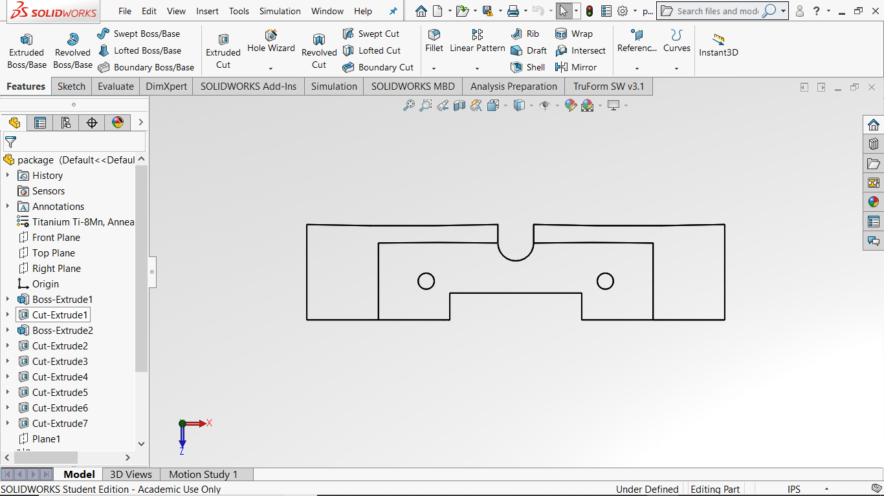

Figure 4, Holes used to fasten the working platform to the bracket (Solidworks, 2020)

Manufacturing Process, Material and Loading conditions
With the further advancement of additive manufacturing processes used for space exploration, the requirement for high quality material is increasing (Lemu, et al., 2018). As researched by (Zaldivar, et al., (2018) ULTEM 9085 is a thermoplastic that is commonly used in the areospace industry due to its extremely high, heat resistant properties. Anderson, (2017) adds that the material has a heat resistance of 170°C and tensile strength of 15200PSI which makes it very useful in the space industry, however, Anderson, (2017) suggests that other materials such as ULTEM 1010, with a heat resistance of 195°C would be more suitable.
Due to ULTEM 9085 being a thermoplastic, it becomes a semi solid, viscous material with the elevation of its temperature. As a result, one manufacturing method for the required bracket is by Fused Deposition Modelling (FDM). According to Huang & Singamneni, (2019) FDM is the process whereby a 3D CAD model is manufactured, layer by layer, using a thermoplastic material. This is demonstrated in figure 5 as below.
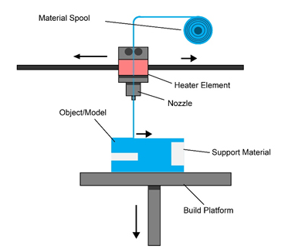

Figure 5, Image demonstrating fused deposition modelling (Gibson, 2016)

In terms of manufacturing the bracket there are several advantages of the FDM process compared to the traditional injection moulding method. Achillas, et al., (2017) suggest, that the FDM method is beneficial for specialised components whereby there will be low volume production. This increases flexibility, reduces warehouse costs and lead time. Garg, et al., (2016) goes gurther by adding that 3D printing maintains the materials properties, such as heat resistance and tensile stress, whilst allowing the designer to make changes to the CAD software if needed.

Material Properties
The table below displays the properties of ULTEM 9085 given and the loading conditions that need to be applied to the Boattail bracket. Its figures have been converted into metric from imperial.

ULTEM 9085 Properties and Loading Conditions | Imperial | Metric
Maximum strength allowable | 4500 PSI | 310.26 Bar
Young’s Modulus | 325KSI | 2240.79MPa
Shear Modulus | 130.54KSI | 0.9GPa
Specific gravity | 1.34
Density | 1340$kg/m^{3}$
Poisson’s ratio | 0.41
Maximum part weight | 0.1lbs | 0.044kg
Minimum wall thickness | 0.040inches | 1.016mm
Ultimate load in Z direction | 600lbf | 2668.93N
Table 1, Loading conditions converted from imperial to metric (Doyle, 2020).

Shear Modulus
Otherwise known as the modulus of rigidity, Zhou, et al., (2018) explains that it is the shearing force for the coefficient of elasticity and is the ratio of shear stress to shear strain. According to Bhandari & Lopez, (2018) the mechanical property of shear modulus for ULTEM 9085 is 0.9GPa. This is further supported by Jaglom, (2018). It is given by -

$G=\frac{shear stress}{shear strain} (N/M^{2})$

Density
The specific gravity of a material is a ratio of the density of a substance to a reference liquid, usually water with a density of 1000 $kg/m^{3}$ (Spellman, 2016). This is shown below -

$$Specific gravity=\frac{Density}{1000kg/m^{3}}$$

$$Density=1.34 ×1000kg/m^{3}$$

$$Density=1340kg/m^{3}$$

Ultimate load in Z direction and Constraints
There is a load of 600lbf, or when converted, 2668.93N of force applied in the Z direction of the component due to the work platform shown in figure 6. It’s assumed that this takes in too account the weight of the loading platform, human being and tools needed. Powers, (2010) states that the average human weighs 82kg, with tools weighing 25kg. When a factor of safety of 2.5 is included, this comes to a total load of 2565N which suggests that the assumption is reasonable.
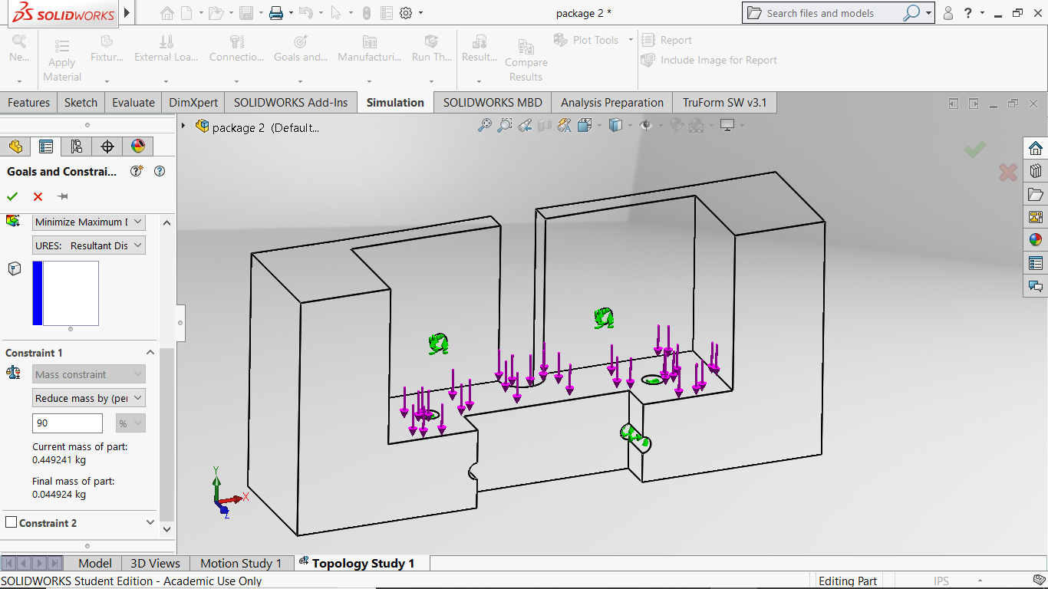

Figure 6, Force in Z direction (Solidworks, 2020).

Mass reduction
A components weight is seen as a first order effect on performance, therefore, a minimum weight of 0.1lbs has been enforced. Using the metric system, the current weight of the bracket is 0.445Kg. It is, therefore, a requirement to place a 90% weight reduction on the topology optimisation software as shown in figure 7.

Figure 7, Reducing the weight reduction by 90% on the topology software (Solidworks, 2020)

Mesh
Careful consideration should be taken prior to meshing a component on Solidworks, so that a compromise can be achieved between accuracy and efficiency. In Planchards view, (2020) meshing should only be choosen after analysing important factors such as geometry type, likely stress concentrations and the time taken.

Mesh Size and Density
As stated by Planchard, (2020) choosing the size of of the mesh is usually a compromise between accuracy and efficiency, with Kurowski, (2019) arguing that a smaller mesh density does increase result certaintly, but the time taken for the results, can lead to further costs. The table below demonstrates the analysis to obtain an efficent yet accurate mesh size for the boattail bracket.

Mesh size of elements (mm) | Total Elements used to produce the meshed part | Time taken to produce the meshed part (Seconds) | Maximum stress value when changing mesh size (Mpa)
1mm | 2198649 | 677s | 6.060Mpa
2mm | 242286 | 270.6s | 6.051Mpa
3mm | 81560 | 31s | 6.023Mpa
5mm | 20645 | 9s | 5.75Mpa
10mm | 4704 | 2s | 5.10Mpa
Table 2, Table to display time taken at different mesh sizes, with maximum stress

Figure 8, Graph to show maximum stress size with mesh size decrease (Doyle, 2020).

Figure 9, Graph comparing mesh size with time taken (Doyle, 2020).

Figures 8 and 9 show that from 3mm to 2mm, the maximum stress reaches convergence, whereas the time taken starts to significantly rise. It demonstrates that a 3mm mesh size is a reasonable comprimise between accuracy and time taken.

Mesh control
On a part that is fixed with bolts, Goyat, et al., (2018) suggest that this is going to be an area on the component that experiences one of the greatest levels of stress concentration. As a result Batista, (2011) explains that an FEA analysis can determine if the stress around the holes, is higher than the materials yield strength. Steffen & Nudehi, (2019) state that a smaller mesh results in improved stress figures in a model. Steffen & Nudehi, (2019) go on to explain that mesh control, allows the user to select regions where there is a high stress gradient. This is demonstrated on the four figures below that compare the maximum stress on the component, with and without the mesh control.
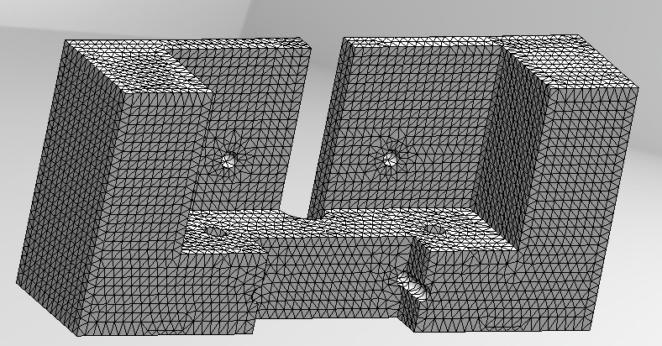

Figure 10, 3mm mesh with no mesh control
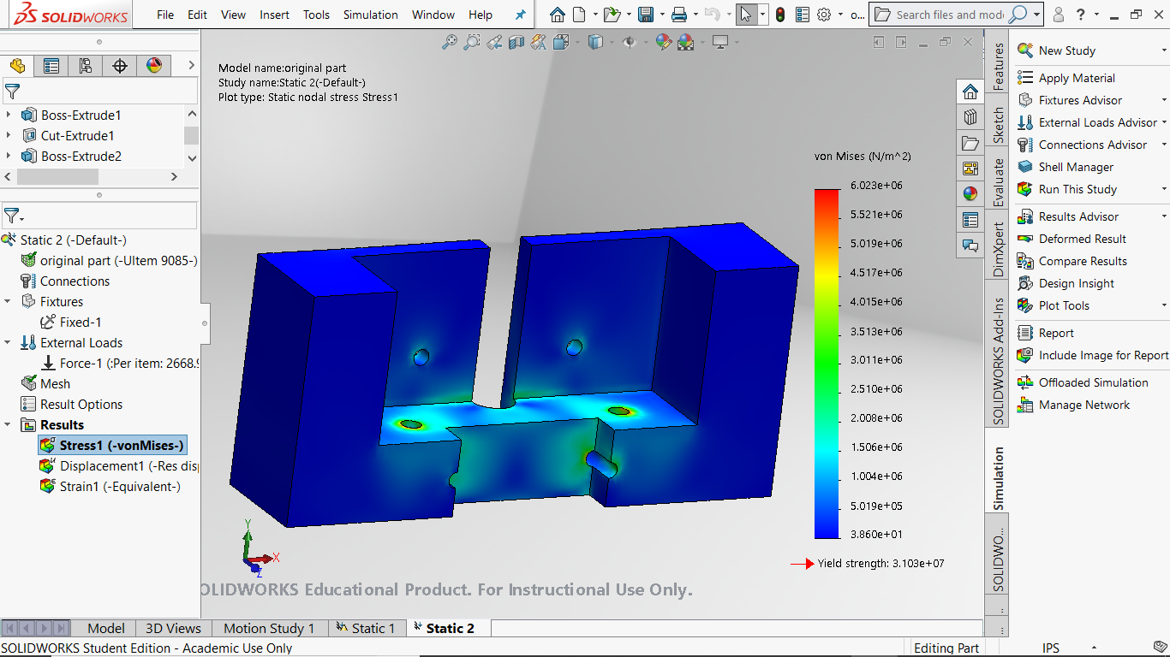

Figure 11, FEA stress analysis with no mesh control
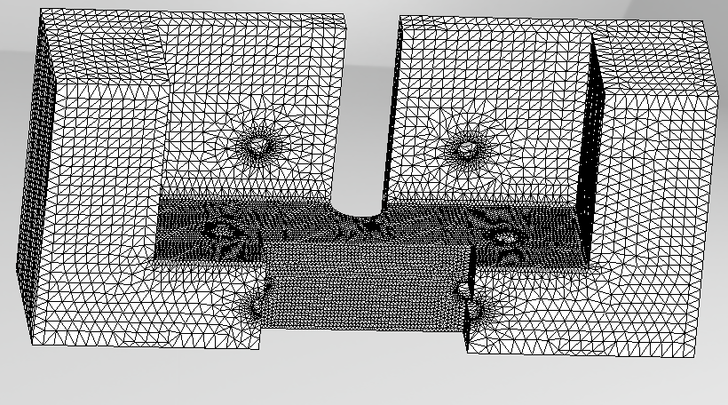

Figure 12, 1mm mesh control applied to high stress areas (Solidworks, 2020).
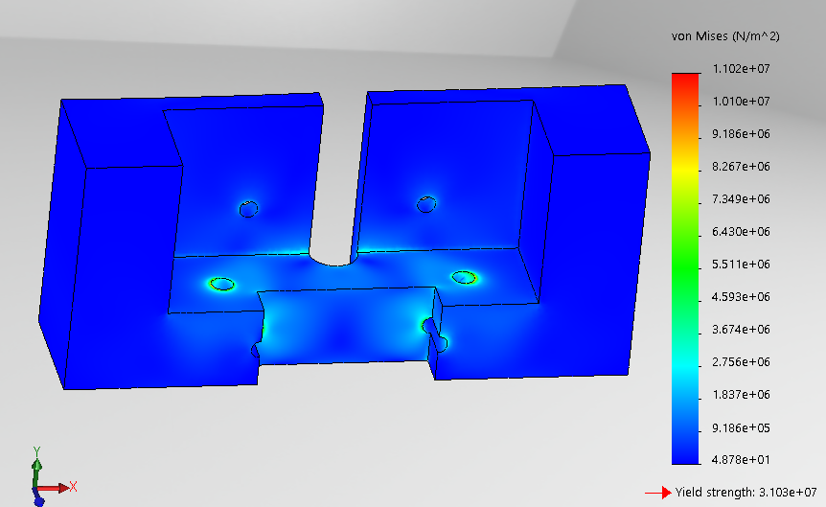

Figure 13, FEA stress analysis with mesh control (Solidworks, 2020).

From the four figures above, it is seen that the max stress concentration has increased from 6.023Mpa, to 11.02Mpa. These results are realistic, as they are both below the materials yield stress. Even though a 1mm mesh was used, a recommendation could be to keep reducing this parameter until the stress increase does not change.

Assumptions and Recommendations
An important assumption made is that the area of the component constrained has 6 degrees of freedom, but this suggests that the attached component is infinitely stiff. Further analysis needs to be carried out to consider the supporting component. Another assumption, is the results given, using the Von Mises theory of elasticity. According to Bhandari, (2013), there are several theories that have been proposed, with each giving a different hypothesis of failure. They all give slightly different results depending on the materials used. It is recommended to carry studies with different theories to compare results.

Mesh Quality
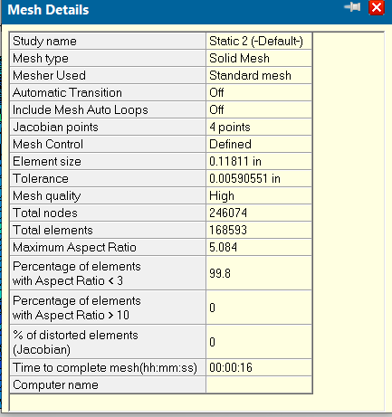
When conducting an FEA analysis on a component, it is essential that you maintain a high mesh quality, otherwise this can affect the overall results. According to Lee, (2012) a good element quality can reduce runtime, which can be a factor when choosing mesh size to increase efficiency. One such quality metric is the aspect ratio. In Clarks view, (2009) it is the maximum edge length divided by the shortest and a perfectly shaped tetrahedral element, will give a value of 1. Any value under 3 is considered to be good. Figures 14 and 15 illustrate the aspect ratio of the meshing on the support bracket.

Figure 14, Aspect ratio of the elements used on the support bracket (Solidworks, 2020).
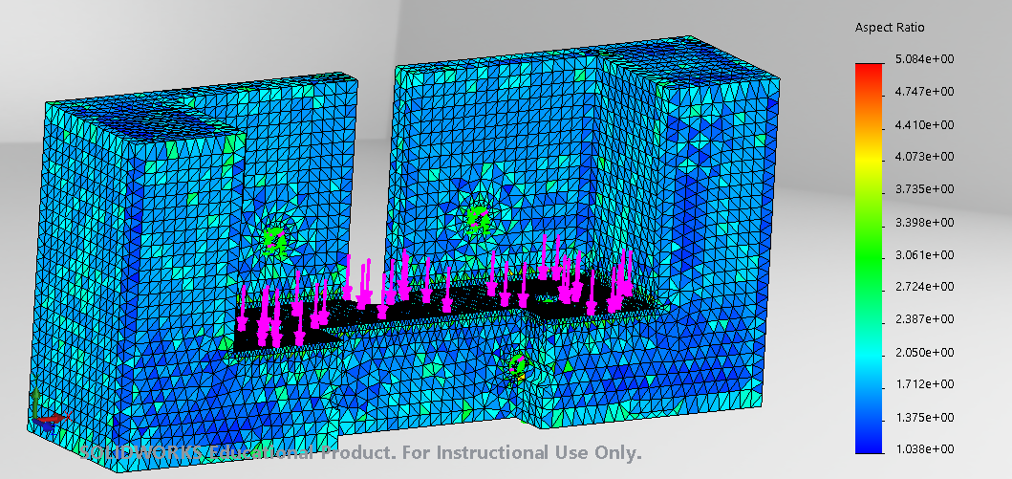

Figure 15, Illustration of Aspect ratio on support bracket (Solidworks, 2020).

The study finds the highest aspect ratio figure of 5 with over 99.8% of elements being below 3. This does suggest that the element quality in terms of the aspect ratio, is good.

Topology Optimisation of Component

Due to advancements in technology, demand for higher quality and increasing competition, there are numerous topology optimisation packages available that can provide topology results. There are, however, a variety of problems that occur when transferring or exporting data from one to the other, that can interfere with the results. Larsson, (2016) explains the transfer between two topology softwares tends to create problems with boundary conditions, checkerboarding and mesh quality issues. The different softwares used are Truform, Design Studio and Solidworks Topology study and their results appear in the three figures below
Truform Topology Analysis
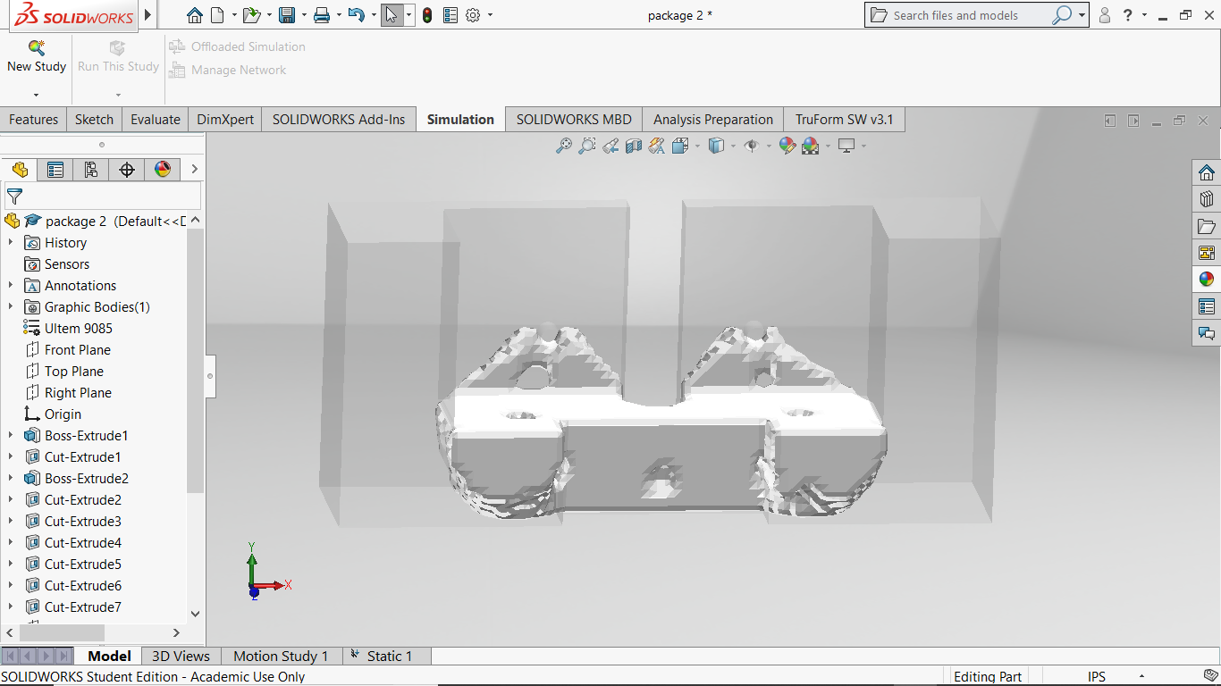

Figure 16, Truform topology of Bracket (Truform, 2020)
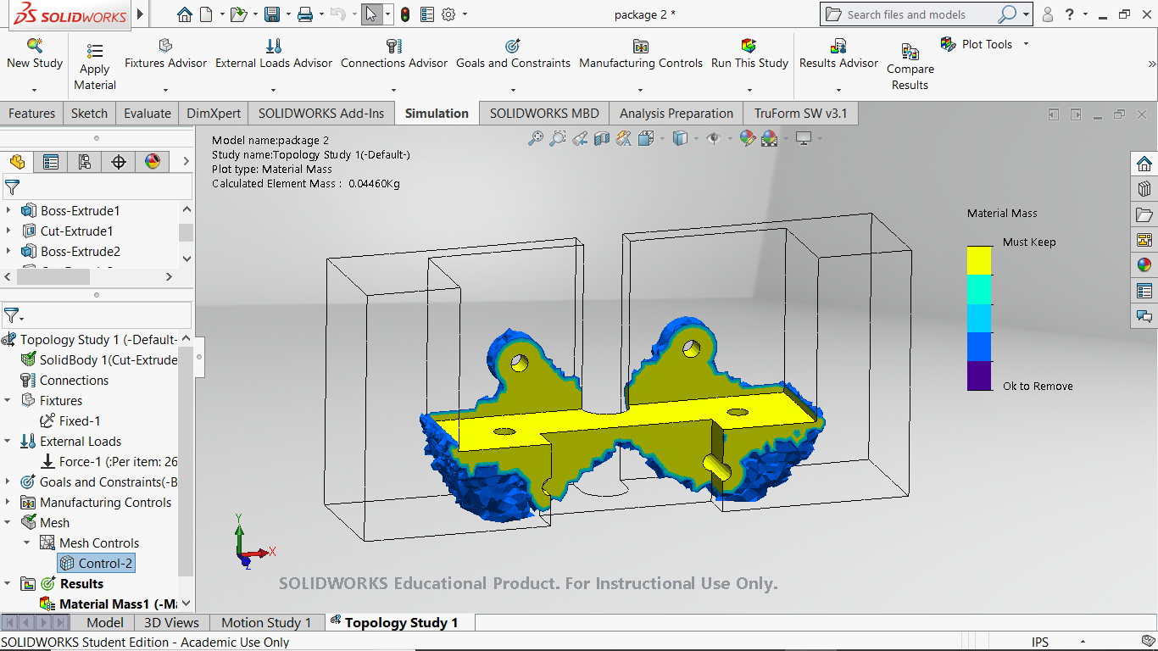
Solidworks Topology Study
Figure 17, Solidworks Topology study of Bracket (Solidworks, 2020)
Design Studio
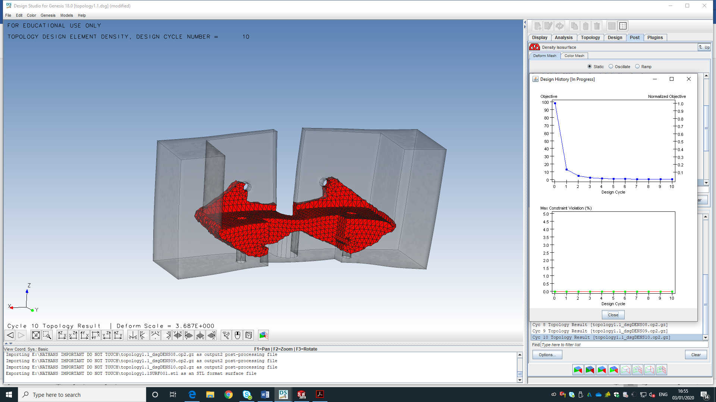

Figure 18, Design Studio topology of bracket (Studio, 2020)

The software has reached a hard convergence after 10 cycles whereas a soft convergence is reached after one cycle. This occurs with no constraint violations. Even though the software has achieved its mass target. It has not met the requirement of keeping material around the hole. The part would need to be designed with that in consideration.

Figure 19, Graphs showing design cycle and constraint violations for part (Studio, 2020)

Their results using the three topology tools clearly show very similar topology shapes with areas of less stress being removed. The results, however, highlight the problems with using different topology software, as the results show slightly different regions experiencing high stress gradients. Theoretically, all results should be equal. It is recommended to use additional software to obtain a greater set of topology results.

Interpretation of Topology results

Once topology optimisation has been completed on the component, Hopf, et al., (2017) explains that designs and modifications should be carried out identifing features created on the software. Below, figure 20 is an illustration that solidworks develops, showing the component with smooth surfaces, using features from both solidworks topology and trueform. It is annotated to justify areas that have some common features to the three softwares optimisation results and further improvements that can be made
As suggested by all three software’s, the two holes need material connecting to the components main body. This is however, an area of a less stress gradient displayed on the Truform study.
As required from the brief, it must have material surrounding all holes. This is influenced by the Solidworks topology result.

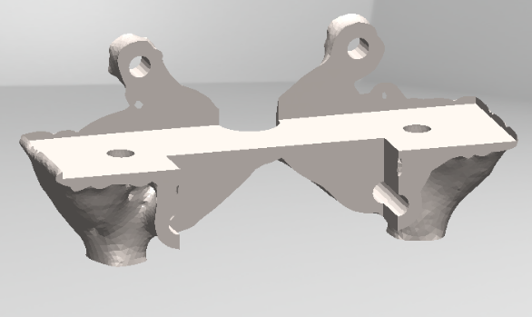
This area is necessary in design studio and Truform, therefore, it may need to be included.

The use of a radius and ribs can be applied here to maintain strength.
The three studies suggest that material is not required in this region, therefore, the new part would have material removed at this location.

Figure 20, Smooth component created by Solidworks and justification of new design (Solidworks, 2020)
Even though it is assumed that the software packages give accurate results, it is recommended that the new component be manufactured and thoroughly tested in a workshop under the specific loading conditions. Only then, can it be confident in operating correctly.

Comparison to winning design
Here is a comparison of the winning design and the Solidworks smoothed mesh component from the three Solidworks studies.

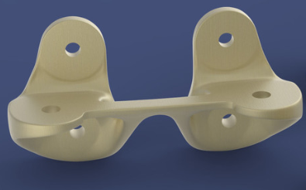

Areas kept as experience stress under load.
Removed material

Figure 21, Similarities to the winning design (Grabcad, 2016)
It is recommended that the part be transferred and designed in CAD from the topology optimisation study with features such as ribs, chamfers and fillets to reduce stress concentrations along the part. This is observed in the winning design.

Conclusion

The report’s findings have indicated that topology can be used to reduce the support brackets mass, yet maintain its function under certain loads, however, there are a variety of factors that can influence the topology results. The report shows that the quality of a topology study, relies on the quality of mesh, correct software and a good knowledge of the constraints loads applied to the component. In terms of the bracket, the report analyses a variety of mesh controls, as well as justifying the reasons for using a 3mm mesh size over others. It also examines the manufacturing method of producing the support bracket and compares other methods, along with justifying the loads provided. This includes the weight of humans and their tools.
The use of topology, as shown in this report, is significantly increasing within industry, as companies are continually trying to reduce cost, yet improve performance in their business. Their focus, therefore, is trying to reduce the weight of their components. For the support bracket, the topology studies, consist of three different software’s and combined them to produce a part that meets all the requirements. Once produced, a part has been smooth meshed using Solidworks and then not only compared to all topology studies, but also to the winner of the initial contest. This reports comparison shows that the studies have areas of similarity which highlights the effectiveness of the topology optimisation carried out.

References
Achillas, C., Tzetzis, D. & Olga, M., 2017. Alternative production strategies based on the comparison of additive and traditional manufacturing technologies. International Journal of Production Research, 55(12), pp. 3497-3510.
Anderson, S., 2017. Customised Tooling, Generalised Time Savings. Automotive Design and Production , 129(12), pp. 10-21.
Batista, M., 2011. On the stress concentration around a hole in an infinite plate subject to a uniform load at infinity. International Journal of Mechanical Sciences, 53(4), pp. 254-261.
Bhandari, S. & Lopez, R., 2018. Finite Element analysis of thermoplastic polymer extrusion 3D printed material for mechanical property prediction. Additive Manufacturing , Volume 22, pp. 187-196.
Bhandari, V. B., 2013. Introduction to Machine Design. New York: Tata Mcgraw-Hill Education.
Bourchak, M. & Dobah, Y., 2013. Effect of Finite Element Mesh and Load Location on the Stress and Deflection of a Light Aircraft Metal Wing Structure. Journal of Aerospace Science , 56(2), pp. 70-74.
Clark, B. W., 2009. Proceedings of the 18th International Meshing Roundtable. Berlin: Springer Science and Buisness Media.
Doyle, N., 2020. Basic internal boattail bracket. [Art] (UWTSD Swansea).
Frederic, A., 2014. A changing topology moving mesh technique for large displacement. Engineering with computers, pp. 175-200.
Garg, A., Bhattacharya, A. & Batish, A., 2016. On Surface Finish and Dimensional Accuracy of FDM Parts after Cold Vapor Treatment. Materials and Manufacturing Processes, 31(4), pp. 522-530.
Gebisa, A. W. & Lemu, H. G., 2017. A casr study on topology optimised design for additive manufacturing. Materials Science and Engineering, 276(1), pp. 217-237.
Gibson, J., 2016. Additive Manufacturing Research Group. [Online]
Available at: https://www.lboro.ac.uk/research/amrg/about/the7categoriesofadditivemanufacturing/materialextrusion/
[Accessed 4 January 2020].
Goyat, V., Verma, S. & Garg, R., 2018. Reduction in stress concentration around a pair of circular holes with functionally graded material layer. Acta Mechanica , 229(3), pp. 1045-1060.
Grabcad, 2016. ULA Bracket. [Online]
Available at: https://grabcad.com/challenges/3-2-1-liftoff-ula-rocket-hardware-challenge
[Accessed 24 January 2020].
Hopf, A., Bartsch, G., Kramer, F. & Weber, C., 2017. CFD Topology and Shape Optimisation for Port Development of Integrated Exhaust Manifolds. Conference Proceedings , Volume 2, pp. 15-41.
Huang, B. & Singamneni, S., 2019. Raster angle mechanics in fused deposition modelling. Journal of Composite Materials , 49(3), pp. 363-383.
Jaglom, E., 2018. Certified ULTEM 9085 Resin. [Online]
Available at: file:///C:/Users/emily/AppData/Local/Packages/Microsoft.MicrosoftEdge_8wekyb3d8bbwe/TempState/Downloads/MDS_FDM_ULTEM9085Cert_0618b%20(1).pdf
[Accessed 13 january 2020].
Joshi, S. et al., 2016. CAD Integrated Topology Optimisation. Munich: Technische Universitat Munchen.
Kurowski, P., 2019. Engineering Analysis with Solidworks Simluation. Mission: SDC Publications .
Larsson, R., 2016. Methodology for Topology and Shape Optimisation: Application to a Rear Lower Control Arm, Goteburg: Chalmers University of Technology.
Lee, H.-H., 2012. Finite Element Simulations with ANSYS Workbench 14. Mission: SDC Publications.
Lemu, H. G., Gebisa, A. W. & Byberg, K. I., 2018. Mechanical properties of Ultem 9085 material processed by fused deposition modelling. Polymer Testing, Volume 72, pp. 335-347.
Mejia, D., Ruiz-Salguero, O. & Jairo R, S., 2018. Hybrid Geometry/ Topology bases mesh segmentation for reverse engineering. Computers and Graphics , pp. 47-58.
Planchard, V. D., 2020. Solidworks 2020 Reference Guide. Mission: SDC Publications .
Powers, H., 2010. Human nutrition. New York: Elesvier.
Reyes, A., 2017. Beginners Guide to Solidworks. Mission: SDC Publications .
Sevcik, S. et al., 2016. 3-2-1 Liftoff! ULA Rocket Hardware Challenge. [Online]
Available at: https://grabcad.com/challenges/3-2-1-liftoff-ula-rocket-hardware-challenge
Solidworks, 2020. Reducing weight using solidworks software. Swansea: UWTSD.
Spellman, F. R., 2016. The Science of Renewable Energy. London: CRC Press.
Steffen, J. & Nudehi, S., 2019. Analysis of Machine Elements Using Solidworks Simulation. Mission: SDC Publications.
Studio, D., 2020. Topology Optimisation using design studio. Swansea: UWTSD.
Trueform, 2020. Topology Optimisation using Trueform. Swansea: UWTSD.
Turner, M., 2005. Rocket and Spacecraft Propulsion. London: Springer Science and Buisness.
Zaldivar, R. J. et al., 2018. Effect of initial filament moisture content on the microstructure and mechanical performance of ULTEM 9085 3D printed parts. Additive Manufacturing, Volume 24, pp. 457-466.
Zhou, H., Shenghua, X. & Zhiwei, S., 2018. Real time in situ observation of shear modulus evolution during Ostwald ripening of colloidal crystallisation. Journal of Crystal Growth, Volume 502, pp. 35-40.

