


penetration testing OF AN INDUSTRIAL IOT wIRELESS SENSOR NETWORK
by
Ivan Alexander Thomas

Supervisor: Dr Carlene Campbell

Project submitted as part of the requirements for the award of BSc (Hons) Computer Networks & Cybersecurity

April 2018

Declaration of Originality

I, ............................................(FULL NAME)………………………………… declare that I am the sole author of this Project; that all references cited have been consulted; that I have conducted all work of which this is a record, and that the finished work lies within the prescribed word limits.

This work has not previously been accepted as part of any other degree submission.

Signed : .............................................

Date : ...............................................

FORM OF CONSENT

I ............................................(FULL NAME)………………………………… hereby consent that my Project, submitted in candidature for the B.Sc.(Hons) Computer Networks degree, if successful, may be made available for inter-library loan or photocopying (subject to the law of copyright), and that the title and abstract may be made available to outside organisations.

Signed : .............................................

Date : ...............................................

Copyright Acknowledgement

I acknowledge that the copyright of this project report, and any product developed as part of the project, belong to University of Wales Trinity Saint David, Swansea.

ABSTRACT

This project focuses on security concerns of large-scale adaptation of IoT devices into secure networks. Through a controlled experiment the author seeks to prove a hypothesis to validate further concerns with regards to attacking IoT devices. Research found within this report spans across multiple sectors including, healthcare, transport, and gas and electricity providers. An in-depth understanding of why these devices are being adopted and what risks did it pose was researched to better understand the IoT model. The literature review discusses at length the CIA triad model of cybersecurity and where the shortfalls are within IoT. Furthermore, the universal smart grid concept is evaluated for risks and benefits to a local economy. The necessary research and development stages follow on from the literature review, gathering of data regarding the target and possible ways to exploit any vulnerabilities. Design and implantation stages are rehearsed and tested for the attack making sure all ethics and risks are mitigated. Followed by the testing and a detailed evaluation of the results and comparing them to any opinions held.

Contents
Copyright Acknowledgement iii
ACKNOWLEDGEMENTS vi
Chapter 1 1
1.1 Introduction 1
1.2 Aim 2
1.3 Objectives 2
1.4 Structure Of The Project 2
Chapter 2 - RESEARCH & REVIEW OF LITERATURE 4
2.1 Introduction 4
2.2 Methodology 4
2.3 IOT Background and research 4
2.4 Conclusion 20
Chapter 3 - RESEARCH METHODOLOGY 21
3.1 Introduction 21
3.2 Research Overview 21
Figure 11: 23
3.2.1 Research Process 24
3.2.2 Research Philosophy 24
3.2.3 Research Approach 24
3.2.4 Research Strategy 24
3.3 Research Design 25
3.3.1 Research Deliverables 28
3.4 Triangulation 28
3.5 Conclusion 28
Chapter 4 - DESIGN & IMPLEMENTATION 29
4.1 Introduction 29
4.2 problem formulation 29
4.3 Design 34
4.4 Implementation 35
4.5 Conclusion 38
Chapter 5 – Testing and Evaluation 39
46
46
Chapter 6 - CONCLUSIONS AND RECOMMENDATIONS 47
6.1 Summary 47
6.2 Conclusion 47
6.3 Recommendations for Further Research 48
Chapter 7 – Reflections 49
chapter 8 - REFERENCES 51
chapter 9 - BIBLIOGRAPHY 55
APPENDICES 56
PROJECT MANAGEMENT 59
GLOSSARY 61

ACKNOWLEDGEMENTS

I’d like to acknowledge several influential and supportive people who have built me up to this monumental moment. Firstly, I would like to express my most profound gratitude to my fiancé Sian, for supporting me throughout my academic and personal life over the past four years, your encouragement, kindness and love has been a pillar of strength throughout my three years of academia. My father who has both financially and emotionally aided me throughout my studies over the past six years. Thirdly I would like to put on record my gratitude to my supervisor Carlene Campbell and PhD student Simon Downes. Their guidance and teaching throughout the difficulties of this project that will far reach beyond my time as a student at the university. Finally, I would like to dedicate this paper, my largest and proudest moment to my late grandfather who sadly passed away in the latter stages of this project. Your belief and unwavering support gave me the strength to push on and finish my third and final year.

Chapter 1

Introduction

The author's project focuses on the IoT (Internet of things) sector, specifically looking at cybersecurity in Industrial IoT (IIoT) nodes found within the operational technology sector. Operational technology is responsible for the storage, flow and supply of the critically valuable resources of our society. Potential cyberattacks at this sector would likely have repercussions on a national, possibly goalball scale potentially causing distress, harm, and even death to thousands of people. Lack of privacy and security particularly in consumer IoT devices are well documented. However, considering these issues, IoT growth is on a continued upward curve of with [1] ‘BCG is predicting that by 2020 €250B ($267B) will be spent on IoT technologies, products, and services’. Smart is the new buzzword in the marketing sector, and countries are looking to implement smart cities, smart grids and intelligent homes into their infrastructure. Currently, London, Singapore and Barcelona are undergoing a gradual smart city transition to improve air quality, energy management and traffic control. With this continued growth in spite of security and interoperability issues there seems to be little signs of plateauing or decreasing growth. Smart technology is rapidly changing the way business look at their models and is helping reduce running finances through automation of tasks, monitoring of power consumption and employee wellbeing. With such high gains and losses, the author wishes to research real-world examples of IoT facilitating cyberattacks and examples of inadequate security in market-ready devices. The Experimental part of the project will look to attack an Industrial IoT sensor network found within an operation technology sector environment and to see what security is in place and if there are any backdoors or routes to gain unauthorised access to their data and functionality.

Aim

This report aims to evaluate and test an Industrial wireless sensor network (WSN) against common and frequent cyber threats.

Objectives

The objectives are to:

Review current Industrial IoT devices in the operational technology sector.

Evaluate and compare similar studies on this subject

Develop a small-scale experiment and test for cybersecurity issues through penetration testing and packet sniffing.

Identify future growth and research challenges in the industrial IoT field.

Make an informed conclusion on whether IoT devices are secure enough to be used in such a critically important sector.

Structure Of The Project

The project is primarily in three parts. Part 1 entails research into the IoT model and highlights vital concerns with regards to cybersecurity in IoT devices. Numerous studies are critically reviewed for their findings, and a hypothesis is created on the research found. The second part of the project looks to establish a method of either proving or disapproving the interpretation through a controlled experiment. Research and reconnaissance while documenting all problems that were not accounted for. The final part of the project proposes solutions to any given problems and analysing the experiments results against the hypothesis.

Chapter one illustrates an overview of the report. It details the aims and objectives that once achieved will bring success to this research.

Chapter two concentrates on the background research into consumer and Industry IoT devices.

Chapter three details the research approach and design that will ultimately steer the project to success.

Chapter four discusses the solutions put forward to issues, justifying those solutions and their logical design and implantation into the experiment.

Chapter five consists of the testing and documentation of the experiment with screenshots detailing each step in the process.

Chapter six focuses on evaluating the experiment results and relating them to the projects aim and objective.

Chapter 2 - RESEARCH & REVIEW OF LITERATURE

Introduction

This chapter will look too critically review current and recent studies into IoT. The smart grid idea will be investigated for ongoing research, experiments and implementations into real-world environments. The author will research and identify relevant academic research into the IOT sector. Any analysis is critically reviewed for feasibility and longevity issues while comparing each one’s findings and comparing them to any assumptions made or opinions held.

Methodology

IOT Background and research

One of many terms to describe IoT is an interconnected ecosystem of sensors, people, computer networks, [2] ‘smart objects whose purpose is to interconnect all IP enabled devices in such a way to make them more intelligent’. Kevin Ashton, a co-founder of a [3] ‘Auto-ID Centre at the Massachusetts Institute of Technology (MIT),’ is widely believed to be the first person to propose an IoT solution into his supply chain management system. Kevin’s proposal entailed Machine to machine communication (M2M) [4] ‘Linking ...P&G's supply chain to the then-red-hot topic of the Internet’ thus, providing a more efficient business model. Kevin suggested that RFID technology could track inventory used within the same local network to increase productivity by reducing his work forces human errors. The IoT of present-day has continued to develop around Kevin's idea of M2M communication. IoT growth facilitated by integrating biometric technology into the IoT model has taken the M2M communication idea and has involved the user in machining and machine to user communication. Talking to a car, phone, t.v with speech recognition software is now conventional practice, whereas this was science fiction 70 years ago. This mobility and validity of information regardless of their communication methods, IP domains, and their geographical locations are mostly thanks to the internet. The vision of all IoT vendors and enthusiasts is a world of everyday objects [5] ‘using sensors, to perceive their context, and via built-in networking capabilities, (are) able to communicate with each other, access Internet services and interact with people’.

Giving standalone devices computational power and a way to communicate with each other provides many solutions to problems far reaching from the device or its environment. For example, smart homes with IoT devices surveyed over a lengthy period can produce accurate and informative data on the environments energy supply and requirements and thus calculate an exact demand to the nearest voltage. Based on new IoT provided information energy suppliers can make informed decisions on their supply and demand, estimating consumption to a high standard and accurately predicting patterns in customer behaviour. [6] ‘From smart meters to smart appliances to the more intelligent control of distribution, transmission, and generation, an advanced grid offers the potential of improved utilisation of all generation and storage resources.’

Currently, crucial corporate and government environments are taking an Interest in IoT and how it can operate into our OT (operational technology) sector; such projects include [7]’ (The) agriculture and food processing industry. Environmental monitoring (for conservation), security surveillance, and others’. The study group Gartner has predicted that 50 Billion IP enabled devices will be connected to the internet by 2020, and this throws up valid concerns with physical and virtual security concerns. [8] ‘The consensus among enterprise professionals is that IoT security has emerged as a front-of-mind topic. Indeed, a year’s worth of IoT hacks and botnet headlines have underscored both the slow adoption of security-focused manufacturing and the obvious need for it.’ With the industry ripe with proprietary IoT protocols vendor lock-in shut of consumers from others and adds further to interoperability issues with existing legacy infrastructures.

The company [9] ’TIA’ completed a survey paper with companies who are looking into interoperating IoT with their infrastructures. [10] ‘(59%) of survey respondents reported that they expect the magnitude of change for IoT integrations to be either significant or major for their companies’ with many others holding off until an open standard for IoT is introduced and used by vendors.

[11] Figure 1 an overview of the Internet of things and the sectors that have or are introducing IoT type devices.
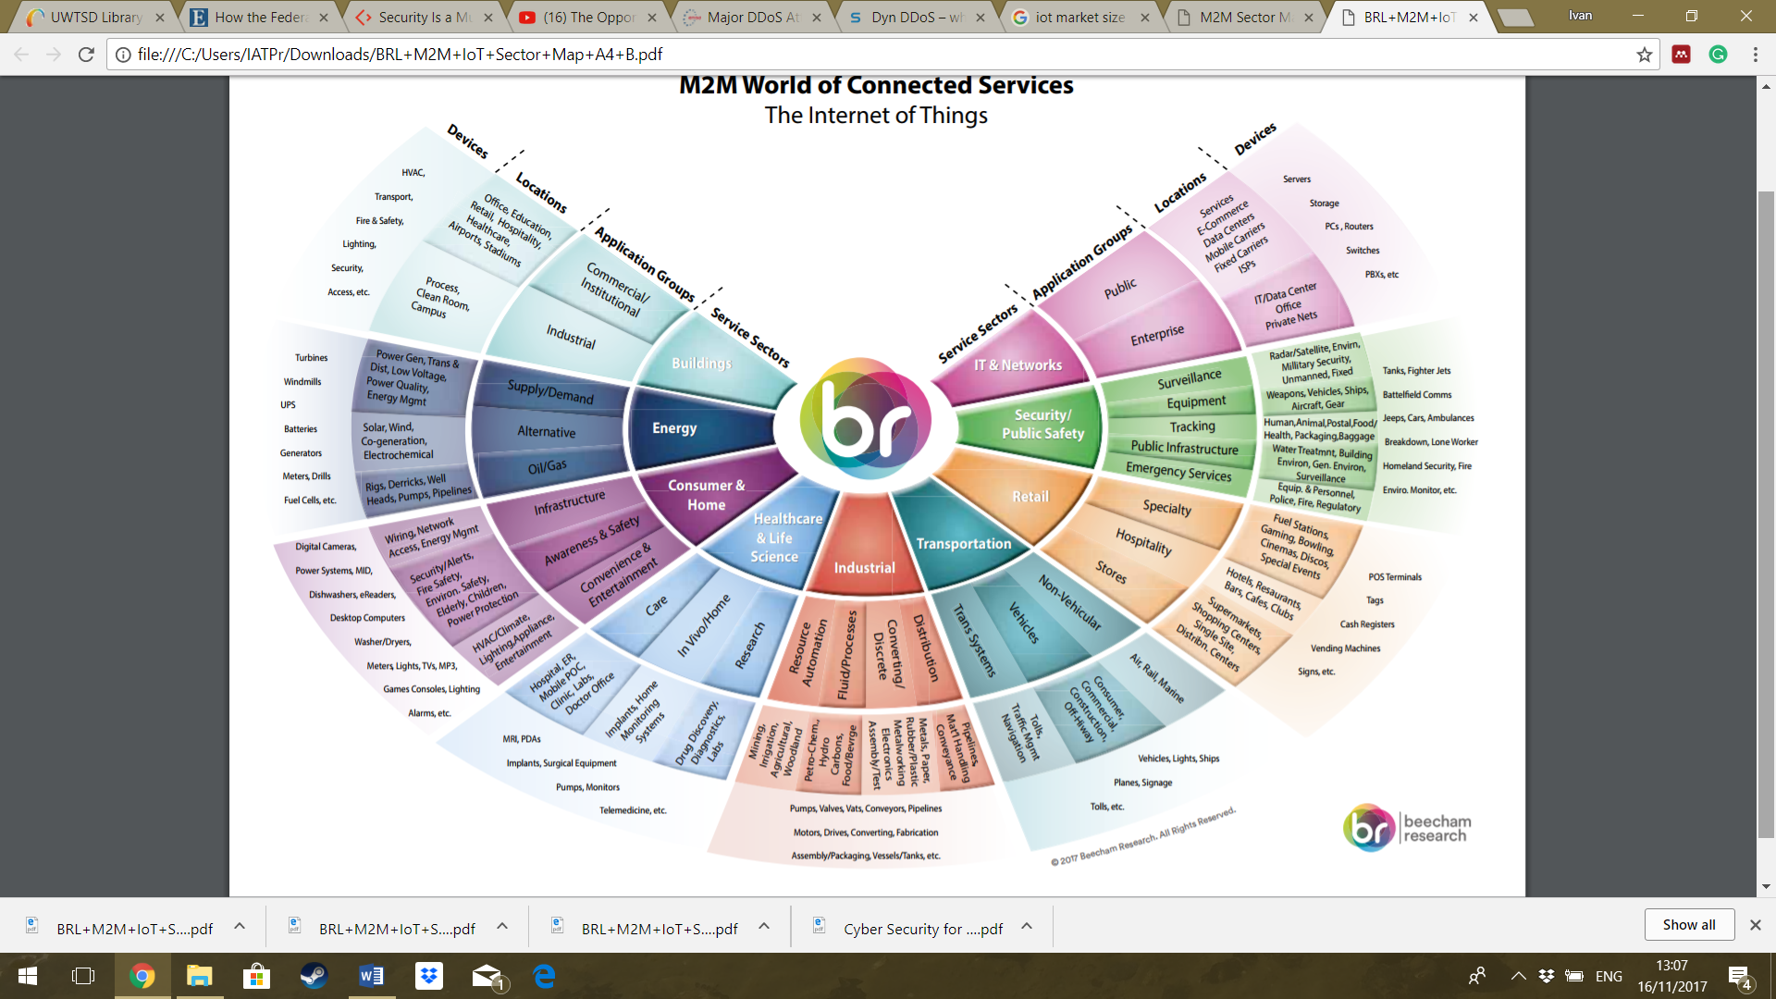

Figure 1 is a visual representation from [11] ‘Beecham research’, of the nine types of sectors and technologies that make up IoT. Designing and ensuring connectivity among these vast industries devices and technologies is one fundamental problem that is highlighted within IoT as it produces a fragmented and patched ecosystem of compromise and complexity. Such issues stem from complications with interoperation issues due to vendor-specific proprietary protocols within product lines. [12] ‘A product company selling (an IoT device) and, wants to connect their Thing to the internet, the idea of buying everything you need from a one-stop-shop vendor is initially attractive.’ When the time comes to interoperate those devices with others on the internet or in business partner collaboration scenario the customer becomes locked to others using the same vendor… (known as vendor lock-in). Due to the competitiveness of the IoT market, the development of IoT products requires vendors to produce the product quickly to bring to market. These devices are often without any standardisation body testing and are often vulnerable to cyber attacks through lax security or poor future proofing. Current IoT has suffered from, this situation and continues to have a significant effect on the overall interoperability of devices across the globe and business models.

The same issues plague the Industrial Internet of things sector (IIOT) as any computer networks IT management staff will explain. Their environments require various solutions and architecture models unique to their business and partners requirements. With no IT environment being entirely the same this produces issues in security and interoperability as consumer IoT devices just on a larger scale. [13] ‘Standardization is a major prerequisite to achieve interoperability, not only between products of different vendors but also between different solutions, applications and (IP) domains.’ The process of standardisation is a gathering of interested and relevant parties for the development of a set of rules for a new technical device or method.

By using these open standardisation protocols and models, the sector can ensure that all nodes can intercommunicate with each other regardless of the vendor as they have been built and designed to the same rules and regulations. Some examples of national standards organisations include the [14] ‘International Organization for Standards, ISO, International Electrotechnical Commission, IEC, Institution of Electrical and Electronics Engineering of Standards Association, (IEEE)

IoT is a vast and expansive field where each node is implemented into an urban, rural or IT environment. Standardisation bodies have addressed this issue somewhat with 140 IEEE open standard protocols for IoT to combat vendor locking customers and to govern the sector slightly with a relevant and everyday language. The IEEE has subdivided IOT into two main subcategories depending on their requirements and target market to better their standardisation process. Type 1 is commercial IoT; it uses embedded devices which typically but not exclusively have no internet connection. They vary from sophisticated algorithms for lighting or speech recognition to standard movement sensors for better lighting and cheaper costs. Regardless they must share the primary functions to operate keeping them small and low on power consumption.

IoT devices use WPAN (Wireless personal area networks) using a short range and lower power protocol, i.e. Bluetooth, Zigbee or a vendor specific service. Thus enabling their smart devices to communicate, using a WPAN also allows remote management of that area through a service application such as a vendor app installed on a customer's smartphone.

The second type of commercial IoT is designed on a non-intrusive data collection for the benefit of the consumer and utilises the power of the internet for analytical and research purposes. Due to its scalability, this type of IoT device is commonly a wireless node than connects to a wireless local area network (WLAN) They more commonly use the open standard IEEE protocols, i.e. ZigBee for broader area communication and low power management for sustainability over lengthy periods. Both types of IoT networks collect interact and store information typically locally in an edge node which operates as the gateway or interface for remote access or GUI.

Industrial IoT (IIoT) focuses on many types of infrastructures depending on their client’s needs. These devices are usually hybrids of commercial devices however they utilise the internet where commercial IoT do not or do less. IIoT connects to management or control service on the internet via the IPV6 protocol. IIoT nodes are slightly more significant than embedded devices as more onboard computational resources are required via the uploading real-time data to service providers or storage. Reliably connecting and maintaining this connection is essential to an accurate data record. Therefore IPV6 with its less complicated header and security features is often recommended over IPV4 due to its more substantial overhead and NAT translations. Consequently, all IIoT and IoT devices must follow the standardisation rules of communicating should they wish to pass through the internet.

IT communication networks communicate with each other via the 7-layer foundation of the “Open Systems Interconnection standard (OSI). First introduced in 1984 by the international organisation of standardisation (ISO) to address the interoperability issues of the then internet. All IP enabled devices must follow these set of rules to communicate on the internet, successfully adding layers to the data as it is passed down the stack when sending then reversing the process by removing the layers at the destination. Current transition technologies between IPV4 & IPV6 allow both protocols to coexist on the internet. However, IPV6 is still recommended for adding IPV4 translation will slow the transmission and add to the complexity of the configuration of nodes.

Figure 2:
An example of Web and IOT protocol stack
[15]
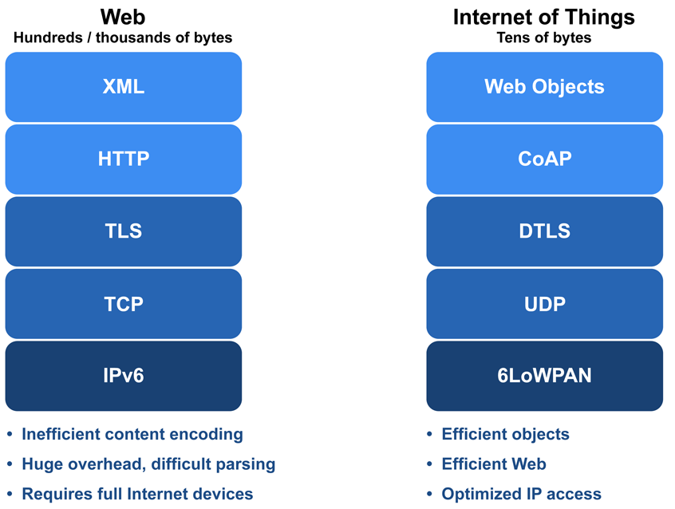

Figure 2 shows five popular IoT protocols used for communication, CoAP a protocol commonly used for IoT devices, utilises the IPV6 and UDP protocol while redesigning the vital reliability functions from TCP into a low payload and small overhead packet. CoAp makes it ideal for a reliable machine to machine communication without compromising on interoperability by using UDP protocol for establishing connections across the internet. However, at the time of writing, we still do not have a dynamic discovery protocol for IoT devices meaning an administrator must add static routing for peer to peer communication for each device. Which again leads to the complexity and security issue of interoperability when dealing with potentially thousands of devices per network as the manual configuration is slow, and prone to human error especially on a larger scale.

Cities are considering the “smart city” idea; a concept where the municipality assimilate all urban buildings and surrounding infrastructure with computational power and communication resources. Countries are looking to future-proof their foundations as [16] ‘the rapid increase in the cost of fossil fuels’ coupled with the inability or reluctance of utility companies to expand their energy generation capacity is not in line with the rising demand for electricity from consumers. This demand has accelerated the need to modernise the distribution network by introducing’ IIoT devices for regulation, monitorisation and smart redistribution. Singapore is the process of creating a smart grid for its residents with a lengthy study covering the processes, and implementation stages Figure 3 is a artists representation of a logical communication method between home and grid. [17] ‘The smart grid is envisioned as a future power network with hundreds of millions of endpoints, where each endpoint may generate, sense, compute, communicate and actuate its own energy needs’.

[18]
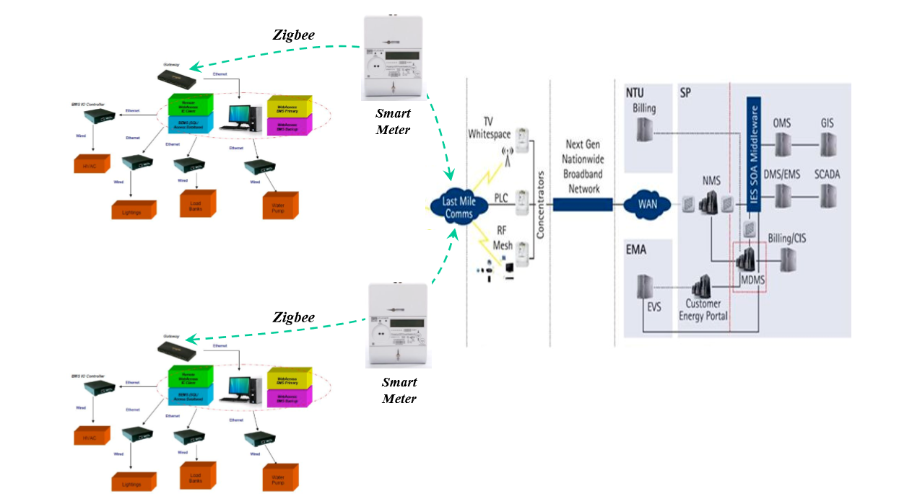
Figure 3: Singapore proposed communication solutions from smart home to the smart grid.

The utility grids across the globe have primarily served the needs of developing countries for the past 120 years. Inevitably, advancing technology and increasing demand has placed the existing models under immense pressure and highlighting the limitations of continually upgrading legacy infrastructures. Thus, the smart grid revolution has been investigated by countries across the globe with research and development into bringing the idea into reality with the aid of IoT technology.

Concerns have been raised about producing such a wide variety of new devices and software into critical Infrastructures to hastily. The widescale acceptance and deliverance of automated meter readers (AMR - smart meters) in homes is a welcomed step forward. Smart meters allow an electronic record of [19] ‘interval data that can provide near real-time information about electricity usage and cost to an in-home display or software application’. This record is then shared with the grid the through the two-way communication medium provided by the smart meter. [16] ‘With consumption records, alarms, and status from customers provided’ to the grid unforeseen surges in demands can be predicted and distributed when needed.

As so often is used in the marketing side of IoT the term smart has been introduced to help consumers understand that an infrastructure, device or location that has computational power. There are several concepts of the smart grid. Intelligent grid design and solutions vary from country to country, ultimately, they all agree that the smart grid is [19].. changing the traditional one-way flow of centrally generated power to end users into a more distributed, dynamic system characterised by the two-way flow of energy and information.’

Current IoT integration examples include [20] ‘Germanies strategic INDUSTRIE project 4.0 to computerise the manufacturing industry with the help of IoT (technology). (Present at the time) British PM David Cameron announced a collaboration between UK and Germany on IoT. Moreover, China is (also) investing heavily in IoT and has made it part of its 5-year plan’. Figure [4] and 5 shows an artist’s concept of what a smart grid and a connected smart home may look.

[21]

Figure 4: An artist idea of a self-sufficient smart home.
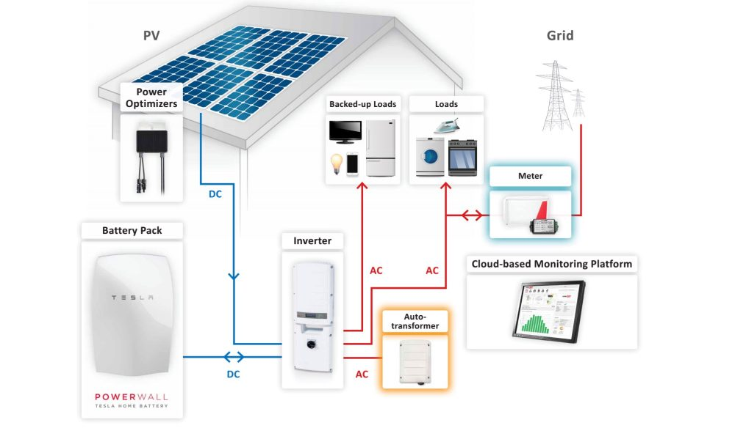

[22]
Figure 5: An artist’s overview of the Smart grid.
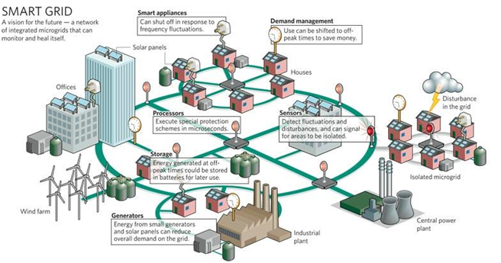

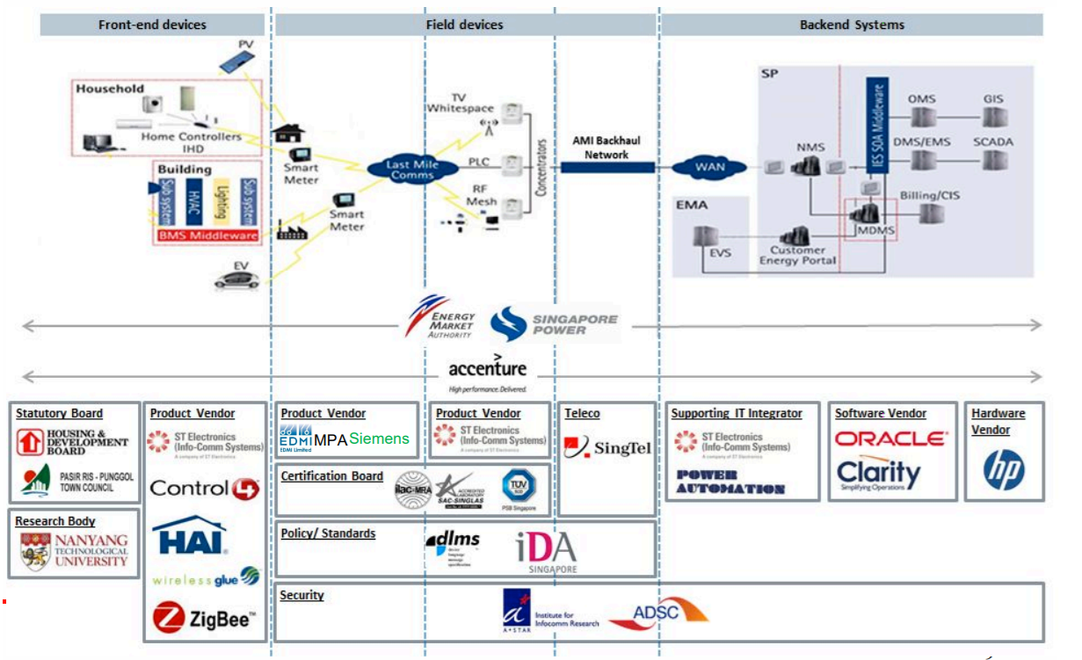
Figure 7: Singapore’s Smart grid and software and hardware vendors.
[18]

Figure 7 shows Singapore's logical view of the smart grid and details the collaboration of hardware, software and security vendors that have signed up so far. In the author's opinion, from analysing figure 7 that the diagram weighs in favour of the security and interoperability issues highlighted in IoT. There must be a guarantee that each vendor and its devices are not producing proprietary solutions, and that a collaboration of ideas must be drawn up with all parties understanding their role within this cyber ecosystem. A proprietary patchwork of compromise and negotiation will produce latency and exploits as each protocol must negotiate how they can communicate. The complexity and the volume of administrative configuration on IoT devices in a smart city environment, and so far the lack of a commonly agreed upon protocol for communication across all devices leave the sector under constant scrutiny.

[23] ‘All major players like Cisco, Qualcomm, IBM, Broadcom, Samsung, Microsoft have similar strategies for creating (IoT) standards.’ The complexity of the communicating two different IoT vendor products leaves many IT security specialists sceptical of its growth for the time being due to vendor lock-in. This scepticism is a healthy attitude as a cybersecurity professionals training encourages a cynical mind and to always act on a best practice of trusted rules and guidelines to which IoT has yet to produce.

The foundation of cybersecurity is the “security requirements triad” also known as the “CIA” triad. This concept consists of three layers which embody the fundamental security objectives for both data and information resources. Figure 8 is a visual representation of the CIA triad.
Figure 8: CIA triad model

[24]

The triangle represents [24] ‘a sliding scale, the more available the information, the less confidential it becomes. The model and its design are a well-known concept in Information Security. The closer one moves towards one apex; the further one is removed from the other two. The idea here is to make the trade off a sensible one, based on the value and sensitivity of the information that is being protected. Confidentiality refers to sensitive material such as employees, salaries, student’s grades or enrolment information at a university. Any information that may be deemed private or relevant to a person or persons must be secured under this category. Should this information be stolen, it could provide leverage over individuals and employers. Consequently, security professionals use the triad to reference the importance of securing this information correctly.

The integrity of data stored within a computing resource must be trusted to both accurate and the original. For example, a doctor must fully believe a patient’s hospital medical record and entrust that the information is up to date and correct. Any tampering or false information about a patients list of allergens could be potentially put lives at risk. The critically important and final part of the triad is availability; availability requirements can vary depending on the computing resource and its role within the infrastructure. For instance, a cooperate businesses registry, and accountancy servers will have a higher level of availability than any other service within the network. Their services are required for authentication of salaries and business financial records which has a high impact on business strategies. Any interruption of service to these resources will result in a moderate to catastrophic consequences to that infrastructure. Whereas the availability to log on to the network for a group or single user is not a critical issue and will be flagged as a low priority.

CIA triad provided a well-established and trusted blueprint of data security for cybersecurity professionals to abide and to develop their infrastructures. In recent years, accountability and authenticity have been suggested and unofficially introduced but widely added to the blueprint for up to date version of the triad to address the issues we face today an example is shown in figure 9. Threats are very different to when the triad was initially developed. Authenticity provides an assurance that data is being received from a trusted source through verification of a trusted certificate. Cyber attacks are becoming increasingly common, and cybersecurity professionals are often playing catch-up to attackers. The need for an actionable plan to trace a breach to a party or parties through logs and computer forensic investigations is vital to aid in disputes and future proofing from the attack again.

Figure 9: CIA Triad with Authenticity and Accountability:

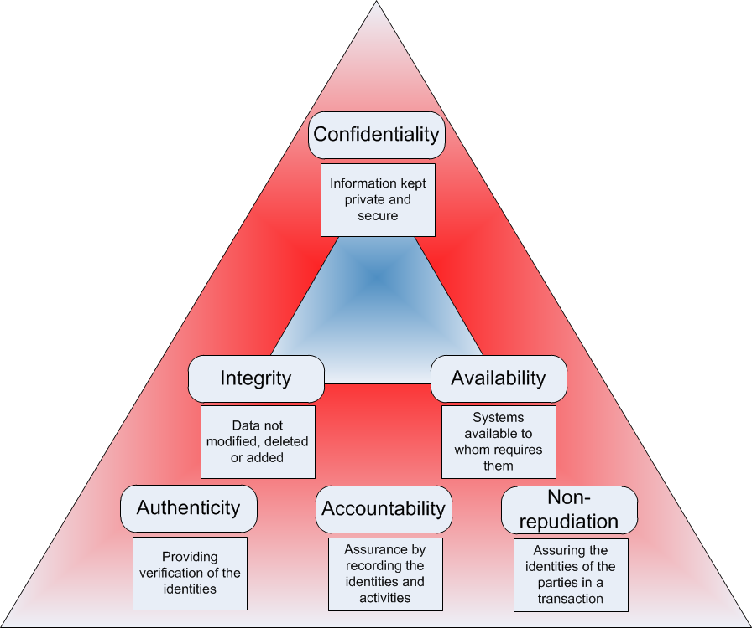
[25]

Cybersecurity is both a fascinating and complex sector of Information technology. If we were to take it as a generalisation, it seems simple enough to follow the triad guidelines of confidentiality, integrity, availability, authenticity and accountability. The challenges faced include constraints on budget allocation, vendor-specific services and the attitude towards cybersecurity. It is an afterthought to user-friendly operations and is only ever considered relevant when an attack happens. [26] ‘While the board and executive oversight of cyber issues are improving, cybersecurity is still not viewed as an enterprise-wide risk management issue at many companies’.

An alarming information security report by PwC in 2014 found [27] ‘that one in four (26%) respondents said their Chief Information Security Officer (CISO) or Chief Security Officer (CSO) makes a security presentation to the Board only once a year, while 30% of respondents said their senior security executive makes quarterly security presentations. However, 28% of respondents said their security leaders make no presentations at all. Hacking groups and individuals alike often target large business and government infrastructures with Denial of service attacks (DOS), Web page defacements and data to either gain notoriety, embarrass the target and solely for personal gain or amusement. [27] ‘In the past, public knowledge of cybercrime was typically limited to only those incidents requiring disclosure’. Nevertheless, due to recent significant and successful cyber attacks aided by social media, the public’s interest has been tipped, and they want to know who, where and why of all individual cyber attacks. As is the case in the world, what is not understood is often feared, and the media are quick to broadcast any attacks to the public raising the story, the profile and the fear.

Cyber attacks come in numerous ways, and methods, therefore cybersecurity professionals when they are investigating a breach begin with categorising the offense into one or two methods. Classification varies on an in-depth review of an attacks methods and its primary function, with thousands of malware created each day it is essential to understand them and group them accordingly to protect ourselves better. One such attack is a passive attack. They are notoriously hard to stop as they developed to be as least intrusive as possible to any security features in place. They are produced to eavesdrop on a systems design, data and participants and broadcast it back to an unauthorised location or persons for analysis of weaknesses or profit.

Passive attacks are frequent in industrial espionage and secret cyber sparing between countries who wish to gain information on one another. One such example is the alleged tampering in the USA presidential election in 2016 by Russia. [28] ‘investigations into the scandal are unresolved, but it is important to recognise that the US election hack has dispelled any lingering scepticism about the impact of cyber-attacks on national and international security’. An active attack as the name suggests is an ongoing or destructive attack against a computing resource. Distributed Denial of service attack (DDOS) is one active attack that is very common. A DDOS attack cripples the victim’s critical areas by flooding them with PDU (Protocol data units) to the point where they cease to work. A received PDU is processed by the node thinking it is a relevant request. Although the request is not valid and takes up computational resources for finding the resolutions firstly within its infastructure then escaltaing it to a DNS server. While this is happening, another 500,000 PDU’s are arriving every second and are requesting processing. Therefore the system becomes overwhelmed with the demand and hardware, or software failure becomes highly likely. [27] Distributed denial of service (DDoS) attacks are becoming increasingly potent and are one of the most frequent types of cybersecurity incidents, cited by 18% of survey respondents to the 2015 PWC cybercrime survey.

A DDOS attack is a useful attack against e-commerce sector who rely on applications and websites for customers purchasing or using their products. IoT devices are facilitating the most massive DDOS attacks to date. [29] ‘Having witnessed the disruptive power of compromised IoT devices, these DDoS incidents also highlight the need to address IoT security issues’. The problem cybersecurity personnel face is often closing all found loopholes while an attacker tries to find them. The advantage being in the attacker's favour as only one entry point is needed to implement a passive or active attack. A security professional is constrained to tiptoeing through already implemented systems and policies. He or she may not be able to close all known issues as they must also cater to user requirements. A particularly advantageous type of malware (Malicious software) is called ransomware which is causing billions of dollars of losses through ransoming users from their computers or files. There are two types of ransomware, [30] ‘Locker ransomware (computer locker): Denies access to the computer or device until the payment has been received. And crypto ransomware (data locker): Prevents access to files or data. Crypto ransomware does not necessarily have to use encryption to stop users from accessing their data, but the clear majority of it does’. Should payment not be received within the set time stated the records are either destroyed or remain encrypted. Ransomware has proven a very effective method as it creates the urgency for the victim to pay the ransom. Cisco’s annual cybersecurity report states [31] ‘ransomware is growing at a yearly rate of 350%’.

To summarise currently, much time, money and effort are focused on creating solutions and protection against evolving threats in cyberspace. It is clear cybersecurity professionals are at a clear disadvantage to attackers and malicious software as they must exhaust every possible attack and at every possible angle they can establish. A hacker or software must merely find their way in the perimeter defences and execute a function to cause damage to that environment. Consumer IoT has been perceived to lack the very essential cybersecurity features expected on market ready nodes. These devices are providing entry points into the home and corporate networks through patchable exploits. IoT devices are facilitating cyber attacks across the globe with documentation of poorly managed IoT devices used as launching pads for strong active (DDOS) or passive attacks (Spyware). [32] ‘A swarm of IoT devices, hijacked by Mirai malware, generated about 1 Tbps of DDoS traffic to a French web host in September 2016 forcing them to take down their website.’ A Botnet acting as single connection controlling approximately 145,000 infected IoT devices began routing traffic simultaneously to the IP address.

An investigation into the attack found that the Chinese company “Xenogamies” had its IoT devices hacked via its default credentials that were hardcoded into the machine. The manufacturer ‘Xiongmai’ has since recalled some of its IP camera range to address security problems. The opinion of the author is that the blame is rolled out at the feet of the developers for making insecure devices. This is somewhat an unfair criticism as cybersecurity is not their forte, the developer's task is with developing the device quickly, and efficiently working for manufacturers who wish to gain competitive edges over the market. IoT is the proverbial new kid on the block and so often with unfamiliarity comes mistakes. The consumer market (Smart homes) is currently leading IoT integration. Growth across the IIoT (industrial internet of things) and IoT sector is predicted to rise 28% year on year until 2020, shown in figure 10. Industrial devices potentially have the most significant positive impact on a global scale for predicting growth, increasing efficiency and maximising profit.

Figure [10]
Visual representation of IoT growth regardless of the security flaws.
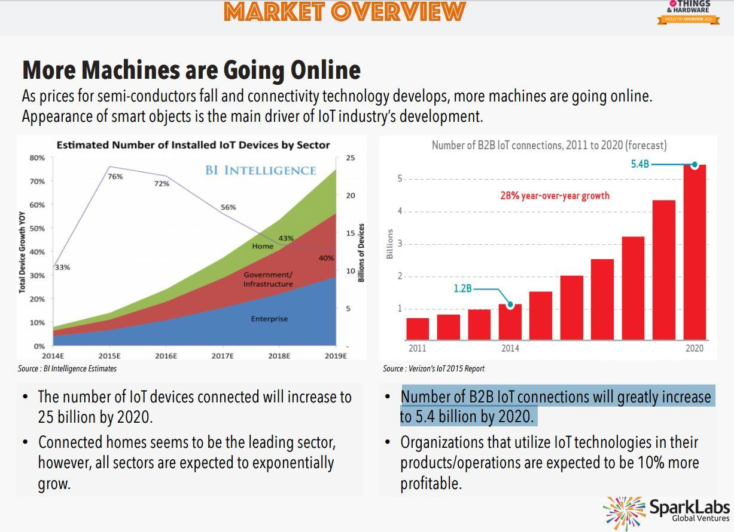
[33]

Industrial IoT growth is also revelling in large-scale global growth with Grandview research predicting [34] ‘that by 2025 the IIoT sector in the united stated alone will be worth approximately USD 9963.25 Billion’. The smart grid idea also comes under the IIoT umbrella along with healthcare, transportation, aviation and agriculture. Due to the nature of the environments these devices will be aiding, IIoT devices are more secure than their consumer partners and are fitted with encryption and authentication resources to ensure they are communicating as intended with their correct neighbours. The experimental part of the project will look deeply at the specifications of one such WSN located within the university and look to gain access to these devices without the knowledge of the administrator. The fundamental issue security concern that this report wishes to highlight that theoretically if the devices were compromised large-scale damage could be done to a town, city or country possibly human fatalities should they be monitoring a dangerous location or material. [35] ‘One example of the damage that could result from compromised network systems is the 2015 hacking of Ukraine’s electrical grid, which resulted in a massive power failure. More than 30 of the country’s 135 power substations were shut down for about six hours, cutting electricity to more than 80,000 homes. Hackers reportedly used malware to direct the grid’s industrial control computers to disconnect the substations, then followed this up with a virus that made the computers inoperable’.

Conclusion

To summarise this chapter, the author has looked at IoT and the solutions it promises by connecting multiple sectors. Currently, [36] ‘complicating the IoT standards (movement) is the sheer diversity of end devices, sensors, actuators, meters, controllers, appliances.’ Who are more than likely are [36] ‘vendors pushing end-to-end, proprietary, single-vendor solutions’. Many papers read state the “Why” we should secure IoT devices and why we need standardisation, yet the author is yet to discover a feasible actionable plan for an IoT device that works. Much of this growth and marketing drive assumes that all these billions of IoT devices will interoperate. Whereas research found within this chapter points the evidence to this being the contrary. The IoT model is not working the way vendors, and enthusiasts are proposing it does. This has not gone unnoticed, and further reading suggests standardisation bodies and vendors are investigating solutions for this issue. [2] ‘In 2014, the IEEE created an IoT Initiative’. This platform provides and encourages shared research and development of IoT standardisation, the first of its kind. [23] ‘And the IETF is doing its part in the standardisation of the communication protocol, with 6LoWPAN, an IP based communication protocol, that is used as the base for the Thread protocol’. Research suggests vendors still strongly believe their proprietary protocols and security solutions provide the consumer with the best all-around package for implementing IoT or IIoT networks. While in some cases this may indeed be true as their protocol has developed to work on their hardware and software. The main issue stems with the backwards compatibility with legacy infrastructures, and other vendors remain, leaving a fragmented island of IoT networks unable to communicate with each other. In an industrial or cooperate environment many believe the benefits outweigh the risks with regards to IoT. The public attitude towards cyber security is changing with many high-profile data leaks making the news daily. It is the opinion of the author that this can only favour IoT further, as cybersecurity conscious consumers will help not only secure IoT devices but IT across the globe.

Chapter 3 - RESEARCH METHODOLOGY

Introduction

This chapter aims to explain the methods, timescale, and the structure of the project while documenting any findings or similarities to the research detailed in section 2. The final part of this chapter will reveal the surveillance and analysis needed for the experiment and any problems that were encountered. Furthermore, knowledge gained from the literature review will continuously aid the research and findings into similar experimental projects.

Research Overview

The research methodology for the project developed its structure with the aid of a structured model. Each layer has provided a concrete structure for the development of this project. The guidance of a layered structure has helped the author create a relevant and accurate actionable plan to work with along with the aid of a Gantt chart. With regards to research and background knowledge various academic and survey, papers obtained from several resources made available through the university and paid subscriptions which are structured in table 1. All research is continued through the project with chapter 2 outlining and solidifying positives and negatives of IoT implemented into critical infrastructures. This research continues throughout the project as the author explores ways to exploit weaknesses in the WSN design or functionality much like a real attacker preparation is vital for the attack to be successful.

Table 1:
Topic | Source | Method
Introduction  Chapter 1.1 | Cisco.com, Lynda.com, Forbes.com, Project Supervisor and PhD students. | Video courses, online articles and critical reading. Pass sessions
IOT Overview  Chapter 2 .3 | IEEE Library, UWTSD Owen Library, Google Scholar, Lynda.com Vendor websites. Project Supervisor and PhD students. | Video courses, Critical reading. News Articles, Survey papers. Pass sessions
Research Methodology Introduction  Chapter 3.1 | Google Scholar, IEEE Library Project Supervisor and PhD students. | Background reading, Project examples. Pass sessions.
Research Overview | Project Supervisor and PhD students. | Background reading, Project examples. Pass sessions.
Research Design | Moninet Website/Web chat.  Droidsheep/Youtube/Google | Vendor research, Attacking through Mobile research
Design & implementation | Google, Bluestacks, PhD student, Supervisor | Researching rooting, emulating and purchasing
Testing & Conclusion | Author | Evaluating and comparing results to research findings.

Figure 11:
A step by step process of the project's methodology.
Research Overview
Research Process

Philosophy
Pragmatism
Positivism
Approach

Deductive
Inductive
Strategy
Survey
Experiment
Time Horizon
Grounded Theory

Cross-sectional
Analysis
Longitudinal

Mono-Collection Method
Multi-Collection Method

Research Process

The authors project will be an experimental project, looking at the practical issues with IoT. Results will be a mono collection of results through a serious of attempts to gain access to an IoT device to highlight security concerns within this field. Research into similar experimental projects and knowledge gained through literature review will continue to aid the experiment up until the end of the project.

Research Philosophy

The author has taken a pragmatic approach to this projects philosophy for several reasons. Practical experiences and academic research across the last six years as an IT undergraduate has shaped a sceptical approach to modern technology and its benefits. This was a difficult decision to make as the author can see and sympathise with the argument of how IoT can benefit the world. Despite this, current attitude of convenience over security has further strengthened this sceptical belief through the literature review, research and present cybersecurity issues.

Research Approach

Researching academia for the projects literature review and many academic semesters has provided the author with a deductive research approach based on a theory-driven hypothesis. The generalisation that this statement is indeed correct. The project will look at attacking an Industrial type IoT devices working as together as a WSN.

Research Strategy

The strategy for this project is to either prove or disapprove the theoretical hypothesis through a controlled experiment and analysing the results. Limitations of access to the nodes and the administrator’s availability to have the nodes functioning hinder the time scale the attack can be carried out. The author a BSC Computer Network and cybersecurity undergraduate is hoping the knowledge gained through the last three years will provide the critical thinking needed to overcome any obstacles which may occur such as vendor security.

    - Time-scale

A cross-sectional timescale has been decided for the author's experimental project due to the academic calendar this experiment must conclude by the end of March. Results themselves are will either be successful or unsuccessful with all middle ground reviewed and justified with a conscious security approach.

    - Research analysis

The results will provide an accurate, detailed report on how the experiment was carried out and the findings the test presented. Should the test be successful, this will justify the concerns of many cybersecurity professionals in the field including the authors. Attempts will be made to document all methods used when attacking the WSN and whether the results were successful.

Research Design

For the experiment to be successful planning is well underway for the types of attacks that will be used against the WSN. Before any strike, hackers carry out surveillance of the target to intimately gather information that can aid the chances of success; attackers will likely get one chance to attack as once discovered mitigation measures will prevent the same methods being successful twice over. The author found through a web chat with the vendor support team that the IIoT devices are using a vendor-proprietary protocol built with strong encryption both in the LAN and WAN transmission stages. The vendor [37] ‘monnit’ boast of bank-level encryption and claims that their IIOT sensors used in the target network are unhackable. [38] ‘They also employ a new Encrypt-RF™ Security (256-bit Diffie Hellman key exchange and AES-128 CBC) encryption for all sensor data.’ The author assumed that the victim WSN was using the open standard IEEE 802.15.4 protocol, and thus all research and scenarios have been based around exploits in this protocol. The author took the experiment back to the drawing board to find a weakness in this network and exploit it if possible. Figure 12 shows the vendor IIoT sensor that is located within the WSN.

[37]
Figure 12
Monnit sensor node and gateway found within the victim wireless sensor network. [39]

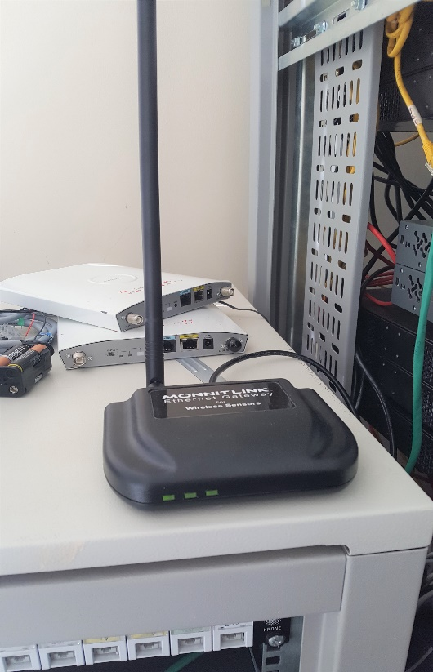
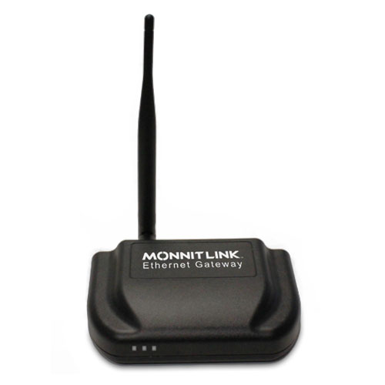
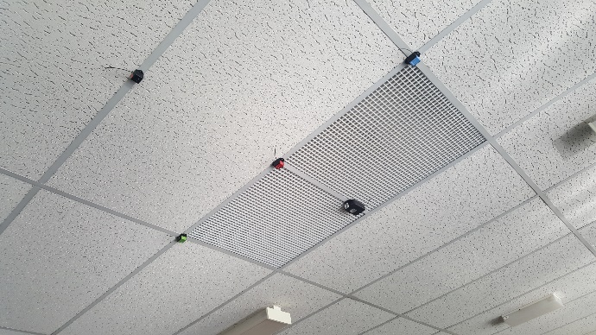
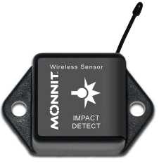

Figure 1: Research Design 1

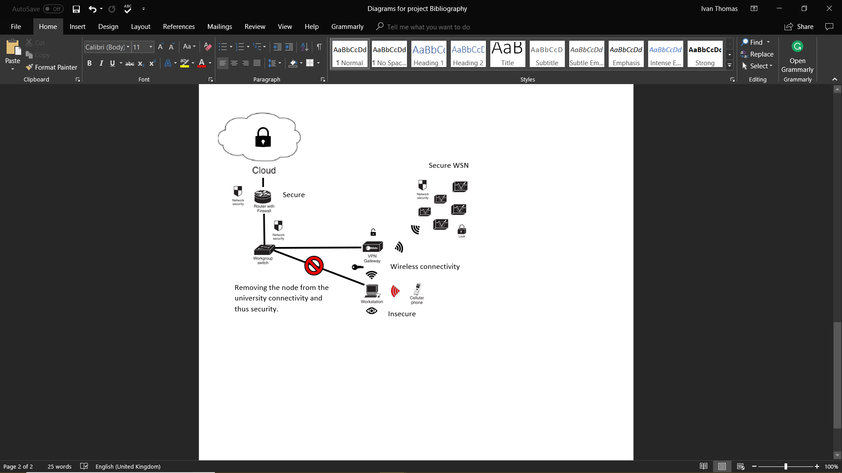

Research Deliverables

Results themselves will be difficult to show in standard data collection methods as this is an alive and active attack. Screenshots will be provided of the steps of attempts to attack the WSN successful and unsuccessful with detailed documentation of the thinking behind that attack and whether it was successful.

Triangulation

Verifying the results will be done by the author and the PhD student participating in the experiment. The PhD Student is the original architect of the WSN and is using the attacking methods and data gathering to further their research into WSN technology. The author will undertake an evaluation of the results of the experiment; it is believed the active research and study over the last three years of the author's undergraduate degree provides sufficient knowledge to evaluate a cyber attack objectively and therefore its success or failure and any unknown factors.

Conclusion

To summarise this chapter, the author detailed the necessary objectives for the project to be completed in a timely and efficient manner. As this is a cross-sectional project, the author has taken care to anticipate issues and meet strict deadlines. Due to the pragmatic approach of the experiment the research and design process have been given due time and consideration throughout this part of the project. Careful planning and extensive research have afforded the author two attacks against the victim’s network. The machine that wirelessly configures and administers the sensor nodes is the weakest link in the chain of information flow. Two attacks are set to be tested, one being a non-intrusive passive attack to gather information such as user password and login details, and the other being active attack called denial of service attack which will deny wireless connectivity to its internet connection, therefore, denying access to the information. Displaying this information will be done through camera phone images of the attack while live and adding screenshots of relevant and detailed steps that this experiment will take.

Chapter 4 - DESIGN & IMPLEMENTATION

Introduction

Chapter 4 details the issues faced in the design, and implementation of the experimental part of the project. Constraints, ethics, budget, interoperability are all issues faced when strategising a successful cyber attack. This chapter aims to document the positive and negative experiences of the tools used to attack the victim's network and the solutions to overcome any barriers that were presented when researching how to attack a highly encrypted and secure system successfully.

problem formulation

From the outset, most of the research in chapter 2 was based on the 802.15.4 Protocol called Zigbee. While intelligence gathering about the victim, the author interviewed the original creator of the sensor network found within the university. While gathering information, the creator of the WSN suggested researching the vendor and thus a web chat transcript was started with Monnits IT sales service representative. Acting as an interested party, the author began a conversation about how the devices operated and what protocol was being used. A screenshot of this transcript can be found in the appendices in Figure 1. It is vital to state that although the name is Simon Downes in the transcript, this is the author using his Immonit account to contact them as it was felt an existing customer will possibly be given more information.

Through a detailed conversation, the author had learned the vendor uses proprietary solutions to their products and that their products boasted strong encryption between node and cloud service. To further complicate the attack the gateway used for transmission requires power over Ethernet connection and therefore must be connected to a networking device with an internet connection. To outline the challenge ahead, the author is tasked with attacking a highly secure encrypted and authenticated sensor network. All wireless communication is built and designed to the vendor's specifications, and all transmission goes through the universities network connection and all the layers of security that resides there. Attached to the transcript was a security document that detailed the information of how they operate and how secure they claim to be.

Monnit say that their [38] ‘their bi-directional communication (on sensor nodes) allows them to verify delivery of messages (Integrity), receive acknowledgements for the messages they send and continually confirm, and they are connected to a Monnit Link gateway (Authentication) and the newest addition to their protocol is a powerful 128-bit encryption engine (Confidentiality). The vendor has designed the protocol to the guidance of the CIA Triad while researching how to mitigate common cyber-attacks, overall an impressive model and a challenging victim to attack. Monnit boasts customers including Google, 3M, and P&G, further confirmation that they are held with high regard in the industry for their products. Figure 15 shows the possible number of keys that would need to be exhausted to decrypt the sensor data through a brute force attack.
[40]
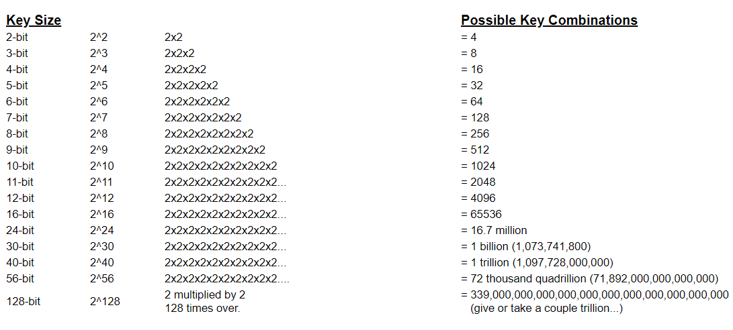
Figure 15: Encryption keys and their possible outcomes

It is clear the author lacks resources, knowledge and timescale to attack such a highly secure network successfully. On the other hand, there is one node inside this network that is not a Monnit product and a lot less reliable. The administrator logs onto the IMonnit portal through a desktop PC to configure and monitor the sensor nodes. The author has decided that the passive and active attack will occur against the PC and the administrator. Cybersecurity often stresses the user is the weakest link in any computer network. Unfortunately, Uber learned by not educating their employees on the appropriate use of sensitive data. Even though there were no cyberhackers successfully breaking into their systems, their image was tarnished with the leakage of massive amounts of customer details through spyware in employee devices. It is through a similar attack that the author is hoping to obtain the login credentials of the administrator used to authenticate on the IMonnit interface. Should this be successful, and the credentials earned the author has found an exploit to navigate around all the encryption, authentication and integrity solutions Monnit have in place. Monnits integrity and reputation is upheld to its customers as it can deny any cyber breach and distance itself from the attack by stating endpoint security is beyond their control, and therefore the user and the infrastructure that housed the node were at fault. Due to the authors access to the victim’s PC, the attack will be an inside job, attacking the victim through the universities network or the internet will provide extra challenges that will slow the timescale and require a substantially larger budget.

The first attack is the active attack; the goal is to prevent the user from internet access through a wireless DOS attack. The offense will be facilitated by a mobile phone which will be connected to the same LAN as the victims PC. For the mobile phone to run the DOS application a process of rooting needs to be completed. [41] ‘Many advanced users often tweak their devices by gaining access to the highest privilege, also known as root and can manipulate the OS (operating system) to install and customise’. The author will purchase an android phone and a sim card and then root the phone. This will enable the phone to download the necessary applications and permissions to attack the network. Figure 16 is the chosen phone for the attack running version 6 android operating system.

Figure 16:
Doogee X20 smartphone, the chosen device to facilitate the attack

[42]

To root the phone and provide the required privileges a software application called [43] ‘KingRoot’ will be used. Tutorials suggest the rooting will be straightforward with negligible risk to damaging the phone. This procedure will be carried out prior the experiment to allow troubleshooting if needed. The chosen application for the DOS is called [44] ‘WIFI Kill, the application operates by making other devices in the same network believe the attaching device is a router. Subsequently, they will try to connect to the internet through the device. WIFI Kill then drops the connections of these other devices and therefore their connection to the internet’. The second attack will be a passive attack against the same node as the active attack. The idea of this attack is to gather information without the knowledge of the user silently. Ultimately the information that is the target is the administrator’s login details to the IMonnit portal. The malware of choice is a keylogger, [45] ‘which boasts invisibility in all operating systems in hidden mode - even in process listings.’ This malware logs keystrokes, copies to clipboards, and internet sessions even in the free version where others charge a fee for these features, therefore this has been chosen as the weapon of choice. [45] ‘Actual Keylogger’ provides [45] ‘case sensitive keystroke recorder and log search with or without case sensitivity. Limits settings on clipboard contents so that only the required part is saved and separates limits for text log and screenshot size.’ Downloading the keylogger and installing it within the university will leave an electronic breadcrumb to the culprit. Therefore the author will download the keylogger and test the features before copying it on a USB stick and installing it before the attack.

Actual keylogger provides email delivery with the upgraded version shown in figure 17: This option was not taken as this experiment is a controlled and documented processes with all relevant party’s consent. Should this attack be in a real-world scenario, the email delivery version and other features will profoundly escalate the chances of success. Only set up a fake email account and send the email from a node that cannot be traced back to the perpetrator and utilise the FTP delivery service built in that delivers electronic logs to a configured FTP server.

Figure 17: Screenshot of Email Delivery service of the keylogger through the paid version.

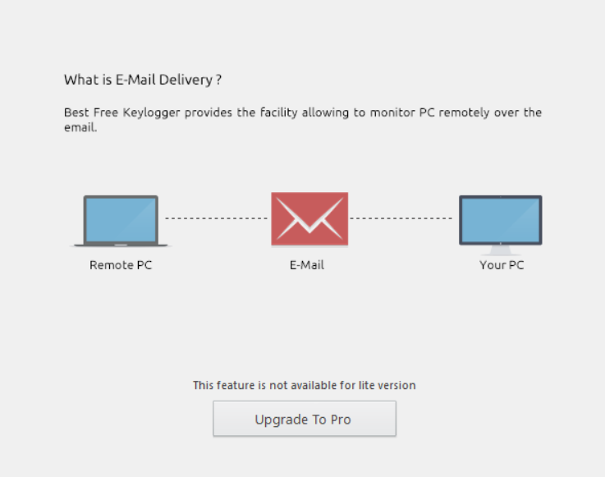
[45]

Figure 18: Screenshot of remote FTP delivery service
[45]


As an attacker, the author is concerned about network SNMP (Simple network management protocol) flagging suspicious activity while uploading the data to the FTP server. Therefore, if the attacker has access to the infected node. Utilizing Actual keyloggers USB delivery is a risky but high reward method of collecting stolen data bypassing the networks security features. This is a paid subscription option, and one that will not be taken in the experiment as access is available to the victim. However, the opportunity is there should there be any unforeseen security measures.
[45]
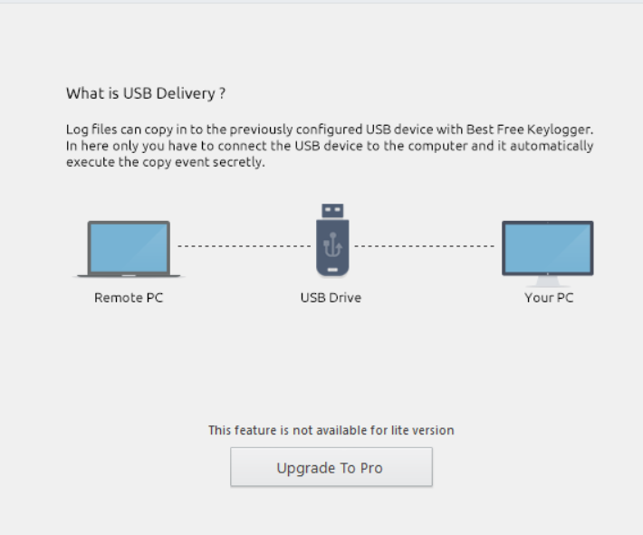
Figure 19: USB delivery feature obtained in the Pro version

Design

The scenario the project simulates is a disgruntled employee or an industrial or military espionage attack against a fellow organisation. Reconnaissance has established that the gateway requires internet and a PoE (Power over Ethernet) connection. Monnit [38] ‘state that in an unfortunate event of a power outage or similar that takes a gateway offline, the(in) intelligent sensors recognize that their secure connection has been disrupted and enter(s) a “Link” state waiting for the power to be restored to the gateway and then only after re-establishing their connection with the gateway do they start transmitting data again’. To counteract this security measure, the author has designed and developed a simple LAN connection within the campus utilising a purchased router and internet access provided through a mobile phone hotspot. The design can be found in the appendices of this project and is recommended to be studied before continuing as the description of this attack will be confusing at times without a visual aid. With the support of the diagrams created and located in the appendices, Figure 2 is a basic diagram of how the data is transmitted to an IoT cloud for analytics. Figure 3 is the proposed resolution of removing the WSN network from a secure connection to an unsecured one created by the attacker. The following description details the design of the current WSN designed in figure 2, refer to appendices for the diagram. Currently, the sensor node gateway is directly connected to a PoE enabled switch to provide power, for description purposes the switch is called switch A. Switch A has a PoE port but is not used on the university network. To establish an internet connection, Switch A is connected to a Switch B. Switch B is part of the university network topology therefore where the layers of university security begin. In the experiment Switch A will remain in use, while Switch B will not.

To provide an internet connection, the author has a rooted mobile phone broadcasting its wireless access under the same SSID (service set Identification) as the current WLAN (Wireless Local area network). The router provided by the attacker in the experiment will need to be configured to repeat the mobile SSID, extending this rogue AP signal and giving access to any directly connected devices through ethernet cables. In theory, the switch should allow the internet connection to carry on through the router and into the gateway. Consequently taking the WSN out of the universities protection and into the less secure cellular connection.

The steps highlighted prior is more for demonstration purposes in the final viva in this report to showcase to the author's peers that it can be done. The author was told that attacking the WSN from the internet would be extremely difficult due to the universities cybersecurity solutions. By removing the WSN from the universities network, this opens the possibility of attacking the network remotely. However, this is a hypothesis and will be tested in the experiment, remote cyber-attacks are beyond the scope of this experiment and therefore will not be documented further. Attack number one, located in figure 4 in the appendices does not require the WSN to be taken off the university network as the attack will be against the node that configures and administers the Monnit sensors. A diagram can be found in the appendices under figure 4. The rooted phone once again acts a rogue access point broadcasting the same SSID. Once the administrator connects to the phone and is discoverable on the WIFI kill application, the author will utilise the applications kill feature which prevents internet access to all devices on the same LAN. The Hotspot will be used in the experiment in order not to directly attack the universities access point and potentially disrupt essential tools and users. However, the concept can be tested against any wireless network. Attack number two’s diagram can be found in the appendices as figure 5. Attack number 2 will consist of the author bringing in a USB stick and plugging it into the victim’s machine. The author believes the university SNMP may block any download attempts to the PC. Therefore, a USB is the preferred option. Located on the USB stick is the executable file of the keylogger software. Once installed the author will enable the logging features on the application and hide the interface. For the experiment, the administrator will log onto the sensors through Monnit’s secure login portal. Attacking here will be very difficult due to the security certificate, and encryption enabled. The author believes that the attack will collect the information as intended as the attack is not against the website but the local machine.

Implementation

Figure 20 The purchased mobile phone before rooting.




Attempts to root the phone have so far been unsuccessful an example has been shown in figure 21 and figure 22 below. The author is unable to find the solution to this. The opinion of users who have come across the same issue stem with the concise that the most likely cause is that the [46] ‘developer has not (yet) found an exploit to use. The more rare/unpopular the device, the more unlikely a root method will be found.’

Figure 21: Beginning the rooting process


Figure 22: Screen capture of the rooting failing on the Doogee X20


[47]’Bluestacks’ is an android an emulator that allows a personal computer to run and interact with versions of an Android operating system. The Authors idea being running an Android OS and rooting the software inside the emulator. Although the rooting was indeed successful, see figure 22 show visual aid. The software still lacked a mobile internet connection outside of Wifi networks. A solution to the problem could be rectified by purchasing a mobile dongle and connecting to the cellular network. However, the author found an older phone running an older version of Android and successfully rooted the phone. The emulator and dongle remain a backup should the phone be lost, broke or not work. The keylogger formerly has been straightforward to download and operate; the author has opted to stay with the free version of the software directly to see if the cheapest option will work. Upgrading will be considered in the event the keylogger does not obtain the information as expected. The keylogger’s security feature hides the keylogger by default. Accordingly, the author must press Shift, Ctrl, Alt & K simultaneously on the machine. The author is prompted to add a password, due to the nature of the information that will be collected the password will be added and the password known only to the author. Figure 23 is a screenshot of the keylogger prompting for a password.

Figure 23: Password Prompt from Actual Keylogger to access its features


Features include silently uninstalling the software at a time a scheduled time or date without user prompting the OS to do so. Rapid delivery through a pre-configured USB, email delivery of keylogger to the victim, and screen captures also logged and displayed in a sperate log.

Conclusion

To deduce, the experiment will consist of two cyber-attacks against a windows PC to indirectly compromise and deny access to an Industrial IoT WSN. The authors favoured attack in a real-world scenario is the keylogger software as it has many features to enable the attacker to keep the raid stealthy and potentially gather copious amounts of data. Such data will include but not limited to login credentials, screen captures, and websites visited. Due to the attack being locally administered on the machine cryptography, and authentication methods are ineffective, once login credentials are obtained the attacker can impersonate themselves as a legitimate user or create new accounts and escalate their privileges to operate from these accounts as not to arouse suspicion. The vendor attacked has networks in environments such as water treatment plants, electricity grids, gas supplies, ISPs and, Search engines. Should this attack be successful, this threat could pose a real security concern on a national scale. If an attacker gained access to critical systems or the sensor nodes and altered their behaviour, inaccurate data may represent a disaster type scenario of enormous proportions. The active attack is more of a potential inconvenience than a danger to the behaviour of a system. Where the DOS attack excels, is that primary network troubleshooting does not detect any abnormal actions even though the victim is unable to connect to the internet. Speed tests, traceroutes and pings and signal strength are unaffected therefore this may cause issues for a time, however, the author believes a wireless SMNP would eventually detect a rogue access point and establish this as the point of attack.

Chapter 5 – Testing and Evaluation

This chapter details a step by step guide of how the experiment unfolded and discussed the results of each attack and details any problems that arose while the operation was carried out.

Step 1: Attack 1:

The PC in the experiment is connected to an access layer switch via the yellow Ethernet see figure 24. As the DOS attack stems from wireless connectivity, the wired connection was removed, and a wireless adapter placed into an available USB slot in the back of the PC. No known issues arose while installing the drivers and setting up the wireless adapter. Ergo the next step of the experiment was to enable a wireless connection for the PC to attack.

DOS attack

Figure 24: Removing the yellow ethernet cable. Figure 25: The Wireless adapter used in the experiment.
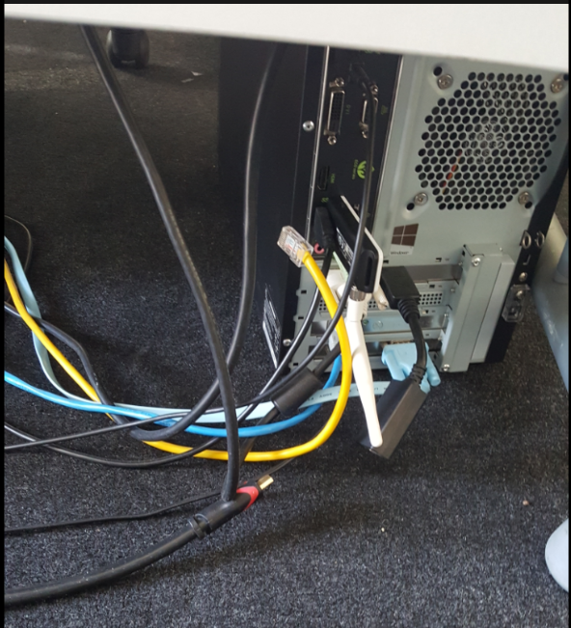

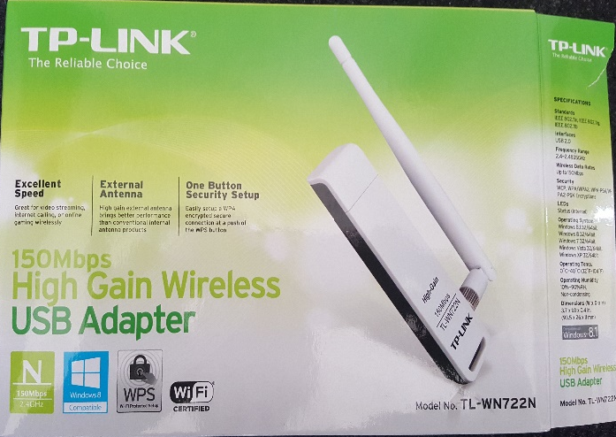

Step 2: Attack 1:
Enabling the phones hotspot feature shown in figure 25 allowed the PC to connect to the rooted phone wirelessly. The credentials were provided to the PC for connection in this experiment.
Figure 25: Mobile hotspot
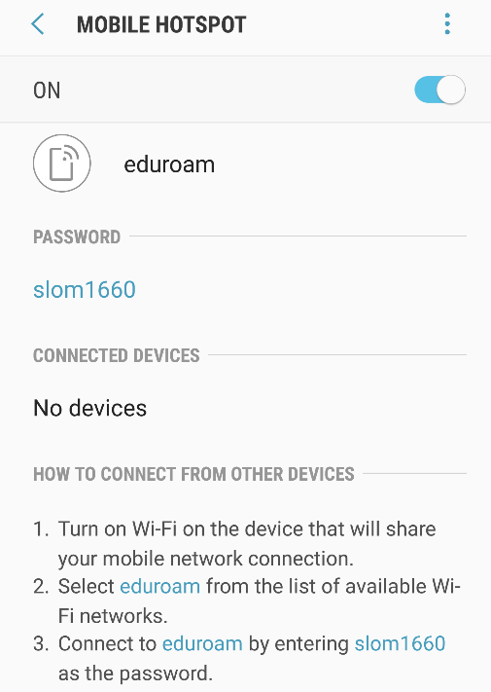

Step 3: Attack 1:

Then begin the WIFI kill application and scan for the IP address of the PC, Figure 26 Is the IP given by DHCP and is thus the one that must be denied access to the internet. Figure 27 is a screenshot of the WIFIKILL application showing that the PC has been discovered.

Figure 26: Checking IP address of the machine
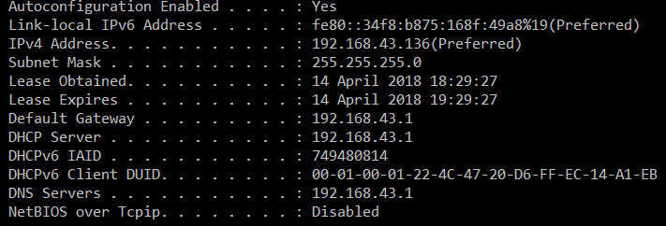

Step 4: Attack 1:

Figure 27: WIFI Application showing the PC’s IP address
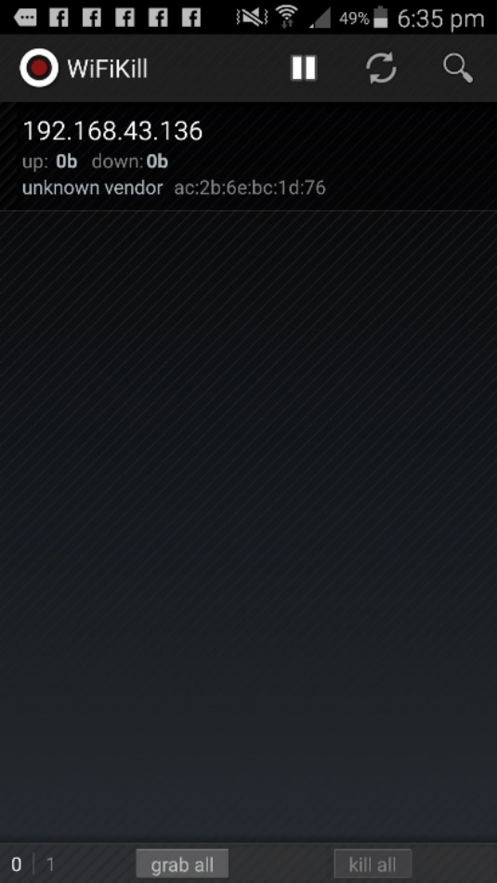

Figure 28 and 29: Attaching and killing the Internet connection to the PC.
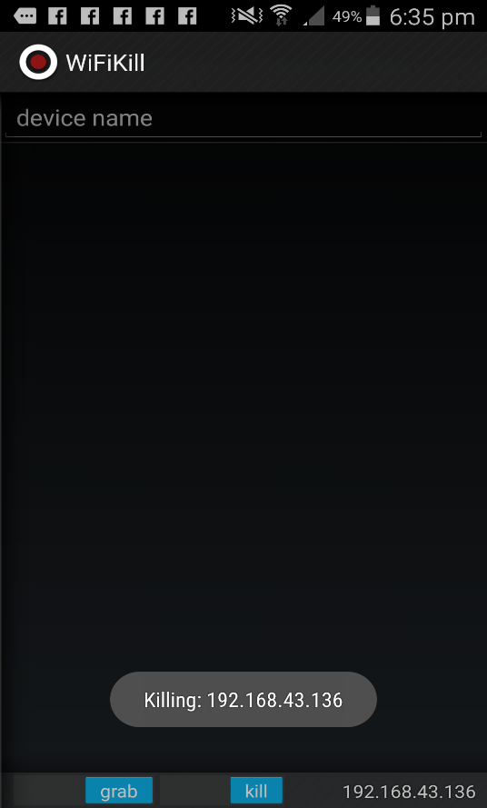
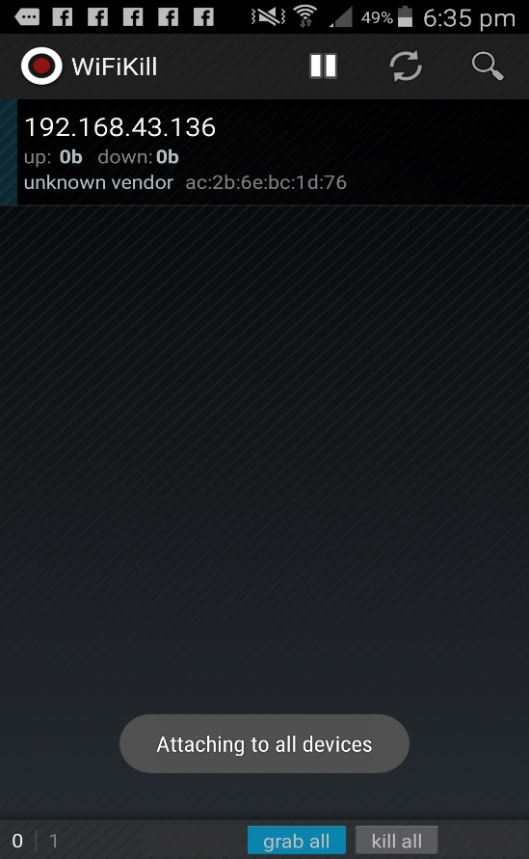

Step 5: Attack 1:

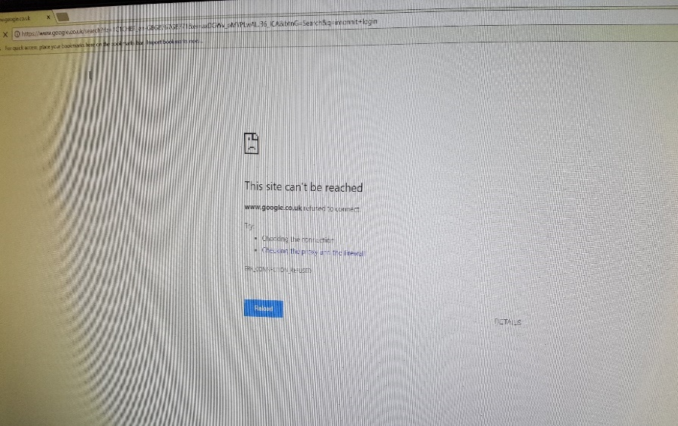

Figure 30 and Figure 31: The attempt and the result to connect to the Imonnit portal

The result of the active attack was a success and as anticipated network troubleshooting for common issues result in the PC saying the connection is stable and there are no apparent issues with the network connection.

Keylogger attack
Step 1: Attack 2:


Figure 32:

Figure 32, is a screenshot taken from the settings page, the author is in a controlled experiment with rules and ethics to consider. Subsequently, the amount of logging is limited to 2GB of data and is set to uninstall itself after the test.


Figure 33:

Figure 33 displays the features of keylogger, for the experiment all elements other than the scheduled monitoring is enabled. The planned monitoring is not needed as the attack is in a controlled environment and the attacker does not need to cast a wide net for the information required.

Step 2: Attack 2:

Figure 34 represents a screenshot from the login page for the sensors. For demonstration purposes the author has highlighted the security on the website showcasing the security challenges attacking the site over the machine would entail.

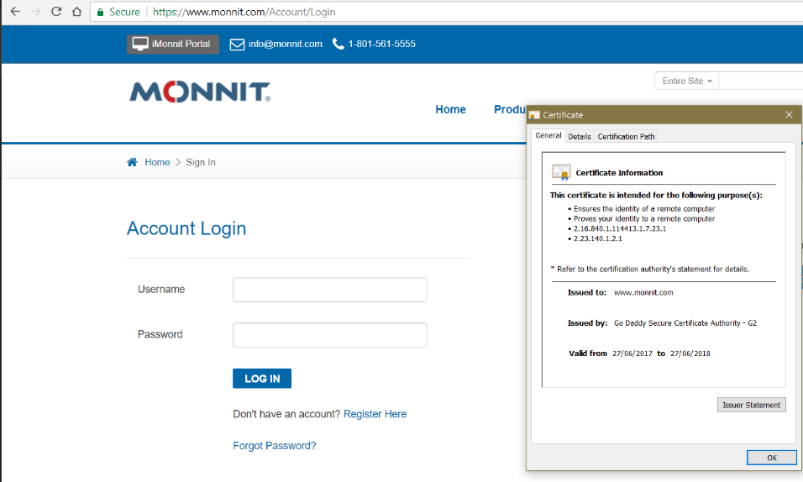
Figure 34: Figure 35: 256 SHA Encryption

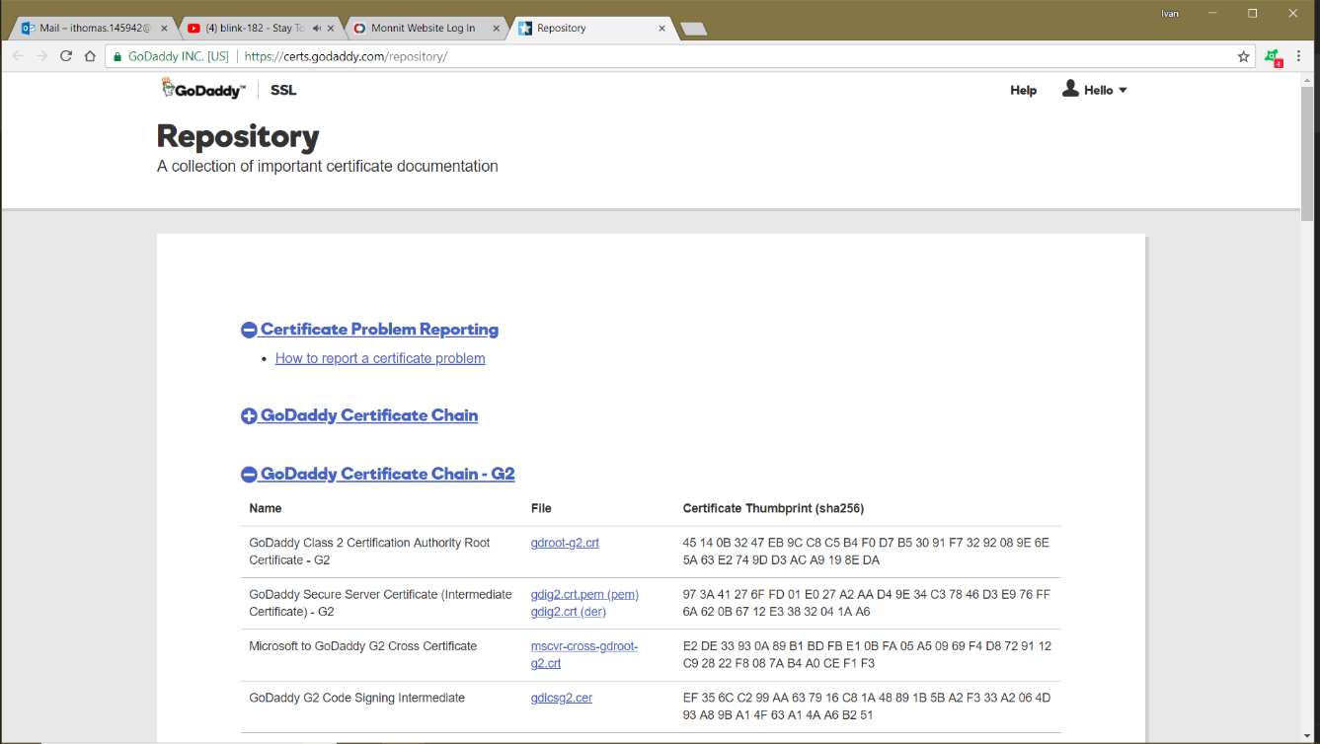
Figure 35:

Step 3: Attack 2:

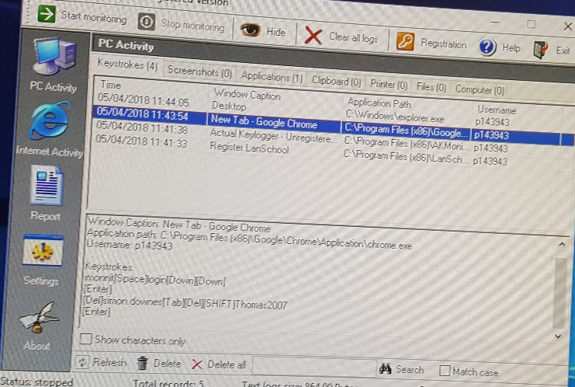
Figure 36

Figure 36 details the logs created from the keylogger over a 3-minute period of monitoring the PC. For the experiment, the browser log is the one of interest. Unrelated but the attacker also obtained and deleted the administrator's network credentials as they logged onto the network. If this were a malicious attack, this information would provide an entry point into a secured system for an attacker to facilitate further attacks.

Step 4: Attack 2:


Figure 37:

User password removed
First name removed

Figure 37 represents the result of the keyloggers output; the administrator’s login credentials as expected were captured. For security and ethical issues, the administrator’s username and their password have been removed from the screenshot. The password and username were then tested from home, and the access was granted. Regrettably, this cannot be shown in a screenshot as the administrator changed their password since the last attempt.

Chapter 6 - CONCLUSIONS AND RECOMMENDATIONS

Summary

Both attacks were successful, and the author credits this mainly to the research found in the advanced cyber security module. Throughout lectures and labs, the author was researching how these attacks worked and whether they could be implemented into the project. Large parts of the module detailed web security and encryption methods and it became evidently clear that attacking the website, or sensors were beyond the scope of the project and the author's knowledge. Facilitating an attack from a mobile phone was recalled inside the mobile security presentation. Within this lecture, the class were taught about the advantages and disadvantages of rooting mobile phones and popular applications that were used to attack networks. Effective time management allowed troubleshooting and alternative attacks to be drawn up, i.e. the Bluestacks and dongle method. The keylogger idea was a natural conclusion to make, throughout chapter two multiple cybersecurity papers were cross-examined. Reading white papers and web articles brought attention to attackers using social engineering to gain sensitive data by tricking them out of their passwords. Establishing the user’s PC as the weakest link in the chain it was, therefore, decided this be NIL where the attack could realistically be made.

Conclusion

The purpose of this project was to highlight the benefits and risks of integrating IoT devices into computer networks and operational technology sectors. Through two low tech attacks, the author has disrupted access to the wireless sensor network through a wireless connection. Moreover, with the aid of a free keylogger the author has sidestepped the 128, and 256-bit encryption on the devices, and authenticated against their website security by impersonating as the administrator. There is not a two-step authentication, such as texting or emailing the user to double check login credentials when done from a new device. Therefore, the user will not know they have been compromised until they suspect tampering or damage and investigate further. The research and the experiment were based around cybersecurity. Concluding thoughts are that the project has highlighted the lack of underlying security in market ready IoT devices through analysis in chapter two. Overall, considering that the vendor has a wealthy clientele and they have their tools inside systems that directly affect large-scale operations. A one password authentication method is a weak point in what is a very good and secure WSN. Furthermore, Monnit’s proprietary solutions to security and communications further verify the conclusions in chapter two that IoT vendors prefer to use their own proprietary solutions. This limits local integration between the WSN and any other IT devices within the university. Theoretically they may be able to communicate with other IT devices through the internet. Although this will pose security issues as the traffic is going through a worldwide unsecure network and adds further network traffic for the routers to compute. The proposed disaster scenario of a compromised smart grid is leaving the millions without power, gas and clean water theoretically could occur through an inside passive attack such as the one the author carried out in the experiments. Uber suffered a similar attack through malware on employee devices. [48] ‘Hackers stole personal data including names, email addresses and phone numbers, as well as the names and driver’s license numbers of about 600,000 drivers in the United States’. Resulting in 57 million user’s data being stolen and held for ransom for 100,000 dollars. [48] ‘Uber said more sensitive information, such as location data, credit card numbers, bank account numbers, social security numbers, and birth dates, had not been compromised’. Likely due to this information being stored on secure servers and not on employee devices. To conclude the author believes that businesses such as Uber, vendors such as Monnit and IT professionals such as the university administrator must not overlook the importance of identifying local or connecting nodes to their devices as a potential platform to facilitate cyberattacks.

Recommendations for Further Research

Although the author carried out extensive research throughout the timescale of the project, due to the sheer size and relatively new nature of the IoT sector. A unique and comprehensive analysis of IoT's future will be required throughout the coming years to address some critical issues highlighted in this project.

Recommendations for further research would include

Research the long-term plan of consumer IoT vendors.

Research and conclude whether proprietary solutions are hindering the very core values IoT.

Further research on the what steps are being taken to address the lack of necessary security on IoT consumer devices.

What challenges has the Singapore smart grid encountered and what are the proposed solutions.

Research Barcelona, London smart city blueprints and how security concerns are being addressed.

Proposed plans to overcome political issues with regards to data ownership and privacy

Chapter 7 – Reflections

This research aimed to evaluate and test an industrial wireless sensor network against common and frequent cyber-attacks. The author feels confident that the aims set out at the beginning have been accomplished to the best of his ability. Relating to the beginning of the project the aim was to carry out at least three attacks against the network. As the project developed and reconnaissance progressed it became clear that the author had a harder challenge than anticipated. With hindsight looking at the network's gateway and researching the vendor would have been a better course of action. This would likely highlight the proprietary solution over open standard protocols that were believed to be in use. A key objective of the project was to research IoT technology in the operation technology sector. It Is felt that this was only partly achieved, firstly by reviewing and interacting with Monnit devices and understanding their high reputation as a leading Industrial IoT vendor but secondly, understanding this was a purely personal interaction and that this report lacks documented research into their functionality. The second objective to evaluate and compare similar studies on IoT security was not met. While many hours of research and studies have been evaluated within this project, a direct comparison of two or more studies has not been achieved. Although many of the problems highlighted in this project are further validated by peers in the industry, the author feels a more comprehensive review of solutions and collaborations of technologies could have been investigated. The third objective to develop a small-scale experiment and test for cybersecurity issues was achieved. Many issues arose in the design, and implementation, stage of the experiment but the testing itself was carried out without any complications. An argument could be made that no penetration attempt was made against the network. However, the author would argue that a penetration testing includes methods to access data without directly attacking the network. By establishing an internet connection through a wireless bridge, the author has drastically reduced the barriers to attacking the network directly as the universities defences are now removed from the equation. The fourth objective was to identify future growth and research challenges in the industrial IoT field. Once more, this objective was only partly achieved as much of the project took a pragmatic approach to IoT. The authors bias has overlooked the bigger picture, and should the report have any shortcomings it would be a lack of research into the solutions to the issues proposed in the project. The final objective, was to reach a conclusion on whether IoT devices are secure enough to be used in such a critically important sector. Concluding thoughts as this project ends are that IoT devices are already being introduced into these sectors regardless if there is a security concern. IoT continues to receive substantial amounts of growth in the face of negative headlines. The security on the Monnit devices in the project have a proficient amount security to be introduced into a secure network. Long-term there would need to be an actionable plan for bridging the interoperability issues of propriety protocols.

chapter 8 - REFERENCES

[1] Louis Columbus, “Internet Of Things Market To Reach $267B By 2020.” [Online]. Available: https://www.forbes.com/sites/louiscolumbus/2017/01/29/internet-of-things-market-to-reach-267b-by-2020/#54747a6c609b. [Accessed: 07-Apr-2018].
[2] IEEE Standards Association, “Internet of Things (IoT) Ecosystem Study,” no. January, pp. 1–3, 2015.
[3] M. Bauer and S. Lange, Enabling Things to Talk. .
[4] K. Ashton, “That ‘Internet of Things’ Thing,” RFiD J., p. 4986, 2009.
[5] F. M. and C. Floerkemeier and Distributed, “From the internet of computers to the internet of things,” Lect. Notes Comput. Sci. (including Subser. Lect. Notes Artif. Intell. Lect. Notes Bioinformatics), vol. 6462 LNCS, pp. 242–259, 2010.
[6] R. Processes, “GridWise Alliance Principles for Grid Cybersecurity GridWise Alliance , All Rights Reserved GridWise Alliance , All Rights Reserved,” no. September, pp. 1–3, 2011.
[7] L. Da Xu, W. He, and S. Li, “Internet of things in industries: A survey,” IEEE Trans. Ind. Informatics, vol. 10, no. 4, pp. 2233–2243, 2014.
[8] Jeff Finn, “Why IoT device manufacturers must partner with network providers,” Internet of things institue, 2017. [Online]. Available: https://www.ioti.com/security/iot-device-manufacturers-must-work-network-providers. [Accessed: 08-Mar-2018].
[9] TIA, “TIA Solutions in: Internet of Things | Telecommunications Industry Association.” [Online]. Available: http://www.tiaonline.org/tia-solutions-internet-things. [Accessed: 07-Apr-2018].
[10] A. Castonguay, “Internet of Things Enterprise Survey Prepared by,” 2016.
[11] Beecham Research, “M2M World of Connected Services - The Internet of Things,” p. 201, 2009.
[12] Yatin Jog, “Vendor lock in and Internet of things – SITM Blog,” Symbiosis institue of telecom management, 2017. [Online]. Available: https://blog.sitm.ac.in/vendor-lock-in-iot/. [Accessed: 08-Mar-2018].
[13] S. Yinbiao et al., “Internet of Things: Wireless Sensor Networks,” Int. Electron. Commision, no. December, pp. 1–78, 2014.
[14] Zahraa Khalil, Standardization process. 2017.
[15] Micrium, “Part 3: IoT Protocol Stack Options | Micrium.” [Online]. Available: https://www.micrium.com/iot/internet-protocols/. [Accessed: 07-Apr-2018].
[16] H. Farhangi, “The path of the smart grid,” IEEE Power Energy Mag., vol. 8, no. 1, pp. 18–28, 2010.
[17] W. Tushar et al., “Smart grid testbed for demand focused energy management in end user environments,” IEEE Wirel. Commun., vol. 23, no. 6, pp. 70–80, 2016.
[18] E. Kiat and P. Specialist, “Smart Grid Initiative in Singapore.”
[19] G. W. Arnold, “Challenges and opportunities in smart grid: A position article,” Proc. IEEE, vol. 99, no. 6, pp. 922–927, 2011.
[20] B. Bunse, H. Kagermann, and W. Wahlster, “Industrie 4.0,” Ger. Trade a& Invest, p. 21, 2014.
[21] GadgetZZ, “A Society Where Each Home Generates Its Own Electricity - Gadgetzz.” [Online]. Available: http://gadgetzz.com/2016/09/21/a-society-where-each-home-generates-its-own-electricity/. [Accessed: 07-Apr-2018].
[22] Viterbi Voices, “Getting Smart with the USC Smart Grid Project - Viterbi Voices.” [Online]. Available: http://viterbivoices.usc.edu/zachg/getting-smart-with-the-usc-smart-grid-project/. [Accessed: 07-Apr-2018].
[23] “Internet of Things: The Good, the Bad and the Ugly · Anand Mani Sankar.” [Online]. Available: http://anandmanisankar.com/posts/IoT-internet-of-things-good-bad-ugly/. [Accessed: 10-Apr-2018].
[24] K. D. Integrity, “The CIA triad : Have you thought about Integrity ?,” 2007.
[25] Geraint W, “cia triad authenticity and accountability - Google Search,” Online Blog. [Online]. Available: https://www.google.co.uk/search?q=cia+triad+authenticity+and+accountability&rlz=1C1NDCM_enGB787GB787&source=lnms&tbm=isch&sa=X&ved=0ahUKEwjTjNuV_azaAhVBYsAKHQk2C2cQ_AUICigB&biw=2048&bih=1063#imgrc=W9vorJW2byNI4M: [Accessed: 09-Apr-2018].
[26] C. H. Matthew H Meade, Sue C Friedbreg, Pamela E Hepp, Katelyn L Diehl, “Attacking Cybersecurity from the Inside Out.: EBSCOhost.”
[27] E. Kitchen, “US Cybercrime: Rising Key findings from the 2014 US State of Cybercrime Survey,” Natl. Serv. Secur., no. July, p. 21, 2015.
[28] The Conversation, “The US election hack, fake news, data theft: the cyber security lessons from 2017,” 2017. [Online]. Available: https://theconversation.com/the-us-election-hack-fake-news-data-theft-the-cyber-security-lessons-from-2017-89280. [Accessed: 09-Apr-2018].
[29] European union agency, “No Title,” Major DDoS Attacks Involv. IoT Devices, 2016.
[30] K. Savage, P. Coogan, and H. Lau, “Information Resources,” Res. Manag., vol. 54, no. 5, pp. 59–63, 2011.
[31] Cybersecurity Ventures, “Ransomware Damage Costs $5 Billion in 2017, Up from $350 Million in 2015Cybersecurity Ventures.” [Online]. Available: https://cybersecurityventures.com/ransomware-damage-report-2017-5-billion/. [Accessed: 09-Apr-2018].
[32] N.-N. Dao, T. V. Phan, U. S. ad, J. Kim, T. Bauschert, and S. Cho, “Securing Heterogeneous IoT with Intelligent DDoS Attack Behavior Learning,” pp. 1–7, 2017.
[33] “spark-digital.” .
[34] Grandveiw research, “Industrial IoT Market Size Worth $933.62 Billion By 2025 | CAGR: 27.8%.” [Online]. Available: https://www.grandviewresearch.com/press-release/global-industrial-internet-of-things-iiot-market. [Accessed: 09-Apr-2018].
[35] R. Banham, “As the internet of things expands , the risks — and questions of liability — become more complicated .”
[36] M. Manufacturing and R. Feb, “Building The Internet of Things : Standards And Technology,” pp. 1–4, 2017.
[37] “iMonnit - Online Wireless Sensors Portal | Login.” [Online]. Available: https://www.imonnit.com/Account/Logon?ReturnUrl=/. [Accessed: 09-Apr-2018].
[38] “Monnit Knowledge Base | Monnit System Security.” [Online]. Available: https://www.monnit.com/support/general/monnit-system-security/. [Accessed: 09-Apr-2018].
[39] “Monnit Ethernet Gateway | MNG-9-EG-EGW.” [Online]. Available: https://www.monnit.com/Product/MNG-9-EG-EGW. [Accessed: 09-Apr-2018].
[40] Inet, “FAQ About Encryption - SSL &amp; 128 Bit.” [Online]. Available: http://www.inet2000.com/public/encryption.htm. [Accessed: 10-Apr-2018].
[41] L. Nguyen-Vu, N.-T. Chau, S. Kang, and S. Jung, “Android Rooting: An Arms Race between Evasion and Detection,” Secur. Commun. Networks, vol. 2017, pp. 1–13, Oct. 2017.
[42] Amazon, “Sim Free Mobile Phones, DOOGEE X20 Dual SIM Unlocked Smartphones, 3G 5.0 Inch HD smart Phone with Android 7.0 - MT6580 - 16 GB Rom - Dual Rear Cameras 5.0MP + 5.0MP Smartphone - 2580mAh - Bluetooth - GPS - Black: Amazon.co.uk: Electronics.” [Online]. Available: https://www.amazon.co.uk/gp/product/B073YR8T34/ref=oh_aui_detailpage_o01_s00?ie=UTF8&psc=1. [Accessed: 11-Apr-2018].
[43] Kingroot, “About KingRoot Studio - One Click Root Tool Install via APK | KingRoot [Official Site].” [Online]. Available: https://kingroot.net/about/. [Accessed: 11-Apr-2018].
[44] WIFIKILL Official, “WifiKill Official - Disable internet for Network Hoggers.” [Online]. Available: https://wifikillapk.com/. [Accessed: 11-Apr-2018].
[45] Actual Keylogger, “Actual Keylogger Software for Windows - Free Download.” [Online]. Available: http://www.actualkeylogger.com/. [Accessed: 11-Apr-2018].
[46] Android Central, “Some phones impossible to root?? - Android Forums at AndroidCentral.com.” [Online]. Available: https://forums.androidcentral.com/android-4-4-kitkat/455686-some-phones-impossible-root.html. [Accessed: 13-Apr-2018].
[47] Bluestacks, “Bluestacks - The Best Android Emulator on PC as Rated by You.” [Online]. Available: https://www.bluestacks.com/#gref. [Accessed: 13-Apr-2018].
[48] Julia Carrie Wong, “Uber concealed massive hack that exposed data of 57m users and drivers | Technology | The Guardian,” The guardian, 2017. [Online]. Available: https://www.theguardian.com/technology/2017/nov/21/uber-data-hack-cyber-attack. [Accessed: 17-Apr-2018].
[49] Q. Xin and J. Wu, “A novel wearable device for continuous, non-invasion blood pressure measurement,” Comput. Biol. Chem., vol. 69, pp. 134–137, 2017.
[50] C. Products, “Cisco Systems Corporate Iconography Cisco Products Cisco Systems Corporate Iconography Cisco Products,” vol. 3174.

chapter 9 - BIBLIOGRAPHY

Xin, Qin, Wu, Jianping, A novel wearable device for continuous, non-invasion blood pressure measurement, 2017

ICT Monitor Worldwide; Amman [Amman] Looking Back: IoT Growth and Struggles 30 July 2016

Farooq, M., Waseem, Muhammad, Khairi, Anjum, Mazhar, Sadia, A Critical Analysis on the Security Concerns of Internet of Things (IoT) International Journal of Computer Applications, 2015

Fadi Shrouf, Giovanni Miragliott, Energy management based on Internet of Things: practices and framework for adoption in production management, Available online 27 March 2015

Sunny courtland, The internet of things, https://sites.google.com/a/cortland.edu/the-internet-of-things/disadvantages

It’s all about the face, NEC, www.necam.com/docs/?id=09841596-da09-4f39-8c03-5ce9e81e8c30

https://www.youtube.com/watch?v=JwRTpWZReJk

ICT for Sustainable Growth | Europa-Information Society, http://ec.europa.eu/information_society/activities/sustainable_growth/index_en.html

Bring your own device, Information commissioner’s office, ico.org.uk/media/for-organisations/documents/1563/ico_bring_your_own_device_byod_guidance.pdf

Taking charge of the IoT's security vulnerabilities, https://pages.ubuntu.com/rs/066-EOV-335/images/IoTSecurityWhitepaper-FinalReport.pdf

APPENDICES

The transcript between the author and the sales representative at Monnit

Figure 1:



Figure 2: A logical overview of the Monnits existing infrastructure.
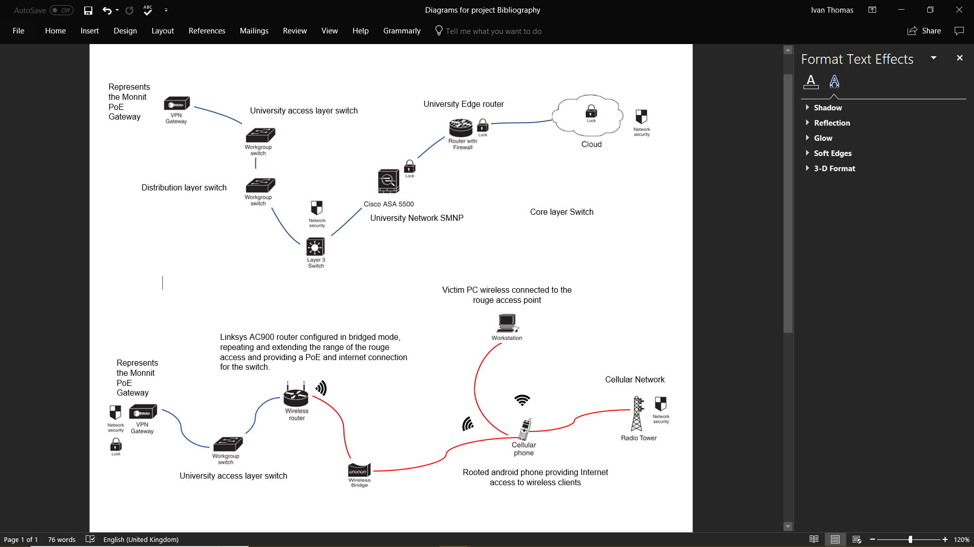
[50]
Switch B
Switch A

Figure 3: Taking the internet connection out of the university network:
Figure 4: Denial of service attack against the Administrators PC:
Switch A
A rooted android phone broadcasting, a SSID for the PC to connect.

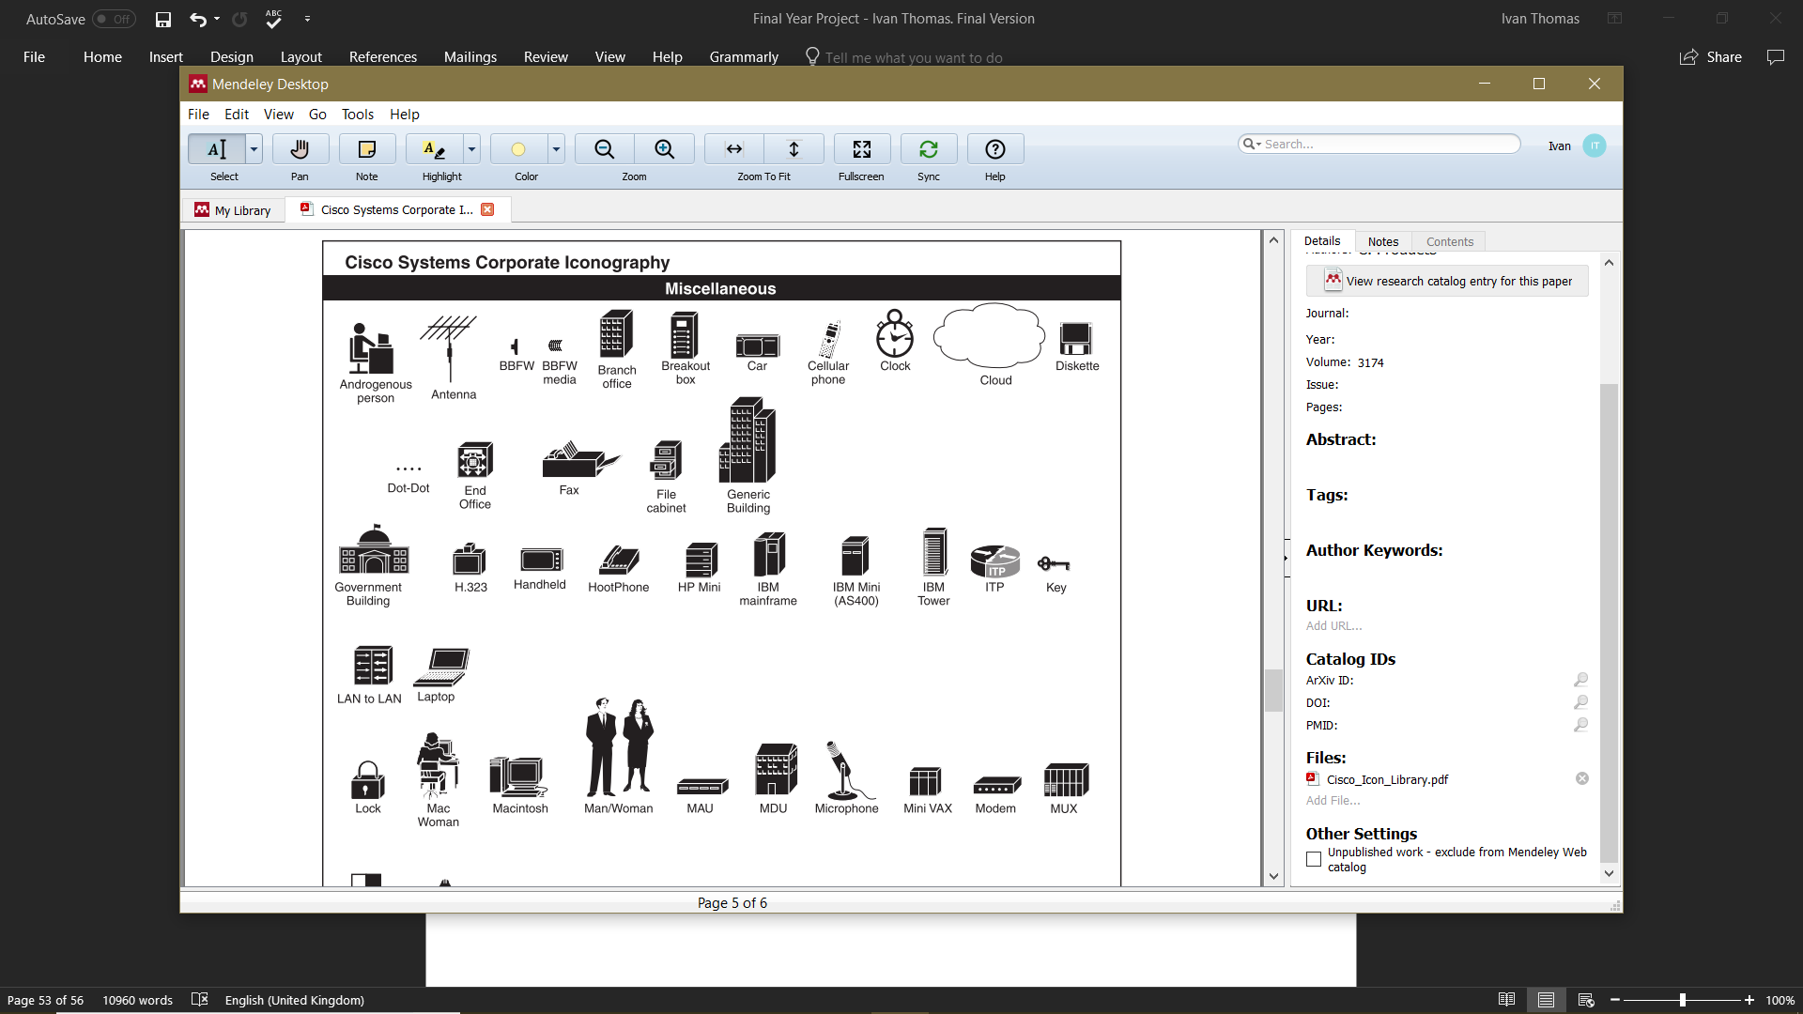

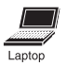

Administrators PC, Connected to the Phone for internet connection.

Rooted Phone gathers the IP’s of devices on the same Local area network.



Browsing has ceased, Internet says connected and normal trouble shooting will not show any issues with the connection.
Attacker utilizes the applications grab feature and grabs the IP of the PC and kills the connection.

Figure 5: An example of the keylogger being added installed on the machine.

Collecting user input with the keylogger installed
Without the keylogger installed





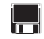
USB delivery allows the software to copy the logs onto the USB for Grab and go.


Remote FTP server collecting key logger information


Figure 6:

PROJECT MANAGEMENT

Figure 6 located in the appendices represents the original Gantt chart for the project. This Gantt chart acted as a timescale for the author to abide too and keep ahead of the curve. The Gantt chart timeline was followed flawlessly up until the week of Monday the 25th of January 2018; it was within the reconnaissance stage that a significant issue arose. The original idea of the creator of the WSN and the author of this project were that the victim's network was running the open standard communication protocol Zigbee. At this point attacks, and research was slowly in favour of exploiting the Zigbee protocol. The system is running a 128-bit encryption protocol providing, authentication and integrity, this hurdle required alterations to the attack, and for several weeks the author researched another route to attack the network. During an Advanced cybersecurity lecture the author was taught about facilitating cyber threats from a mobile device. A process of giving the user access to developer tools in the operating system was explained and the author decided this was a valid option of attack. The process called rooting allows the user to download applications to the software that you will not find on the play store. Within this lecture, several applications for cyber attacks on rooted devices were shown and discussed. The author took notes within this lecture and researched the applications in the lecture. The attacks were web hacking tools for a man in the middle attacks. These were considered but ultimately dropped. The portal on the website is a secured with a security certificate that would encrypt and interrupt any hijacking attempt. While researching, an application that provided a local area DOS attack, the software tricks other devices on the node to route their traffic to the attacker. Once traffic is routed through the attacker, the connection can be eradicated denying any internet access to the victim. Creating and advertising a rogue access point for wireless devices and killing their connection was to be the active attack within the project. The passive attack hopes to highlight the lack of node security within networks as the authors opinion that internal threats receive less security measures than perimeter threats. To minimize risk, all attacks are wireless and are created inside a local area network separate from the university resources. The keylogger is installed on a university resources therefore due diligence and research has been carried out on the software to protect the universities network infrastructure. Great guidance and care has been taken to mitigate any risk to personal data, university resources and user identity. The rouge LAN idea is based around the School of Applied Computing network which is a sperate network located on the campus and is not connected for security purposes. This project utilizes this idea scaled down to removing security layers, gain passwords and deny service.

GLOSSARY

LAN - local area network.
DOS - Denial of service attack.
DDOS - Distributed denial of service attack.
WLAN - Wireless local area network.
IoT - Internet of things.
IIoT - Industrial internet of things.
PoE - Power over Ethernet.
WSN - Wireless Sensor Network.
Malware - Malicious software
SSID - Service set identification
FTP - File transfer protocol
USB - Universal serial bus
PC - Personal computer
SNMP - Simple network management protocol
Android - Mobile Phone operating system
WAN – Wide area network

