
Applied Industrial Placement (SPORT)
M5X02295
Placement Portfolio Template

Student Name
Name – Jonathan Bayliss
P Number – P150486
Report
Title – Placement Portfolio
Word Count – 3744
References (Total) – 4
Job Title – Teaching Assistant
Organisation
Name – Ysgol Gymraeg Ystalyfera
Address – Ystalyfera, Swansea, SA9 2DY
Email – LlewellynA68@hwbmail.net
Telephone Number –
Line Manager
Name – Matthew Evans
Position – Headmaster
Email – EvansM863@hwbmail.net
Telephone Number –

TASK A – (Reflective Learning Log 1 - 500 words – First Experience of Placement)
Recommend to link the reflective experience to two different key themes.
During my placement at Ysgol Gymraeg Ystalyfera, I worked in different class rooms every day to support the class in any way needed. I had to manage between a few students to help them with any, and all, support that they needed. Whether that would be spelling, writing, reading or communicating questions and answers with the teacher. My management skills were managed greatly as I would completing various tasks throughout the day to help the students. The definition of management is the control and organization of something, esp. a business and its employees or students.
Problem solving is a great management skill to have. It involves identifying a certain problem and figuring out the best way to approach it and solve the issue, as quickly as possible. This could be a student having a problem with a maths equation, and myself stepping in to guide them to solving the equation. Another management skill which was vital for myself on placement was motivating. Motivating was a huge factor during my placement, I learnt very quickly. When giving support in the class room, it is very important to be positive and motivating at all times. If the pupils see that you’re not very interested or positive, this can have an effect on them as they will not be as open to support if you are not showing a positive mentality towards them. You must always be motivating to help all that need assistance.
During my placement, not only did I help in class rooms, I also supported the sport coaches. I would often be placed in sports classes to help coach and to also develop my own coaching skills. It was great to have an insight on coaching in this environment, as I spotted many similarities to my coaching module. I was given the chance to lead some sessions myself, and took the opportunity to exercise the coaching points that I’ve learned from the Advance Coaching and Mentoring module, I believed I did very well, and the impressed response from the teachers proved this. I did find it slightly harder to coach in the school, as some of the children didn’t want to take part and wouldn’t cooperate with me, making them difficult to coach. Whereas the groups who come to visit us at the university all wanted to be there and take part, making them easier to coach as they were open to learning. The age range I coached was varied, from a year seven class, to GCSE students. I wouldn’t always lead the group itself, and I found I learned just as much observing the coaching, as I did actually coaching. The largest difference that I noticed with the difference in age groups, was the intensity of the sessions. With the lowers years such as year 7 and 8, the sessions were a lot more light hearted and fun as the enjoyment of them was more important as not everyone was interested in sport. Whereas the GCSE students have all chosen sport as one of their subjects, meaning the coach would go into a lot more detail in the sessions and tackle specific skills as well as general fitness.

TASK A – (Reflective Learning Log 2 - 500 words – Mid Point Experience)
Recommend to link the reflective experience to two different key themes.
A few weeks into being involved at Ystalyfera school, I started to have a few more responsibilities, such as covering lessons and taking a sport class myself without assistance from the teachers - it felt great. It was fantastic to have been given this responsibility, and to have the chance to show leadership during my time on placement. The extra responsibility allowed me to take this placement to the next level. When I was covering a class, my main focus was to ensure that all pupils understood their work for that lessons and that they were completing their tasks within the timeframe. I didn’t have to plan the lessons myself, as they were planned by the teacher who usually takes the class – but I was put in charge for that lesson to ensure that the plan was being followed as hoped. The sports class was different – as I was given the reigns to construct and take the class all by myself. In the beginning I was quite nervous to be in charge of my own class, so I ensured that before every session that I would plan it out thoroughly and stick to it throughout. I loved seeing the students develop their skills through my sessions that I had planned by myself, and to see their enjoyment whilst doing so. My confidence grew with each session and I thrived on being the leader, as it was a chance to showcase everything I’ve learned during my time at university. The support and validation from the teachers that I was succeeding definitely helped my confidence too.

I had different roles during my placement, and one of these was being in charge of the isolation room. This room was used as a space for the students who were asked to leave class to sit and think about their inappropriate behaviour during lessons, they would remain there under my supervision until the headmaster decided when they were allowed to return to class. There would only ever be a maximum of two students at once – which was enough to work on my organisation skills. I would be in charge of giving them their work and supervise them for as long as they were present – so although they are sent out of the classroom they aren’t missing out on their education I was also able to mark other work and construct my future coaching sessions whilst being in charge, which made my time there very constructive. I liked that the headmaster trusted me to give me the role, as I was in charge of students who were likely to be ill-disciplined, he saw me as responsible enough to watch over them. Experiencing many different behaviours within the isolation room will definitely help me with the many personalities that I will meet during my coaching career.

TASK A – (Reflective Learning Log 3 - 500 words – Mid Point Experience)
Recommend to link the reflective experience to two different key themes.
During my time on placement, I was very involved with planning events and trips for the students. What is event planning? “Event planning is the process of managing a project such as a meeting, convention, tradeshow, ceremony, team building activity, party, or convention.”(Cambridge, 2019) I would be involved in the meetings which occur between teachers that decide where and when the trips would be taking place. One of the trips that I had a substantial say on was for year 7, for their Welsh class. Some suggestions for the location of this trip were the Brecon Beacons, Snowdon or Cadair Idris. However, the main issue was that all these locations were too far away from the school, and the children would miss an entire day of lessons which the teachers didn’t want. To overcome the main problem of location, I suggested The Sleeping Giant, a landmark located only 10 minutes from the school in Abercrave. I voiced that this location was close enough for the children to complete the trip, take a questionnaire on said trip and then attend a full afternoon of lessons. The Welsh department discussed my suggestion and decided to go ahead with the trip to the Sleeping Giant, agreeing to all my reasonings. Upon completion of the trip, the teachers thanked me and were pleased with me being involved in the planning and choosing the location. This led to me being asked to be involved in the planning of the year 9 trip, and I was very pleased with that.

As well as coaching, a big part of my time with the physical education classes was mentoring. I was mentoring the GCSE students to coach frequently. When I was with the year 10 and 11 classes, it wouldn’t just be me coaching them, I also was teaching them how to coach – I was mentoring. As I’ve done quite a bit of mentoring through university, I saw this as a great opportunity to develop those skills through a real life situation. It was definitely an experience doing so, as it was a completely different environment with different groups that I was used to during my time at university mentoring. The main challenge was adapting my mentoring to different students, as everyone reacts differently to a specific type of teaching. My mentoring style was tested, as the schools were different to the university groups – but I saw it as a great opportunity to compose my sessions and deliver skills in a different and challenging way. I enjoyed the year groups that I mentored too. The GCSE level students are willing to participate a lot more, and have chosen to be there and learn as opposed to it being compulsory. It gave me the chance to give quite complex and challenging sessions to these students (to a certain degree) as they were willing to develop their coaching skills themselves and grow as coaches. It was an enjoyable learning curve to mentor the students and help them with their end goal which was passing their Physical Education GCSE. It was great to witness.

TASK A – (Reflective Learning Log 4 - 500 words – Near end of Experience)
Recommend to link the reflective experience to two different key themes.
As it was coming to the end of my placement, I began to reflect on what my roles were during my time at the school. I realised my main role was operations manager during my time on placement. This definition of operations management confirms my role: “Operations management involves planning, organizing, and supervising processes, and make necessary improvements for higher profitability.” I was heavily involved with planning sport sessions, activities in class, trips and even work for the children who would accompany me in the isolation room. When I first went in to placement, I never expected to be this heavily involved. I didn’t think that I would have been involved in planning sessions or helping with trips, I thought I’d only be helping with the coaching side of things. However, it was great to have this responsibility and chance to plan sessions, organise sessions and try and make necessary improvements that were needed. I personally think I chose the perfect place to go on placement for myself. I learned new skills, new coaching techniques, how to coach GCSE classes, and how to organise trips. I also learned a lot more of what goes in to being a fantastic teacher, which opened my eyes to future possibilities. I was open minded going in to my placement as I didn’t know exactly what I would be doing, and I think this did help me a lot in the long run as I adapted to new roles and situation very quickly. I expected to be helping out in classes and also help with coaching, but I ended up being heavily involved with coaching as I would take charge of years 8 and 9. It came as a surprise when I was given this role, but also excitement as I would use my rugby knowledge to help me during my time coaching these teams. It was a great experience and a fantastic opportunity to adapt my knowledge from my coaching module at university to coach these year groups on a day to day basis. I had numerous choices of where to complete my placement, but I personally think I made the right decision. As I had been there before during my time in school, I knew the exact layout of the school, I knew most of the teachers, it made it a lot easier to settle in and get on with my learning. When I was in the isolation room, it was a good experience to see how things are while working in a school, not just to experience the sport side of things. I appreciated the opportunity to be in charge of the isolation room, and have the chance to be in charge of handing out work and marking it ensuring it was done correctly. By doing this I was gaining new skills and learning both sides of what working in a school is like. I thoroughly enjoyed my time on placement, and it’s great to list on my CV that I had done placement in a school working with children – I believe this will help me in the future. I am grateful and thankful to the school for welcoming me with open arms and giving me the opportunity to work there and share my coaching skills with all the students.

TASK A – (Add 250 words on link to future Continued Professional Development and Reference list based on total referenced material in Task A)
Continued Professional Development post placement (250 words - Link to pre placement module)
After completing my placement at Ysgol Gyfun Ystalyfera, I have a few options of the next step in my professional development in mind. My first option is to go to do a Postgraduate Certificate in Education (PGCE). “A PGCE is a one or two year academic qualification you can achieve during your teacher training.” If you would like to go in to teaching after completing your degree, in most cases, you would most likely have to complete a PGCE course. After being in the teaching environment during my placement, I am considering going down that path as it does interest me a lot and it’s something I can see myself enjoying. An alternative option for me would be to go down the coaching side. I enjoy my coaching thoroughly and would be interested in completing the UEFA coaching badges. I have a passion for coaching, and it’s something I’d like to pursue in the future, so this option is definitely something I’m considering. I believe that the placement I chose to do was perfect for me, it had parts of teaching and parts of coaching which is what I wanted to do, and I got exactly what I wanted out of this experience and it has set me on the right path of what id like to do in the future.

References from TASK A (10+ references)
- . Dictionary.cambridge.org. (2019). EVENT PLANNING | meaning in the Cambridge English Dictionary. [online] Available at: https://dictionary.cambridge.org/dictionary/english/event-planning [Accessed 7 Aug. 2019].

- . Dictionary.cambridge.org. (2019). MANAGEMENT | meaning in the Cambridge English Dictionary. [online] Available at: https://dictionary.cambridge.org/dictionary/english/management [Accessed 7 Aug. 2019].

- . Cleverism. (2019). Operations Management: Definition, Principles, Activities, Trends. [online] Available at: https://www.cleverism.com/operations-management-definition-principles-activities-trends/ [Accessed 7 Aug. 2019].

- . Getintoteaching.education.gov.uk. (2019). PGCE | Get Into Teaching. [online] Available at: https://getintoteaching.education.gov.uk/explore-my-options/teacher-training-routes/pgce [Accessed 7 Aug. 2019].

- .

- .

- .

- .

- .

- .

- .

- .

TASK B – (YouTube Video – 10 x 1 min integrated video) (Experience, Roles, Improvements)
NOTE – Make sure the link works correctly
Website Link –

Link Password –

Video Duration –

Device used to create video –

Software used to create video –

Production contributors
Name | Position | Organisation

TASK B – (Picture Board – 5 pics (40MB upload limit to Turnitin) (Experience, Roles, Improvements)
Picture | Text (Paragraph)
 | This picture was taken when I was involved in a school trip. This is a photo of The Sleeping Giant located in Abercrave, just 10 minutes down the road from the school. This was a trip for year 7. I was pleased to be asked to go on this trip, and to look out and to be in charge of the students.
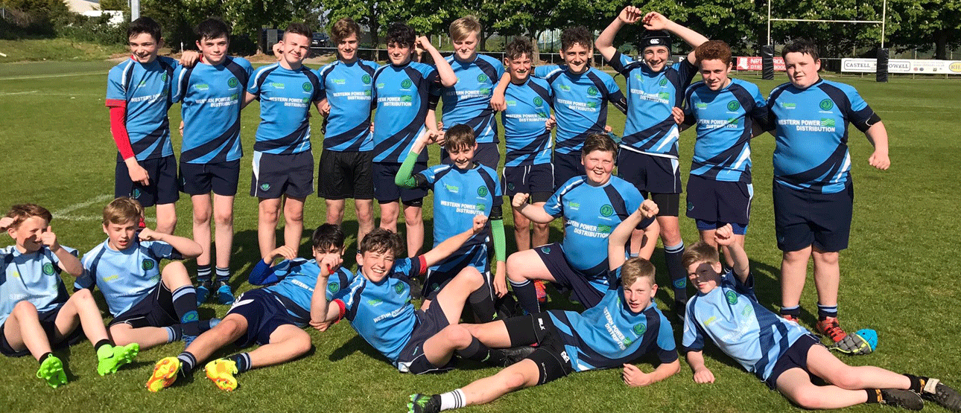 | This is a photo of the year 10 rugby team I helped coach. This photo was taken after the team secured a win over Llangatwg school. I worked with this team for 6 weeks during my placement, with training taking place during dinner time every Monday. It was great to see this team succeed after working hard for this game.
*No photos were allowed in the school* | The isolation room is a room within the school where I would be placed to ensure that students who have been sent out of class complete their work that was given under my supervision. I would be in charge of them during the time they were in this room.
*No photos were allowed in the school* | Watching over a class was a new experience for me, I had been assisting in classes but taking one myself was a new and exciting challenge. It was great to have the chance to show that I was capable of this.
*No photos were allowed in the school* | Helping out in the class as a teaching assistant was great, you would work close with the children on a 1:1 basis, which made the work easier as I would know what they need help with and have all their focus and attention. They definitely appreciated having my help when needed.

TASK B – (Picture Board Cont.–5 pics (40MB upload limit to Turnitin) (Experience, Roles, Improvements)
Picture | Text (Paragraph)
*No photos were allowed in the school* | It was great to be a part of the coaching team when classes had a physical education session. It was a new experience to deliver sessions in front of classes rather than groups in the university environment.
*No photos were allowed in the school* | Mentoring was a good challenge, it was great to see the participants using the coaching skills I had showed them.
*No photos were allowed in the school* | I thoroughly enjoyed my time on placement, for me, the best part was seeing the rugby team succeed which I was apart of the coaching team. This has helped my management and coaching skills for future use.
*No photos were allowed in the school* | As school was coming to an end for summer, the school hosts events everyday such as the ‘eisteddfod’ and sports day. I enjoyed being part of the team trying to organise this and plan it out, it was great to improve on my events planning skill which will be useful for the future.
*No photos were allowed in the school*

TASK C Evidence – Employer Report (Signed),
NOTE – This will be compared against the report sent to the University.
NOTE – You will need to complete additional copies if you have more than one provider.
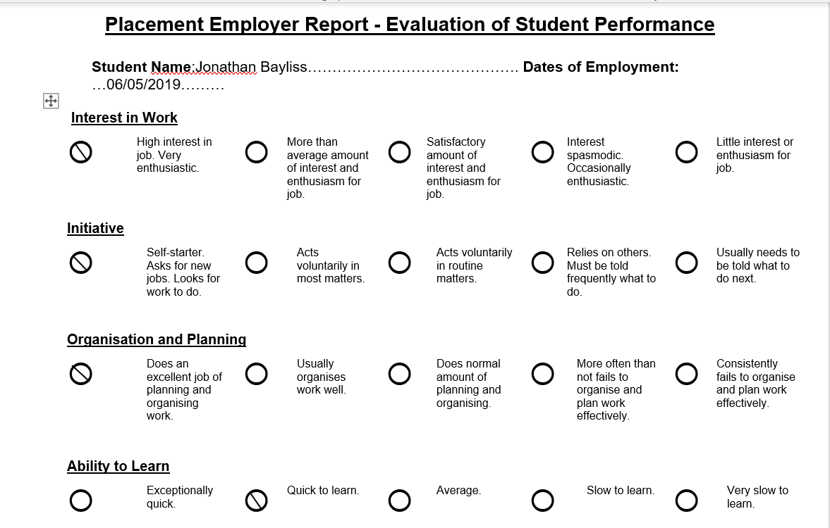

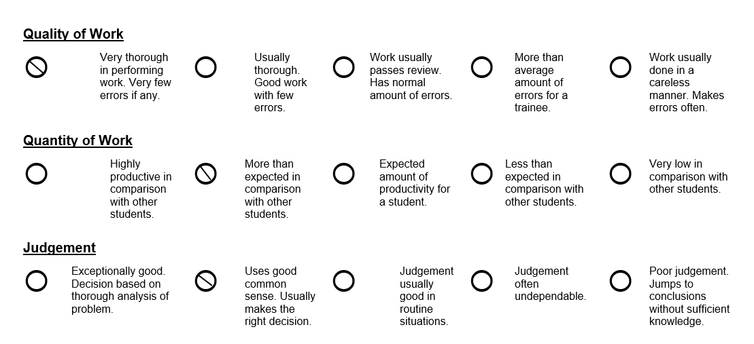

TASK C Continued Evidence – Employer Report (Signed),
NOTE – This will be compared against the report sent to the University.
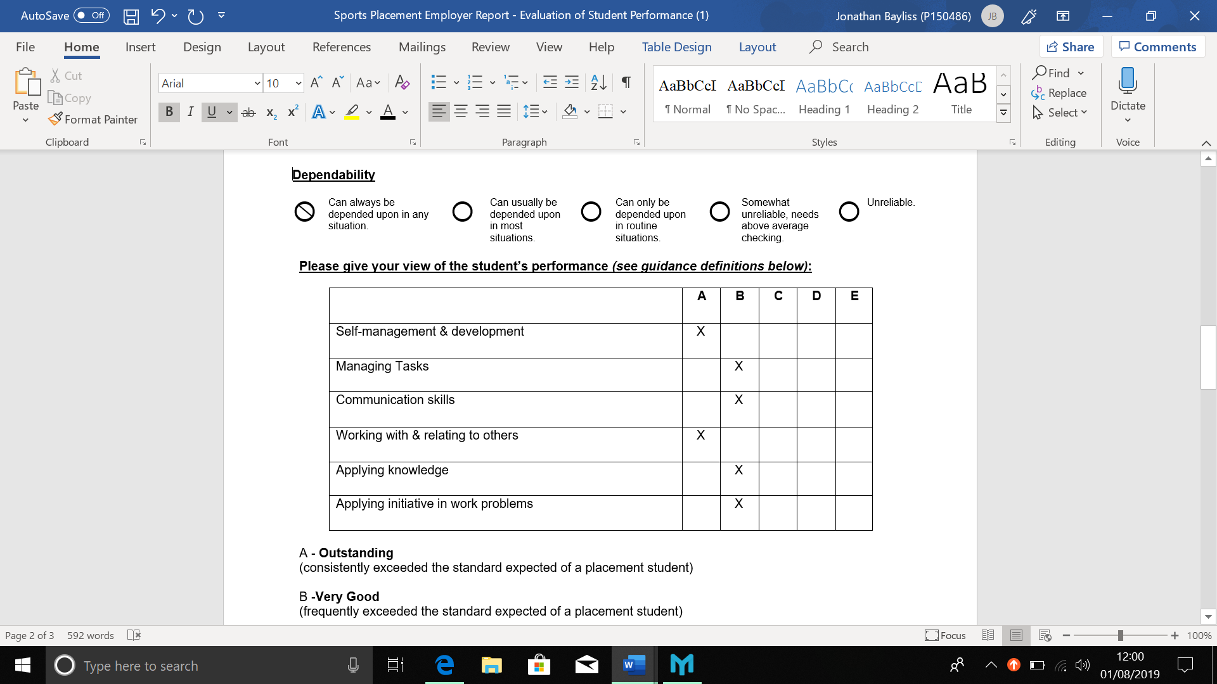

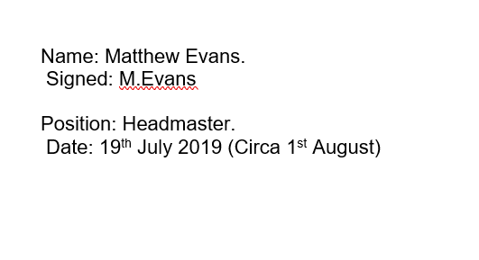
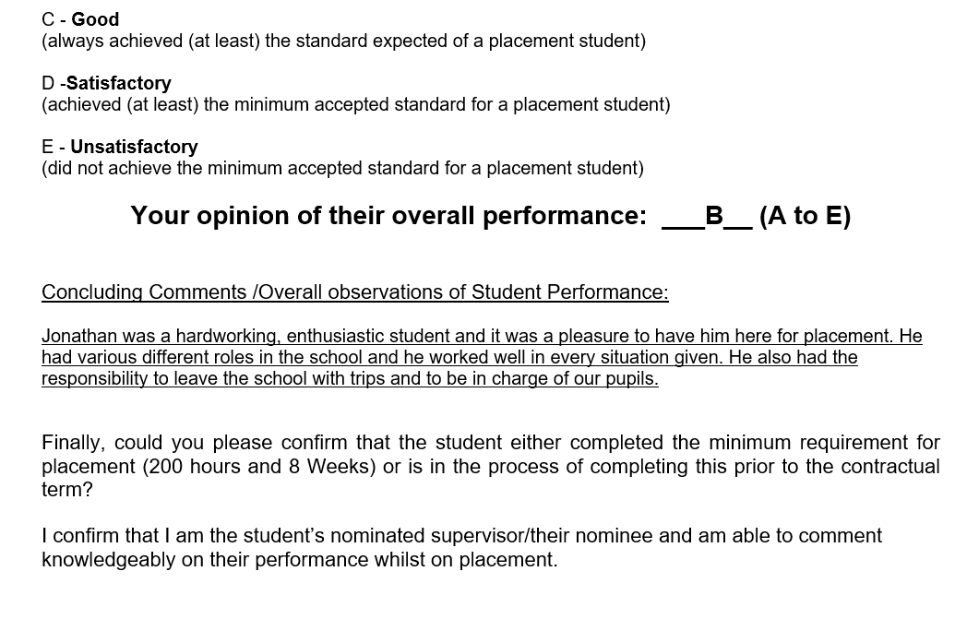

TASK C Evidence – Ethics Form – Signed by Organisation and Lecturer
NOTE – You will need to complete additional copies if you have more than one provider.
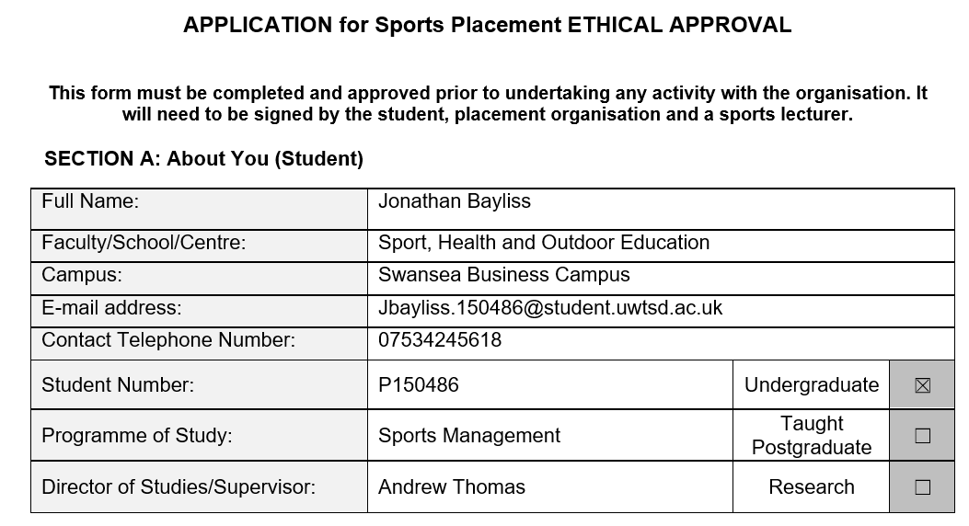

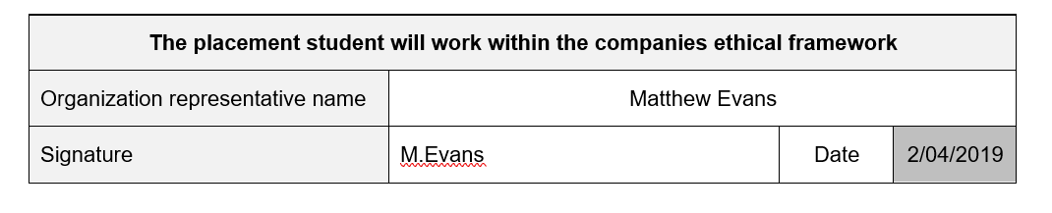
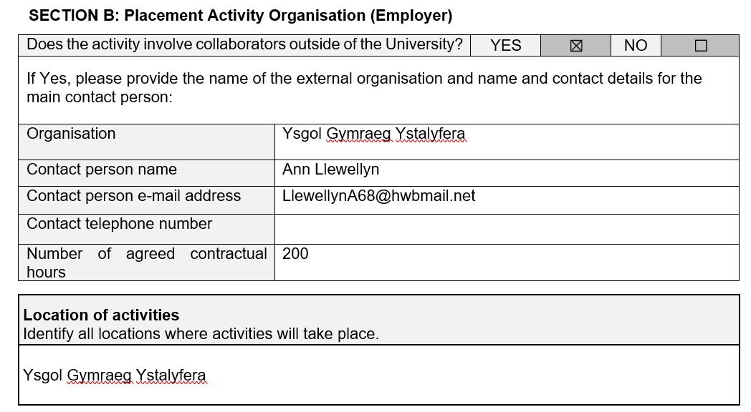

TASK C Evidence – Ethics Form Continued
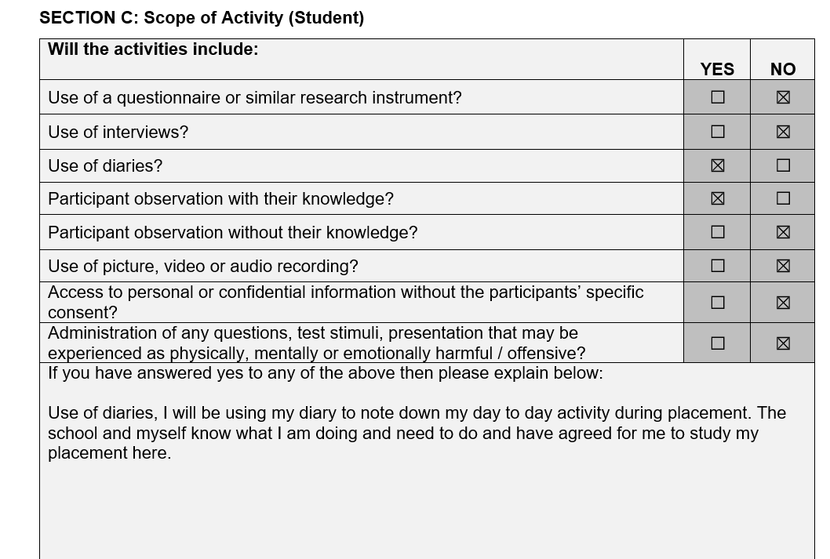

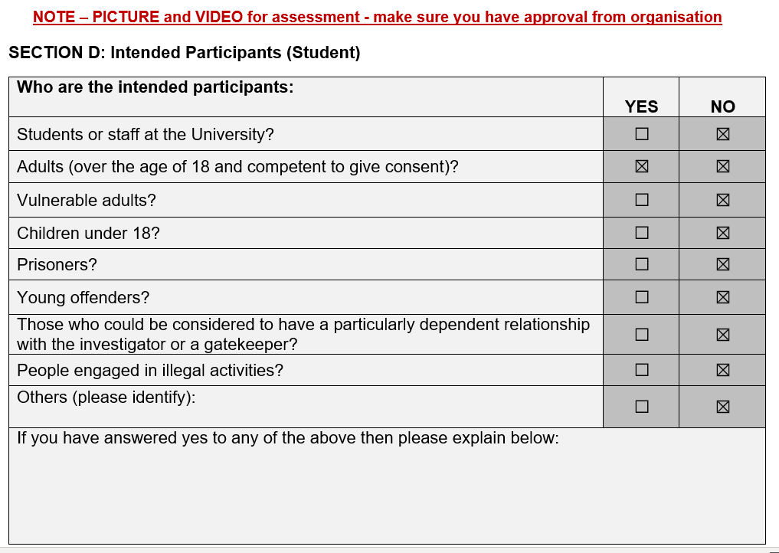

TASK C Evidence – Ethics Form Continued
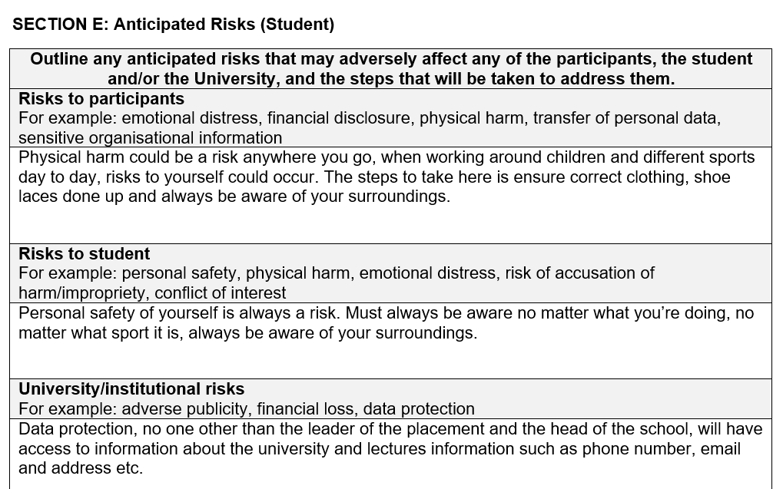

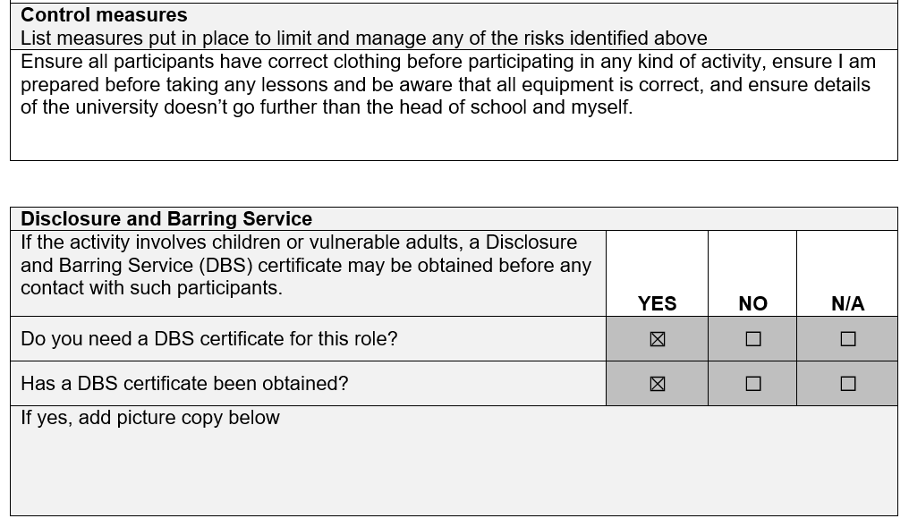

TASK C Evidence – Ethics Form Continued
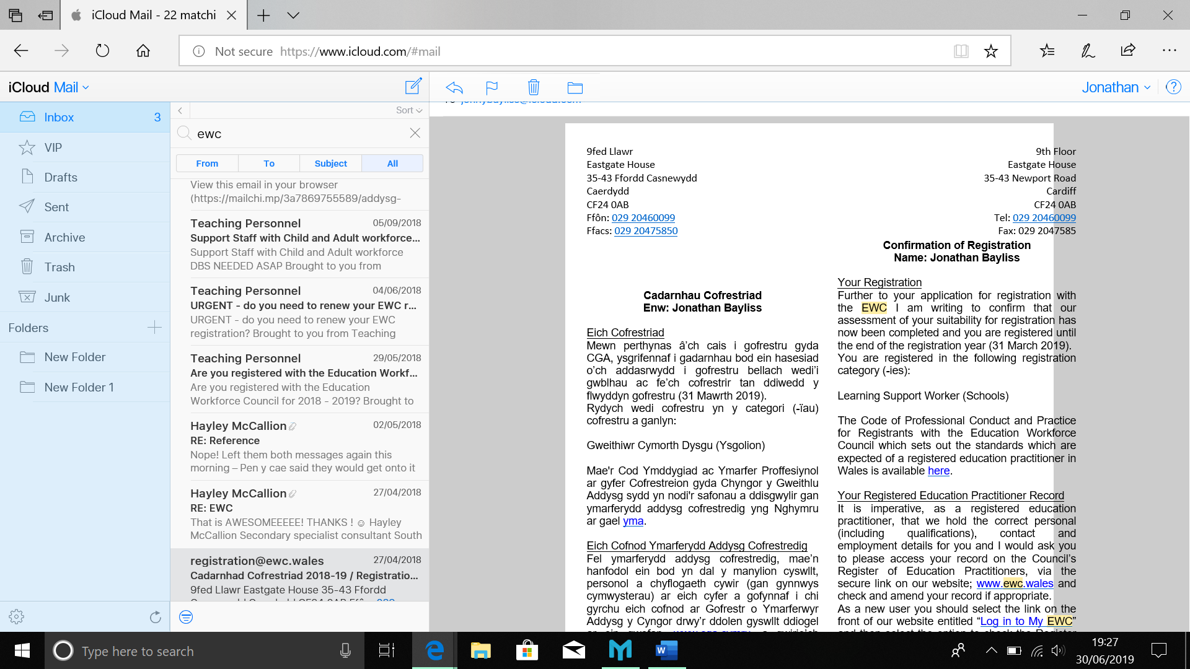

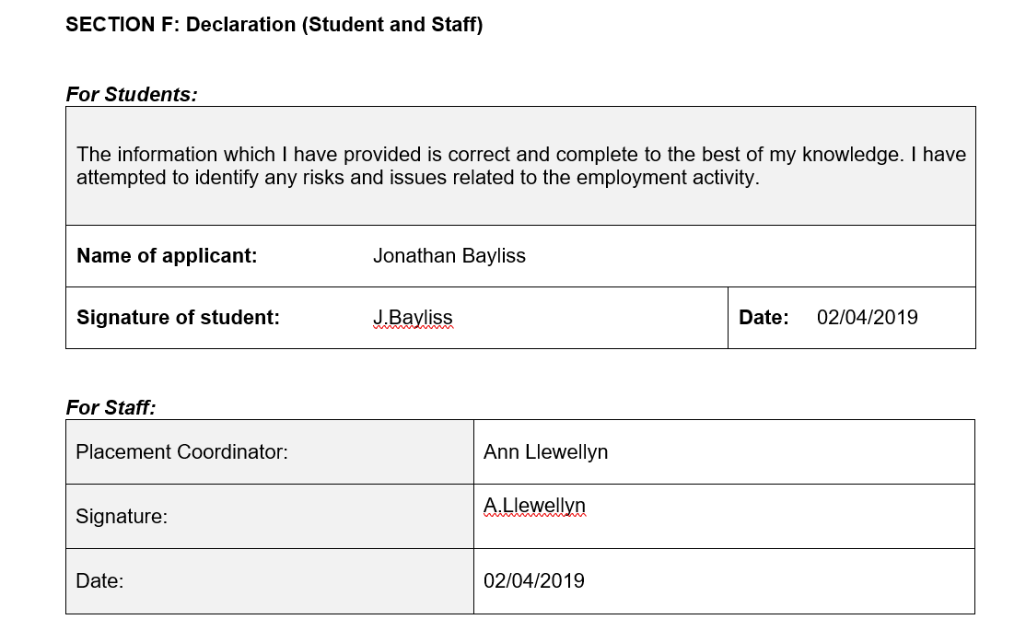
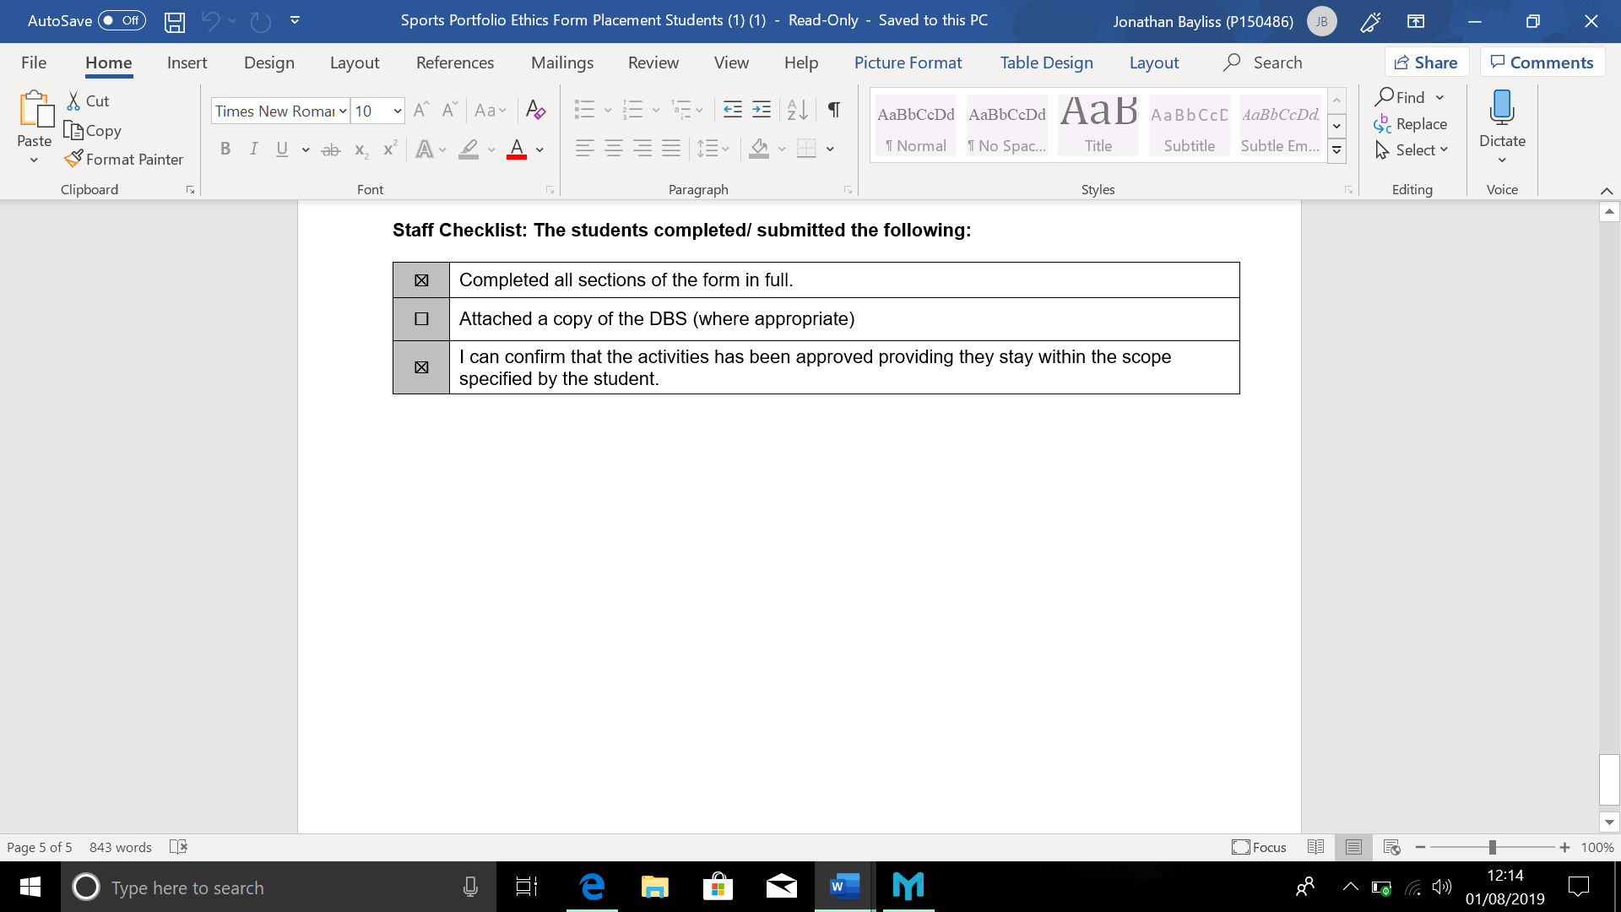

TASK C Evidence – Post Placement Review and Feedback
Dear Participant

Many thanks for your involvement in the work placement. I hope that you had a positive experience. The University of Wales Trinity Saint David reviews the provision annually for enhancement purposes and so we would be pleased to hear your feedback on any aspect of the placement.

Yours sincerely

Andrew Thomas, Placement Coordinator Sports Management Portfolio

Name of provider’s organisation: |  | Ysgol Gyfun Ystalyfera
Name of student: |  | Jonathan Bayliss
What were the positive aspects?
It was great to be in this environment to see how teachers work, and be given different roles and coaching in a different environment.

Were there any problems?
No, it was difficult to control some students but it was handled well. It was strange to be in a situation where I was in charge and had to tell students off, and give them work when in the isolation room so this took a while to get used too.

Do you have any recommendations for enhancement for the future?
Be prepared for any situation, I was only expecting to be coaching but I had a few different roles including working in a class room.

Signed: | J.Bayliss
Name in block capitals: | JONATHAN BAYLISS
Position (please tick one): | ☐ Placement Provider  ☒ Student  ☐ Placement Tutor |  | Date: | 26/07/2019

TASK C Evidence – Student Placement Induction Checklist
Student Name: | Jonathan Bayliss
Name of Placement Provider organisation: | Ysgol Gyfun Ystalyfera
Placement Site Address: | Glanyrafon Road, Swansea SA9 2JJ

Health & Safety Issues | No | Yes | Date
- Introduction to key staff members and their roles explained |  | X | 03/05/19
- Location of welfare facilities (e.g. toilets, kitchen, rest room, showers, etc.) |  | X | 03/05/19
- Emergency procedures |  | X | 03/05/19
- Copy of safety policy received or location known |  | X | 03/05/19
- Location of first aid facilities and contact for first aiders |  | X | 03/05/19
- Fire procedures and location of fire-fighting equipment |  | X | 03/05/19
- Accident/incident reporting and location of accident book |  | X | 03/05/19
- Use/control measures for hazardous substances in the workplace (e.g. COSHH) – if applicable |  | X | 03/05/19
- Display Screen Equipment Regulations and associated procedures – if applicable |  | X | 03/05/19
- Manual handling procedures – if applicable |  | X | 03/05/19
- Protective clothing/equipment arrangements – if applicable | X
- Instruction on equipment you will be using (list equipment) |  | X | 03/05/19
- Specific training for tasks to be undertaken |  | X | 03/05/19
- Specific information relating to risk assessments covering tasks to be undertaken |  | X | 03/05/19
- Location of health and safety information and advice |  | X | 03/05/19
- Specific disability related induction issues | X
- Other issues covered/to be covered please state:

As a minimum, the topics listed above should be included within the induction that you provide for the student on placement, preferably on their first day. Please check off the subjects as they are covered.

PLACEMENT PROVIDER CONFIRMATION

I confirm that the student has been provided with the induction specified above:
Signed: | A.Llewellyn
Print Name: | Ann Llewellyn
Position: | Secretary | Date: | 03/05/2019

STUDENT CONFIRMATION

I confirm that I have been provided with an appropriate induction as specified above:
Signed: | J.Bayliss
Print Name: | Jonathan Bayliss
Position: | Student | Date: | 03/05/2019

NOTE – If this is not completed please ask your supervisor on the placement to complete ASAP. However, please inform the placement coordinator at the earliest possible opportunity if this procedure does not take place.


UWTSD SPORT
Placement

