Addressing the problem of staff shortage in Proper Care, UK.
Nassiri Basti Elvis Liviu
University of Wales

Table of contents

Introduction 1
Understanding the nature and impact of staff shortage in Proper Care 2
Identify the causes of Staff Shortage in Propper Care using PESTLE and Fishbone 2
Possible/alternative solutions to address Staff Shortage in Propper Care, UK 6
Evaluation of the possible solutions using PMI 6
Plan for implementing the solution. 7
Monitoring the solution we choose 7
Review the Process 7
Conclusion 8
References: 8

Introduction

In this rapport, we will try to analyse which factors, external and internal lead to staff shortages in Proper Care, also we will discuss various factors that can help to reduce the staff shortages in care homes. Problem-solving is the act of defining a problem; identifying prioritizing, selecting alternatives for a solution and implementing a solution. While it is generally believed that human resources are the most influential factor in an organization's success, it is also legitimate to debate the need for employees to motivate themselves to reach their goals.
Various factors that can affect care homes like environment, human resources, and capital, are all based on the individual's motivation. While human resources are typically the most important factor that an organization's success is based on, it is also important to consider the need for employees to reach their goals to improve their performance.
This briefing aims to provide a comprehensive analysis of the workforce challenges that face Proper Care and the steps that the government and the private sectors can take to address these. It also highlights the importance of establishing a long-term strategy to support the workforce. We believe these challenges are now more threatening to the quality of care than the funding challenges that care homes face.
In this rapport, we will try to find a quick short-term solution, also a long-term solution to make workforce shortages in care homes a thing of the past.

Understanding the nature and impact of staff shortage in Proper Care
Severe shortages of key staff in NHS and care homes, and other healthcare professionals are seriously affecting the organisations, patients and employees. The ageing population and the increasing number of people with chronic diseases and staff from overseas leaving the country after Brexit are also contributing to the workforce shortage.
Staff shortages have been increasing over the past years. Some of the factors that have contributed to this include the lack of proper planning and recruitment and the increasing number of care homes staff leaving the care homes before they retire. The government's restrictive immigration policies, and low wages, are also contributing to the issue. Staff shortages are now threatening the working lives of care home workers. Many studies proved that overworking hours can lead to cardiovascular, cerebrovascular, hypertension, diabetes, anxiety, stress, etcetera and the results showed that employees who are working long hours were vulnerable.

Following a detailed understanding of the nature and impact of staff shortage for Propper Care and its employees, the next step in terms of solving problems is to identify the causes.

Identify the causes of Staff Shortage in Propper Care using PESTLE and Fishbone

To solve the problem of staff shortage for Popper Care it is important to understand the causes of the problem. This is consistent with the views of Oakes (2014) who argues that identifying the problem causes is a prerequisite to solving them. There is a range of analytic tools that could we use to identify the problem causes. However, in this report, the PESTLE and Fishbone frameworks have been employed.
A PESTEL analysis (Francis Aguilar 1960s), is a tool which allows us to assess the external environment which is affecting a business.

As we can see in this PESTLE analysis, they are four PESTEL factors that are primarily responsible for staff shortages.

Political Factors
Brexit
On the political side, Brexit is one of the most important issues the care homes are facing, due to a large number of care home professionals in the country care homes took a hit and people start thinking about living conditions becoming less favourable for them. Due to the government's inefficiency of inform people regarding the rights of living in the UK after Brexit and the confusion from the mass media workers rush to leave the country (Dalingwater, L., 2019).

Ineffective Laws
Different ways to try to bring qualified staff from overseas it becomes very difficult, the process to bring someone from EU is taking too long because the laws are not very clear, the application fees are quite high, especially for workers from eastern European countries, where is the highest demand from people who are looking for work in countries like the UK.
Insufficient Funds
The global economy went through a significant downturn following the financial crisis of 2008. The UK was not immune to this, and the country's healthcare system has been struggling due to the economic situation. For over a decade now, the has been struggling due to various factors, such as regulatory issues and economic reasons Stuckler et al. (2017).
Economic
Unattractive salaries
Lack of funding from the government made the jobs in care homes to be unattractive because of the low salaries, workers from care homes were unable to pay rent or more often rely on food banks because the money they earned after a week of work is not enough.
Social factors
Ageing Population
Number of people over the age of 65 is a common phenomenon worldwide. As the healthcare system improves, the average lifespan of people is increasing. However, this also means that older individuals are more prone to experiencing health problems. Some of these include diabetes and cancer. Due to the increasing number of people with these conditions, the UK's ageing population is putting strain on the national health service.
Patient High Expectations
Social media allows information to spread now, patient expectations are highest than ever, and patients have now better knowledge of the treatment options available to them, which creates a new challenge for care homes staff to provide a higher quality of services than before Um et al. (2018)
Legal
Litigations
The rise of litigation is a global phenomenon that affects various aspects of life. It is also a growing concern for the care homes as patients and their families are taking to courts to seek redress for the quality of services received in care homes.
Due to the increasing number of lawsuits, the NHS and care homes have had to spend a lot of money on legal fees. This is a new expense that the healthcare body has to deal with Oliver et na. (2008).
In addition to the PESTEL analyses, we also made a Fishbone diagram. The Fishbone diagram (Kaoru Ishikawa 1960s) is a problem-solving tool which identifies many possible causes for an effect or problem. PESTEL analyses only focus on the external problems of the staff shortage we have done a Fishbone diagram to identify and cover more causes.
Looking at the Fishbone diagram we can see that poor working conditions, lack of financial support and sickness related to long working hours are major effects of the staff shortage, also Brexit, bad working environment and many other factors that have led to staff shortage in care homes.
Working conditions, because of the high volume of work and staff shortage care homes often require agencies staff who needs time to get used to the place and new work requirements. Because most of the time are in care homes only for short periods it is likely to don’t be as efficient as care home standards required Brown et na. (2010.)
Financial, with low wages, unattractive bonuses or poor pension scheme is less likely someone will like to follow a career in care homes Robertson et na. (2017).
Sickness, long working hours, and high pressure from work are related to mental health sickness, stress, cardiovascular problems, unhealthy lifestyle and many others, Virtanen et na. (2018).
Brexit, because of lack of information from the government many people left the country because they become unsure about their future of living and working in the UK also bringing staff into the UK after Brexit becomes more difficult because of long waiting times for the applications to be completed and assessed.
Environment, unexpected high volume of work created by lack of staff and stressful working conditions is making the workplace to be unsafe for the patients and staff.
Other factors which lead to staff shortage are lack of financial support and career attitude.
The next step is to identify possible solutions that target the main causes identified from PESTEL and Fishbone analysis.

Possible/alternative solutions to address Staff Shortage in Propper Care, UK
After the PESTLE and Fishbone anslyses, we came up with three possible solutions.

- Efficient laws to bring staff into the UK
- Attractive salaries
- Funding from the government
Efficient laws to bring staff into the UK
Bringing qualified staff into the UK from other countries is the fastest solution and it can save a lot of time because the qualified staff does not need training says Buchan et al. (2019). Many people from eastern European countries dream to come and start a new life in the UK. Long times needed to complete the applications and high fees and waiting cues for the applications to be assessed discourage them and they prefer to choose other countries from EU
Attractive salaries
Care homes are one of the sectors where the salaries are very low and employees are struggling to do their day by day leaving them facing problems in paying rent or relying on food banks. Better pay rates and bonuses will make people think about starting a career in care homes.
Funding from the government
Government funding is difficult to obtain but is not repayable so it can carefully be invested in creating a modern care house with all the facilities for the patients and staff, the latest technology can be used in Proper Care to make it a more attractive place to work, also government funding increase trust that proper care is a safe and secure place to work.
As is been identified the possible solutions, it is important to identify the most appropriate solution and this is done by evaluation.

Evaluation of the possible solutions using PMI
We are going to use a PMI evaluation to identify the most appropriate solution for Proper Care. A PMI is a tool which helps us to see all the viewpoints before concluding which is the solution we are going to implement. In this PMI we used numbers on a scale of +5 to -5 monitoring all the viewpoints, negative and positives and based on the best scoring we will choose the best solution to implement in Proper Care.

Efficient laws to bring staff into the U.K.
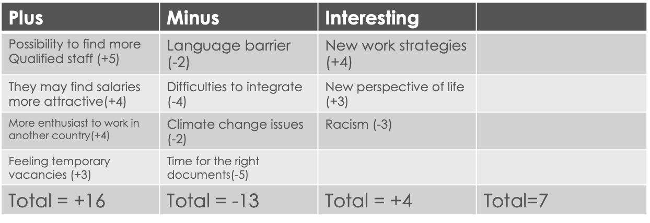

Attractive salaries
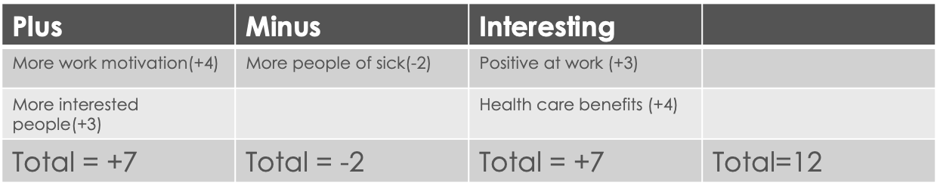

More support from the government
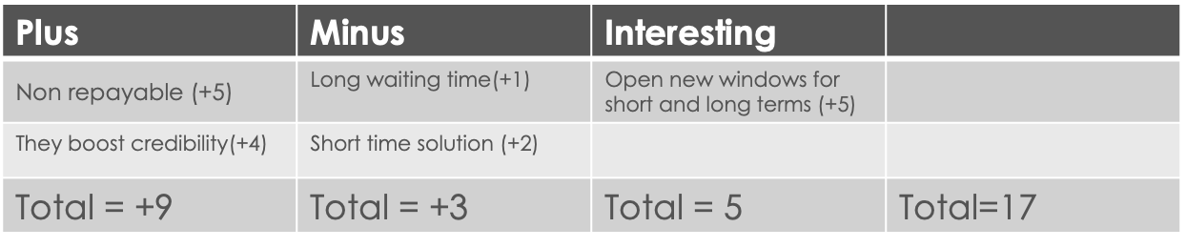

After the PMI we can observe that the most appropriate solution is to try acceding government funding.

Plan for implementing the solution.
Accessing government funding is not a long-term solution but in a short time, it helps because government money is not returnable.

Monitoring solution we choose
Investing money in Proper Care to make it on high standards with new technology will ensure a good start for a care home and patients will feel welcome and happy because they choose Proper Care.

Review the Process
Creating a safe environment for the employees with attractive salaries and bonuses will ensure that Proper care will be able to offer high-quality services for its patients.

Conclusion
In this report about the staff shortage facing care homes in the UK after we have been able to identify the problem using PESTEL analyses and the Fishbone diagram, we have been able to come out with some solutions. From the possible solutions found we have been able to implement the best solution in Proper Care to make it a success after carefully analysing the PMI.

References:
Buchan, J., Charlesworth, A., Gershlick, B. and Seccombe, I., 2019. A critical moment: NHS staffing trends, retention and attrition. London: The Health Foundation, http://www.health.org.uk/sites/default/files/upload/publications/2019/A%20Critical%20Moment_1.pdf.

Dalingwater, L., 2019. NHS staffing shortages and the Brexit effect. Observatoire de la
société britannique, https://journals.openedition.org/osb/3216.

Geiger-Brown, J. and Lipscomb, J., 2010. The health care work environment and adverse health and safety consequences for nurses. Annual review of nursing research, https://connect.springerpub.com/content/sgrarnr/28/1/191.

Oliver, D., Killick, S., Even, T. and Willmott, M., 2008. Do falls and falls-injuries in hospital indicate negligent care—and how big is the risk? A retrospective analysis of the NHS Litigation Authority Database of clinical negligence claims, resulting from falls in hospitals in England 1995 to 2006. BMJ Quality & Safety, https://qualitysafety.bmj.com/content/17/6/431.short

Robertson, R., Wenzel, L., Thompson, J. and Charles, A., 2017. Understanding NHS financial pressures. How are they affecting patient care. https://www.abhi.org.uk/media/1534/kf-understanding-nhs-financial-pressures-full-report.pdf

Stuckler, D., Reeves, A., Loopstra, R., Karanikolos, M. and McKee, M., 2017. Austerity and health: the impact in the UK and Europe. European journal of public health, https://academic.oup.com/eurpub/article/27/suppl_4/18/4430523.\

Um, K.H. and Lau, A.K., 2018. Healthcare service failure: how dissatisfied patients respond to poor service quality. International Journal of Operations & Production Management, https://www.emerald.com/insight/content/doi/10.1108/IJOPM-11-2016-0669/full/html

Virtanen, M. and Kivimäki, M., 2018. Long working hours and risk of cardiovascular disease. Current cardiology reports, https://link.springer.com/article/10.1007/s11886-018-1049-9.

