Assessment 2 – Technological Change and Innovation
This report is based around the automobile industry, sustainable business practices and the circular economy [This report will be formatted in print layout Microsoft Word .docx style] Lucy in the Sky with Diamonds

Introduction

In this report I will be proposing my innovation plan for a sustainable business project in the United Kingdom. In this module we have been tasked with drafting a report on a form of innovation idea that hasn’t yet been implemented but that we think is potentially viable. My idea for a sustainable business project is applying the circular economy model currently being trialled on home appliances and clothes to the automobile industry and transport sector, as well as how our current national fleet of personal cars, motorcycles and transport vehicles can be modernised, made more efficient and more sustainable in the long term.

What is sustainable business?

To understand my business proposal, you must first understand what sustainability means, McGill University defines sustainability as “Meeting our own needs without compromising the ability of future generations to meet their own needs” [1] In essence, sustainability is the practice of meeting the needs of the present without compromising the ability of future generations to meet their own.

Sustainability encompasses social, economic, and environmental dimensions. In terms of the economy, sustainability has several impacts. For example, sustainable business practices can lead to cost savings for companies through increased efficiency and reduced waste. Additionally, investing in sustainable practices and technologies can create jobs and stimulate economic growth. Furthermore, a sustainable economy can lead to more stable and resilient communities by reducing dependence on non-renewable resources and reducing the negative impacts of economic activity on the environment. However, the implementation of sustainable practices can also lead to increased costs for companies and individuals in the short term, which can be a barrier to adoption. [2]

A sustainable business can include incorporating environmentally friendly practices, treating employees and stakeholders ethically, and contributing to economic development in a way that benefits the local community.

Sustainability in the global community – Art by Greenpeace

What is the Circular Economy?

The crux of my proposal lies with the implementation of circular economic principles, but what is a circular economy? Oxford Dictionary defines the circular economy as “An economic system based on the reuse and regeneration of materials or products, especially as a means of continuing production in a sustainable or environmentally friendly way.” [3]

The circular economy concept can be applied to the auto industry in several ways. One way is by designing cars to be more easily recyclable, to use materials that can be easily reused or repurposed. Another way is by extending the life of cars through scheduled repairs and upgrades, instead of constantly producing new vehicles. Additionally, sharing and leasing models, as well as circular business models, such as product-as-a-service, can reduce the need for individual car ownership and thus decrease waste and resource use. Lastly, electric vehicles, which do not emit harmful pollutants, can reduce the environmental impact of transportation. [4]
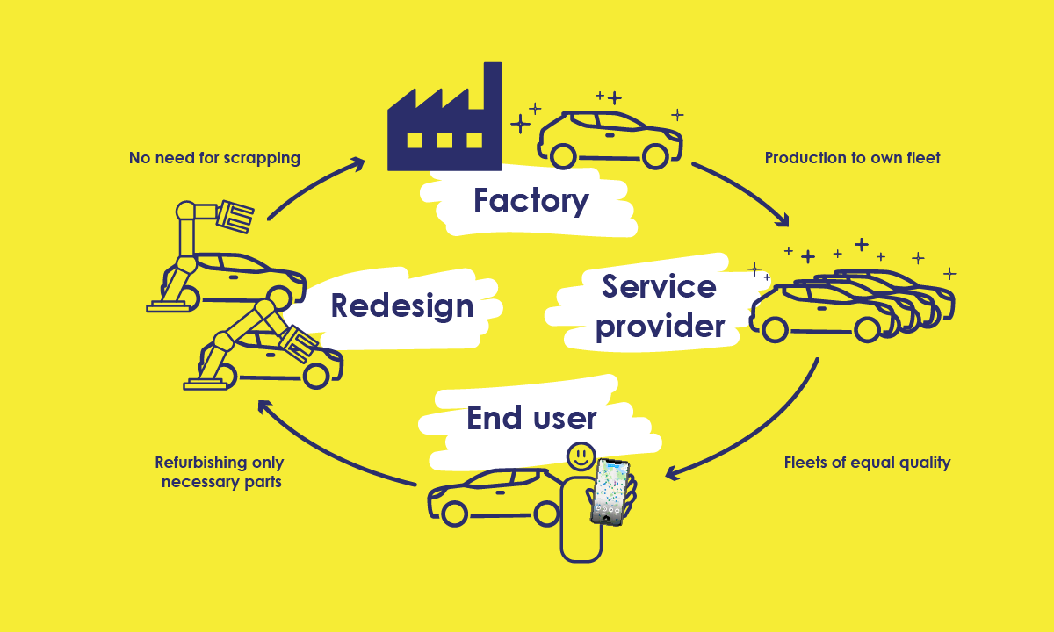
Circular Car Economy – Sampo’s Blog

We can create a system where our cars are supported by the manufacturer long past what we currently see as their expected service life, Cars can expand beyond the need for yearly model revisions requiring you to purchase a whole new car to benefit from technological advancements, using a refrigerator as an example, we can theoretically keep the appliance running smoothly for our whole lives, if we just kept a strict eye on preventative maintenance and fixing components as they break, instead of scrapping and starting over whenever a small malfunction occurs. We already do maintenance on our cars, but we don’t do enough, we can extend cars lives for generations to save on resources and we know that we already can, there are Ford model T’s still running from the early 20th century.

The United Kingdom’s car market

Car ownership in the UK is relatively common, with many people using cars as their primary mode of transportation. The process of buying and owning a car in the UK is like that in other developed countries. Cars can be purchased new or used from dealerships or private sellers and must be registered with the government and insured. There are also various costs associated with car ownership, such as fuel, maintenance, and road taxes. Additionally, there are strict laws and regulations in place to ensure the safety and environmental impact of vehicles on the road.
It is estimated that there are around 38 million cars on the road in the UK with 32.8 million of them being personal passenger vehicles. [5]

Joseph Schumpeter's theory of creative destruction posits that economic growth and innovation are driven by the continuous replacement of existing products, processes, and organizational forms by new and more efficient ones. In the context of the car industry, this could manifest in the development and widespread adoption of new technologies such as electric or autonomous vehicles, which would disrupt and replace traditional gasoline-powered cars. This process of disruption and replacement can lead to significant changes in the structure of the industry, as well as the creation of new markets and opportunities for growth. [6]

Currently we have a problem in our country with car ownership. Cars are often misused and mistreated, millions of people neglect to properly service their car as most don’t see cars as long-term investments, there is also a problem with the current generation of cars being made too unreliable and fragile. There are several factors that can contribute to cars becoming less reliable. Some possible reasons include increased complexity, as cars have become more advanced, they have also become more complex, with more systems and components that can potentially malfunction. Cheaper manufacturing is also an issue as some manufacturers may use lower-quality materials or cut corners in the manufacturing process to reduce costs, which can lead to more frequent breakdowns and repairs. Shortened product lifecycles are the biggest contributor to the decline in motor reliability as many manufacturers are introducing new models and technologies at a faster rate than in the past, which can mean that cars may be less reliable over time as they age. Lastly is the increasing use of more electronics, with the increasing use of electronics in cars, there is a greater chance of something going wrong with the car's electrical systems. [7]
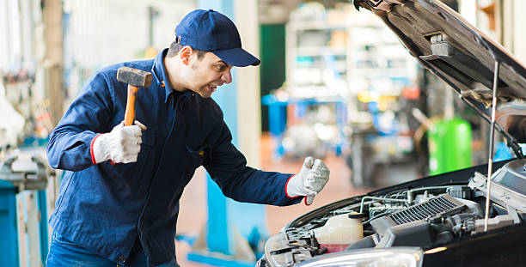
Mad Mechanic - iStock
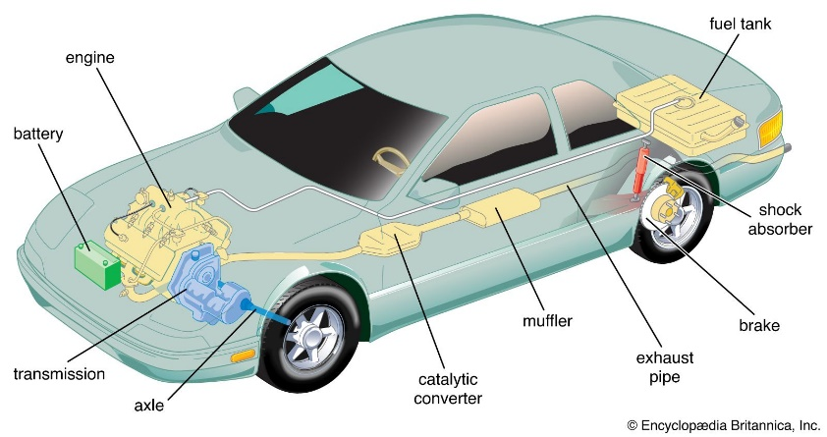
It's worth noting that not all cars are becoming less reliable. Some manufacturers are still producing cars with a good reputation for reliability, Toyota being an industry leader in reliability. Also, some of the above factors could be more relevant to certain carmakers or models than to others.
The average service life of a car in this country is 8.9 years with only 13 years before scrappaging and I find that to be unacceptable, my proposal would extend the service lives of our cars, saving resources and reducing emissions. Every part of a car is manufactured and can be repaired or replaced, There is no need to turn a car into a cube just because of singular component failure. [8]

Automobile - Britannica

Dealership and mechanic shop scammers also put barriers up for people willing to service their cars regularly or are new to car ownership and don’t know where to begin with car maintenance. The disposability of cars is also an issue, manufacturers bake in planned obsolescence into their cars more aggressively with more car parts being made from plastic instead of metal, or the aforementioned cheapened manufacturing processes. The United Kingdom has been a key part of the development of automatic motion, my business proposal gives us the opportunity to start a change

It’s safe to say cars are an integral part of British culture, it’s how we stay connected to friends and family, get to work and or school and carry our groceries home. The humble automobile has been the unsung hero in our nations development in not just our transport sector, but our health service, energy industry as well as our manufacturing and finance sectors. Cars are so much more than just small metal boxes with wheels that we use to zip around, they are the backbone of our economy and culture, our towns and cities were planned and built to accommodate cars, In essence we have become dependent on them, and we have a great opportunity to transform the way we develop and use our limited resources in our ever-growing nation.

The nature of innovation

Innovation refers to the introduction of new ideas, methods, or products. It can refer to improvements in technology, business practices, or products and services. Innovation can also refer to the process of creating or implementing new ideas or methods. [9] It is an important factor in economic growth and competitiveness and can take many forms, such as research and development, product design and marketing, and organizational change.

Innovation plays a crucial role in the development of sustainable business practices because it allows companies to find new and more efficient ways of operating that minimize their impact on the environment and society. For example, innovations in renewable energy, recycling, and sustainable manufacturing processes can help reduce a company's carbon footprint and improve their overall sustainability. [10] Additionally, innovations in business models and organizational structures can lead to the creation of more socially responsible and ethical companies. In short, innovation is key to finding new and better ways of doing things that can help protect the environment and improve the lives of people, which is the goal of sustainable business practices. [11]
The relationship between cars and society

The United Kingdom has always been a world leader in car innovation and manufacturing, my business proposal would revitalise our transport sector, and we can set a global example for why the change to a more sustainable economic lifestyle would be an overall positive one for our economy and national health. As previously mentioned with Schumpeter’s creative destruction theory, we wouldn’t need a revolution to be more sustainable and circular focused, we can be more environmentally protective with simple innovations on individual parts on a car, or by changing the way we plan the service lives of said machines. [12]

Internal combustion engines

Petrol and diesel-powered cars have been the dominant mode of transport and have played a key role in helping us develop our economy and fight wars for well over a century, With breakthroughs in electric motion technology, these types of fossil fuel engines now look outdated and impractical, but that’s not the case, internal combustion engines can still play a key role in our transport sector today, petroleum is not yet going the way of the dinosaur, but we are close to phasing it out.
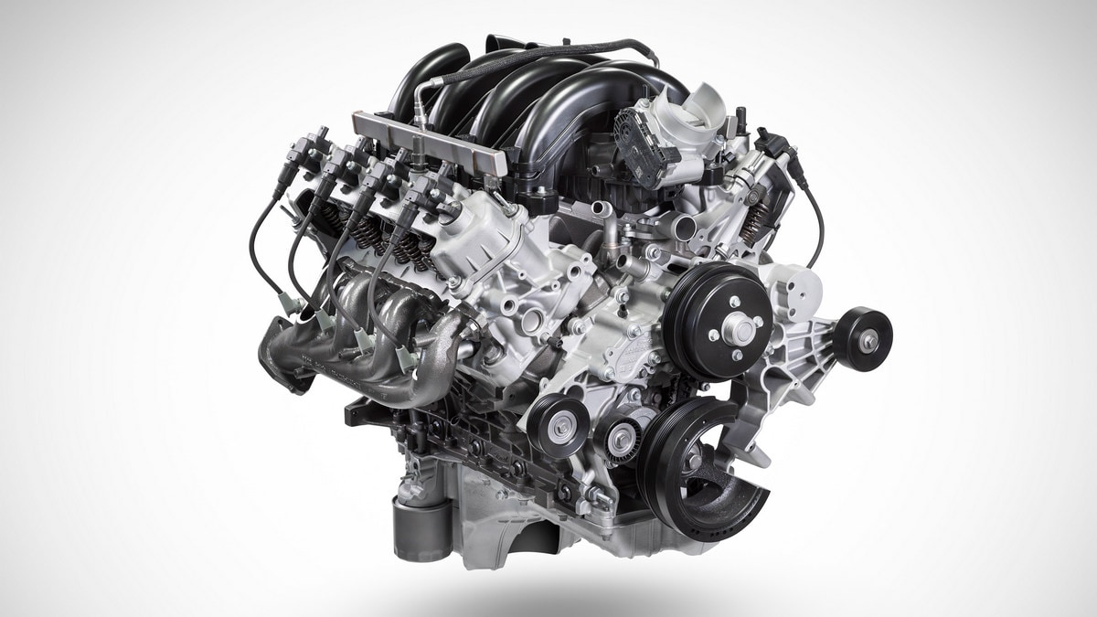
V8 Engine – Kelley Blue Book

Internal combustion cars have several negative impacts on the environment. They emit pollutants such as carbon monoxide, nitrogen oxides, and particulate matter, which can have negative effects on air quality and public health. They also contribute to climate change by releasing carbon dioxide, a greenhouse gas, into the atmosphere. Additionally, they rely on non-renewable fossil fuels, which can lead to depletion of resources and increased dependence on foreign countries for oil. Finally, internal combustion engines are less efficient than electric motors, which can result in higher fuel costs for consumers. [13]

Cont.
Furthermore, petroleum, or crude oil, is a finite resource, meaning that it is not renewable and there is a limited amount of it. As demand for oil increases and more is extracted, the amount remaining in the ground decreases. Additionally, oil is not distributed evenly around the world, so some countries have more reserves than others. As reserves in certain areas are depleted, it becomes more difficult and expensive to extract the remaining oil. This can lead to a decline in production and an eventual shortage of oil. Alternative energy sources such as solar, wind and biofuels are being developed to help reduce the dependency on fossil fuels. [14]

Internal combustion engines can be made more efficient through a variety of methods, such as:

- Improving combustion efficiency by adjusting the engine's compression ratio, fuel injection timing, and valve timing.

- Reducing friction in the engine by using low-friction bearings, coatings, and lubricants.

- Using lightweight materials in the engine and other components to reduce weight and improve fuel economy.

- Implementing a turbocharger or supercharger to increase the amount of air in the combustion chamber, resulting in more complete combustion.
- Using hybrid or electric powertrain technology, which can capture and reuse energy that would otherwise be lost during braking and coasting.

- Implementing the start-stop system that automatically turns off the engine when the car is idling, such as at a stoplight.

- Using aerodynamic designs and low-rolling resistance tires to reduce wind resistance and improve fuel economy.

- Implementing advanced transmission technology such as continuously variable transmission (CVT) or dual-clutch transmission (DCT) to improve efficiency.

Using alternative fuels: Internal combustion engines can be designed to run on biofuels, hydrogen, or natural gas, which produce fewer emissions than traditional gasoline or diesel.
Increasing the use of electric power: Hybrids and plug-in hybrids combine internal combustion engines with electric motors to increase fuel efficiency and reduce emissions.

Electrification

Electric cars are considered sustainable because they produce zero emissions when running, and their source of power can come from renewable energy sources such as solar or wind power. Additionally, electric cars can have a lower total cost of ownership than gasoline-powered cars because they have fewer moving parts and require less maintenance. This means they have a lower environmental impact and are cheaper to operate over time, making them a more sustainable option. [15] Making consumers justified in shifting towards this more renewable form of travel.

However, there are still several factors that may prevent widespread adoption of electric cars, primarily being cost, electric cars are still generally more expensive than their gasoline-powered counterparts, which can make them less accessible to some consumers. Limited range is also a critical issue as electric cars have a limited driving range before needing to be recharged, which can make them less practical for long distance travel.
Lastly, consumer perceptions. Some consumers may be hesitant to adopt electric cars due to misconceptions about their capabilities or concerns about their environmental impact, However, this can be rectified with government policies such as tax deductions and financial incentives along with publicly funded charging points can positively affect the adoption of electric cars.
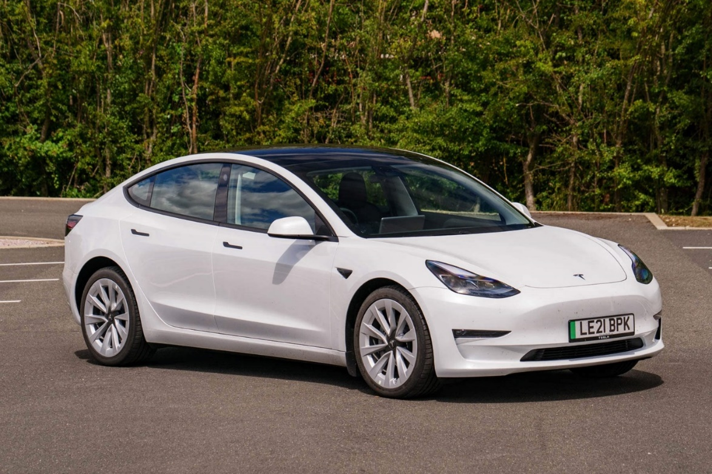
Tesla Model 3 – CAR Magazine

Furthermore, internal combustion cars can be retrofitted to electric by installing an electric motor, battery pack, and necessary controllers and wiring. This process, known as "retrofitting," involves removing the internal combustion engine and associated components and replacing them with an electric drivetrain. A professional mechanic or conversion company with experience in electric vehicle conversions should perform the retrofit. It is important to note that retrofitting a car to electric power can be a complex and costly process and may not be practical for all vehicles. Additionally, it is important to check the legality of retrofitting a vehicle in your area. [16]

How the government can be involved

The UK government can play a major contributing role to implementing my circular economy model.
There is already a system for enforcing MOT evaders, government legislation for mechanics to be skill tested and certified. Cars that don’t comply can get picked up by ANPR cameras and traffic patrols, this is already how the government makes arrests and fines for road tax avoiders and those who drive unsafe cars. The government could also introduce a credit scheme for those who keep their cars past our current average service expectancy as an incentive for people to look after their cars, this credit could be exchanged for discounts on new cars for when the time comes for a real replacement, or the government could simply refuse sale of cars to those with too little credit.

Ministry of Transport Logo

MOT stands for "Ministry of Transport" and it is an annual test that checks that vehicles meet the minimum safety and environmental standards required by law in the United Kingdom. MOT tests are required for most vehicles that are more than three years old. The test checks various components of the vehicle such as the brakes, tires, lights, and emissions, among other things. If a vehicle passes the MOT test, a certificate is issued which is required to be presented when renewing the vehicle's registration. If a vehicle fails the MOT test, repairs must be made, and the vehicle must be retested before it can be legally driven on the road again. [17] There is an opportunity to expand the parameters tested on an MOT test. Cars that are too unsafe and produce too many emissions are already deemed unroadworthy for Britain’s public highways, so there is room to expand the ban to the really old clunkers that can’t be saved.

The government may set a limit on how many cars you can own, to curb celebrities from collecting dozens of cars they may never use, however this would most likely be considered authoritarian and would be unpopular. The government may also require that manufacturers keep inventory an of parts for older models past 5 or even 20 years.

The ownership credit proposal can be flaunted by people intentionally crashing their car to write them off so that they can buy new ones earlier. First time buyers would be hurt as second-hand cars are harder to come by as there would be less of them on the road following stricter standards of what constitutes a safe and efficient used car. Political bickering and those who are willing to exploit the good graces that this proposal intends. There will be great costs to the car producers, how can they make money from repairing cars for free? They won’t, they can have the repairs carried out by dealerships or licensed mechanics.

The Stakeholders

There are so many stakeholders in this issue, the biggest group being car owners, with so many millions of people owning cars in this country we can greatly benefit from making our cars more sustainable and adopting a circular economy approach. As previously discussed, the government is a stakeholder, without our transport infrastructure the government has no way to effectively enforce its laws and maintain trade. The government can see a benefit from a circular economic approach with increased gross domestic product and taxation from all the newly generated revenue, however political partisanship from our political parties could hinder its efficiency in being introduced. Car owners, business owners with fleets, car dealerships and manufacturers, all these stakeholders play a major role in the circular economy, maintaining the vehicle entirely falls down to the customer and the manufacturer.

Conclusion

In conclusion, there are many methods to making our transport sector more sustainable, adopting a circular economy approach highlights solutions to some of the most challenging problems with our transport economy. The circular economy can create jobs in the car industry by promoting the design, production, and maintenance of more sustainable and long-lasting vehicles. This can include implementing recycling and refurbishment programs for car parts, encouraging the use of electric and alternative fuel vehicles, and investing in research and development for new technologies. Additionally, the circular economy can also create jobs in the recycling and repurposing of materials used in car production, such as batteries and plastics. Overall, the circular economy can help shift the car industry towards a more sustainable and job-rich future. However, there are many barriers and drawbacks to implanting this system. [18]

Sources used:

- What is sustainability? (2016) McGill University. https://www.mcgill.ca/sustainability/files/sustainability/what-is-sustainability.pdf - Accessed on 25/03/2022
- What does “sustainability” mean in business? (2018) Harvard Business School Online https://online.hbs.edu/blog/post/what-is-sustainability-in-business - Accessed on 13/01/2023
- Definition of ‘Circular Economy’ (2022) Oxford Dictionary - Accessed on 13/01/2023
- Sustainability (2022) Volvo https://www.volvocars.com/uk/v/sustainability/circular-economy#:~:text=A%20circular%20economy%20maximises%20resources,value%20delivered%20throughout%20that%20time [Paste into browser] - Accessed on 13/01/2023
- Number of Cars in the UK 2023 (2023) NimbleFins https://www.nimblefins.co.uk/cheap-car-insurance/number-cars-great-britain#:~:text=How%20many%20cars%20are%20there,cars%20registered%20in%20the%20UK. - Accessed on 13/01/2023
- Schumpeter’s Theory of Creative Destruction (2019) Carnegie Mellon University https://www.cmu.edu/epp/irle/irle-blog-pages/schumpeters-theory-of-creative-destruction.html - Accessed on 13/01/2023
- Are modern cars less problematic? (2010) HowStuffWorks https://auto.howstuffworks.com/under-the-hood/diagnosing-car-problems/mechanical/cars-less-problematic.html - Accessed on 13/01/2023
- Average Vehicle Age (2022) Society of Motor Manufactures and Traders https://www.smmt.co.uk/industry-topics/sustainability/average-vehicle-age/ Accessed on 14/01/2023
- What is innovation? (2014) BDC https://www.bdc.ca/en/articles-tools/business-strategy-planning/innovate/what-is-innovation Accessed on 14/01/2023
- Why Sustainability Is Now the Key Driver of Innovation (2009) Harvard Business Review https://hbr.org/2009/09/why-sustainability-is-now-the-key-driver-of-innovation Accessed on 15/01/2023
- Sustainable innovation practices and their relationship with the performance of industrial companies (2019) Emerald Insight https://www.emerald.com/insight/content/doi/10.1108/REGE-01-2018-0005/full/html Accessed on 16/01/2023
- The Automobile: Social Game Changer (“2020) N.C. Government & Heritage Library - NCpedia https://www.ncpedia.org/automobile-social-game-changer-k-8 Accessed on 16/01/2023
- Internal Combustion Engines Are An Avoidable Public Health Menace (2020) Green Energy Consumers Alliance https://www.greenenergyconsumers.org/drivegreen/learnmore/environmenthealth/publichealth#:~:text=Internal%20combustion%20engines%20create%20air,with%20elements%20of%20the%20atmosphere. Accessed on 16/01/2023
- When will fossil fuels run out? (2021) MET Group https://group.met.com/en/mind-the-fyouture/mindthefyouture/when-will-fossil-fuels-run-out#:~:text=It%20is%20predicted%20that%20we,our%20reserves%20can%20speed%20up. Accessed on 18/01/2023
- Benefits of electric cars on the environment (2018) EDF https://www.edfenergy.com/for-home/energywise/electric-cars-and-environment#:~:text=Research%20has%20shown%20that%20electric,generation%20to%20keep%20them%20running. Accessed on 20/01/2023
- Convert Vehicle from Petrol to Electric (2022) James Russell - National Numbers https://www.nationalnumbers.co.uk/blog/2022/07/convert-vehicle-from-petrol-to-electric.html#:~:text=The%20answer%20is%20yes!,specialise%20in%20electric%20car%20conversion. Accessed on 20/01/2023
- Checks to except in the MOT test (2022) AA https://www.theaa.com/mot/advice/what-is-checked-during-an-mot Accessed on 20/01/2023
- Driving Ambitions: The Business Case for Circular Economy in the Car Industry (2022) World Business Council for Sustainable Development https://www.wbcsd.org/Programs/Cities-and-Mobility/Transforming-Urban-Mobility/Mobility-Decarbonization/Circular-Cars-Initiative/Resources/Driving-Ambitions-The-Business-Case-for-Circular-Economy-in-the-Car-Industry Accessed on 20/01/2023

