
Skills for the Workplace
Module Assignment Submission
Student Name: | Enrique Quevedo Diaz
Student Number: | 1917750
Module No: | BMSK4003
Module Title: | Digital Skills and Research Methods

Statement of Confirmation of Authenticity
By the act of making this submission, the student declares that this is the work of the student named above. The work has not, in whole or in part, been knowingly presented elsewhere for assessment, or where assessment has been built on a previous assessment, this has been identified. Where materials have been used from other sources it has been properly acknowledged. If this statement is untrue, the student acknowledges that an assessment offence has been committed.
Attention is drawn to the plagiarism and unfair practice policies of both the University and of ILM.

Permission for ILM to use this script
ILM uses learners’ submissions – on an anonymous basis – for assessment standardisation. By submitting, both the centre and the learner agree that ILM may use this script on condition that identifying information is removed. However, if you are unwilling to allow ILM use this script, please refuse by ticking the box: □

Table of Contents

What has been the impact of 21st Century Technologies on the modern workplace? …............................................................... 4
Welcome to the era of mass communication and interaction
Satellites
Cyber Security and data usage of tech companies
TikTok
Amazon
Huawei
How to minimise risks
Online sales changed the behaviour of the buyer.
Evolution of the offices
A Modern Workplace

Research and Explore the use of modern technologies and social media in their workplace …......................................................... 11
Colleagues connected
Scientists using digital platforms
The connectivity during the 2020 Pandemic
The marketing point of view
LinkedIn profile and other social media platforms that enhance networking and career prospects............................................... 14
My LinkedIn experience
How to build it

Research Methods....................................................................... 15
Ackoff Research Method

Identify and Evaluate the appropriate source of information and gather data on how modern technology has affected the world of business........................................................…............................ 16
Building Credibility
The Craap Test
Demonstration of the use of IT approaches presenting an analysis of data
Excel cost-benefit analysis to buy a minibus

References. …............................................................................................20
Appendix 1. 6.............................................................................................23
Appendix 2. 7…..........................................................................................24

What has been the impact of 21st Century Technologies on the modern workplace?

Welcome to the era of mass communication and interaction
The impact of digital technologies has changed the way we connect and live. The current year with the Covid-19 Pandemic has forced it. In the digital era, the modern workplace can be anywhere comfortable and suitable. To work it, we would need the basics. Fixed and mobile network, a laptop and a smart mobile phone. Mobile phones are powerful tools for work, they are not only able used to make phone calls, video conferences, messages and organise our diary calendar, we can also purchase and search for information with an immediate response. From then on, we are responsible for developing our abilities to use technology and to develop our knowledge. Managing social media applications, it has become a useful skill for creating digital identities and marketing purposes. Critical thinking is necessary to sustain credibility, get too much information; we must make sure that what we read and share text, image and videos from reliable sources.
The affective and cognitive abilities are essential in the modern workplace and are often called 21st-century skills. According to Koenig (2020), who has been developing several workshops about the topic since 2007, indicates that experienced and trained managers who have got the capabilities of abstract thinking, solve complex problems and are critically task thinker.

Satellites
In the digital era, we have seen incredible advances, fantastic developments in medicine using nanotechnology and robotic surgery. None of these changes would have happened without satellites. According to the Union of Concerned Scientist and Students of the Massachusetts Institute of Technology (MIT, 2015), satellites are the objects sent to orbit where we communicate from the earth and receive signals back for television, mobile phones, navigation, business and finance, weather, space science, land observation for safety and climate and environment supervising.

Cyber Security and Data usage of Tech Companies
Computer software's have been under attack since the 80's decade, government espionage, and billions stolen to the most digitally sophisticated stores. Scammers can steal data, credit cards details and information in general (Checkpoint 2020).
A lot has changed since then, the studies informed (Kemp 2020), that at the beginning of 2020, more than 3.95 billion people are using social media where data is collected and managed by the companies.

TikTok
Cybersecurity and surveillance report (Doffman, 2020) explains that TikTok is a Chinese social media app, that is competing against other American social media apps, such as Facebook, Instagram and Youtube. The fact that the Chinese app came strong in the market, for the first-time competing head to head with the others, has risen concern from the American Government, saying that they could be stealing data and send them to the Chinese Government. Executives from TikTok denied the accusations. The answer from the researcher is clear; no data is sent to the Chinese Government and
Regarding the Chinese app, the report indicates that (Thornton-Trump, I. Cited in Doffman, 2020): "It is not any worse or any better than what Facebook, Google and thousands of apps are doing already. Any free service is going to want to monetise the data it is accumulating."
American Senator (Warren, E. 2019) exposing the power of Silicon Valley, "Today's big tech companies have too much power — too much power over our economy, our society, and our democracy. They have bulldozed competition, used our private information for profit, and tilted the playing field against everyone else. Furthermore, in the process, they have hurt small businesses and stifled innovation."

Amazon
Journalist research (Panorama, 2020) investigates Amazon's usage of the data, demonstrating that customers from Romania were listened by actual people from Amazon through Alexa device. In the rise of the gigantic company, we observed a massive data-gathering operation. The technology will control the data with Artificial Intelligence and will shape the future of the retail. The mastermind behind the data and sale orientated business is the Electrical Engineer and Computer Scientist Jeff Bezos.

Huawei
A similar thing is happening with the Chinese Telecommunications Company Huawei, (Bowler, 2020) where there have been accusations of spying for the Chinese Government. Huawei executives have denied this accusation by saying they would not comply with any request from the Chinese Government to provide information.
The articles confirm that the UK is monitoring the Chinese company under the Huawei Cyber Security Evaluation Centre, which is part of the National Cyber Security Centre (NCSC).
"In March 2019, it said it hadn't found evidence of malicious Chinese state activity, but it did identify some serious defects in Huawei's software engineering and cyber-security competence".
It is one of the reasons why Huawei will not be joining the fast network 5G, because the new technology network it is ten times faster than the 4G one, and it could be more comfortable for the Chinese company to brake cybersecurity.

How to minimise risks
The research (Kemp, 2020) indicates that everybody who works and uses technology is under threat of a cyber-attack. For that reason, we could be under an assault unleashed by cybercriminals using their knowledge of computing skills versus to log in to another computer or a network. Cyber-attacks would malevolently deactivate computers, take data, or use a violated computer to release activity for other attacks. Cybercriminals employ a different practice to launch cyber-attacks, for example, malware, phishing or ransomware, as well as others.
Phishing is scams that do not contain a malicious attachment, but a threat of blackmailing if there is no money in return. Scammers would use computer engineering skills to send messages to the inbox of the recipient's email.
Malware would be a software created to enter another computer to break it or to steal data.
Ransomware is where scammers break into other person or network computers and ask for money to return the software or computer to the owner.
People and small businesses need to protect themselves from Cyber-attack, and Joe (2020) proposed the five following basics points for protection:

- Buy malware and anti-virus security package. There are free versions but do not provide much protection.

- Maintain the services updated. By maintaining all the devices updated frequently, in this way, all the data and information can be kept safe. Computers and mobile phones send reminders or alert messages to indicate that it is time to update. If it is the preferable choice, to allow the system to update automatically. That is the most efficient way to fix any bug in the software.

- Create unique and different passwords
It can be challenging because we must keep in mind that we have different passwords for different devices and applications. It is vital to stop cyber-attacks because if scammers find out passwords and only using that one, then there is trouble. They can access the accounts. There are other choices, for example, the online password generators.

- Prefer using a VPN
The virtual private network, known as a VPN, keeps privacy when connecting to the public internet. It provides protection and makes the information untraceable. It is perfect, particularly for those who travel frequently.

- Be savvy on social media.
To stay in the safe side and protect all the information uploaded on social media is to be careful and keep it private. Please do not accept the requests of those people we do not know; they could be scammers who keep an eye on details and are looking for the two-factor authentication code, such as credit cards and PINs.
If we must protect the data of a big company from cyber-attacks, we must get in touch to a qualified IT specialist. Because we must provide the service on a big scale, the value of our business it highly depends on how we look after it and on for that reason we must keep safe all the information we share and the data we manage.

Online sales changed the behaviour of the buyer
In business, online transactions are almost immediately, simplifying the action of going out, looking for something we need. Today we check or Google something, and usually purchase it on Amazon, company that made it very easy for us to buy, and that doubled its profit during the pandemic to $5.2 billion, according to the report of Squire (2020).
We have seen that many big mainstream shops and stores that have been closing down, John Lewis, Debenhams, Boots. It seems that buyers have found another 'Gran Via' or avenue, to purchase quickly.

Evolution of the offices
A study made by Park et al. (2018) suggests that the way we relate with our habitat and landmark has changed. In the pre-digital era, people were going to town for their activities, usually working in iconic buildings, then going to the bank and have lunch around the corner, all together in one location. Today we can have an online bank transaction; we can use our mobile phone applications to search for a Michelin star or a popular restaurant recommendation on our phone. The social media will let us know where people or friends are checking in, using a Location-Based Service (LBS) and Global Positioning Systems (GPS).
The current need of remotely working has made corporate teams generating, even more, being productive, but also has increased the level of anxiety, because companies are firmly monitoring, so staying at home five days a week for work purposes is not a very good option. The evolution proposed is the hybrid way of work, because we need the social/human interaction, face to face. For example, working remotely three days a week, and another two days for attending meetings with clients or colleagues about the critical business will be necessary, indicates McBee (2020)

We should be able to adapt to change; if not, we will struggle. However, are we capable of being up to date with all the technology available out there? Indeed, not everybody, Barnard (2019) mentioned that nearly a quarter of the adult British population lacks the essential digital skills. That is nearly 12 million people who are struggling to do some essential skills online.
Modern technologies have changed the lives and the way we connect, work and live.

A Modern Workplace
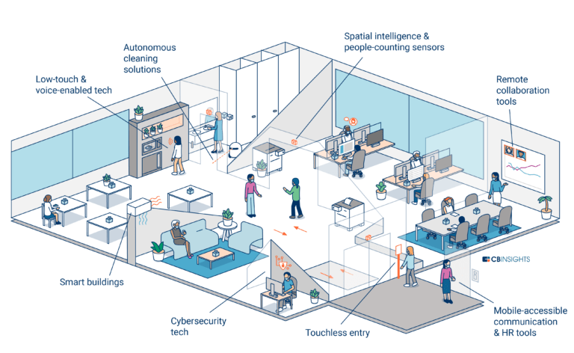
(CBInsights, 2020)

According to studies made by Mander (2020), during the year 2019, 1 in 4 of the professionals surveyed said: “their company did not permit remote working in any circumstances – a figure which peaked at 50% among workers in Japan”.
Practically overnight, this condition changed drastically.
The studies show that several other location types have seen notable rises, professionals choosing to work in shared offices and Coffee shops.
The author prompted the open question “what will happen once the threat of coronavirus eventually precedes. Will office life return to pre-pandemic normality? Alternatively, will companies need to embrace a future in which remote working is a much more mainstream proposition?”

Explore the use of modern technologies and social media in their workplace

It is unthinkable today that a business can be successful without an office with modern technology. (Pfano and Beharry, 2016, p. 376) states that telephones and computers especially are the main instruments for workers in the creation of business opportunities. There is a close relationship between modern technology in the workplace and positive transformation in management performance.
The authors reflect that: “In businesses, an effective way to improve productivity is to raise the level of technology. Management support plays a vital role; managers are the key to ensuring that technology to benefit the business”.

Colleagues connected
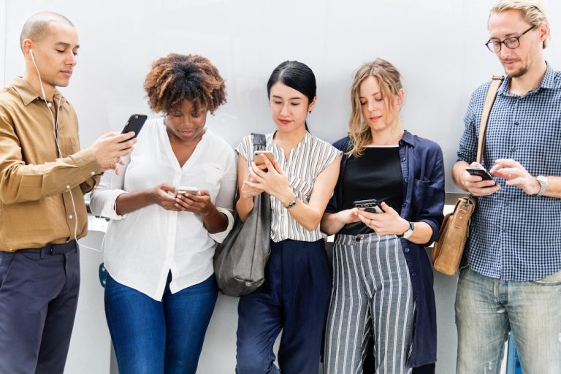
The impact of social media in the office (Cleary, 2019)

Scientists using digital platforms
(Collins, Shiffman and Rock, 2016) A study shows that social media has established a network of communication channels that simplify connections and make available information where scientists talk about their thoughts and advances between colleagues, friend and family members.
The academics send questions to 587 scientists, and 203 of them replied. For the survey, the authors followed protocol and asked The University of Otago Ethics Committee, that granted permission for this research.
Most of the scientist who replied to the research expressed that they like to exchange their scientific knowledge within the platforms, being Facebook their preferred one, but they use it mostly to keep in contact with family and friends. The studies demonstrate that blogs have got an essential role for the public to understand science and they mentioned that scientists use their Twitter accounts to be in touch with other scientists and to share the research they do. Note that the article does not mention if it is a lack of knowledge from the scientists to use Twitter or the lack of knowledge of the public who uses the platform and does not understand the content shared by the scientists. Only a few use academia-focused social networks, such as Academia.edu or Mendeley.

The connectivity during the 2020 Pandemic
The worldwide digital environment is shaping the way we work and connect, with the Covid-19 pandemic lockdowns we observe that the new digital behaviours that individuals adopted during confinement have persevered, causing significant escalations in various kinds of digital activity.
A survey (Ericsson, 2020) shows that internet-connected technologies have assisted people during the pandemic, permitting them to help children's education (76 per cent), keep in touch with friends and family (74 per cent), and at the same time improve in their mental health and wellbeing (43 per cent). The study mentioned that "As people spent more time online at home, network traffic loads shifted geographically from city centres and office areas to suburban residential areas. The largest share of the traffic increase as lockdowns went into place was absorbed by the fixed residential network. However, many service providers also experienced an increased demand for the mobile network".

The marketing point of view
Studies show that the growing technological trend of social media transformed the way we see content, and at the same time, the way people see us. People and brands can create an account and build a digital identity, which its success will depend on the content developed in it as reported by Kemp (2020), who informed that at the beginning of 2020, more than 3.95 billion people are using social media. That is more than half of the population of the world actively using connecting technology.
Brand storytelling can produce excellent commerce opportunities; social platforms present brands a unique chance to connect with and engage consumers. People connect to a broader variety of social media apps across the platforms; on average, one person is using around nine different social platforms.
Daily, the social media attracts over a million new users across the platforms, that is people using social media for the very first time.
Kemp continues, "Facebook continues to dominate our ranking of the world's most popular social media platforms. The company's 'core' platform now claims more than 2.6 billion monthly active users, while 2 billion people use its top messenger platform, WhatsApp.
Instagram has also seen impressive growth over recent weeks, with the company's latest advertising audience data indicating that more than 1.08 billion people now use the platform each month".
The research also reports that social media consumers spend typically of 2 hours and 20 minutes per day.
Nevertheless, this data focused on surveys done between January and March this year, so it looks like with the Covid-19 lockdowns will have resulted in people spending even more time using social media daily.

LinkedIn profile and other social media platforms that enhance networking and career prospects

In career prospects, in this case, academics (Donelan, H. 2015) suggests that those who engage in the usage of social media tools experience a better outcome of it. Posting and engaging with social media generates a feeling of progression in careers, where we develop our thoughts and share them within the community.

My LinkedIn experience
To prove the social engagement and interaction of the LinkedIn network, I would like to talk about my recent personal experience. For the process of re-building my own LinkedIn profile, during the present module, I was contacted, on this mentioned platform, by the ex-director of business of the Chilean Embassy in London and I was offered to be part of a team, to build a digital company. I'm revising the characteristics of the company and how could I add value to that business in terms of sales.

How to build it
An article from can help to build an excellent profile to build our brand on the platform (Fleming, 2020) and it is an excellent opportunity to market ourselves, featuring knowledge, personal skills and motivations.
It starts by choosing the right profile and background photo and making the headline more than only a job title. Tune in with specific words that are not overused, such as specialised, leader. Link the e-mail with the contacts. Numerate personal skills show the services offered, generate feedback to the people who interact. From then on, the marketing leader of LinkedIn continues recommending to: "Take a skills assessment, request recommendations, showcase your passion for learning, share media and marketing collateral, get credit for your thought-leadership with publications, share relevant content from your LinkedIn feed, add comments, follow relevant influencers for the industry, become an employee advocate, publish long-form content – and use it to start conversations."

Ackoff Research Method
Professor Ackoff: Data, Information, Knowledge and Wisdom
Studies proposed that (Bellinger et al., 2004), according to Russell Ackoff, a systems theorist and professor of organisational change, "The content of the human mind can be classified into five categories:
1. Data: symbols
2. Information: data that are processed to be useful; provides answers to who, what, where, and when questions
3. Knowledge: application of data and information; answers how questions
4. Understanding: appreciation of why
5. Wisdom: evaluated understanding.”

According to the study, data would be raw material, information would be the meaning given to the data, knowledge it is the process of collecting the information and memorizing it. Understanding can synthesize the knowledge and accommodate and add mor knowledge to the one learned. Wisdom over the levels of conscious. In this stage we can discern between right and wrong.

Identify and Evaluate the appropriate source of information and gather data on how modern technology has affected the world of business.

Building Credibility
The credibility of the sources, understanding data and research is the key. As we have so much information on the web, we could fall in the spiral of the fake news if we do not have a critical thinking analysis skill. The information we gather must be accurate and reputable; accurate resources would help to build credibility.
Using Primary and Secondary sources.
Primary sources are those original researches, for example, a survey or an interview. Secondary resources are the ones that require analysis, collected from the primary sources. For example, an article or research works.

The Craap Test
Craap Test, to define the credibility of the source
(Kurpiel S. 2020) The definition of CRAAP, according to the author "CRAAP is an acronym for Currency, Relevance, Authority, Accuracy, and Purpose.
Currency: the timeliness of the information
- When was the information published or posted?
- Has the information been revised or updated?
- Is the information current or out-of-date for your topic?
- Are the links functional?
Relevance: the importance of the information for your needs
- Does the information relate to your topic or answer your question?
- Who is the intended audience?
- Is the information at an appropriate level (i.e. not too elementary or advanced for your needs)?
- Have you looked at a variety of sources before determining this is one you will use?
- Would you be comfortable using this source for a research paper?

Authority: the source of the information
- Who is the author/publisher/source/sponsor?
- Are the author's credentials or organizational affiliations given?
- What are the author's credentials or organizational affiliations are given?
- What are the author's qualifications to write on the topic?
- Is there contact information, such as a publisher or e-mail address?
- Does the URL reveal anything about the author or source?
  - examples:
    - .com (commercial), .edu (educational), .gov (U.S. government)
    - .org (nonprofit organization), or
    - .net (network)
Accuracy: The reliability, truthfulness, and correctness of the content
- Where does the information come from?
- Is the information supported by evidence?
- Has the information been reviewed or refereed?
- Can you verify any of the information in another source or from personal knowledge?
- Does the language or tone seem biased and free of emotion?
- Are there spelling, grammar, or other typographical errors?
Purpose: the reason the information exists
- What is the purpose of the information? to inform? teach? sell? entertain? persuade?
- Do the authors/sponsors make their intentions or purpose clear?
- Is the information fact? opinion? propaganda?
- Does the point of view appear objective and impartial?
- Are there political, ideological, cultural, religious, institutional, or personal biases?"

Demonstration of the use of IT approaches presenting an analysis of data.
Using the Cost-Benefit Analysis (Quevedo Diaz E. 2020), we can demonstrate own skills

Excel cost-benefit analysis to buy a minibus
Cost Benefit Analysis
 | LDV | Ford | Iveco | Rented
Total Cost | £7,600.00 | £7,600.00 | £8,600 | £6,200
Total Benefit | £600 | £2,000 | £500 | £200
Cost Benefit Ratio | 12.7 | 3.8 | 17.2 | 31

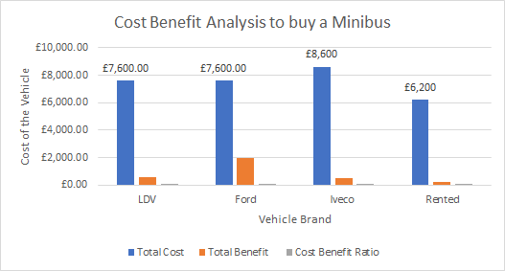

References

Barnard, J. (2019) Digital Future: The New Underclass
https://www.bbc.co.uk/programmes/m000823p Accessed 01.10.20

Bellinger G. et al., (2004) Systems Thinking, A journey in the realm of systems, Data, Information, Knowledge, and Wisdom, [online] Available https://www.systems-thinking.org/dikw/dikw.htm Accessed 03.10.20

Bowler, T. (2020) Huawei: Why is it being banned from the UK's 5G network? [online] Available https://www.bbc.co.uk/news/newsbeat-47041341 Accessed 02.10.20

Cbinsights (2020) Reopening: The Tech-Enabled Office In A Post-COVID World (2020) [online] Available
https://www.cbinsights.com/research-future-of-the-office?utm_term=%2Bfuture%20%2Boffice&utm_campaign=marketing_future-office_2020-07&utm_source=adwords&utm_medium=ppc&utm_content=adwords-reports-europe&hsa_tgt=kwd-308156276583&hsa_grp=112433326452&hsa_src=g&hsa_net=adwords&hsa_mt=b&hsa_ver=3&hsa_ad=457850182926&hsa_acc=5728918340&hsa_kw=%2Bfuture%20%2Boffice&hsa_cam=270202443&gclid=CjwKCAjwlID8BRAFEiwAnUoK1VBFw97Yj9AtkTbX13krBW9I_X2rVAZ3iIe3CLnRqh5MfNPQgO1PZBoC8ekQAvD_BwE=457850182926&hsa_acc=5728918340&hsa_kw=%2Bfuture%20%2Boffice&hsa_cam=270202443&gclid=CjwKCAjwlID8BRAFEiwAnUoK1VBFw97Yj9AtkTbX13krBW9I_X2rVAZ3iIe3CLnRqh5MfNPQgO1PZBoC8ekQAvD_BwE Accessed 28.09.20

Check Point Software Technologies (2020) What is Cybersecurity? [online] Available
https://www.checkpoint.com/cyber-hub/cyber-security/what-is-cybersecurity/ Accessed 28.09.2020

Cleary, J. (2019) The impact of social media at the workplace. [online] Available
https://inhouse-legal.eu/in-house-managment/social-media-workplace/
Accessed 21.09.20

Collins K. (2016) How Are Scientists Using Social Media in the Workplace? [online] Available https://journals.plos.org/plosone/article?id=10.1371/journal.pone.0162680 Accessed14.09.20

Doffman, Z. (2020) Forbes, Is TikTok Seriously Dangerous—Do You Need To Delete It? [online] Available https://www.forbes.com/sites/zakdoffman/2020/07/11/tiktok-seriously-dangerous-warning-delete-app-trump-ban/#11f3812b2b0e Accessed 03.10.20

Donelan, H. (2016) Journal of Further and Higher Education, Social media for professional development and networking opportunities in academia P. 727 [online] Available https://www-tandfonline-com.ezproxy.uwtsd.ac.uk/doi/pdf/10.1080/0309877X.2015.1014321?needAccess=true Accessed 19.09.20

Fleming, J. LinkedIn (2020) 20 steps to a better LinkedIn profile in 2020 [online] Available https://business.linkedin.com/en-uk/marketing-solutions/blog/posts/content-marketing/2017/17-steps-to-a-better-LinkedIn-profile-in-2017 Accessed 16.09.20

Forbes (2019) Elizabeth Warren vows to break up Amazon, Google and Facebook [online] Available https://www.ft.com/content/29e9a7f8-41b6-11e9-b896-fe36ec32aece Accessed 08.10.20

Identifying information sources. Online University of Michigan Flint [online] Available at: https://www.umflint.edu/library/identifying-information-sources. Accessed: 01.10.20

Joe, A. (2020) Top Ways to Protect Your Data from Cyber Attacks [online] Available
https://marketbusinessnews.com/protect-data-from-cyber-attacks/246852/ Accessed 01.10.20

Koenig, J. (2020) Assessing 21st Century Skills: Summary of a Workshop. [online] Available https://www.learntechlib.org/p/159080/. Accessed 28.09.20

Kurpiel, S. (2020) Evaluating Sources: The CRAAP Test. Benedictine University : https://researchguides.ben.edu/source-evaluation Accessed 03.10.20

Mander, J. (2020) The future of remote working [online] Available
https://blog.globalwebindex.com/chart-of-the-week/future-of-remote-working/ Accessed 29.09.20

McBee, R. (2020) The office of the future will be hybrid [online] Available
https://gulfbusiness.com/the-office-of-the-future-will-be-hybrid/
Accessed 12.09.20

Panorama, (2020) Amazon: What They Know About Us [online] Available https://www.bbc.co.uk/programmes/m000fjdz Accessed 04.10.20

Park et al. (2018) Lynch’s Elements of the City in the Digital Era Park [online] Available https://www.researchgate.net/publication/330709396_Lynch's_Elements_of_the_City_in_the_Digital_Era Accessed 04.10.20

Pfano et al. (2006) The effect of modern office technology on management performance: Durban Westville P.376 Accessed 15.09.20

Quevedo Diaz E. (2020) UWTSD. Problem Solving and Decision Making, Cost Benefit Analysis, [online] Available Moodle Accessed 09.10.20

Squire, P (2020) Amazon posts record-shattering profit thanks to pandemic sales [online] Available https://www.digitaltrends.com/news/amazon-quarter-2-earnings-2020-record-profit/ Accessed 16.09.20

Ucsusa (2014) What Are Satellites Used For? [online] Available https://www.ucsusa.org/resources/what-are-satellites-used Accessed 29.09.20

Appendix 1

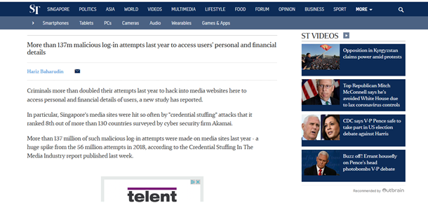
The Straits Times (2020)
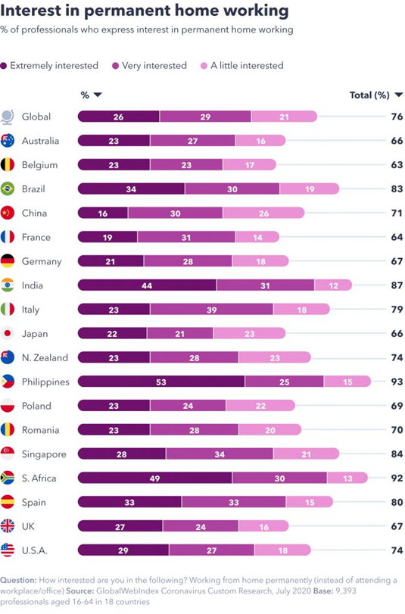Globalwebindex.com (2020)
Fig. 1
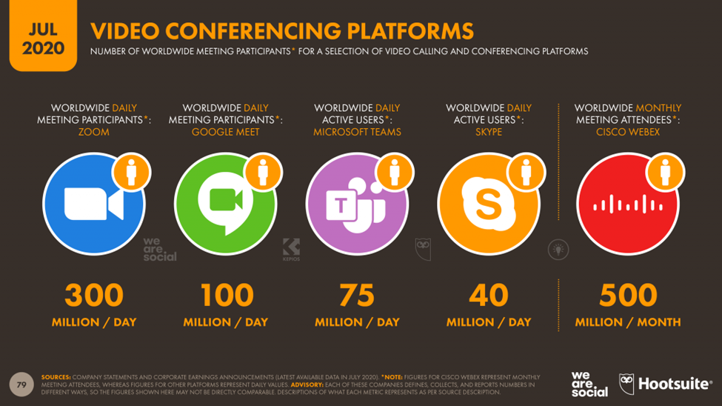
Wearesocial.com (2020)
Fig. 2
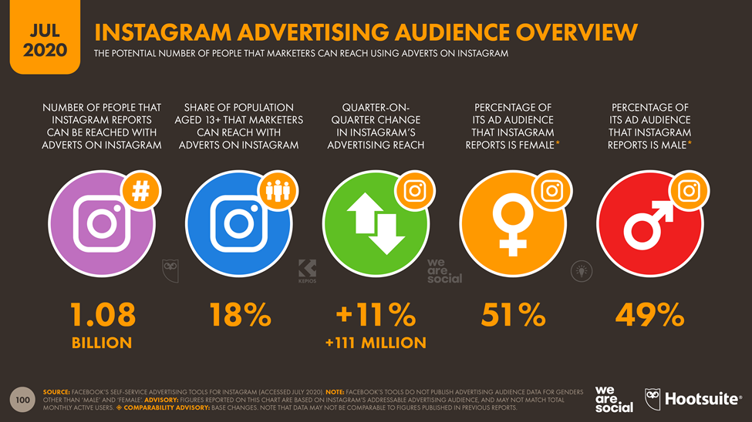
Wearesocial.com (2020)

Fig. 3
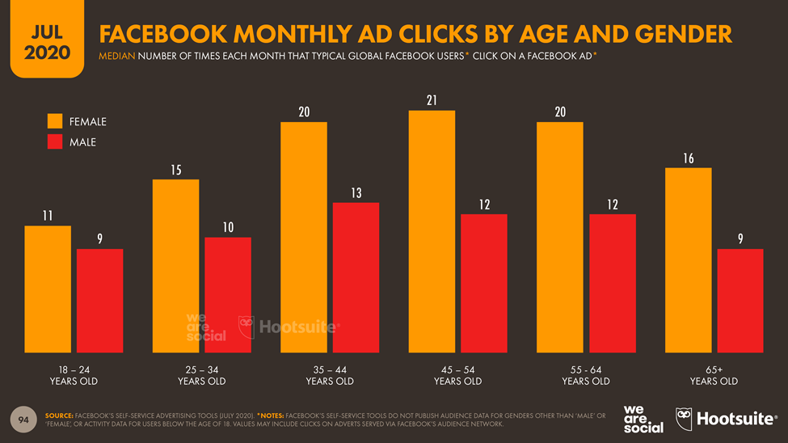
Wearesocial.com (2020)
Fig. 4
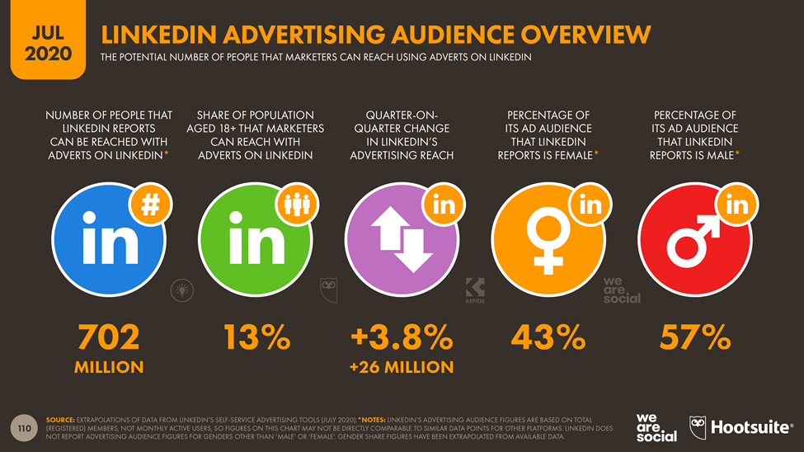
Wearesocial.com (2020)

Appendix 2

LinkedIn profile link
https://www.linkedin.com/in/enrique-quevedo-d%C3%ADaz-9243a118/

Printed screen of LinkedIn profile


