

A Balancing Act : Evaluating the Effectiveness and Ethics of the Use of Force in Modern Policing

William Lee

2124739
BSc (Hons) Professional Policing Practice

8419 Words

Declaration
This work has not previously been accepted in substance for any degree and is not being concurrently submitted in candidature for any degree.
Signed: 2124739
Date: 20/10/2024

STATEMENT 1
This dissertation is being submitted in partial fulfilment of the requirements for the degree of BA.
Signed: 2124739
Date: 20/10/2024

STATEMENT 2
This dissertation is the result of my own independent work/investigation, except where otherwise stated.
Other sources are acknowledged by footnotes giving explicit references. A bibliography is appended.
Signed: 2124739
Date: 20/10/2024

STATEMENT 3
I hereby give consent for my dissertation, if accepted, to be available for photocopying and for interlibrary loan, and for the title and summary to be made available to outside organisations.
Signed: 2124739
Date: 20/10/2024

STATEMENT 4
I hereby give consent for my dissertation, if accepted, to be available on the university’s IT system to those who have consent to use the system.
Signed: 2124739
Date: 20/10/2024

Abstract

This research will delve into the viewpoints of police officers regarding the application of force, in policing practices while evaluating its efficacy in ensuring safety and addressing ethical considerations associated with it.
As public scrutiny increases in relevance the study investigates how officers perceive the influence of force on resolving conflicts enforcing laws and maintaining safety.
Additionally, it explores their perspectives on how the community views the use of force the portrayal of policing, in media and whether they feel supported by their superiors in using force.
Data, from 190 officers has been gathered for a survey exploring how police officers perceive the legal guidelines that shape their conduct in the field. The study aims to uncover the officers’ perspectives on balancing policing with considerations they encounter regularly and how outside opinions might impact their on-duty decisions.

Table of Contents
Chapter One – Introduction 6
Chapter Two – Literature Review 7
2.1 Background 7
2.2 History 7-8
Chapter Three – Methodology 9
3.1 Introduction 9
3.2 Research Philosophy 9
3.3 Research Approach 10
3.4 Ethical Considerations 10
3.5 Research Strategy and Choice 11
3.6 Time Horizon 11
3.7 Sample 11
3.8 Reliability and Validity 11-12
3.9 Conclusion 12
Chapter Four – Analysis of Results 14
4.1 Introduction 14
4.2 Data Analysis 14
4.3 Advantages of Using Survey Planet 14
4.4 Disadvantages of Using Survey Planet 15
4.5 Questionnaire Findings 15-23
4.5.1 How often are you required to use force in your current role? 14
4.5.2 How effective do you feel the use of force is in achieving successful
conflict resolution? 15-16
4.5.3 How often does the use of force lead to de-escalation in violent
situations? 16-17
4.5.4 Do you believe current guidelines and policies regarding use of
force are ethically sound? Do you believe there are adequate
accountability mechanisms in place to review use of force incidents? 17-18
4.5.5 In your opinion, how does the public generally perceive the
use of force by police? Do you believe the public understands
the complexities of when and why force is used by police
officers? 18-19
4.5.6 Have public perceptions of the police's use of force influenced
how you apply it in your duties? 19-20
4.5.7 Do you feel that the media's portrayal of use of force incidents
fairly represents what happens in real-life policing? 21
4.6 Conclusion 23
Chapter Five – Findings and Conclusion 24-26
5.1 Introduction 23
5.2 Analysis and Implications of Findings 23
5.3 Main findings of the dissertation 24-25
5.4 Limitations 25-26
5.5 Recommendations
Chapter Six – Bibliography 27-28
Appendix 1: Questionnaire 29-54
Appendix 2: Questionnaire Responses 55-79
Appendix 3: Research Proposal 80-83
Appendix 4: Ethics Form 85-100

Chapter One : Introduction
The application of force in Policing remains a contentious topic of discussion, among professionals and the general public alike. This is particularly true when considering its real-world implications and the ethical dilemmas that arise from its implementation. Police officers regularly face scenarios where decisions on the use of force may either resolve conflicts or provoke a public backlash / scrutiny. These challenges stress the difficult relationship between effective policing, community trust, public perceptions and the ethical requirements behind modern policing.
The following dissertation will showcase the perceptions that officers hold regarding the use of force during their duties, particularly its effectiveness in ensuring safety and its ethical boundaries. This will be done by the survey response of 190 officer and will aim to explore the following objectives:

- Evaluate the frequency and perceived effectiveness of the use of force in policing.

- Investigate the officers’ views on the ethical soundness of current guidelines and accountability mechanisms.

- Assess the influence of public perceptions and media portrayals on officers’ decision-making processes.

In an age of heightened and public scrutiny surrounding not only UK policing practices but that of the world these objectives aim to uncover the factors influencing officers’ use of force, offering insights to inform policy, training, and public engagement strategies. By exploring the balance that officers must now face surrounding accountability, transparency, and moral judgment, this study contributes to ongoing discussions about the ever-evolving role of the use of force in modern policing.

Chapter two : Literature Review
2.1 Background
Over recent decades policing policies and utilising force within a police officer’s role has become an area for significant discussion both within a professional environment but also the publics opinion. Numerous high-profile incidents have come to the forefront of public knowledge and have caused a high level of criticism, namely the George Floyd case in America, and the incident on British Soil in Manchester Airport. Not only have these incidents come under discrepancy due to their perceived use of excessive force but also whether force is disproportionately utilised against those of minority backgrounds. Wingfield (2021) shows that within American forces there are significant inconsistencies in the policies in place controlling the use of force and the way they can be utilised against minority groups. Albeit these finding indicate a American issue however these issues are echoed throughout westernised policing especially that of the UK (HMICFRS, 2021; IOPC, 2022).
2.2 History
Milton et al. (1977) states that one of the most distinctive characteristics of policing even 50 years ago was the trust and authority given to officers to use force when necessary. However, what has changed in 50 years that has led to the scrutiny officers find themselves under today?
Even in 1977 it was noted that police were far more likely to opt for a less forceful and abrupt resolution and would turn to a more patient and restrained approach to manage incidents (Milton et al., 1977). Owen, 2003 has described a growth of minority ethnic populations within the UK over this period, which could in turn relate to the change in behaviours towards utilising force within policing incidents.
As the police forces have become more aware of the impact use of force is having on public perception and the bonds they form with their communities, more focus has been placed on sufficient education being provided to officers to ensure they understand their powers and the impact utilising force can have on communities (Chapman, 2012). However, Chapman, 2012 has also shown that education and sufficient training is not the only impact factor when considering why force is used, they have also identified that officer characteristics play a significant role in how officers choose to deal with an incident. This is not only representative in a policing environment but could also be seen in a more public setting with how individuals react to high stress or potentially dangerous situations. This is also supported by an individual’s nervous system response to high stress situations, where an autonomic branch of the human nervous system will choose a fight or flight response, where no conscious effort will be engaged (Spierer et al., 2009). This shows that whilst a level of training can guide an individual’s reaction, in a moment of high pressure or significant danger an individual can make a subconscious decision to either run from the threat or fight the threat and that they may not be in control of the decision they make in the moment.
However, this has been questioned by Taylor et al., 2002 who have stated that a fight or flight response may not be representative of a human female’s response to stress, and that females may be more inclined to a tend and befriend response. This should be considered when analysing changes in the use of force over periods of time as the frontline policing workforce becomes more split between men and women. It should also be considered when analysing the results of this study as to the difference between the male and female perception of use of force.
Not only is the aim of this research to identify why officers utilise force in their day-to-day role but also to consider the impact that media and the current scrutiny officers are under has on their decision to use force.
In recent years there has been a significant increase in the publics use of social media, not only openly discussing topics and news across forums around the world, but also the sharing of personal videos. This has opened a whole new aspect of managing public perceptions of police, in addition to locally managing expectations and grievances that may have been shared through word of mouth, but also managing the scale of consumption of information by the public meaning that not only can local issues have an impact on policing local communities, but also international incidents can impact on local perceptions of police.
Walsh & O'Connor. (2018) states that the current climate and increasing utilisation of social media opens up policing to a far greater level of exposure and circulation to the publics perceived injustices, such as excessive use of force, unfair discrimination or other queries regarding ethical dilemmas that officers were previously left unscrutinised for. It has been seen that short visual clips of incidents involving use of force can strongly influence public perceptions of police actions and may often frame their actions as excessive and unjust, however if provided with wider context can provide a more transparent method of policing (Miethe et al., 2019).
Utilising social media could also be viewed as an asset which could be utilised to improve public opinions and aid in allowing the public access to footage of real-life scenarios that are uncensored by news outlets to provide them with an opportunity to better understand the ethical dilemmas faced by police on a daily basis. This is supported by a media campaign produced by the Scottish Police Federation which depicted difficult to accept scenarios and then asked the public what they would do if faced with that situation, this allows for an open dialogue to be created and attempt to provide the public with a better understanding of the full circumstances of incidents officers may face on a day to day basis (Scottish Police Federation, 2017). It has been shown that the use of social media by police forces has been seen by the public as beneficial in increasing the transparency of police forces, it is also considered that the information put out on social media by police forces themselves is highly censored and therefore allows the police a large amount of control over the narrative which they provide to the public (Colbran, 2018).
  - Evaluate the frequency and perceived effectiveness of the use of force in policing.
Use of force is a widely studied and debated subject, where not only does the frequency and amount of force used come under scrutiny, but also the effectiveness of the force used. Stroshine & Brandl, 2019 have shown that officers opt for physical force rather than use of appointments in incidents where the subject appears to be less resistant, this shows that an officers main aim in utilising force is to reduce resistance of the subject. They have however identified that this study is limited in being able to identify what was effective force and what would be classed as excessive force.
This is supported by research that shows that in only 23% of tactics used to make arrests was utilising physical force (Smith & Petrocelli, 2002). This was conducted through utilising questionnaires where officers have stated that they felt that utilisation of verbal requests combined with use of force was highly effective in achieving the desired outcome. It has also highlighted that most officers felt that the vast majority of arrests and incidents were non-violent and therefore there was no need for force to be utilised.
It has also been shown that use of force is not a singular entity but a continuum where officers can escalate and deescalate the amount of force they use throughout an encounter. Showing that officers have to adapt to a subject’s behaviour as the situation changes, and that their use of force is directly impacted by a range of factors identifying that use of force cannot be fairly assessed just by the highest level of force used within an incident but also by the context and whether it has been adapted proportionately and incrementally throughout the incident (Terrill, 2005).
Force may not only be utilised by officers when apprehending offenders but in the current day and age where officers are asked to deploy to incidents of mental health and medical emergencies, force may also be used to ensure an individual’s safety from themselves or any risk they may pose to other members of the public or officers themselves. Compton et al., 2009 has shown that officers that deal with incidents of mental health crisis’ felt that utilisation of force towards individuals with mental disorder was less effective in resolving the incident and achieving a desired outcome. This may because the subject is less in control of their actions and therefore will not react in a positive manner to force being utilised. It is also important to consider in the scenarios the impact that use of force can have on somebody that is in crisis and may be displaying symptoms of Acute Behavioural Disturbance, it is important for officers to consider the impact the force may have on keeping the individual safe in the short term but also the long term underlying health impacts of using force on an individual who is already displaying symptoms of an extreme stress reaction prior to police intervention.
  - Investigate the officers’ views on the ethical soundness of current guidelines and accountability mechanisms.
Not only does the type and amount of force used come under scrutiny, but also the ethical guidelines and whether officers consider ethics when deciding to use force. Widely studied has been the ethics behind utilising lethal force in policing, however the same ethical considerations will apply to all levels of utilising force. Jones, 2021 states that it is often poor policing tactics that result in the creation of a situation where using force becomes necessary, and that officers often avoid the blame for these situations as they are protected unfairly by the law, and this in turn will increase public mistrust in police and continue to exacerbate a culture in policing that lacks accountability. This has also been supported by research that has found that officers should act on an evidence-based approach rather than on organisational culture, or what is deemed as best practice, which can often lead to a less harmful outcome, which in turn has a less substantial impact on the communities which they police (Mitchell & Lewis, 2017). This supports the idea that officers may make decisions based not on the actions of the subject that is in front of them but based on preconceived ideas of what may happen or how other colleagues may perceive their actions, for example wanting to prove their abilities, rather than dealing with the situation and individual in front of them.
However, it is important to consider each individual officers’ ability and own personal decision making in these situations, ultimately the decisions that are made in a situation where force may be used comes down to how the officer decides to rationalise their behaviour, and how they wish to maintain a moral self-image. This could be conscious decisions that result from training, or unconscious decisions that are the result of training or the way an individual wishes to be perceived (Prinsloo & Kingshott, 2004).
It has also been shown that a feminist ethics care approach can be utilised to de-escalate a situation, therefore allowing officers more time and flexibility in resolving a situation, which in turn can reduce the need or intensity of force used (Schuck et al., 2023). However, this study also shows that this is beneficial when encounters where the non-compliance is non-hazardous but may not be able to be utilized where significant hazards are identified to the subject, the public or the officers themselves.
Each piece of research identifies that the ethical dilemmas faced when using force often come down to an individual’s decision making when faced with a situation, ultimately individuals will consider their individual self-image, not only in the public perception but also in the eyes of their colleague and the organisational culture they find them surrounded in every day. This organisational culture is the main issue faced in the ethics behind utilising force.
  - Assess the influence of public perceptions and media portrayals on officers’ decision-making processes.
The last decade has seen a vast increase in public use of technology, and this in turn has resulted in a greater exposure for the public to videos and media of police interactions. IT has been shown that since an increase in media coverage there appears to have been an increase in claims against police of unfair police practices (Pitts, 2022). Pitts, 2022 has also stated that media portrayals of use of force has been shown to exacerbate negative public perceptions of police encounters without providing the understanding of how and why the force was used.
In relation to media influence it is important to consider not only the impact of social media but also the impact of the ever-growing industry of true crime dramas, and other police entertainment programmes. It has been shown that viewers of programmes such as these are likely to be more in support of police actions, and more likely to believe that force is only used when absolutely necessary, compared to the opinions of those who mainly gain their opinions from the news or other social media outlets (Donovan & Klahm, 2015).
Further research into what type of media the public consume and the impact that has on their opinions of police and use of force has shown that there is a complex relationship between media consumption and public opinion, and opinion can differ based on the type of media consumed. It has been identified that individuals who consume network news tend to have a more negative impression of police believing misconduct is a frequent occurrence, this is also supported by minority groups that view network media feeling that those of a Caucasian background are more likely to receive better treatment by police. It has also been identified that those that consume crime dramas feel there is a level of discrimination between classes, however those that view crime solving shows did not (Dowler & Zawilski, 2007).
It has been shown that due to media portrayals of police a majority of the public will drastically overestimate the number of incidents where force is used but also will believe that these incidents are likely to be disproportionately aimed towards people of colour, but also underestimating the number of incidents that have been reviewed and deemed as justified and necessary (Dierenfeldt et al., 2024).
This shows that as social media and formal news outlets become more easily accessible to the public and police use of force becomes at the forefront of the publics interest the media portrayal of police, but also the type of media the public are consuming can have a significant impact on the publics perception of use of force.
Overall, the aim of this research is to identify the opinions of police officers that utilise force on a regular basis regarding their opinions on what factors impact their decision to use force, the impact social media has on their use of force, and how effective they feel the utilisation of force is in resolving policing incidents. It will also consider the impact of gender, ethnicity and age on how officers utilise force, and how these groups may differ in their perception of force. Overall analysing the effectiveness and ethical dilemma of utilising force in a policing role.
Chapter Three: Methodology
3.1 Introduction
This study takes a quantitative approach to understanding police officers' attitudes about the use of force, drawing on survey responses from 190 participants, all of whom were police officers in the United Kingdom. To gather diverse viewpoints on the efficacy, moral dilemmas, and outside factors pertaining to force, a systematic questionnaire comprising both closed-ended questions and Likert scales was created. This approach enables unambiguous, readily quantifiable insights on officers' attitudes, beliefs, and practices about the use of force.
The survey was shared using online channels whilst maintaining the anonymity of each participant I ensured this by not recording the participants location, device used, name or date of birth. My rational for doing this, was done to encourage the participants to provide open responses in order to be as truthful in what they responded. Participants were told of the study's objectives, the confidentiality of their responses, and their right to withdraw at any time, in accordance with ethical guidelines. The survey gathered information on officers' views on conflict resolution, public and media perceptions of policing, and the level of support they feel from their supervisors.
The data was examined using statistics to highlight general patterns in responses received from the participants feedback gathered through Likert scale surveys helped uncover correlations like whether endorsement from senior officials influences officers’ attitudes towards ethical use of force situations This method offers a systematic examination of officers viewpoints while leaving room for interpretation, on how perspectives might differ among various segments of the surveyed population.

3.2 Research Philosophy
This research takes an approach focused on real world results and firsthand encounters rather than that of theoretical concepts alone. Pragmatism proves to be well suited for investigating topics like the application of force in policing due to the importance of both efficacy and ethical considerations. The underlying belief of this philosophy is that a wide variety of viewpoints can enrich our comprehension and that in turn valuable insights can emerge from both the evidence and personal narratives provided.
The research focuses on the viewpoints of Police Officers who often have to make split second decisions regarding the use of force. Their perspectives play a role in grasping the dynamics of policing on the ground and how external factors such as public perception, mass media coverage and support from higher ranking officials can impact their decision-making process. Aiming to capture insights from 190 officers the study utilises survey data to present tangible and relatable findings based on their day, to day encounters and viewpoints.
The research examines the viewpoints of Police Officers who frequently encounter dilemmas regarding the use of force in the line of their duties. The findings aim to contribute to ever constant improvements in policies and training, addressing the balance officers must maintain between effective enforcement and ethical standards of the public that they are sworn to protect.

3.3 Research Approach
This study uses a strategy to explore how police officers perceive and approach the use of force in their roles. This approach was selected to collect measurable information that can uncover trends and patterns among the participants. The quantitative research aids in offering insights into the attitudes and encounters (according to Creswells work in 2014) making it effective, in comprehending how officers interpret the use of force and the associated difficulties they encounter.
A structured survey was distributed to a range of police officers across the UK for data collection purposes. The responses received from the survey came to a total of 190 responses. The use of surveys is beneficial for gathering data consistently and facilitates easy comparison of responses as noted by Bryman (2012). The survey comprised of a mix of closed-ended questions and Likert scales to gauge officers’ views regarding the efficacy of force usage and ethical issues as well as how public perception, alongside media coverage and leadership influence their decision-making process.
This method of analysis can show us connections, such as whether officers who feel supported by how their senior leadership team view’ the use of force differently than those who do not.

3.4 Ethical Considerations
Ethical considerations are pivotal especially regarding surveys and dissertations. This research was designed so that participants rights and well fare was maintained to further ensure that the ethical guidelines of The University of Wales Trinity St Davids were upheld.
The participation in the survey was entirely optional with no incentives whatsoever for those officers who opened the like to the survey. Officers were given clear information regarding the survey and the purposes that their answers would be used for. The use of secure data collection methods (i.e. The link to the survey site and use of their own choice of device) safeguarded the participants’ identities offering them an environment to answer honestly without repercussion. Additionally, participants were given the right to withdraw from the survey at any time they wished without any consequences.
A series of questions in the format of a survey was utilised to ensure that the participants were engaged and did not feel any annoyance at their voluntary participation in my survey. The survey was designed that participants were aware that they could at anytime skip a question they did not feel comfortable to answer and or end said survey at a moment’s notice.
The data that the participants entered into the survey was securely stored, and only accessible to me as the researcher. The inputted data will remain in compliance with only being kept for a limited period of time and no longer than necessary to the use of myself as the researcher.

3.5 Research Strategy and Choice
This study uses a survey-based approach to gather insights, from police officers regarding their use of force in situations. Polls are useful, for gathering data from a group of respondents. This enables the researcher to pinpoint patterns among the participants (Saunders,Lewis,& Thornhill 2016).
The survey was conducted using a survey website called Survey Planet. I choose this platform due to its ease of use, user-friendly format and secure handling of data. Additionally, the platform was easy to distribute amount participants, whilst maintaining its ability to handle the volume of responses with ease whilst simultaneously providing me with useful and actionable results.

3.6 Sample
When researchers talk about a sample, in their studies (Bryman,2016) they're referring to a group selected from a population(Bryman,2016). This sampling process is crucial because gathering data from a population can be difficult due to its size and the logistical challenges involved (Ghauri et al, 2020). In research especially it's important to have large sample sizes to ensure reliable results; smaller samples may be influenced by individual responses (Flick, 2011).
This research project focused on the use of force by police officers from the answers provided by 190 officers. These 190 officers that choose to participate in the sample reflect that of the population of front-line police officers throughout the UK.

3.8 Reliability and Validity
It's crucial to ensure that our research results can be trusted by focusing on reliability and validity factors. Reliability in research means that the findings are consistent and dependable—when you repeat the method in similar conditions and get the same results (Bryman, 2016). To ensure reliability in this study conducted with 190 police officers involved a survey, with standardised questions. By maintaining consistency in how data's collected through this survey approach helps to reduce discrepancies and enables others to reproduce similar findings.
The accuracy of a study hinges on its ability to measure what it purports to measure (Creswell, 2014). In this research projects case study on validity was bolstered by formulating survey inquiries that effectively captured Police Officers’ views on force usage and ethical dilemmas well as external influences that affect their work environment. Great care was taken to ensure the questions were clear and pertinent to the objectives of the study. Furthermore, the survey underwent a test to uncover any potential misunderstandings or biases that could skew responses and thus refine its precision.
To enhance the credibility of the findings in the study’ data analysis; the process relied on known techniques for validation purposes. Furthermore, ensuring that the survey encompassed a wide array of factors to the research subject was crucial in upholding validity.
Overall, these measures help ensure that the research findings are both reliable and valid, providing a solid foundation for any conclusions drawn.

3.9 Conclusion
This chapter explains the methods used to explore police officers’ perspectives on the application of force. A standardised questionnaire was distributed to 190 officers to ensure consistency and reliable results. This methodology section sets the foundation, for addressing the study’s main questions and provides important insights into officers’ experiences with using force. In the next chapter I will look to compile, analyse and present the surveys findings.

This section delves into examining the findings from primary research concerning police officers’ viewpoints on the application of force in their work settings. The survey conducted provided valuable data from 190 respondents, offering insights into how officers view the effectiveness, ethical considerations, and external influences on the use of force.
The review of existing literature emphasised the importance of conducting up to date research on the experiences of officers and the influences that affect their decision-making processes. The survey conducted in this study intends to address gaps in current literature and offer a more comprehensive insight into the viewpoints held by modern police officers. Examining the responses from the survey will aid in recognising shared trends and variations, in how officers view their duties the effects of media attention and the level of support they receive from higher ranking officials.
The purpose of this chapter is to compile, interpret, and present the results of the survey, offering a comprehensive look at the responses that were collected. This analysis of these results will shed light on how officers navigate the challenges of using force, contributing to a broader understanding that can inform future policy and training. Detailed results from the survey can be found in the Appendix.

Chapter Four - Analysis of Results
4.1 Introduction
This section delves into examining the findings from primary research concerning police officers’ viewpoints on the application of force in their work settings. The survey conducted provided valuable data from 190 respondents, offering insights into how officers view the effectiveness, ethical considerations, and external influences on the use of force. Detailed results from the survey can be found in the Appendix.
4.2 Data Analysis
Responses were received from 190 officers, which were then collected and organised for the analysis stage. Basic statistics were used by utilising Microsoft Excel to gain an overview of common responses and patterns. This included examining how often specific answers appeared and overall trends in the Likert scale questions. This helped identify key themes in officers' views on the effectiveness of force, ethical issues, and their perceptions of public and media opinions.
The analysis was conducted using reliable software to ensure accuracy and consistency. Charts and tables are used in this section to present the findings clearly. These results provide insight into how officers’ views align with or differ from current research, contributing to a better understanding that can help improve policies and practices in policing.
Data analysis, put simply, is the process of organising and examining information collected to highlight patterns or themes, with consistent answers potentially indicating a response to a research question (Bryman and Hardy, 2009). This chapter’s analysis will aim to address the main research question posed throughout the project. While the data collection was completed using Survey Planet, Microsoft Excel was used to sort and evaluate the data effectively. This approach allows for a thorough exploration of any trends or significant findings within the collected survey data.

4.3 Advantages of Using Survey Planet
Collecting data for this study through Survey Planet offered advantages that proved beneficial for the research projects success. The user-friendly interface made it easy for participants to complete the survey smoothly and increased the chances of receiving responses without causing any confusion. Anonymous submissions, on the platform enabled participants to express their opinions without any worries. This likely boosted the sincerity and trustworthiness of their answers.
Survey Planet made it simple to collect data from participants, with its user interface that kept them interested and ensured that the survey questions were easy to comprehend at a glance. Exporting data was also seamlessly which easily allowed integration with Microsoft Excel for a continuation of the process.
Overall, the method of using Survey Planet provided an effective and reliable means for collecting and managing data, contributing to the overall success and ease of the research process.

4.4 Disadvantages of Using Survey Planet
Though Survey Planet proved useful for gathering data it's important to acknowledge its drawbacks. A prevalent challenge, with surveys is the possibility that participants may not consistently offer honest responses resulting in skewed. Additionally, respondents might refrain from answering questions they believe could portray them negatively impacting the credibility of their responses.
In this research, there were occasions of non-responses, which can impact data reliability. For example, out of 190 respondents, some questions were left unanswered. Specifically, there were 189 responses for questions 2, 6, 13, 14, 16, and 17; question 20 received 188 responses, and question 3 received 187 responses. These missing responses indicate that not all participants completed every question, leading to slight gaps in the data that could influence the overall analysis.
Furthermore, participants may not always adhere to survey instructions or question formats leading to impacts on the consistency of data collected. While these instances of non-responses did not notably distort the findings of the study they do draw attention to an aspect to consider when conducting surveys.
Despite these drawbacks, the collected data remained robust enough to provide meaningful insights into officers' perspectives. Recognising these limitations helps contextualise the findings and emphasises the need for careful question design and follow-up when using survey tools.

4.5 Questionnaire Findings
4.5.1 How often are you required to use force in your current role?
This query aimed to capture the regularity with which officers engage in scenarios necessitating the use of force, providing a key metric for understanding the operational realities of modern policing.
Out of the 190 respondents, the distribution of answers was as follows:
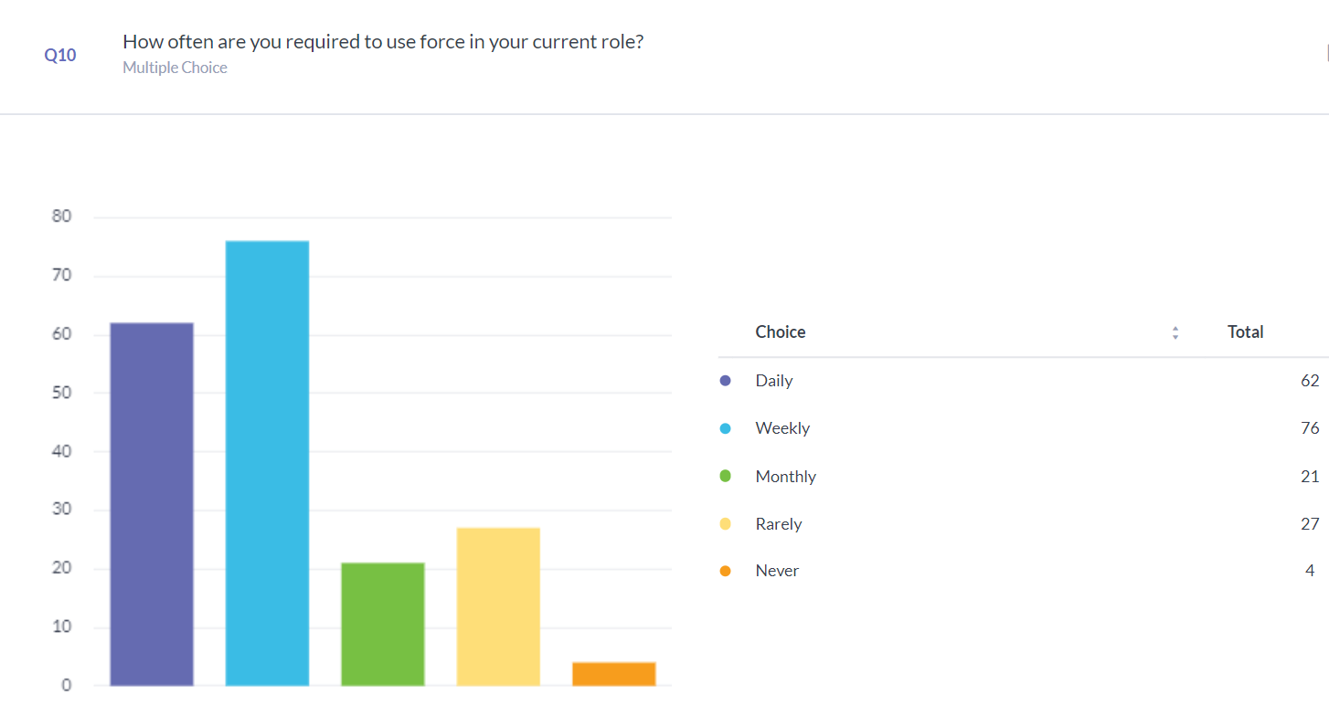
The findings indicate that a significant portion of the police force, approximately 73% (combining daily and weekly responses), face the necessity of employing force at least on a weekly basis. This highlights how prevalent force application is in policing duties, emphasising the continuous challenges officers face in balancing enforcement and ethical standards.
The limited number of responses indicating rare or non-existent use of force (approximately 16% for "Rarely" and 2% for "Never") could suggest that, while force is an inherent aspect of Policing, its application varies significantly based on role, context, and environment. This variation may be influenced by assignment types (e.g., frontline versus office-based roles), training, and situational demands​(Survey Output).
These findings are critical for assessing the impact of policies, training adequacy, and the pressures officers face. The necessity of force application on such a frequent basis underlines the importance of providing continuous and practical training tailored to real-life scenarios, as highlighted in subsequent responses regarding training and support

4.5.2 How effective do you feel the use of force is in achieving successful conflict resolution?
This question is pivotal in evaluating officers' views on whether the use of force meets its intended purpose of de-escalating and resolving conflicts effectively.
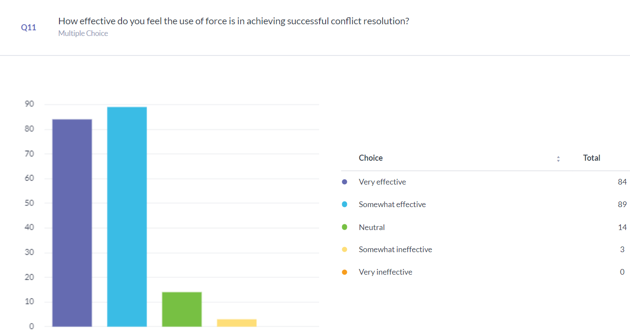
The responses from 190 officers were as follows:
These results indicate that a substantial majority—approximately 91% of respondents—perceive the use of force as at least somewhat effective in resolving conflicts. The confidence shown by 44% who deemed it "Very effective" suggests that, for many, force remains a necessary and impactful tool in achieving compliance and maintaining safety during confrontational situations.
However, the presence of 14 neutral responses and a small number (approximately 2%) who found it "Somewhat ineffective" may point to nuanced experiences where force does not guarantee resolution or could lead to unintended consequences. This underlines the complexities of using force as a strategy and suggests potential areas for training improvement and strategic adaptation.
These findings reflect the delicate balance police officers must strike between applying force effectively and minimising risks. They also prompt deeper considerations regarding the methods used for training officers to ensure that when force is applied, it is done with the highest possible efficacy and adherence to ethical standards​

4.5.3 How often does the use of force lead to de-escalation in violent situations?
This question is significant as it probes the extent to which force contributes positively to calming high-stress and potentially dangerous encounters. The breakdown of responses from 189 officers was:
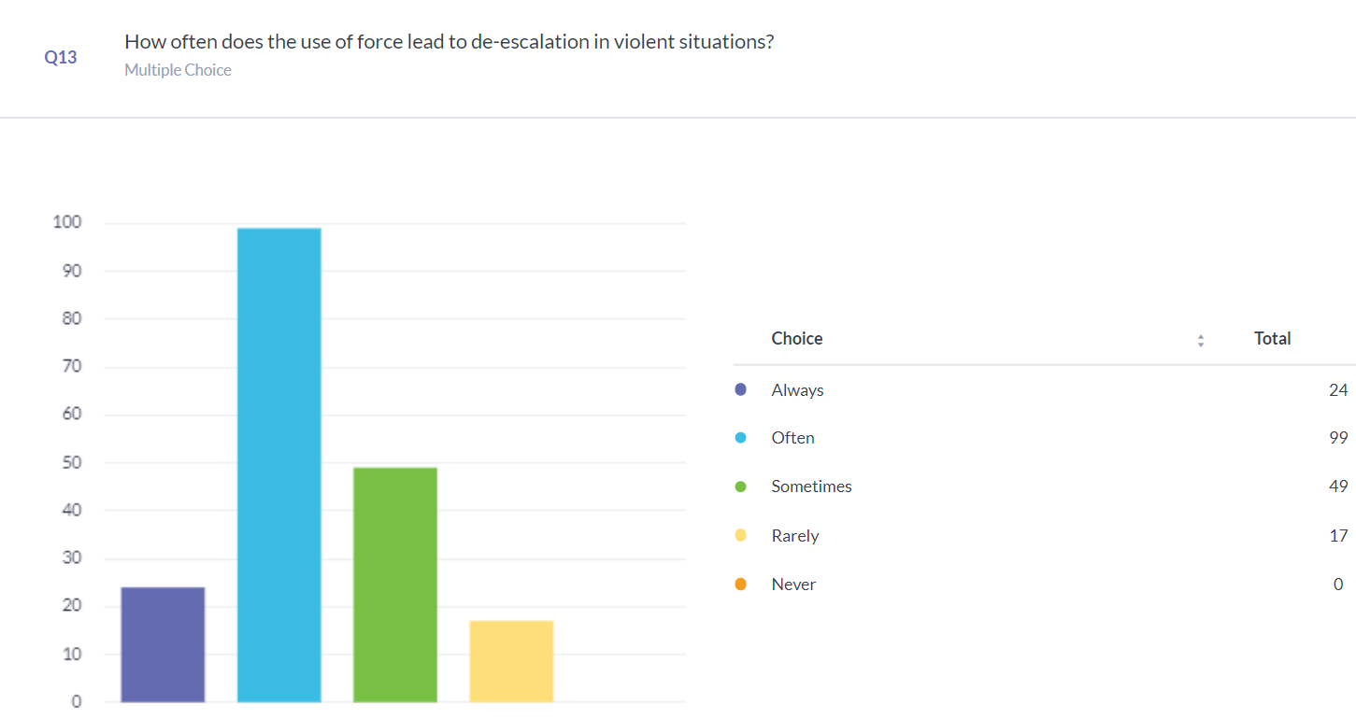
The data indicates that a notable 65% of respondents believe that force always or often results in de-escalation. This suggests that, in many instances, officers perceive force as an effective means to reduce violence and restore control. The fact that 26% selected "Sometimes" hints at the variability of outcomes, likely influenced by the nature of the incident, the type of force used, and external factors such as the individuals involved and environmental conditions.
The small percentage of responses indicating "Rarely" (9%) shows that while force is largely viewed as a de-escalatory tool, it does not uniformly achieve this outcome. This raises important points for consideration in training and policy development, emphasising the need for nuanced force application strategies that adapt to specific contexts.
Overall, these findings underscore the complex role of force as both a potential solution and a risk in violent situations. They highlight the importance of continuous training focused on situational assessment and alternative de-escalation techniques that could complement or substitute force where feasible

4.5.4 Do you believe current guidelines and policies regarding use of force are ethically sound? Do you believe there are adequate accountability mechanisms in place to review use of force incidents?
These questions aim to capture officers' perspectives on the integrity of the policies they follow and the systems that evaluate their actions.
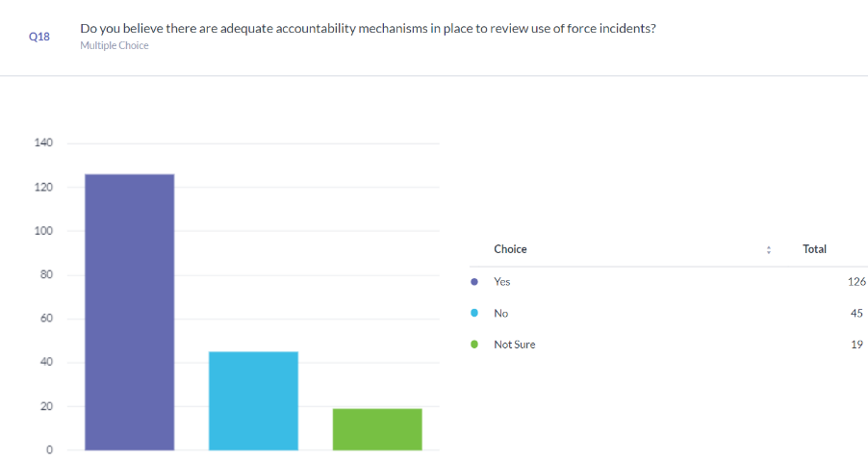
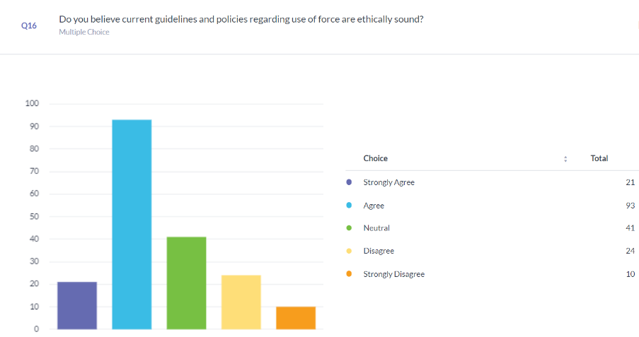

The responses to Question 16 show that approximately 60% of officers either "Strongly agree" or "Agree" that the current guidelines and policies on the use of force are ethically sound. This reflects a moderate level of confidence in the ethical foundations of force policies. However, 23% of officers expressed disagreement or strong disagreement, signalling that nearly a quarter of respondents’ harbour doubts about the ethical robustness of these guidelines.
The responses to Question 18 indicate that 66% of officers believe there are adequate accountability mechanisms in place to review incidents involving the use of force. However, a significant 24% expressed that these mechanisms are insufficient, while 10% were uncertain.
These combined findings emphasise an important dynamic of, while most officers are relatively confident in the ethical guidelines they operate under, there is less certainty about the capability of accountability mechanisms. The 24% who disagree with the ethical dependability of guidelines and the 34% who are not fully convinced by current accountability structures may point to areas where policy improvements, and clearer oversight could reinforce trust and faithfulness to ethical standards.
The responses to these questions emphasise that while a majority of officers maintain confidence in both ethical guidelines and review mechanisms, there is still a significant proportion that expresses concern. These insights, stress the importance of continuous evaluation and potential enhancement of both ethical frameworks and accountability systems to ensure they remain transparent, effective, and in alignment with policing standards

4.5.5 In your opinion, how does the public generally perceive the use of force by police? Do you believe the public understands the complexities of when and why force is used by police officers?
Question 21 asked, "In your opinion, how does the public generally perceive the use of force by police?", while Question 22 asks, "Do you believe the public understands the complexities of when and why force is used by police officers?" These questions are crucial for understanding the possible gap between police actions and public acceptance.
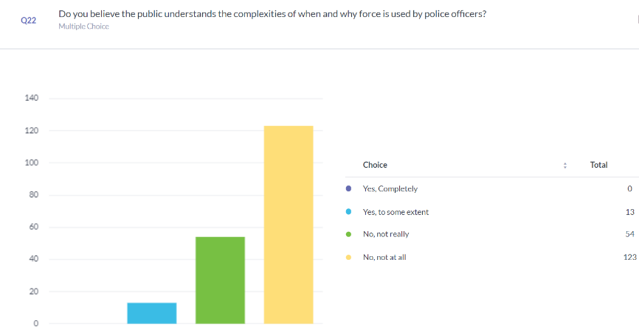
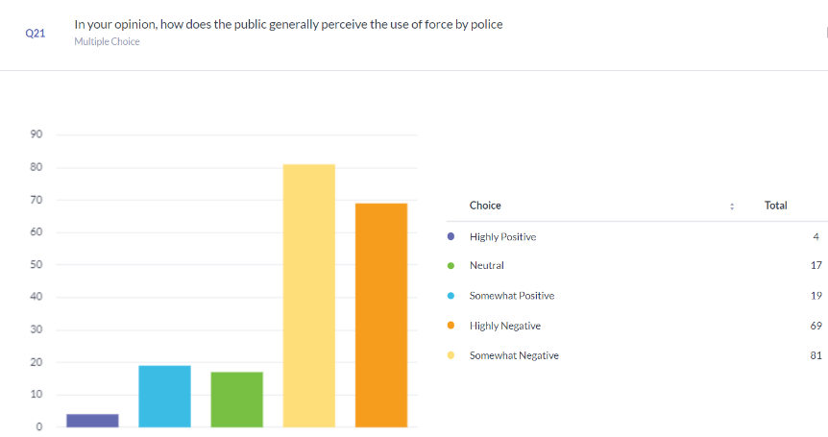
The responses to question 21 reveal a prevailing sense of negativity regarding public perception, with 42% of officers selecting "Highly Negative" and 43% choosing "Somewhat Negative." This indicates that 85% of the respondents feel that the public views the use of force in a negative light. Only a small proportion, about 12%, reported that the public holds a neutral or positive view.
Question 22 further reinforces this finding, as 93% of officers believe that the public either does not really understand or does not at all understand the complexities involved in the use of force. No officers indicated complete public understanding, and only 7% felt there was partial awareness.
The findings point to a divide, between the police and the public when it comes to the use of force. Police officers largely believe that the public harbour views and lacks insight into the intricacies surrounding the circumstances for applying force. This disconnect could have repercussions on trust, collaboration, and the broader rapport, between the police and society.
The findings suggest a critical need for strategies aimed at bridging this gap. Enhancing transparency, through educational campaigns or community engagement, could foster greater awareness of the challenges officers face, and the complex decision making involved in using force. These campaigns could educate the public as to the necessities of Police using force and why/when force is proportionate in certain circumstances. Additionally, this data highlights the importance of body cameras and timely public statements, as these tools can contribute to improving trust and clarifying the context surrounding incidents.

4.5.6 Have public perceptions of the police's use of force influenced how you apply it in your duties?
Question 24 asked, "Have public perceptions of the police's use of force influenced how you apply it in your duties?" This question helps understand the extent to which officers adjust their behaviour based on public sentiment and scrutiny.

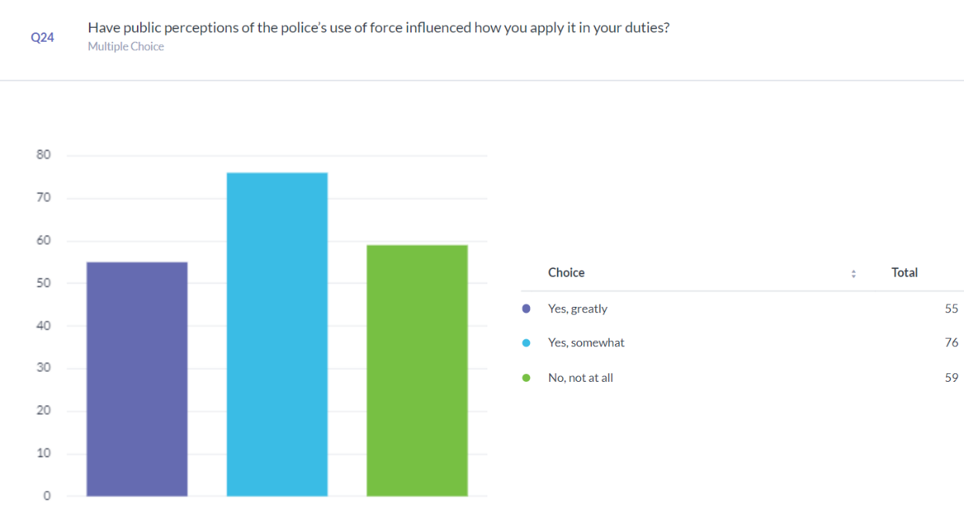

According to the feedback received it seems that a significant portion of officers (69%) believe that public opinion plays a role in their decision making when it comes to the use of force. With 29% admitting it has an impact and 40% finding it moderately influential. However, the data also reveals that 31% of respondents claim their actions are entirely unaffected, by public perception.
This reply stresses how public opinion can influence policing methods and potentially leading to more cautious or altered approaches in force application. It could also indicate an understanding that the scrutiny from the media and society can impact their lives and trust from the public. While it may be beneficial, in encouraging accountability and transparency this pressure could also introduce doubt or reconsideration in moments, which might affect the effectiveness of responses.
The fact that most officers report being influenced by public perception highlights the importance of ensuring that public awareness aligns with the realities of policing. This could mean reinforcing transparency measures, improving communication about why force is used, and providing educational insights into policing procedures. The influence of public opinion suggests that maintaining community trust and understanding is not only desirable but vital for officers' decision-making and confidence on duty.

4.5.7 Do you feel that the media's portrayal of use of force incidents fairly represents what happens in real-life policing?
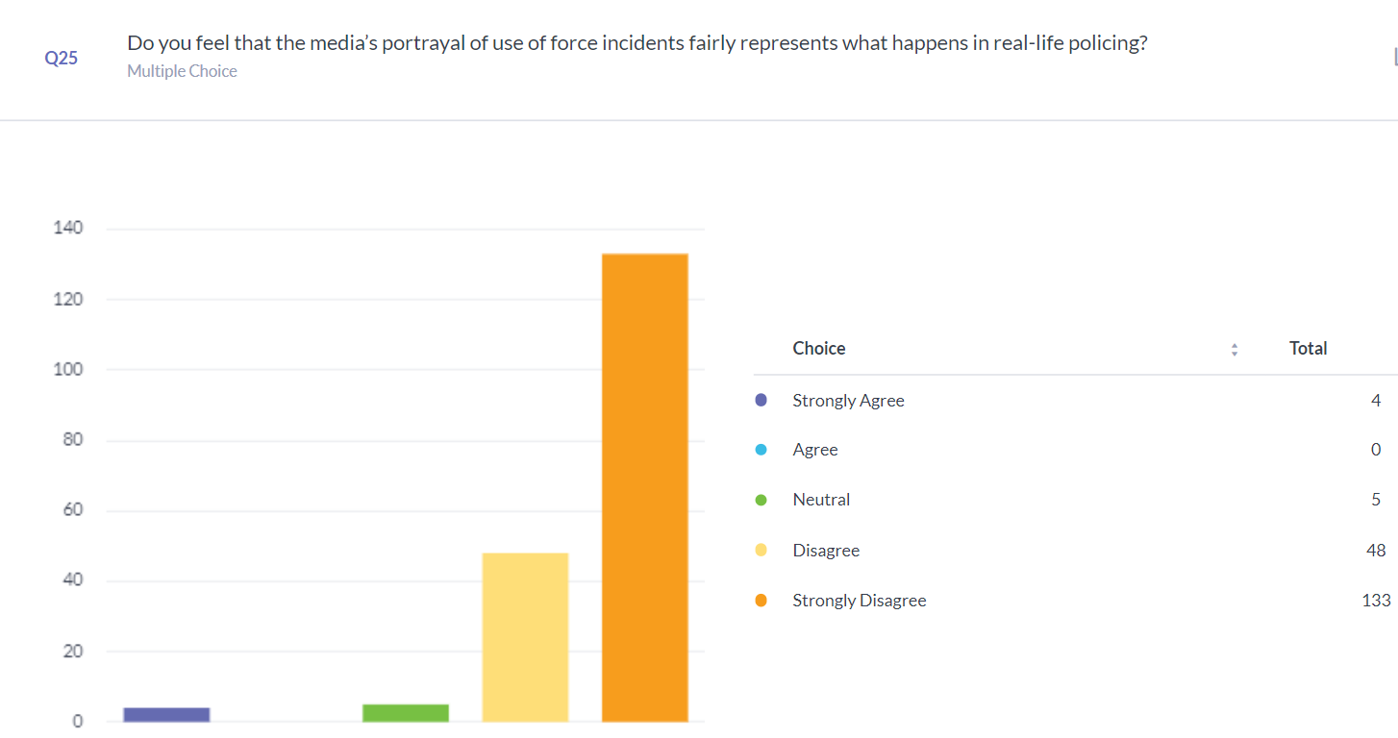
Question 25 asked, "Do you feel that the media's portrayal of use of force incidents fairly represents what happens in real-life policing?" This question is essential for assessing the perceived gap between media coverage and the actual experiences of police officers. This in turn can complement question 24, as the media plays a pivotal role in influence the perceptions on how the public view the police.
The responses to this question reveal a strong attitude among officers that media do not accurately reflect real-life policing. A strong 95% of respondents either "Disagree" or "Strongly Disagree" with the statement that media representation is fair, with 70% choosing "Strongly Disagree." This overwhelming consensus suggests that officers perceive a considerable disconnect between their experiences and how those incidents are depicted by the media.
Out of those surveyed in the group, 2% showed agreement with the media’s accuracy level. The 3% who selected "Neutral" may acknowledge occasional balanced coverage but remain cautious about overall representation.
The results suggest that many officers feel frustrated and lack trust in how the media covers their work which could affect how they engage with the media professionals. The perception of being misrepresented might lead to relationships, between Police Officers and communities as public opinion can be heavily influenced by media portrayals. The information also underscores the significance of promoting lines of communication between policing and the community directly. Implementing methods like sharing body camera recordings early on and conducting police media briefings could help bridge the gap and provide context that media stories might lack or simplify.

4.6 Conclusion
The examination of the survey results provides insights, into how police officers view and engage with the use of force in their in the course of their duties The data shows that force is a regular part of policing, with most officers using it on a weekly or more often basis. While many respondents feel force is effective in resolving conflicts and de-escalating violence, results vary based on context, underscoring the need for thorough training and clear policy guidance.
Questions related to ethical standards and accountability mechanisms reveal that while a majority of officers trust current guidelines, a significant minority question their adequacy. Public and media perceptions are seen as overwhelmingly negative, with most officers believing that the public lacks an understanding of the complexities of using force and that media coverage is often inaccurate. This influences how officers apply force, underlining the external pressures they face.
Overall, the finding show the importance of having continuous training inputs, transparency regarding policies, and better way on showcasing the realities of policing with the public. In turn this will in theory strengthen the trust and faith of non-police educated public in the realities of modern policing.

Chapter Five - Findings and Conclusion
5.1 Introduction
The results of this study offer a valuable insight, into how Police Officers view the use of force in their daily duties, considering both its effectiveness and the ethical concerns it raises. Investigating information gained from the 190 participants begins to reveal patterns in officers’ viewpoints on the implementation of force, training proficiency, the public and media perceptions and the support they receive from their employers. This chapter combines these findings, discussing their implications and drawing conclusions that could inform future policy’s, training practices, and public engagement strategies.

5.2 Analysis and Implications of Findings
The examination of the data uncovers understandings into how police officers view the necessity of using force in their line of duty. A notable aspect is the application of force by 73% of respondents indicating that they use force on a weekly basis which highlights the importance of ongoing training that mirrors real world situations and offers flexible approaches, for diverse circumstances. The majority supports the effectiveness of utilising force as a way to de-escalate situations; nevertheless, there are some critical reactions that highlight situations where the use of force may not always lead to the intended results. This indicates the necessity for subtle and context aware strategies to be implemented in order to guarantee that when force is utilised it enhances safety while also adhering to ethical standards.
One important point to consider is how police officers view the way they are perceived by the public and the media alike. Around 85% officers feel that the publics opinion of them is negative and almost 95% doubt if the media represents them fairly. This disparity between what officer’s experience and how they are seen by the public highlights an notable issue. It has consequences for building trust with communities and maintaining relationships. This emphasises the importance of communication strategies and open practices. The survey responses also show that external perceptions can impact police officers’ decision-making processes. This could result in officers being more cautious in their actions which might affect their effectiveness, in carrying out their duties.
Moreover, while most officers’ express confidence in the ethical grounding of current use-of-force policies, a notable portion questions the adequacy of oversight and accountability mechanisms. This underlines an area for policy refinement, ensuring that guidelines not only meet ethical standards but also maintain transparency and instil confidence among officers and the public.

5.3 Main Findings of the Dissertation
This research sought to explore how police officers view the use of force in terms of its effectiveness and ethical implications, in relation to perception and media portrayal. Some notable discoveries, from the study include:
Frequency of Use of Force: A substantial proportion of respondents (73%) reported using force at least weekly, with 16% indicating rare use and only 2% stating they never use force. This emphasises the regularity with which officers engage in forceful actions as part of their duties, highlighting the operational pressures in balancing force application with ethical and professional standards.

Effectiveness in Conflict Resolution 91 percent of the individuals surveyed considered the deployment of force to be somewhat effective, in addressing conflicts; 44 percent even labelled it as "highly effective." This suggests that many Police Officers perceive force as essential for ensuring compliance and maintaining safety, in scenarios. However, there were also contrasting opinions and neutral stances expressed in the study highlighting the nature of applying force and the likelihood of results depending on specific situations.

Perceived Role in De-escalation: According to the survey results obtained from participants responses; 65 percent of them believed that using force usually helps in calming situations while 26 percent mentioned that it works on occasions; 9 Percent expressed that it seldom achieves the desired outcome. This indicates that although force is generally seen as effective, in instances it can also be influenced by circumstances which highlight the importance of providing officers with proper training to improve their ability to assess situations and make informed decisions.

Ethical Confidence and Accountability: The survey showed that people have differing views, on the ethical guidelines for using force in the study area; 60% believed the current policies were ethically sound while 23 percent had doubts about them. In addition to this finding was that 66% were happy with the systems of responsibility in place while 34% had issues with them for reasons. This suggests a requirement for more solid guidelines to strengthen officers’ confidence, in how oversights carried out.

Public and Media Perception: From the officers’ responses an overwhelming majority of 85% believe that the public view their use of force negatively. An even higher amount of 93% state that the public lack understanding of the complexities involved in day-to-day policing. The danger that this perceived gap brings a higher likelihood that the mutual understanding grows further apart. This in turn may undermine the trust between both sides. Moreover, 95%of the participants expressed that the way the media portrays them is not accurate which highlights a gap, between their experiences and how they are depicted in the media. This indicates that officers believe they are not being portrayed truthfully which might affect their interactions, with both the media and public communication

Influence of Public Sentiment: Around 69% of police officers mentioned that the way the public perceives them impacts how they use force in their job responsibilities. This suggests that officers are mindful of the scrutiny they're under and may modify their actions as a result with their interactions with the public. This highlights the significance of establishing trust with the public and making sure that public understands the actualities of policing.

The finding highlights a delicate balance between effective policing of the public and the ethical obligations that naturally come with the role. Additionally, they also empathise the external pressures that come with media scrutiny, senior management and the process of possible consequences of utilising any force.

5.4 Limitations
As with every research endeavour it has its limitations and obstacles that can impact the results. This study is no different in that regard to the limitations that were faced
- Cross Sectional:
Due to the timeframe that the survey was conducted. it only captures a momentary glimpse of police officers’ perspectives at a specific point in time. This means that while the data provides valuable insights, it does not reflect changes in attitudes or perceptions over time. One notable drawback is the fact that the research's cross sectional in nature; it only captures a momentary glimpse of police officers’ perspectives at a specific point in time. This means that while the data provides valuable insights, it does not reflect changes in attitudes or perceptions over time.
- Self-Reported Data:
One issue to be aware of is the use of self-reported survey information which might be influenced by bias; officers could intentionally or unintentionally provide answers that they think are more socially acceptable or meet certain expectations that could affect the accuracy of the data collected even though anonymity was maintained to promote truthfulness.
- Sample Size:
The sample size of 190 officers, while fitting for a study of this scale, may not fully represent the entire population of police officers across all 43 forces of England and Wales.

- External Influences
Lastly, external influences like scrutiny and media attention could influence how officers perceive and answer this survey which might lead to a bias in the data being collected from the surveys. The acknowledgement of these constraints is important, for gaining an understanding of the environment in which the outcomes are analysed and for guarantee that forthcoming investigations can expand on these discoveries.

5.5 Recommendations
From this research and the findings above it has identified gaps in the understanding of the policing role and the impact factors officers consider when utilising force. More in depth research into the impact the media portrayal of policing has on an officers decision making and consideration of force may prove beneficial in identifying whether officers are more or less likely to use force when they consider how their actions could be perceived in the media, but also whether the decision they make based on this can impact the overall outcome of the incident their attached to, resulting in less successful outcomes to incidents.
In order to try and ensure that the significant concern raised by officers in this paper regarding them feeling unfairly represented in the media I would suggest forces start further utilising their social media platform to provide more body worn video footage to allow transparency to the public and provide them with a better understanding of what officers are dealing with in the current day and age. Campaigns similar to the ‘what would you do campaign’, could be reintroduced to restart an open dialogue between police forces and the communities they serve.
Further research could also be conducted into how both officers and the public feel that the police should be held responsible for their actions, this research has shown that a reasonable percentage of the officers that were included in this study identified that they do not feel there are reasonable processes to ensure accountability and perhaps if developed in an open dialogue with the public a more transparent approach can be identified.
Overall, this research has shown that Use of force is still an under discussed topic, often officers are unwilling to discuss the matter due to how it is perceived in the media and by the public.
Policing has often been seen to be a very closed circle and what happens within its walls was seldom discussed with the public. However, in the current day where Social Media and News outlets are easily accessible across the world, and officers are facing increasing criticism for their use of force now is the time to break down those barriers and allow effective communication so that either side of the wall can see the topic from all aspects.

Bibliography
Anon (2021) Research methods : the basics /. Third edition. Abingdon, Oxon ; New York, NY :, Routledge,.
Bell, J. (2018) Doing your research project : a guide for first-time researchers . Seventh edition. London, England ; New York, New York :; London, England ; New York, New York :, McGraw-Hill Education.
Bryman, A. (2012). Social Research Methods. 4th ed. Oxford: Oxford University Press.
Chapman, C. (2012). ‘Use of force in minority communities is related to police education, age, experience, and ethnicity’, Police Practice and Research, 13(5), pp. 421–436. doi:10.1080/15614263.2011.596711.
Colbran, M.P. (2018). ‘Policing, social media and the new media landscape: Can the police and the traditional media ever successfully bypass each other?’, Policing and Society, 30(3), pp. 295–309. doi:10.1080/10439463.2018.1532426.
Compton, M.T. et al. (2009) ‘Use of force preferences and perceived effectiveness of actions among crisis intervention team (CIT) police officers and non-cit officers in an escalating psychiatric crisis involving a subject with schizophrenia’, Schizophrenia Bulletin, 37(4), pp. 737–745. doi:10.1093/schbul/sbp146.
Creswell, J.W. (2014). Research Design: Qualitative, Quantitative, and Mixed Methods Approaches. 4th ed. Thousand Oaks, CA: Sage Publications.
Dierenfeldt, R. et al. (2024) ‘(mis)perceptions of the use of deadly force by police: Exploring the role of social media consumption’, International Journal of Offender Therapy and Comparative Criminology [Preprint]. doi:10.1177/0306624x241227408.
Donovan, K.M. and Klahm, C.F. (2015) ‘The role of entertainment media in perceptions of police use of force’, Criminal Justice and Behavior, 42(12), pp. 1261–1281. doi:10.1177/0093854815604180.
Dowler, K. and Zawilski, V. (2007) ‘Public perceptions of police misconduct and discrimination: Examining the impact of media consumption’, Journal of Criminal Justice, 35(2), pp. 193–203. doi:10.1016/j.jcrimjus.2007.01.006.
Flick, U. (2011). Introducing Research Methodology: A Beginner’s Guide to Doing a Research Project. London: Sage.
Ghauri, P., Gronhaug, K. and Strange, R. (2020) Research Methods in Business Studies. Cambridge University Press.
Ghauri, P., Grønhaug, K., & Strange, R. (2020). Research Methods in Business Studies. 5th ed. Cambridge: Cambridge University Press.
Hill, R., and Conner, P. (2021). Effective Policing Practices: Training and Ethics. Cambridge: Cambridge University Press.
Jones, B. (2021) ‘Police-generated killings: The gap between ethics and law’, Political Research Quarterly, 75(2), pp. 366–378. doi:10.1177/10659129211009596.
Miethe, T.D., Venger, O., and Lieberman, J.D. (2019). ‘Police use of force and its video coverage: An experimental study of the impact of media source and content on public perceptions’, Journal of Criminal Justice, 60, pp. 35–46. doi:10.1016/j.jcrimjus.2018.10.006.
Milton, C. et al. (1977). Police use of deadly force. Washington: Police Foundation.
Mitchell, R.J. and Lewis, S. (2017) ‘Intention is not method, belief is not evidence, rank is not proof’, International Journal of Emergency Services, 6(3), pp. 188–199. doi:10.1108/ijes-04-2017-0018.
Owen, D. (2003). ‘The demographic characteristics of people from minority ethnic groups in Britain’, Explaining ethnic differences, pp. 21–52. doi:10.51952/9781847425768.ch003.
Patton, M.Q. (2015) Qualitative research and evaluation methods . 4th edition. Los Angeles :, SAGE.
Pitts, J.M.A. (2022) ‘Justice or Just Us: Media Portrayals and the Context of Police Violence’, Justice Policy Journal, 19(1).
Prinsloo, J. and Kingshott, B. (2004) ‘Ethics in policing’, Phronimon, 5(1).
Saunders, M., Lewis, P., & Thornhill, A. (2016). Research Methods for Business Students. 7th ed. Harlow: Pearson Education.
Schuck, A.M., Rabe-Hemp, C. and Harris, C. (2023) ‘A feminist ethics of care approach to de-escalation in policing’, Police Conflict Management, Volume I, pp. 169–193. doi:10.1007/978-3-031-41096-3_8.
Scottish Police Federation (2017). #itswhatwedo Campaign Video. [online] Available at: [https://www.youtube.com/watch?v=qU0mbo5KbCw].
Smith, M.R. and Petrocelli, M. (2002) ‘The effectiveness of force used by police in making arrests’, Police Practice and Research, 3(3), pp. 201–215. doi:10.1080/15614260220150591.
Spierer, D.K., Griffiths, E., and Sterland, T. (2009). ‘Fight or flight: Measuring and understanding human stress response in tactical situations’, The Tactical Edge [Preprint].
Stroshine, M.S. and Brandl, S.G. (2019) ‘The use, effectiveness, and hazards associated with police use of force: The unique case of weaponless physical force’, Police Practice and Research, 21(6), pp. 591–608. doi:10.1080/15614263.2019.1582342.
Taylor, S.E. et al. (2002). ‘Biobehavioral responses to stress in females: Tend-and-befriend, not fight-or-flight’, Foundations in Social Neuroscience, pp. 661–694. doi:10.7551/mitpress/3077.003.0048.
Terrill, W. (2005) ‘Police use of force: A transactional approach’, Justice Quarterly, 22(1), pp. 107–138. doi:10.1080/0741882042000333663.
Tyler, T.R. (2006). Why People Obey the Law. Princeton: Princeton University Press.
Walsh, J.P., and O’Connor, C. (2018). ‘Social Media and Policing: A review of recent research’, Sociology Compass, 13(1). doi:10.1111/soc4.12648.
Wingfield, K. (2021). ‘Historical Analysis of Policing in the United States: Impact on Use of Force Policies’. All Capstone Projects, 550. Available at: https://opus.govst.edu/capstones/550
Her Majesty's Inspectorate of Constabulary and Fire & Rescue Services (HMICFRS) (2021) Disproportionate use of police powers: A spotlight on stop and search and the use of force. Available at: https://hmicfrs.justiceinspectorates.gov.uk/publications/disproportionate-use-of-police-powers-a-spotlight-on-stop-and-search-and-the-use-of-force/ (Accessed: 25 November 2024).
Independent Office for Police Conduct (IOPC) (2022) National stop and search learning report. Available at: https://www.policeconduct.gov.uk/publications/national-stop-and-search-learning-report (Accessed: 25 November 2024).

Appendix 1 : Questionnaire

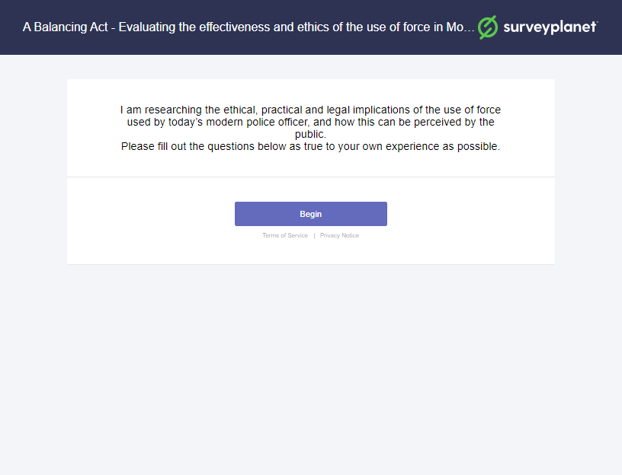

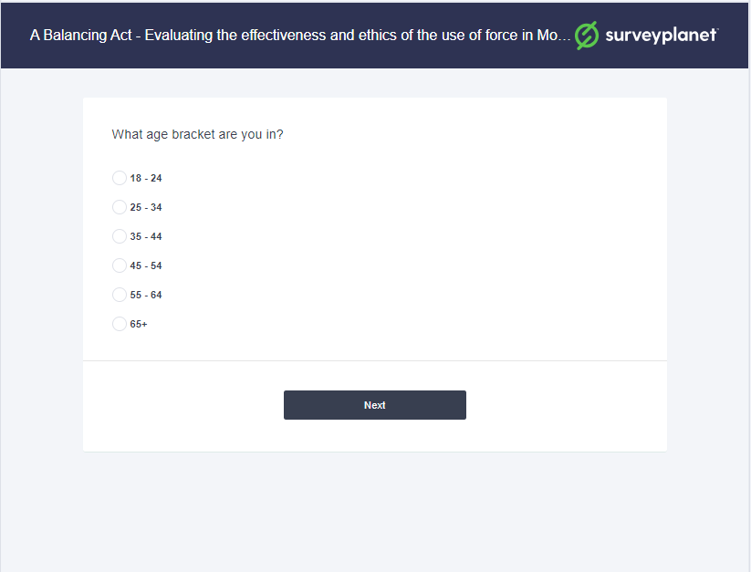

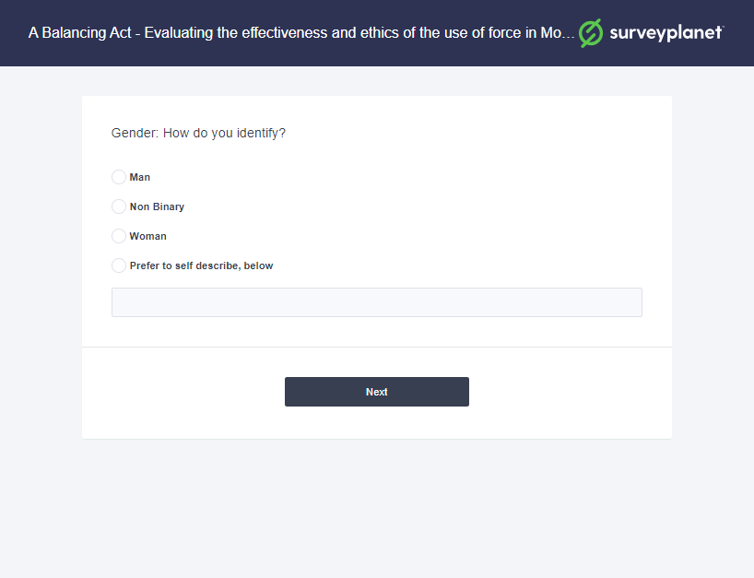

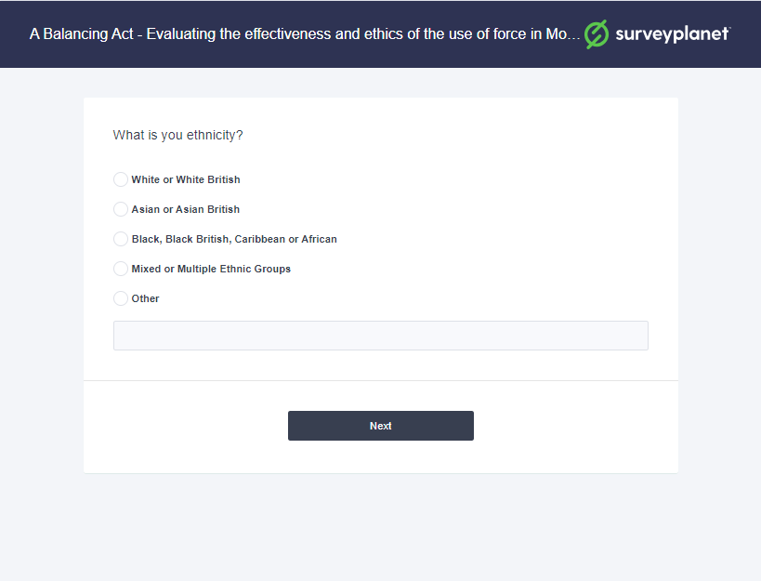

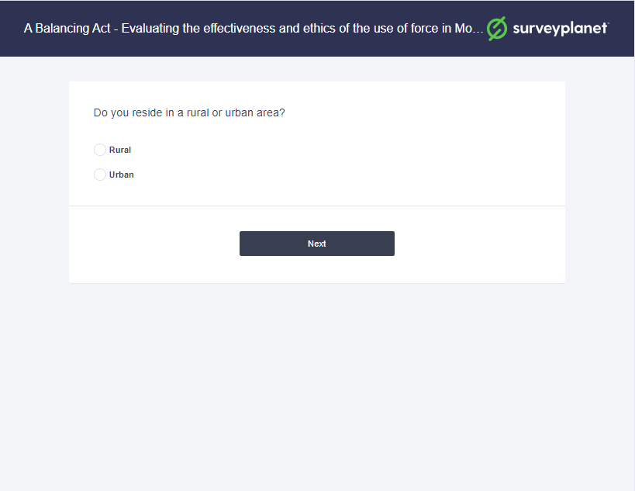

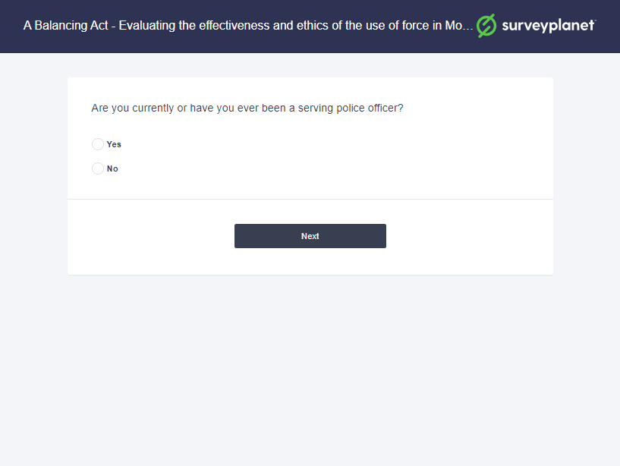

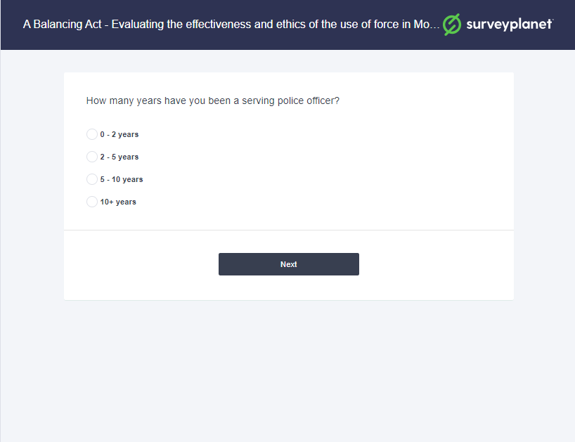

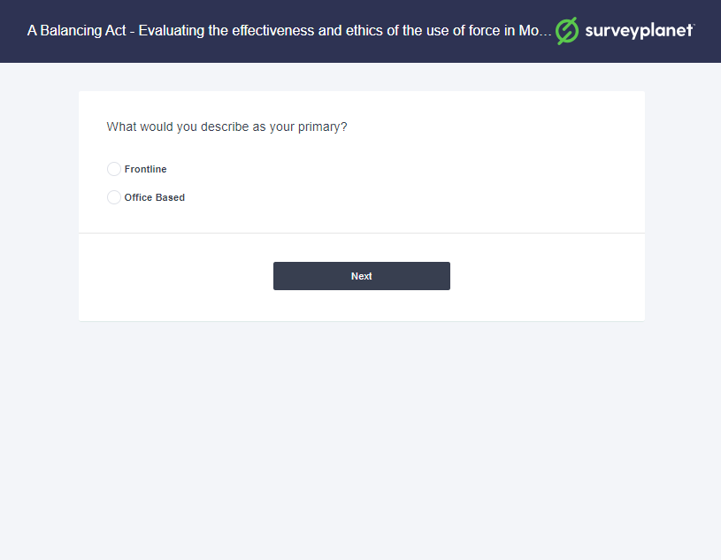

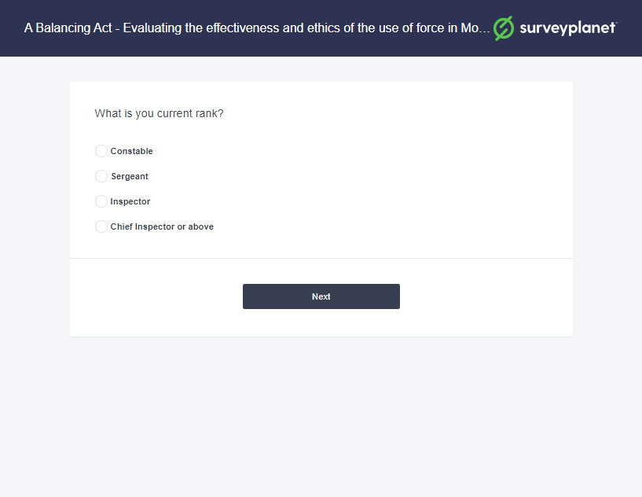

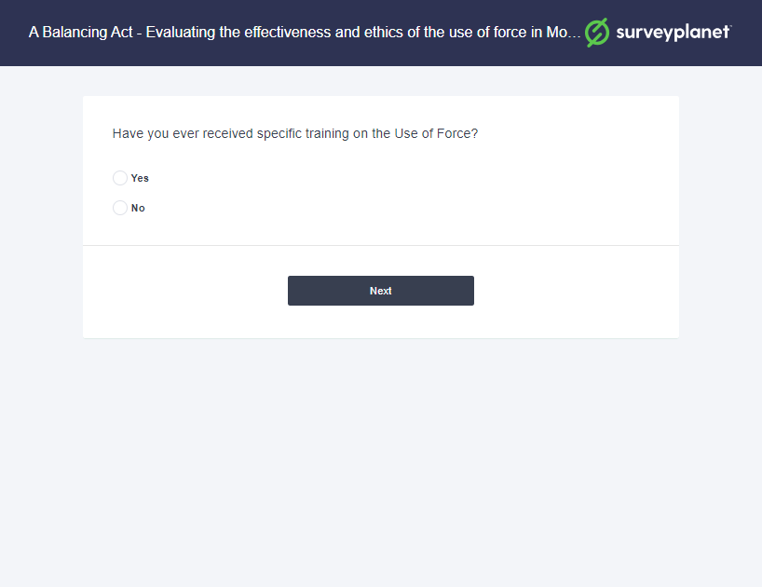

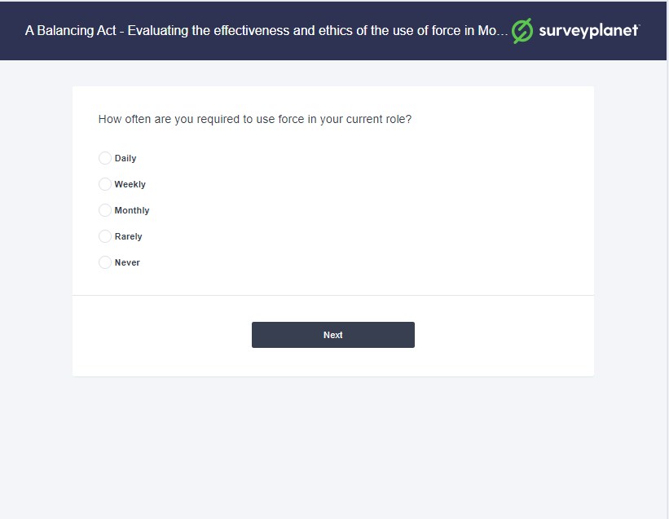

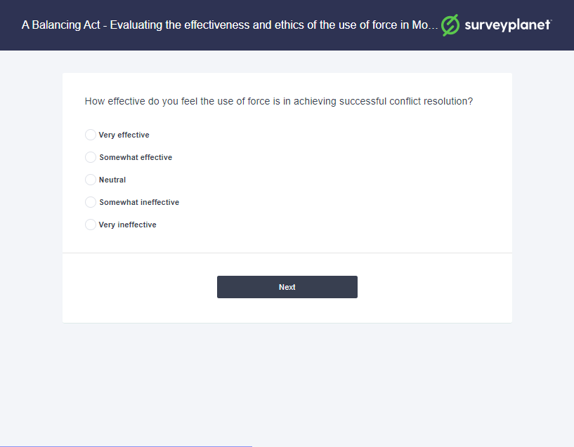

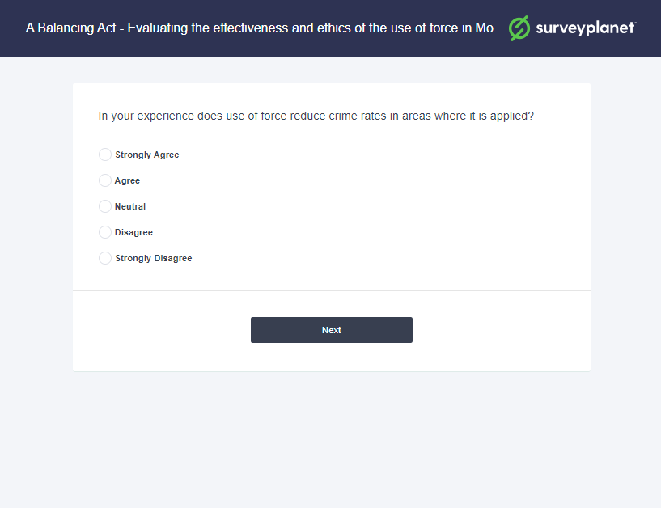

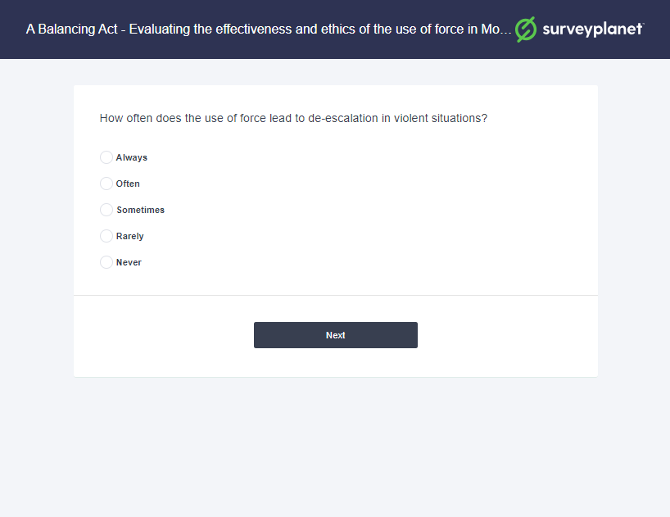

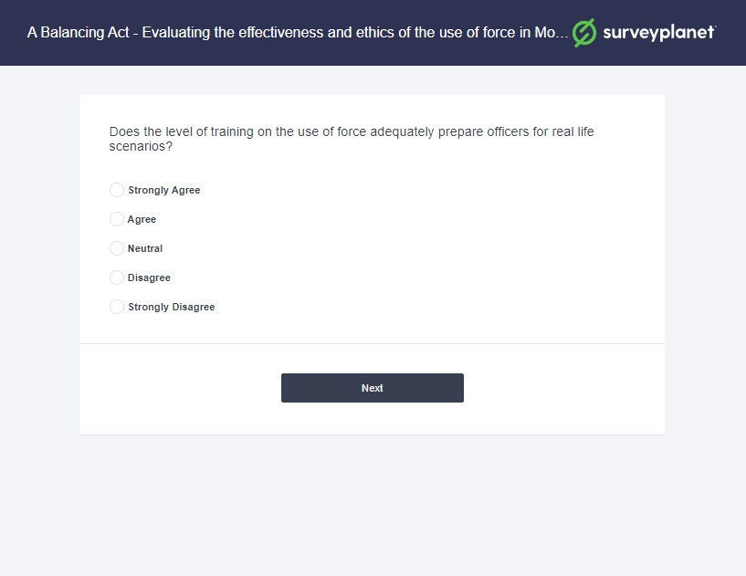

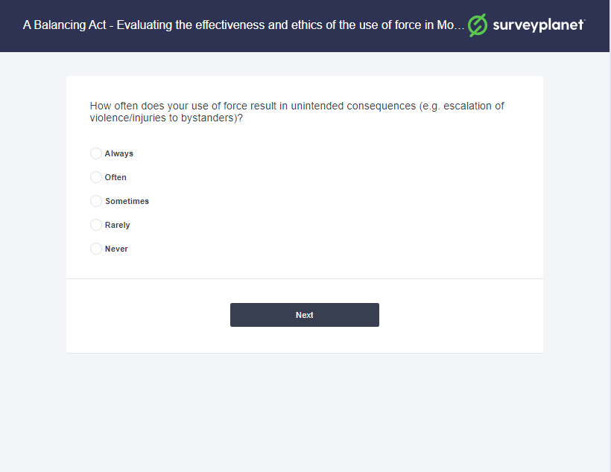

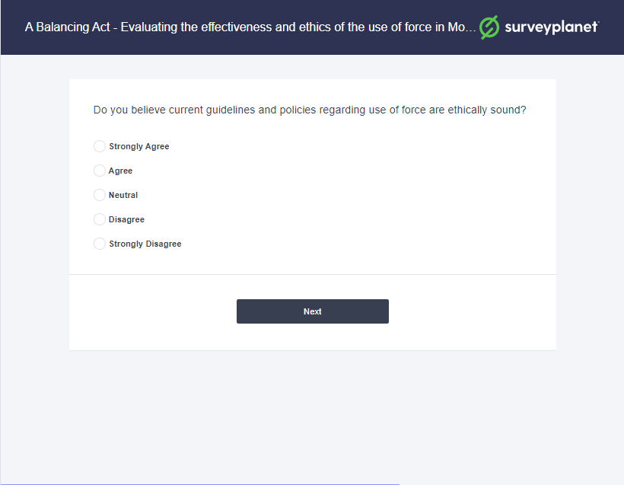

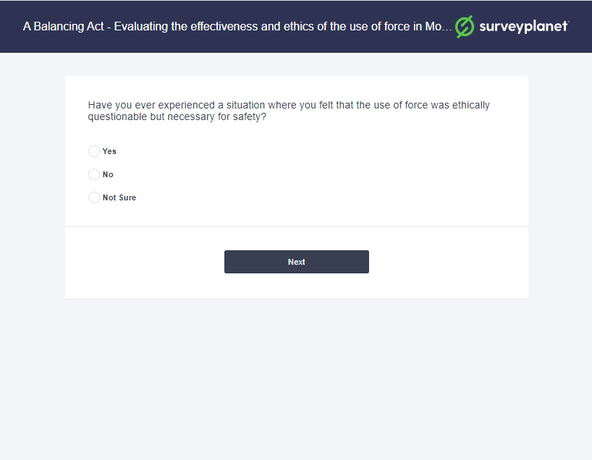

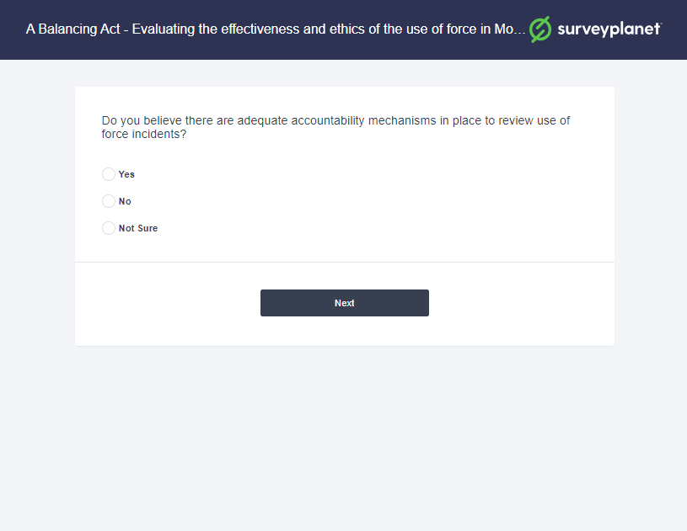

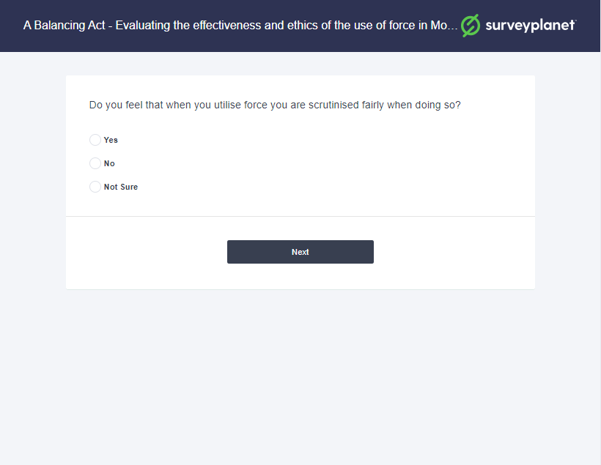

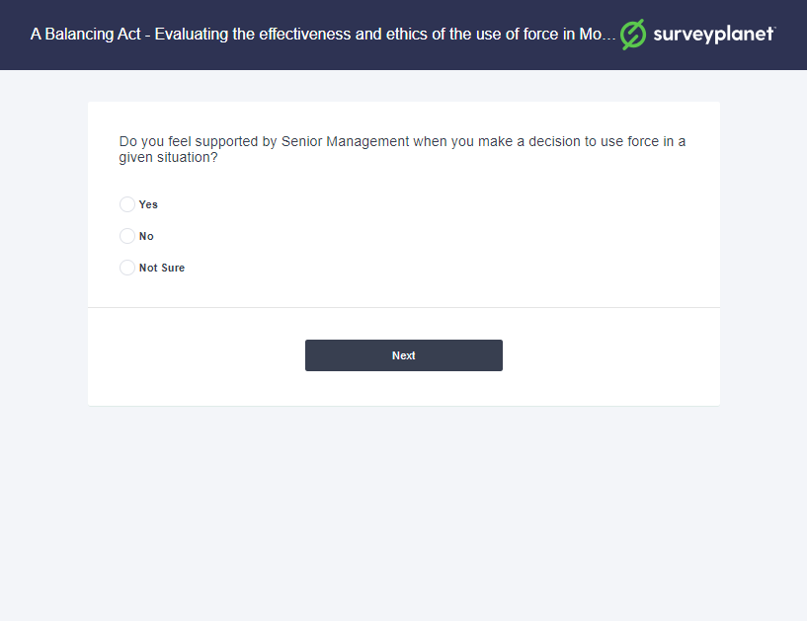

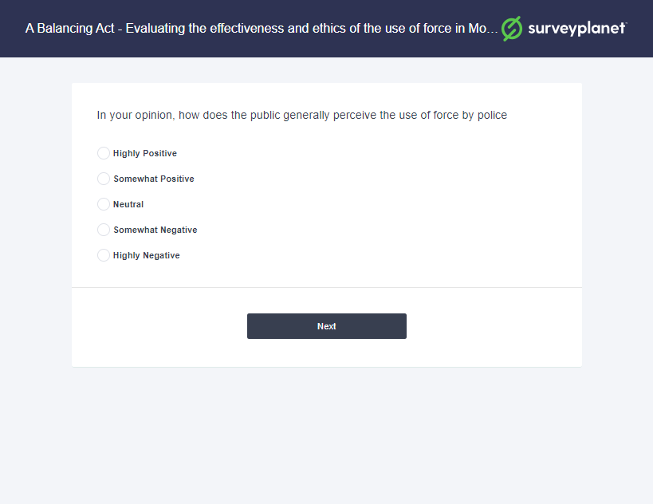

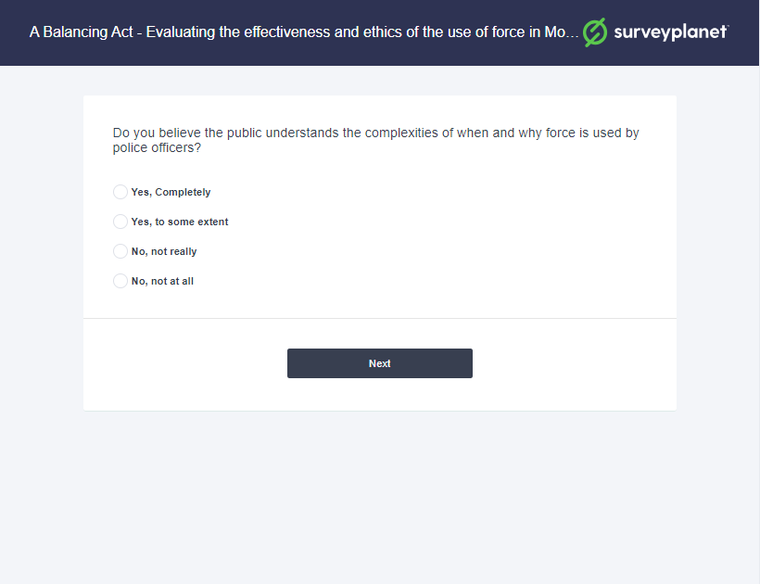

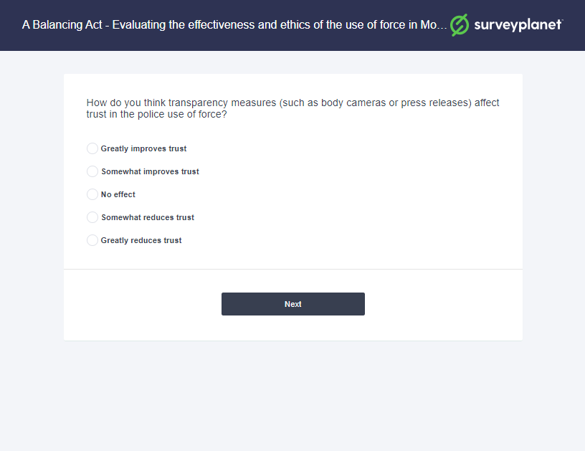

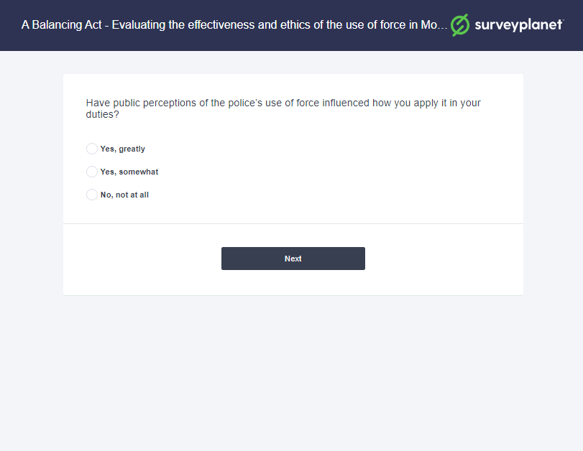

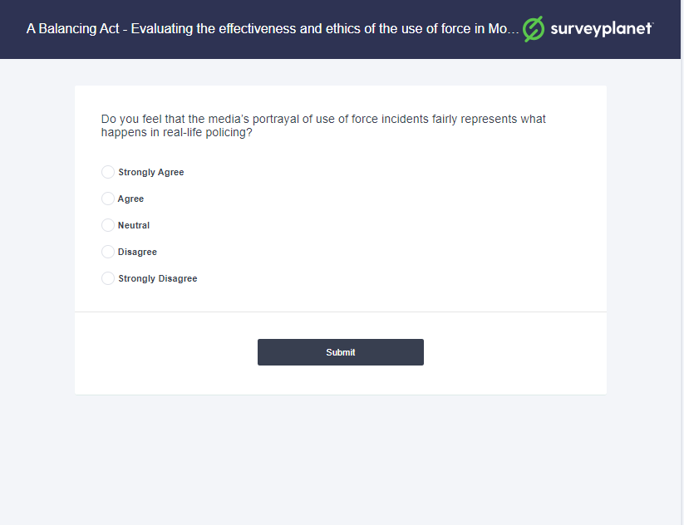

Appendix 2: Questionnaire Responses

A Balancing Act - Evaluating the effectiveness and ethics of the use of force in Modern Policing
I am researching the ethical, practical and legal implications of the use of force used by today's modern police officer, and how this can be perceived by the public. Please fill out the questions below as true to your own experience as possible.
Q1 What age bracket are you in?
Multiple Choice
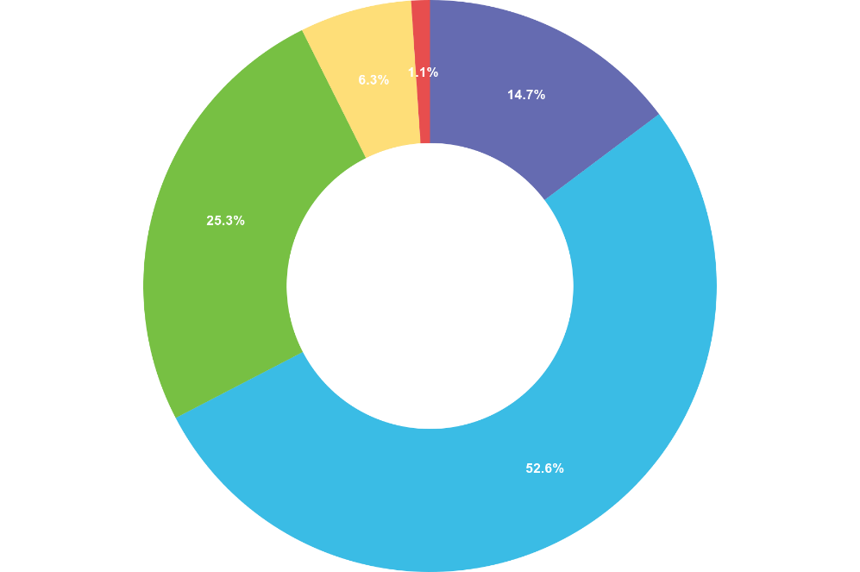

 | Choice | Totals
• | 18 - 24 | 28
• | 25 - 34 | 100
• | 35 - 44 | 48
• | 45 - 54 | 12
• | 55 - 64 | 0
• | 65+ | 2
Responses 190 Answered 190 Unanswered 0
Q2 Gender: How do you identify?
Multiple Choice
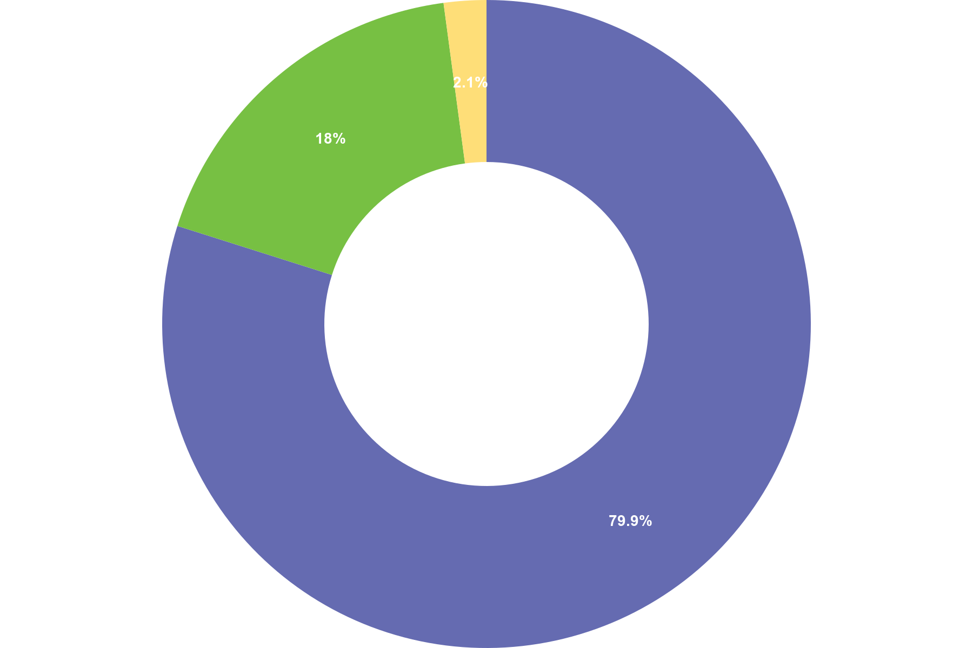
 | Choice | Totals
• | Man | 151
• | Non Binary | 0
• | Woman | 34
• | Prefer to self-describe, below | 4
Responses 190 Answered 189 Unanswered 1

Q3 What is you ethnicity?
Multiple Choice
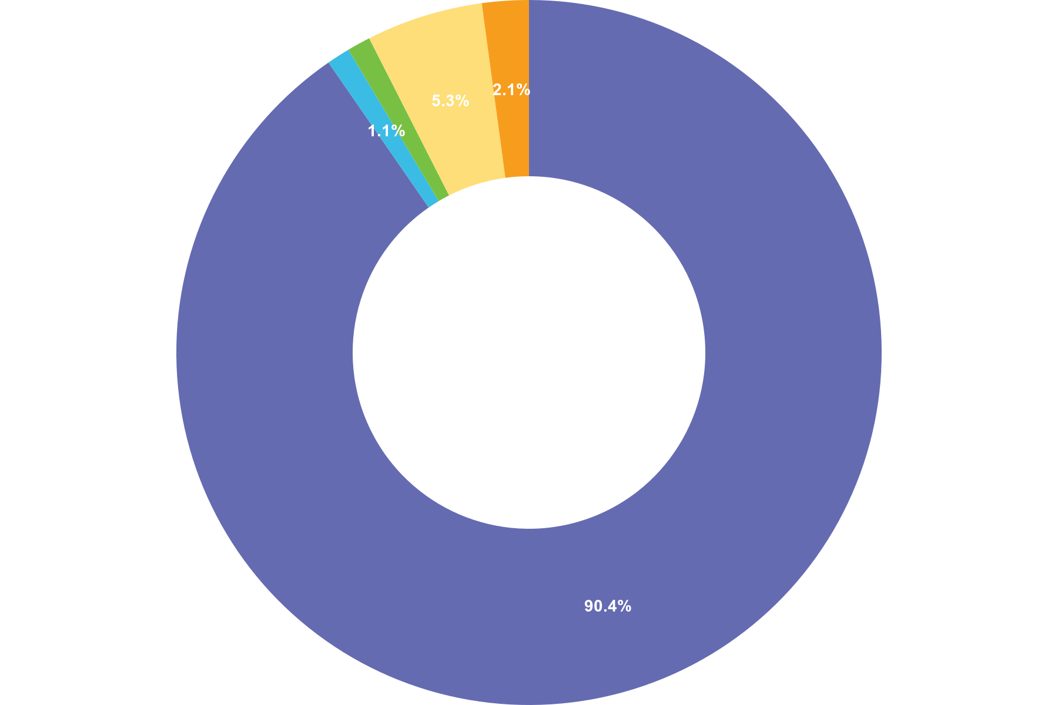
 | Choice | Totals
• | White or White British | 169
• | Asian or Asian British | 2
• | Black, Black British, Caribbean or African | 2
• | Mixed or Multiple Ethnic Groups | 10
• | Other | 4
Responses 190 Answered 187 Unanswered 3
Q4 Do you reside in a rural or urban area?
Multiple Choice
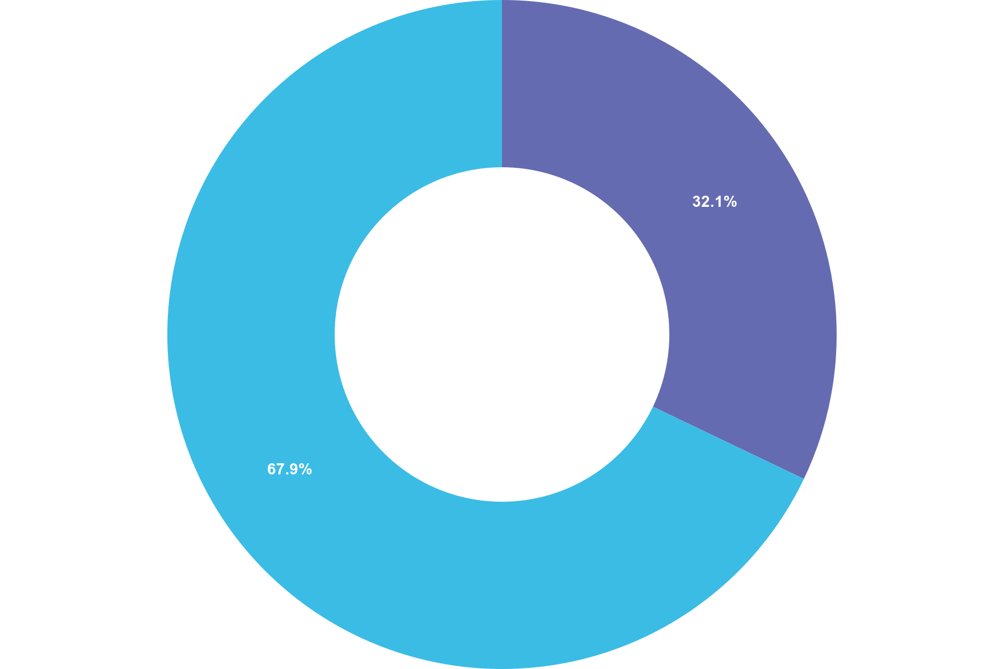
 | Choice | Totals
• | Rural | 61
• | Urban | 129
Responses 190 Answered 190 Unanswered 0

Q5 Are you currently or have you ever been a serving police officer?
Multiple Choice
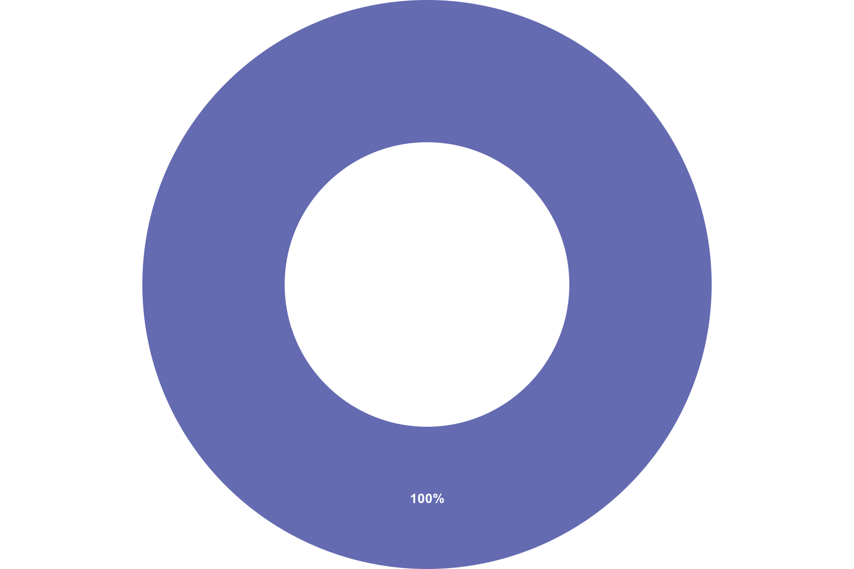
 | Choice | Totals
• | Yes | 190
• | No | 0
Responses 190 Answered 190 Unanswered 0

Q6 How many years have you been a serving police officer?
Multiple Choice
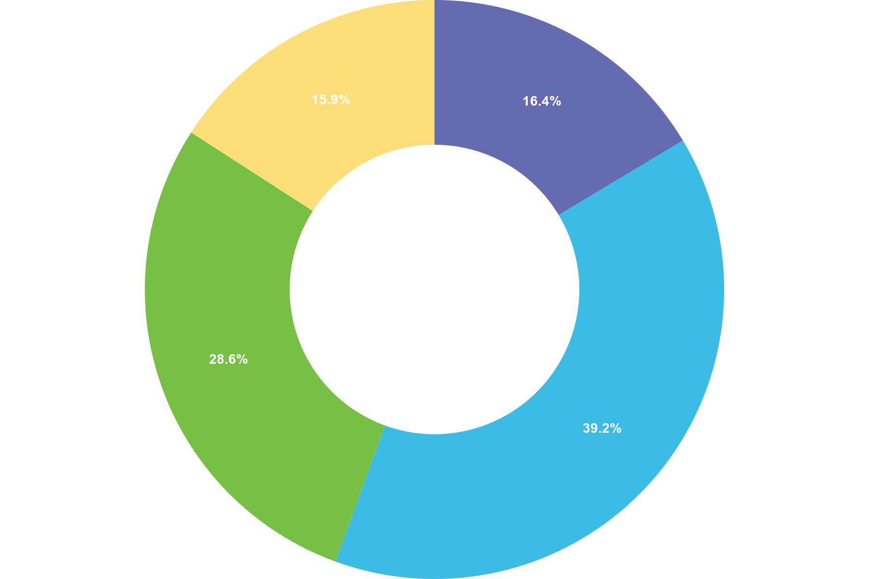
 | Choice | Totals
• | 0 - 2 years | 31
• | 2 - 5 years | 74
• | 5 - 10 years | 54
• | 10+ years | 30
Responses 190 Answered 189 Unanswered 1

Q7 What would you describe as your primary?
Multiple Choice
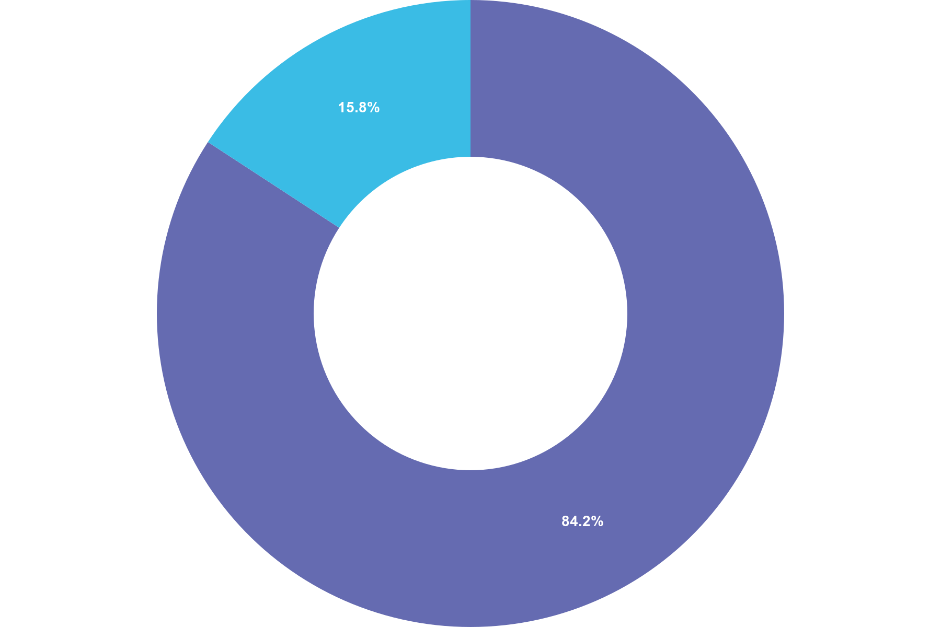
 | Choice | Totals
• | Frontline | 160
• | Office Based | 30
Responses 190 Answered 190 Unanswered 0

Q8 What is you current rank?
Multiple Choice
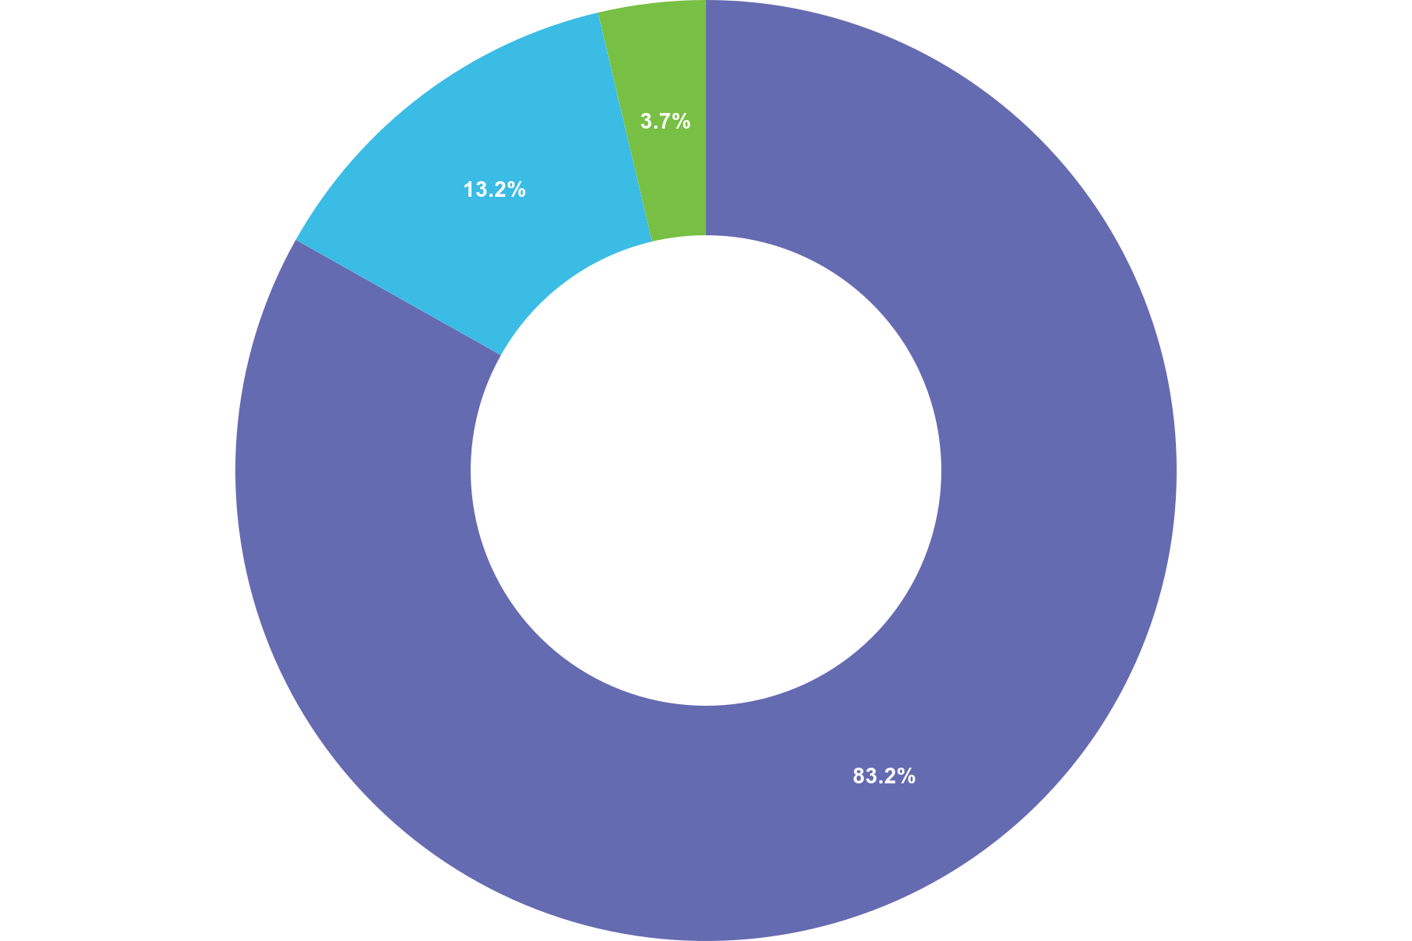
 | Choice | Totals
• | Constable | 158
• | Sergeant | 25
• | Inspector | 7
• | Chief Inspector or above | 0
Responses 190 Answered 190 Unanswered 0

Q9 Have you ever received specific training on the Use of Force?
Multiple Choice
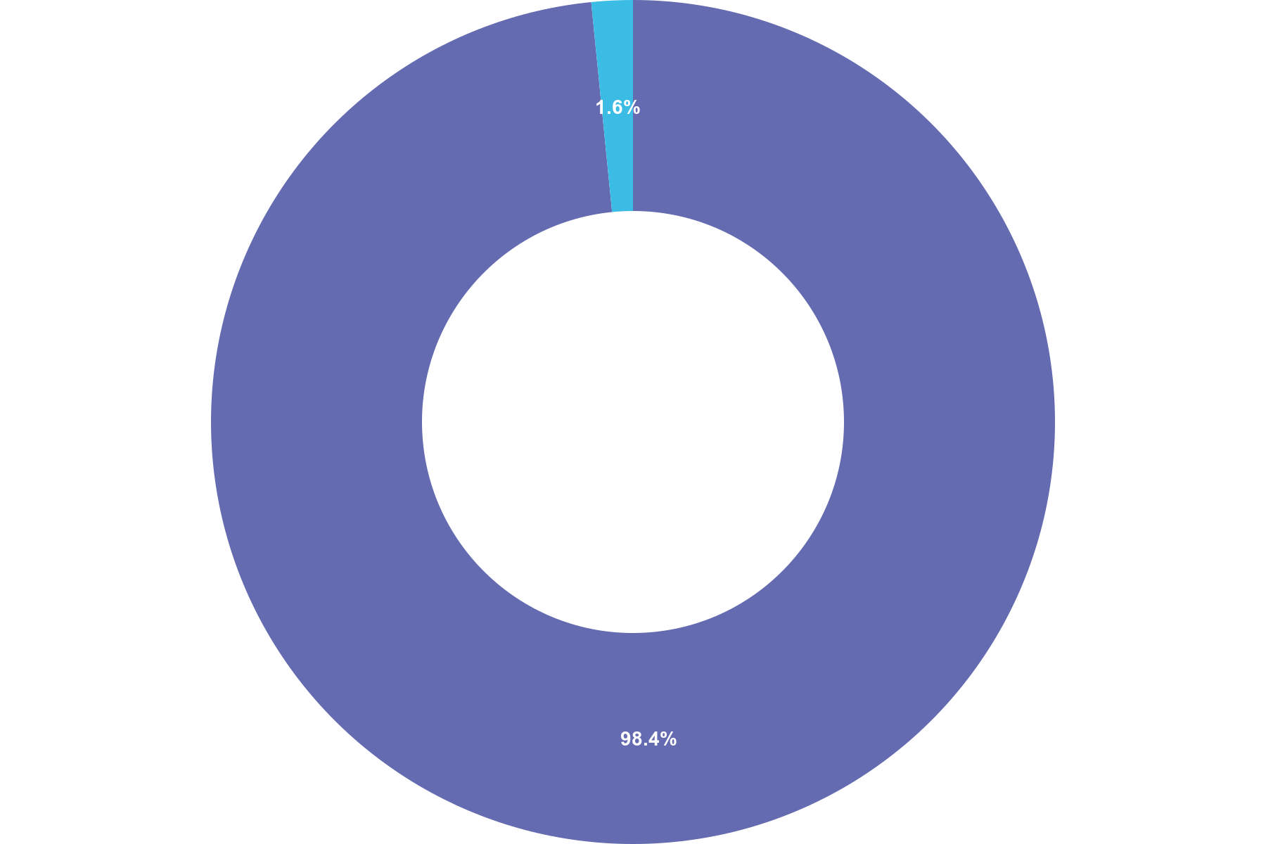
 | Choice | Totals
• | Yes | 187
• | No | 3
Responses 190 Answered 190 Unanswered 0

Q10 How often are you required to use force in your current role?
Multiple Choice
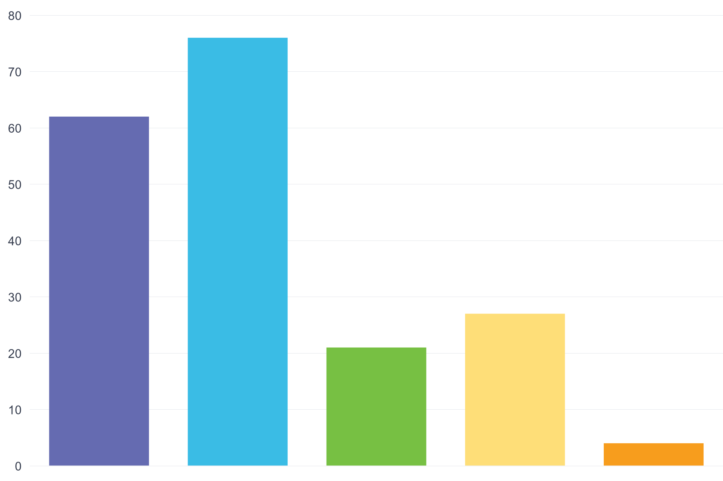
 | Choice | Totals
• | Daily | 62
• | Weekly | 76
• | Monthly | 21
• | Rarely | 27
• | Never | 4
Responses 190 Answered 190 Unanswered 0
Q11 How effective do you feel the use of force is in achieving successful conflict resolution?
Multiple Choice
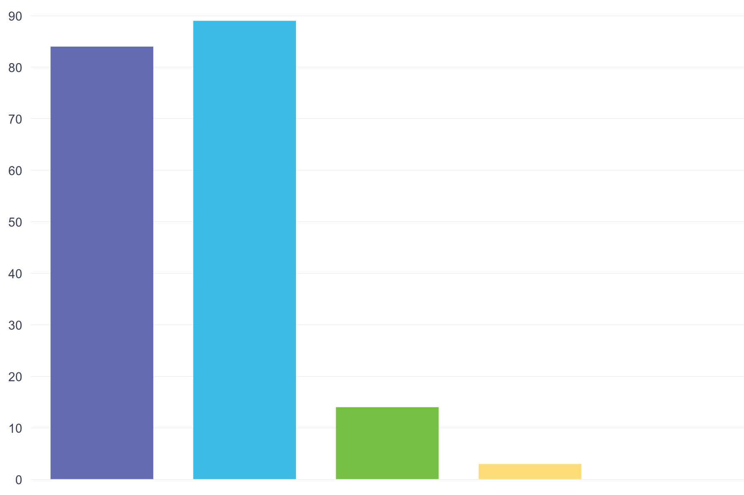
 | Choice | Totals
• | Very effective | 84
• | Somewhat effective | 89
• | Neutral | 14
• | Somewhat ineffective | 3
• | Very ineffective | 0
Responses 190 Answered 190 Unanswered 0
Q12 In your experience does use of force reduce crime rates in areas where it is applied?
Multiple Choice
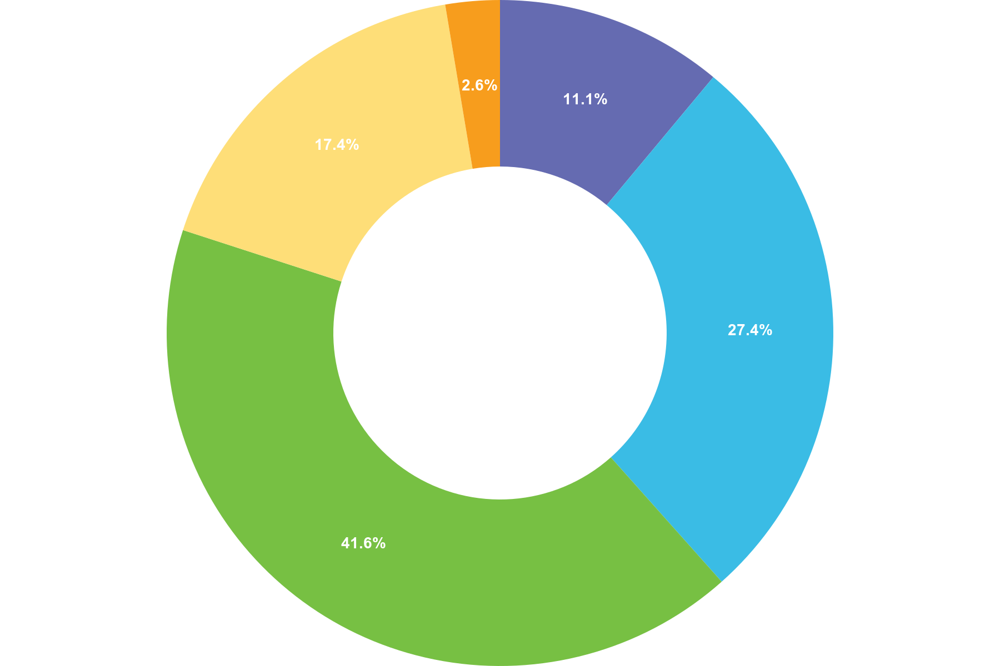
 | Choice | Totals
• | Strongly Agree | 21
• | Agree | 52
• | Neutral | 79
• | Disagree | 33
• | Strongly Disagree | 5
Responses 190 Answered 190 Unanswered 0
Q13 How often does the use of force lead to de-escalation in violent situations?
Multiple Choice
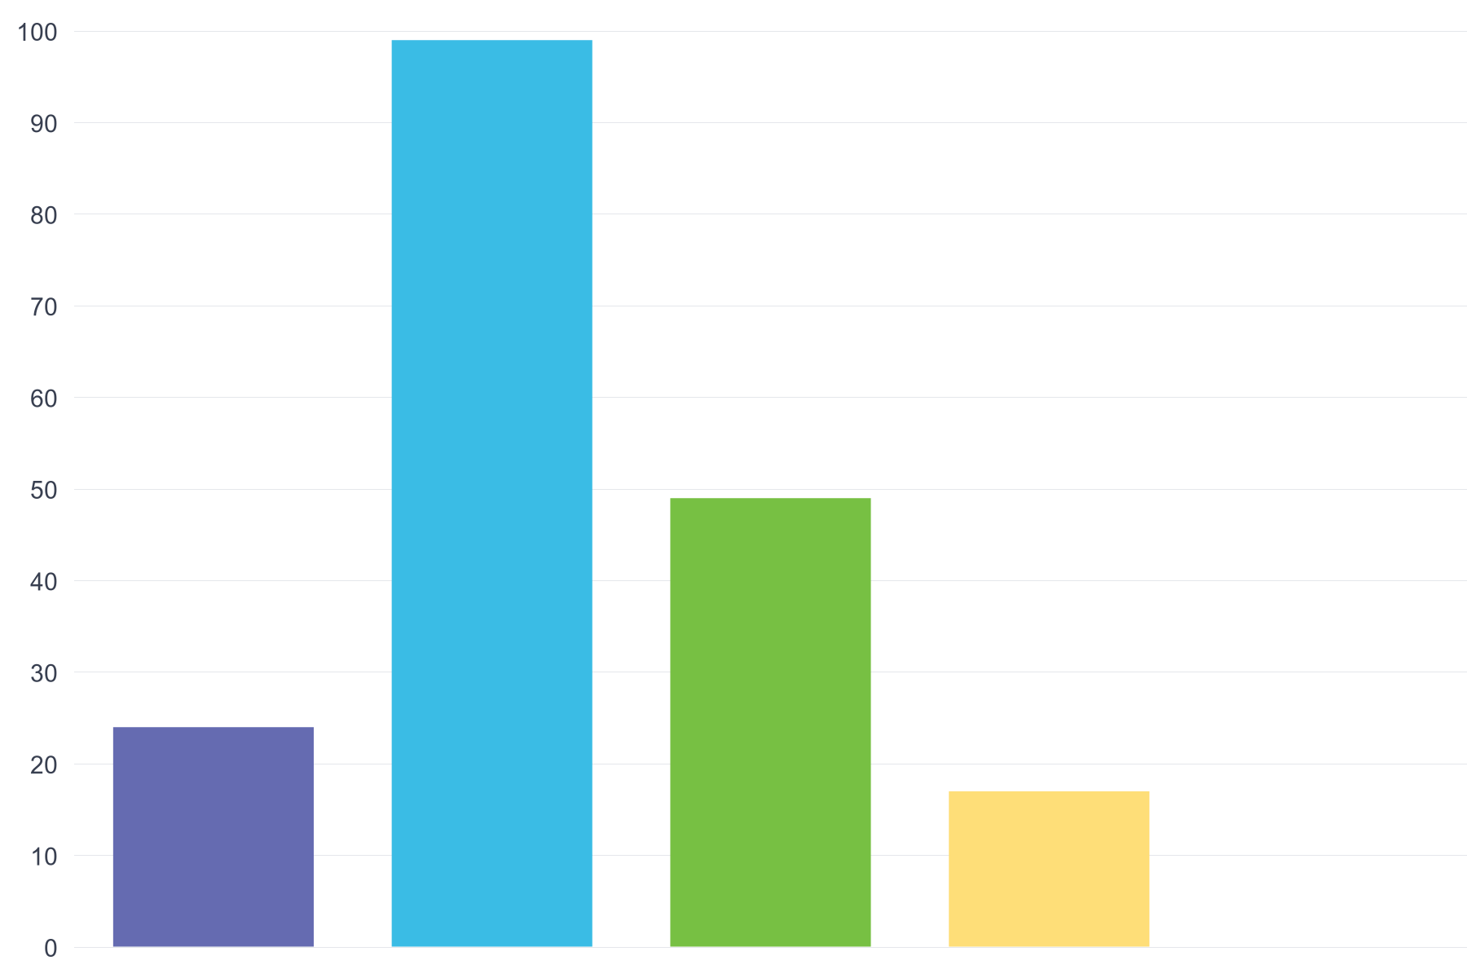
 | Choice | Totals
• | Always | 24
• | Often | 99
• | Sometimes | 49
• | Rarely | 17
• | Never | 0
Responses 190 Answered 189 Unanswered 1
Q14 Does the level of training on the use of force adequately prepare officers for real life scenarios?
Multiple Choice
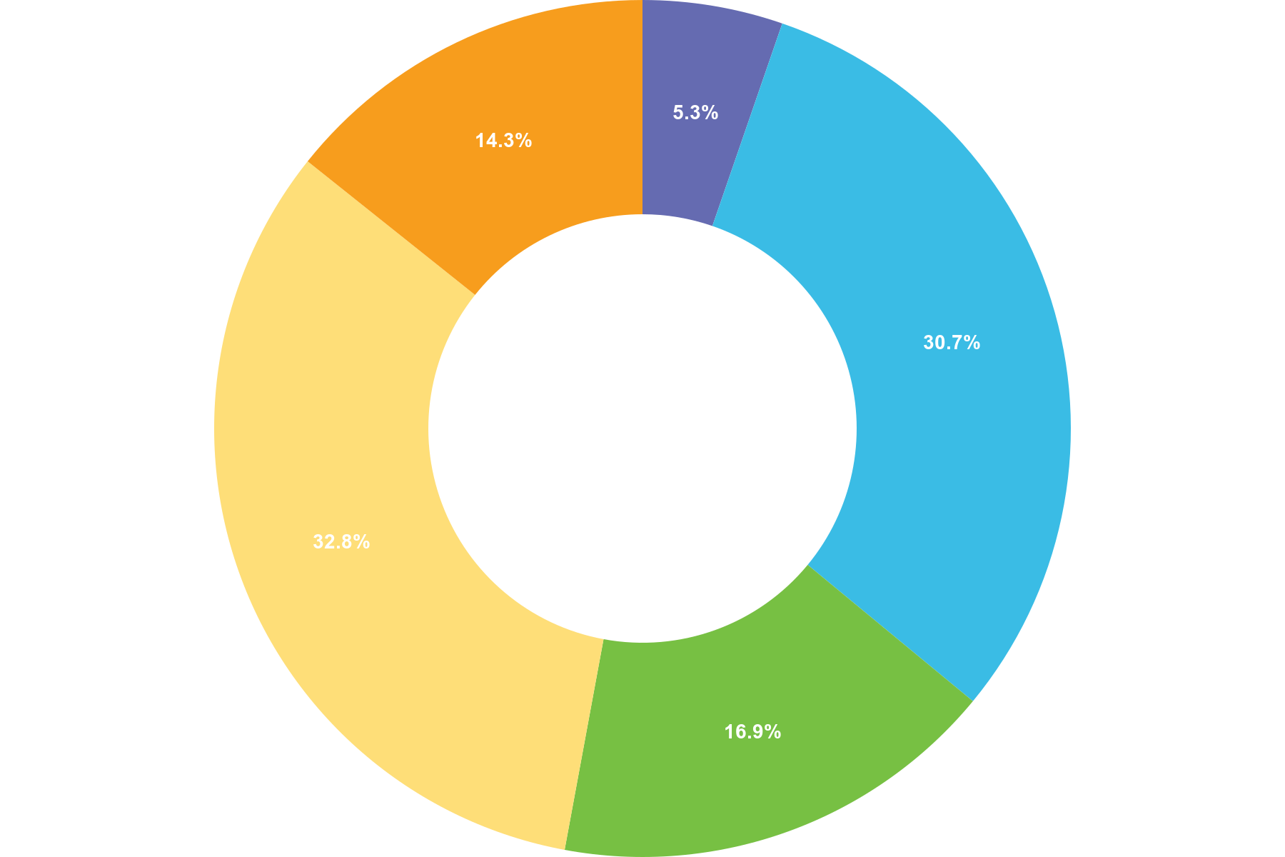
 | Choice | Totals
• | Strongly Agree | 10
• | Agree | 58
• | Neutral | 32
• | Disagree | 62
• | Strongly Disagree | 27
Responses 190 Answered 189 Unanswered 1
Q15 How often does your use of force result in unintended consequences (e.g. escalation of violence/injuries to bystanders)?
Multiple Choice
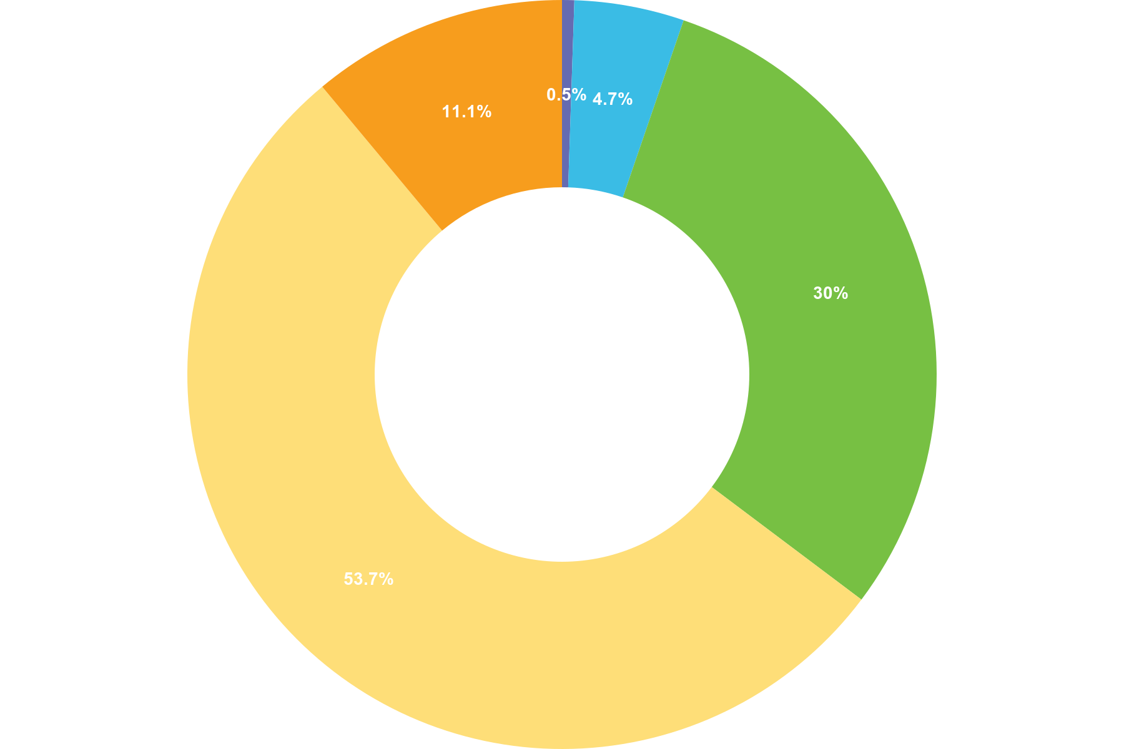
 | Choice | Totals
• | Always | 1
• | Often | 9
• | Sometimes | 57
• | Rarely | 102
• | Never | 21
Responses 190 Answered 190 Unanswered 0
Q16 Do you believe current guidelines and policies regarding use of force are ethically sound?
Multiple Choice
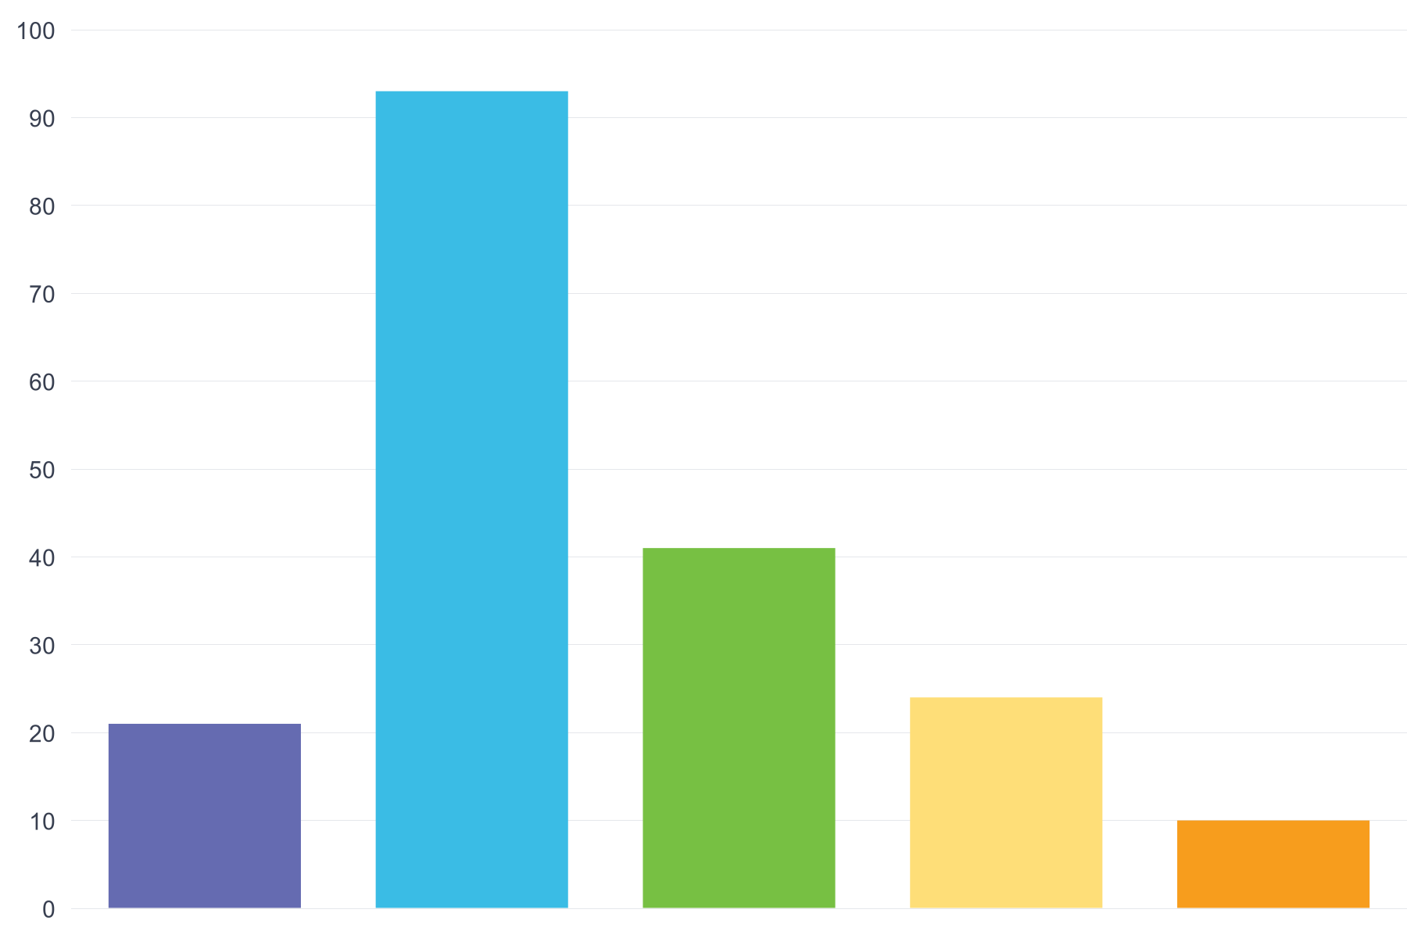
 | Choice | Totals
• | Strongly Agree | 21
• | Agree | 93
• | Neutral | 41
• | Disagree | 24
• | Strongly Disagree | 10
Responses 190 Answered 189 Unanswered 1
Q17 Have you ever experienced a situation where you felt that the use of force was ethically questionable but necessary for safety?
Multiple Choice
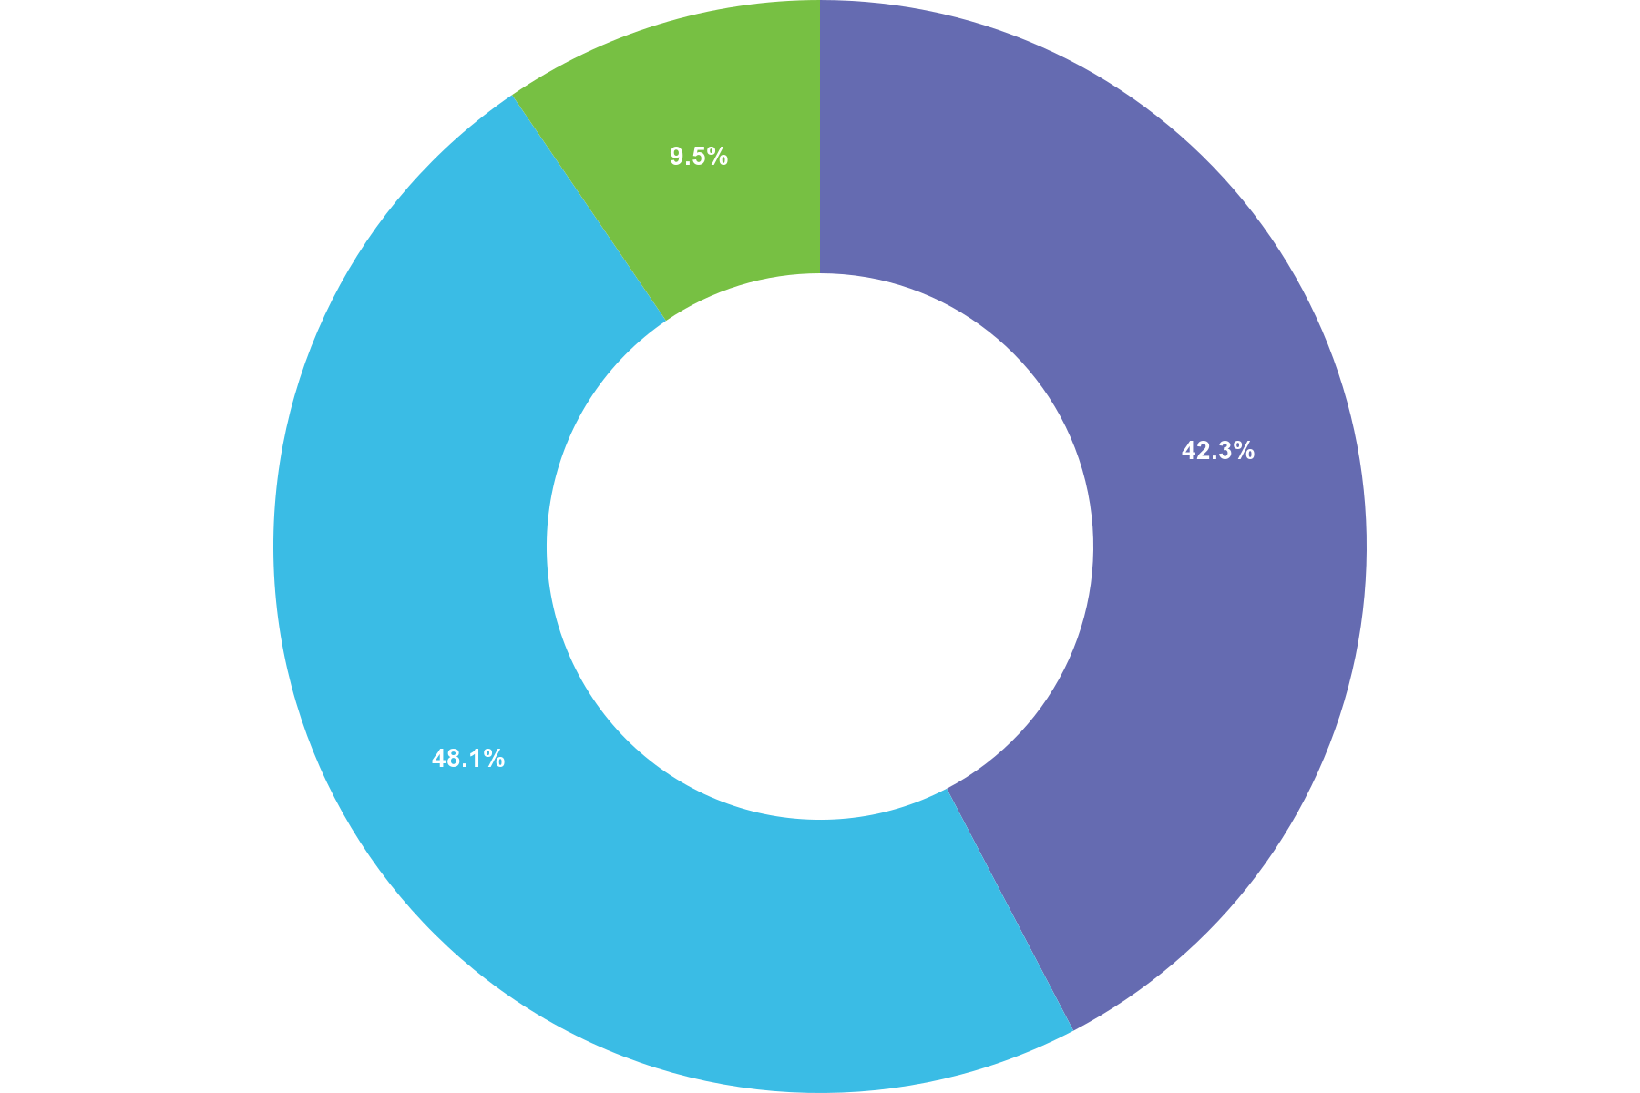
 | Choice | Totals
• | Yes | 80
• | No | 91
• | Not Sure | 18
Responses 190 Answered 189 Unanswered 1

Q18 Do you believe there are adequate accountability mechanisms in place to review use of force incidents?
Multiple Choice
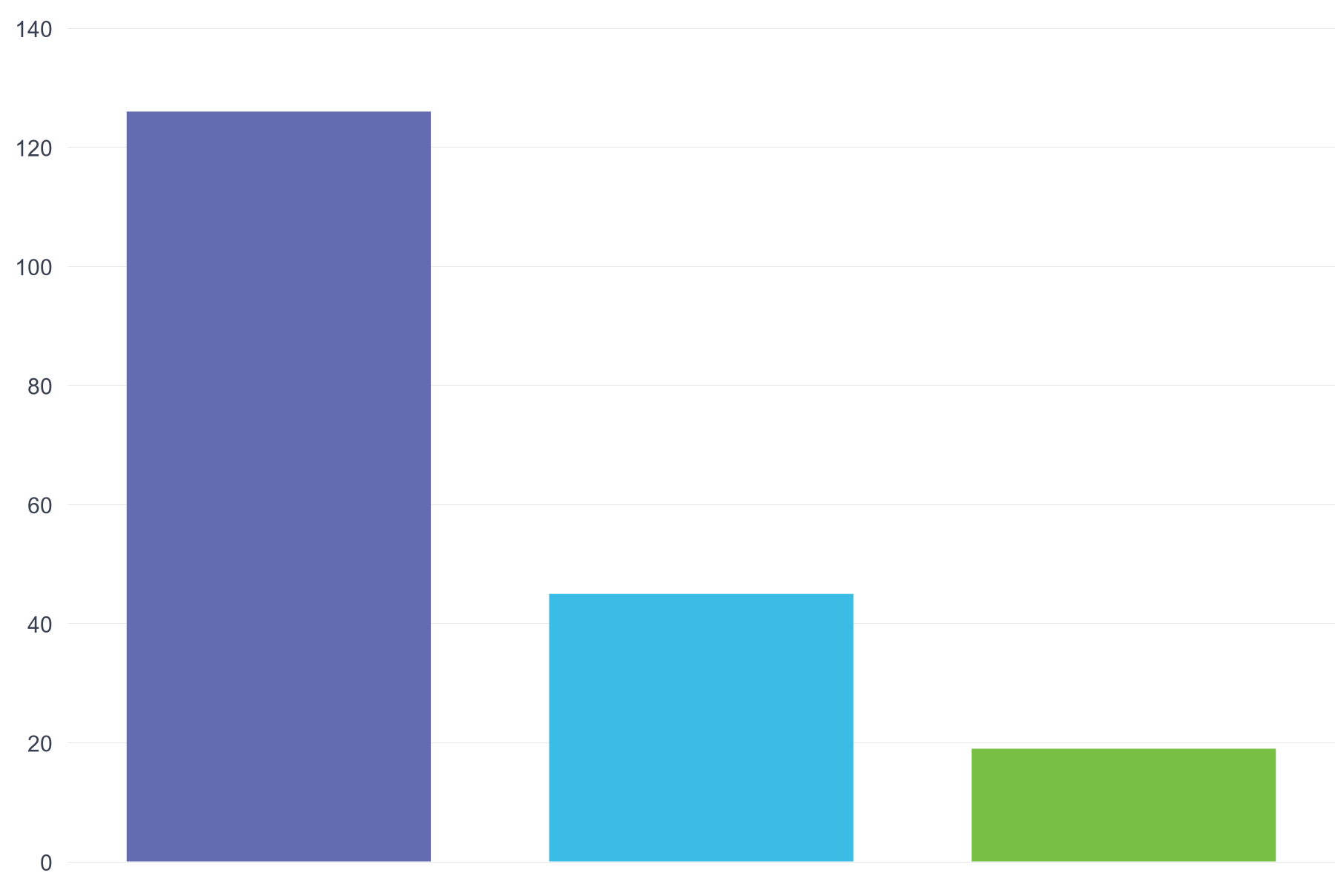
 | Choice | Totals
• | Yes | 126
• | No | 45
• | Not Sure | 19
Responses 190 Answered 190 Unanswered 0

Q19 Do you feel that when you utilise force you are scrutinised fairly when doing so?
Multiple Choice
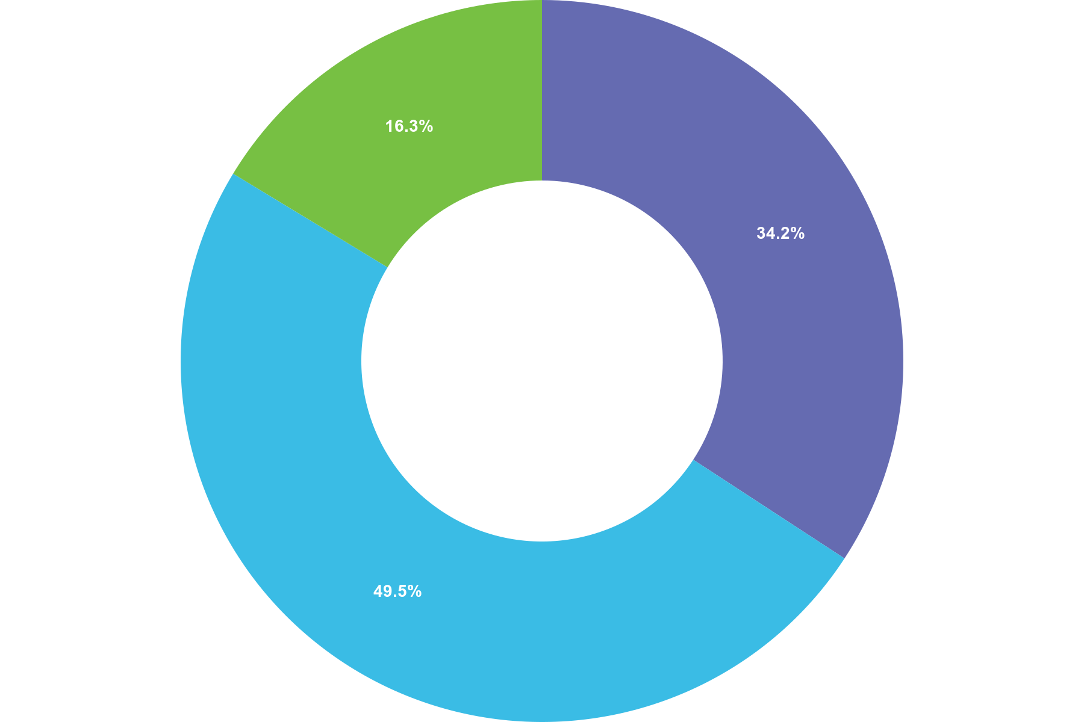
 | Choice | Totals
• | Yes | 65
• | No | 94
• | Not Sure | 31
Responses 190 Answered 190 Unanswered 0

Q20 Do you feel supported by Senior Management when you make a decision to use force in a given situation?
Multiple Choice
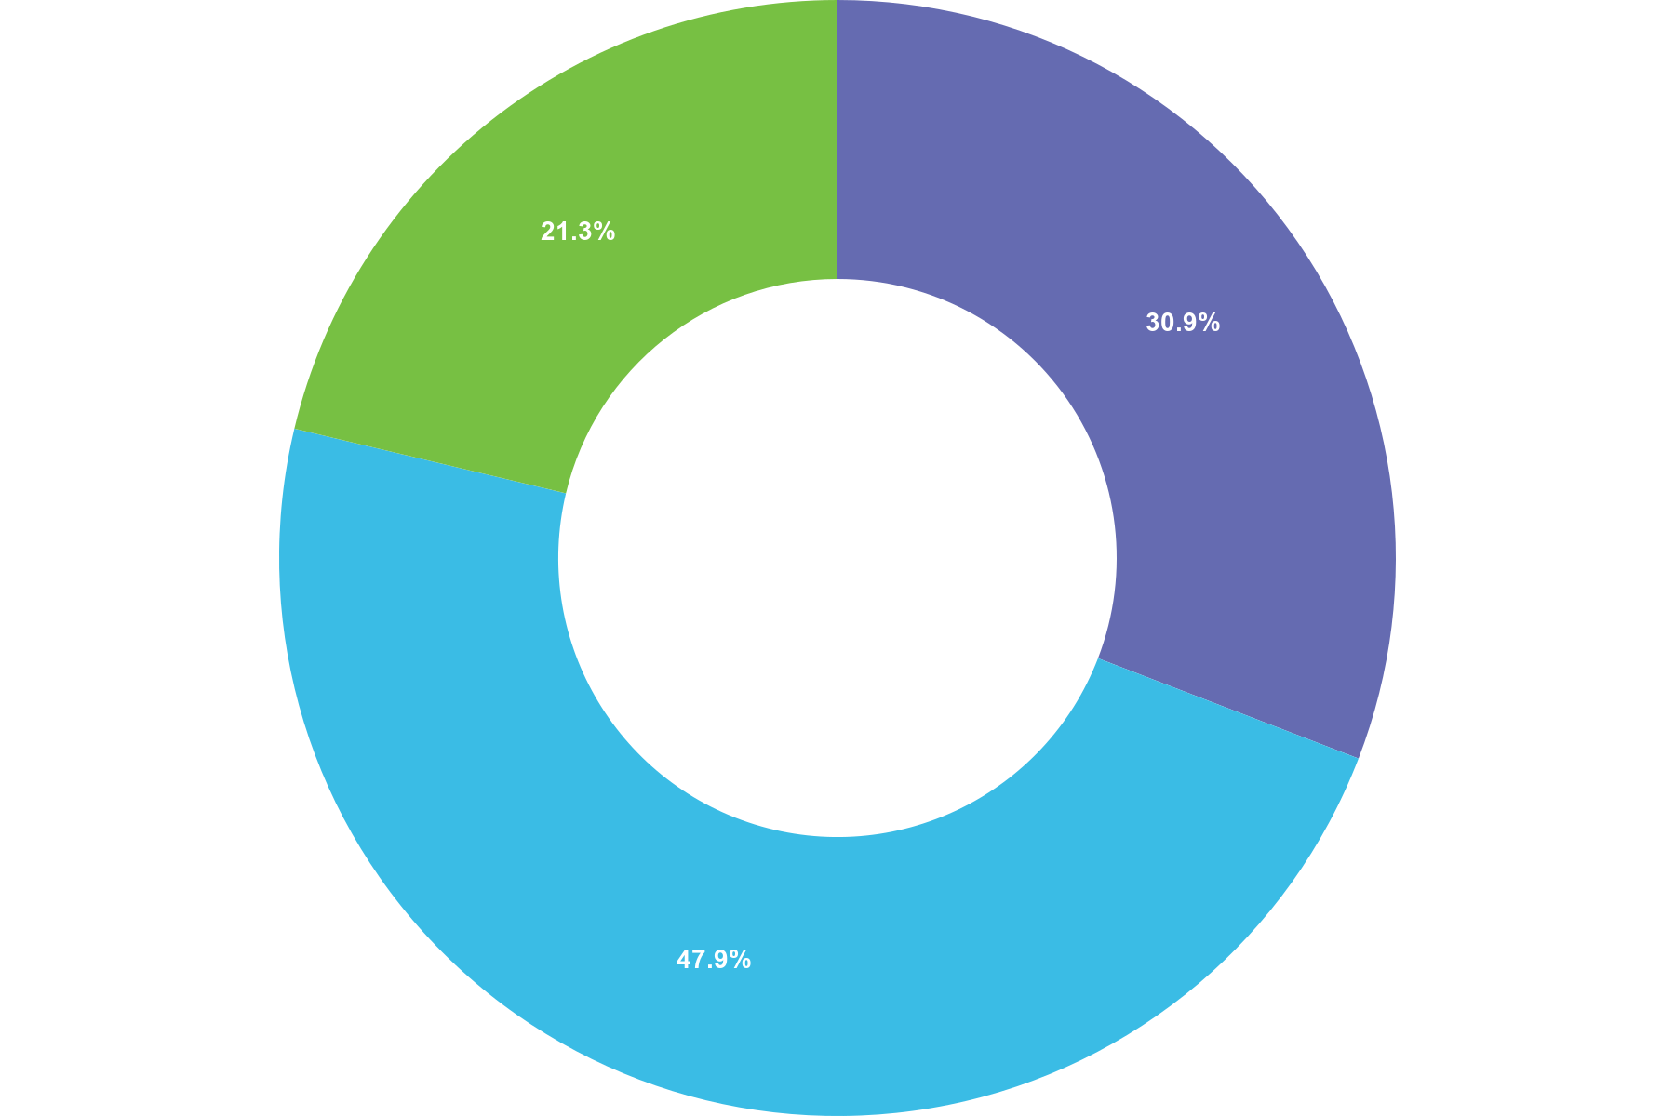
 | Choice | Totals
• | Yes | 58
• | No | 90
• | Not Sure | 40
Responses 190 Answered 188 Unanswered 2

Q21 In your opinion, how does the public generally perceive the use of force by police
Multiple Choice
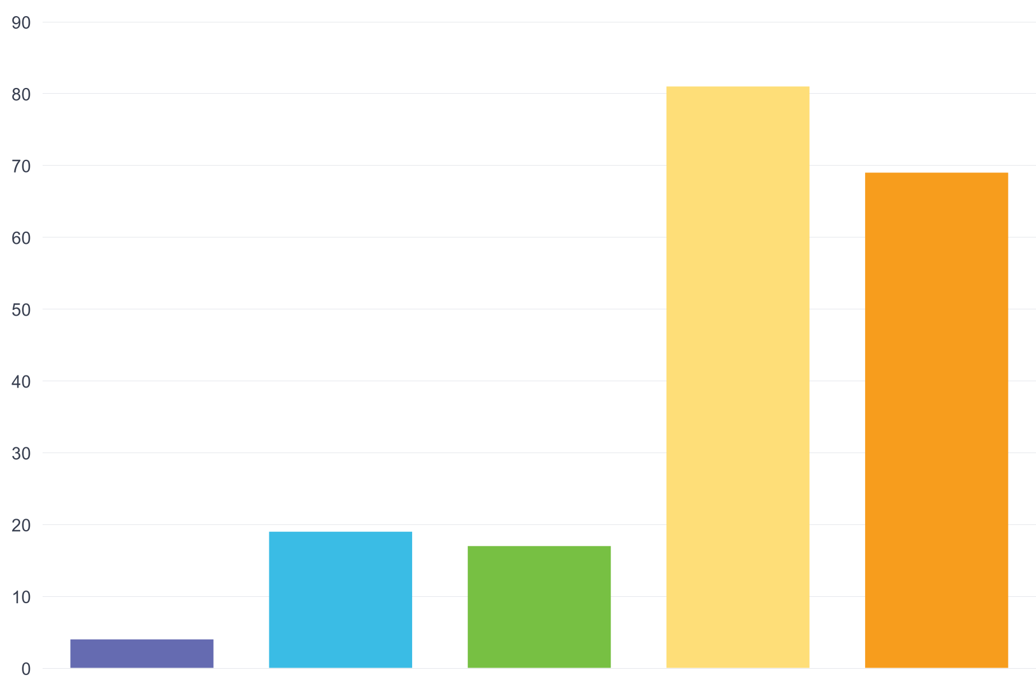
 | Choice | Totals
• | Highly Positive | 4
• | Somewhat Positive | 19
• | Neutral | 17
• | Somewhat Negative | 81
• | Highly Negative | 69
Responses 190 Answered 190 Unanswered 0
Q22 Do you believe the public understands the complexities of when and why force is used by police officers?
Multiple Choice
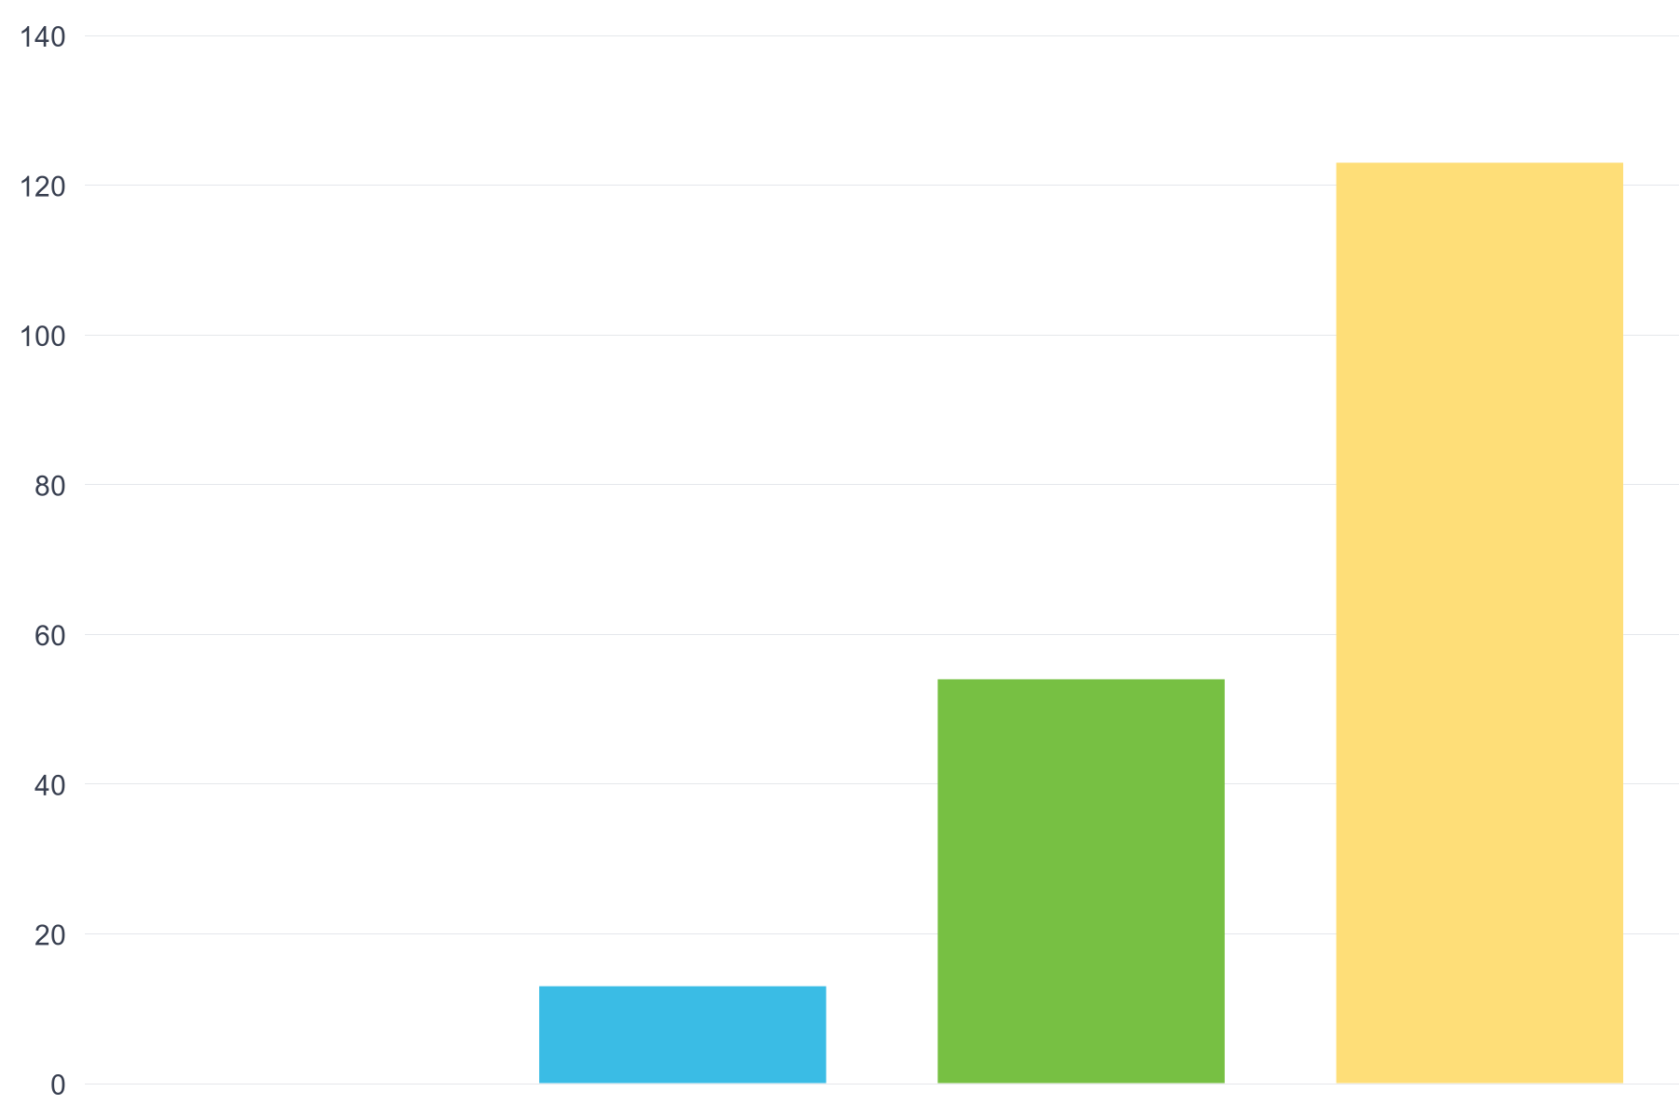
 | Choice | Totals
• | Yes, Completely | 0
• | Yes, to some extent | 13
• | No, not really | 54
• | No, not at all | 123
Responses 190 Answered 190 Unanswered 0
Q23 How do you think transparency measures (such as body cameras or press releases) affect trust in the police use of force?
Multiple Choice
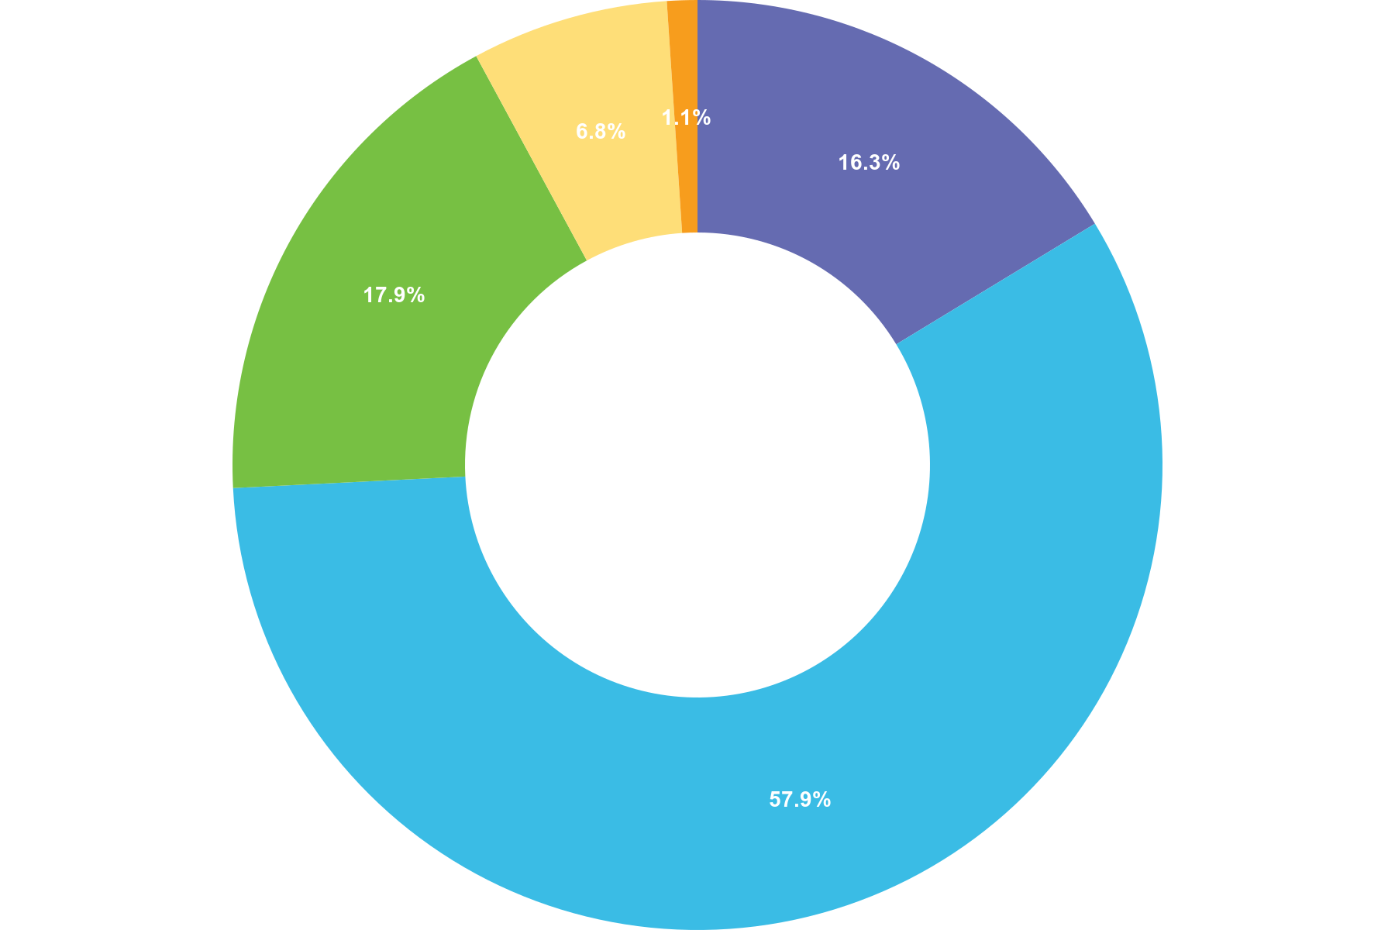
 | Choice | Totals
• | Greatly improves trust | 31
• | Somewhat improves trust | 110
• | No effect | 34
• | Somewhat reduces trust | 13
• | Greatly reduces trust | 2
Responses 190 Answered 190 Unanswered 0
Q24 Have public perceptions of the police&#39;s use of force influenced how you apply it in your duties?
Multiple Choice
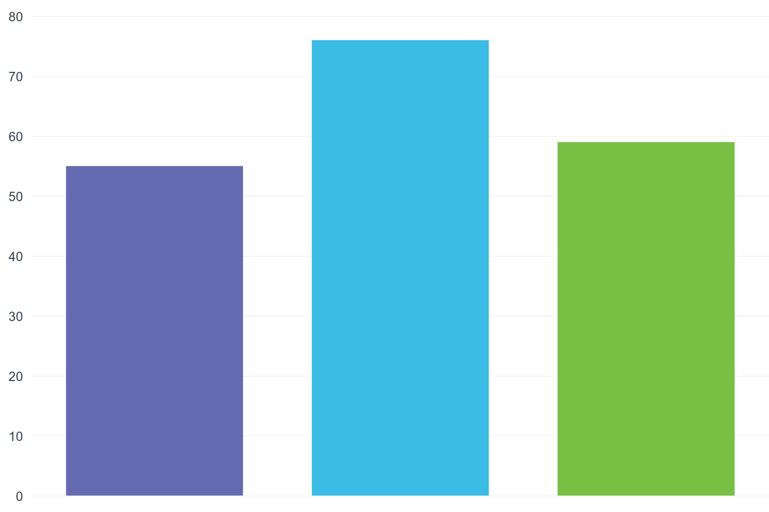
 | Choice | Totals
• | Yes, greatly | 55
• | Yes, somewhat | 76
• | No, not at all | 59
Responses 190 Answered 190 Unanswered 0

Q25 Do you feel that the media&#39;s portrayal of use of force incidents fairly represents what happens in real-life policing?
Multiple Choice
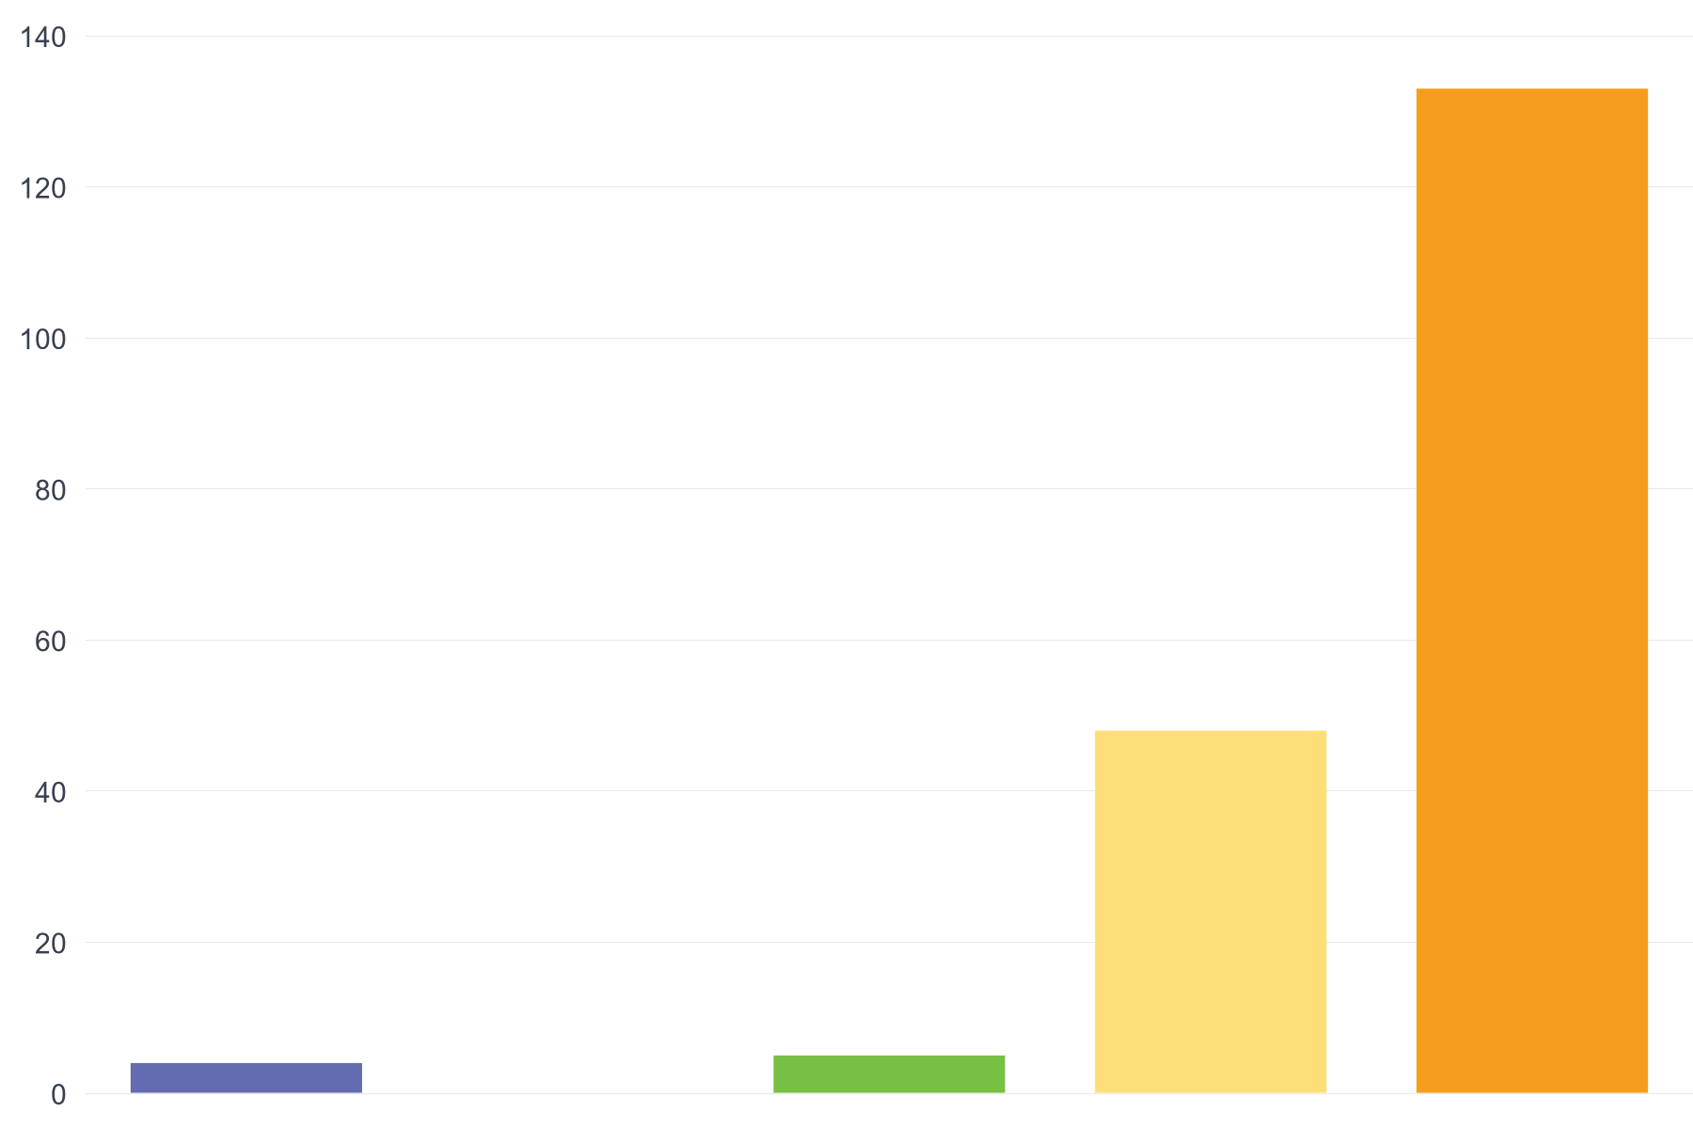
 | Choice | Totals
• | Strongly Agree | 4
• | Agree | 0
• | Neutral | 5
• | Disagree | 48
• | Strongly Disagree | 133
Responses 190 Answered 190 Unanswered 0
Appendix Three: Dissertation Proposal


UNDERGRADUATE DISSERTATION
RESEARCH PROPOSAL FORM

Please complete the following research proposal and submit it to Turnitin.

Which project option are you taking? Please tick:

8,000 word project:

Please remove the red writing for your final submission.

NAME:  William LEE | STUDENT ID No.:  2124739
DRAFT RESEARCH TITLE QUESTION:
‘’A Balancing Act : Evaluating the Effectiveness and Ethics of the Use of Force in Modern Policing’’.
INTRODUCTION:

The debate, around the application of force in today’s modern policing environment is an active issue that plays a role integral role in maintaining a delicate equilibrium between safeguarding public welfare and upholding individual liberties. This subject is worthy of exploration given its legal dimensions that are now under heightened public scrutiny due to notable incidents in recent times. These occurrences have ignited discussions among lawmakers and Police enforcement well as the general population; underscoring the necessity for a thorough review of the principles and oversight mechanisms guiding the use of force, by police officers.

This dissertation aims to dissect the effectiveness and ethical considerations of force in policing, a subject ripe for scholarly investigation given its relevance to current societal dynamics and Policing Organisation practices. The literature review has revealed a broad spectrum of perspectives, emphasizing the complex decision-making process officers face during potentially forceful encounters. By analysing both the practical outcomes and ethical dimensions of force use, this research seeks to contribute to the ongoing discourse, with the potential to inform future policy and training.

During the stages of this research project is when we delved into studies and theoretical perspectives to shed light on the complex nature of this topic at hand. The purpose of this proposal is to pave the way, for an examination of the two elements. Effectiveness and ethical considerations in the Police’s use of force, with the goal of providing perspectives that meet both safety goals and moral principles.

SUMMARY OF RESEARCH OBJECTIVES:

The research delves into the complex aspects of force in policing, aiming to clarify its effectiveness, ethical grounds, and impact on public trust. The key objectives are:

1. Assess Effectiveness:
To empirically analyse how force impacts conflict resolution, crime rates, and safety, considering the influence of various situational and individual factors.

2. Review Ethical Standards:
To examine the moral and legal principles shaping force use in policing, including a look at national and international guidelines and ethical codes, aiming to identify ethical boundaries and their policy implications.

3. Investigate Community Impact:
To explore how force usage affects perceptions of police legitimacy, employing surveys, interviews, and focus groups to understand public sentiment, with attention to how demographics influence these views.

The research will utilise a mixed-methods approach, combining quantitative analysis with qualitative insights, to provide a comprehensive view of force use in policing and its broader implications, contributing to the discourse on policing ethics and effectiveness.

LITERATURE REVIEW:

For the literature review, the focus will be on materials pertinent to the UK context, drawing from a mix of academic texts, peer-reviewed journals, official government reports, and policy documents from UK-based Policing bodies. Key sources include:

1."Policing by Consent: Understanding the Dynamics of Police Power and Legitimacy in the UK- This book provides an in-depth exploration of the principles that underpin policing in the UK, with a particular emphasis on the legal and ethical frameworks governing the use of force.

2. "Identity, legitimacy and “making sense” of police use of force", which offers insights into public acceptance of the legitimacy of police use of force.

3. The Home Office's "Police Use of Force Statistics, England and Wales" reports, which present comprehensive data on the incidents of force application by police forces across England and Wales, offering a factual basis for understanding the scale and context of force use.

4. Strategic documents from major UK police forces and the College of Policing, such as the "Guidance on the Management, Command and Deployment of Armed Officers", which outline the operational guidelines and ethical considerations for the use of force, including armed interventions.

5. " HOW JIU JITSU TRAINING CAN REDUCE USE-OF-FORCE INCIDENTS IN POLICING " by Jiu Jitsu Five-0 make claims on how front line police officers can through training Jiu Jitsu can have better outcomes of dealing with incidents involving use of force requiring lower risks of injuries for all involved.

6." Justifying violence: legitimacy, ideology and public support for police use of force " by Monica M. Gerber & Jonathan Jackson, this article provides critical insights into the operational realities of policing, including the justification of use of force. It offers a nuanced perspective on the balance between maintaining order and the ethical use of force.

7. "Excessive Force: Power, Politics, and Population Control" by Ian Loader, an investigative piece that examines the conditions under which force might be considered excessive, its implications for public trust, and the political underpinnings of policing strategies in the UK.

8."Public Perceptions of Police Accountability and Decision Making" in the Policing and Society journal, which presents research findings on how the public's view of police use of force affects their perception of police legitimacy and accountability, providing a contemporary view on public trust issues.

9. " Body-worn cameras’ effects on police officers and citizen behaviour: A systematic review " This article evaluates the influence of body-worn cameras on policing practices, including the use of force, offering insights into how transparency and accountability are being enhanced in UK policing.

10.Home Office's "Police Use of Taser Statistics, England and Wales", which provides specific data on the deployment of Tasers by the police, offering a lens into the operational use of less-lethal options in force application and the debates surrounding their use.

This selection of literature lays a solid foundation for exploring the use of force in UK policing, covering principles, practices, public perceptions, and the impact of technology. It provides a balanced view on the ethical, operational, and societal aspects, setting the stage for a nuanced analysis. This research aims to extend the existing discourse, offering new insights into the ethical application of force, guided by the rich academic and practical contributions in the field, ultimately aiming to enhance policing effectiveness and public trust.

SUMMARY OF RESEARCH –SURVEY METHOD:
The study plans to employ a combination of surveys and interviews, for gathering information, on police use of force practices from both Police Officers and the general public to obtain comprehensive and measurable data points.
This method is selected for its straightforwardness and efficiency. Surveys offer an overview while interviews delve into specifics to ensure a complete grasp of perspectives, on police use of force and the underlying motivations. This approach is pragmatic, straightforward and apt for revealing the insights, for this study.

SUMMARY OF SAMPLING FRAMEWORK:
The sampling framework will target two distinct groups that of being frontline police officers and members of the public. The aim is to capture a comprehensive view of the use of force from both those who implement it and those who experience or observe it.

For police officers, the sample will focus on those with direct involvement in frontline duties, ensuring insights from individuals with firsthand experience in decision-making and execution regarding the use of force. This will include a range of ranks and roles to get a broad perspective on practices and attitudes within the force.

A diverse group of individuals, from the community will be surveyed to gauge opinions and responses to incidents of police’ use of force. The sample will include people from various age groups and backgrounds, and locations to capture a broad spectrum of perspectives and experiences.

The reason, for selecting this two part method is its capacity to offer a rounded perspective of the application of force in Police enforcement by encompass both the real world practices and community viewpoints. This method guarantees that the study outcomes are rooted in the encounters of police officers and the societal environment where law enforcement takes place; therefore making it especially appropriate, for accomplishing the research goals.
.

ETHICAL ISSUES:
In this research, key ethical considerations include:

- Informed Consent: Participants must be fully aware of the study's aims and agree to participate voluntarily.

- Confidentiality: Participant identities will be protected to ensure privacy and reduce risk.

- Bias and Objectivity: The research will be conducted impartially to uphold the validity of the findings.

TIME SCALE:
Standard practice to consider each stage of your research work that you will undertake.
REFERENCE LIST:
Please follow the Harvard referencing system

Appendix Four: Ethics Form
APPLICATION FOR ETHICAL APPROVAL
RESEARCH STUDENTS
This form is to be completed by the student within SIX months for full-time students and TWELVE months for part time students, after the commencement of the research degree or following progression to Part Two of your course.

Once complete, submit this form via the MyTSD Doctoral College Portal at (https://mytsd.uwtsd.ac.uk).

This document is also available in Welsh.

RESEARCH STAFF ONLY
All communications relating to this application during its processing must be in writing and emailed to pgresearch@uwtsd.ac.uk , with the title ‘Ethical Approval’ followed by your name.

STUDENTS ON UNDERGRADUATE OR TAUGHT MASTERS PROGRAMMES should submit this form (and receive the outcome) via systems explained to you by the supervisor/module leader.

In order for research to result in benefit and minimise risk of harm, it must be conducted ethically. A researcher may not be covered by the University’s insurance if ethical approval has not been obtained prior to commencement.

The University follows the OECD Frascati manual definition of research activity: “creative work undertaken on a systematic basis in order to increase the stock of knowledge, including knowledge of man, culture and society, and the use of this stock of knowledge to devise new applications”. As such this covers activities undertaken by members of staff, postgraduate research students, and both taught postgraduate and undergraduate students working on dissertations/projects.

The individual undertaking the research activity is known as the “principal researcher”.

Ethical approval is not required for routine audits, performance reviews, quality assurance studies, testing within normal educational requirements, and literary or artistic criticism.

Please read the notes for guidance before completing ALL sections of the form.

This form must be completed and approved prior to undertaking any research activity. Please see Checklist for details of process for different categories of application.

SECTION A: About You (Principal Researcher)
1 | Full Name: |  | William Lee
2 | Tick all boxes that apply: |  | Member of staff: | ☐ | Honorary research fellow: | ☐
 | Undergraduate Student | ☐ | Taught Postgraduate Student | ☐ | Postgraduate Research Student | ☐

3 | Institute/Academic Discipline/Centre: | IMH
4 | Campus: | Swansea
5 | E-mail address: | 2124739@student.uwtsd.ac.uk
6 | Contact Telephone Number: | n/a
 | For students:
7 | Student Number: | 2124739
8 | Programme of Study: | BSc (Hons) Professional Policing Practice
9 | Director of Studies/Supervisor: | Jane Thomas

SECTION B: Approval for Research Activity
1 | Has the research activity received approval in principle?  (please check the Guidance Notes as to the appropriate approval process for different levels of research by different categories of individual) |  | YES | ☒ | NO | ☐
 |  |  |  |  | Date
2 | If Yes, please indicate source of approval (and date where known): Approval in principle must be obtained from the relevant source prior to seeking ethical approval | Research Degrees Committee |  | ☐
2 |  | Institute Research Committee |  | ☐
2 |  | Other (write in) |  | ☒ | Jane Thomas

SECTION C: Internal and External Ethical Guidance Materials
 | Please list the core ethical guidance documents that have been referred to during the completion of this form (including any discipline-specific codes of research ethics, location-specific codes of research ethics, and also any specific ethical guidance relating to the proposed methodology). Please tick to confirm that your research proposal adheres to these codes and guidelines. You may add rows to this table if needed.
1 | UWTSD Research Ethics & Integrity Code of Practice | ☒
2 | UWTSD Research Data Management Policy | ☒
3 | [List any other relevant documents here] | ☐

SECTION D: External Collaborative Research Activity
If there are external collaborators then you should gain consent from the contact persons to share their personal data with the university. If there are no external collaborators then leave this section blank and continue to section E.
1 | Institution | N/A
2 | Contact person name | N/A
3 | Contact person e-mail address | N/A
4 | Is your research externally funded? |  | YES | ☐ | NO |  | ☐
5 | Are you in receipt of a KESS scholarship? |  | YES | ☐ | NO |  | ☐
6 | Are you specifically employed to undertake this research in either a paid or voluntary capacity? | Voluntary | YES | ☐ | NO | ☐
7 |  | Employed | YES | ☐ | NO | ☐
8 | Is the research being undertaken within an existing UWTSD Athrofa Professional Learning Partnership (APLP)? | If YES then the permission question below does not need to be answered. | YES | ☐ | NO |  | ☐
9 | Has permission to undertake the research has been provided by the partner organisation? | (If YES attach copy)  If NO the application cannot continue | YES | ☐ | NO |  | ☐

Where research activity is carried out in collaboration with an external organisation
10 | Does this organisation have its own ethics approval system? | YES | ☐ | NO | ☐
 | If Yes, please attach a copy of any final approval (or interim approval) from the organisation (this may be a copy of an email if appropriate).

SECTION E: Details of Research Activity
1 | Indicative title:
2 | Proposed start date: |  | Proposed end date:
Introduction to the Research (maximum 300 words per section)
Ensure that you write for a Non-Specialist Audience when outlining your response to the points below:
- Purpose of Research Activity
- Proposed Research Question
- Aims of Research Activity
- Objectives of Research Activity
Demonstrate, briefly, how Existing Research has informed the proposed activity and explain
- What the research activity will add to the body of knowledge
- How it addresses an area of importance.
3 | Purpose of Research Activity  (this box should expand as you type)
4 | Research Question  (this box should expand as you type)
5 | Aims of Research Activity  (this box should expand as you type)
6 | Objectives of Research Activity  (this box should expand as you type)
Proposed methods (maximum 600 words)
Provide a brief summary of all the methods that may be used in the research activity, making it clear what specific techniques may be used. If methods other than those listed in this section are deemed appropriate later, additional ethical approval for those methods will be needed. You do not need to justify the methods here, but should instead describe how you intend to collect the data necessary for you to complete your project.
7 | (this box should expand as you type)
Location of research activity
Identify all locations where research activity will take place.
8 | South Wales, Wales, United Kingdom  (this box should expand as you type)
Research activity outside of the UK
If research activity will take place overseas, you are responsible for ensuring that local ethical considerations are complied with and that the relevant permissions are sought. Specify any local guidelines (e.g. from local professional associations/learned societies/universities) that exist and whether these involve any ethical stipulations beyond those usual in the UK (provide details of any licenses or permissions required). Also specify whether there are any specific ethical issues raised by the local context in which the research activity is taking place, for example, particular cultural and/or legal sensitivities or vulnerabilities of participants. If you live in the country where you will do the research then please state this.
9 | N/A  (this box should expand as you type)

10 | Use of documentation not in the public domain: Are any documents NOT publicly available? | NO | ☒
10 |  | YES | ☐
11 | If Yes, please provide details here of how you will gain access to specific documentation that is not in the public domain and that this is in accordance with the current data protection law of the country in question and that of England and Wales.  N/A  (this box should expand as you type)

 | Does your research relate to one or more of the seven aims of the Well-being of Future Generations (Wales) Act 2015? | YES | NO
12 | A prosperous Wales | ☐ | ☒
13 | A resilient Wales | ☐ | ☒
14 | A healthier Wales | ☐ | ☒
15 | A more equal Wales | ☐ | ☒
16 | A Wales of cohesive communities | ☐ | ☒
17 | A Wales of vibrant culture and thriving Welsh language | ☐ | ☒
18 | A globally responsible Wales | ☐ | ☒
19 | If YES to any of the above, please give details:
 | (this box should expand as you type)

SECTION F: Scope of Research Activity
 | Will the research activity include: | YES | NO
1 | Use of a questionnaire or similar research instrument? | ☒ | ☐
2 | Use of interviews? | ☒ | ☐
3 | Use of focus groups? | ☐ | ☒
4 | Use of participant diaries? | ☐ | ☒
5 | Use of video or audio recording? | ☐ | ☒
6 | Use of computer-generated log files? | ☐ | ☒
7 | Participant observation with their knowledge? | ☐ | ☒
8 | Participant observation without their knowledge? | ☐ | ☒
9 | Access to personal or confidential information without the participants’ specific consent? | ☐ | ☒
10 | Administration of any questions, test stimuli, presentation that may be experienced as physically, mentally or emotionally harmful / offensive? | ☐ | ☒
11 | Performance of any acts which may cause embarrassment or affect self-esteem? | ☐ | ☒
12 | Investigation of participants involved in illegal activities? | ☐ | ☒
13 | Use of procedures that involve deception? | ☐ | ☒
14 | Administration of any substance, agent or placebo? | ☐ | ☒
15 | Working with live vertebrate animals? | ☐ | ☒
16 | Procedures that may have a negative impact on the environment? | ☐ | ☒
17 | Other primary data collection methods. Please indicate the type of data collection method(s) below. | ☐ | ☒
 | Details of any other primary data collection method:  (this box should expand as you type) | ☐ | ☒
If NO to every question, then the research activity is (ethically) low risk and may be exempt from some of the following sections (please refer to Guidance Notes).

If YES to any question, then no research activity should be undertaken until full ethical approval has been obtained.

SECTION G: Intended Participants
If there are no participants then do not complete this section, but go directly to section H.

 | Who are the intended participants: | YES | NO
1 | Students or staff at the University? | ☒ | ☐
2 | Adults (over the age of 18 and competent to give consent)? | ☒ | ☐
3 | Vulnerable adults? | ☐ | ☒
4 | Children and Young People under the age of 18? (Consent from Parent, Carer or Guardian will be required) | ☐ | ☒
5 | Prisoners? | ☐ | ☒
6 | Young offenders? | ☐ | ☒
7 | Those who could be considered to have a particularly dependent relationship with the investigator or a gatekeeper? | ☐ | ☒
8 | People engaged in illegal activities? | ☐ | ☒
9 | Others. Please indicate the participants below, and specifically any group who may be unable to give consent. | ☐ | ☐
 | Details of any other participant groups:  (this box should expand as you type) | ☐ | ☐

Participant numbers and source
Provide an estimate of the expected number of participants. How will you identify participants and how will they be recruited?
10 | How many participants are expected? | 2-3  (this box should expand as you type)
11 | Who will the participants be? | Police Officers, Police Force leads on use of force tactics, social media, and possible other persons with a vested interest or opinion on the use of force used by police.  (this box should expand as you type)
12 | How will you identify the participants? | Officers of Experience, Delegated officers whose job role is that of a force lead for use of force, entity’s with a mixture of opinion on the ethics and practicality of the police’ use of force.  (this box should expand as you type)

 | Information for participants: | YES | NO | N/A
13 | Will you describe the main research procedures to participants in advance, so that they are informed about what to expect? | ☒ | ☐ | ☐
14 | Will you tell participants that their participation is voluntary? | ☒ | ☐ | ☐
15 | Will you obtain written consent for participation? | ☒ | ☐ | ☐
16 | Will you explain to participants that refusal to participate in the research will not affect their treatment or education (if relevant)? | ☒ | ☐ | ☐
17 | If the research is observational, will you ask participants for their consent to being observed? | ☐ | ☐ | ☒
18 | Will you tell participants that they may withdraw from the research at any time and for any reason? | ☒ | ☐ | ☐
19 | With questionnaires, will you give participants the option of omitting questions they do not want to answer? | ☒ | ☐ | ☐
20 | Will you tell participants that their data will be treated with full confidentiality and that, if published, it will not be identifiable as theirs? | ☒ | ☐ | ☐
21 | Will you debrief participants at the end of their participation, in a way appropriate to the type of research undertaken? | ☐ | ☐ | ☒
22 | If NO to any of above questions, please give an explanation
N/A

(this box should expand as you type)

 | Information for participants: | YES | NO | N/A
24 | Will participants be paid? | ☐ | ☒ | ☐
25 | Is specialist electrical or other equipment to be used with participants? | ☐ | ☒ | ☐
26 | Are there any financial or other interests to the investigator or University arising from this study? | ☐ | ☒ | ☐
27 | Will the research activity involve deliberately misleading participants in any way, or the partial or full concealment of the specific study aims? | ☐ | ☒ | ☐
28 | If YES to any question, please provide full details
N/A

(this box should expand as you type)

SECTION H: Anticipated Risks

Outline any anticipated risks that may adversely affect any of the participants, the researchers and/or the University, and the steps that will be taken to address them.

If you have completed a full risk assessment (for example as required by a laboratory, or external research collaborator) you may append that to this form.
1 | Full risk assessment completed and appended? |  | Yes | ☐
1 |  |  | No | ☐
2 | Risks to participants  For example: sector-specific health & safety, emotional distress, financial disclosure, physical harm, transfer of personal data, sensitive organisational information
 | Risk to participants:  low  (this box should expand as you type) | How you will mitigate the risk to participants:  No Risks  (this box should expand as you type)
3 | If research activity may include sensitive, embarrassing or upsetting topics (e.g. sexual activity, drug use) or issues likely to disclose information requiring further action (e.g. criminal activity), give details of the procedures to deal with these issues, including any support/advice (e.g. helpline numbers) to be offered to participants. Note that where applicable, consent procedures should make it clear that if something potentially or actually illegal is discovered in the course of a project, it may need to be disclosed to the proper authorities
N/A

(this box should expand as you type)
4 | Risks to the investigator  For example: personal health & safety, physical harm, emotional distress, risk of accusation of harm/impropriety, conflict of interest
 | Risk to the investigator:  Low  (this box should expand as you type) | How you will mitigate the risk to the investigator:  No Risks  (this box should expand as you type)
5 | University/institutional risks  For example: adverse publicity, financial loss, data protection
 | Risk to the University:  Low  (this box should expand as you type) | How you will mitigate the risk to the University:  No Risks  (this box should expand as you type)
6 | Environmental risks  For example: accidental spillage of pollutants, damage to local ecosystems
 | Risk to the environment:  Low  (this box should expand as you type) | How you will mitigate the risk to environment:  No Risks  (this box should expand as you type)

 | Disclosure and Barring Service
 | If the research activity involves children or vulnerable adults, a Disclosure and Barring Service (DBS) certificate must be obtained before any contact with such participants. | YES | NO | N/A
7 | Does your research require you to hold a current DBS Certificate? | ☐ | ☐ | ☒
8 | If YES, please give the certificate number. If the certificate number is not available please write “Pending”; in this case any ethical approval will be subject to providing the appropriate certificate number.

SECTION I: Feedback, Consent and Confidentiality

1 | Feedback  What de-briefing and feedback will be provided to participants, how will this be done and when?
The participants will be informed before and after of what is expected on behalf of their participation and what I intend to do with the information that they have provided me.

(this box should expand as you type)
2 | Informed consent  Describe the arrangements to inform potential participants, before providing consent, of what is involved in participating. Describe the arrangements for participants to provide full consent before data collection begins. If gaining consent in this way is inappropriate, explain how consent will be obtained and recorded in accordance with prevailing data protection legislation.
There will be no inappropriate methods of gaining consent of any participants. All those involved will be aware that they are solely participating on a voluntary basis and can leave at any time.

(this box should expand as you type)
3 | Confidentiality / Anonymity  Set out how anonymity of participants and confidentiality will be ensured in any outputs. If anonymity is not being offered, explain why this is the case.
Should the participants wish to remain anonymous then no identifiable details will be published within the paper. Should the participant wish to withdraw at any time then I will not be publishing any of the information that I would’ve obtained as I feel that it would be inappropriate to go against their wishes

(this box should expand as you type)

SECTION J: Data Protection and Storage

 | Does the research activity involve personal data (as defined by the General Data Protection Regulation 2016 “GDPR” and the Data Protection Act 2018 “DPA”)? | YES | NO
1 | “Personal data” means any information relating to an identified or identifiable natural person (‘data subject’). An identifiable natural person is one who can be identified, directly or indirectly, in particular by reference to an identifier such as a name, an identification number, location data, an online identifier or to one or more factors specific to the physical, physiological, genetic, mental, economic, cultural or social identity of that natural person. Any video or audio recordings of participants is considered to be personal data. | ☐ | ☒
 | If YES, provide a description of the data and explain why this data needs to be collected:
2 | (this box should expand as you type)
 | Does it involve special category data (as defined by the GDPR)? | YES | NO
3 | “Special category data” means sensitive personal data consisting of information as to the data subjects’ –  (a) racial or ethnic origin,  (b) political opinions,  (c ) religious beliefs or other beliefs of a similar nature,  (d) membership of a trade union (within the meaning of the Trade Union and Labour Relations (Consolidation) Act 1992),  (e) physical or mental health or condition,  (f) sexual life,  (g) genetics,  (h) biometric data (as used for ID purposes), | ☐ | ☒
 | If YES, provide a description of the special category data and explain why this data needs to be collected:
4 | (this box should expand as you type)

 | Will data from the research activity (collected data, drafts of the thesis, or materials for publication) be stored in any of the following ways? | YES | NO
5 | Manual files (i.e. in paper form)? | ☐ | ☒
6 | University computers? | ☐ | ☒
7 | Private company computers? | ☒ | ☐
8 | Home or other personal computers? | ☒ | ☐
9 | Laptop computers/ CDs/ Portable disk-drives/ memory sticks? | ☐ | ☒
10 | “Cloud” storage or websites? | ☐ | ☒
11 | Other – specify: | ☐ | ☒
12 | For all stored data, explain the measures in place to ensure the security of the data collected, data confidentiality, including details of backup procedures, password protection, encryption, anonymisation and pseudonymisation:
The Data will be stored on personal police issued laptop to maintain the security of the data.
(this box should expand as you type)

 | Data Protection
 | Will the research activity involve any of the following activities: | YES | NO
13 | Electronic transfer of data in any form? | ☒ | ☐
14 | Sharing of data with others at the University outside of the immediate research team? | ☐ | ☒
15 | Sharing of data with other organisations? | ☐ | ☒
16 | Export of data outside the UK or importing of data from outside the UK? | ☐ | ☒
17 | Use of personal addresses, postcodes, faxes, emails or telephone numbers? | ☐ | ☒
18 | Publication of data that might allow identification of individuals? | ☐ | ☒
19 | Use of data management system? | ☐ | ☒
20 | Data archiving? | ☐ | ☒
21 | If YES to any question, please provide full details, explaining how this will be conducted in accordance with the GDPR and Data Protection Act (2018) (and any international equivalents, where appropriate):
 | (this box should expand as you type)
22 | List all who will have access to the data generated by the research activity:
n/a

(this box should expand as you type)
23 | List who will have control of, and act as custodian(s) for, data generated by the research activity:
n/a

(this box should expand as you type)
24 | Give details of data storage arrangements, including security measures in place to protect the data, where data will be stored, how long for, and in what form. Will data be archived – if so how and if not why not.
The Data will be stored on personal police issued laptop to maintain the security of the data.

(this box should expand as you type)
25 | Please indicate if your data will be stored in the UWTSD Research Data Repository (see https://researchdata.uwtsd.ac.uk/ ). If so please explain. (Most relevant to academic staff)
n/a

(this box should expand as you type)
26 | Confirm that you have read the UWTSD guidance on data management (see https://www.uwtsd.ac.uk/library/research-data-management/) | YES | ☒
27 | Confirm that you are aware that you need to keep all data until after your research has completed or the end of your funding | YES | ☒

SECTION K: Declaration
The information which I have provided is correct and complete to the best of my knowledge. I have attempted to identify any risks and issues related to the research activity and acknowledge my obligations and the rights of the participants.

In submitting this application I hereby confirm that I undertake to ensure that the above named research activity will meet the University’s Research Ethics and Integrity Code of Practice which is published on the website: https://www.uwtsd.ac.uk/research/research-ethics/
1 | Signature of applicant: | William Lee | Date:23/02/24

For STUDENT Submissions:
2 | Director of Studies/Supervisor: |  | Date:
3 | Signature: |  | Date:

For STAFF Submissions:
4 | Academic Director/ Assistant Dean: |  | Date:
5 | Signature: |  | Date:

Checklist: Please complete the checklist below to ensure that you have completed the form according to the guidelines and attached any required documentation:
☐ | I have read the guidance notes supplied before completing the form.
☐ | I have completed ALL RELEVANT sections of the form in full.
☐ | I confirm that the research activity has received approval in principle
☐ | I have attached a copy of final/interim approval from external organisation (where appropriate)
☐ | I have attached a full risk assessment (where appropriate) ONLY TICK IF YOU HAVE ATTACHED A FULL RISK ASSESSMENT
☐ | I understand that it is my responsibility to ensure that the above named research activity will meet the University’s Research Ethics and Integrity Code of Practice.
☐ | I understand that before commencing data collection all documents aimed at respondents (including information sheets, consent forms, questionnaires, interview schedules etc.) must be confirmed by the DoS/Supervisor, module tutor or Academic Director.

RESEARCH STUDENTS ONLY
Once complete, submit this form via the MyTSD Doctoral College Portal at (https://mytsd.uwtsd.ac.uk).

RESEARCH STAFF ONLY
All communications relating to this application during its processing must be in writing and emailed to pgresearch@uwtsd.ac.uk , with the title ‘Ethical Approval’ followed by your name.

STUDENTS ON UNDERGRADUATE OR TAUGHT MASTERS PROGRAMMES should submit this form (and receive the outcome) via systems explained to you by the supervisor/module leader.

