Student name: Mahagoub Abdelbanat
Module:
Managing Business Information
Module code: LCLM 5004

Table of Contents
Proposal Report: Modernizing AKPerog Ltd.’s Information Systems for Operational Excellence 3
1. Introduction 3
Overview of the Business Case 3
Key Challenges 3
2. Evaluation of Existing Systems 4
2.1 Current Information Systems Overview 4
2.2 Inefficiencies and Gaps 4
2.3 Impact on Performance 4
3. Recommended Solution 5
3.1 Proposed System 5
3.2 Justification 5
3.3 Features and Benefits 5
3.4 Anticipated Outcomes 6
4. Implementation Plan 6
4.1 Project Phases 6
4.2 Work Breakdown Structure (Text Representation) 7
4.3 Quad Chart Summary 7
4.4 12-Month Gantt Timeline 7
4.5 Training and Change Management 8
4.6 Integration with Existing Infrastructure 8
4.7 Risk Management 8
5. Conclusion 8
6. References (Harvard Style) 10

Proposal Report: Modernizing AKPerog Ltd.’s Information Systems for Operational Excellence

1. Introduction

Overview of the Business Case
AKPerog Ltd. is a fast-growing consumer electronics retailer with 30 physical stores and an expanding e-commerce platform. The company’s success over the past year has been accompanied by rising operational pressures, revealing significant weaknesses in its information systems. Current processes rely heavily on manual operations, leading to errors, inefficiencies, and customer dissatisfaction (Laudon & Laudon, 2022). As the company seeks to scale, these deficiencies threaten its profitability and ability to maintain competitive advantage in the retail technology sector.

Key Challenges
The principal challenges identified at AKPerog Ltd. include:
- Manual and Fragmented Inventory Management:
Inventory is tracked manually using spreadsheets, resulting in stock discrepancies between physical stores and online orders. This leads to delayed fulfilment and customer complaints.
- Disjointed Customer Data and CRM Processes:
Customer information is spread across disconnected systems, impeding the company’s ability to track purchase history or provide personalized service (Buttle & Maklan, 2019).
- Inefficient Decision-Making:
Reporting relies on manual spreadsheet compilation, which introduces inaccuracies and delays, limiting management’s ability to make informed decisions (Davenport, 2018).
- Non-Compliance and Data Security Risks:
Weak access controls and data governance raise GDPR compliance concerns (European Commission, 2024).
- Lack of System Integration:
The sales, finance, and inventory systems do not communicate effectively, resulting in duplication of effort and inconsistent information across departments.
These challenges collectively diminish operational performance, customer satisfaction, and compliance readiness. A comprehensive technological overhaul is therefore required.

2. Evaluation of Existing Systems

2.1 Current Information Systems Overview
AKPerog Ltd. currently operates a patchwork of manual processes and outdated standalone software.
- Inventory Management: Conducted manually using spreadsheets at each store level.
- Point-of-Sale (POS): Independent POS systems that are not connected in real time to the central database or e-commerce platform.
- Customer Data: Stored across several uncoordinated tools, including email marketing lists and legacy databases.
- Financial Records: Managed using basic accounting software that lacks integration with sales or inventory systems.
- Reporting: Department heads manually compile data into spreadsheets for management meetings.

2.2 Inefficiencies and Gaps
System Area | Current Practice | Gap/Issue
Inventory | Manual spreadsheets | Errors, delays, stockouts and overstocking
Sales | Disconnected POS systems | Lack of centralized visibility
CRM | Fragmented databases | Poor customer insight, missed cross-selling opportunities
Reporting | Manual collation | Outdated data and decision delays
Finance | Isolated software | Duplication and reconciliation issues
Security | Weak access control | GDPR non-compliance, data risks

2.3 Impact on Performance
The absence of integration reduces data reliability and inflates operational costs. Store managers spend significant time reconciling stock levels, marketing teams lack access to accurate customer data, and executives operate without real-time sales visibility. The result is lower productivity, diminished customer experience, and strategic blind spots (O’Brien & Marakas, 2019). The company’s manual, siloed systems are not sustainable as it grows.

3. Recommended Solution

3.1 Proposed System
It is recommended that AKPerog Ltd. adopt an integrated Enterprise Resource Planning (ERP) and Customer Relationship Management (CRM) system, such as Microsoft Dynamics 365 or SAP Business One Cloud. Both platforms provide a unified, cloud-based solution that consolidates inventory, sales, finance, and customer data. The ERP component will manage back-office operations, while the CRM module enhances customer engagement and marketing automation (Turban, Pollard & Wood, 2021).

3.2 Justification
- Operational Efficiency:
Integration eliminates redundant data entry, automates stock management, and synchronizes online and offline sales channels (Monk & Wagner, 2013).
- Data Accuracy and Real-Time Visibility:
All departments will access a single source of truth, improving forecasting and responsiveness to market changes (Gartner, 2024).
- Customer Centricity:
The CRM system will centralize customer data, enabling targeted promotions, loyalty programs, and faster issue resolution (Buttle & Maklan, 2019).
- Scalability and Cost-Effectiveness:
Cloud-based deployment minimizes upfront investment and allows flexible scaling as the company grows (Microsoft, 2024).
- Compliance and Security:
Modern ERP/CRM suites include GDPR-compliant data protection, audit trails, and role-based access (ISO, 2023).

3.3 Features and Benefits
Module | Core Functionality | Expected Benefit
Inventory & Supply Chain | Real-time tracking, automated reorder alerts | Accurate stock levels and lower carrying costs
POS & Sales | Unified transaction system across channels | Consistent pricing and reporting
CRM | Centralized customer records, segmentation tools | Improved retention and marketing ROI
Finance | Automated reconciliation, financial dashboards | Faster reporting and reduced errors
Analytics | Predictive insights and performance dashboards | Informed decision-making
Security | Encryption, access control, audit logs | Data protection and regulatory compliance

3.4 Anticipated Outcomes
The new integrated system will improve order accuracy, accelerate reporting cycles, and enhance the customer experience. Management will gain visibility across the enterprise, supporting data-driven decisions and more agile responses to market changes. Customer trust will improve through better communication and reliable service.

4. Implementation Plan

4.1 Project Phases

Phase 1: Planning and Requirements (Months 1–2)
- Conduct detailed process mapping with stakeholders.
- Define technical and functional requirements.
- Establish project governance and success criteria.

Phase 2: System Design and Configuration (Months 3–5)
- Customize modules to reflect AKPerog’s business model.
- Configure workflows, user roles, and data fields.
- Plan data migration and integration with POS and e-commerce systems.

Phase 3: Data Migration and Integration (Months 6–7)
- Cleanse legacy data and migrate to the ERP/CRM platform.
- Validate data integrity and perform integration testing.

Phase 4: Training and Testing (Months 8–9)
- Deliver targeted user training sessions.
- Conduct User Acceptance Testing (UAT) and address feedback.

Phase 5: Deployment (Months 10–11)
- Roll out system company-wide in stages.
- Provide live support and monitor early performance.

Phase 6: Evaluation and Optimization (Month 12)
- Assess outcomes against KPIs.
- Implement continuous improvement actions and performance reviews.

4.2 Work Breakdown Structure (Text Representation)
- Project Management
1.1 Initiation
1.2 Planning
1.3 Risk Management
- System Design
2.1 Requirements Analysis
2.2 Customization
2.3 Integration Setup
- Data Migration
3.1 Cleansing
3.2 Transfer
3.3 Validation
- Training and UAT
4.1 Training Sessions
4.2 UAT
- Deployment and Support
5.1 Rollout
5.2 Monitoring
- Evaluation
6.1 KPI Review
6.2 Optimization

4.3 Quad Chart Summary
Aspect | Details
Objective | Implement an integrated cloud-based ERP-CRM system to improve efficiency and compliance.
Approach | Adopt Microsoft Dynamics 365, integrating POS, inventory, and customer data.
Risks | User resistance, migration errors, downtime.
Mitigation | Change management, phased rollout, vendor support, robust testing.

4.4 12-Month Gantt Timeline
Month | Activity
1–2 | Planning & Requirements
3–5 | System Design & Configuration
6–7 | Data Migration & Integration
8–9 | Training & UAT
10–11 | Deployment
12 | Evaluation & Optimization

4.5 Training and Change Management
A structured change management plan will ensure adoption:
- Workshops and e-learning for employees across departments.
- Super-user program to provide internal champions.
- Feedback loops for continuous learning (Kotter, 2012).

4.6 Integration with Existing Infrastructure
The ERP/CRM system will integrate with existing POS hardware and the e-commerce site via APIs, ensuring continuity and minimizing disruption. Integration with Microsoft 365 tools will streamline collaboration and reporting (Microsoft, 2024).

4.7 Risk Management
Risk | Likelihood | Impact | Mitigation
Data loss during migration | Medium | High | Backup and staged migration
User adoption issues | High | Medium | Comprehensive training
Implementation delays | Medium | Medium | Agile project management
Cybersecurity threats | Low | High | Regular updates and monitoring

5. Conclusion
AKPerog Ltd. must act decisively to modernize its information infrastructure. The analysis demonstrates that fragmented, manual systems are constraining operational performance and exposing the company to compliance risks. Implementing an integrated ERP-CRM solution such as Microsoft Dynamics 365 will unify data flows, automate routine tasks, and enhance customer engagement.
The proposed system provides scalability, accuracy, and compliance, positioning AKPerog Ltd. for sustainable growth. By following the phased implementation plan and strong change management approach, the company will achieve measurable improvements in efficiency, decision-making, and customer satisfaction.
The investment in modern information systems is not merely a technology upgrade—it is a strategic transformation aligning people, processes, and technology to secure AKPerog Ltd.’s long-term competitive advantage.

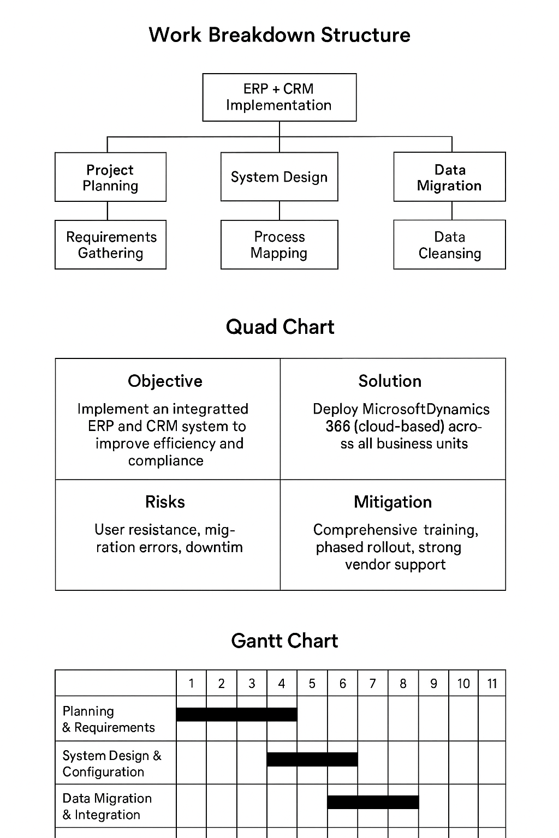

6. References (Harvard Style)
Buttle, F. and Maklan, S. (2019) Customer Relationship Management: Concepts and Technologies. 4th edn. Routledge.
Davenport, T.H. (2018) Process Management for Knowledge Work. Harvard Business Review Press.
European Commission (2024) General Data Protection Regulation (GDPR). Available at: https://gdpr.eu/ (Accessed: 6 November 2025).
Gartner (2024) Magic Quadrant for Cloud ERP for Product-Centric Enterprises. Gartner Research.
ISO (2023) Information Security Management Systems (ISO/IEC 27001). International Organization for Standardization.
Kotter, J.P. (2012) Leading Change. Harvard Business School Press.
Laudon, K.C. and Laudon, J.P. (2022) Management Information Systems: Managing the Digital Firm. 17th edn. Pearson.
Microsoft (2024) Dynamics 365 Overview. Available at: https://dynamics.microsoft.com/ (Accessed: 6 November 2025).
Monk, E. and Wagner, B. (2013) Concepts in Enterprise Resource Planning. 4th edn. Cengage Learning.
O’Brien, J.A. and Marakas, G.M. (2019) Introduction to Information Systems. 17th edn. McGraw-Hill Education.
Turban, E., Pollard, C. and Wood, G. (2021) Information Technology for Management: Driving Digital Transformation. 12th edn. Wiley.
Ward, J. and Peppard, J. (2016) The Strategic Management of Information Systems. 4th edn. Wiley.

