

BSc Health and Social Care
Module number: BMHP5015
Change makers: Building your Personal Brand for Sustainable Employment
Component 1: Online Portfolio of Set Exercises
Student name: Robina Kausar
Student number: 2407033
Submission Date: 26th October 2026
Teacher’s Name: Zahra Ahmed
Word count: 2108

Task 1 – Personal Brand
Personal branding is thoughtful presentation of values, talents, and dependability so that employers understand what I stand for. Peters (1997) argued that everyone should manage themselves as “the brand called You." Trust is basis of all relationships in health and social care, and employers recruit for character and qualifications.
My strengths are compassion, reliability, and active listening, and I would describe myself as patient, and dependable in my SWOT analysis. My weaknesses are that my experience is mostly informal, gained by supporting family and community, my CV lacks measurable achievements, and my online presence is limited. Opportunities are volunteering, career events, and LinkedIn; threats are competition for opportunities and lack of time. My strengths are to be communicated, not claimed, as personal branding is related to professional visibility, employability, and identity(Neves et al., 2026).
I will take 3 steps. First, I will be gaining structured experience with volunteering and bank work in a care home. Second, I will gain leadership and communication skills through feedback from tutors and supervisors. Third, I will develop a LinkedIn professional profile and a customised CV with a coherent message. One drawback is that there is still a lack of evidence: Neves et al. (2026) report that research about personal branding in nursing profession is still limited and inconsistent. On the other hand, Godsey and Hayes (2023) note that messages in personal brands are inconsistent. So I will consider branding as a reflective device based on actual behavior.
With consistent and a credible brand, I can progress from care worker to registered care home manager, as employers will be able to see my values and evidence.

Task 2 - Network Map and Rationale
Figure 1 maps my network across four dimensions: career, social, support and community.
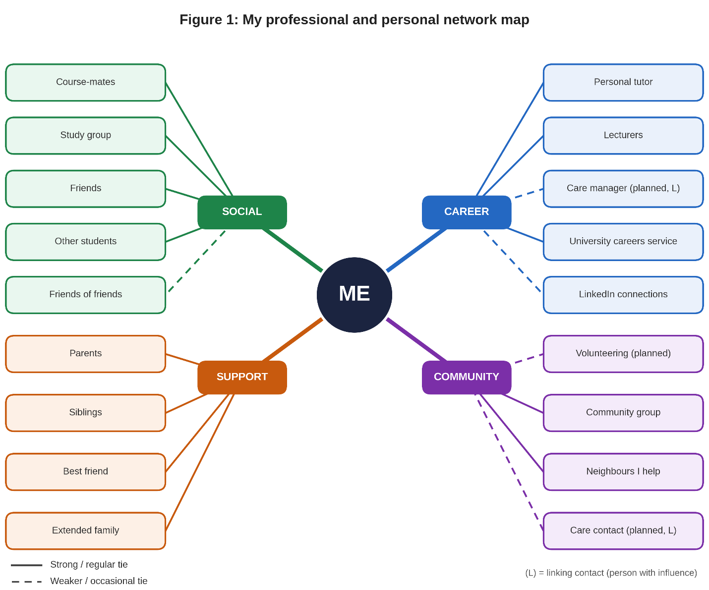

Rationale
My network is a hybrid network. It is mainly closed but has some selective components. Mostly connections are family, close friends, and course mates, but I make it a point to go to my personal tutor and lecturers for academic and career advice. Helping family and neighbors has built trust, nonetheless typically within close ties, so it is not yet an open network.
Social capital can be divided into bonding, bridging, and linking social capital (Pedersen et al., 2023). Bonding is joining the persons similar, Bridging is joining the persons dissimilar and Linking is, joining the persons with authority. My bonding capital is good, my bridging capital is less, and my linking capital is the least. My sphere of work is narrow, and I don't know many people working in care management that could give me any advice and/or open doors.
This has professional significance, as Pedersen et al. (2023) reported that bonding and bridging social capital among hospital staff members were positively linked to the employees' reports of quality of care. To improve, I will follow Phillips and Ellinas's (2014) steps of identifying and connecting with new contacts attending university careers events, building up a LinkedIn profile, and asking my tutor to introduce me to someone who works in care (linking). Also, I want to volunteer locally, meeting people from different ages and backgrounds (bridging).
A constraint is that networking takes time and sureness, so I will establish one small target and one new professional connection every month.

Task 3- Blog

Social Care Vacancies are at 10-year low. So why does it still matter?
Audience: students and career changers considering adult social care
Thinking about a career in adult social care? It is said that the sector is “in crisis." The recent statistics, however, are more optimistic but more complex and illustrate how your abilities can help right now.
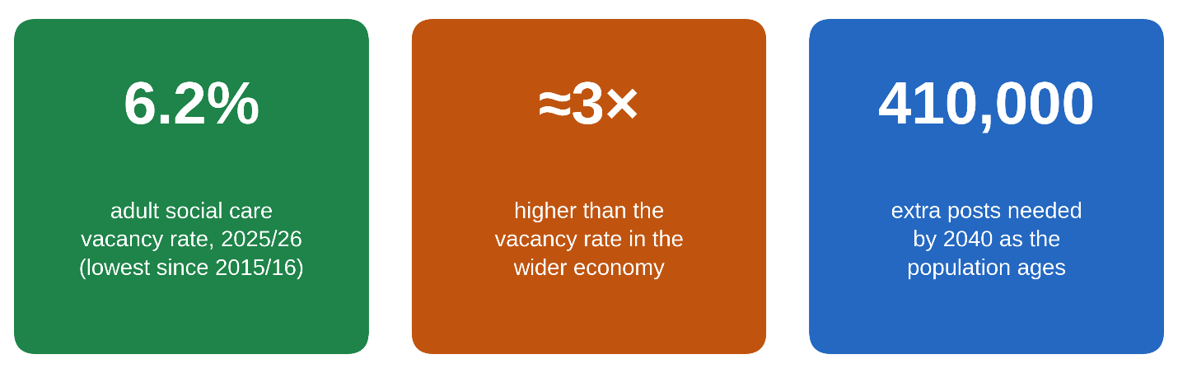
Figure 2: Key figures for adult social care in England. Source: Skills for Care (2026).

The good news
According to Skills for Care (2026), adult social care vacancies in England decreased to 6.2% in 2025/26, the lowest rate since 2015/16, and employment has increased for four consecutive years. Those numbers represent more stable teams that know the people they serve - something residents and families want. Continuity is important because people feel safe when having a familiar face to support them, not when a different face continually comes and goes.

The catch
There are still approximately three times more vacancies than in broader economy, and the sector will require approximately 410,000 additional jobs by 2040 to account fo aging population (Skills for Care, 2026). Recent expansion has also been largely due to international recruitment, and the number of British workers has declined. International colleagues have skill and commitment, but they will remain only when treated well and given a feeling of belonging. NHS England (2023) states that inclusion is connected to improved retention, and this is true in care homes and in home care.

What this means
High retention rates are heavily dependent upon good management. If you're thinking about pursuing this career, seek out employers that provide:
• consistently high staff expectations and standards
• regular, supportive supervision;
• funded training and clear routes for progression.
These are not option or extras. They make care workers feel appreciated, and valued staff stay, so protecting continuity of care for individuals who are valued. The first step is to volunteer and engage with others already in care sector and then develop skills like communication, empathy, and resilience, which are other employers' priorities than qualifications.

Conclusion: next step
Though vacancies are decent news, they are not source for complacency. There is a need for people who are both concerned and professional in sector, and that can be you. Speak with somebody doing care work this week or discovery out about volunteering in the range. If it was helpful, let a friend who is planning next know.

Task 4- NHS Equality, Diversity and Inclusion Quiz
- What is the primary goal of the NHS Equality, Diversity, and Inclusion Improvement Plan?
It seeks to increase equality, diversity and inclusion in NHS and is working on discrimination and staff experience and sense of belonging (NHS England, 2023).
- How does the NHS EDI Improvement Plan propose to tackle the gender pay gap?
Organisations must analyse pay by protected characteristic and act on it, using Mend the Gap recommendations and active flexible working policies (NHS England, 2023)

- What is meant by the term ‘intersectionality’ as used in the NHS EDI Improvement Plan?
It recognises that individuals have multiple and complex identities and that various experiences of disadvantage can intersect and create barriers that are not accounted for by any one characteristic (NHS England, 2023).

- Why is it important for the NHS to create a psychologically safe work environment?
As per NHS England, (2023), the respectful staff members are more likely to voice concerns and own up to errors, leading to safer and improved patient care.

- How does the NHS EDI Improvement Plan suggest improving the experience of internationally recruited staff?
It recommends clear pre-arrival direction, full training and pastoral support, ethnically aware line managers, and equivalent access to development prospects (NHS England, 2023).

- What role does leadership play in advancing EDI objectives according to the NHS Improvement Plan?
Leaders establish the culture, so chief executives, chairs and boards must have strong, measurable EDI goals and be held to account via appraisal (NHS England, 2023).

- Identify one way the NHS EDI Improvement Plan aims to reduce health inequalities within the workforce.
The line manager should have regular, effective wellbeing conversations with their team, following the National NHS Health and Wellbeing Framework (NHS England, 2023).

- Why does the NHS EDI Improvement Plan emphasise the importance of collecting and analysing data on protected characteristics?
If inequalities are not identified by reliable data they won't be known to boards, who can then set targets, monitor progress and hold leaders to account (NHS England, 2023).

- Explain how flexible working policies can contribute to equality and inclusion in the NHS workforce.
Staff will benefit from flexible working, allowing them to balance caring responsibilities and health and work, improving staff retention and progression (particularly amongst women) and reducing pay gaps (NHS England 2023).

- What is one strategy mentioned in the NHS EDI Improvement Plan to combat bullying and harassment in the workplace?
There should be an analysis of bullying/harassment data by protected characteristic, with targets set for reduction, and early intervention should be provided, with focus on informally also formally (NHS England, 2023).

Task 5- A Letter to Yourself

Dear younger me,
I'm writing to you about your preparation for important exams. You appeared fine on outside, but on inside, you were tired, nervous, and scared of not being successful. Studying late, sleeping incorrectly, saying that you are coping because you thought you should cope by yourself, etc.
I now realize that it wasn't a lack of ability; it was a lack of tools to manage emotions. Chung, Cichocki, and Chung (2023) define self-awareness as identifying your own emotions and how they impact you and self-regulation as controlling your emotions.. Empathy would have helped too; your classmates would likely have been as anxious as you were, and you could have talked through it so it didn't seem like you were as alone as you felt. Additionally, Urtubia-Herrera et al. (2024) provided evidence that emotional intelligence is associated with the well-being of students and healthcare professionals.
Resilience is not something you possess or lack and can be enhanced in health care workers as a method to adversit (Henshall et al., 2022). You thought it was a weakness to seek assistance. In practice, resilient people influence others to help them. Talking to a teacher, family member, or friend; making a realistic revision timetable; and protecting sleep made that period so much easier.
I'm not blaming you. At the time you did what you could. You were also always very good with supporting others at home, but you can't do that if you don't take care of your needs. This is important for my future career in health and social care, as I will be able to identify when I am stressed, remain calm, and support other people when they are stressed.
Beware of being hard on yourself and seek assistance early. Doing so is a skill, not a failure.
With love,
Your future self

Task 6- GANTT Chart
Task | Oct 26–Mar 27 | Apr 27–Sep 27 | Oct 27–Mar 28 | Apr 28–Sep 28 | Oct 28–Mar 29 | Apr 29–Sep 29 | Oct 29–Mar 30 | Apr 30–Sep 30 | Oct 30–Mar 31 | Apr 31–Sep 31
Task 1: Skills audit (SWOT), SMART goal, development plan
Task 2: Complete Level 5
Task 3: Care experience: volunteering, bank work
Task 4: Build network: events, LinkedIn, mentor
Task 5: Complete Level 6
Task 6: Update CV, LinkedIn, cover letter)
Task 7: Apply for team leader/senior carer roles)
Task 8: Work as team leader/deputy manager
Task 9: Level 5 Leadership and Management Diploma
Task 10: Apply for registered manager roles
Task 11: Six-monthly review with tutor/mentor |  | ◆ | ◆ | ◆ | ◆ | ◆ | ◆ | ◆ | ◆ | ◆
Milestone: registered manager (Jul 31) |  |  |  |  |  |  |  |  |  | ◆
Key: shading = active period; ◆ = milestone/review; “after Task n” = dependency.
My object is to be a registered care home manager by 31 July 2031. I have fragmented this into dated tasks with dependencies, utlising project life-cycle phases and SMART goals (Doran, 1981). Graduation (June '28), first leadership role (October '28), and manager (July '31) are main milestones. I will evaluate progress six-monthly with my mentor.

Task 7- Making Changes- Report

Report: Introducing Digital Care Planning in a Residential Care Home

1. Introduction
As manager of a residential care home, I want to replace paper care plans with a secure digital care planning system. Paper records require time to read, are hard to follow and can fall out, resulting in loss of information. This report explains the change, requirements for skills and potential challenges.

2. Planning the Change
Lewin's (1951) Force Field Analysis indicates that any driving force, including record accuracy, time savings over the long term, and support from the regulators, must be reinforced with any restraining forces, such as lack of confidence, fear of error, and lack of training (Dege, 2023). Then I will proceed to Kotter's (1995) steps. I will establish an agenda for the urgency of audit results regarding recording errors, form a guiding coalition with senior carers, agree with my deputy and a digital champion on a vision of accurate, person-centered records, and agree on a vision of accurate, person-centered records. Staff will be empowered via paid training and a pilot on one unit, which will yield short-term wins—Malley et al. (2026) found that acceptance increased when staff were trained and introduced gradually in English care providers. I will extend the system throughout the home and then integrate it into induction following evaluation. One drawback of Kotter's model is that the steps are sequential, and so I will adjust them to match the size and speed of my home (Carreño, 2024).

3. Skills Required
For change, it's crucial to be able to communicate. Empathy and self-regulation (Goleman, 1995) are examples of emotional intelligence that support me to stay calm when I am feeling anxious. (Chung, Cichocki, Chung, 2023) I also necessitate planning and risk management to plan training and around rotas, active listening to gather feedback and leadership to role model new system.

4. Barriers and Solutions
Low digital confidence and resistance: train staff early, provide individual training, and designate digital champions among staff (Malley et al., 2026).
Budget restraints: make a business case for time saved; discuss outside financing possibilities.
Time pressure: safeguard training time, phase and utilize bank staff.
Fear of errors: shape psychological safety so early errors took as learning, not blame (NHS England, 2023).

5. Conclusion
Digital care planning can contribute to increased correctness, time saving and person centred care. I can facilitate sustainable change through Lewin and Kotter, leadership development, and overcoming obstacles via participation, training and psychological security.

Reference List
Carreño, A.M. (2024) ‘An analytical review of John Kotter’s change leadership framework: a modern approach to sustainable organizational transformation’, SSRN. Available at: https://papers.ssrn.com/sol3/Delivery.cfm?abstractid=5044428(Accessed: 17 October 2026).
Chung, S.R., Cichocki, M.N. and Chung, K.C. (2023) ‘Building emotional intelligence’, Plastic and Reconstructive Surgery, 151(1), pp. 1–5. Available at: https://journals.lww.com/plasreconsurg/fulltext/10.1097/prs.0000000000009756~building-emotional-intelligence(Accessed: 17 October 2026).
Dege, M. (2023) ‘The Lewinian tradition’, in Action research and critical psychology: an investigation of subjectivity and participation. Cham: Springer International Publishing, pp. 59–95. Available at: https://link.springer.com/chapter/10.1007/978-3-031-31197-0_4(Accessed: 17 October 2026).
Doran, G.T. (1981) ‘There’s a S.M.A.R.T. way to write management’s goals and objectives’, Management Review, 70(11), pp. 35–36.
Godsey, J.A. and Hayes, T. (2023) ‘All nurses are leaders: 5 steps to reconstruct the professional identity and brand image of nursing’, Nurse Leader, 21(2), pp. 188–194. Available at: https://www.sciencedirect.com/science/article/pii/S1541461222003329(Accessed: 17 October 2026).
Goleman, D. (1995) Emotional intelligence: why it can matter more than IQ. New York: Bantam Books.
Henshall, C. et al. (2022) ‘Examining the effectiveness of web-based interventions to enhance resilience in health care professionals: systematic review’, JMIR Medical Education, 8(3), e34230. Available at: https://doi.org/10.2196/34230(Accessed: 17 October 2026).
Kotter, J.P. (1995) ‘Leading change: why transformation efforts fail’, Harvard Business Review, 73(2), pp. 59–67.
Lewin, K. (1951) Field theory in social science: selected theoretical papers. Edited by D. Cartwright. New York: Harper & Row.
Malley, J. et al. (2026) ‘A rapid evaluation of the implementation of Digital Social Care Records in England’, Health and Social Care Delivery Research, 14(16), pp. 1–82. Available at: https://doi.org/10.3310/gjjw2821(Accessed: 17 October 2026).
Neves, F.B. et al. (2026) ‘Personal branding and personal marketing in the nursing job market: a scoping review’, Revista Brasileira de Enfermagem, 79, e20240631. Available at: https://doi.org/10.1590/0034-7167-2024-0631(Accessed: 17 October 2026).
NHS England (2023) NHS equality, diversity and inclusion improvement plan. Available at: https://www.england.nhs.uk/long-read/nhs-equality-diversity-and-inclusion-improvement-plan/(Accessed: 17 October 2026).
Pedersen, L.M. et al. (2023) ‘Positive association between social capital and the quality of health care service: a cross-sectional study’, International Journal of Nursing Studies, 137, article 104380. Available at: https://doi.org/10.1016/j.ijnurstu.2022.104380(Accessed: 17 October 2026).
Peters, T. (1997) ‘The brand called you’, Fast Company, 10 (August/September).
Phillips, S. and Ellinas, S. (2014) The complete guide to professional networking: the secrets of online and offline success. London: Kogan Page.
Skills for Care (2026) Size and structure of the adult social care sector and workforce in England. Leeds: Skills for Care. Available at: https://www.skillsforcare.org.uk/sizeandstructure(Accessed: 17 October 2026).
Urtubia-Herrera, V. et al. (2024) ‘The relationship between sense of coherence and emotional intelligence as individual health assets for mental health promotion in students and healthcare professionals: a scoping review’, Frontiers in Public Health, 12, article 1304310. Available at: https://doi.org/10.3389/fpubh.2024.1304310(Accessed: 17 October 2026).

