Construction Technology 2
Designing Student Accommodation for UWTSD at SA1 (Continued)
Student: Finn Gale (2326098)
Date: 24/04/2025

Contents
Introduction 2
Environmental Impact 2
Orientation 2
Life Cycle 3
Energy Performance 3
Aesthetics 3
Façade Greening and SUDS 4
Green Facades 4
SUDS – Sustainable. Urban. Drainage. Systems 4
Greenfield Runoff rate 5
Post Development Runoff Rate 5
Infiltration Rate / Infiltration Testing 6
Flexibility in Design and use 6
Flexibility for Changing user needs 6
Future Uses 6
Conclusion 7
References 7

Introduction
Located in a central hub for university students, this accommodation block designed to meet modern standards and needs of current students exists of private en-suite rooms, shared kitchens/communal spaces including lounges, games rooms and a student union facility. The location of this proposal issues a number of obstacles, being next to the estuary does provide a naturally pleasing view however causes the ground surrounding to be malleable and unstable for the required footings when proposing a large block of flats.
It is currently an empty plot; the University of Wales Trinity Saint David have requested a proposed design of a block of student accommodation that fits well into the existing structures surrounding. All around the site there are restaurants, general need shops, gyms etc, a perfect location for a student housing proposition.
The current proposal shows that the foundations are ‘pile’ type, this is due to the bore hole logs (Handed in within last assignment) showing that the ground type is made up of clay, sand, silt and gravel. This report discusses the future proposals for the building, the effect of SUDS can have on the construction type, how this will affect local rainfall/flooding, how the orientation will affect the sun trap of the building, and the advantages of façade greening on a medium rise building.

Environmental Impact

Orientation
The orientation of the building has been carefully considered in order to maximise the natural light and potential ventilation; this can significantly reduce the buildings dependency on powered lighting and positive ventilation systems. Due to the building sitting landscape to both east and west orientation, the majority of rooms gather optimal sunlight throughout the day. This reduces the usage of powered services and therefor saves cost in the long run, storing solar panels at an elevated height helps hold solar power for heating during winter months and contributes to the building’s overall sustainability. Fresh air circulating throughout the property can be facilitated through windows open at opposite ends of the building, creating a suction effect allowing air to be flowing continuously, this improves air quality dramatically and reduces the need to power mechanical positive ventilation cooling. The orientation of the building will massively impact the seasonal comfort of the residents/consumers, the solar angles will be considered to prevent overheating during the summer and to maximise passive gains within the winter months. Larger depth eaves or overhangs will be installed to reduce glare from the sun when directly above. Another note to add, the placement of the windows will make a large impact on noise exposure from nearby roads or pedestrian routes.
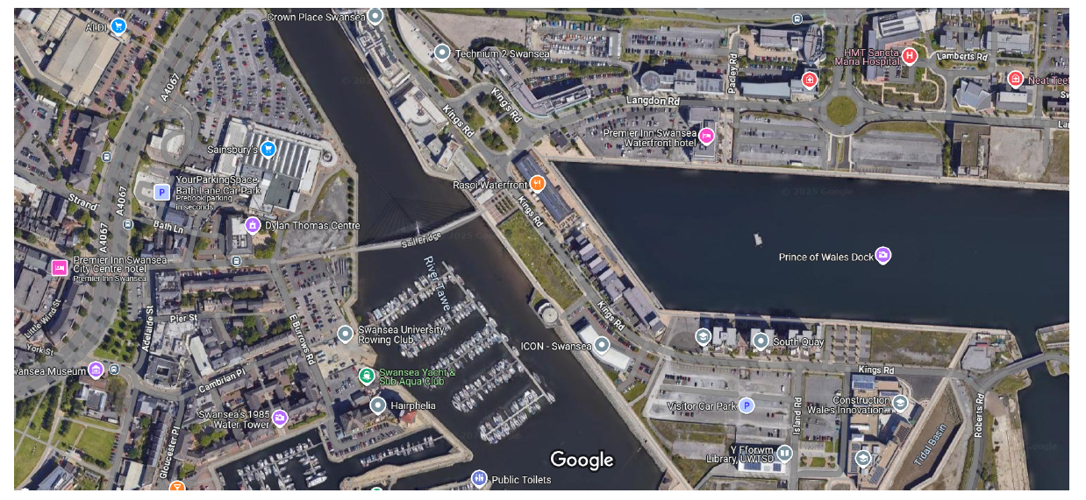
N
Google Maps. (n.d.). Google Maps. https://www.google.com/maps/@51.7963776,-4.964352,5383m/data=!3m1!1e3?entry=ttu&g_ep=EgoyMDI1MDUwMy4wIKXMDSoASAFQAw%3D%3D
As you can see from the attached image taken from Google maps, the orientation of the building takes a Northwest angle, this shows that the length of the building will be taking in a considerable amount of UV/sunlight from all four sides at different points throughout the day.

Life Cycle
Projected life cycle of this building’s materials is of long-term usage, the structure incorporates in-situ casted reinforced concrete floors offering high thermal mass, longevity and low maintenance. The steel H-beams used for structural support were chosen due to their strength, reliability and longevity, these items can also be recycled at certain plants which is another advantage. Other façade items such as the insulated cladding and double-glazed windows are enhancing the energy efficiency while also being low maintenance. Insulation materials such as Celotex were selected for their lifespan and resistance to invading moisture and pests. These materials are helping to prolong the product lifestyle of this building and help reduce costs in the long run.

Energy Performance
In addition to the passive design implementation of this building, it also incorporates high-performing energy systems such as an integrated building management system (BMS). These monitor energy usage in real time, which allows building maintenance managers to identify inefficiencies to the performance and optimise consumption. Motion sensors are also a great way to minimise communal areas energy waste. Using low energy appliances such as A+++ rating lightbulbs or LEDs throughout the building is a must.

Aesthetics
The aesthetics of the building is dominated by the insulated cladding panels which fit well within the contemporary waterfront developments down at SA1. Blending in well with the waterfront/harbour style of which the general façade is based upon. Expert studies show that access to natural light, rivers and Biophilic (Incorporating nature) designs are known to improve the well-being of tenants and overall satisfaction. The sharp finish combined with state-of-the-art floor to ceiling height double glazed windows gives the building a modern sleek aesthetic that lines up well with the current universities building line up, while supporting their expectations of their students who will accommodating it. The colours have been chosen to compliment the local landscape and river without stealing too much attention from the surrounding heritage sites across the river.

Façade Greening and SUDS
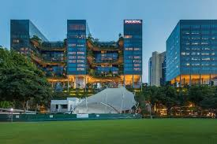
Top 7: Green facades. (n.d.-b). World of PORR. https://worldofporr.com/en/storys/top-7-green-facades/

Green Facades
Although green facades were not included in the original specifications and scope of work, they could very easily and confidently be retrofitted to the building. Vertical greening systems such as green walls offer incredible benefits including exceptional temperature regulation from the external leaf to the internal and would provide aesthetic enhancement by attracting local wildlife to choose as their habitat. This is becoming massively popular in modern urban developments and so would work well in this amendment.
As the buildings landscape sides attract the most sunlight, it would be prudent to fit them here, from here they can regulate the heat and reduce surface temperatures which will ultimately prolong the lifecycle of the cladding as\ would limit sun fading/cracking. Introducing these green walls to the building would be very popular with stakeholders as will create an ease of maintenance and the potential of plant replacement.

SUDS – Sustainable. Urban. Drainage. Systems
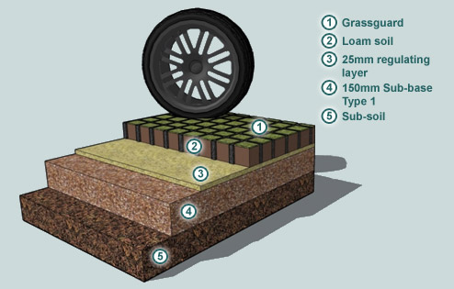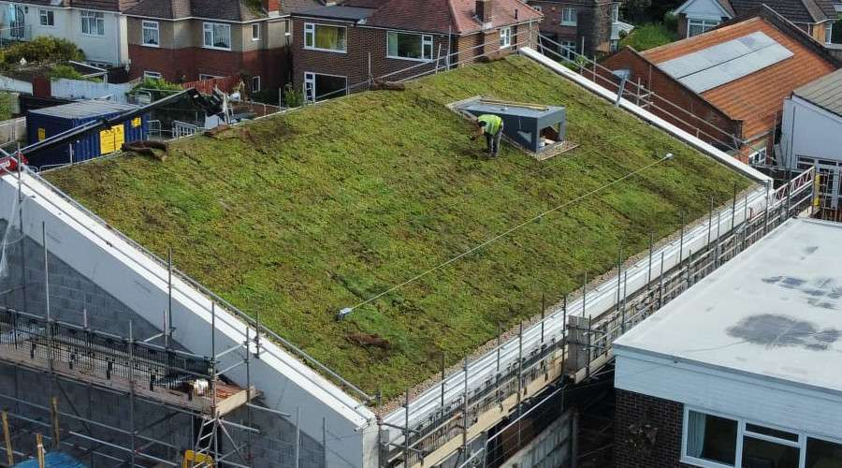
Sustainable drainage. (n.d.). https://www.susdrain.org/delivering-suds/using-suds/background/sustainable-drainage.html Accessed on 02/05/2025
What are Sustainable Drainage Systems | NetRegs | Environmental guidance for your business in Northern Ireland & Scotland. (n.d.). https://www.netregs.org.uk/environmental-topics/water/sustainable-drainage-systems-suds/what-are-sustainable-drainage-systems/ Accessed on 02/05/2025
Sustainable urban drainage systems can and will play a significant role in a building of this size, especially considering the proximity to the River Tawe. Permeable pedestrian paving will be very beneficial surrounding the building, it will soak all of the excess water run-off and drain under the existing walk path adjacent to the river and flow into said river. A green roof will also be included, as per the below image, which will absorb rainwater which will slow down runoff and improve thermal performance and biodiversity, this will dramatically reduce the urban island heat effect which is a common term used for when urban environments are identified as much hotter than the more open environments such as the countryside. Green roofs/walls are also good indicators to fit a rainwater harvesting system, all rainwater can be stored for the dryer days in the summer where landscaping is required.

Greenfield Runoff rate
Q=AREA×SAAR×SOIL
AREA = catchment area (Hectares)
SAAR = standard average annual rainfall (mm)
SOIL = soil runoff index (1–5)
1960M² Area of Proposed building = 0.196 Hectares
1,334mm per year average rainfall for Swansea SA1
Likely to be 4 soil runoff index as per reference for the area SA1.
Weather & Climate https://weather-ad-climate.com/average-monthly-precipitation-Rainfall%2Cswansea-glamorgan-gb%2CUnited-Kingdom?utm

Q = 0.196x1,334x4 = 1.046, the Greenfield runoff rate

Post Development Runoff Rate

Q=2.78×C×i×A
QQQ = peak runoff rate (litres/second)
CCC = runoff coefficient, depends on surface type such as concrete = 0.9, grass = 0.3
iii = rainfall intensity (mm/hr) for the design storm 2.22mm/ph. Mumbles Head (Swansea) Location-specific long-term averages (no date). https://www.metoffice.gov.uk/research/climate/maps-and-data/location-specific-long-term-averages/gcjjm7j5g?ut

AAA = area (hectares)
Q = 2.78x0.3(Grass)x2.22mm/phx0.196
Q = 0.36 (Post development Runoff rate)

Infiltration Rate / Infiltration Testing
For systems such as soakaways or infiltration basins, a percolation test will need to be carried out to determine the infiltration capacity of the soil. This will help confirm whether or not infiltration is a viable disposal method.
Before any construction begins – here is the step-by-step process that will be carried out to confirm the infiltration test (BRE 365)
- Excavate a test pit (Approximately 1M²x1.5M³) x3 recommended pits for this size of site
- Pre-soak the pit by filling it with water roughly 75% full and proceed to allow it to drain completely. The purpose of this is to mimic the soils saturation level in real time use
- Fill the pit again and measure the time it takes for the water to drop from 75% to 25%. Repeat this for 3 times to gain a good average record.
Following this, we will calculate the infiltration rate using the formula:
f=A×tV​
VVV = volume of water infiltrated (m³) 0.5M³
AAA = internal surface area of the pit through which infiltration occurs (m²). Sidewall Area 4M²
ttt = time for infiltration (s). 1800 Seconds
f= 0.5m(height) / 4M² x 1800 seconds (30Minutes) = 6.94x10m/s
Nimbus Civil and Environmental Engineers (2024) BRE365 Percolation Test | Nimbus Engineering Consultants. https://www.nimbusengineering.co.uk/services/bre365-percolation-test/#:~:text=BRE365%20Percolation%20Tests%20establish%20whether,at%20a%20much%20lower%20rate
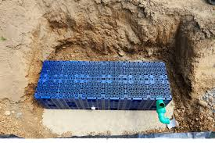
Nimbus Civil and Environmental Engineers (2024b) BRE365 Percolation Test | Nimbus Engineering Consultants. https://www.nimbusengineering.co.uk/services/bre365-percolation-test/. Accessed on 12/05/2025

Flexibility in Design and use

Flexibility for Changing user needs
Fortunately, this building has been designed for future adaptability in mind. With the large open plan areas, communal student rooms, and private living spaces these could all be easily reconfigured to allow changes. This is beneficial in the instance that the university does not require the accommodation block anymore. The building has also been designed so that if the changes do require some construction scope of work, the load-bearing walls are equally spaced out, and the remaining open plan spaces could be retro-fitted with portable screening walls which would look very similar to prefabricated school classrooms, along with this, the HVAC systems have been spaced out accordingly to further allow future zones to be isolated. These systems in place provide the building with the ability to easily undergo a refurbishment or function change.

Future Uses
Although the building has been designed as student accommodation, the building as previously mentioned can undergo a number of designs uses changes, including:
- Co-living apartments for young professionals/people
- Affordable housing units / short term rentals
- Offices or mixed-use developments such as daycares etc
- Emergency accommodation
Each accommodation room is self-contained with private en-suite bedrooms; this will make a transition to housing very straightforward. The communal areas and flexible floor plans on the lower floors are an excellent space to move around for office spaces and other business uses.
There is a similar case in Manchester called Boundary Lodge, originally being a student residence same as the proposed building, however this block was transformed into supported housing for young people leaving the world of foster care. In total the block was transformed into 30 homes for residents aged between 16 & 18. This shows that in the real world that these transformations and future uses of buildings just like this are possible and in demand. In this case, the renovated block undertook minimal interior scope of work and now serves as a precedent for how buildings just like this can quickly react to shifts in the market demand.

Conclusion
In conclusion, this proposal is a good demonstration highlighting the sustainable approach to the previously proposed student accommodation block. The buildings orientation has been intricately designed to harness and maximise light and ventilation, this is a massive benefit to the buildings owner/manager as it will drastically reduce the dependency of artificial systems such as positive ventilation systems (PIV) and enhance the energy efficiency overall. This, added with the context of insulated external cladding, IWI and reinforced concrete contributes to a much longer lifecycle that will minimise the environmental impact from the building.
The proposed features such as façade greening and sustainable urban drainage systems (SUDS) offer additional benefits such as heat loss regulation, biodiversity expansion to the local wildlife and effective water management that will create uses instead of waste. The building has been designed with the future in mind now, the open plan communal areas, the modular construction configuration and the location mean in can now be repurposed in years to come as described previously just like the Boundary lodge in Manchester.
Overall, the proposal now demonstrates the strategic planning taken into consideration when designing a building of this magnitude while meeting the modern standards for students. The block also takes into consideration the future adaptability that can be undergone with minimal alterations.

References
Average rainfall figures (1st October to March 31st) | DataMapWales (no date). https://datamap.gov.wales/maps/average-rainfall-figures-1st-october-to-march-31st/?utm_ . Accessed on 08/05/2025
BRE 365 Soakaway Testing | Jaystones (no date). https://www.jaystones.co.uk/bre-365-soakaway-testing. Accessed on 09/05/2025
Google Maps. (n.d.). Google Maps. https://www.google.com/maps/@51.7963776,-4.964352,5383m/data=!3m1!1e3?entry=ttu&g_ep=EgoyMDI1MDUwMy4wIKXMDSoASAFQAw%3D%3D Accessed on 07/095/2025
Kohler, J. (2021, January 18). Green Roofs and Biodiversity: What you need to know - MKA Ecology. MKA Ecology. https://www.googleadservices.com/pagead/aclk?sa=L&ai=DChcSEwiZpM744ZGNAxVXlFAGHYdaNRsYABABGgJkZw&co=1&gclid=EAIaIQobChMImaTO-OGRjQMVV5RQBh2HWjUbEAAYAyAAEgIDevD_BwE&ohost=www.google.com&cid=CAASJeRoWMYcjjAGWZrYghqG3DoN7y9NxksSdCD_Eyb3lxobTmIZTII&sig=AOD64_3cMsuebbclMXNjyI70Qmmff3162Q&q&adurl&ved=2ahUKEwiqr8n44ZGNAxXIV0EAHe0hBYsQ0Qx6BAgNEAE Accessed on 07/05/2025
Manchester student block to be converted to supported housing for young people. (n.d.). https://www.msvhousing.co.uk/news-and-views/msv-news/manchester-student-block-to-be-converted-to-supported-housing-for-young-people/ Accessed on 02/05/2025
Mumbles Head (Swansea) Location-specific long-term averages (no date). https://www.metoffice.gov.uk/research/climate/maps-and-data/location-specific-long-term-averages/gcjjm7j5g?utm . Accessed on 09/05/2025
Nimbus Civil and Environmental Engineers (2024) BRE365 Percolation Test | Nimbus Engineering Consultants. https://www.nimbusengineering.co.uk/services/bre365-percolation-test/#:~:text=BRE365%20Percolation%20Tests%20establish%20whether,at%20a%20much%20lower%20rate. Accessed on 09/05/2025
Post Development Runoff Rates and Volumes - REFH Technical Guide (no date). https://refhdocs.hydrosolutions.co.uk/Drainage-Design-Applications/Post-Development-Runoff-Rates-and-Volumes/. Accessed on 09/05/2025
Redirect notice. (n.d.). https://www.google.com/url?sa=i&url=https%3A%2F%2Fwww.permaroof.co.uk%2Fcommercial%2Fcommercial-green-roofing&psig=AOvVaw2MILA0IVUpeMOE9fOI85XC&ust=1746721168309000&source=images&cd=vfe&opi=89978449&ved=0CBcQjhxqFwoTCPDdysfhkY0DFQAAAAAdAAAAABAE Accessed on 05/05/2025
Sustainable drainage. (n.d.). https://www.susdrain.org/delivering-suds/using-suds/background/sustainable-drainage.html Accessed on 02/05/2025
Taylor, C. (2025, February 5). What is Co-living, and how can it help solve the UK Housing Crisis? Chapman Taylor. https://www.chapmantaylor.com/insights/what-is-co-living-and-how-can-it-help-solve-the-uk-housing-crisis Accessed on 02/05/2025
Top 7: Green facades. (n.d.). World of PORR. https://worldofporr.com/en/storys/top-7-green-facades/ Accessed on 07/05/2025
What are Sustainable Drainage Systems | NetRegs | Environmental guidance for your business in Northern Ireland & Scotland. (n.d.). https://www.netregs.org.uk/environmental-topics/water/sustainable-drainage-systems-suds/what-are-sustainable-drainage-systems/ Accessed on 02/05/2025
What is an urban heat island? (n.d.). NASA Climate Kids. https://climatekids.nasa.gov/heat-islands/ Accessed on 05/05/2025
Weather & Climate.https://weather-and-climate.com/average-monthly-precipitation-Rainfall%2Cswansea-glamorgan-gb%2CUnited-Kingdom?utm_Accessed on 08/05/2025
Nimbus Civil and Environmental Engineers (2024b) BRE365 Percolation Test | Nimbus Engineering Consultants. https://www.nimbusengineering.co.uk/services/bre365-percolation-test/. Accessed on 12/05/2025

