
PROGRAMME: BSC (Hons) Health and social care
Module Code: BMHP5015
Module: Changemakers: Building your Personal Brand for Sustainable Employment
Assignment Title: Component 2
Written Assignment (Report)
HEALTH CARE ASSISTANCE.


STUDENT NAME: ALIYA ATIK
STUDENT ID NUMBER: 2323993
LECTURERS NAME: RAHHELA SHAIKH

TABLE OF CONTENT
Contents pages
1.0 INTRODUCTION 3
2.0 JOB ADVERTISEMENT 3
3. JOB ROLE EMPLOYABILITY SKILLS 5
3.1 Communication: 5
3.2 Teamwork: 6
3.3 Time management and organisation: 6
4.0 SELF-EVALUATION OF SKILLS 6
4.1 Self-Evaluation of Skills 6
4.2 Self-Assessment and Experience 7
4.3 Strengths 7
4.4 Areas for Improvement and Support 7
5.0 ACTION PLAN AND TIMELINE FOR DEVELOPMENT 8
5.1 Short-Term Goals (0–12 months) 8
5.2 Medium-Term Goals (1–3 years) 8
5.3 Long-Term Goals (3–5 years) 9
6. BUILDING A PERSONAL BRAND 9
7. PROMOTING PROFESSIONAL IDENTITY 10
8. BUILDING A NETWORK FOR SUCCESSFUL EMPLOYMENT 10
9. CONCLUSION 11
10. REFERENCES 12
11.APPENDICES 14

1.0 INTRODUCTION
In the UK's health and social care system, a health care assistant (HCA) plays a critical role in supporting nurses, physicians, and clients in hospitals, assisted living facilities, and community settings. By helping with personal care, mobility, nutrition, and emotional support, HCAs make a substantial contribution to patients' well-being (NHS Careers, 2024). I am interested in this position because I have a strong desire to help people in living independently and with dignity and to advance person-cantered, compassionate care. my report assesses my present capabilities, examines the employability skills needed for the Health Care Assistant position, and provides a growth plan to help me reach my career objective.

2.0 JOB ADVERTISEMENT

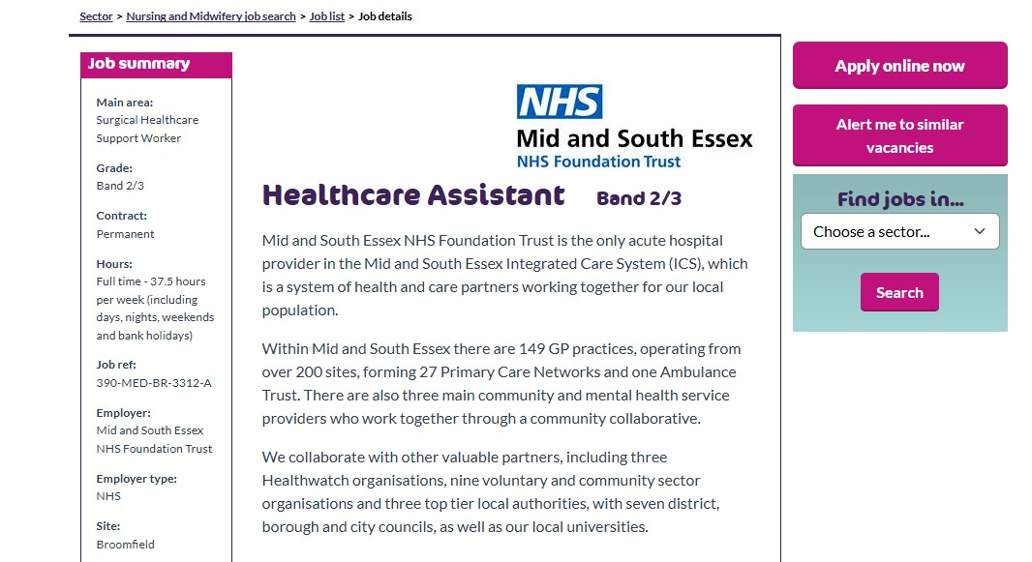

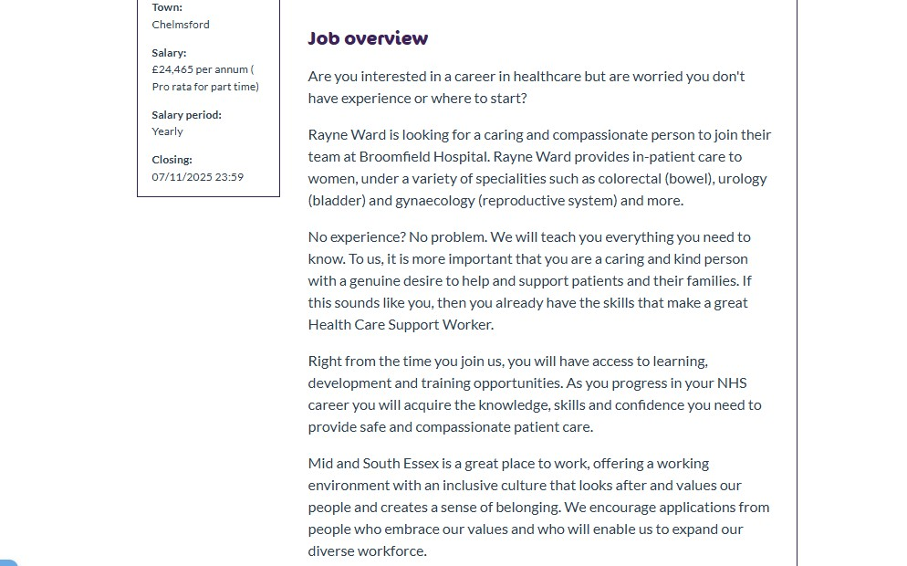
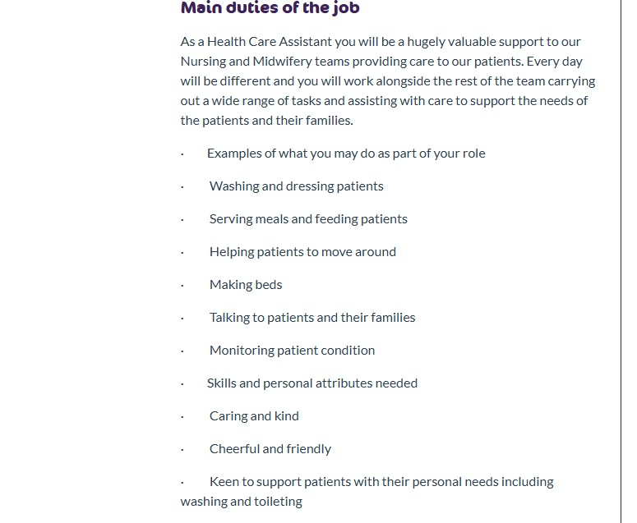

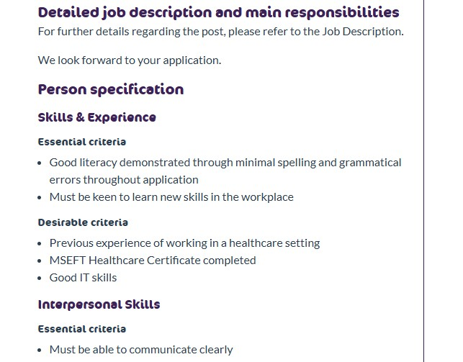
Figure 1: NHS Jobs advertisement – Mid and South Essex NHS Foundation Trust: Healthcare Assistant (Band 2/3) (2025). Source: (NHS Jobs. 2025)

3. JOB ROLE EMPLOYABILITY SKILLS
To guarantee high levels of patient care, the Health Care Assistant (HCA) position at Mid and South Essex NHS Foundation Trust requires a blend of professional, personal, and technological skills. Compassion, teamwork, communication, flexibility, and a desire to learn are all emphasized in the job description (Figure 1) as being essential components of good health care practice.

3.1 Communication:
One of the most important employability skills is communication. Every day, HCAs interact with patients, families, and medical professionals, often in delicate or emotionally taxing circumstances. Trust, certainty, and correct information exchange are all facilitated by the ability to communicate effectively, listen intently, and react sympathetically (NHS England, 2023). Additionally, effective communication helps avoid misconceptions that might jeopardize the safety or dignity of patients.

3.2 Teamwork:
Another crucial ability mentioned in the position is teamwork. To deliver seamless, person-cantered care, HCAs work collaboratively with physicians, nurses, and therapists. Working as a team fosters respect for one another, improves decision-making, and enables staff to effectively adapt to patients' evolving requirements (Fausett et al., 2024).

3.3 Time management and organisation:
Organization and time management are equally important. Being able to prioritize ensures that all patients receive timely and consistent treatment, as HCAs manage a variety of responsibilities, including personal care, observations, and paperwork.
Technical and practical skills are also required for the position. Accuracy and adherence to infection control and safeguarding procedures are necessary for properly carrying out duties including feeding, cleaning, helping with mobility, and keeping an eye on vital signs (Grealy et al., 2023).
Finally, a readiness to learn and adapt is emphasized in the person criteria. As healthcare systems change, ongoing professional development helps HCAs stay competent, self-assured, and productive (Health Education England, 2023). The NHS values of respect, inclusivity, and excellence are reflected in the compassionate, dependable, and high-quality patient care that is built upon these employability skills (Department of Health and Social Care, 2024).

4.0 SELF-EVALUATION OF SKILLS

4.1 Self-Evaluation of Skills
Self-evaluation is an essential step in determining my preparedness for the role of Health Care Assistant (HCA) and identifying areas in need of improvement. Sincerely evaluating my present skills and experiences will help me match my professional development to the standards established by Skills for Care (2024) and the NHS.

4.2 Self-Assessment and Experience
During my voluntary and paid work at a residential care facility and supported living, I assisted older adults with personal care, mobility, food help, and social interaction, giving me invaluable experience in the health and social care sector. My cooperation, empathy, and communication skills, all essential to person-cantered care, were enhanced by this experience. I also have MAPA (Managing Actual or Potential Aggression) training, which has prepared me to react to difficult circumstances in a composed and secure manner.
My qualifications include an NVQ Level 2 in Health and Social Care, which taught me about duty of care, equality, and safeguarding. I have successfully finished the Care Certificate, and my goal is to advance to NVQ Level 6, which will improve my leadership and supervising skills.

4.3 Strengths
Empathy, communication, dependability, and teamwork are some of my strongest traits. Connecting with individuals from different backgrounds and paying close attention to their needs comes naturally to me. The NHS places a strong focus on compassion and respect, and my voluntary experience showed that I could help people in a dignified manner while fostering their comfort and dignity (Department of Health and Social Care, 2023).
I also take responsibility for performing my tasks to a high quality and am trustworthy. Supervisors have acknowledged my professionalism and dedication, especially my ability to stay composed under pressure and my timeliness. These attributes show that I can be a valuable member of a care team and uphold the confidence of patients and coworkers.

4.4 Areas for Improvement and Support
Although my interpersonal skills are well developed, I need to improve my clinical and technical competencies, including measuring vital signs, infection control, and digital record-keeping. I plan to strengthen these areas through supervised placements, shadowing experienced HCAs, and completing CPD modules provided by Health Education England (2023).
Mentorship from senior healthcare assistants and registered nurses will also be key in developing confidence and applying new knowledge in practice. By engaging with professional networks such as Skills for Care Exchange, I will continue learning, share experiences with others, and remain updated on best practices.
Through consistent reflection, structured learning, and professional guidance, I aim to enhance my competence and deliver safe, compassionate, and high-quality care as a Health Care Assistant. (see appendix 1).

5.0 ACTION PLAN AND TIMELINE FOR DEVELOPMENT
A well-thought-out and practical strategy that draws on prior training and real-world experience is necessary to achieve ongoing professional development as a Health Care Assistant (HCA). To improve competence, clinical skills, and long-term employability in the UK's health and social care sector, the following five-year action plan lays out specific objectives. (see Appendix 2).

5.1 Short-Term Goals (0–12 months)
Having successfully completed both the Care Certificate and NVQ Level 3 in Health and Social Care, the short-term focus is on consolidating practical experience within a formal healthcare environment. Securing a permanent or part-time HCA position in an NHS Trust or care home will provide opportunities to apply learned skills, particularly in areas such as patient monitoring, documentation, and infection control.
Additional development during this stage will include completing short CPD courses in topics such as manual handling, dementia awareness, and safeguarding to enhance technical competence. Participation in MAPA refresher training will ensure confidence in managing challenging behaviour safely and professionally.

5.2 Medium-Term Goals (1–3 years)
Within the next three years, the aim is to strengthen clinical knowledge and prepare for career advancement by enrolling in a Level 6 Diploma in Leadership for Health and Social Care. This qualification will expand management and supervisory skills, preparing for potential progression into senior HCA or team leader roles.
Ongoing participation in mentorship and supervision from senior healthcare professionals will help refine practice standards and encourage reflective learning. Joining professional networks such as Skills for Care Exchange and maintaining an up-to-date LinkedIn profile will support the development of a professional identity and encourage networking across the health sector.

5.3 Long-Term Goals (3–5 years)
By year five, the goal is to progress to a Band 4 Assistant Practitioner role or undertake Nursing Associate training to widen clinical responsibility (NHS England, 2023). Continuing to attend mandatory CPD sessions, including digital literacy and patient-safety training, will ensure alignment with NHS quality frameworks and patient-care standards (NHS Digital, 2023).
Annual self-assessment and review of this action plan will allow for adjustments based on evolving professional goals and service demands. By maintaining dedication to learning, ethical care, and teamwork, long-term development will lead to increased confidence, competence, and sustainability within the healthcare profession (Ramani, 2024). This structured plan therefore serves as a foundation for advancing from a skilled Health Care Assistant to a capable and compassionate practitioner contributing positively to patient wellbeing.

6. BUILDING A PERSONAL BRAND
Developing a strong personal brand is an important step in establishing a credible and recognisable professional identity within the health and social care sector (Branzetti et al., 2025). For a Health Care Assistant (HCA), personal branding is not about self-promotion but about demonstrating authenticity, compassion, and commitment to delivering high-quality care, values that reflect the NHS ethos.
However, building a professional brand requires credibility, exposure, and consistency. Keeping a current LinkedIn profile that showcases credentials like the Care Certificate, the NVQ Level 2 in Health and Social Care, and pertinent volunteer experience contributes to building a reliable online presence. Sharing thoughts on person-cantered care, communication, or cooperation on a regular basis through brief, reflective postings or articles shows that one is also interested in modern healthcare procedures (Rybacka, 2024).
While participating constructively in online professional forums upholds credibility and ongoing learning, attending conferences, professional networking events, and NHS employment fairs offers chances to network with employers and practitioners (Rolls et al., 2024). Professional exposure may also be increased by building a basic website or personal digital portfolio to display credentials, CPD accomplishments, and comments.
Therefore, a personal brand may effectively communicate professional competence and genuine concern by continuously articulating the essential principles of empathy, reliability, and excellence (Ghaltakhchyan, 2025). These traits set an aspiring health care assistant apart in the highly competitive healthcare industry.

7. PROMOTING PROFESSIONAL IDENTITY
Effectively promoting a professional identity is essential for demonstrating credibility and employability within the health and social care sector (Adams et al., 2023). As a developing Health Care Assistant (HCA), communicating skills and experiences clearly allows potential employers to recognise commitment, capability, and alignment with NHS values.
Creating a well-organized curriculum vitae (CV) that promotes credentials like the Care Certificate and NVQ Level 3 in Health and Social Care, as well as real-world accomplishments from training and volunteer work, is an important tactic. The CV should be brief, have distinct sections, and include quantifiable instances of competence, such helping residents move about or promoting infection-control procedures. Alongside this, a customized cover letter might highlight a desire for providing compassionate care, collaboration, and ongoing education while meeting certain job description requirements.
However, establishing a professional and active internet presence is equally crucial. Keeping one's LinkedIn page up to date facilitates networking with medical professionals, sharing reflective practice ideas, and exhibiting certificates. Additionally, certifications, proof of CPD, and brief summaries of learning accomplishments might be shown on a professional homepage or personal digital portfolio.
When combined, these tactics strengthen a professional image based on competence, empathy, and lifelong learning, elements that set a dedicated healthcare worker apart in the NHS and larger care community.

8. BUILDING A NETWORK FOR SUCCESSFUL EMPLOYMENT
One of the most important aspects of career growth in the health and social care industry is creating strong professional networks. In addition to creating job chances, networking gives access to continued professional development, mentorship, and teamwork (Lair et al., 2025). Effective networking fosters development, boosts self-esteem, and aids in the comprehension of best practices in various care settings for a health care assistant (HCA).
Furthermore, reaching out to skilled professionals like registered nurses, care managers, and senior HCAs may provide career insights and helpful advice (Palmer, 2023). Building mentoring connections in an NHS Trust or community-based care organization promotes structured support and feedback, both of which are critical for career advancement.
Also, engaging with professional bodies such as Skills for Care, Health Education England, and the Royal College of Nursing (RCN) provides access to training resources, online forums, and sector updates (Cunningham et al., 2024). Attendance at NHS recruitment events, care career fairs, or local health conferences can also expand contacts with employers and educators.
In addition, maintaining an active LinkedIn network allows consistent communication with peers and mentors while showcasing professional achievements (Keeney et al., 2023). Combining digital networking with in-person engagement helps build a well-rounded professional reputation, ensuring visibility and credibility in a competitive employment market.

9. CONCLUSION
The key employability needs, professional identity-building techniques, and personal development methods required for success as a Health Care Assistant (HCA) in the UK health and social care sector have been examined in this report. The examination of the job posting revealed that the position requires empathy, clear communication, collaboration, and flexibility, elements that are very compatible with the NHS's basic principles.
Through the self-evaluation process, existing strengths such as empathy, reliability, and interpersonal awareness were identified, alongside areas for improvement including technical competence and confidence in clinical skills. The five-year action plan provided a structured pathway for achieving these goals through further education, mentorship, and continuous professional development.
Strategies for promoting a professional identity and building a personal brand highlighted the importance of visibility, authenticity, and engagement across professional platforms such as LinkedIn and Skills for Care Exchange. Networking with mentors and professional bodies was also recognised as essential for long-term growth and career advancement.
Overall, the report reflects a strong commitment to delivering compassionate, safe, and high-quality care. With dedication to learning and alignment to NHS values, the Health Care Assistant pathway offers both personal fulfilment and professional progression within a respected and rewarding field.

10. REFERENCES
Adams, K., Hean, S., Sturgis, P. and Clark, J.M., (2023). Investigating the factors influencing professional identity of first‐year health and social care students. Learning in health and social care, 5(2), pp.55-68.
Branzetti, J., Gisondi, M.A., Hopson, L.R., Regan, L. and Botti, S., (2025). Physician, know thyself: Applying brand management principles to professional identity in academic medicine. Medical education, 59(7), pp.694-703.
Cunningham, F.C., Ranmuthugala, G., Plumb, J., Georgiou, A., Westbrook, J.I. and Braithwaite, J., (2024). Health professional networks as a vector for improving healthcare quality and safety: a systematic review. BMJ quality & safety, 21(3), pp.239-249.
Department of Health and Social Care. (2023) The NHS Constitution for England. London: Department of Health and Social Care. Available at: https://www.gov.uk/government/publications/the-nhs-constitution-for-england [Accessed 18th October 2025].
Fausett, C.M., Korentsides, J.M., Miller, Z.N. and Keebler, J.R., (2024). Adaptive leadership in health care organizations: Five insights to promote effective teamwork. Psychology of Leaders and Leadership, 27(1), p.6.
Ghaltakhchyan, s., (2025). personal branding: shaping and maintaining a successful personal brand. armenian folia anglistika, 21(1 (31)), pp.125-142.
Grealy, B., Johansson, L. and Coyer, F., (2023). Essential nursing care of the critically ill patient. Crit Care Nurs, 103.
Health Education England. (2023) Careers in the healthcare support workforce. Available at: https://www.hee.nhs.uk [Accessed 24 October 2025].
Lair, D.J., Sullivan, K. and Cheney, G., (2025). Marketization and the recasting of the professional self: The rhetoric and ethics of personal branding. Management communication quarterly, 18(3), pp.307-343.
Keeney, S., Hasson, F. and McKenna, H., (2023). Health care assistants: the views of managers of health care agencies on training and employment. Journal of nursing management, 13(1), pp.83-92.
NHS Careers. (2024) Health care assistant job profile. Available at: https://www.healthcareers.nhs.uk/ [Accessed 23rd October 2025].
NHS Digital. (2023) Digital skills and the NHS workforce. London: NHS Digital. Available at: https://digital.nhs.uk [Accessed 27th October 2025].
NHS England. (2023) The NHS Core Values. London: NHS England. Available at: https://www.england.nhs.uk/about/nhs-constitution/nhs-core-values/ [Accessed 27th October 2025].
NHS Jobs. (2025) Healthcare Assistant (Band 2/3) – Mid and South Essex NHS Foundation Trust. Available at: https://www.jobs.nhs.uk [Accessed 20th October 2025].
Palmer, S.J., (2023). Career progression from HCA to nurse: bridging the gap. British Journal of Healthcare Assistants, 14(7), pp.350-353.
Ramani, S., McMahon, G.T. and Armstrong, E.G., (2024). Continuing professional development to foster behaviour change: from principles to practice in health professions education. Medical teacher, 41(9), pp.1045-1052.
Rolls, K., Hansen, M., Jackson, D. and Elliott, D., (2024). How health care professionals use social media to create virtual communities: an integrative review. Journal of medical Internet research, 18(6), p.e166.
Rybacka, M., (2024). The experiences of registered nurses seeking support to care for a person living with dementia: A Hermeneutic Phenomenological Study.

11.APPENDICES
Appendix 1
Table 1: SWOT analysis. Source: (Author, 2025).
Strengths | Weaknesses
• I am naturally empathetic and able to connect easily with patients, which helps me deliver compassionate and person-centred care.  • My communication and listening skills allow me to build trust with patients, families, and colleagues.  • I am dependable, punctual, and always follow professional care standards.  • Previous volunteer experience in a residential home has strengthened my teamwork and understanding of patient needs. | • I need to improve my confidence and competence in taking vital signs and completing basic clinical observations independently.  • I sometimes find it challenging to manage multiple tasks under time pressure.  • My knowledge of medical terminology and digital record-keeping systems is still developing.
Opportunities | Threats
• I plan to complete the Care Certificate and pursue NVQ Level 5 to expand my clinical and leadership skills.  • NHS Trusts offer continuous professional development (CPD), mentorship, and training opportunities to build my technical expertise.  • Networking through Skills for Care Exchange will help me stay informed about career development and best practice. | • Balancing further study, work, and personal commitments could slow my professional progress.  • The competitive nature of NHS recruitment means I must continuously update my knowledge and demonstrate commitment to self-improvement.  • Limited access to clinical placements could delay the development of practical competencies.

The SWOT analysis above highlights both my current abilities and areas requiring improvement as I prepare for the Health Care Assistant role. My key strengths, empathy, communication, and reliability, demonstrate a genuine commitment to person-centred care, which aligns closely with the NHS’s core values of compassion and respect. These qualities allow me to build positive relationships with patients and colleagues and contribute effectively to team-based care.
However, the analysis also recognises that further development is needed in technical and clinical competence, particularly in vital sign monitoring, infection control, and digital documentation. The opportunities identified, such as completing the Care Certificate, NVQ Level 5, and engaging in continuous professional development, will enable these gaps to be addressed. Although balancing study and work may present challenges, proactive time management, mentorship, and reflective learning will support ongoing growth and ensure consistent, high-quality care delivery in line with professional standards.

