

The Impact of Digital Transformation
on Business Strategy
for UK High Street Retailers

Programme: BA BUSINESS MANAGEMENT
Module Title: Dissertation
Module Code: LCBB6000
Student Name: Mihaela Boicu
Student ID: 2223393
Internal Verifier: Dr Anupam Mazumdar

1.Introduction
The UK high street retail sector has undergone significant disruption in recent years, driven largely by the increasing influence of digital technologies. Retailers that once thrived through traditional in-store models now face declining footfall, growing operational costs, and intense competition from e-commerce platforms. This rapid change has pushed high street businesses to rethink their strategies in order to survive and remain competitive (Chaffey and Ellis-Chadwick, 2019, ch.2). At the core of this transformation is the need to integrate digital tools into core operations, marketing, and customer engagement—marking a shift from conventional practices to technology-led models.
The term digital transformation refers not just to the use of new technologies but to the broader strategic change it forces across all areas of a business. According to Westerman, Bonnet and McAfee (2014, p.10), digital transformation reshapes how organisations deliver value, communicate with customers, and make strategic decisions. For UK high street retailers, this means adopting digital solutions such as AI-powered customer service, data-driven marketing, e-commerce platforms, and in-store technologies like self-checkout and mobile integration.
This research focuses on how digital transformation is influencing business strategy—a core concern for retail firms aiming to adapt while maintaining their market identity and profitability. Retailers like Next and M&S are examples of businesses actively investing in digital tools to remain relevant, while others like Debenhams have struggled to transition effectively and collapsed under digital pressure (PwC, 2024).
Digital transformation is not just a trend but a foundational shift in how value is created across sectors (McKinsey & Company, 2024). The proposed study will explore what digital transformation looks like in practice within the UK high street sector, what technologies are driving change, and how strategic priorities are being realigned. By focusing on both internal changes (e.g. operations and staff roles) and external factors (e.g. customer experience and market position), the research aims to contribute valuable insight into the future of traditional retail in a digital-first environment.

2. Research Aim and Research Objectives
Research Aim
The aim of this research is to explore how digital transformation is influencing the business strategies of UK high street retailers. With rapid changes in consumer expectations, the growth of e-commerce, and the increased use of digital technologies such as artificial intelligence, mobile platforms, and customer data analytics, many traditional retailers have been forced to rethink how they operate and compete. This research seeks to understand how these businesses are adapting their strategic decisions in response to digital pressures, and whether those changes are helping them stay relevant in a fast-changing retail environment.
Rather than just looking at technology adoption on its own, this study focuses on the wider effects of digital transformation on strategic planning. It will explore how digital tools are being integrated into customer service, marketing, operations, and long-term business models. It will also consider the internal changes required for these strategies to succeed, such as staff training, leadership roles, and organisational culture. The aim is to provide a balanced view of how UK high street retailers are using digital transformation not only to survive, but also to build competitive advantage.
This research will be helpful for retail professionals who are currently making strategic decisions about digital investments, as well as for academics interested in how traditional industries manage digital disruption.
Research Objectives
To achieve this aim, the following specific objectives have been set:
- To identify and assess how digital transformation has influenced strategic decisions in the UK high street retail sector, with a focus on core areas such as product delivery, customer interaction, and market expansion.
- To explore the specific digital technologies—such as CRM systems, e-commerce platforms, AI tools, and data analytics—that are shaping strategic direction and competitive advantage.
- To analyse internal and external factors (e.g., organisational culture, market competition, technological readiness) that influence the success of digital strategies in retail.
- To evaluate the impact of digital transformation on customer engagement and brand positioning, particularly how retailers are using digital tools to maintain relevance and loyalty.
- To identify challenges, risks, and limitations faced by high street retailers in aligning traditional strategies with digital imperatives, including workforce adaptation, financial constraints, and legacy systems.

3. Research Questions
Given the complex nature of strategic change, the questions are exploratory and qualitative in focus. They aim to uncover how and why certain changes are taking place, rather than simply measuring their existence. Each question is rooted in current challenges facing UK retailers and reflects both academic discussions and real-world business developments (Westerman, Bonnet and McAfee, 2014, p.11).
Primary Research Question:
How has digital transformation influenced the strategic direction of UK high street retailers?
This overarching question explores the core of the study—how businesses have responded to digital disruption. It will examine changes in long-term business planning, digital investment, competitive focus, and overall corporate strategy.
Supporting Research Questions:
- Which digital technologies are most instrumental in shaping retail business strategy?
This question investigates the specific tools and innovations retailers are adopting, such as data analytics, customer relationship management (CRM) systems, mobile apps, cloud-based services, and AI. It aims to identify which technologies are seen as most valuable and how they’re being deployed across strategic functions (Laudon and Traver, 2021, ch.5).
- What organisational and market-based challenges do retailers face during digital transformation?
This question focuses on barriers such as employee resistance, outdated infrastructure, limited digital expertise, budget constraints, and competitive pressure. It also explores how external forces—such as changing customer expectations and e-commerce growth—affect internal strategy (Hill and Hill, 2018, ch.6).
- How do digital strategies affect customer engagement and brand competitiveness in the high street retail sector?
Customer experience has become central to digital success. This question explores whether digital tools have helped retailers build stronger relationships with customers, improve loyalty, personalise services, and differentiate their brand in a saturated market (Kotler and Keller, 2019, ch.10).

4. Justification of the Research
The UK high street has been experiencing a period of sustained disruption, with major brands such as Debenhams and Arcadia Group collapsing, while others like Next, M&S, and Primark continue to evolve digitally. This divide signals a crucial need to understand what makes digital strategy successful for some and unsustainable for others. As digital transformation becomes central to strategic planning, this study is vital for providing real-world insight into how traditional retailers can adapt to the modern consumer and technological landscape. The UK Parliament’s POST (2025) highlights digital transformation as a key focus for national competitiveness and innovation, further justifying this research in a policy context.
Academic studies suggest digital transformation not only changes operational tools but redefines the entire strategic framework of firms (Westerman, Bonnet and McAfee, 2014, p.5). Retailers must make critical choices about which technologies to adopt, how to restructure operations, and how to retrain their workforce, all while preserving brand identity and customer trust. Moreover, the speed of digital change adds urgency to understanding how strategic decision-making can keep pace.
This topic is important now because the UK high street faces an existential challenge. While brands like Next have succeeded by integrating online and offline strategies, others like Debenhams have failed to adapt and collapsed. Understanding how digital transformation intersects with strategy can reveal insights into sustainable retail models. The findings will provide insight on business strategy and digitalisation, while also serving as a practical guide for retail managers seeking to navigate this complex transition (Chaffey and Ellis-Chadwick, 2019, ch.2).

5. A Review of Literature
Digital transformation is widely recognised as one of the most significant forces reshaping modern business strategy, especially in consumer-facing sectors such as retail. As defined by Westerman, Bonnet and McAfee (2014, p.5), digital transformation is “the use of technology to radically improve the performance or reach of enterprises.” It affects not just operations, but also organisational culture, customer interaction, and strategic direction. Within the UK high street retail sector, this transformation has gained urgency due to the rise of online shopping, changing consumer behaviour, and financial pressures on traditional stores.
One of the key drivers of strategic change is the rise of e-commerce and omnichannel models, which blend digital and physical customer experiences. According to Chaffey and Ellis-Chadwick (2019, ch.2), successful high street retailers now rely on seamless digital integration across websites, apps, social media, and in-store technologies. For example, M&S has invested in a digital loyalty platform and delivery infrastructure, while Argos operates a ‘click-and-collect’ model that connects its website to local stores. These changes indicate that business strategy has become inseparable from digital capability.
Technology adoption is central to this shift. Laudon and Traver (2021, ch.5) highlight the importance of CRM systems, AI-driven analytics, and mobile platforms in enabling firms to personalise services and respond to customer needs in real time. Retailers like Next use data analytics to forecast trends and manage stock, demonstrating how digital tools are shaping strategic decisions around supply chain management and marketing. Retailers are increasingly leveraging artificial intelligence to optimise operations and personalise customer experiences (Deloitte, 2023).However, the ability to leverage such tools depends on organisational readiness and internal capabilities.
This is where strategic theory becomes useful. The Resource-Based View (RBV) suggests that a firm’s internal resources—such as IT infrastructure, skilled personnel, and digital leadership—are essential for achieving a sustainable competitive advantage (Hill and Hill, 2018, ch.7). In contrast, Porter’s (2008) Five Forces model focuses on external pressures, such as the bargaining power of customers and the threat of substitutes, both of which have increased in the digital era. Together, these models help to explain the different strategic responses observed across UK high street retailers.
Despite the benefits, there are barriers to transformation. Johnston and Clark (2018, ch.4) point to issues such as legacy systems, resistance to change, and skills gaps as common challenges. Many traditional retailers lack the digital expertise or agile culture needed to implement large-scale strategic changes. This is one reason why firms like Debenhams were unable to keep up with the pace of digital disruption and eventually collapsed. On the other hand, digital-first brands like JD Sports and Zara, which invested early in mobile apps and social media strategy, have gained strong competitive positions.
Customer behaviour is another key theme. As Kotler and Keller (2019, ch.10) explain, modern consumers expect personalisation, convenience, and rapid service. Digital transformation enables retailers to meet these expectations through data analytics, recommendation engines, and 24/7 customer support tools. Therefore, customer expectations are no longer just marketing concerns—they are strategic drivers.
In summary, the literature reveals that digital transformation is not simply about technology, but about rethinking strategy across all levels of the organisation. The gap in existing studies lies in understanding how high street retailers in the UK, specifically, are translating digital initiatives into long-term strategic advantage. This study seeks to address that gap.

6. Methodology
This research will adopt a qualitative methodology in order to explore how digital transformation is influencing business strategies within UK high street retailers. A qualitative approach is suitable because the study aims to investigate managerial perspectives, strategic decisions, and internal experiences rather than measure numerical outcomes. As Saunders, Lewis and Thornhill (2019, p.179) explain, qualitative research enables a deeper understanding of complex organisational behaviour and is often used when the researcher wants to interpret meanings and opinions.
The research will follow an interpretivist philosophical stance, which recognises that business strategy is shaped by subjective, socially constructed factors, including leadership culture, internal communication, and employee attitudes. Interpretivism is appropriate when exploring organisational change, because it values the viewpoints of participants and acknowledges multiple realities (Bryman and Bell, 2015, p.29). In this case, managers’ interpretations of digital transformation are central to understanding how strategic decisions are made.
The primary data will be collected using semi-structured interviews, which allow participants to explain their experiences in depth while still addressing the key themes of the research. An interview guide will be developed based on the research questions and will include open-ended questions related to strategy, technology adoption, and customer engagement. For example: “How has your company adapted its strategy due to digital transformation?” or “What internal challenges did your team face during the process?”
A purposive sampling method will be used to select 5–7 participants with relevant experience, such as retail store managers, digital marketing leads, or operations staff in UK-based high street companies. This non-random sampling is appropriate for small-scale qualitative studies where the goal is to gain insight from those directly involved in the subject matter (Saunders et al., 2019, p.315).
The collected data will be analysed using thematic analysis, following Braun and Clarke’s (2006) six-phase framework: familiarisation with the data, coding, generating themes, reviewing themes, defining themes, and producing the report. This method allows for the identification of patterns across participant responses while maintaining flexibility in interpretation.
Interviews will last approximately 30–45 minutes and be recorded with consent. Ethical approval will be sought in advance of data collection. Participants will receive an information sheet and consent form explaining the study’s purpose, the voluntary nature of participation, and their right to withdraw at any time. All data will be anonymised and stored securely in line with university research ethics guidelines.
This approach will allow the researcher to generate meaningful insights into how digital transformation affects strategic decision-making across different UK high street retailers.

Timeline – Gantt Chart

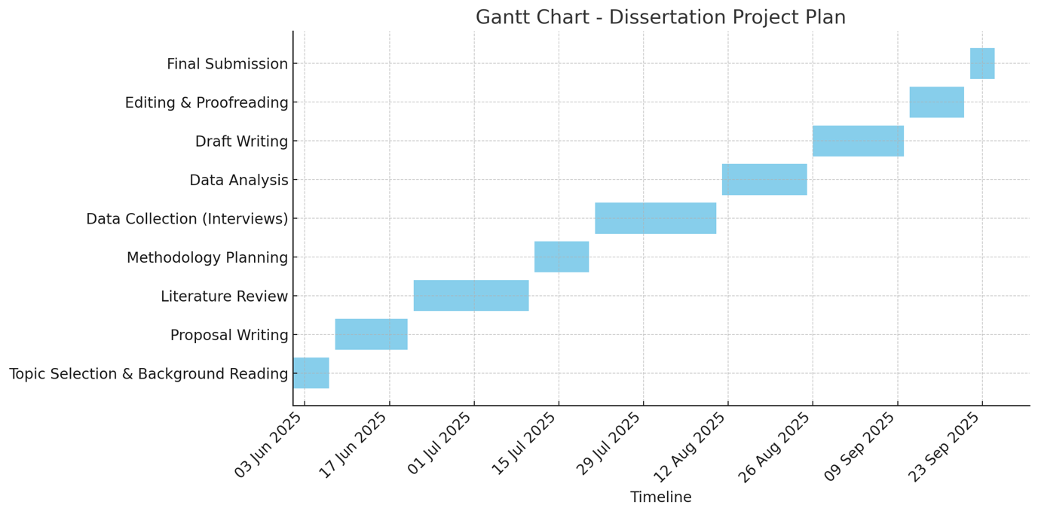

References

Braun, V. and Clarke, V. (2006) Using thematic analysis in psychology. Qualitative Research in Psychology, 3(2), pp.77–101.
Bryman, A. and Bell, E. (2015) Business research methods. 4th edn. Oxford: Oxford University Press.
Chaffey, D. and Ellis-Chadwick, F. (2019) Digital marketing. 7th edn. Harlow: Pearson.
Deloitte (2023) Retail trends 2023: The coming of age of retail AI. Available at: https://www2.deloitte.com/uk/en/pages/consumer-business/articles/retail-trends.html (Accessed: 3 June 2025).
Hill, A. and Hill, T. (2018) Essential operations management. 3rd edn. London: Palgrave.
Johnston, R. and Clark, G. (2018) Service operations management: Improving service delivery. 5th edn. Harlow: Pearson.
Kotler, P. and Keller, K.L. (2019) Marketing management. 15th edn. Harlow: Pearson.
Laudon, K.C. and Traver, C.G. (2021) E-commerce: business, technology, society. 16th edn. Harlow: Pearson.
McKinsey & Company (2024) What is digital transformation? Available at: https://www.mckinsey.com/featured-insights/mckinsey-explainers/what-is-digital-transformation (Accessed: 3 June 2025).
Porter, M.E. (2008) Competitive strategy: Techniques for analyzing industries and competitors. New York: Free Press.
PwC (2024) Store Openings and Closures 2024. Available at: https://www.pwc.co.uk/industries/retail-consumer/insights/store-openings-and-closures.html (Accessed: 3 June 2025).
Saunders, M., Lewis, P. and Thornhill, A. (2019) Research methods for business students. 8th edn. Harlow: Pearson.
UK Parliament POST (2025) Digital Transformation in Government. Available at: https://post.parliament.uk/research-briefings/post-pn-0743/ (Accessed: 3 June 2025).
Westerman, G., Bonnet, D. and McAfee, A. (2014) Leading digital: Turning technology into business transformation. Boston: Harvard Business Review Press.

