MARKETING FUNNDAMENTALS
ASSIGMENT 1
LCBB4004

Student name: Bozhidar Ivanov Minev
Student Number: 1921806
Assignment Title: Blogging to Communicate
Lecturer: Rula Alousi

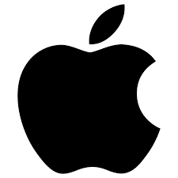
Apple Company
Apple is an American multinational company. It is situated in Cupertino, California. Our company is specialized in the design and developments of electronics for customers.

The Apple Inc company is founded by Steve Jobs, Steve Wozniak, and Ronald Wayne. They found it in 1976. The company is developing and selling products like customer electronics, computer software, and online services.
Their first development and sell were of the Wozniak Apple I that was a personal computer. n 1977, the Apple Inc. sales their second personal computer Apple II.
Steve Jobs Steve Wozniak Ronald Wayne

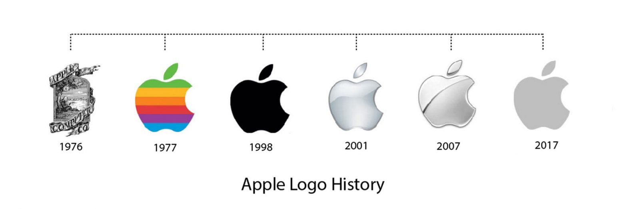
After a few years, the Wozniak and Jobs have hired staff and starting to produce a line. In 1985. Steve Wozniak was leaving Apple and taking with him the best employee. At the same time, Steve Jobs was going to find its own company named NeXT.
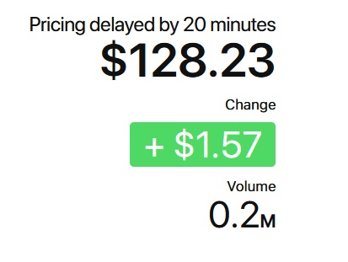
In 1980, the company went on the stock. Their first shares were stocked on prices of $22.00. Now the company shares are $128.23.


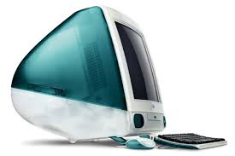
Later, in the 1990s the company was struggling and losing market shares because of its competitors like Microsoft and Intel Personal Computers. The Board of Apple with CEO Gil Amelio is considering buying the NeXT company and bringing Steve Jobs back to Apple company.
This brings some life back to Apple Computers Inc. In 1998, our company is launching iMac product that is giving the opportunity that is needed and Apple is stating retail chain of Apple Stores.

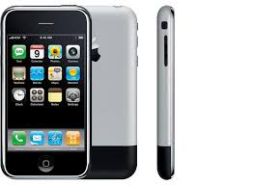
In 2007, Apple is focusing on consumer electronics and its launch first iPhone. The company at the beginning was named as Apple Computer, Inc but in 2007 the word “computer” was removed from the name because the company was oriented into the customer electronic market not only on personal computers.

Unfortunately, in 2011 Steve Jobs died from cancer but our company continue its operating and improving its product portfolio.
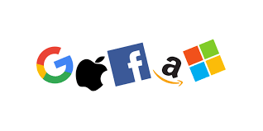
The Apple company revenue is in $274.5 billion for 2020.
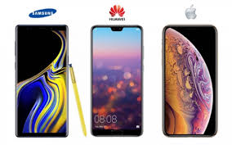
Our company is one of the biggest companies in the informational technology industry in the USA. The Apple company is part of Big Tech group that including domination companies in information technology the others are Amazon, Google, Facebook, and Microsoft.

Apple is in third place among with the largest mobile phone companies Samsung and Huawei.

Portfolio of Apple products
Apple company is specializing in developing, producing, and selling of customers electrics, computer software and many online services.
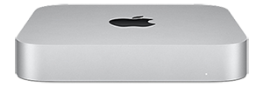
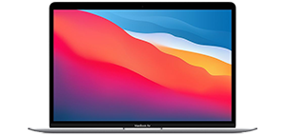
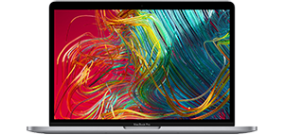
Here it will be presented some of the products portfolios of Apple:
Mac Mini
iMac Book Air
iMac Book Pro

Macintosh products are personal computer. There are several types of them like iMac and iMac Pro those are desktop computers. There is a Mac Mini that’s an entry-level desktop. There are some portable personal computers like MacBook Pro and MacBook Air. Those two are professional notebook. The operating system is Mac OS and its special development from them.
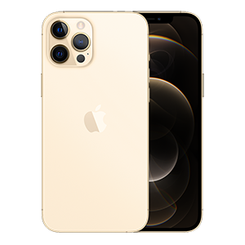
The other main products are iPhones. The first iPhone was released in 2007. Those mobile phones are with touchscreen and smartphone design. There are a special operating system iOS and a special App store where customers can download different apps. That changes all technological of smartphones.
Last model iPhone
First iPone

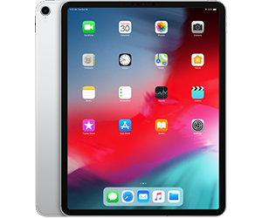
There are some other products like the iPod and iPad. The iPod is a portable media player. This device is using for listening to music. There is a special iTunes store where customer can find their favorite songs and artists. The iPad is a portable multimedia tablet computer. The operating system is iOS. For the first time, the iPad was released in 2010.
iPad Pro
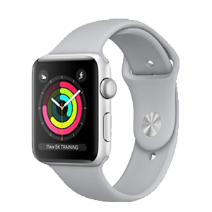
In 2014, Apple company is releasing its first Apple Watch. This is a smartwatch that is tracking the fitness and health of the customer. It is operating with watchOS and is comparable to other Apple products.
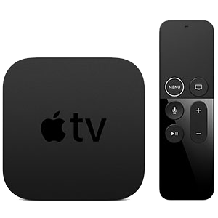
Apple Watch Series 3
The Apple company is having Apple TV in its portfolio. This is a digital media player, and it is a small network device that can receive music, videos, video game and audio content from other Apple devices. The operating system of these devices is tvOS.
Apple TV 4K

Apple company is owning operating systems for suitable for their devices macOS, iOS, watchOS and tvOS. The company is developing many other software and services like iMovie, iWork, iLife, iCloud. They are having different characters and specifications.
The products of our company are unique because of this it is one of the leaders in manufacturing of technological information products and services.
Apple company is having some subsidiaries:

Braeburn Capital is a company that is dealing with the assets of Apple. The company is created in 2015 for better management of the assets of Apple company.



Beats Electronics is also known as Beats by Dr Dre is specialized in the production of special audio products. The company is founded by Dr Dre but in 2014 it became a subsidiary of Apple. The company is producing headphones and speakers.

Claris is a computer software development company. The company is developing several programs for Apple.
Anobit is designing a flash memory controller. In 2012, the company became a subsidiary of Apple and started producing flash-memory components for it.

Beddit is a company that is making sleep-tracking devices and apps to help to monitor the sleep of people. In 2017 it became a subsidiary of Apple. This company is releasing a sleep-tracking app for Apple Watches.

What will cost you to have Apple products?
iMac Book Air
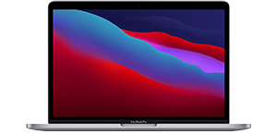
Apple company is offering high-quality products at higher prices.
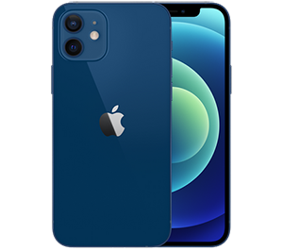
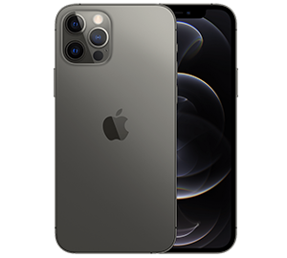
MacBook Air prices are starting from $999 and may go to $1,999 according to specifications and characteristics that these products have like capacitation of hard and RAM, colours, and year of release. The most expensive are the devices that are released in 2020. The iMac prices are starting from $1, 299 and goes up to$2,300.
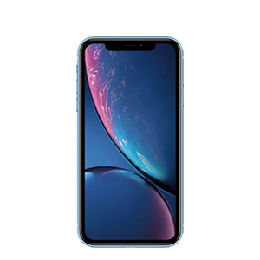
iPhone XR
iPhone 12 Pro Max
iPhone 12 Pro
iPhone 12

The iPhone 12 prices start at $799 for 64GB capacity and go up to $979 for the 256GB capacity. The iPhone 12 Pro is supporting the 5G networks and the prices with a capacity of 256 GB is $1,099 with space of 512 GB the prices is $1,299. The price of iPhone 12 Pro Max is starting from $1,099 it goes up to $1,399.
There are some more affordable iPhones like iPhone XR with prices starting from $749.99 or iPhone 11 with prices from $599.99.

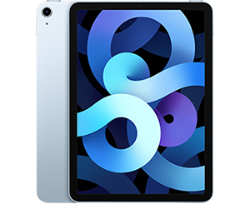
The iPad according to its date of release are starting from $329 up to $879 according to its characteristic like memory capacity, the size of screen and others.
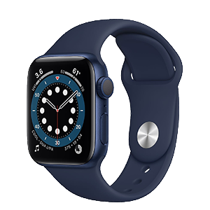
The Apple Watch Series 5 is started from price $399 and goes up to $529 according to its size of the loop, colour, and other specifications. The Apple Watch Series 4 prices are started from $499 up to $529. The series 3 is with lower prices $199 up to $500 according to GPS availability and other things.
iPad Air

The Apple Watch Series 6 is started from $399 up to $749 according to some specifications like the size of the loop, material of loop, GPS, and cellular connectivity.
Apple Watch Series 6
The prices of Apple TV are affordable is started from $179 up to $200. The price of the iPod started from $199 up to $399.

Apple TV 4K
The company price policy is related to the innovation of new devices. If the products are new the cost is higher. Also, the company have higher prices on devices that are offering more specific and higher parametric than others.
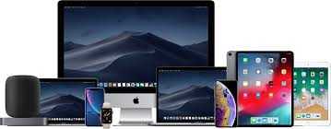
Out company price policy is offering affordable products with higher quality that are suitable for mass consumers, but alto is it offering higher quality products that are suitable for professionalism and people who need their phone and devices for business purpose.

Distribution of Apple company products
Apple company is opening its retail stores in major cities all around the world.
The first Apple stores were opened in 2001 with two main locations. Later the stores have a new design and conceptions that are revealing the potential of the Apple company.
Most of the Apple stores are located in big shopping malls.


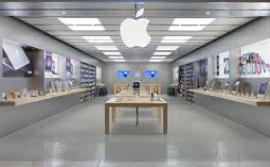
The Apple stores are selling all various Apple products like iPhones, iPad, Mac personal computers, Apple Watches, and others. The company is receiving and architectural awards for its store design and construction. Especially, for the use of glass staircases and cubs in stores.
The Apple Stores are very influencing the customers that are interesting in technological information devices and services. The Apple Stores are very accessible for all people because of their specific location into a shopping mall and centers.
Apple Stores are located mostly in the United States. There are 271 Apple Stores. There are stores in Europe in the United Kingdom, Italy, Germany, Spain, France, Sweden, Netherlands, and others. Also, there are some stores in Japan, Canada, Australia, China, and others.
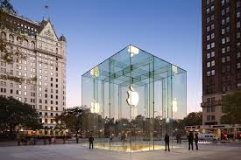
Another way of selling our products is by using online stores. The Apple company was selling its products online for a while. In 2015, from the official website of Apple was removed the online store and it's only for retail experience.

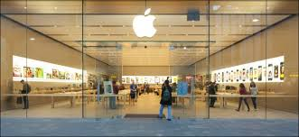
The next distributional channel that is having Apple Company is third party retail. The Apple company is giving the right of other companies and shops to sell their products in the world. The company is having this network to distribute its products all around the world. This network is very important for the company. In this way, Apple products are delivered to all customer in other countries and continents.

The third part of retail is helping in the announcement of new Apple products and the adverting of them. This help to improve the customer's awareness about the news and innovation in Apple Company.

The way of adverting the Apple company products
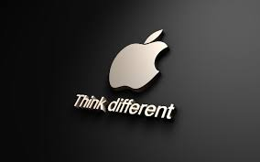
The promotion strategy is very important for the Apple company. The company is promoting itself is many distributional channels composing relations and personal selling. The company is organizing many informative presentations about new products and their improvements. Those presentations are helping the company to keep its customers well informed about Apple products and innovation that the company is implementing in their new products.
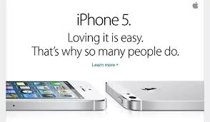
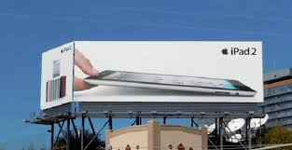
The Apple company is doing a TV commercial to presents its new products in society. Some of the TV commercials are organized by third party companies that have the interest to increase products sales because they are having advantages of this.

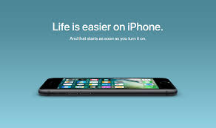
Another way that Apple is promoting itself in society is through celebrities. The company is using some famous people to promote their products in public or joining in TV commercials.


The company is having a special promotion strategy when it is launching new products. First, the company is having a larger PR promotion campaign. Apple is introducing its products before releasing its official to the mass consumers. On the stage of releasing the products, it is available on stores and there are TV commercials and social media advertisings. At this stage, the products are available on Apple Stores, third retail and online. Apple is doing more aggressive advertising during this period. At the last stage, post-launch the company is continuing to advertise these products but not so aggressive. Usually, customers are making a review and showing opportunities and advantages of new products compared to older models. The company is continuing digital campaigning the new products.

The Apple Company promotion strategy is very aggressive because the company is advertising new products before they are launched and then they are available on stores. Customers can buy products before they are launched in pro-order. This is a distinctive feature of the company.

REFERENCES
- Apple, (2020). Annual Report 2020. Available online on: https://s2.q4cdn.com/470004039/files/doc_financials/2020/ar/_10-K-2020-(As-Filed).pdf Accessed on 22 December 2020
- Capilla, A. (2011). Bringing the best personal computing experiences to all. International Journal of Competitive Intelligence. (4).
- Crukshanks, J. (2006). The Apple Way. New York: McGaw Hill.
- Heracleous, L, Papachroni, A. (2016). Strategic Leadership and Innovation at Apple Inc.
- Isaacson, W. (2011). Steve Jobs. New York: Simons & Schuster.
- Kao, R. (2018). Disruptive Leadership: Apple and the Technology of Caring Deeply--Nine Keys to Organizational Excellence and Global Impact. Taylor & Francis, ISBN 9781351399357.
- Kotler, Ph., Armstrong, G. (2016). Principles of Marketing, 16th Edition, Pearson.
- Kubilay, I. (2015). The Founding of Apple and the Reasons behind Its Success. Procedia - Social and Behavioral Sciences.
- Lashinsky, A. (2012). Inside Apple: How America's Most Admired--and Secretive--Company Really Works. Hachette UK, ISBN: 9781455512171.
- Schlender, Br, Tetzeli, R. (2016). Becoming Steve Jobs: The Evolution of a Reckless Upstart into a Visionary Leader. Crown Business; Reprint edition. ISBN 9780385347426.
- Tozzi, J. (2007). The greatest entrepreneurs of all time. Business Week.
- Yoffie, D., Slind, M. (2008). Apple Inc. Harvard Business School.

