Name: Jamie Jones
Cohort: 3:20
Student number: 1922420

Essay 1 – Analyse the role of independent bodies (i.e., IOPC/HMICFRS) in holding the police accountable to those they serve

The role of organisations like the Independent Office for Police Conduct (IOPC), Her Majesty’s Inspectorate of Constabulary and Fire & Rescue Services (HMICFRS), and the College of Policing (CoP), are independent bodies that are responsible for holding the police accountable when standards are not met. Throughout this essay, it will analyses the role of these independent bodies in holding the police accountable to those they serve. It will analyse two independent bodies – these being IOPC and HMICFRS.

In 2018 the IOPC, CoP, and HMICFRS formed a concordant agreement – with the purpose to identify a common understanding and the role of each of the three organisations (HMICFRS, 2018). These organisations are independent from any police force and government in the UK (HMICFRS, 2018). Each organisation has a definitive role to play, and works together when there is mutual interest in an area of their given responsibility.

Maintaining public confidence is a fundamental necessity for successfully policing communities in the UK. As stated by the CoP –
“Without the cooperation of the public, policing in developed democracies would become essentially unworkable. In simple terms, the police service would cease to function without the active support of the communities it serves” (2013).
The United Kingdom is a democratic country and legitimacy in the police force is paramount. Therefore, checks and balances must be put in place to ensure that standards are maintained at all times to guarantee a service that enables the public to have confidence in their police force. The role of independent bodies are given the responsibility to monitor and inspect the behaviours and actions of the police force – and the police are obligated to comply with these bodies.

The IOPC are designed to be a safe guard measure in not allowing members of the police force to engage in behaviour that is not in accordance with the law and Code of Ethics. The IOPC state on their website “Our mission is to improve public confidence in policing by ensuring the police are accountable for their actions and lessons are learnt” (2019). If ever there is a situation where this might arise, members of the community can report these issues to the IOPC. In 2019/2020 the IOPC received 28,223 complaints (IOPC, 2020), thus, this shows that it is a service that is utilised by the public.

An incident occurred involving Sussex Police Constabulary, whereby it was reported to the IOPC that police officers failed to carry out the appropriate action when dealing with an incident that centred on an allegation of assault (IOPC, 2021). This incident involved a level of corruptions that was completely unacceptable. Therefore, the IOPC conducted an investigation. As a result, two police officer were dismissed from the force for gross misconduct. The IOPC Regional Director Graham Beesley responded to this by saying “Without doubt this kind of police corruption erodes trust and confidence in the police and anyone who behaves in such a way can have no place in policing” (IOPC, 2021). This validates the key role that the IOPC plays in holding the police accountable for their actions, and maintaining the high standards expected by the police force.

However, the opinion of the IOPC is varied - West Midlands Police Federation (2021), Phill Matthews addressed the Home Affairs Select Committee, stating that the IOPC is shrouded in secrecy, their staff are lacking the right depth and breadth of knowledge, and failing to get the right training. Matthews went onto comment saying “the IOPC are absolutely unaccountable”. The IOPC have also been criticised by Matthews for the long delays in carrying out their investigations on police officers, and as a result have caused damage to the officers themselves and their families.

HMICFRS have an important role of inspecting, monitoring and reporting on the efficiency and effectiveness of the Police, as well as the Fire Service in England and Wales. As stated on the HMICFRS website - “we ask the questions that citizens would ask, and publish the answers in accessible form, using our expertise to interpret the evidence and make recommendations for improvement” (2018).

HMICFRS carry out annual audits, which they call PEEL Assessments. PEEL stands for Police Effectiveness, Efficiency and Legitimacy (HMICFRS, 2018). This takes into consideration the police force performance and areas for improvement. These reports are published and outlines the findings of the assessment. It states what was good and what needs improving. As these reports can be accessed by anyone, it places pressure on the police to attain high standards and makes the force accountable for their performance to the public.

In the 2015 HMICFRS PEEL report for South Wales Police (HMICFRS, 2016), it highlighted an area needing improvement in regards to the Stop Search records. The report stated –
“The force should ensure that stop and search records include sufficient reasonable grounds to justify the lawful use of the power, and that officers fully understand the grounds required to stop and search.” (HMICFRS, 2016).
As a result, South Wales Police were forced to review this area and make the necessary improvements. When HMICFRS undertook a follow up visit to conduct the Revisit Assessment (HMICFRS, 2016), they reported that steps have been made in a positive direction and improvements have been implemented. However, it was noted there was still further improvements needed in certain areas. This kind of independent review ensures that standards do not slip and the public get the best service possible.

An alternative perspective of the HMICFRS that should be considered is when the Police Federation Chairman Steve Taylor stated “Don’t criticise hard working officers, criticise those who have caused austerity” (Essex Police Federation, 2020). This was in response to the HMICFRS criticising police officers where they implied the public do not report crimes anymore, because of a lack of confidence with officers to deal with them. Steve Taylor has accused the HMICFRS of vilifying police officers, when officers are simply doing the best with the resources they have available to them, it is not fair. This kind of statements from the HMICFRS has a significant potential to negatively affect public perception of police officers, and officers moral.

Throughout this essay it has analysed the IPOC and HMICFRS who are independent bodies responsible for holding the police accountable for their actions and behaviours. It has discussed the importance of their role to ensure public confidence is maintained if problems arise, or standards are not met. In addition, it has discussed some of the issues that are associated with the independent bodies.

Word count = 1079

Essay 2 - Examine the ethical dimension of ‘real time’ operational decisions

Police officers can often find themselves placed in stressful situations due to the job role (Edwards, AM, 2020). This was also highlighted by Lancashire’s Chief Constable Andy Rhodes – “Policing is by its nature a stressful job and officers are exposed to some of life's most challenging situations on a daily basis” (University of Cambridge, 2019). Police officers are then forced to make ethical operational decisions which often have significant consequences on individual’s lives. Situations like this can also have ramifications on the police officer making the decisions. If their operational decision has been deemed to have been un-ethical by management, or by those involved, the police officer will be called to justify their actions; and possibly face disciplinary action (For Better Policing, 2020). The implications of possibly making a wrong decision adds further pressure to an already complex decision making process. This essay will examine some of these dimensions that play a role in making “real time” ethical operational decisions, and tools officers can utilise to help make ethical decisions.

Police officers are professionally obligated to make ethical decisions. Ethical is defined as - “being in accordance with the rules or standards for right conduct or practice, especially the standards of a profession”. (Dictionary.com, 2021). Officers are trained with a high priority to have a comprehensive understanding of the Code of Ethics (College of Policing, 2014). What is set out in the Code of Ethics are the rules and standards officers are governed by - and that their behaviour and operational decisions must be in line with at all times. . The Code of Ethics consist of the nine Policing Principles and the ten Standards of professional Behaviour. Any decisions or actions that contradicts what is outlined in the Code of Ethics could likely be deemed un-ethical.

Policing principles
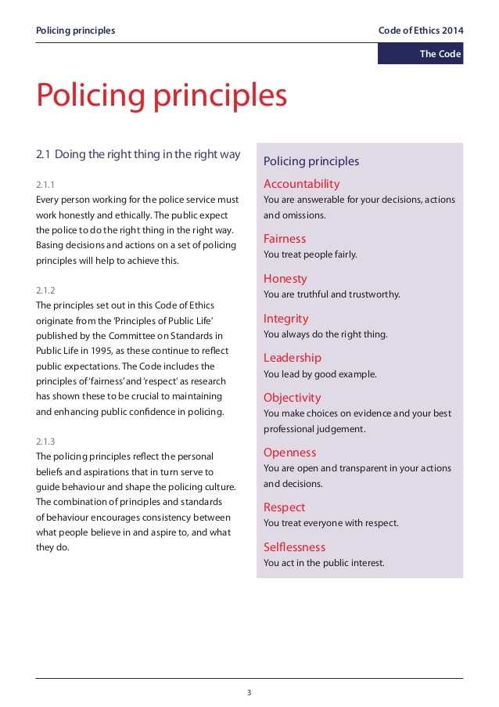
Fig 1 (College of Policing, 2014)

Standards of behaviour

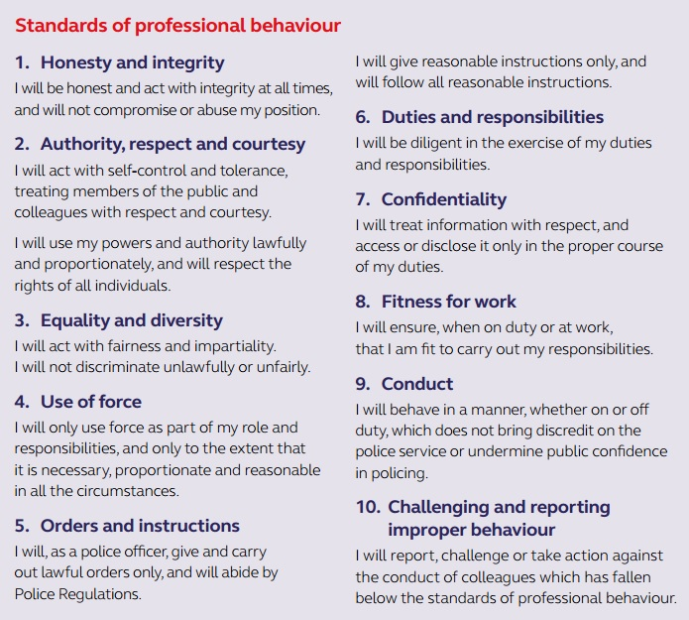
Fig 2 (College of Policing, 2014)

To assist with the decision making process, police officers are trained to utilise the National Decisions Model or otherwise known as the NDM for short (College of Policing, 2014). This aids police officers to systematically come to the best possible ethical decision with the information they have at that time. Having a format such as the NDM allows there to be a standardised format that all officer are trained to use during incidents. The NDM is also used for other officers to assess and analyse how another officers has come to make their decisions during that incident (The Open University, 2021).

Combining the application of the Code of Ethics, and the implementation of the National Decision Model affords the officers at an incident the best opportunity to execute sound ethical decisions. The NDM is made up of five parts which is centred on Code of Ethics. Each part is to be methodically worked through in a dynamic fashion as the incident progresses. Having this simplistic process supports in the efforts of the police officers making intelligent and ethical decisions based on what information is available to them at that time.

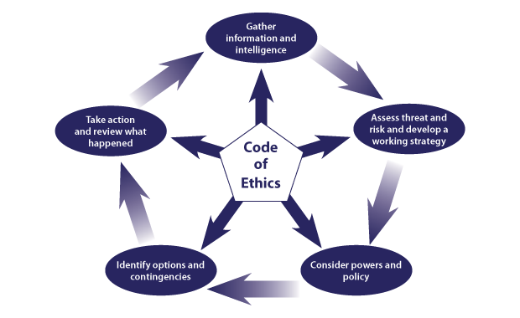fig 3 (College of Policing, 2014)

The importance of making fair and ethical decisions has a direct effect on the individual’s attitude and behaviour towards police officers during that interaction. This was discussed by the National Police Improvement Agency in the “It’s a fair cop? Police legitimacy, public cooperation, and crime reduction” (Myhill, 2011). It stated that individuals will be more likely to accept the decision which are not favoured for them, if they are treated well and believe that the decision making process has been fair.

Police officers are given a level of autonomy and discretion to make ethical decisions for what they believe to be the best course of action. However, as humans we can sometimes view and interpret incidents different from each another – this being known as the hermeneutic effect. As mentioned in the article called “Why People Think Different” it discusses that humans understanding of information is guided by their inherent biases and prejudices shaped by personal experiences (Pantelo, 2017). Police officers are from all walks of life and have diverse life experiences. Given what was stated by Pantelo (2017) in his article, there is potential for police officers to interpret information presented at an incident in a different manner from one another. Thus, possibly leading to a different resolution. This unavoidable human trait is something that is to be considered when examining the ethical dimensions of making decisions during an incident.
Another aspect to consider when examining the dimensions of ethical decision making at an incident, is when police officers are in a sleep deprived state. Police officers work shift patterns which involves working through the late night and into the early morning. This can often prove difficult for individuals, as the normal circadian rhythm does not carter for any person to be awake through these times. The human body is designed to sleep during the night time, therefore, altering a sleeping cycle to best prepare officers to get adequate sleep to see them the least compromised through a typical night shift is challenging (National Institute of General Medical Science, 2017).

The consequences of not having adequate sleep can have serious ramifications on an individual’s decision making process. During a study conducted by Washington State University (WSU) - Sleep and Performance Research Centre (2015) – it involved placing individuals in a sleep deprived state and conducting numerous decision making experiments. The study concluded that individuals who were compromised in a sleep deprived state experienced significant decision making errors. This included individuals having difficulties with initial learning, attention lapses, and decision making. The WSU stated –
“The data shows that no matter how hard a person wants to make the right choice, sleep loss does something to the brain that simply prevents it from effectively using feedback”.
All of which were tested during the study are fundamental processes in allowing a police officer to make sound ethical decisions.

This essay has examined the importance of the Code of Ethics and the implementation of the National Decision Model when police officers make any operational decision whilst on duty. Furthermore, sleep deprivation has also been examined as a factor and how it has a negative effect on the decision making process. Finally, the hermeneutic effect, which stated that due to previous life experience, police officers can interpret information different from one another, this leading to the possibility of different operational resolutions.

Word count = 1065

Essay 3 - Assess the impact of organisational justice on police agency

This essay will be assessing organisational justice in the work environment and the effects it has on individual’s health and wellbeing. Further to, it will assess the benefits of organisational justice within the police for officers on work performance and wellbeing.

Organisational justice simply put is how fair an individual is treated within an organisation, or perceives they are being treated (Greenberg, 1987). This would include aspects like organisations behaviours, decisions and actions. Organisational justice has been broken down to two components. These being: (a) Procedural Justice and (b) Distribution Justice. Organisational Justice has been proven to have a direct outcome on the effectiveness of that individual’s performance in the work place (Greenberg, 1990). Furthermore, organisational justice has been linked to better health and well-being. A study (Kivimäki et al. ,2004) conducted which involved asking a group of workers (Civil Servants) a series of questions, where factors such as fairness of interpersonal treatment were subjectively rated by the workforce. This was a reliable indicator of the individual’s self-assessed health across a three and six year follow-up period. It summarised that the individuals involved who perceived what they felt to be unfair criticism were predictors of poor health. An organisation that promotes a positive balance of procedural and distributive justice will benefit the individual, the team, and organisation. Through studies conducted, it has concluded that individual performance and loyalty to the organisation is some of the aspects that made a noticeable difference (Colquitt et al., 2013)

Procedural Justice is centred on the application of fairness of the decision making and the procedure that leads to that outcome (Greenberg, 1987). It has been noted in the journal of “Justice at the millennium, a decade later” (Colquitt et al., 2013) that individuals within a work environment believe that Procedural Justice is when they have the ability to express their opinion about the process. Further to this, it also states that individuals feels there needs to be an accurate, consistent, ethical approach, and remain bias free when making these decisions (Colquitt et al., 2013). Examples of procedural justice in the work place would be, equal pay for men and women doing the same job, and individuals getting fairly promoted in work based on their competency at their job role. Greenberg (2011) stated that studies have indicated that Procedural Justice had a more profound impact then compared to Distribution Justice on an individual’s attitudes and behaviours. Therefore, a particular focus should be placed in this area.

Distribution Justice relates to how an individual gets fairly allocated, or they perceive to get fairly allocated desirable outcomes in the workplace – or, the equal distribution of resources which is the consistent standard in that given work environment (Kaufman, A. 2012). In a journal called “Distributive and procedural justice in the workplace” (Folger, 1987, p143 -159) it highlights that there is a direct link between how individuals in the workplace feel if they have been discriminated by in distributive manner will negatively influence their perception of organisational justice. Examples of distribution justice would be: individuals who are afforded the same career progressing opportunities as other people members of the team; the work load is shared evenly amongst the team; members of the team take turns fairly of being allocated undesirable tasks.
In terms of a policing context, the job exposes police officers to dangerous and traumatic events (Edwards, AM, 2020). This continuous exposure to these environments has been proven to have adverse effects on a police officer’s health and well-being. A survey conducted by the University of Cambridge (2019) concluded from a sample section of 16,587 police officers that 1 in 5 suffer from PTSD (University of Cambridge, 2019). Further to this, a survey was conducted by the Police Federation (2016) where the questions were centred on the mental health of police officers. The survey of 17,000 officers concluded 39% of those officers were seeking help with their mental health issues due to job related incidents.

Although these studies do not show that the health and well-being of police officers is being negatively affected by an absence of organisational justice in the work environment, however, it does highlight the importance of having culture organisational justice in the work place. By doing so would improve the health and well-being of police officers, something that appears to be needed due to the nature of the role. This is supported by what has been discussed in “Organisational justice and change in justice as predictors of employee health” (Kivimäki et al. ,2004). It drew a direct link between employee’s health and wellbeing, and a working environment that supports organisational justice. An environment that promotes organisation justice would place police officers in a far better position to deal with the undesirable aspects of the stresses that is associated with the day to day incidents. A work environment that promotes organisational justice would mitigate the negative effects of potential trauma faced at these incidents and deliver a better service to the public.

A study by Bradford University (2013) conducted a survey amongst police officers and police staff at Durham Constabulary, where questions were asked which centred on their experiences of organisation justice. The result of which highlighted that officers were inclined to “do the right thing” not through fear of disciplinary consequences. The findings also highlighted that officers were shown to have identified themselves as belonging with the force and as a result of this felt empowered. Autonomy to utilise discretion as and when appropriate was also a positive factor. These behaviours go a long way in building and maintaining public approval and boost public confidence in their police force.

An area where there appears to be a need in improvement in organisational justice for police officers across the country is when police officers rest days are being cancelled at late notice. Police forces in England, Wales, and Scotland are owed over 481,419 rest days (West Yorkshire Police Federation, 2020). This is echoed, by Staffordshire Police Federation who stipulate “officers believe that cancelled rest days are being unfairly assigned to the same officers consistently” (Staffordshire Police Federation, 2019). Thus, having a negative effect on officers.

This essay has assessed the impact of organisational justice on the police agency, where it has outlined through a number of studies that organisational justice has a positive effect on the individual’s health and wellbeing -as well as, the individuals work performance. It has analysed an area that the police agency is failing in regards to organisational justice, as officers believe they are being unfairly chosen to work on their rest days.

Word Count - 1092

Essay 4 - Analyse potential links between serious and organised crime and public protection issues

Serious and organised crime as defined by the Home Office (2014) – “We define serious and organised crime as individuals planning, co-ordinating and committing serious offences, whether individually, in groups and/or as part of transnational networks”. Serious and organised crime includes human trafficking, weapons trafficking, drugs trafficking, child sexual exploitation, modern day slavery, fraud, and economic crime (National Audit Office, 2019). The National Strategic Assessment report for serious and organised crime (National Crime Agency, 2020) stated that 350,000 individuals are estimated to be involved with Serious and Organised crime, with an estimation of 4,772 organised crime groups in the UK. It also goes on to mention that the social and economic cost to the UK due to serious and organised crime is approximately £37 billion a year. This essay will analyse the potential links between serious and organised crime and public protection issues – paying particular attention to the drug traffic aspect, also known as “County Lines”.

The National Crime Agency website (2021) defines County Lines as the illegal drugs transportation to different parts of the UK, while crossing different police and local authority’s borders. These drugs are usually transported by children, or vulnerable people who have been coerced by gangs. As a direct result of this behaviour, the areas receiving the transport of drugs, reported increased levels of violence and weapon-related crimes. Subsequently, drug related homicides have also increased over the past ten years within the UK according to National Strategic Report (National Crime Agency, 2020); in 2008-09 it was 36%, and fast forward to 2018-19, it had risen to 47%.

The County Lines business model (National Crime Agency, 2019) exploits vulnerable adult and children to transport, deliver and sell drugs. This strategy allows the offenders to distance themselves away from the front lines, which is where there is significant risk of being caught by police and serving heavy penalties in the form of jail time. The College of Policing define a vulnerable person as ‘unable to take care of or protect themselves or others from harm or exploitation’ (2020). Gangs have be known to target as young as 12; however the more common age for children appears to be 15-16 years old. Factors that increase the potential of someone being targeted by gangs would be whether the individual has experienced neglect, and if they have been victim of physical or sexual abuse. Also, a lack of a stable home environment, economic difficulties, learning disabilities as well as physical disabilities are taken into consideration too (Home Office, 2020). Tactics of making individuals incur drug debts, which they are forced to pay-off through County Lines activity is used as a recruiting tool (NSPC, 2021). The offenders will also entice individuals who have limited economic opportunities by offering financial payments or material possessions that they would not be able to get unless through illegal activity (National Crime Agency, 2019). Males will also target vulnerable females by giving them the illusion that they are in a relationship and provide gifts, to trick them into participating in County Lines’ activity (National Crime Agency, 2019).

There are a common behaviours associated with County Lines’ activities where the dealers will invade a local property to operate from. These properties which are targeted tend to be owned by individuals who are classed as vulnerable. This action is commonly known as cuckooing (National Crime Agency, 2021). An example of this has been detailed in Crime Prevention Otawa (2013). It discusses a case study that has been carried out in the UK; it was centred on an individual who had his flat cuckooed. The victim in this case was a drug user who recently lost his family which was his support network, along with his job. Therefore, in order to support his drug use he allowed dealers into his home. Initially they supplied him with drugs but, after a week, their attitude changed and they became aggressive towards him, which led to psychological and physical abuse. Shortly, more people began to move in and further crimes were taking place at his home, such as prostitution and drug deals.

In another case study, a fifty-five year old Clarence Spencer had been a victim of cuckooing. He had always been able to maintain a job and a home, but, once his sister left Britain to go back to Jamaica, his life began to fall apart. He turned to crack cocaine and drug dealers soon moved into his home, paying him with cocaine to feed his addiction and to secure their position in his home. Clarence reports, “I ended up with seven dealers living in my house. There was prostitution, robbery, mugging, murder - all kinds of things were happening for them to get their money”. Clarence ended up with an expensive crack habit and he felt that going to the police was not an option. The police subsequently raided Clarence’s home and he received an Anti-Social Behaviour Order. He lost his home and spent six months in a homeless shelter. Fortunately, he was able to get completely clean of drugs, moving into a shared home and has started to rebuild his life (BBC, 2008)

In cases of targeted children, if any agency working with the child has concerns that they are being exploited by gangs for criminal activity such as County Lines’ activity, they are obligated to report it to the Social Services under S130 of the Social Services and Wellbeing Act. Then under section 47 of the Children Act 1989, considerations must be taken to see if an investigation should take place. At this stage, a Multi-Agency strategy meeting should take place, where local authorities who are relevant to the case are present. The police must be informed so they can make the decision regarding whether they deem the child is at risk. The meeting should result in a strategy for the well-being of the child. Also, the meeting should explore if there are any other concerns for the child and how to avoid any further exploitation (Social Care Wales, 2021).

This essay has brought light to the link between Serious Organised Crime, in this case, County Lines’ activity, and the public protection issues. As discussed, it can be see that County Line’s criminal activity predicates on recruiting vulnerable people to carry out the high risk jobs, such as the transportation and distribution of the illegal drugs. Along with exploiting vulnerable individuals’ homes to run drug operations from, known as cuckooing.

Word Count = 1070

Bibliography

AAA PPP For Better Policing. (2020). The Code of Ethics of the UK Police: explained. Available: https://www.aaappp.org.uk/the-code-of-ethics-of-the-uk-police-explained/. (Last accessed 26th Sep 2021).
College of Policing . (2013). Engagement and communication. Available: https://www.app.college.police.uk/app-content/engagement-and-communication/engaging-with-communities/#:~:text=Neighbourhood%20policing%20has%20shown%20that%20public%20confidence%20improves,the%20polic. (Last accessed 23rd Sep 2021).
College of Policing . (2020). Recognising and responding to vulnerability related risk. Available: https://paas-s3-broker-prod-lon-6453d964-1d1a-432a-9260-5e0ba7d2fc51.s3.eu-west-2.amazonaws.com/s3fs-public/Recognising-responding-vulnerability-related-risks-guidelines.pdf. (Last accessed 5th Oct 2021).
College of Policing. (2014). Code of Ethics. Available: https://paas-s3-broker-prod-lon-6453d964-1d1a-432a-9260-5e0ba7d2fc51.s3.eu-west-2.amazonaws.com/s3fs-public/2021-02/code_of_ethics.pdf. (Last accessed 4th September 2021).
College of Policing. (2014). National Decision Model. Available: https://www.app.college.police.uk/app-content/national-decision-model/the-national-decision-model/. (Last accessed 4th September 2021).
Colquitt et al., 2013. Colquitt, J. A., Scott, B. A., Rodell, J. B., Long, D. M., Zapata, C. P., Conlon, D. E., & Wesson, M. J. (2013). Justice at the millennium, a decade later: A meta-analytic test of social exchange and affect-based perspectives. Journal of Applied Psychology, 98, 2, 199-236
Dan Pantelo. (2017). Why People Interpret Things Differently. Available: https://medium.com/@danpantelo/hermeneutics-why-people-interpret-things-differently-870f35436fe8. (Last accessed 5th Sep 2021).
Dictionary.com. (2021). Ethical definition . Available: https://www.dictionary.com/browse/ethical. (Last accessed 4th July 2021).
Edwards, AM. Kotera, Y.. (2020). Mental Health in the UK Police Force: a Qualitative Investigation into the Stigma with Mental Illness. Available: https://link.springer.com/article/10.1007/s11469-019-00214-x#citeas. (Last accessed 26th Sep 2021).
Essex Police Federation. (2020). HMICFRS Report: Don’t criticise hard working officers, criticise those who have caused austerity. Available: https://www.polfed.org/essex/news/2020-articles/hmicfrs-report-don-t-criticise-hard-working-officers-criticise-those-who-have-caused-austerity/. (Last accessed 26th Sep 2021).
Folger, Robert. (1987). Distributive and procedural justice in the workplace. Social Justice Research . 1 (1), P143 -159.
Greenberg, J. (1990). Organisational Justice: Yesterday, Today, and Tomorrow.. Journal of Management . 16 (2), P 399 - 426.
Greenberg, J. (2011) Organizational justice: The dynamics of fairness in the workplace, in: Sheldon, Z. (ed) APA handbook of industrial and organizational psychology, vol. 3: Maintaining, expanding, and contracting the organization. Washington, DC: American Psychological Association.
Greenberg, J. . (1987). A Taxonomy of Organizational Justice Theories.. The Academy of Management Review. 12 (2), 9-22.
HMICFRS. (2016). HMIC Best Use of Stop and Search (BUSS) scheme revisit assessment . Available: https://www.justiceinspectorates.gov.uk/hmicfrs/wp-content/uploads/south-wales-buss-letter.pdf. (Last accessed 24th Aug 2021).
HMICFRS. (2016). PEEL: Police legitimacy 2015 An inspection of South Wales Police. Available: https://www.justiceinspectorates.gov.uk/hmicfrs/wp-content/uploads/peel-police-legitimacy-2015-south-wales.pdf. (Last accessed 24th Aug 2021).
HMICFRS. (2018). Annual, all-force inspections (PEEL assessments). Available: https://www.justiceinspectorates.gov.uk/hmicfrs/our-work/article/peel-assessments/#:~:text=PEEL%20is%20the%20programme%20in%20which%20HMICFRS%20draws,of%20their%20force%20and%20policing%20as%20a%20who. (Last accessed 25th Sep 2021).
HMICFRS. (2018). The College of Policing and the IOPC. Available: https://www.justiceinspectorates.gov.uk/hmicfrs/police-forces/working-with-others/college-policing-ipcc/. (Last accessed 20th Sep 2021).
HMICFRS. (2018). What we do. Available: https://www.justiceinspectorates.gov.uk/hmicfrs/about-us/what-we-do/. (Last accessed 25th Sep 2021).
Home Office. (2014). Serious and Organised Crime Strategy. Available: https://www.gov.uk/government/collections/serious-and-organised-crime-strategy. (Last accessed 5th Oct 2021).
Home Office. (2020). Criminal exploitation of children and vulnerable adults: county lines. Available: https://www.gov.uk/government/publications/criminal-exploitation-of-children-and-vulnerable-adults-county-lines/criminal-exploitation-of-children-and-vulnerable-adults-county-lines. (Last accessed 5th Oct 2021).
IOPC. (2018). Making a difference . Available: https://www.policeconduct.gov.uk/sites/default/files/Documents/Who-we-are/accountability-performance/IOPC_Impact_Report_201819.pdf#:~:text=Maintaining%20public%20confidence%20in%20policing%20by%20inde. (Last accessed 23rd Sep 2021).
IOPC. (2020). Police complaint: Statistics for England and Wales 2019/2020. Available: https://policeconduct.gov.uk/sites/default/files/Documents/statistics/complaints_statistics_2019_20.pdf. (Last accessed 20th Sep 2021).
IOPC. (2021). Sussex Police officers dismissed without notice after gross misconduct proven. Available: https://policeconduct.gov.uk/news/sussex-police-officers-dismissed-without-notice-after-gross-misconduct-proven. (Last accessed 23rd Sep 2021).

Kaufman, A. (2012). Distributive Justice. Available: https://www.sciencedirect.com/topics/social-sciences/distributive-justice. (Last accessed 1st Oct 2021).
Kivimäki M, Ferrie J, Head J, Shipley M, Vahtera J, Marmot M (2004), ‘Organisational
justice and change in justice as predictors of employee health: The Whitehall II
study’, Journal of Epidemiology and Community Health, Vol. 58, pp. 931‐937
National Audit Office. (2019). Tackling serious and organised crime. Available: https://www.nao.org.uk/report/serious-and-organised-crime/#. (Last accessed 5th Oct 2021).
National Crime Agency. (2019). Count Lines Drug Supply, Vulnerability and Harm. Available: https://www.nationalcrimeagency.gov.uk/who-we-are/publications/257-county-lines-drug-supply-vulnerability-and-harm-2018/file. (Last accessed 5th Oct 2021).
National Crime Agency. (2020). National Strategic Assessment of Serious Organised Crime 2020. Available: https://www.nationalcrimeagency.gov.uk/who-we-are/publications/437-national-strategic-assessment-of-serious-and-organised-crime-2020/file. (Last accessed 5th Oct 2021).
National Crime Agency. (2021). County Lines. Available: https://www.nationalcrimeagency.gov.uk/what-we-do/crime-threats/drug-trafficking/county-lines. (Last accessed 5th Oct 2021).
National Crime Agency. (2021). County Lines. Available: https://www.nationalcrimeagency.gov.uk/what-we-do/crime-threats/drug-trafficking/county-lines. (Last accessed 5th Oct 2021).
National Institute of General Medical Science . (2017). Circadian Rhythms . Available: https://www.nigms.nih.gov/education/Documents/CircadianRhythms.pdf. (Last accessed 18th Oct 2021).
NPIA. (2011). It’s a fair cop? Police legitimacy, public cooperation, and crime reduction . Available: https://whatworks.college.police.uk/Research/Documents/Fair_cop_Full_Report.pdf. (Last accessed 27th Sep 2021).
NSPC Learning. (2021). Protecting children from county lines. Available: https://learning.nspcc.org.uk/child-abuse-and-neglect/county-lines#:~:text=Who%20is%20vulnerable%20to%20county%20lines%20exploitation%3F%20Any,the%20past%3B%20social%20isolation%20or%20social%20diffic. (Last accessed 5th Oct 2021).
Police Federation. (2016). Mental Health. Available: https://www.polfed.org/our-work/wellbeing/mental-health/.( Last accessed 2nd July 2021).
Social Care Wales. (2021). Safeguarding children from Child Criminal Exploitation (CCE). Available: https://www.safeguarding.wales/chi/c6/c6.p1.html. Last accessed 13th Oct 2021.

Staffordshire Police Federation. (2019). Cancelled Rest Days. Available: https://staffordshire.polfed.org/news/376-cancelled-rest-days. (Last accessed 4th Oct 2021).
The Open University . (2021). Decision making in policing. Available: https://www.open.edu/openlearn/ocw/mod/oucontent/view.php?id=65950§ion=5.1. (Last accessed 26th Sep 2021).
University of Cambridge . (2019). Police Workforce: almost one in five suffer with a form of PTSD. Available: https://www.cam.ac.uk/policeptsd. (Last accessed 26th Sep 2021).
University of Cambridge . (2019). Police Workforce: almost one in five suffer with a form of PTSD. Available: https://www.cam.ac.uk/policeptsd. (Last accessed 17th Sep 2021).
Washington State University . (2017). Research shows sleep loss impedes decision making in crisis. Available: https://news.wsu.edu/press-release/2015/05/07/research-shows-sleep-loss-impedes-decision-making-in-crisis/. (Last accessed 28th Sep 2021).
West Midlands Police Federation . (2021). IOPC shrouded in secrecy. Available: https://www.polfed.org/westmids/news/latest-news/iopc-shrouded-in-secrecy/#:~:text=28%20January%202021%20The%20Independent%20Office%20for%20Police,national%20conduct%20and%20performance%20chair%20has%. (Last accessed 23rd Sep 2021).

West Yorkshire Police Federation. (2020). Officers Are Owed Huge Number Of Rest Days. Available: https://wypf.polfed.org/2020/09/11/officers-are-owed-huge-number-of-rest-days/. (Last accessed 4th Oct 2021).

