
MASTER OF BUSINESS ADMINISTRATION
Assignment Title: Financial performance and management for General Electronics

Lecturer: Isaiah Oino
Title: Final Strategic and Financial Conclusion for General Electronics

Student Name: Amisha Leuva
Student ID : 2504370

Word Count: 5145
Executive Summary
In this report, the authors have analysed the financial performance and risk position of General Electronics over the period of 2020 to 2024, and paid attention to the financial management effectiveness. The analysis has exposed a sharp decline in financial health, which is characterised by falling revenues, continuous operating losses, decreasing liquidity, weak management of working capital, and an increase in financial leverage. Ratio analysis and Altman Z-score prove the high risk of financial distress. Nevertheless, the company has some cash-generating potential despite these difficulties. As a solution to such weaknesses, the report suggests overall financial restructuring of the company, which includes asset divestment, equity recapitalisation, debt refinancing, and operational cost rationalisation, without compromising ethical and international standards. Capital budgeting analysis finds that Project C is the best choice of investment as it has the maximum value creation in the long run, and the project is beneficial in meeting the financial recovery and sustainability of the company.
Table of Contents
1. Introduction 3
2. Financial health Check 3
3. Working capital management analysis 11
4. Strategic Financial restructuring plan 14
5. Investment appraisal and capital budgeting 18
6. Conclusion 24
Reference List 26
Appendices 33

1. Introduction
This report describes the financial performance and financial management of General Electronics, which is an international company in the consumer electronics world, and is competitive. The analysis is focused on reviewing the Chief Financial Officer, which is based on a critical analysis of the financial situation over the last five years of the company based on published income statements, balance sheets and cash flow data of the company. The study emphasises the financial ratios, working capital analysis, corporate failure prediction models, and capital budgeting methods to diagnose the source of its weaknesses as well as evaluate financial risk. The report offers a financially and ethically viable long-term plan.

2. Financial health Check
2.1 General electronics’ financial statement analysis
The financial statements of General Electronics over the five-year period from 2020 to 2024 show a clear decline in financial performance and stability. In 2022, the revenue decreased significantly by more than 15% compared to £614,680 million in 2020, and this is considered as the company has been exhibiting persistent pressure on revenues, sales volume, and price power. In that case, the cost of sales has fallen during the same period, which is not proportionate to the decrease in revenue. For this reason, this resulted in the gross profit generation and the reduction of the margin. There is a widespread trend in the case of operating performance. Having made working profits of £37,267 million in 2020, the company faced issues in operating losses in 2023 (£85,301 million) and continued to make losses in 2024. This decline is indicative of growing operating costs, which have identified costs, and huge impairment losses, which indicate structural inefficiencies instead of cyclical issues. Net income had a similar trend as in 2020; it had a healthy profit of £38,572 million, and in 2023 and 2024, it incurred extensive losses, undermining retained earnings and shareholder confidence. The financial statement has highlighted that total assets have been decreasing by £510,290 million in 2020 to £323,354 million in 2024, which is mostly related to decreases in inventories, property, plant and equipment, and cash balances. However, the reduction in them became significant, which constrained the self-finance of operations and investments by the firm. In that case, the financial reports show that the company is shifting out of profitability and stability to financial distress that justifies an in-depth ratio-based examination and turnaround strategy (Akomea-Frimpong et al., 2021).
2.2 Ratio analysis
Ratio analysis will be used to present a systematic assessment of the profitability, liquidity, efficiency, leverage, investment performance and cash flow of the player in a comparative manner over time, such as General Electronics (Rashid, 2021).
2.2.1 Profitability
Profitability ratios indicate a continued loss in the earning capacity of the firm (Hasidi et al., 2024). In that case, gross profit margin has been quite resilient in the initial years; however, it decreased with declining revenues and pressure on prices surpassing cost-cutting. More importantly, the operating margin became negative in 2023 and 2024, indicating that the company was not able to manage overheads, as well as expenses inherent in restructuring. Net profit margin had a comparable direction as it passed through positive values in 2020 to negative values that were extremely negative in the last two years.
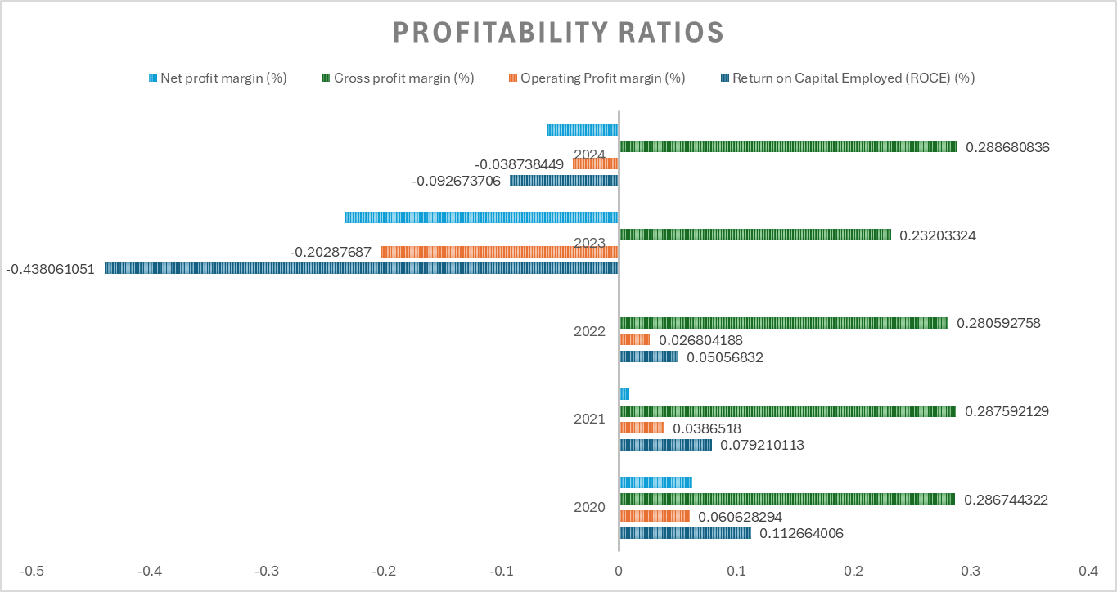
Figure 1: Profitability ratio analysis
(Source: Self-created)
The operating losses continue to indicate that profitability problems are structural. The profitability problems result in cost rigidity, ineffective operations, and deteriorated competitive positioning instead of short-term market fluctuation (Chairani and Siregar, 2021).
2.2.2 Liquidity
There is a progressive decline in the short-term financial strength reflected in liquidity ratios. The current ratio declined to 2024 levels of about 1.5 times compared to 2020, which were above comfortable levels.
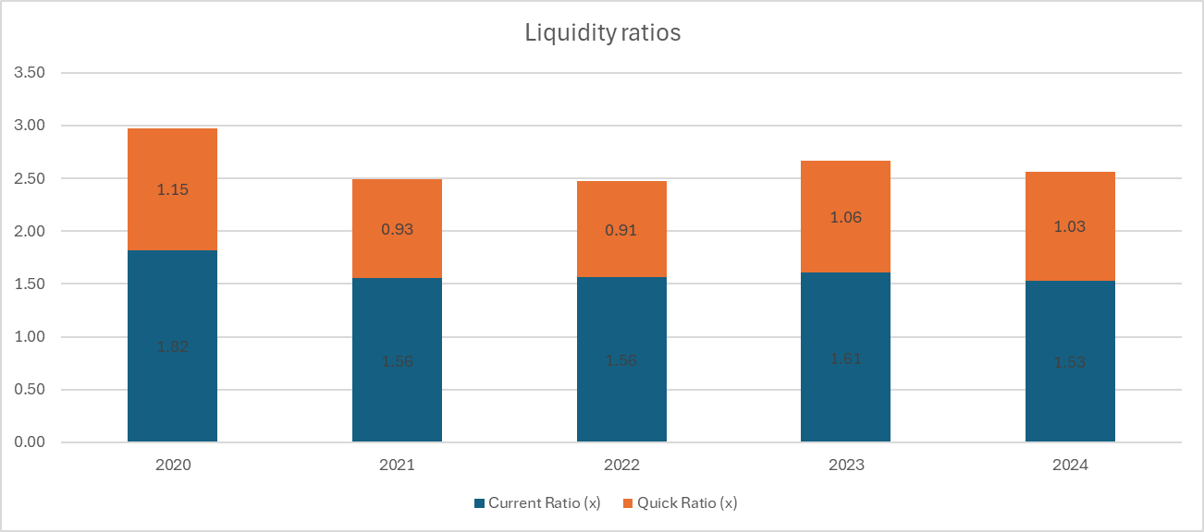
Figure 2: Liquidity ratio analysis
(Source: Self-created)
Its liquid assets (excluding inventories) were close to covering short-term liabilities in the last few years, which indicates that it was relying on inventory turnover and external financing to settle its immediate liabilities. This increases the liquidity risk facing the company, especially when there is further disruption of sales or slow payables collections (Barnabas and Oloyede, 2024).
2.2.3 Efficiency
The working capital management has major weaknesses based on the efficiency ratios. In that case, the improvement was recorded in 2024; the inventory days are high compared to previous years. The increasing inventory days reveal that a lot of capital is tied up together, as well as augmenting the risks in a rapidly changing electronics market (Elmghaamez et al., 2024).
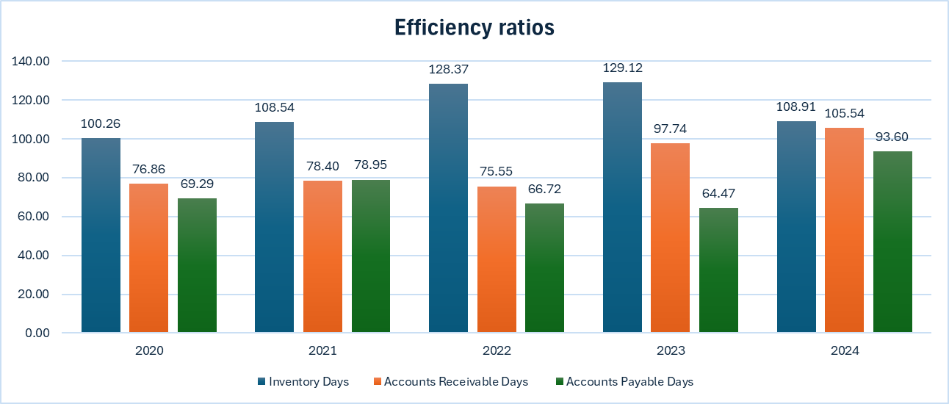
Figure 3: Efficiency ratio analysis
(Source: Self-created)
Collection of the receivables was poor, and the debtor days had risen significantly during the last two years. This implies lax credit policy or deteriorating quality of customers, all of which become a burden on cash flows (Khan et al., 2022).
2.2.4 Gearing
The ratio of debt to equity increases progressively over time. It indicates the decreasing equity, not high levels of new borrowing. The growing share of total capital used during the time when the retained earnings were diminishing due to losses (Aldo, 2022).
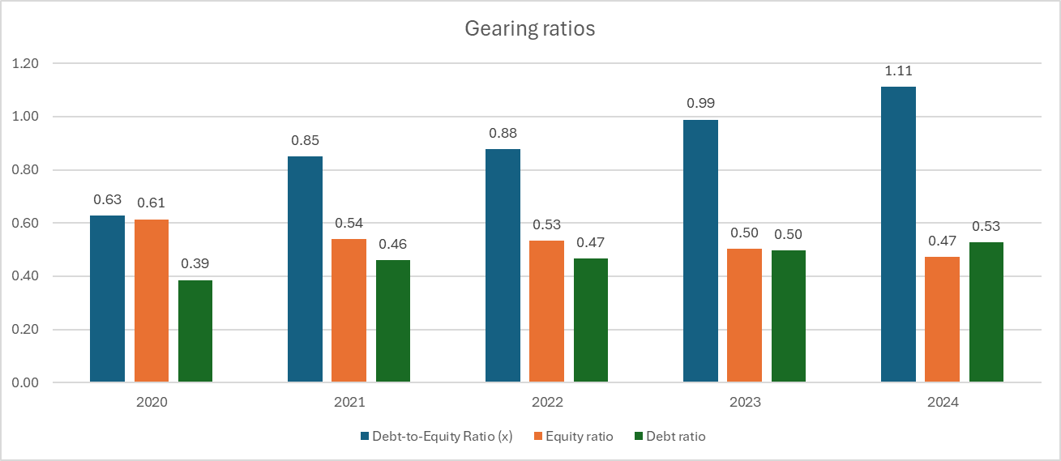
Figure 4: Gearing ratio analysis
(Source: Self-created)
Increasing gearing increases financial risk, especially when operating income is negative. The interest payments are made difficult to service, and the ability of the firm to effective shock reduction becomes lower (Tulung et al., 2024).
2.2.5 Investment
Shareholder value is reducing, as indicated in investment ratios. Earnings per share (EPS) reduced sharply and remained negative in 2023 and 2024, after registering high positive values in 2020. A negative EPS has a negative impact on the market because the company is destroying value rather than creating it for investors (Chen et al., 2021).
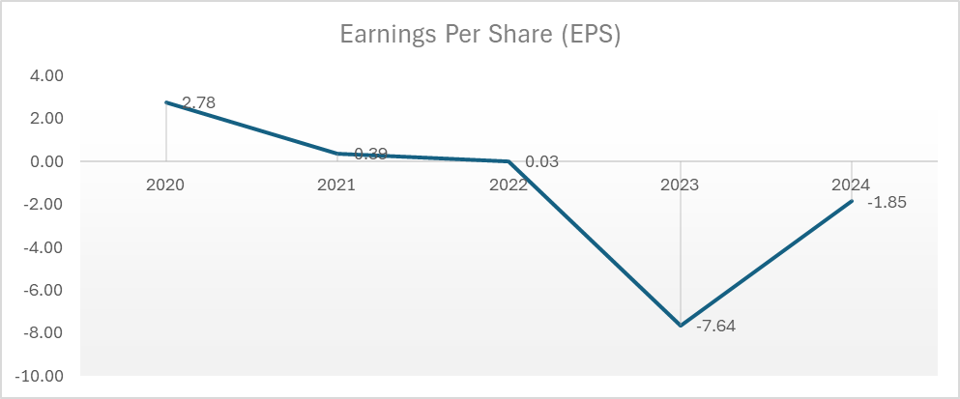
Figure 5: Investment ratio analysis with EPS
(Source: Self-created)
This diminishes investor confidence, increases the cost of capital to the firm and restricts accessibility to equity financing. Due to the lack of knowledge, corrective measures are implemented; the company cannot expect to remain undervalued in the long term (Burcă et al., 2024).
2.2.6 Cash flow
The cash flow ratios support the concerns identified in other parts of the analysis. The current liabilities-to-operating cash flow ratio decreased. In that case, cash flows increased in the same direction, and the size of this operation decreased greatly, minimising the financial flexibility (Attah et al., 2024).
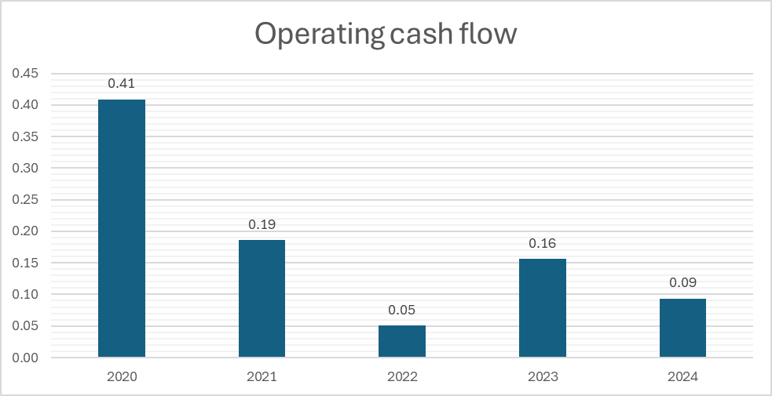
Figure 6: Cash flow analysis
(Source: Self-created)
The trend indicates that increasing dependence on external financing, as well as supplier credit, is necessary to maintain operations. Poor cash flow coverage enhances liquidity in a distress situation where credit conditions tighten (Hanifah, 2023).
2.3 Key trends, strengths and threat evaluation
The financial analysis identifies several major trends across different operational areas. On the other hand, General Electronics experiences decreasing revenues, continuous operating losses, increasing leverage, and poor working capital efficiency. However, there are still some strengths. The company can still generate good operating cash flow, indicating that its main business has cash-generating potential. The decline in total assets and inventories is indicative of premature attempts to rationalise the balance sheet (Gunawan et al., 2023).
2.4 Altman-Z score evaluation for corporate failure prediction
The Altman Z-score model provides a comprehensive evaluation of the risk of bankruptcy for the General Electronics Company by analysing liquidity, profitability, leverage, solvency, and activity measures. The Z-score of the company in 2020 indicates that it was well within the safe zone, as it showed high earnings, high equity, and good asset utilisation (Elumilade et al., 2022).
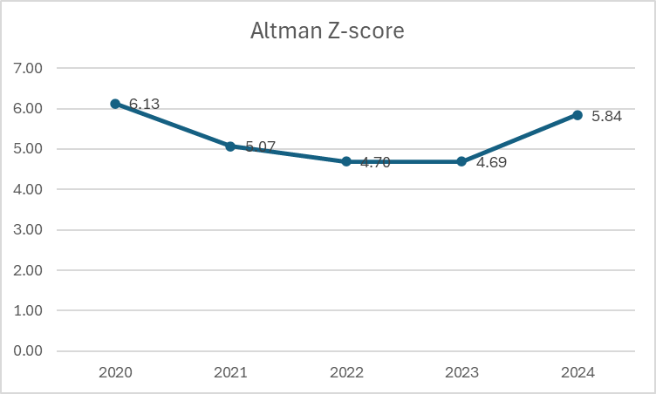
Figure 7: Altman-Z score analysis over the years
(Source: Self-created)
As highlighted in Figure 7, the Z-score steadily decreased as the years passed by. The key factors contributing to the deterioration were the dropped retained earnings, dwindling EBIT and lack of market confidence. By 2023, the score had made it to the grey zone, which implied increased chances of financial distress. In that case, the slight improvement was seen in 2024, the Z-score was lower than the safe threshold, which proves that the company is still at high risk of default. This result supports the results of the ratio analysis and demonstrates a strong need to carry out financial restructuring, reforming of working capital, and discipline investment choices (Al-Najjar and Jawad, 2023).

3. Working capital management analysis
3.1 Cash operating cycle evaluation
Working capital management is extremely important in maintaining the liquidity and continuity in operations, especially in those companies that are experiencing diminishing profitability and investment leverage (Wanof, 2023). Cash operating cycle (COC) is a measure of the number of days that the firm requires to transform its investments in stock and collection of the funds after consideration of payment deferrals to suppliers. In the case of General Electronics, the cash operating cycle has increased significantly over the past five years, indicating a lack of efficiency in the working capital utilisation. During 2020-2021, the cash operating cycle was rather stable, indicating balanced changes in holding gifts, collecting receivables, and settling payables. However, since the year 2022, the situation has worsened. The inventory days were rising considerably, which indicates the presence of a large amount of inventory in stock and a slow rate of inventory turnover (Amira and Hafssa, 2021). This is an issue in the consumer electronics sector, where technological change is high, and therefore, there are high chances of incurring obsolescence or markdown.
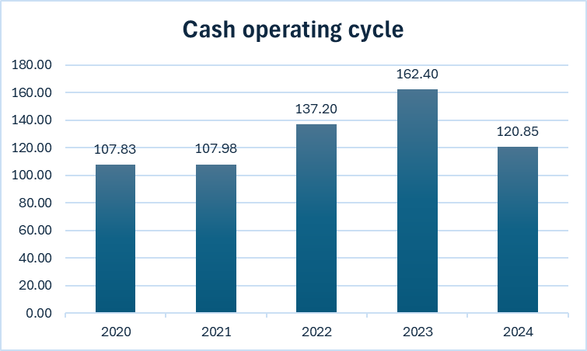
Figure 8: Cash operating cycle
(Source: Self-created)
Meanwhile, both receivable days became significantly higher in 2023 and 2024, which indicates ineffective credit control, delayed payments by the customers, or exposure to financially weak purchasers. The fact that the firm has increased its payable days to suppliers in the later years, albeit in partial offsetting of the effect on cash flows, is indicative of the reactive liquidity management approach as opposed to sustainable optimisation. The resultant long cash operating cycle indicates that cash is held up longer, resulting in dependence on short-term financing and an increase in liquidity risk. In general, the analysis has shown that inefficiencies in General Electronics' working capital are among the biggest factors that have weakened its cash flow. Unless remedial action is carried out, a long cash cycle can be an added trigger of liquidity, limit operational flexibility, and deter supplier and customer relationships.
3.2 Improvement strategies for liquidity improvement with capital reforms
To recover its liquidity and enhance its financial resilience, General Electronics will need to undertake specific working capital reforms, aided by disciplined capital management practices.
A major concern should be the optimisation of inventory. To ensure that unnecessary and slow-moving inventory is minimised, the company needs to enhance demand forecasting and increase production levels in line with the demand in the market. Some techniques, such as the ABC classification of inventory, can be used to give priority to high-value and quick-moving products, and just-in-time procurement can be used to ensure that unnecessary stockholding is not permitted. By decreasing inventories, the cash that is tied up would be released, costs would be saved on warehouses, and the chances of technological obsolescence would decrease.
There is a need to improve receivables management. To minimise high-risk customers who create exposure to risky customers, stricter credit assessment procedures should be implemented. In that case, cash inflows can be hastened by incentivising early settlements with discounts and reinforcing collection actions. The functionality of digital invoicing and automated reminders can help to increase the efficiency of gathering further and the visibility of cash.
Management of payables should be handled more strategically. Although lengthening supplier payment terms has helped in the short term to sustain liquidity, overextent of delays can destroy supplier confidence and dislodge supply chains. The company needs to renegotiate some more organised terms of payment with important suppliers, weighing liquidity requirements and sustainability of relations in the long run. Flexibility can be achieved through leveraging supplier financing programs or dynamic discounting arrangements without compromising its stability in operation.
In addition to operational reforms, capital discipline is necessary. General Electronics needs to match the working capital goals to the overall financial realigning goals and objectives, and upcoming liquidity gains ought to be enshrined in performance measurement mechanisms. The accountability and cross-functionality can be created by introducing working capital-based KPIs based on procurement, sales, and finance teams. All these reforms would help in reducing the cash operating cycle, increasing the liquidity buffers, and decreasing the reliance on external funding.
3.3 Comparing short vs long term financing operations
The choice between short-term and long-term financing has significant implications for liquidity management and financial risk, particularly for a firm under financial pressure, such as General Electronics.
Short-term financing, including bank overdrafts, revolving credit facilities, and trade credit, offers flexibility and rapid access to funds. It is commonly used to bridge temporary cash flow gaps arising from working capital mismatches. However, excessive reliance on short-term financing exposes the firm to refinancing risk, interest rate volatility, and liquidity shocks. For General Electronics, increased use of short-term credit in recent years reflects constrained internal cash generation and an extended cash operating cycle. In a distressed environment, this heightens vulnerability to tightening credit conditions.
In contrast, long-term financing, such as term loans, bond issuance, or equity injections, provides greater stability by spreading repayment obligations over extended periods. Although long-term financing often carries higher fixed costs or potential equity dilution, it reduces refinancing pressure and improves cash flow predictability. For General Electronics, restructuring short-term debt into longer-term instruments could ease immediate liquidity stress and support operational recovery.
From a strategic perspective, financial theory suggests matching the maturity of financing with the life of assets being financed. Short-term funding is appropriate for seasonal working capital fluctuations, whereas long-term financing should support restructuring initiatives and capital investments. Given General Electronics’ weakened liquidity position and elevated leverage, a rebalancing toward longer-term financing is more suitable. Short-term facilities should be retained only as supplementary liquidity buffers rather than primary funding sources.

4. Strategic Financial restructuring plan
4.1 Recommendation for financial restructuring options
Considering the current operating losses, deteriorating liquidity and increasing leverage as observed in the financial health analysis, General Electronics needs a proper financial restructuring strategy and not incremental changes. Restructuring should aim at stabilising cash flows, regaining solvency, and establishing a capital structure that will enable it to be competitive in the global consumer electronics market in the long term.
One of the main possible restructuring alternatives is selling non-core and poorly performing assets. The weakening asset base of the firm and the lack of inventory efficiencies point to the fact that some product lines, business lines or geographical operations may not be viable strategic and financial wise. The sale of these assets would result in one-time cash flows, simplification of operations, and management would be able to allocate resources to other profitable and technology-competitive segments. Sell-offs of assets would reduce depreciation and overheads and accountable operating margins in the long run. Equity recapitalisation ought to be an option for enhancing the weakened capital base of the firm. Retained earnings have been eroded because of continuous losses, and the company has grown to be more dependent on debt financing. A mix of equity capital injections, via a rights issue, a private placement, or a strategic investor, would increase solvency ratios, reduce financial risk, and improve the credibility of creditors. Even though equity financing can, in the short run, dilute the existing shareholders, it has permanent capital and no repayment is required, which is essential at times of turnover.
Debt restructuring and refinancing are other important restructuring alternatives. General Electronics has grown entirely reliant on short-term borrowings to pay the liquidity. The high-cost or short-term debt would be refinanced as long-term instruments, which would minimise the refinancing risk and ease cash flows. Breaching interest rates, lengthening of maturities or restructuring of covenants with lenders would be of great assistance in alleviating financial strain. Partial debt-for-equity swaps can be suitable in certain instances, as they will lead to lower leverage and creditor interests must be aligned with long-term recovery.
Moreover, another way to financial and operational recovery could be through strategic alliances or mergers. The collaboration or acquisition by a financially more robust company may mean access to funds, technology, and distribution channels. These provisional agreements may create economies of scale and cost synergies, as well as more convenient access to the market, especially in a highly competitive and innovative industry. Yet this alternative will need to undergo due diligence to enable strategic alignment and value creation.
Lastly, financial measures should be accompanied by the restructuring costs of operations. Other restructuring without restructuring the business would be a short-term resolution. Rationalisation in the workforce, the supply chain, and automation programs would need to be engaged in to reduce the cost base and enhance productivity. These restructuring alternatives are designed as a combined recovery framework to restore the company's financial stability and strategic viability.
4.2 Stakeholder value, debt structure and operational flexibility
4.2.1 Impact on stakeholder value
Financial reorganisation has a very broad impact on various stakeholders such as shareholders, creditors, employees, suppliers and customers. In the case of shareholders, there are such short-term effects as dilution due to the issue of shares or decreased dividends. However, these are reasonable in case they avert insolvency and regain long-term value. Restructuring creates higher earning potential and market value for the future of the firm by stabilising cash flows and enhancing profitability, which in the long term benefits shareholders. The creditors will benefit from better repaying ability and less risk of default. Restructuring of debts increases the interest cover and reduces the likelihood of default, effectively boosting confidence among lenders. The process of divestment or cost rationalisation can cause uncertainty to the employees, although there are better chances to hire them in the long term as long as the company is restored to its financial sustainability. Suppliers and customers enjoy better operational stability, timely payments, and supply relationships that are not disturbed. All in all, despite having trade-offs, restructuring can promote the values of broader stakeholders through organisational survival and recovery.
4.2.2 Impact on debt structure
The suggested reorganisation would significantly enhance the debt composition of General Electronics. In that case, the financial vulnerability was exacerbated by increasing leverage and declining profits. To ease liquidity pressure, refinancing short-term liabilities into long-term liabilities would place the debt maturity in line with the asset base and recovery period of the firm. Reduced interest costs and longer maturities would augment predictability in the cash flows and minimise the default risk (Nkwinika and Akinola, 2023). This could be done by equity injections or through the sale of asset proceeds, wherein some of the current debt is retired, the gearing ratios are improved, and the balance sheets are recovered. The higher sustainability of debt would improve the creditworthiness of the firm, making it easier to obtain financing at a more favourable rate. In general, restructuring would move the company more toward a capital structure that is more resilient and strategic.
4.2.3 Impact on operational flexibility
The value of operational flexibility is vital for companies in dynamic, technology-driven markets. Restructuring helps in creating flexibility within the company by taking the management off the hook of liquidity pressure and short-term debts (Sharma, 2023). Selling non-core operations enables the firm to concentrate on its strategic priorities, increases the pace of innovation and responds to changes in the market more efficiently. Better capital structure allows an increased number of investments in research and development, digital transformation, and product innovations areas, which are fundamental in being competitive in consumer electronics (Shahriar et al., 2021). Moreover, a stabilised financial status improves bargaining power with suppliers and partners and allows for more flexible operational frameworks. Thus, restructuring will ensure it has the financial and strategic space to respond flexibly and grow in the long term.
4.3 International and ethics consideration
As an international company, General Electronics has to put in mind international and ethical aspects in practising financial restructuring. Cross-border operations expose the firm to different regulatory systems, taxation regimes, currency risks and social-economic expectations. Any divestment, merger, or equity restructuring of international market participants should be done in line with local laws, competition regulations and tax regulations to suppress the possibility of regulatory action and reputational losses (Braunsberger and Aschauer, 2025). The issue of currency risk poses a major problem during the process of restructuring foreign assets or debt. The exchange rate volatility would interfere with the asset values, debt service costs and cash flows after the restructuring process (Cındık and Armutlulu, 2021; Nukala and Prasada Rao, 2021). The financial plan must consider the right hedging measures, including forward contracts or currency swaps, as a way of controlling the exposure and safeguarding the value.
Moral aspects are important factors to ensure improvement regarding ethical stance during growth. Restructuring choices should compromise between the financial goals and the social responsibility. Mass layoffs, cancellation of contracts with suppliers, or aggressive tax optimisation techniques can enhance short-term financial indicators; however, at the cost of corporate image and trust in corporate management (Asman et al., 2022). Ethical reorganisation demands effective communication, treatment of the employees, responsible supply chain management, and compliance with environment, social, and governance (ESG) practices.
Moreover, funders have been paying more attention to ESG performance in their capital allocation choices. An ethical plan of restructuring can be associated with sustainability as well as ethical considerations to increase investor confidence, lower the cost of capital, and create long term value (Laghari et al., 2023). General Electronics can save its own situation without affecting its social licence to operate by applying the idea of ethical governance and international compliance to the restructuring of its finances.

5. Investment appraisal analysis and company’s capital budgeting
5.1 Proposal for investing in a project
The decisions on capital budgeting are important to General Electronics as its low profitability has been undermined, its liquidity is limited, and there is an increase in financial risk for the company. Decisions made regarding investments need to be focused on value creation, sustainability of cash flows and contained risks. In this section the three proposed investment projects have been evaluated through various appraisal methods namely Net Present Value (NPV), Payback Period (PBP), Accounting rate of Return (ARR), Internal rate of Return (IRR), and Profitability index (PI) to make informed decisions within the constraints of capital rationing (Hussain et al., 2021; Al-Hashimy et al., 2022). The company has three exclusive investment projects with different cash flow profiles and capital requirements. Project A involves an initial capital of £40 million, and its cash inflows are fairly stable yet, on the rise, over the next five years. Project B is associated with less upfront investment of £30 million at initially constant annual inflows, whereas Project C requires the largest investment of £50 million, which is larger and growing with time. The cost of capital in the firm is 10%, and straight-line depreciation of assets to zero will be taken.
5.1.1 NPV
Net Present Value (NPV) is considered to be the most valid method of capital budgeting since it directly includes the time value of money and quantifies value creation (Pamungkas, 2023; Kuzmina, 2023 ). NPV is the difference between current cash inflows and the outlay of future cash inflows anticipated in the future. The NPV analysis highlights that Project C creates the most positive NPV, as it has a high-long-term value creation although it is more expensive in initial costing. Project A has a small positive NPV, which implies minimal value addition, whereas Project B has a negative NPV, which implies creation of value at the projected discount rate. In the case of General Electronics, which is already in financial distress, the application of the NPV is especially applicable since it centres on the creation of absolute values as opposed to relative returns. The positive NPV is directly related to the shareholders and enhances the long-term monetary stance of the firm (Alalade et al., 2024. Project C is the most appealing investment in terms of its NPV point of view, whereas Project B should be dismissed.
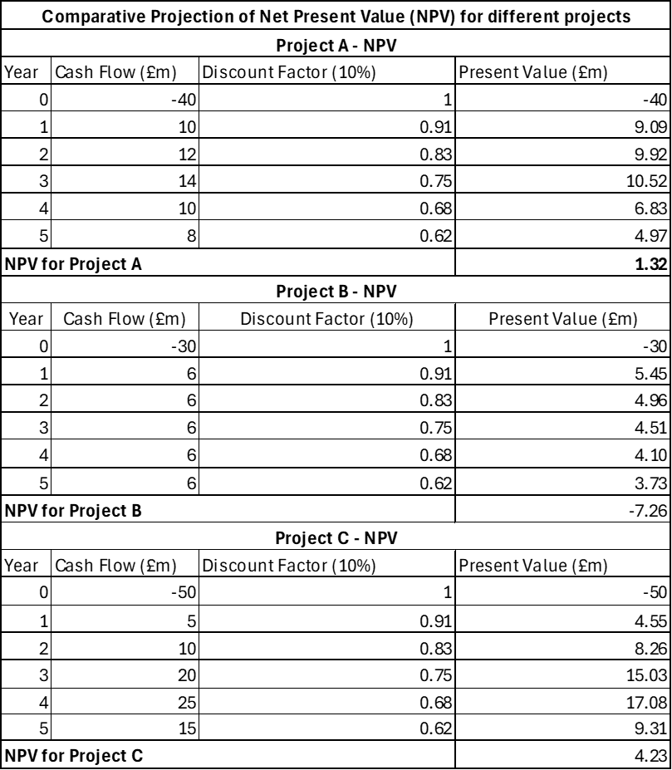
Table 1: Comparing NPV for all projects
5.1.2 PBP
Payback Period (PBP) is the period it takes a project to be beneficial due to its initial investment based on net cash inflows (Cecchetti, 2023; Hegde et al., 2023). The technique is effective in the determination of liquidity risk, particularly in companies experiencing an issue with cash flow.
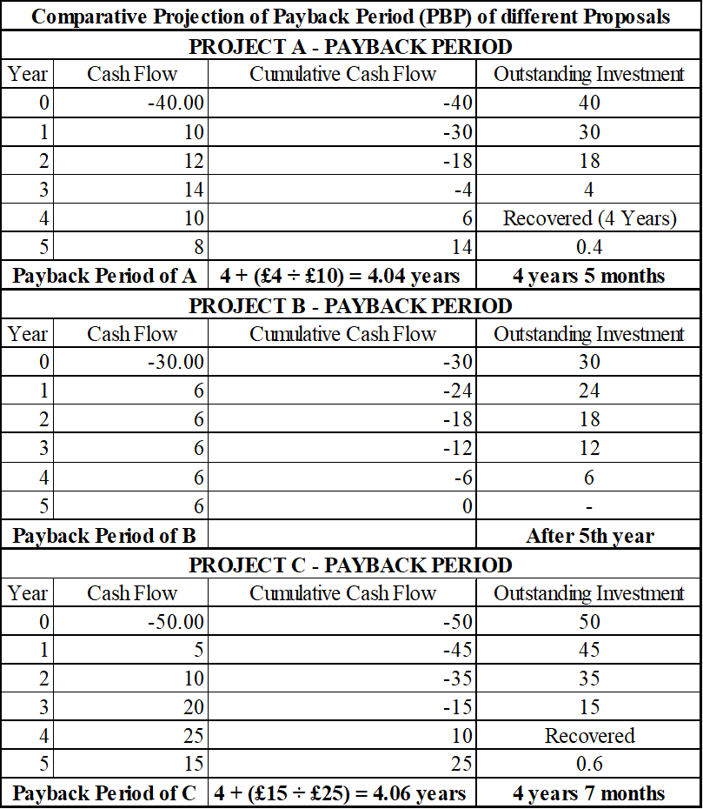
Table 2: Comparing PBP for all projects
It is revealed that the speed of payback is the highest in Project A, and it recovers its initial investment a bit earlier than Project C, which forecasts back-loaded cash inflows, and Project B recovers at the end of the project life, hence a poor liquidity position.
5.1.3 ARR
Accounting rate of Return (ARR) measures a project in terms of the average annual accounting profit divided by the sum of the initial investment. It offers an understanding of the effects of the project on reported profitability (Yahaya, 2025). According to ARR calculations, Project C has the highest ARR, and this shows a superior profitability throughout its life span. Project A provides an average ARR, whereas Project B will provide little or no ARR, which proves its low earning capacity.
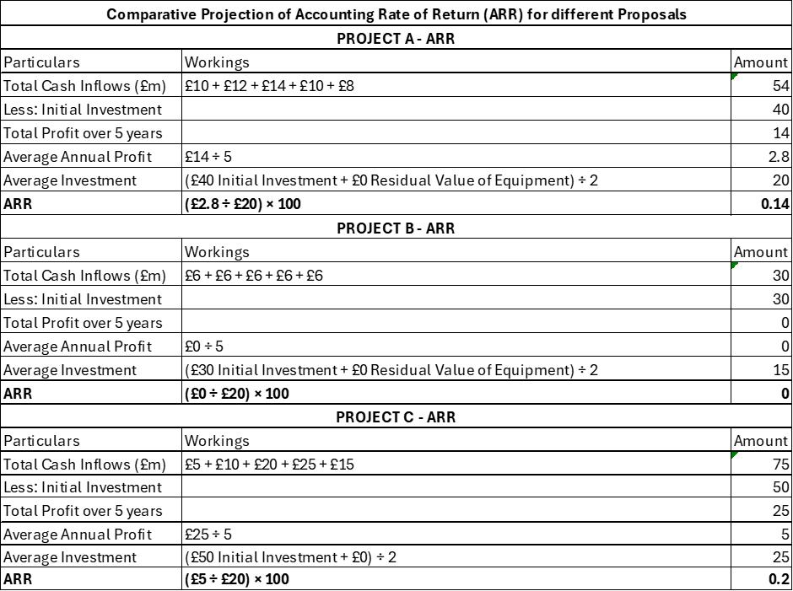
Table 3: Comparing ARR for all projects
ARR is simple to comprehend and compatible with performance metrics based on accounting; however, it does not consider the timing of the cash flow or the time value of money (Oyeyipo et al., 2023). ARR applies to General Electronics irrespective of these constraints since the company has incurred losses in its accounts, which has led to a loss of investor confidence. Improving reported profitability in projects is useful in maximising perception in the market and rebuilding stakeholder confidence. Project C prevails in the alternatives from an ARR perspective.
5.1.4 IRR
Internal Rate of Return (IRR) is the discount rate at which the NPV of a project will have zero value (Mavlutova et al., 2021). It is usually used alongside the firm's cost of capital to determine acceptability. Project A and Project C produce higher IRRs than the discounted rate of 10%, which implies that they are higher than the minimum returns. The IRR of Project B is roughly close to the discount rate, meaning that there is no economic surplus as well, which supports the lack of appeal towards Project B.
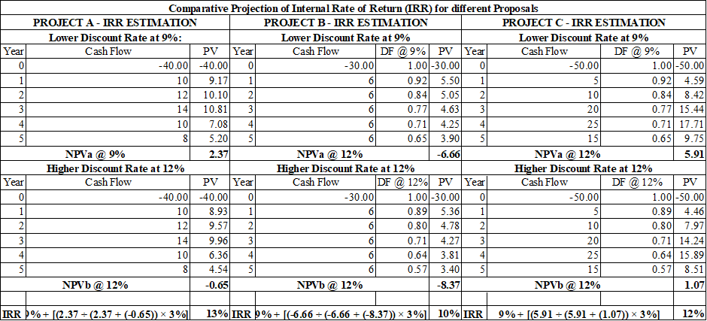
Table 4: Comparing IRR for all projects
Although IRR is easy to understand and has deep penetration, it has significant flaws, especially where capital rationing takes place or where there are unconventional cash flows (Zaramella, 2023). Within the context of the case, Project A has a competitive IRR; however, the creation of absolute values is much smaller than in the case of Project C.
5.1.5 PI
The Profitability Index (PI) is a measure of the value of future cash inflows at a specific unit of initial investment, based on present value, and is especially effective in conditions of capital rationing (Shang et al., 2023). As reported by the PI results, project C is the most profitable with a high profitability index of 3.69, then project A comes with a PI of 3.69, whereas project B has a profitability index of less than one, which proves that it destroys value. The PI is greater than one, which implies that a project has more value than its cost, and the PI is below one, which implies that there is inefficiency in a project (Grundy et al., 2022).
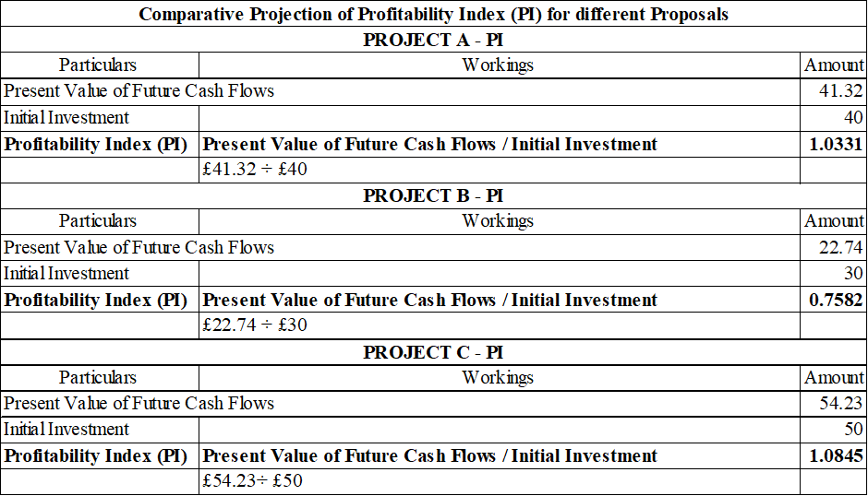
Table 4: Comparing PI for all projects
PI is very relevant given that the industry is facing a tight investment budget, and liquidity constraints are experienced by this firm. It assists in ranking projects that make the most out of the foodstuff invested (Ritchken and Wu, 2021). The PI of project C is better indicating that it utilises more capital effectively compared to the alternatives, despite having a more expensive start-up cost.
5.2 Final investment recommendation
Given the assumption of capital rationing, with a minimum investment limit of £60 million, General Electronics cannot carry out all projects at the same time. Project C is the most feasible project, which should be selected based on the results obtained after combining the NPV, the ARR, the IRR, and the PI. Project C needs £50 million that fits within the capital limitation and has the greatest value creation at the absolute and relative levels. Project A would be slightly acceptable; however, its integration with Project C would be extremely over the budget and investing capital in Project A rather than Project C would lead to lower value creation. Project B is not to be accepted at all as it has a negative NPV, poor profitability, and inefficient use of capital.
5.3 Justification for financial performance and risk evaluation
The positive financial situation and risk profile of General Electronics support the idea of increasing investment in Project C. The company is experiencing reduced profitability, diminished cash flow coverage and increased leverage. In this regard, investments should yield high long-term returns to justify capital commitment and recover funds lost in the financial recovery. Financial performance-wise, Project C is the best with regard to adding to profitability in terms of having the highest NPV and involvement in profitability, as indicated by the high ARR. Its rising cash inflows in the long run are best placed in a company with a desire to restore earning capacity and enhance the operating cash flows (Zaramella, 2023). Project A, on the other hand, offers marginal incremental value, whereas Project B would increase financial pressure by chewing up capital without offering sufficient returns. Back-loaded cash flows mean that Project C has certain exposure in terms of risk. However, the risk of this is overcome by the fact that the project has great value creation and fits a set of long-term strategic goals. Moreover, Project A is less risky about cash flow timing; it does not pay good returns to a material change in the financial position of the firm (Putri and Willim, 2024). Project B has an unacceptable risk because it cannot produce an economic value. Furthermore, investing in Project C is an ambivalent and strategically oriented choice. It maximises the value of its shareholders, promotes financial sustainability in the long-term, and aligns the allocation of capital to the recovery strategy of the firm. Being a company with an operational crisis dictated by financial strains, the selection of disciplined investments based on proper appraisal approaches is paramount, and Project C fits these requirements the most.

6. Conclusion
The General Electronics company is in a state of serious financial distress, evident in a deteriorating profit margin, deteriorating liquidity conditions, ineffective working capital utilisation and an escalating debt to equity ratio. The balance sheet review and Altman Z-score assessment prove that the risks of default are very high, and there is a strong necessity to use decisive financial measures. As a solution to these problems, a detailed restructuring strategy involving strengthening of the balance sheet, realignment of the debts and efficiency in operations has been suggested. Moreover, the strict capital budgeting analysis reveals that value-enhancing recovery heavily depends on disciplined investment selection, of which Project C was identified as the most important choice.

Reference List
Akomea-Frimpong, I., Jin, X. and Osei-Kyei, R. (2021). A holistic review of research studies on financial risk management in public–private partnership projects. Engineering, construction and architectural management, 28(9), pp.2549-2569.https://www.academia.edu/download/65310221/Published_ECAM_Financial_Risks_of_PPPs.pdf
Alalade, Y.S., Ademola, O.C., Ajayi-Owoeye, A.O., Ogunwale, O. and Ali, A.L., (2024). Optimising Liquidity Management Strategies to Enhance Financial Performance in Nigerian Manufacturing Firms. https://www.researchgate.net/profile/Olufemi-Ademola/publication/386175075_Optimizing_Liquidity_Management_Strategies_to_Enhance_Financial_Performance_in_Nigerian_Manufacturing_Firms/links/674780b3359dcb4d9d3ca183/Optimizing-Liquidity-Management-Strategies-to-Enhance-Financial-Performance-in-Nigerian-Manufacturing-Firms.pdf
Aldo, M., (2022). The Effect of Gearing, Price Earning Ratio, Interest Rate, Risk on Abnormal Return. Indonesian Interdisciplinary Journal of Sharia Economics (IIJSE), 5(2), pp.751-767.http://e-journal.uac.ac.id/index.php/iijse/article/download/2195/990
Al-Hashimy, H.H., Alabdullah, T.T.Y., Ries, E., Ahmed, M.A., Nor, M.I. and Jamal, K.A.M., (2022). The Impact of financial management elements and behavioral intention on the financial performance. International Journal of Scientific and Management Research, 5(12), pp.117-149. https://ijsmr.in/doc/ijsmr05_176.pdf
Al-Najjar, S.M. and Jawad, M.K., (2023). Application of Z–Score and Z-3 Score Models to Evaluate the Financial Situation of the Modern Sewing Company: A Case Study. International Journal for Humanities & Social Sciences (IJHS), (2), pp.46-57. https://www.researchgate.net/profile/International-Journal-Social-Sciences-Ijhs/publication/380575417_Application_of_Z-Score_and_Z-3_Score_Models_to_Evaluate_the_Financial_Situation_of_the_Modern_Sewing_Company_A_Case_Study/links/6644698d7091b94e932bef77/Application-of-Z-Score-and-Z-3-Score-Models-to-Evaluate-the-Financial-Situation-of-the-Modern-Sewing-Company-A-Case-Study.pdf
Amira, T. and Hafssa, Y., (2021). Financial risk of indebted companies: A study of the Impact of financial structure and the earnings growth. Journal of Accounting and Finance, 21(5), pp.63-74. https://www.researchgate.net/profile/Amira-Tahiri/publication/371317800_Financial_Risk_of_Indebted_Companies_A_Study_of_the_Impact_of_Financial_Structure_and_the_Earnings_Growth/links/647f2354b3dfd73b77682fcc/Financial-Risk-of-Indebted-Companies-A-Study-of-the-Impact-of-Financial-Structure-and-the-Earnings-Growth.pdf?origin=journalDetail&_tp=eyJwYWdlIjoiam91cm5hbERldGFpbCJ9
Asman, F.N., Fernandez, D., Jamaludin, N.A., Omar Zaki, H. and Ghazali, A.W., (2022). Cash conversion cycle and firm’s performance. International Journal of Academic Research in Business and Social Sciences, 12(11), pp.2682-2692.https://www.academia.edu/download/106769993/cash-conversion-cycle-and-firms-performance.pdf
Attah, R.U., Garba, B.M.P., Gil-Ozoudeh, I. and Iwuanyanwu, O., (2024). Corporate banking strategies and financial services innovation: Conceptual analysis for driving corporate growth and market expansion. Int J Eng Res Dev, 20(11), pp.1339-49.https://www.researchgate.net/profile/Ifechukwu-Gil-Ozoudeh/publication/386997394_Corporate_Banking_Strategies_and_Financial_Services_Innovation_Conceptual_Analysis_for_Driving_Corporate_Growth_and_Market_Expansion/links/675c00638a08a27dd0bbfe2d/Corporate-Banking-Strategies-and-Financial-Services-Innovation-Conceptual-Analysis-for-Driving-Corporate-Growth-and-Market-Expansion.pdf
Barnabas, B. and Oloyede, J., 2024. Cash Flow Optimisation: Strategies for Enhancing Short-Term Liquidity. Available at SSRN 5004465.https://papers.ssrn.com/sol3/Delivery.cfm?abstractid=5004465
Braunsberger, C. and Aschauer, E., (2025). Corporate failure prediction: A literature review of Altman Z-score and machine learning models within a technology adoption framework. Journal of Risk and Financial Management, 18(8), p.465. https://www.mdpi.com/1911-8074/18/8/465
Burcă, V., Bogdan, O., Bunget, O.C. and Dumitrescu, A.C., (2024). Corporate Financial Performance vs. Corporate Sustainability Performance, between Earnings Management and Process Improvement. Sustainability (2071-1050), 16(17). https://www.mdpi.com/2071-1050/16/17/7744
Cecchetti, S.G., (2023). The road to financial stability: Capital regulation, liquidity regulation, and resolution. 40th issue (June 2015) of the International Journal of Central Banking.https://www.ijcb.org/journal/ijcb15q3a3.pdf
Chairani, C. and Siregar, S.V., (2021). The effect of enterprise risk management on financial performance and firm value: the role of environmental, social and governance performance. Meditari Accountancy Research, 29(3), pp.647-670.https://www.emerald.com/insight/content/doi/10.1108/medar-09-2019-0549/full/html
Chen, S.C., Lee, D.S. and Huang, C.Y., (2021). Evaluating the sustainable operating performance of electronics industry groups: Taiwanese firms in mainland China. Sustainability, 13(21), p.12030. https://www.mdpi.com/2071-1050/13/21/12030
Cındık, Z. and Armutlulu, I.H., (2021). A revision of Altman Z-Score model and a comparative analysis of Turkish companies’ financial distress prediction. National Accounting Review, 3(2), pp.237-255. https://www.aimspress.com/aimspress-data/nar/2021/2/PDF/NAR-03-02-012.pdf
Elmghaamez, I.K., Nwachukwu, J. and Ntim, C.G., (2024). ESG disclosure and financial performance of multinational enterprises: The moderating effect of board standing committees. International Journal of Finance & Economics, 29(3), pp.3593-3638.https://clok.uclan.ac.uk/id/eprint/47402/1/IJFE%20M%2005-2023%20Final%20Version.pdf
Elumilade, O.O., Ogundeji, I.A., Achumie, G.O., Omokhoa, H.E. and Omowole, B.M., (2022). Optimising corporate tax strategies and transfer pricing policies to improve financial efficiency and compliance. Journal of Advance Multidisciplinary Research, 1(2), pp.28-38. https://www.synstojournals.com/multi/article/download/147/145
Grundy, T., Johnson, G. and Scholes, K., (2022). Strategic Financial Management. Bachelor of Business Administration Programme Code: BBA Duration–3 Years Full Time, 2(1), pp.1-575. https://www.amity.edu/gwalior/naac/1_1_3/syllabus/1.1.3%20abs%20new.pdf#page=529
Gunawan, A., Jufrizen, J. and Pulungan, D.R., (2023). Improving MSME performance through financial literacy, financial technology, and financial inclusion. International Journal of Applied Economics, Finance and Accounting, 15(1), pp.39-52. https://www.academia.edu/download/102724262/714.pdf
Hanifah, H., (2023). Analysis of the Impact of liquidity and adequacy of operational cash flow on the detection of financial distress risk in retail companies listed on the Indonesian Stock Exchange. Jurnal ASET (Akuntansi Riset), 15(2), pp.325-334.https://ejournal.upi.edu/index.php/aset/article/download/58408/25809
Hasidi, M.H., Baheri, J. and Hajar, K.I., (2024). Financial performance evaluation using profitability and liquidity ratio analysis.https://www.researchgate.net/profile/Chnar-Rashid/publication/348686551_THE_EFFICIENCY_OF_FINANCIAL_RATIOS_ANALYSIS_TO_EVALUATE_COMPANY'S_PROFITABILITY/links/600ad9df92851c13fe2b24ba/THE-EFFICIENCY-OF-FINANCIAL-RATIOS-ANALYSIS-TO-EVALUATE-COMPANYS-PROFITABILITY.pdf
Hegde, A.A., Panda, A.K. and Masuna, V., (2023). Does companies' financial flexibility drive their leverage dynamics? New evidence. Managerial Finance, 49(2), pp.270-290. https://www.researchgate.net/profile/Apoorva-Hegde/publication/363155027_Does_companies'_financial_flexibility_drive_their_leverage_dynamics_New_evidence/links/6352a74b6e0d367d91b23e62/Does-companies-financial-flexibility-drive-their-leverage-dynamics-New-evidence.pdf
Hussain, S., Hassan, A.A.G., Quddus, A., Rafiq, M. and Nguyen, V.C., (2021). Cash conversion cycle sensitivity by moderating role of exchange rates volatility on firm’s financial performance. Business: Theory and Practice, 22(2), pp.277-289. https://aviation.vgtu.lt/index.php/BTP/article/download/13147/10683
Khan, P.A., Johl, S.K. and Akhtar, S., (2022). Vinculum of sustainable development goal practices and firms’ financial performance: A moderation role of green innovation. Journal of Risk and Financial Management, 15(3), p.96. https://www.mdpi.com/1911-8074/15/3/96/pdf
Kuzmina, O., (2023). Employment flexibility and capital structure: Evidence from a natural experiment. Management Science, 69(9), pp.4992-5017. https://papers.ssrn.com/sol3/Delivery.cfm?abstractid=3795202
Laghari, F., Ahmed, F. and López García, M.D.L.N., (2023). Cash flow management and its effect on firm performance: Empirical evidence on non-financial firms of China. Plos one, 18(6), p.e0287135. https://journals.plos.org/plosone/article/file?id=10.1371/journal.pone.0287135&type=printable
Mavlutova, I., Babenko, V., Dykan, V., Prokopenko, N., Kalinichenko, S. and Tokmakova, I., (2021). Business restructuring as a method of strengtening company’s financial position. Journal of Optimization in Industrial Engineering, 14(1), pp.129-139. https://www.academia.edu/download/81063588/article_677839_cd06f5c50b09f28acf4802268302e8ba.pdf
Nkwinika, E. and Akinola, S., (2023). The importance of financial management in small and medium-sized enterprises (SMEs): an analysis of challenges and best practices. Technology audit and production reserves, 5(4 (73)), pp.12-20. https://journals.uran.ua/tarp/article/download/285749/282012
Nukala, V.B. and Prasada Rao, S.S., (2021). Role of debt-to-equity ratio in project investment valuation, assessing risk and Return in capital markets. Future Business Journal, 7(1), p.13. https://link.springer.com/content/pdf/10.1186/s43093-021-00058-9.pdf
Oyeyipo, I., Attipoe, V., Mayienga, B.A., Onwuzulike, O.C., Ayodeji, D.C., Nwaozomudoh, M.O., Isibor, N.J. and Ahmadu, J., (2023). A conceptual framework for transforming corporate finance through strategic growth, profitability, and risk optimisation. International Journal of Advanced Multidisciplinary Research and Studies, 3(5), pp.1527-1538.https://www.multiresearchjournal.com/admin/uploads/archives/archive-1742807323.pdf
Pamungkas, M.S., (2023). Capital Management Strategy for Liquidity Refinancing: A study on SMEs' Restructuring Solutions. SUKUK: INTERNATIONAL JOURNAL OF BANKING, FINANCE, MANAGEMENT AND BUSINESS, 2(II), pp.17-30.https://sukukjournal.org.uk/index.php/sukuk/article/download/27/33
Putri, R.L. and Willim, A.P., (2024). Analysis of the effect of assets structure, earning volatility and financial flexibility on capital structure in consumer goods industry sector companies on the Indonesia stock exchange. LBS Journal of Management & Research, 22(1), pp.25-36. https://www.emerald.com/insight/content/doi/10.1108/LBSJMR-11-2022-0069/full/pdf
Rashid, C.A., (2021). The efficiency of financial ratios analysis to evaluate company’s profitability. Journal of Global Economics and Business, 2(4), pp.119-132.https://www.researchgate.net/profile/Chnar-Rashid/publication/348686551_THE_EFFICIENCY_OF_FINANCIAL_RATIOS_ANALYSIS_TO_EVALUATE_COMPANY'S_PROFITABILITY/links/600ad9df92851c13fe2b24ba/THE-EFFICIENCY-OF-FINANCIAL-RATIOS-ANALYSIS-TO-EVALUATE-COMPANYS-PROFITABILITY.pdf
Ritchken, P. and Wu, Q., (2021). Capacity investment, production flexibility, and capital structure. Production and Operations Management, 30(12), pp.4593-4613. https://www.academia.edu/download/121467152/poms.1325320250221-1-76nrn2.pdf
Shahriar, M.S., Hasan, K.B.M.R., Hossain, T., Beg, T.H., Islam, K.A. and Zayed, N.M., (2021). Financial decision making and forecasting techniques on project evaluation: a planning, development and entrepreneurial perspective. Academy of Entrepreneurship Journal, 27(4), pp.1-7. https://www.academia.edu/download/91261672/Financial-decision-making-and-forecasting-techniques-on-project-evaluation-a-planning-development-1528-2686-27-4-553.pdf
Shang, Y., Pu, Y., Yu, Y., Gao, N. and Lu, Y., (2023). Role of the e-exhibition industry in the green growth of businesses and recovery. Economic Change and Restructuring, 56(3), pp.2003-2020. https://pmc.ncbi.nlm.nih.gov/articles/PMC10026782/pdf/10644_2023_Article_9502.pdf
Sharma, P., (2023). Analysing How Rigorous Financial Analysis Informs Strategic Decisions and Contributes to Corporate Growth. Nanotechnology Perceptions, 20, pp.219-229. https://www.researchgate.net/profile/Pragya-Sharma-81/publication/389993854_Analyzing_How_Rigorous_Financial_Analysis_Informs_Strategic_Decisions_and_Contributes_to_Corporate_Growth/links/67dc067635f7044c924cc145/Analyzing-How-Rigorous-Financial-Analysis-Informs-Strategic-Decisions-and-Contributes-to-Corporate-Growth.pdf
Tulung, J.E., Sondakh, J.J., Wangke, S.J.C. and Posumah, R.F.K., (2024). EFFECTS OF CAPITAL RATIO, QUALITY OF RECEIVABLES, LIQUIDITY, AND GEARING RATIO ON PROFITABILITY: A STUDY FINANCIAL INSTITUTIONS’GOVERNANCE. Journal of Governance and Regulation/Volume, 13(3).https://virtusinterpress.org/IMG/pdf/jgrv13i3art4.pd
Wanof, M.I., (2023). Digital technology innovation in improving financial access for low-income communities. Technology and Society Perspectives (TACIT), 1(1), pp.26-34. https://journal.literasisainsnusantara.com/index.php/tacit/article/download/35/52
Yahaya, O.A., (2025). Non-executive directors and capital cost. Journal of Business and Management, 20(8), pp.67-109. https://www.researchgate.net/profile/Ahmad-Yusuf-23/publication/395446864_Non-executive_directors_and_capital_cost/links/68c42a7f4eef4b024b8b1ca1/Non-executive-directors-and-capital-cost.pdf
Zaramella, G., (2023). Financial Restructuring: analysis and applications.https://unitesi.unive.it/bitstream/20.500.14247/4284/1/872666-1280209.pdf

Appendices
Appendix 1: Financial ratio analysis for General Electronics
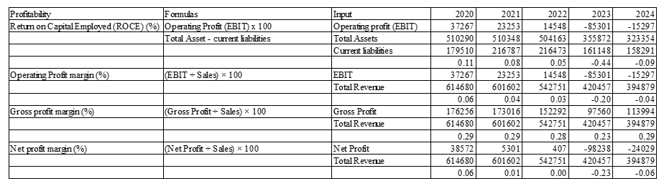
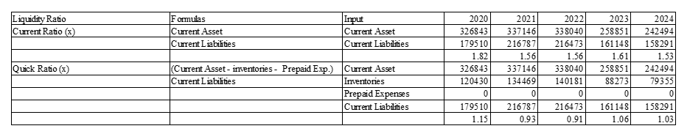
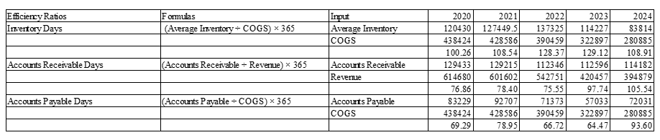
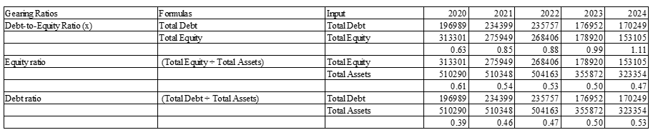

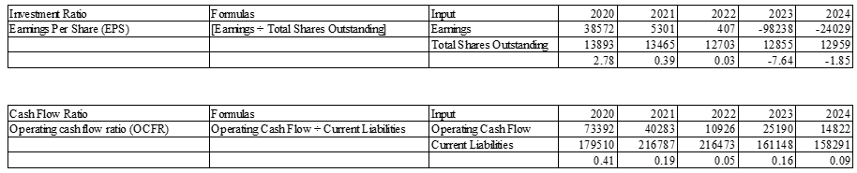
Appendix 2: Altman-Z model for corporate failure predictions
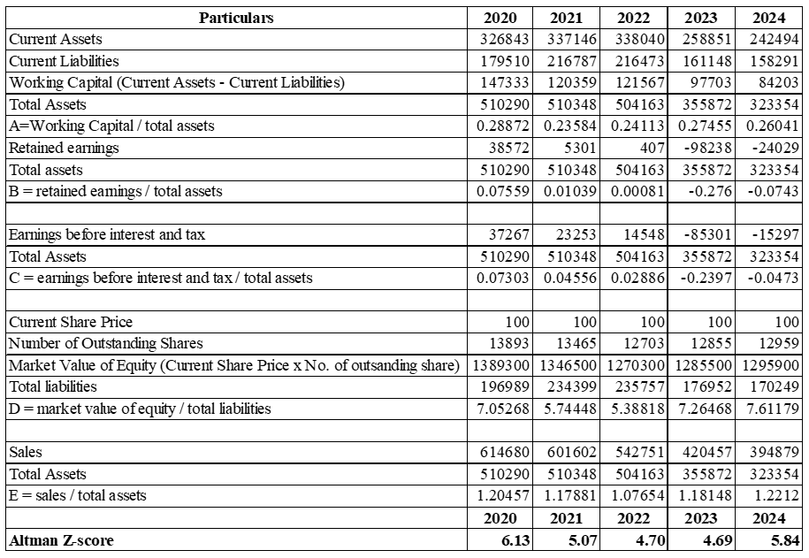

Appendix 3: Investment appraisal for General Electronics


