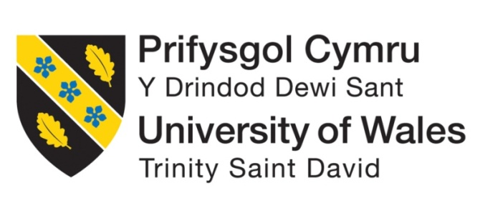

Programme: BA International Hotel Management
Module Title: Management & Organisational Behaviour
Module Code: BMIH5004
Student Name: A K M Amdadul Hoque
Student ID:2107424
Teacher Name: Julia Ault

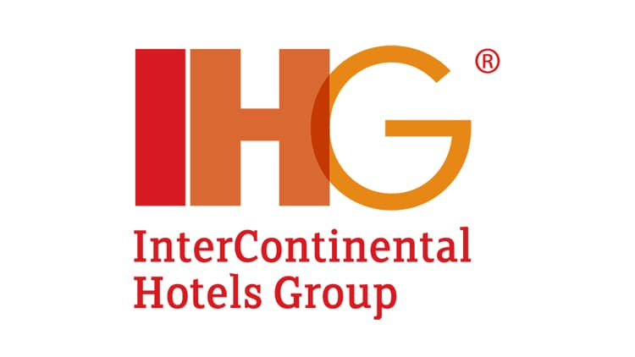

Executive Summary
The InterContinental Hotels Group (IHG) shows a robust organisational structure built to deliver balance between centrally and localisation, effectiveness and social performance standards. The most recent strategies include digital transformation, focus on sustainability and the long-term IHG LIFT program. The example of IHG implies that its strategic course must be linked to further global expansion, willingness to innovate and make a focus on sustainability. The recommendations would be to make them invest more in technology, implement strategic collaboration and focus on sustainability. Overall, it is possible to say that its robust structure, proactive change management and strategic planning aspects will keep it driving its success and market-leading position.

Table of Contents
1. Introduction 4
2. Main Body 4
2.1. Organisation Structure, Culture and Goals 4
2.1.1. Organisation Structure 4
2.1.2. Culture 6
2.1.3. Goals 8
2.2. Recent Change Initiatives, Their Impact and How Well These Were Managed 8
2.2.1. Recent Change Initiatives 8
2.2.2. Rationale Behind these Initiatives 9
2.2.3. Impact of Change Initiatives 9
2.2.4. Management of Change 10
2.2.5. Dobson’s Guide to Changing Culture 11
2.3. The Organisation’s Strategic Direction 11
2.3.1. Overview of IHG’s Current Strategy 11
2.3.3. Competitive Positioning 12
2.3.4. Future Outlook 12
2.3.5. Recommendations 12
3. Conclusion 12
4. Reference List 13

1. Introduction
InterContinental Hotels Group is one of the most well-known figures in the global hospitality industry and claims a rich history that began in 1777 when the Bass Brewery was founded in England (Gyurácz-Németh et al., 2024). Transforming over the years, the group entered the accommodation industry through a series of mergers and acquisitions, including buying Holiday Inn International in 1988 (Page and Connell, 2020). Nowadays, being a major hospitality corporation, IHG is known for its expansive offer that includes no less than 19 hotel brands serving demanding travellers in more than 100 countries. The extensive network underscores the group’s profound impact on the industry, creating a formidable operator committed to delivering outstanding client service.
Figure 1: InterContinental Hotels Group
(Source: ihgplc.com, 2024)
The analysis conducted will allow the offering of a comprehensive evaluation of IHG's current state and prospects. This report will provide necessary information that will help determine the company’s operational effectiveness, flexibility and competitiveness in the context of the shifting hospitality context by examining the company’s organisational structure, culture and goals, as well as reviewing the recent change initiatives and the chosen target market.

2. Main Body

2.1. Organisation Structure, Culture and Goals

2.1.1. Organisation Structure
InterContinental Hotels Group (IHG) contains a hybrid organisational structure, amalgamating centralised and decentralised aspects to successfully manage its worldwide operations (El-Said et al., 2024).
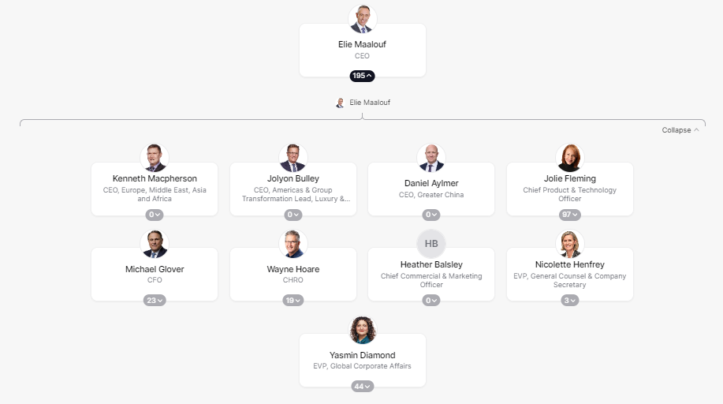
Figure 2: Organisational Structure
(Source: theorg.com, 2024)
- Centralised Aspects: It seems that within IHG, a centralised leadership team drives overall strategic directions, brand management activities and critical financial judgments. The approach ensures consistency and uniformity for the wide spectrum of hotels, thereby deciding the core strategy and guaranteeing brand integrity and the overall strategy’s cohesion.
- Decentralised Aspects: The firm's operational levels are decentralised, which means that the decision-making authority is delegated to the regional or, sometimes, the individual hotels’ management (Friedman, 2021). The decentralised approach allows the management to respond promptly to specific market conditions, adapt to any type of guest in a particular region or context and develop the operational strategy accordingly.
Organisational Theory Utilisation
According to Mthembu and Nzimakwe, (2020), Mintzberg’s organisational configurations case of IHG can give an impression that it is rather a professional bureaucracy or an adhocracy. The fact that centralised leadership executes decisions made at that level should suggest the professional bureaucracy with a hierarchically controlled organisational structure and clearly defined and rather structured processes. However, the decentralised operational decision-making should make it similar to the adhocracy that demonstrates fast reactions to outside stimuli.
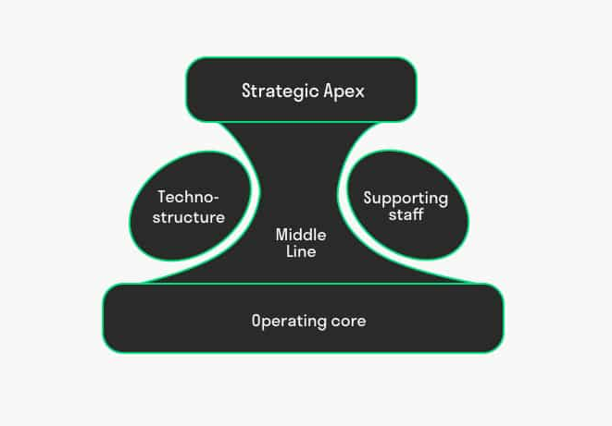
Figure 3: Mintzberg’s Organisational Configurations
(Source: toolshero.com, 2024)

2.1.2. Culture
- Analysis of Organisational Culture: IHG maintains a distinct culture reflected in its fundamental values, with ‘True Hospitality for Good’ capturing the essence of its cultural system (IHG, 2022). The core cultural framework is guest-oriented, socially responsible and characterised by integrity.
- Cultural Values and Influence:IHG’s cultural framework per Schein’s model contains artifacts or visible culture like ‘True Hospitality for Good’, proclaimed ideas such as being guest-centric and environmentally responsible and underlying assumptions or customer-focused service leading to success (IHG, 2022). This culture dictates staff behaviour, visitor relations and service provision, creating a commitment to great experiences, environmental protection and moral conduct. It underlies operational excellence and competitive advantage for IHG in the hospitality sector.
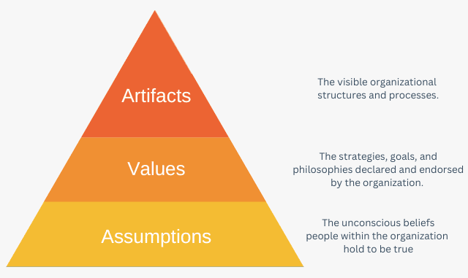
Figure 4: Edgar Schein’s Cultural Model
(Source: expertprogrammanagement.com, 2024)
Application of Handy’s Model
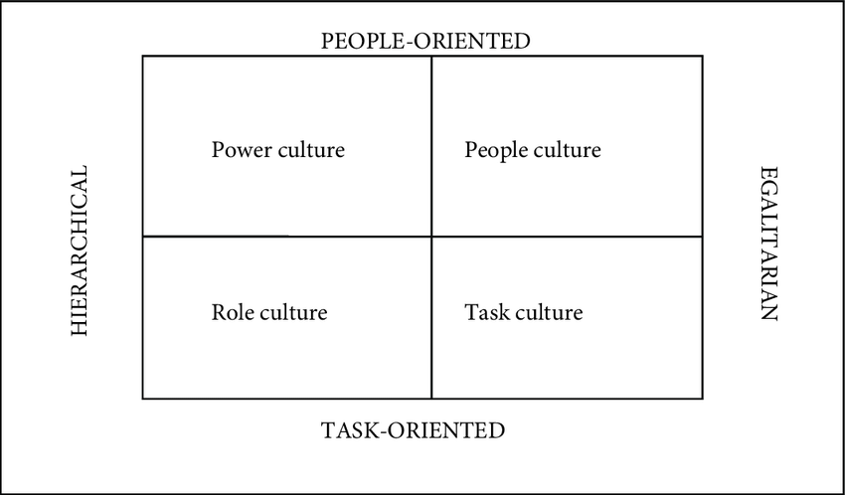
Figure 5: Handy’s Model of Organisational Culture
(Source: researchgate.net, 2024)
According to Klimecka-Tatar and Niciejewska (2021), IHG shows characteristics of both the role culture and the task culture paradigms from Handy’s model of organisational culture. From the role culture perspective, the company is characterised by the focus on established brand standards and conformity to procedures which ensure consistency and credibility in every region of the world. From the task culture perspective, IHG is open to changes in market demands and customer expectations, as regional managers are empowered to develop their initiatives and foster innovations.

2.1.3. Goals
- Financial Goals: These can include maximising revenue, boosting profitability and attaining shareholder value.
- Operational Goals: These might concentrate on boosting guest pleasure, optimising hotel operations and strengthening brand reputation.
- Growth Goals: IHG can attempt to increase its worldwide footprint, penetrate new markets, or create new hotel brands.
- Sustainability Goals:‘True Hospitality for Good’ provides objectives relating to environmental responsibility and social effect (IHG, 2022).
Alignment with Strategy and Mission
IHG's aims should be linked with its overarching strategy and purpose. For instance, a growth plan would entail targets for growing hotel presence, while a focus on sustainability might translate into goals for minimising energy use or waste.

2.2. Recent Change Initiatives, Their Impact and How Well These Were Managed

2.2.1. Recent Change Initiatives
- Digital Transformation:As per Fuchs (2022), IHG has changed its marketing strategy as a response to the virus, focusing on digital channels to talk with customers and provide them with information. This change has been very important in maintaining business continuity and ensuring the health and safety of visitors during the pandemic.
- Sustainability Efforts:According to Stoimenov (2023), IHG implemented several environmental initiatives, including a carbon and energy reduction program. The company seeks to reduce its carbon footprint and operate more sustainably, by the United Nations Sustainable Development Goals.
- Restructuring:Vasić and Petrović (2023) showed that IHG has implemented changes to its performance management program as a way to increase the focus on personal performance and contribution. With this change, the company aims to ensure that all plan members are linked to a standardised set of measures and weightings.
- IHG LIFT Program: IHG has established the IHG LIFT program (InterContinental Hotels Group, 2024). This program introduced by the company as an owner growth strategy is supposed to increase development capacity for owners of hotels from traditionally underrepresented groups. Thus, IHG would provide eligible owners in the U.S. and Canada with support, access to financing and guidance along the lifecycle of owning a hotel.
- Journey to Tomorrow:According to Stoimenov (2023), Journey to Tomorrow is an action plan for the next 10 years, including the promises of good change in the people, communities, carbon & energy, waste and water. The strategy reflects IHG’s focus on sustainable development and the creation of an ethical organisation that contributes to the improvement of the future.

2.2.2. Rationale Behind these Initiatives
The reforms initiated by IHG are based on the target of True Hospitality for Good and the company's commitment to business and its responsibilities. Sarfraz, Shah and Choudhry (2024) recognised that the company should adapt to the new realities dictated by the pandemic and ensure that sustainability and diversity are promoted in all its aspects. The primary goal of these initiatives is to guarantee that IHG can continue its development in the long term and that it has a positive impact on the world and people.

2.2.3. Impact of Change Initiatives
Positive and Negative Impacts
- Employees: Positive benefits are increased opportunities for personal growth and development, such as IHG LIFT. However, the restructuring initiatives can harm employee morale because of increased concerns regarding job security and job position clarity.
- Consumers: The digital revolution has been positive for customers who received better online experiences and communication channels. Additionally, sustainability initiatives might be well regarded by eco-conscious customers. However, restructuring may indirectly impair customer service levels if not handled well.
- Shareholders: Since sustainability activities, particularly digital transformation and restructuring, are connected with long-term value creation and reputation improvement, as per Mullins and Dosser (2013) shareholders are likely to welcome them. At the same time, short-term expenses might evoke concerns about the firm’s profitability and return to investments.
Short-term and Long-term Effects
In terms of the near future, according to Mullins (2016), change activities such as digital transformation and reorganisation are likely to result in operational disruptions and low employee satisfaction. However, in the long run, such practices are expected to benefit the firms by enhancing efficiency, customer involvement and environmental standards. In this way, the IHG LIFT initiative is likely to result in a more diverse group of hotel owners and, consequently, more innovative and community-driven hotel designs.

2.2.4. Management of Change
- Communication and Involvement: IHG has emphasised open communication and stakeholder involvement to achieve buy-in and alignment with transformation goals.
- Training and Assistance: The organisation has provided training and assistance to workers to help them adopt new technology and procedures.
- Leadership Involvement: IHG’s leadership has been involved in pushing transformation projects and showing commitment to their success.
Evaluation of Effectiveness
The effectiveness of IHG change management techniques can be evaluated based on features such as staff morale, operational efficiency and stakeholder satisfaction. Early signals of success, such as the positive feedback of staff and customers coupled with easy implementation, reflect that these strategies have helped turn IHG change management efforts effective.
Employees and Stakeholders’ Reactions to the Changes
As per Li et al. (2021), employees' and stakeholders' response to the changes varies depending on their communication, perceived outcome and the extent of involvement in the change processes. Whereas some employees and stakeholders may accept the programs positively, others may raise doubts or objections. On this note, continuous communication, support and involvement exercises are necessary to address such feelings and ensure effective change implementation.

2.2.5. Dobson’s Guide to Changing Culture
- Step 1: IHG needs to consider actions to take to maintain its culture. One of the steps IHG can take is to change its recruitment and selection criteria to ensure that applicants who resonate with the organisation’s intended beliefs and values, such as sustainability and diversity, could be given greater emphasis. According to Mullins, L (2020), the redundancy rules could be changed to protect employees who exhibit the stated principles.
- Step 2: IHG may also reorganise its workforce to get employees and managers in situ who exhibit the desired characteristics of the existing culture (Scott, 2021).
- Step 3: IHG needs to create an understanding of its new values within the organisation through multiple channels. Moreover, executives have to show values and ideas in their actions and behaviour because top management serves as an example within the organisation.
- Step 4: IHG may need to change its systems, processes and personnel policies, in particular, rewards and performance assessments to support behaviours corresponding to the culture and ideas valued by IHG.

2.3. The Organisation’s Strategic Direction

2.3.1. Overview of IHG’s Current Strategy
- Growth Strategy: IHG aims to increase its global reach through strategic partnerships, acquisitions and brand expansion efforts (Hu et al., 2021). It includes planned growth in key regions and in focus sectors to leverage new opportunities.
- Innovation: The company focuses on innovation in technology, sustainability and guest experience to maintain its competitive edge and cater to the evolving tastes of the customers.
2.3.2. Strategic Objectives and Priorities
- Guest Experience Excellence: Continuously upgrading guest experiences via customised services, digital advances and sustainability efforts.
- Brand Portfolio Optimisation: Optimising the brand portfolio to appeal to varied visitor categories and market preferences, ensuring each brand provides distinct value propositions.

2.3.3. Competitive Positioning
IHG maintains a key position in the hotel business, competing with other big firms like Marriott International and Hilton Worldwide. Its large brand portfolio, global reach and emphasis on sustainability contribute to its market leadership.

2.3.4. Future Outlook
IHG’s future picture looks positive due to growth possibilities in emerging regions, the innovative approach to guest experiences and the commitment to sustainability. However, as per Boddy (2014), some difficulties, such as changes in customer demands and the business environment, might require constant adaptation and agility. The company demonstrates preparedness and the ability to change in the face of future challenges through such strategic initiatives as digital technology integration, environmental performance and brand diversification. The focus on innovation and agility will allow the company to respond to the changing trends and accommodate the evolving customer demands.

2.3.5. Recommendations
- Investing in technology and visitor experience innovations to remain ahead of the competition.
- Forming strategic partnerships and collaborations to enhance market reach and promote growth.
- Strengthening its commitment to sustainable measures to satisfy growing customer expectations and regulatory needs.

3. Conclusion
InterContinental Hotels Group is a company with a firm and robust organisational structure. Moreover, IHG's distinct and achievable culture "True Hospitality for Good" defines that this hotel international chain always has a concern for its guests and nature. IHG's recent change initiatives in line with the digitalisation of the company and sustainable development indicate opportunities and benefits for the company. InterContinental Hotels Group has a good strategic direction that will allow grow, further be innovative and always please its guests, which is its priority target group. The recommendations concern investing in new technologies saving time and effort, various services and sustainable openings.

4. Reference List
Boddy, D. (2014) Management: An Introduction (6th Ed), Harlow, Pearson
El-Said, O.A., Elhoushy, S., Smith, M. and Youssif, M., (2024). Crisis-driven innovation in hospitality: How do international hotel chains innovate to recover from a global crisis?. International Journal of Hospitality Management, 120, p.103758.
Friedman, M., (2021). RESPONSIBLE MANAGEMENT. Principles of Management: Practicing Ethics, Responsibility, Sustainability.
Fuchs, M., (2022). Crisis communication and corporate social responsibility: a case study on IHG Hotels & Resorts and what organizations can learn from Covid-19 (Doctoral dissertation).
Gyurácz-Németh, P., (2024). Introduction to Hotel Operation.
Hu, X., Ma, C., Ren, L. and Chen, P.J., (2021). When in “China” do as the Chinese do: a case study of IHG’s HUALUXE’S localization in China. Journal of Teaching in Travel & Tourism, 21(1), pp.91-103.
IHG (2022). What we stand for. [online] InterContinental Hotels Group PLC. Available at: https://www.ihgplc.com/en/about-us/what-we-stand-for
InterContinental Hotels Group (2024). IHG LIFT. [online] IHG Development. Available at: https://development.ihg.com/hotel-development/ihg-lift
Klimecka-Tatar, D. and Niciejewska, M., (2021). Small-sized enterprises management in the aspect of organizational culture. RevistaGestão&Tecnologia, 21(1), pp.4-24.
Li, J.Y., Sun, R., Tao, W. and Lee, Y., (2021). Employee coping with organizational change in the face of a pandemic: The role of transparent internal communication. Public relations review, 47(1), p.101984.
Mthembu, D.M. and Nzimakwe, T.I., (2020). Towards a Learning Organisation. Administratio Publica, 28(2), pp.152-172.
Mullins, L (2020) Organisational Behaviour in the Workplace (12th edition) Harlow:Pearson
Mullins, L. (2016) Management and Organisational Behaviour (11th edition) Harlow: Pearson
Mullins, L. and Dosser, P. (2013) Hospitality Management and Organisational Behaviour (5th Ed) Harlow, Pearson.
Page, S.J. and Connell, J., (2020). Tourism accommodation and hospitality services. In Tourism (pp. 216-241). Routledge.
Sarfraz, M., Shah, W.U.H. and Choudhry, T., (2024). Organizational Culture: Cultural Change and Technology. BoD–Books on Demand.
Scott, T., (2021). Lead with Hospitality: Be Human. Emotionally Connect. Serve Selflessly.BenBella Books.
Stoimenov, V., (2023). GOOD PRACTICES IN HOTEL BRANDING–SUSTAINABILITY TRENDS OF INTERCONTINENTAL HOTEL GROUP. Предприемачество, 11(1), pp.108-131.
Vasić, Ž. and Petrović, P., (2023). THE ROLE AND IMPORTANCE OF EMPLOYEE PERFORMANCE ASSESSMENT FOR THE SUCCESS OF HOTELS IN BELGRADE. TEME, pp.1051-1070.

