Principles of learning and teaching (ECIE4004) Sophie Blackadder (2008875)
Blog link:
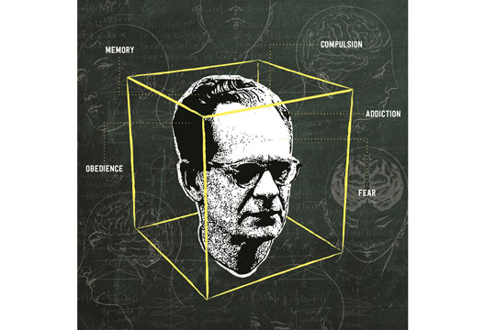
(Rhodes, 2016)
The ‘Skinner Box’
a Look at Operant Conditioning

What is this Skinner Box I hear you ask? No, it is not a box with a man’s head in, although that would be an interesting read. In fact, it is a small, secure, and soundproof box, and the man in the picture above is known as, Burrhus Frederic Skinner. He was a psychologist best-known for his work in the field of behaviorism, in which he used this box to place animals inside. Thus, he could observe their behaviours and interactions with their environment, developing his theory of ‘Operant Conditioning.’ Now, before I continue to Skinner’s theory, let me give you a brief history lesson on the man himself (Gray and Macblain, 2015).
B. F. Skinner (1904-1990)
Skinner was born in Pennsylvania, USA, to a working-class family. He studied English Literature at college with the full intentions of becoming a writer, but quickly became disillusioned with the entire process and decided he would rather write about science than fiction. Inspired by Watson’s book ‘Behaviourism’ (1924) and Pavlov’s work, during the 1890’s, he went on to study psychology at Harvard University, and by 1931 he had gained his doctorate (Aubery and Riley, 2019).

Career

- 1930’s a researcher at Harvard University, developed the ‘Skinner box’
- 1938 saw his first published work, ‘The Behaviour of Organisms’
- 1945 department chair in psychology in University of Indiana
- 1948 a lecturer at Harvard University
- 1971 published his most recognised works ‘Beyond Freedom and Dignity’ (Aubery and Riley, 2019)

The ‘Skinner Box’
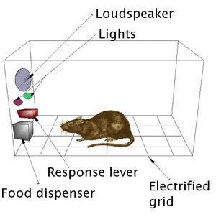
Skinner’s research was very scientifically based,
Whereby he used animals such as, rats and pigeons
to observe and measure behaviours by looking at
environmental factors. It was a simple box with
a button or lever, that would dispense food.
He later added lights, a loudspeaker and electric
grid into the box, using a reward or punishment
system on the animals for engaging in certain
types of behaviours (Udacity, 2015). (Kim, 2014)
What He Discovered!!
He found that the response the animals took was no longer an automatic to a stimulus, e.g., food. Like the previous classical conditioning, their actions were active, it involved the animals deciding (Extra credits, 2012).
But can this really work on humans?? We are supposed to be the superior race, are we not…Although, Skinner proposed ‘the way humans learn behaviour is much the same as the way the rats learnt to press a lever’ (McLeod, 2018, p.1). Skinner believed that operant conditioning explains all human learning.
So, what is ‘Operant Conditioning’?
Skinner’s work was based on Thorndike’s (1898) law of effect, believing individuals are not passive but active learners.
Skinner’s theory states ‘that learning occurs when behaviour is either rewarded or punished. Through operant conditioning an association is made between a behaviour and its consequences’ (Gray and Macblain, 2015, p.56).

Skinner’s work emphasised upon reward, he discovered
that positive reinforcement could strengthen behaviours,
steering them to occur again (Pound, 2005).
For example, giving a pupil praise for their hard work.

(Tyonote, 2021)
Along with positive reinforcement he also establishes that negative reinforcement, the removal, or termination of a reinforcing stimulus could also influence behaviours (McLeod, 2018). Such as, a pupil is no longer putting in the effort in their work, no praise is given.
The other side to Skinner’s theory was punishment, whereby, the reinforcement is to strengthen behaviours, punishment is to weaken. Positive punishment for example, is adding something that an individual would find uncomfortable. Such as, the pupil being reprimanded for not completing their work (Pietrangelo, 2020).
Negative punishment is to decrease unwanted behaviour, by removing something that is good or desirable away from the individual. Such as, the pupil would miss their play until their work is completed.
Schedule of Reinforcement
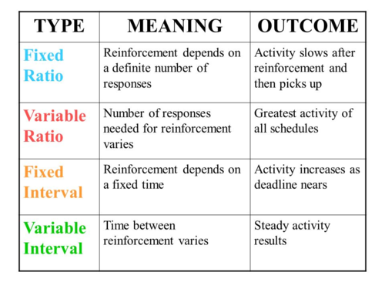
Consider what is meant by ratio and interval?
Skinner determined that the reward system
should be given intermittent and at variable
times, to achieve the best results (Gray and
Macblain, 2015).

(Igbonagwam, 2021)
Shaping
A further contribution made by Skinner, the idea of shaping behaviour, by using reinforcement in a step-by-step process (Li, 2021).

This video shows how Skinner engaged in a learned behaviour. Pigeon Turn https://www.youtube.com/watch?v=TtfQlkGwE2U (BF Skinner Foundation, 2009).

Critiques of His Work
His theory has been applied to varies ways in modifying behaviours, such as: phobias, addiction, in schools and clinics (Lesser, 2021).
Yet, over the years Skinner came into some heavy criticisms, Aubrey, and Riley (2019) suggests that many critics simply could not comprehend comparing animal behaviour to the complexity of human behaviour, with the use of our language and our memory.

What do you think about Skinner’s work? Is it something you have observed, or even used yourself?

Blog Link:
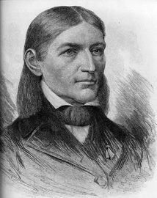
(Froebel Trust, 2020)
Froebel
An Early Years Educator and Thinker

Froebel was known as the founder of kindergarten; you and I, may know this better as a nursery school. Born in Germany in 1782, his mother passed away when he was only 9 months of age, this affected him greatly. Froebel lived through an unhappy childhood, and it effected the way he perceived those early years (Gray and Macblain, 2015). Although, through diversity, he became one of the most influential thinkers of his time, and developed a teaching methodology, that saved children from the repetitiveness of learning.
Friedrich Froebel (1782-1852)
- 1805 began teaching at a school in Frankfurt
- 1816 founded an Educational Institute
- 1826 published ‘The Education of Man’
- 1831 opened schools in Switzerland
- 1937 opened a new type of school, known by 1940 as a Kindergarten
- 1847 established seven kindergartens in Germany
- 1849 Froebelian training begins
(Pound, 2005)
Theory of Play
Froebel strongly believed that children should be allowed to express themselves with individual play, which I mentioned before that it was a complete contrast to how children had previously been taught, he suggested that ‘Play is the highest expression of human development in childhood, for it alone is the free expression of what is in a child's soul (Quoted in Murray, 2018, online).
Believing that children best learn through play and hands on experiences. He placed a great emphasis of the importance of nature and outdoors, believing space and light was essential to learning and forming an understanding of the world (Pound, 2005).
What are Froebelian Principles?
- Childhood is vital to life, it is not just about preparing for adulthood
- He considers the whole child
- Everything is connected, spirituality is found everywhere
- The child should be self-led and self-directed, by the knowledgeable educators
- Observations to inform planning
- Independence is vital
- Engagement with nature
- Used movement song rhythm and rhyme for learning experiences
- Relationships valued: community, parents, carers
- The importance of play
(Early Education, 2021)

Froebel also went on to develop educational tools that he used in his kindergarten; this became central to Froebelian practice. Based on his mathematical and scientific knowledge his designs were known as:

Gifts and Occupations

The Gifts were given in a structured way, The Occupations were given to allow
solid materials, such as, soft balls, wooden access to a wide range of media, such as,
blocks, cylinders, and cubes. Used for hands sewing, drawing, painting, and clay. This
to explore and help identify basic forms and allowed for endless possibilities for
relationships. children to explore (Bruce, 2011).

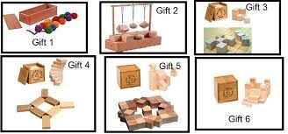

(Gill and Gaunt, 2015) (Create, 2016)

What Was the Role of the Teacher?
Froebel saw educators like gardeners, who tended to their plants (children) there to nurture, support and help to grow. Offering a warm, and engaging relationship and environment.
‘Let us learn from our children, let us attend to their knowledge which their lives greatly urge upon us and listen to the quiet demands of the hearts’ (Quoted in Tovey, 2020, p. 20).
Froebel’s Legacy
Although Froebel’s pedagogy has come from over 200 years ago! It still reinforces much of the provisions we have today, such as, sensory rich, natural, and open-ended resources. Likewise, observed in the most recent Donaldson’s curriculum:
- Strong links between home and school
- Educating the ‘whole child’
- Emphasis on outdoor learning
- Multi-sensory approach
- Integrated cross curriculum subjects
(Dauncey, 2015)

Unfortunately, Froebel did not live to see his concept ‘garden for children’ develop, because in 1851 Germany derived the ban of the kindergarten, and one year later he passed broken hearted. This, however, did not stop the passion and commitment of Froebel’s co-workers, who promoted his work and ideas internationally. Whereby, Froebelian training began in England in 1857 (LeBlanc, 2012).
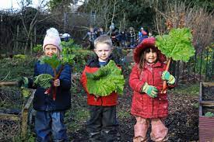
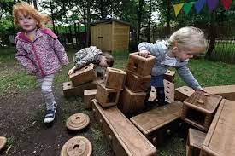
(Bruce and Dyke, 2017) (The Froebel’s Trust, 2020)

Criticism of Froebel’s Education
Some believed his gifts and occupations focused too much on fine motor skills, lacking the opportunity to develop gross motor skills. Personally, given the amount of time children were allowed to play outdoors, I believe there is plenty of opportunities to develop gross motor skills. Criticism also came in the way of his curriculum, that it needed to include more language, writing, and reading for those children who were academically ready (Spielgaben, 2013).
If we look at today’s early years education, do you think the right emphasis is placed on educating young minds?

Blog Link:
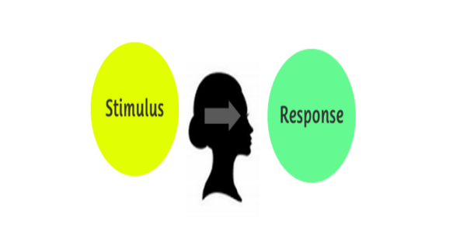
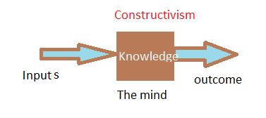
(Durrant, 2015) (Ejiumeano, n.d)
Behaviourism vs Constructivism
This blog will examine two theoretical approaches to learning: Behaviourism and Constructivism. With links to previous works of Skinner and his Operant Conditioning theory and Froebel’s, theory of play.
Definition of Behaviourism
‘Behaviourism, also known as behavioural psychology, is a theory of learning which states all behaviours are learned through interaction with the environment through a process called conditioning. Thus, behaviour is simply a response to environmental stimuli’ (McLeod, 2020, Online).
Where it All Started!!
The behaviourist movement began in 1913 with John Watson, he was best known as the father of behaviourism, after publishing the paper 'Psychology as the behaviourist views it.' He believed he could take any child, train them to be able to achieve any profession, regardless of their background. From then on, behaviourism developed rapidly through the early 20th century (Cherry, 2019).
In addition, to Watson there were many theorists that developed in the field of behaviourism, Pavlov, Skinner, and Thorndike to name a few.
Behaviourism
- Works on humans and animals
- Only observable behaviour to be considered
- Discount any mental activity
- Learner is passive
- Environment shapes behaviour (conditioning)
- Detailed in observation and scientific measurement
(George, 2019)
The Two Types of Conditioning
Classical conditioning was discovered by Ivan Pavlov, this process occurs through an association between an environmental stimulus and a previously natural occurring one (Cherry, 2019).
One of Pavlov’s most noted experiments conducted, was a study of the digestive system of dogs, he monitored their saliva glands when food was offered. To find out the results of this experiment and a detailed look at classical conditioning at work, take a look at this short video below:
Pavlov’s classic experiment with dogs (1897) https://www.youtube.com/watch?v=asmXyJaXBC8 (Flactemb, 2013).
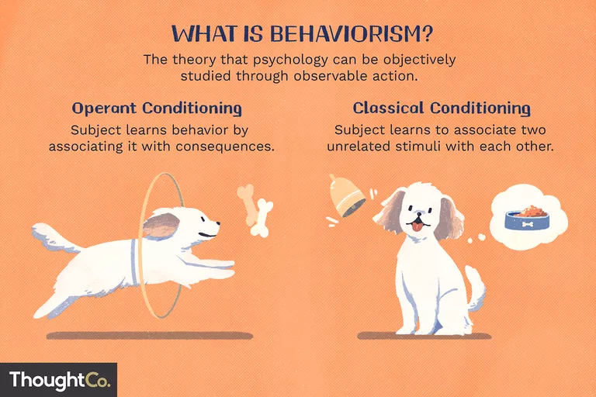
(Zheng, 2019)

As discussed in a previous blog, Operant Conditioning was the brainchild of Skinner. Whereby, the learning process is either strengthened or weakened by an association with a consequence, such as, positive, or negative reinforcement or punishment.
Two sides
The classroom uses rewards and sanctions regularly such as, certificates, praise, or time out. The rewards will only work if they are of high value, given at unexpected times, and rewarding all best efforts. Some critics believe that children that receive rewards frequently would lose interest in learning itself, they suggest it works best from low attaining or low motivated children (Pritchard, 2009).
Definition of Constructivism
‘Constructivism believes in personal construction of meaning by the learner through experience, and that meaning is influenced by the interaction of prior knowledge and new events’ (McLeod, 2019, online).
Key Ideas:
- Learning exists in the mind
- Learners are active
- Learners build on previous knowledge
- Learning is experienced based
- Motivation is vital
(Powell and Kalina, 2009)
Did Froebel Use a Constructivist Approach?
In Short, yes. Froebel was a very prominent figure in early years education, applying the constructivist approach to his theory, believing that children learn through forming meaning to their world, learning by doing, although unlike others, he did not get the recognition he deserved.
Prominent Figures in Constructivism
If you research cognitive constructivist approach, you will find theorists such as: J. Dewey (1933), J. Bruner (1990) and J. Piaget (1972). Let us have a closer look at one of those theories.
Bruner (1915-2016) coined the term ‘scaffolding’, which relates to the support children receive from a more experience other, e.g., teachers. Also identifying 3 stages of cognitive behaviour: the Enactive mode, babies using hands and actions to explore the world. The Iconic mode, learning visually, and the Symbolic mode, using language in learning (Aubrey and Riley, 2019).
The Classroom Approach
The teacher organises activities that promote individual learning, the pupil is required to solve the problem, this can be done with peers or alone. By engaging in these experiences, they construct their own understanding of what is being taught, allowing for a more child-centred classroom (Powell and Kalina, 2009).
Criticism
Although constructivism is viewed as more popular than behaviourism, linked to cognitive science, the work of academics was to solve problems regarding the mind and the brain (Pritchard, 2009). It has still come under some criticism. A constructive view is that all knowledge comes from personal discovery, but over the years critique has shown that this way of learning can lead to false information being learnt, and that direct instruction is a far more effective (Ferguson, 2017).
Which approach, do you believe to be the most useful in an early year’s classroom?

Putting Theory into Practice
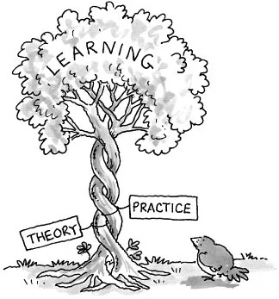

(McLean, 2013)
I hope you have enjoyed these blogs so far; I have looked at two theoretical approaches, behaviourism and constructivism and the theorists behind them.
This blog is to highlight these theories into practice. Let me begin first by mentioning I am a teaching assistant, working within a large nursery setting. I love my job, and with the help of these approaches it can make the children’s learning opportunities so much better. Let us start with Skinner and Operant conditioning, the reward, and sanction approach.
Positive Reinforcement
Now, Skinner strongly believed in using positive reinforcement over punishment (Pritchard, 2009). One of the items we use as a reward is stickers. While setting up this picture shown below, I immediately gained a crowd of several 4-year-olds eager to obtain one. Of course, I used this to my advantage, and suggested that I would be watching their tiding skills, and off they went in a hurry, keen to please. It just goes to show this reward, has high value especially for young children.

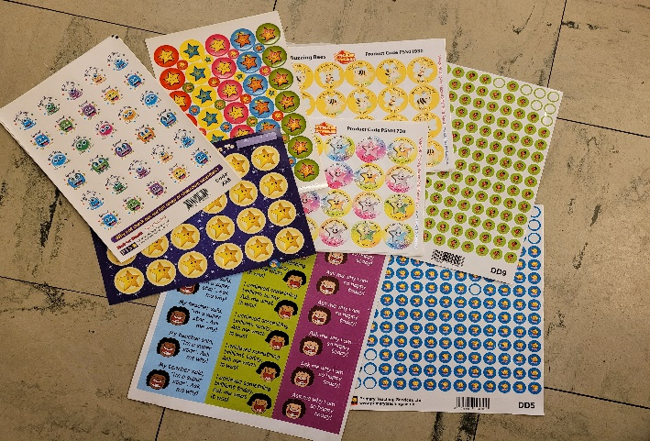
Other Rewards:
- Certificates
- Verbal praise
- Public praise
- Ticks or smiley faces
- Smiles
      - High fives

(Author’s Own, 2021)

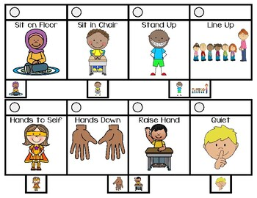
Positive Behaviours
These types of rewards are mostly used for behaviour management. Children can be rewarded for behaviours, such as, tidying, paying attention, treating others with respect, or sitting quietly. Skinner believed that this type of positive reinforcement has a longer lasting effect on behaviour than punishment (Pritchard, 2009). (HoppingAroundElementary, n.d)

It is important that young children are discouraged from certain behaviours, this is achieved by negative reinforcement, such as, ignoring the behaviour, or punishment. In my setting we use a ‘Thinking Chair’, usually used on children whose behaviours have been physically aggressive, e.g., pushing, pulling, or hitting. They are left to calm and reflect on their behaviour. We then discuss their actions and how they can put things right, e.g., apologising.

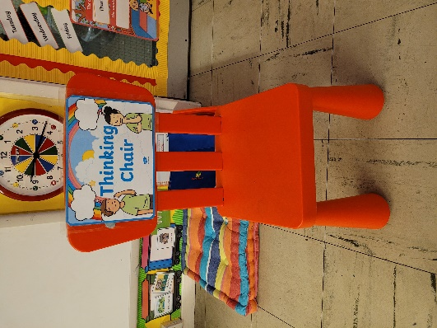
‘Thinking chair’
This only works if children have a good understanding of what is acceptable behaviour, this is promoted using a ‘Class Charter’, where all children have discussed to create a list to achieve the most out of school. Likewise, staff have a clear set of rules and regulations that are outlined in our policies and procedures, e.g., behaviour management policy.

(Author's Own, 2021)

How is Froebel’s theory used within my practice?
Central to Froebel’s philosophy is his commitment to play. Play is crucial for the early development of childhood skills: how to communicate, work with others, be creative, and problem solve. These opportunities are created by teachers design for age-appropriate learning. This can be seen throughout my setting with access to many multi-sensory, hands-on activities, such as, play dough, construction, and role play areas (Sally, 2016).

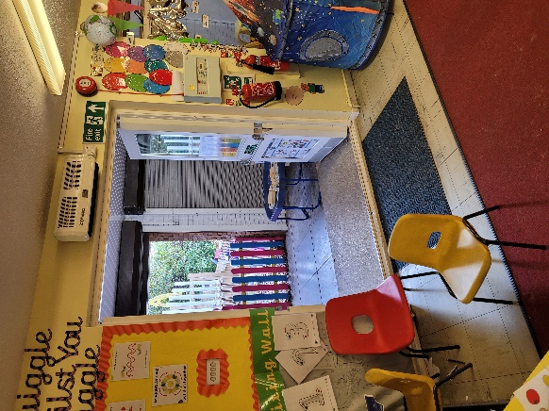
Free Flow
Like Froebel’s idea that everything should be connected. As a setting we allow for continuous free flow between indoors and outdoors. Doors are always open whatever the weather, children have constant access to outside and nature. To explore with freedom, movement, and autonomy.

(Author’s Own, 2021)

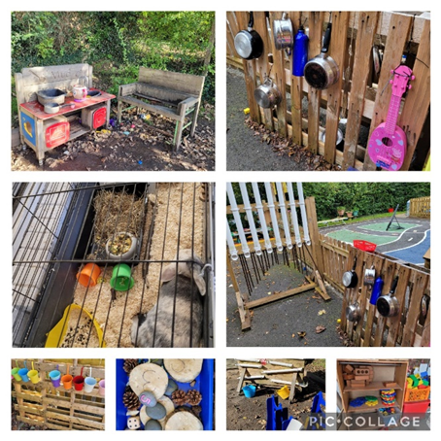
Outdoor Learning Opportunities:
- Mud kitchen
- Music area
- Water/sand play
- Math’s area
- Construction
- Gardening and planting
- Looking after our pet rabbit
- Bikes/climbing frame

(Author’s Own, 2021)

Like Froebel’s gifts and occupations, we support, block play, construction inside and out, and plenty of occupations in the terms of painting, crafts, sand, and water play.
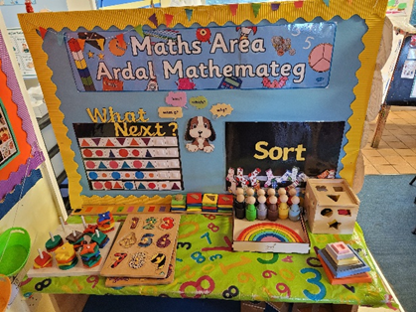 (Author’s Own, 2021) 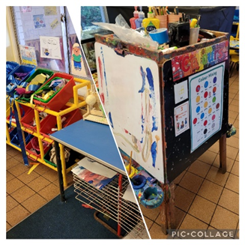
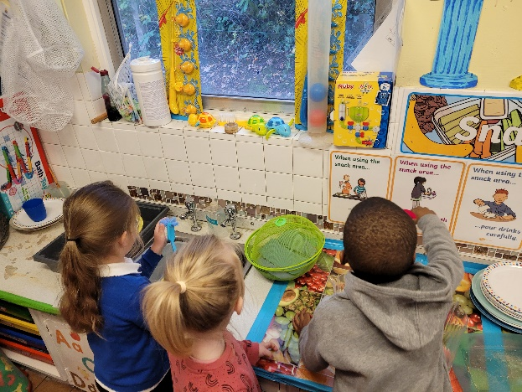
Creating Independence
We encourage independence, with all play and learning. We use ‘One Before Me’, basically, ask a friend for help, before asking an adult. We provide an independent snack station, collecting their own snack and drink, once finished they are to wash their own dishes.

Other Links to Froebel’s Theory
Songs and rhymes are an integral part of our routine, but can also play a more structured part, e.g., Pori Drwy, a programme aimed to support literacy, numeracy, speaking, and listening skills.
Observations are done daily and written in the ‘catch the learner.’ Things that children have excelled at or struggled with; this can be reflected when planning for next activities.
Good relationships with parents and carers are strongly emphasised upon, whereby we have an open-door policy, and you can reach us through, phone or email.
As you can see both theories are profoundly used within an early year setting, in your opinion is there better use of these approaches?

References

Aubrey, K. and Riley, A. (2019) Understanding and Using Educational Theories. Ed. 2. London: SAGE Publications Ltd.

BF Skinner Foundation (2009) Pigeon Turn [Video]. Available at: https://www.youtube.com/watch?v=TtfQlkGwE2U (Accessed: 9th October 2021).
Create, B. (2016) Child hands of a potter [Image]. Available at: https://www.breckcreate.org/event/introduction-clay-kids-lindsay-landers/child-hands-of-a-potter/ (Accessed: 23rd October 2021).

Extra Credits (2012) The Skinner Box-How Games Conditioned People to Play More [video]. Available at: https://www.youtube.com/watch?v=tWtvrPTbQ_c (Accessed: 3rd October 2021).

Gray, C. and Macblain, S. (2015) Leaning Theories in Childhood. Ed. 2. London: SAGE Publications Ltd.

Igbonagwam, C. (2021) AAMC 2 PSY [Image]. Available at: https://quizlet.com/471967710/aamc-2-psy-flash-cards/ (Accessed: 9th October).

Kim, J. (2014) The Compulsion Loop in Game Design Explained [Illustration]. Available at: https://gamemakers.com/the-compulsion-loop-explained/ (Accessed: 4th October).

Lesser, B. (2021) The Concept and Principles of Behavioural Modification. Available at: https://dualdiagnosis.org/treatment-therapies-for-dual-diagnosis-patients/behavioral-modification (Accessed: 10th October).

Li, P. (2021) What is Shaping (Psychology). Available at: https://www.parentingforbrain.com/shaping-psychology/ (Accessed: 10th October).

McLeod, S. (2018) What Is Operant Conditioning and How Does It Work? Available at: https://www.simplypsychology.org/operant-conditioning.html (Accessed: 10th October).

Mclean, C. (2013) Putting Theory into Practice [Illustration]. Available at: https://christinemclean10.wordpress.com/2013/08/25/putting-theory-into-practice/ (Accessed: 26th October 2021).

Pietrangelo, A. (2020) What Is Positive Punishment? Available at: https://www.healthline.com/health/positive-punishment (Accessed: 10th October).

Pound, L. (2005) How children learn. Leamington Spa: Step Forward Publishing Limited.
Pritchard, A. (2009) Ways of Learning. 2nd Ed. Routledge: Oxon.
Rhodes, E. (2016) Opening Skinner’s Box [Illustration]. Available at: https://thepsychologist.bps.org.uk/volume-29/may-2016/opening-skinners-box (Accessed 4th October).

Tyonote (2021) Reinforcement in Operant Conditioning: Definition, 6 Types (Explained) [illustration]. Available at: https://tyonote.com/reinforcement_in_operant_conditioning/
Gill, C and Gaunt, J. (2015) Froebel’s Gifts [Image]. Available at: http://www.edubuzz.org/makingmathsmatter/wp-content/blogs.dir/2337/files/2015/03/Block-Play-with-photos-final-01-Apr-20151.pdf (Accessed: 16th October 2021).
Murray, J. (2018) ‘Value/s in early childhood education’, International Journal of Early Years Education, 26(3), pp. 215-219. Available at: https://doi.org/10.1080/09669760.2018.1490849 (Accessed: 18th October 2021).
Early Education (2021) Friedrich Froebel. Available at: https://www.early-education.org.uk/about-froebel (Accessed: 17th October 2021).
Bruce, T. (2011) EYFS Best Practice: All about ... Friedrich Froebel. Available at: https://www.nurseryworld.co.uk/features/article/eyfs-best-practice-all-about-friedrich-froebel (Accessed: 17th October 2021).
LeBlanc, M. (2012) Friedrich Froebel. Available at: https://www.communityplaythings.co.uk/learning-library/articles/friedrich-froebel (Accessed: 23rd October 2021).
Bruce, T. and Dyke, J. (2017) EYFS Best Practice - Learning from Froebel… Intrinsic motivation [Photo]. Available at: https://www.nurseryworld.co.uk/category/practice-guides/learning-from-froebel (Accessed: 23rd October 2021).
The Froebel’s Trust (2020) [Facebook] [Photo] 10th December. Available at: https://www.facebook.com/pg/thefroebeltrust/photos/ (Accessed: 23rd October 2021).
Spielgaben. (2013) 4 Fundamental Technics To Transform Your Child’s Play [blog]. 5th October. Available at: https://spielgaben.com/comparison-froebel-montessori-reggio-waldorf-part-1/ (Accessed: 24th October 2021).

Dauncey, M. (2015) Donaldson Review: The ‘purposes’ and content of a Curriculum for Wales. Available at: https://research.senedd.wales/research-articles/donaldson-review-the-purposes-and-content-of-a-curriculum-for-wales/ (Accessed: 23rd October 2021).
Tovey, H. (2020) Froebel’s principles and practice today. Available at: https://www.froebel.org.uk/uploads/documents/FT-Froebels-principles-and-practice-today.pdf (Accessed: 24th October 2021).

Flactemb (2013) Pavlov’s Dogs [Video]. Available at: https://www.youtube.com/watch?v=asmXyJaXBC8 (Accessed: 23rd October 2021).

Durrant, B. (2015) Behaviourism [Image]. Available at: http://315631605254846606.weebly.com/behaviourism (Accessed: 24th October 2021).
Ejiumeano (n.d) Constructivism [Image]. Available at: https://sites.google.com/site/ejiumeano/constructivism (Accessed: 24th October 2021).
McLeod, S. (2020) Behaviourist Approach. Available at: https://www.simplypsychology.org/behaviorism.html (Accessed: 25th October 2021).
George, G. (2019) Behaviourism. Available at: https://plato.stanford.edu/archives/spr2019/entries/behaviorism/ (Accessed: 27th October 2021).
McLeod, S. (2019) Constructivism as a theory for teaching and learning. Available at: https://www.simplypsychology.org/constructivism.html (Accessed: 27th October 2021).
Zheng, R. (2019) What Is Behaviourism in Psychology? [illustration] Available at: https://www.thoughtco.com/behaviorism-in-psychology-4171770 (Accessed: 26th October 2021).
Cherry, K. (2019) What Is Classical Conditioning? Available at: https://www.verywellmind.com/classical-conditioning-2794859 (Accessed: 26th October 2021).

Udacity (2015) Skinner box - Intro to Psychology [Video]. Available at: https://www.youtube.com/watch?v=bDWwXdYWqGk (Accessed: 9th October 2021).
Froebel Trust (2020) About Friedrich Froebel, who invented “kindergarten” [illustration]. Available at: https://www.froebel.org.uk/about-friedrich-froebel (Accessed: 29th October 2021).
HoppingAroundElementary (n.d) Behaviour Visual Cue Cards [Image]. Available at: https://www.teacherspayteachers.com/Product/Behavior-Visual-Cue-Cards-4838638 (Accessed: 29th October 2021).

Sally, K. (2017) Following in Froebel’s footsteps. Available: https://www.earlyyearseducator.co.uk/features/article/following-in-froebel-s-footsteps (Accessed: 6th November 2021).
Ferguson, C. (2017) Critique of Constructivism. Available at: https://www.youtube.com/watch?v=39ZynAt6c9Q (Accessed: 6th November 2021).

Powell, K. and Kalina, C. (2009) Cognitive and Social Constructivism: Developing Tools for an Effective Classroom. Available at: https://www.researchgate.net/publication/234717752_Cognitive_and_Social_ConstructivismDeveloping_Tools_for_an_Effective_Classroom (Accessed: 6th November 2021).

