

Student name: ALIA ASHRAFI
Student ID:1916229
Programme: BSc Health and Social Care
Module name: Community Care and Development
Module code: BMHP6022
Lecturer name: LAILA SURANI
Assignment Title: Assessment Component 2 Written Assignment (Report)
Word count (or equivalent): 2000 words

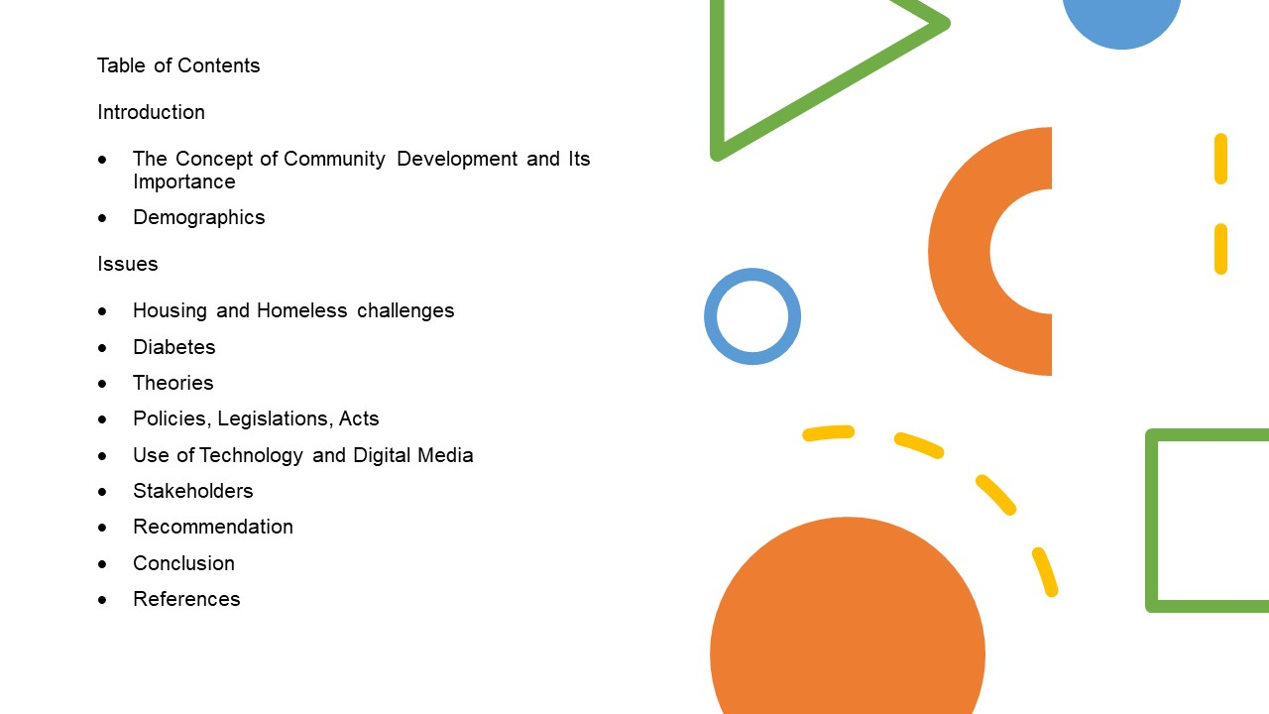

(Figure: 1, sourced from Google Images)
Introduction
The Concept of Community Development and Its Importance
Community development is an intriguing concept. Community development has often been recommended as a popular method of increasing community members' social, economic, and environmental quality of life. (Theodori, 2005) Community engagement promotes health, happiness, wealth, fairness, and opportunity for everyone. It acknowledges that certain individuals, organisations, and communities are marginalised and oppressed due to how society and its systems are set up and ensure justice for all residents by challenging this via community development. (SCDC, 2019 Being a member of a common environment, whether real or virtual, allows individuals to be inspired, solve issues, exchange humour, vent frustrations, and celebrate their accomplishments. People who remain in a community sincerely agree with its principles and share ideas, trust and togetherness. (Clarabut, 2020)
This report identifies The London Borough of Tower Hamlets with two main issues.
- Local housing and Homeless challenges, including a lack of affordable housing and council homes.
- Diabetes. There are increased rates of diabetes, notably among some of the Bangladeshi ethnicity

The report will Critically examine and evaluate techniques and innovations for increasing awareness and influencing positive change. This report will incorporate theory, policy, and practice at every turn and offer suggestions for how these should be modified to fit a more digital environment; then, a summary and conclusion will summarise the report.

Demographics
The London Borough of Tower Hamlets is a part of the city of London that includes a lot of the traditional East End. Tower Hamlets is in East London. It is north of the Thames River. (Tower Hamlets council, 2020) The borough went from 17 to 20 wards in May 2014. The Local Government Boundary Commission for England made the revisions so that every Tower Hamlets councillor represented nearly the same number of inhabitants.
Tower Hamlets' 20 new wards have profiles. They provide sociodemographic features of each place. (Tower Hamlets council, 2020)

Figure: 2, information sourced from (Office for National Statistics, 2021) (Office for National Statistics, 2022) (Tower Hamlets Council, 2018) (Tower Hamlets Council, 2020)
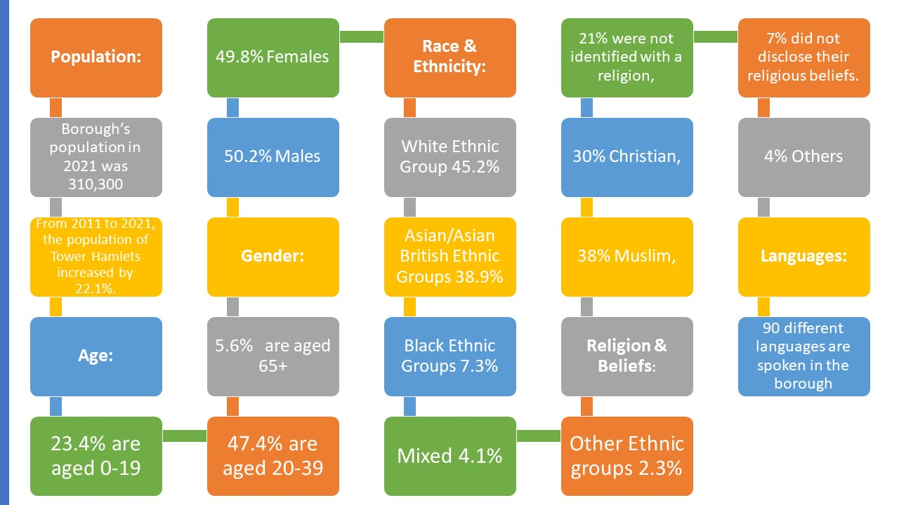

Tower Hamlets' population has more than doubled in the last thirty years, making it the UK's fastest-growing local government and the country's second most densely inhabited borough, behind Islington. Tower Hamlets contains one of the UK's younger, largest growing, and most diversified populations. The population density of Tower Hamlets is now 16,237 people per square kilometre. By 2027, the population is expected to reach 365,200. (Tower Hamlets council, 2020) Tower Hamlets has a youthful population. This is the only local council region with less than 6% of the population (5.6%) over 65.
The Bangladeshi, White British, and 'Other White' populations comprise the borough's three major groupings. People from these three ethnic groups account for almost three-quarters of the Tower Hamlets population. Tower Hamlets is the fourth most linguistically varied location in England and Wales, with at least 90 languages spoken in the borough, according to the Census. (Office for National Statistics, 2021) (Office for National Statistics, 2022) (Tower Hamlets Council, 2018) (Tower Hamlets Council, 2020)

Issues

- Housing and Homeless challenges
The London borough of Tower Hamlets is facing housing challenges, a big worry for people and a top priority for Tower Hamlets Council. With one of London's fastest-growing boroughs, it's hard for many people to find a cheap, safe place to live because private rents are rising, and there need to be more cheap houses. (Tower Hamlets Council, 2021) Despite the fact that Tower Hamlets has created more affordable houses than any other borough in the last five years, there are still 21,480 families on the waiting list, which considerably outnumbers the supply. After Newham and Lambeth, this is the third-longest waiting list in London. Low-income young adults and families struggle to rent or buy quality homes. Overcrowding, evictions, and homelessness are rising. (Peach, 2022) According to figures published by the Office for National Statistics, Tower Hamlets had the highest number of homeless fatalities among all London boroughs in 2021. According to the statistics, there were 12 documented homeless fatalities in Tower Hamlets in 2021, which is 5 higher than the previous year. According to Combined Homelessness and Information Network data, the borough has one of the highest rates of homelessness in London, and the number of rough sleepers has been steadily increasing over the previous several years. (Hasan, 2022) (Combined Homelessness and Information Network (CHAIN), 2022)

Figure: 3, information sourced from (Hasan, 2022) (Combined Homelessness and Information Network (CHAIN), 2022)

Over the past few decades, London has proven to be an industry leader in creating jobs and opportunities. However, at the same time, they have not successfully constructed the houses they need. Now, a whole generation of Londoners cannot pay their rent. As a result, many are compelled to live in situations that are either overcrowded or otherwise unpleasant. (Greater London Authority, 2022)

Theory: Maslow’s Hierarchy needs
The author of Maslow's Hierarchy of Needs explains how people progress to reach their full potential and thrive. Abraham Maslow, a psychologist, proposed the concept of a Hierarchy of Needs in 1943. The first level addresses physiological necessities, which homeless individuals concentrate on daily merely to live. The hierarchy of needs may assist communities in comprehending how to get out of a crisis. Everyone needs assistance from time to time, and thoroughly considering his thesis offers a notion of the kind of assistance individuals may require should they become homeless and strive for more independence. (Selva, 2019)

Figure: 4 sourced from (Selva, 2019)
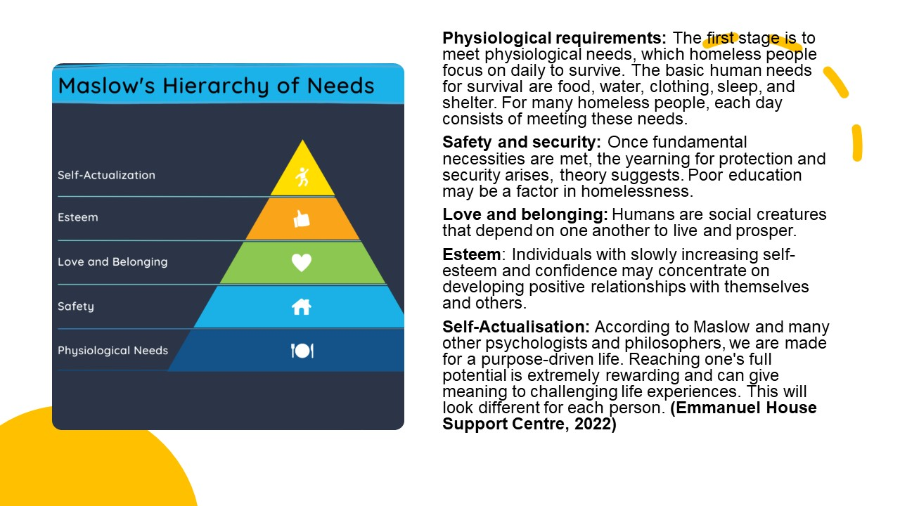

Policy and legislation and Strategies

Housing Act 2004
Housing and Planning Act 2016
Equality Act 2010
Tower Hamlets Council Strategy plan 2022-2026

The United Kingdom is in the grip of a housing crisis. There are not enough construction plans for houses to fulfil demand. Thus, at least 340,000 homes must be built annually, with at least 150,000 being high-quality social rented homes. (UNISON, 2019)
Since 2015, neither the leadership nor any of the opposition parties have parties had an adequate approach to solving the housing crisis, which was most dramatically exemplified by Starter Homes. To the extent that action has been done, it has been, at best ineffective and, at worst detrimental. The only change that has happened is that affordability has worsened, and it has worsened the most in areas where people want to stay. There are just not enough cheap housing units for everyone. Consequently, there is a dearth of affordable housing, which has driven up prices and decreased the number of people who can buy a home; as a result, there are presently more than four million families in the private renting sector in England. Many renters cannot save for a down payment or get a mortgage due to high rents, preventing them from qualifying for a mortgage at a reduced interest rate. (Cheshire and Hilber, 2019)

The following are some of the causes of the housing crisis.
- Construction costs have risen.
- Land shortage in cities
- Migration to metropolitan areas
- A limitation of low-cost housing
- Population expansion (Ali, 2022)

Involving Technology and Digital/social media
Housing accounts for 53% of all repair and maintenance work by value, and the NHBC pays £85 million each year to correct flaws in new construction houses. Significant value might be realised by increasing digital technology and combining BIM and OSM. Using BIM designs to produce housing components or whole modular units will aid in producing higher-quality housing at a quicker pace. Building Information and Offsite Manufacturing (BIM), for example, should be included in the package of steps to address the housing issue.

- Diabetes
Diabetes creates high blood sugar.
Types of diabetes:
The immune system destroys insulin-producing cells in type 1 diabetes. Type 2 diabetes occurs when the body doesn't produce enough insulin or its cells don't react to it. Type 2 diabetes is more common. 90% of Brits have type 2 diabetes. (NHS, 2019) Thousands of people in the UK live much longer; however, they also demand greater support and attention from health and social care agencies. Tower Hamlets residents suffer certain health issues, including high early mortality rates from cardiovascular illness, cancer, and respiratory disease. (Tower Hamlets Together, 2022) In the London Borough of Tower Hamlets, Diabetes prevalence is high, especially among Bangladeshi people. Tower Hamlets has the third-highest incidence of type 2 diabetes in London, with roughly 17,000 persons diagnosed. This is due, in particular, to the huge Bangladeshi minority at a higher risk of getting the illness than another ethnicity. (East London NHS Foundation Trust, 2022) Bangladeshis are a major ethnic group in the United Kingdom, with a high incidence of Type 2 diabetes mellitus. Only 26% of males in Bangladesh and 11% of women in Bangladesh reach the recommended levels of physical exercise. Culture may influence not just the desire to engage in diabetes prevention. However, it may also confound knowledge of diabetes. (Choudhury, Furbish and Chowdhury, 2016) Diabetes and heart disease have no identified causes. Some health differences are already known to be the result of a combination of factors, including genetic variation, socioeconomic differences (involving poverty, nourishment, and poor housing), and social and cultural beliefs and lifestyle practise (e.g., diet/food habits, exercise, and treatment-seeking behaviour).

Figure: 5 (Reza and Heel, 2014)

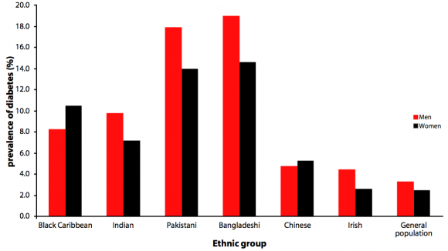

Theory: Albert Bandura's theory of social learning
Albert Bandura's social learning theory stresses the necessity of monitoring, learning, and imitating the behaviours, attitudes, and emotional responses of others. According to social learning theory, environmental and cognitive variables interact to impact human learning and behaviour. Albert Bandura (1977) concurs with the behaviourist learning theories of classical and operant conditioning in social learning theory. (McLeod, 2016)

Figure: 6, (McLeod, 2016)
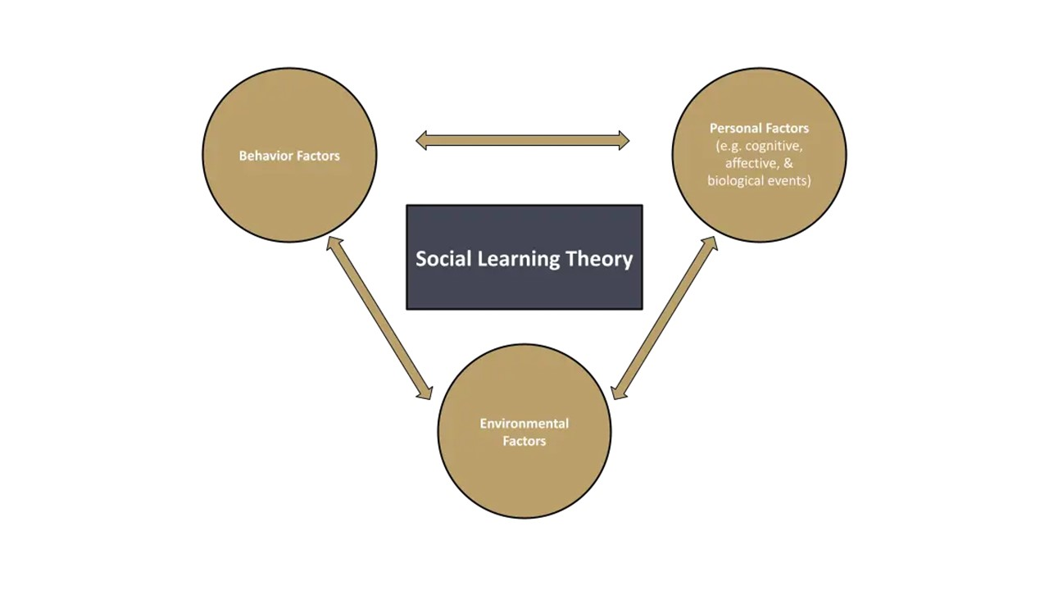
According to this social learning theory, individuals learn behaviours through observing others and mirroring their activities, affected by their environment. Most eating habits and physical activity are learned behaviours that individuals adopt in their homes and workplaces. Diabetes may be controlled if influential environmental variables model and promote physical activity and appropriate eating habits.

Policy and legislation and Strategies
Health Act 2006
Health and Care Act 2022
Equality Act 2010
Health matters: preventing Type 2 Diabetes
NHS Diabetes Prevention Programme
Some significant work is being done in the UK for diabetes prevention. Public Health England and the NHS are working hard. The NHS Diabetes Prevention Programme, Healthier You, identifies individuals at risk of developing type 2 diabetes and sends them to a nine-month, evidence-based lifestyle modification programme. It is a collaboration between NHS England and Diabetes UK. People who participate in face-to-face group sessions get personalised assistance to help them control their weight, eat healthier, and be more physically active. The digital service provides comparable assistance via wearable technology that tracks physical activity and weight levels. (NHS England, 2019)
Using Technology and digital/social media
Digital media/social networks: Media platforms such as Facebook, Instagram, Twitter, YouTube, websites, and blogs may play an important role in reaching a broad audience, exchanging information, increasing communications, raising awareness, educating, and connecting communities. (Huang et al., 2019)
Involving Stakeholders in the project (For both issues)
Members of the household
Additional familial members
Government and the private sector
Academy
Social Mobilisation
Major religious organisations
Municipal government/council
Schools and educational establishments
Charitable organizations
Health care Professionals

Recommendations
People become homeless for a variety of reasons. Homelessness has socioeconomic reasons, such as a lack of cheap housing, poverty, unemployment, and personal circumstances that lead individuals into homelessness. Many individuals become homeless because they are unable to pay their rent. On the other hand, homelessness is almost always avoidable and can always be terminated. Diabetes may also be avoided or delayed by proven, doable lifestyle modifications, such as decreasing a small amount of weight and increasing physical activity, even if you are at high risk. (Crisis UK, 2022)
- The borough's residents are being educated.
- Spreading awareness
- Raising awareness via digital media campaigns
- Basic health care provision
- Empowerment of the Community
- Improving one's diet or eating habits
- Strengthen your family and community.
- Local religious organisations may participate in charitable activities to raise awareness, regardless of family connection or history.
- The government may propose changes to tax and housing laws.

Conclusion

Stable housing may be linked to fewer cases or occurrences of several health problems and better care for them in many ways. Housing stability is a key social factor that affects health. It is related to housing quality and neighbourhood effects but is different in how it affects health. Having a safe, stable place to live and sleep can give you a sense of control and consistency. This stability could make it easier for people to stick to their routines and lessen the number of changes in their lives. This could make it easier to deal with chronic diseases and lead to better health outcomes. (Lim et al., 2020) When there is a housing crisis or someone is homeless, they are more likely to have health problems, and their development can be hurt. People who are homeless have a much higher chance of dying from many things than the rest of the population. As a result, community development is important, and it encourages communities of place and identity to use their assets to improve their community’s quality of life. Assists communities and government agencies in collaborating to improve services and decision-making processes.

Reference list
Ali, M. (2022). Housing Shortage: What Causes It & What Are Its Effects? [online] A blog about real estate, lifestyle and tourism in Pakistan | Zameen Blog. Available at: https://www.zameen.com/blog/housing-shortage-reasons-effects.html [Accessed 16 Dec. 2022].
Cheshire, P. and Hilber, C. (2019). The UK’s housing crisis: what should the next government do? [online] British Politics and Policy at LSE. Available at: https://blogs.lse.ac.uk/politicsandpolicy/housing-crisis-what-should-the-next-government-do/ [Accessed 16 Dec. 2022].
Choudhury, S.R., Furbish, A. and Chowdhury, T.A. (2016). Prevention of diabetes in Bangladeshis in East London: experiences and views of young people. Journal of Translational Internal Medicine, 4(2), pp.88–93. doi:10.1515/jtim-2016-0021.
Clarabut, J. (2020). The Importance of Community. [online] Wellbeing People. Available at: https://www.wellbeingpeople.com/2020/07/23/the-importance-of-an-engaging-community/#:~:text=Being%20part%20of%20an%20engaging [Accessed 14 Dec. 2022].
Combined Homelessness and Information Network (CHAIN) (2022). Rough sleeping in London (CHAIN reports) – London Datastore. [online] London.gov.uk. Available at: https://data.london.gov.uk/dataset/chain-reports [Accessed 16 Dec. 2022].
Crisis UK (2022). About Homelessness | Crisis UK. [online] Crisis. Available at: https://www.crisis.org.uk/ending-homelessness/about-homelessness/#:~:text=Being%20homeless%20can%2C%20in%20turn [Accessed 16 Dec. 2022].
East London NHS Foundation Trust (2022). ELFT. [online] gpextranet.elft.nhs.uk. Available at: https://gpextranet.elft.nhs.uk/tower-hamlets-recovery-college/event/Understanding-Diabetes-/1910 [Accessed 15 Dec. 2022].
Emmanuel House Support Centre (2022). Maslow’s Hierarchy of Needs. [online] Emmanuel House Support Centre. Available at: https://www.emmanuelhouse.org.uk/maslows-hierarchy-of-needs/ [Accessed 16 Dec. 2022].
Forgeard, V. (2021). Why Is Community Development Important in Nation Building - brilliantio. [online] brilliantio.com. Available at: https://brilliantio.com/why-is-community-development-important-in-nation-building/ [Accessed 14 Dec. 2022].
Greater London Authority (2022). Tackling London’s housing crisis | LGOV. [online] www.london.gov.uk. Available at: https://www.london.gov.uk/programmes-strategies/housing-and-land/tackling-londons-housing-crisis [Accessed 15 Dec. 2022].
Hasan, A. (2022). Tower Hamlets had highest number of death of homeless people in London last year – Eastlondonlines. [online] www.eastlondonlines.co.uk. Available at: https://www.eastlondonlines.co.uk/2022/12/tower-hamlets-had-highest-number-of-death-of-homeless-people-in-london-last-year/ [Accessed 16 Dec. 2022].
Huang, L., Clarke, A., Heldsinger, N. and Tian, W. (2019). The communication role of social media in social marketing: a study of the community sustainability knowledge dissemination on LinkedIn and Twitter. Journal of Marketing Analytics, 7(2), pp.64–75. doi:10.1057/s41270-019-00053-8.
Lim, S., Liu, S.Y. (Sam), Jacobson, M.H., Poirot, E., Crossa, A., Locke, S., Brite, J., Hamby, E., Bailey, Z. and Farquhar, S. (2020). Housing stability and diabetes among people living in New York city public housing. SSM - Population Health, 11(1), p.100605. doi:10.1016/j.ssmph.2020.100605.
McLeod, S. (2016). Albert Bandura’s social learning theory. [online] Simply Psychology. Available at: https://www.simplypsychology.org/bandura.html [Accessed 16 Dec. 2022].
NHS (2019). Diabetes. [online] NHS. Available at: https://www.nhs.uk/conditions/diabetes/ [Accessed 16 Dec. 2022].
NHS England (2019). NHS Diabetes Prevention Programme (NHS DPP). [online] England.nhs.uk. Available at: https://www.england.nhs.uk/diabetes/diabetes-prevention/ [Accessed 16 Dec. 2022].
Office for National Statistics (2021). How the population changed in Tower Hamlets, Census 2021 - ONS. [online] www.ons.gov.uk. Available at: https://www.ons.gov.uk/visualisations/censuspopulationchange/E09000030/ [Accessed 24 Nov. 2022].
Office for National Statistics (2022). Population and household estimates, England and Wales - Office for National Statistics. [online] www.ons.gov.uk. Available at: https://www.ons.gov.uk/peoplepopulationandcommunity/populationandmigration/populationestimates/bulletins/populationandhouseholdestimatesenglandandwales/census2021unroundeddata [Accessed 26 Nov. 2022].
Peach, N. (2022). UK census: Tower Hamlets has the worst child poverty rates in the UK. [online] City Monitor. Available at: https://citymonitor.ai/economy/poverty/uk-census-tower-hamlets-has-the-worst-child-poverty-rates-in-the-uk [Accessed 15 Dec. 2022].
Reza, J.N. and Heel, D. van (2014). Diabetes and heart disease in Bangladeshis and Pakistanis | East London Genes & Health. [online] Genesandhealth.org. Available at: https://www.genesandhealth.org/genes-your-health/diabetes-and-heart-disease-bangladeshis-and-pakistanis [Accessed 16 Dec. 2022].
SCDC (2019). SCDC - We believe communities matter. [online] SCDC - We believe communities matter. Available at: https://www.scdc.org.uk/who/what-is-community-development [Accessed 14 Dec. 2022].
Selva, J. (2019). Abraham Maslow, His Theory & Contribution to Psychology [Upd. 2019]. [online] PositivePsychology.com. Available at: https://positivepsychology.com/abraham-maslow/ [Accessed 16 Dec. 2022].
Theodori, G.L. (2005). Community and Community Development in Resource-Based Areas: Operational Definitions Rooted in an Interactional Perspective. Society & Natural Resources, 18(7), pp.661–669. doi:10.1080/08941920590959640.
Tower Hamlets Council (2018). Population Estimates Mid 2017 for Tower Hamlets. [online] Towerhamlets.gov.uk. Available at: https://www.towerhamlets.gov.uk/lgnl/community_and_living/borough_statistics/population.aspx [Accessed 15 Dec. 2022].
Tower Hamlets Council (2020). Borough profile. [online] Towerhamlets.gov.uk. Available at: https://www.towerhamlets.gov.uk/lgnl/community_and_living/borough_statistics/Borough_profile.aspx [Accessed 25 Nov. 2022].
Tower Hamlets Council (2021). Tower Hamlets launches Intermediate Housing Register giving residents first selection on new homes. [online] www.towerhamlets.gov.uk. Available at: https://www.towerhamlets.gov.uk/News_events/2021/October-2021/Tower-Hamlets-launches-Intermediate-Housing-Register-giving-residents-first-selection-on-new-homes.aspx [Accessed 15 Dec. 2022].
Tower Hamlets Council (2022). Tower Hamlets Council Strategic Plan. [online] https://www.towerhamlets.gov.uk. Available at: https://www.towerhamlets.gov.uk/Documents/Strategy-and-performance/Tower-Hamlets-Council-Strategic-Plan-2022-2026.pdf.
Tower Hamlets council (2020). Borough profile. [online] Towerhamlets.gov.uk. Available at: https://www.towerhamlets.gov.uk/lgnl/community_and_living/borough_statistics/Borough_profile.aspx [Accessed 14 Dec. 2022].
Tower Hamlets Together (2022). The Challenge. [online] www.towerhamletstogether.com. Available at: https://www.towerhamletstogether.com/the-challenge [Accessed 16 Dec. 2022].
UNISON (2019). UNISON. [online] UNISON National. Available at: https://www.unison.org.uk/at-work/community/key-issues/housing/ [Accessed 16 Dec. 2022].

