

Module: |  | Developing Innovation and Creativity for Business Advantage
Module code: | BMSW6102 | Contribution to Overall Module Assessment (%): | 100%
Lecturer(s) | Charles Nwaogwugwu | Internal Verifier: | Md Kalam
Assignment Title: | Individual Report on:  Development of innovative product OR unique service proposition | Word count
Submission deadline:  Student name: | 27/04/2023  Radu Elena Alexandra | Student Id: | 1921326

Table of Contents
Introduction 3
Part A 4
Unique and innovative product idea 4
Product Ideation 4
Target customer 5
The product availability in the market 5
Name of the organization 6
Sustaining business by innovative proposition 6
Competitor analysis 6
Part B 8
E-Commerce System Development 8
Software as a service 8
Marketplace 8
Content creation system 8
Payment services 9
PCI-DSS compliance system 9
Encryption of data and Firewall 10
Password protection and upgrade system usage 10
Part C 12
Marketing of Elite Reflections 12
Target customer 12
Positioning 13
Promotional strategies by social media 13
Social media marketing 14
Search engine usage and Email marketing 15
Understanding of the role of the customer journey 16
Part D 17
Data protection act 2018 17
Privacy and Electronic communication regulations 17
Security issue 17
Conclusion 19
References 20

Introduction
Nowadays, the life of an individual is very tough as the coronavirus has impacted the market greatly. Economic recession and other social issues are happening in the whole world as well as social distancing is making the charge of every product the highest level. The demand of people is increasing but based on that product is not prepared properly. In this market, a smart mirror can be made by which business people can get lots of solutions as well as women can get lots of solutions like home automation and finally young people will get their entertainment needs by a single device. The product idea is unique and it will have a lower amount of competitors in the market so this will be brought by Elite Reflections and the customers' acceptance level will be increased in this market automatically. This will make massive changes in the lifestyle of human beings and based on the current economic situation Elite Reflection will try to charge the pricing strategy. So, the report will be presented based on how the venture will retain the privacy of its customers as well as how the organization will do its marketing strategy successfully in the market to provide the product to the market.

Part A

Unique and innovative product idea

Product Ideation
Smart Mirror will be the new product that will be promoted to a target market. People may have a variety of unique products like mobile phones, laptop but smart mirror or devices can be connected to every smart device and can be controlled by a human beings (Årdal et al., 2020). Besides, voice-activated control will be uploaded in a smart mirror as well alighting system will be developed as well temperature-controlling system can be connected. Besides, Bluetooth connectivity will help to connect with different music devices and then everyone will enjoy the quality program. Besides, it will have a touchscreen interface, as well as it, will have unique customized settings. Besides, it will have a connection with virtual assistants like Amazon Alexa as well as with Google Assistant which will help users to get information as per their needs. It will be connected with speakers to provide proper voice to users. Apart from these, unique qualities will be included in the smart mirror to get the attention of the target customers and then it will achieve the competitive advantages that will boost their profitability rate.
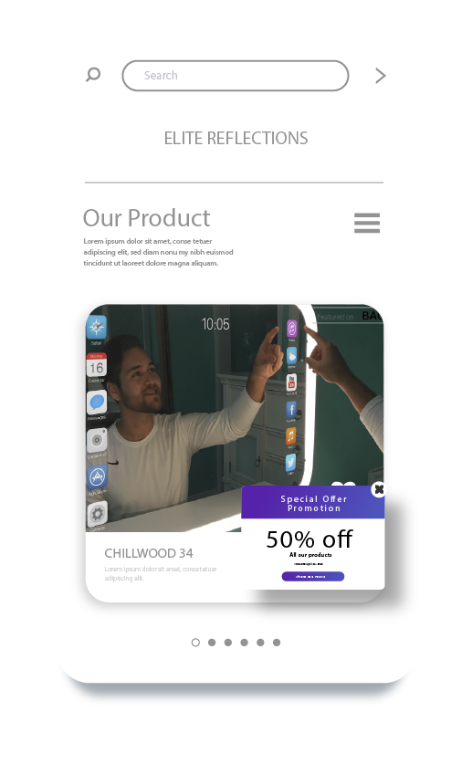

Target customer
The target customer of smart mirrors will be people who have more interest in technological products. Besides, women, as well as men, may need to control their home automation system so they can also use the smart mirror. Besides, some customers who are from smart life will use the product from this company. Besides, this company is designing the smart mirror to give help to males as well as to females. So, any kind of gender, as well as people of any age, can take the product names smart meter to fulfill their needs (Newman et al., 2021). Some may use it for home automation systems also some may use it for their purpose as well as some may use it to get an idea about the current market need.
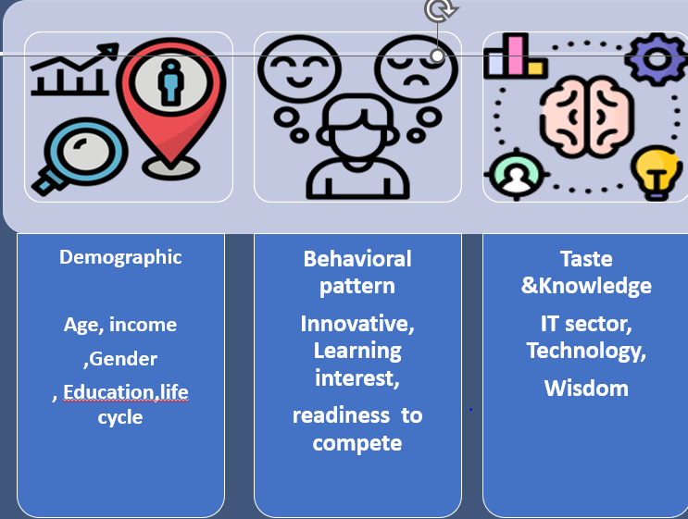

The product availability in the market
From the previous discussion, it can be understood that the smart mirror will be used by many people but most of them will be smart so they will use any platform related to the internet. So, they can have features of the product from social media as well as by usage of our website. We have developed our website that has a name like Elite Reflections so customers can visit our profile and can purchase their product by doing customization. We are providing readymade smart mirrors as well as we are providing options like customization, lighting, and others by which customers will be able to make changes to the product. So, the customer is liable to give an order to the market (Årdal et al., 2020).

Name of the organization
I will have an organization that will sell smart mirrors and the name of my organization will be Elite Reflection which means elite reflections will sell smart mirrors formally. Besides, we will try to sell the product through an online platform which means website development, social media selling system will be used by us as the condition of the market is not good enough (Guillemard et al., 2021). Besides off-line availability, operational expenditure usually increased but by following the smart method, the costing pattern for us will be removed so we will use an online selling system and we are available by online system. Besides, customer can cancel their product based on their demand but they have to maintain some rules and regulations for cancellation of the product. Also, the company will maintain some conditions for their betterment.

Sustaining business by innovative proposition
Sustaining in the competitive market is a challenge so any business can make its position in the market strong by adding different value propositions to their product. So, the smart mirror will offer services and products quickly and immediately based on the demand of customers. Besides, the customer will get a quick response from the website (Mitrano and Wohlleben, 2020). Finally, the customer will be able to analyze different competitors and they will easily understand that the pricing system and the quality system of elite reflection is better compared to others. The service, and application charge will be zero and on the first purchase, an extra discount will be provided. Based on market trends, different offerings will be provided. Besides, high technology will be used by the company to provide the product to the market. Employee development is the prime task and so this organization will provide necessary training to their customer to provide the best service to the store customer may need the idea of handling customers online which is why training will be provided to them. The business operation will have to be managed efficiently and so market leaders of Elite Reflections are liable to extend their service quality.

Competitor analysis
In the United Kingdom, different products are available in the market related to smart mirrors. So, Elite Reflection will provide additional value propositions to the market to get competitive advantages. The organization is coming with a different new product so this is very obvious that Elite Reflection will have all competitors who are running in the market. But none of the organizations are providing unique value propositions like them which is why Elite Reflection will be able to make competitive attainment in the market (Miethke et al., 2021). Within some years, they will be able to sell the maximum amount of their products as well as they will be able to increase their loyal customers. Besides, the organization will get successful if they depend on market trends and so different promotional messages will be designed by elite reflection in a manner by which promotion will be done properly.

Part B

E-Commerce System Development

Software as a service
Software as a service is the internet system basically which provides a connectivity service to an organization. Whenever an organization is demanding any requirement of software, that can be received through the system (Newman et al., 2021). Elite Reflection will need software as a service to make their configuration. Besides, they have to prepare their website which is why configuration and operating system can be developed by getting help from software as a service. Because the company will get different technological tools and techniques from software as a service as well as they will ensure data privacy through the system. The company will update every system based on the regular system and by following regular trends. Efficient management will be established within Elite Reflection. Besides, high qualification and training facilities will be ensured by this company through the usage of this system.

Marketplace
From the analysis, it has been analyzed that Elite Reflection will use online media to sell its product. Their main customer will be the upper class of society and who will love to use technological products. So, geo-fencing will be done by Elite Reflection near different shopping malls, restaurants, parks, and offices (Lacy et al., 2020). The service center-related information will be available on the website. After changing the economic situation, the company may decide to invest in a store. The promotional tools are difficult to be managed in the market but the promotional system will be used by organizations like Facebook, Instagram, and others. So, high-cost and other services-related challenges will be increased but the main target for the organization will be to make a proper position in the market through development. So, the different strategic moves will be taken by a company to make the marketplace successful.

Content creation system
As our business will be new in the market so every new update, a feature about a product will be included on the website. Besides, the usage pattern, the flexibility, and the customization system will be analyzed also. The company will make content that will be useful to any customer. Customers may be loyal or not but new or existing customers will love the content from Elite Reflection and in this manner that strategy will be prepared. Finally, different services will be provided if any maintenance is required by the customer (Cowley and Caprotti, 2019). Besides, unique photos, promotional messages, and others will be updated on the website of Elite Reflection. So, the target for Elite Reflection will be to provide a better service and product to customers by which easy life will be ensured by the organization for their valuable customers. Besides the major question of customers is available on the website of Elite Reflection. Frequently asked questions will be developed by the Elite Reflection and the answer will be presented within the website to give that easy service to Elite Reflection. Current location-related data, application-related data, and verification-related data for new organizations will be available and that will be given if any customer requires the answer to this question. Besides, the best kind of product, as well as unique service and customization, will be the main target for the organization to provide in the market (Guillemard et al., 2021). Customers may receive different services and based on that locations are designed basically. Services and products in the market are unique so Elite Reflections will have to design the strategy in a manner by which the customers will be able to take services properly. Elite Reflection is designing its website in a manner that will try to provide every question answer for customers that is why they have designed different catalogs as well as different information for smart mirrors by which customers will get quick responses to questions.

Payment services
Besides, customers will be able to make their payments through both online as well as offline systems. Off-line, cash on delivery, and checks can be given by customers. Besides, customers can give payment through usage of PayPal and other international payment system. We will try to focus on people's comfort so payment system-related options will be more as this is easier for customers. Service charges may be required for PayPal and that is a challenge (Mitrano and Wohlleben, 2020). The usage of PayPal will be unique and customers will be able to take the usage of this system. Besides, initially, the service charge will have to be given by customers but a 15% charge or discount will be provided by Elite Reflection. Elite Selection will provide a discount if customers make payments through an online card.

PCI-DSS compliance system
When technology will be used, this is necessary to identify related regulations. As organizations will use the online payment method, they will have to follow some rules related to PCI DSS. Different guidelines are given to make easier procedures for security systems (Miethke et al., 2021). Card payments nowadays are a challenging factor and different fraudulent activities can happen in the market so different regulations are given and organizations are bound to maintain that regulation. When proper security will be maintained by users and organizations, online-based services will be more unique in the market. Finally, the cardholder can increase their security level through the appliances of different regulations. Besides, Elite Reflection will follow every kind of rule to maintain their payment system easier.

Encryption of data and Firewall
Encryption of data will be maintained by an organization as proper security can be given by the amplitude data system. Customers may have their privacy related to the transaction so this is the duty of the organization to provide necessary security as well as necessary focus on valuable information. The function of PCI-DSS is to protect the data of customers but this is tough to be maintained. Besides, Firewalls in electronic commerce platform is a blessing. Firewalls will be used by the organization to make that protection in case of customer data. Customers may need proper protection for data transactions so which will have to be provided by the organization that is why a firewall will be used by Elite Reflection (Brown et al., 2019). In this growing market, the valuable information-related emphasis is increased so proper privacy protection will have to be insured by the organization to maintain the relationship with the customer. So proper encryption and firewall development is the target for a new organization to build a positive promotion or position in the market for the new brand name.

Password protection and upgrade system usage
Password should be unique enough that will increase the security for consumers. Electronic commerce in the market is maintained or developed nowadays so the customer has to make proper security on password and then make an account. In case of providing payment for elite reflection, password protection will be provided by the organization that will ensure the safety of customers. The duty of Elite Reflection as well as customers must provide unique security for passwords and only then provide access to payment options. In this manner, proper protection will be ensured by the organization and proper management will be done within the organization or establishment. The unique guideline of this system is to provide that upgrade to software and Elite Reflection is liable to provide every kind of update to the software (Ciampi et al., 2021). Elite Reflection will also focus on a software update system by which customer data will be more protected. Customer data-related privacy is a challenge for any new organization as well as for Elite Reflection but the maintenance of every rule given by this system will ensure the data privacy for customers. So, the organization is bound to provide service to the organization by the maintenance of different rules and regulations.

Part C

Marketing of Elite Reflections
Marketing is the overall procedure by which every organization can create value and can deliver value to their target customers to build customer satisfaction. The marketing role in business is very much important which is why organizations are providing focus over designing different marketing strategies. Marketing helps any organization understand how global capture can be taken. Besides Marketing helps any organization to realize how different services will be provided. Marketing usually identifies a market for a product exists or not. Based on market gap analysis, an evaluation for reducing the market gap has been done. For all of the product selections, different social media will be chosen to do marketing. People are nowadays used to different digital products so they will love the new product named smart mirror. Besides, different services or unique value propositions will be provided by the organization to remove the hassle for the target customer. Besides, the promotion for Elite reflection will be done through the usage of different division marketing tools and techniques. Apart from different ideas, service will be given to potential customers as well as best kind of product will be produced by which proper marketing will be established and then brand awareness will be created properly. Nowadays, people are demanding products that are unique and that will fulfill their needs so we believe that smart mirrors will fulfill the needs of those target customers.

Target customer
Nowadays target customers will be people who are loving to use different technological products. In the United Kingdom, everyone is used to meeting, and doing classes online during the COVID-19 period (Mahase, 2020). Besides, some young people were used to online media usage for their knowledge-developing skills so they will be able to connect with a smart mirror to take their classes as well as to take a recommendation from the internet or by the usage of digital products so it will be fulfilled by our new product launched in the market. So Elite Reflection will try to identify potential customers and based on that proper marketing will be designed for us to provide the best kind of services to market. When customers will get better performance from us and will be loyal to our product, the organization will continuously develop that product to provide the best service and product to the target customer.

Positioning
We will try to sell the product to our potential customers but we will also try our best to provide that quick service to our customers. We will develop different content and we will discuss those through social media marketing as our huge amount of customers are using social media. Besides, customers can make a complaint if they find any. For the first two years of usage, we will provide free service so which will increase the value of the product (Chouaibi et al., 2022). Besides, Elite Reflection will provide a digital payment system by which customers will be able to make payments as quickly as possible. Just-time delivery, online payment, and bank payment will be offered by us to give the best kind of help to our customers. Besides, we will try to charge a very reasonable price for our product by which competitive advantage can be achieved by this company and they will be able to take part in the competitive market.

Promotional strategies by social media
Businesses will reach the top level if they focus on the need fulfillment of target customers. The promotional strategy helps the organization to build very strong communication with the target customer. Based on different services, many promotional tools are designed. Any organization can get success through the use of social media. For example, Facebook marketing is used by reputed organizations to build communication with their customers (Ciampi et al., 2021). Through Facebook, different information about customer preferences can be identified and by that companies can build strategies properly. Apart from these, organizations can identify how to reach the target of fulfilling the demand of customers. When customary demand will be identified, strategies will be designed automatically. On the other hand, Google can be used by Elitereflection to identify which kind of search tools are used by target customers. So, a digital promotional strategy will be designed by the organization based on that. Apart from these, different promotional messages will be given to customers to take an eye view from them. The ultimate target of the business will be to build a strong position in the market. Besides, around £20,000 will be used by Elite Reflection to create their promotional execution but their main target will be to reach their target customers and to build very strong communication with them. When business value will be created, the profitability rate will be increased automatically. So, Elite Reflection will provide focus on the development of strategies to meet the need of customers and then they will reach the target position for them in this dominant market.


Social media marketing
Social media marketing means the vast amount of user availability and this is a potential market for the organisation. Social media marketing are nowadays known by almost everyone so Facebook, Instagram, and Twitter as well as different promotional tools are used by organisation to make communication with the organisation (Demirel and Kesidou, 2019). In the case of Facebook Elite Reflection will open their Facebook page and based on that different setting, the community will be prepared by them. Target customer needs will be analyzed and based on that content will be prepared. Finally, strong communication with the target customer will be developed through the usage of developing content. Pictorial analyses and pictures of the product will be available on Facebook as well as setting options will be available by which customer attention can be drawn. Brand measures will be designed and will be shared through social media to give attractive content to social media. Reputation will be built in this manner that will help to build the organization a significant position in the market.


Search engine usage and Email marketing
Search Engine is a promotional tool that is used by organizations nowadays. Advertisement or product is done through the search engine. Besides, search engine means that authority will have to make payment to boost the post in the marketplace (Papanastassiou et al., 2020). Elite Reflection will purchase some promotional tools and then they will be available at the top of the list when the customer will start. Even, Google and Apple are earning more than 25% of their income just because of the usage of search engine marketing tools. Using different engine tools will be the main target for Google (Mahase, 2020). In the market, Upper class as well as lower-class people will use smartphones and based on their analysis, they will be able to make profitable in the market. The vision of the organization will be to make offerings by which a proper marketing campaign will be designed. Businesses will draw relationships with the target customer by getting help from search engine tools. Email marketing will be used by organizations to make relations with businessmen. They will get a promotional message from the organization through the usage of marketing channels like email systems. Launched promotional channels are used by Elite Reflection but email will be used to make communication with particular target customers.

Understanding of the role of the customer journey
A customer journey map is the procedure by which an organization will be able to understand the behavior of customers. For example, customers will browse the website and based on that need, the wand will be matched with the product only then they will decide on purchasing. If they purchase the product, they will give them information about the new product or not. If their product is performing more than their expectation, their usage for a product will be increased. Message from a different blog, content will be developed by Elite Reflections to get the view from customers. Apart from these, Elite Reflections will fix the problem of the customer as soon as possible to make the journey easier and more comfortable for this company.

Part D

Data protection act 2018
The UK has defined the data protection law with a proper focus on data maintenance by organizations and that has been given so organizations like elite reflections will have to maintain the guideline to manage the data of customers. Elite reflection may have to go through with data privacy endurance also for maintenance of website access. To get the information from the market properly, some requirement has been provided by the data protection act and that will be followed by Elite reflection. Apart from the act, different firewalls, and privacy systems will be maintained by Elite Reflections to ensure data for customers. If customers and their data will not get proper privacy, this will lead to destruction so the company definitely will provide security for the payment-related information and other information. From the access of the website, proper information related to transactions can be attained by the hacker so the duty of the company will be to ensure the safety of data easily.

Privacy and Electronic communication regulations
The information for users is very much vital so the company can’t use any kind of information without the consent of the users (Demirel and Kesidou, 2019). Different marketing communication can be designed so the customer wants a little bit of privacy for that but some companies may not maintain those so that will not be done by Elite Reflection. It will do necessary changes for designing patterns to ensure proper data management. Data privacy will be ensured by which electronic communication will be done with privacy. Besides, customers can delete their conversation or other information if they need so that right will have to be given by the organization properly. The duty of an organization has been defined by different company laws so that will be maintained by legislation to give privacy to their users. Besides, customers are liable to provide some information for payment or for placing an order for the product but that will not be hampered due to the usage of social media and this is the duty of an organization to maintain privacy for the organization and then the reputation for the organization will be improved.

Security issue
The security purpose in this market is significantly different so cloud-providing authority should provide enough emphasis on the cloud-providing system (Papanastassiou et al., 2020). Elite reflection may have the power to access customer's information but that should not violate the security purpose of that user. Besides, different encryption will have to be provided by the organization to ensure the safety of the organizational customers. Besides, frequent changes and easy access can be provided by organizations by which easy access can be provided through organization. Cloud-providing management can be done by maintaining different acts. When the act will be maintained, easily organization will be able to make frequent changes properly. So, this is how the organization can make a proper analysis.

Conclusion
The situation in the whole world is threatening the life of every individual so they are suffering from different problems like economic problems, political problems, and others. Businesses nowadays are not available as they are not getting proper success in the market. COVID-19 has challenged businesses as well as human beings. Public transport was just unavailable in the market so proper safety has not maintained, different challenges are increasing in the market which is why different new businesses were shut down in the market. Though the market has a demand for different products but proper availability or supply is not available due to different issues. Besides, Elite Reflection will come into the market with a smart mirror that will give the solution to business users to do meetings a home as well as women will get help for home automation systems and different exercise-related ideas will be given by smart mirror easily will be offered by Elite reflection. The smart mirror will be available in the market to remove the pain of every individual. In this analysis, different marketing strategies, mix, ideation, target market, positioning related idea has been given to the execution of the product in the market successfully. Besides, proper privacy has been ensured by organizations to create trust and loyalty levels among people.

References
Årdal, C., Balasegaram, M., Laxminarayan, R., McAdams, D., Outterson, K., Rex, J.H. and Sumpradit, N., 2020. development—economic, regulatory and societal challenges. Nature Reviews Microbiology, 18(5), pp.267-274.
Brown, D., Hall, S. and Davis, M.E., 2019. Prosumers in the post subsidy era: an exploration of new prosumer business models in the UK. Energy Policy, 135, p.110984.
Chouaibi, S., Chouaibi, J. and Rossi, M., 2022. ESG and corporate financial performance: the mediating role of green innovation: UK common law versus Germany civil law. EuroMed Journal of Business, 17(1), pp.46-71.
Ciampi, F., Demi, S., Magrini, A., Marzi, G. and Papa, A., 2021. Exploring the impact of big data analytics capabilities on business model innovation: The mediating role of entrepreneurial orientation. Journal of Business Research, 123, pp.1-13.
Cowley, R. and Caprotti, F., 2019. Smart city as anti-planning in the UK. Environment and Planning D: Society and Space, 37(3), pp.428-448.
Demirel, P. and Kesidou, E., 2019. Sustainability‐oriented capabilities for eco‐innovation: Meeting the regulatory, technology, and market demands. Business Strategy and the Environment, 28(5), pp.847-857.
Guillemard, L., Kaplaneris, N., Ackermann, L. and Johansson, M.J., 2021. Late-stage C–H functionalization offers new opportunities in drug discovery. Nature Reviews Chemistry, 5(8), pp.522-545.
Lacy, P., Long, J. and Spindler, W., 2020. The circular economy handbook (Vol. 259). London: Palgrave Macmillan UK.
Mahase, E., 2020. Covid-19: UK starts social distancing after new model points to 260 000 potential deaths.
Miethke, M., Pieroni, M., Weber, T., Brönstrup, M., Hammann, P., Halby, L., Arimondo, P.B., Glaser, P., Aigle, B., Bode, H.B. and Moreira, R., 2021. Towards the sustainable discovery and development of new antibiotics. Nature Reviews Chemistry, 5(10), pp.726-749.
Mitrano, D.M. and Wohlleben, W., 2020. Microplastic regulation should be more precise to incentivize both innovation and environmental safety. Nature communications, 11(1), p.5324.
Newman, C., Edwards, D., Martek, I., Lai, J., Thwala, W.D. and Rillie, I., 2021. Industry 4.0 deployment in the construction industry: a bibliometric literature review and UK-based case study. Smart and Sustainable Built Environment, 10(4), pp.557-580.
Papanastassiou, M., Pearce, R. and Zanfei, A., 2020. Changing perspectives on the internationalization of R&D and innovation by multinational enterprises: A review of the literature. Journal of International Business Studies, 51, pp.623-664.
Petricevic, O. and Teece, D.J., 2019. The structural reshaping of globalization: Implications for strategic sectors, profiting from innovation, and the multinational enterprise. Journal of International Business Studies, 50, pp.1487-1512.
Raymond, M., 2019. The trend forecaster's handbook. Hachette UK.
Sheng, J., Amankwah‐Amoah, J., Khan, Z. and Wang, X., 2021. COVID‐19 pandemic in the new era of big data analytics: Methodological innovations and future research directions. British Journal of Management, 32(4), pp.1164-1183.
Sun, H., Edziah, B.K., Kporsu, A.K., Sarkodie, S.A. and Taghizadeh-Hesary, F., 2021. Energy efficiency: The role of technological innovation and knowledge spillover. Technological Forecasting and Social Change, 167, p.120659.
Voigt, C.A., 2020. Synthetic biology 2020–2030: six commercially-available products that are changing our world. Nature Communications, 11(1), p.6379.

