

University of Wales Trinity Saint David

School of Engineering

Manufacturing Systems

Analysis and Simulation of a Centrifugal Clutch

Stress Analysis and Dynamics 5010

Joseph Lancastle
2214707
6th November 2023
Wordcount: 2496
Edited Wordcount: 3144

Contents
Table of Figures 3
Task A 4
Introduction 4
Overview 4
Development and Applications 5
Materials 8
Conclusion 8
Task B 9
Question 1 9
Question 2 9
Question 3 11
Question 4 13
Questions 5 and 6 14
Question 7 17
Bibliography 18
Appendices 20

Table of Figures
Figure 1: 3rd Angle Projection Drawing of a Centrifugal Clutch Kholil et al. (2021) 4
Figure 2: Early Centrifugal Clutch Example Kirkpatrick (1950) 5
Figure 3: St. John (1980) Clutch Design 5
Figure 4: Spring Surrounded Clutch Nagashima & Hiraizumi, (1988) 6
Figure 5: Counterbalanced Centrifugal Clutch Weiss (1984) 6
Figure 6: FOA Clutch Crane et al. (2004) 6
Figure 7: "S-Type" Centrifugal Clutch Example Crane et al. (2001) 6
Figure 8: Simplified Diagram of Electromagnetic Clutch, Creative (2021) 7
Figure 9: Driven Shaft RPM and Driving Shaft Torque at 0.35 Friction Coefficient 15
Figure 10: Driven Shaft RPM and Driving Shaft Torque at All Friction Coefficients 16

Task A

Introduction

The centrifugal clutch (CC) plays a pivotal role in the use of smaller motor equipment. The evolution of the centrifugal clutch is the product of decades of innovation driven by sectors manufacturing AC motors, small motor equipment, large industrial motors and vehicles. The requirement of more efficient clutch systems in these sectors, in terms of optimising power transmission, minimising size, reducing vibrations and parasitic drag have driven their development, aided by vast improvements in material science since the centrifugal clutches inception. This report will explore the development and history of the centrifugal clutch and will highlight the distinct advantages of their application and their inherent weaknesses resulting from their design.
Overview
The centrifugal clutch comes in a variety of forms dependent on its application all of which operate and engage on the principle of centrifugal force. In the abstract, the centrifugal clutch has a central, driving shaft that is rotating, coming from the motors power source. The end of the shaft is connected to a component named the spider, which is houses the springs (if applicable) and brake shoes, atop the shoes is friction material, known as the Ferrodo lining, which increases the coefficient of friction between the shoe and the inner radius of the drum. As the rotational speed of the driving member increases, the centrifugal force acting on the shoes will overcome the inward acting force and engage the friction lining on the outer drums’ inner radius or the driven member. This then transmits power to the given output of the system. The centrifugal clutch simplifies power engagement systems by eliminating the use of manual operation linkages. The engagement speed can be altered by changing the spring rate of the springs or mass of the shoes.

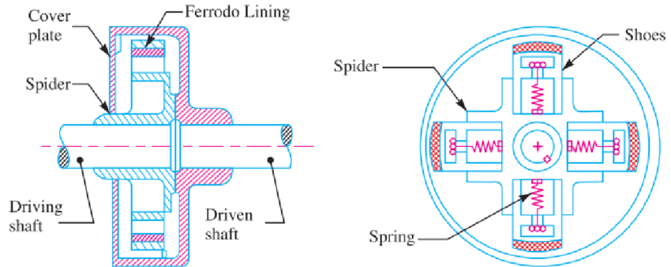
Figure 1: 3rd Angle Projection Drawing of a Centrifugal Clutch Kholil et al. (2021)

Development and Applications
Centrifugal clutch systems have been used for over a century, with the earliest mention in a patent application by Walter A. Crowdus in 1898. However, centrifugal clutches have become more of a preferred option during the last 50 years due to their compact size, automatic engagement, economic viability and overload protection resultant from the clutches slippage. Centrifugal clutches generally fall into two categories. Clutches that are spring loaded, so that they return to their neutral position by utilisation of a coiled spring. The second category contains those that use methods using sprung flexible steel shoes.
The development of assemblies with shoes secured in place by springs, began with Kirkpatrick’s (1950) model Fig 2. St. John (1980) simplified this design to one of the most recognisable examples of a centrifugal clutch that is still in use today. St. John’s example is used primarily in automotive applications, such as go-karts and scooters due to its enhanced torque transmission from increased surface area of the friction lining. The only typical alteration currently is the addition of a third shoe. It is a prevalent system used in these applications as switching from full power to zero power transmission quickly is a necessity for safety and performance. However, this can be dangerous in certain scenarios including strimmer’s and chainsaws where the kick back from saws when they hit resistance can be unexpected and dangerous. The examples produced by Weiss (1984) under the employ of Stihl Saws, devised a method in which this unwanted kick is reduced by counterweights opposing the clutches original engagement mass.
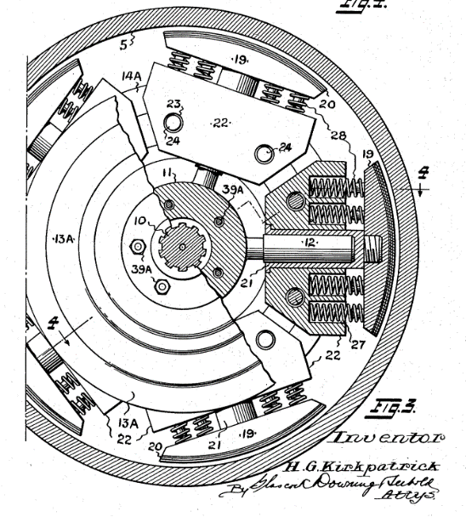
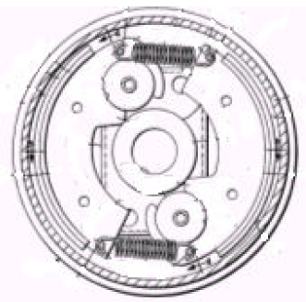
Figure 2: Early Centrifugal Clutch Example Kirkpatrick (1950)
Figure 3: St. John (1980) Clutch Design
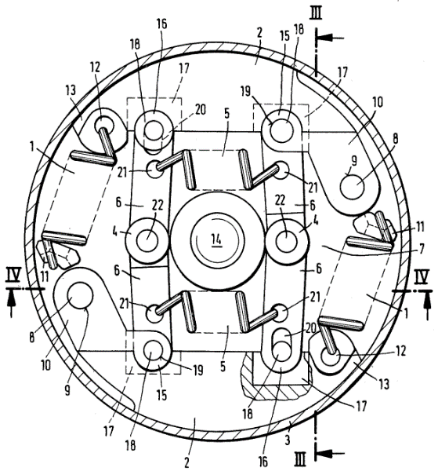
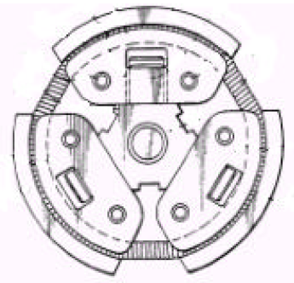
Figure 4: Spring Surrounded Clutch Nagashima & Hiraizumi, (1988)
Figure 5: Counterbalanced Centrifugal Clutch Weiss (1984)

The disadvantages of spring clutches are increased production costs and increased potential failure modes both due to their increased number of components and assembly complexity. Centrifugal clutches of recent years, especially for smaller torque transfer applications use flexible, sprung steel segments that deform when enough torque is applied and engages the clutch, Figure 7. This system of engagement being concurred by the likes of Nickel & Wissmann’s (1987) clutch, and the Floating Opposing Arm (FOA) clutch developed by Crane et al. (2004) shown in Figure 6. This system is generally more cost effective due to its relative simplicity to produce and fewer components that are easier to manufacture from means such as sheet metal stamping. However, it is at risk of fatigue crack propagation due to the continual cyclic loads in normal use in garden equipment, tools and saws. Similarly, the clutch assembly containing springs will also fall victim to fatigue from the cyclic loads applied, however, unlike the flexible metal type, variance in spring rate will be the consequence rather than a catastrophic failure of the clutch when the thin segments become detached inside of the assembly.
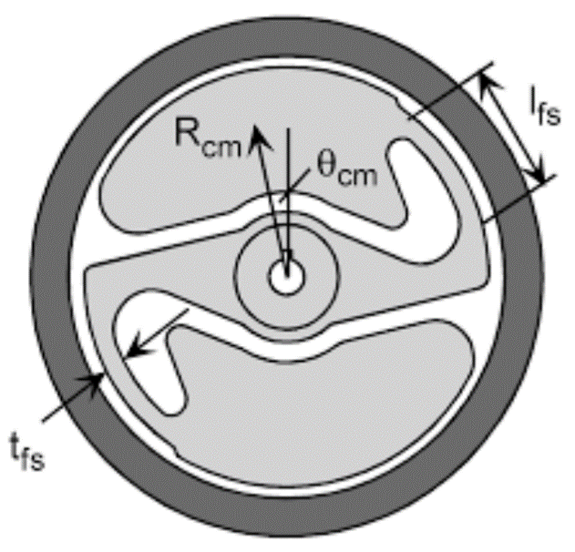
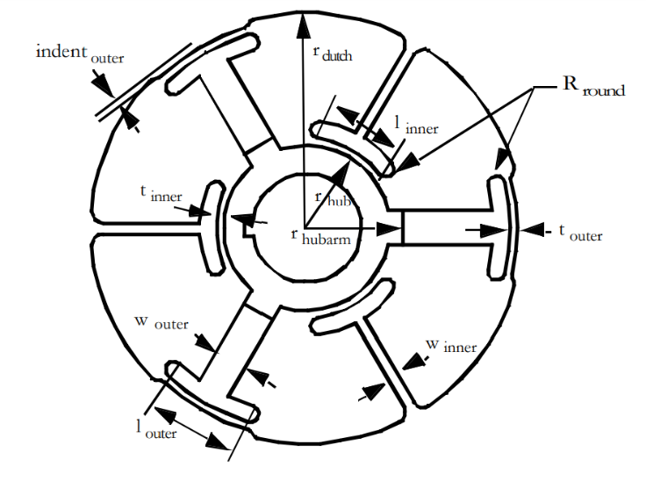
Electromagnetic clutches (EC) are used in many industries, but specifically applied to manufacturing equipment they are used in millers, lathes and high cycle automated assembly lines such as conveyor belts, servo motors and robotics. The benefit of using ECs in these scenarios is their ability to be engaged and disengaged almost instantaneously and having perfect torque transfer capabilities after their initial acceleration.
Figure 6: FOA Clutch Crane et al. (2004)
Figure 7: "S-Type" Centrifugal Clutch Example
Crane et al. (2001)

ECs work on the principle of magnetic attraction. As per Figure 8 a simplified EC comprises of an output, armature, rotor and field coil. The input driving shaft will run through the centre of the field coil and attach to the rotor, the armature affixed to the output component. When a current is run through the field coil a magnetic field is generated, when the magnetic flux crosses the airgap between that of the coil and the armature, the armature is pulled into the rotor, engaging the clutch. When the coil is deactivated, a return spring will disengage the assembly. The instant engagement is a benefit of the EC, unlike centrifugal clutches which rely solely on mechanical means of engagement, the EC needs a control unit to function (Kirchengast et al. 2015). This is an extra complication and expense that needs to be accounted for and may not be feasible depending on the EC’s environment. The major benefit of CC’s is their simplicity and their ability to in environments without any extraneous power source for control.
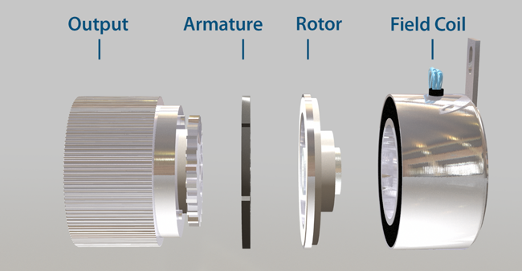
Figure 8: Simplified Diagram of Electromagnetic Clutch, Creative (2021)

Materials
In general, the shoe, spring and hub materials used in centrifugal clutches do not differ largely from steel, as it is necessary for the clutches to be compact due to their applications yet strong enough to endure stresses from rapidly rotating equipment, albeit there may be slight disparities in the compositions of steel in the assembly’s dependent on the application or design. Although Roach & Howell (1999) state that due to the CC being subjected to continuous deflections, the Modulus of Elasticity, or flexibility of the material is more important than the outright strength.
However, the highest impact on performance, is the friction lining material (Liu & Chiang 2016). Kholil et al. (2021) experimented with using novel, more environmentally friendly sources of friction material such as wood powder and coconut fibre. Their testing although flawed due to using only one asbestos containing friction lining material as their control variable, for their basis of comparison. Furthermore, there was no longevity testing or cost efficiency comparison. However, it does emphasise the point that adjustments to the friction material can have profound effects on the coefficient of friction thus torque transfer capabilities, a comparatively inexpensive change compared to trying to achieve the same results in by altering steel composition of the outer drum and mass of the clutches shoes.
The primary disadvantage of centrifugal clutches is slippage between the shoes and the driven member. This creates a poor power transmitting capacity in the system, which is more prevalent with higher input speeds from higher power systems. The slippage in centrifugal clutch systems can result in shorter clutch life, overheating in the system resulting in thermal stress failures and potential glazing of the friction coating. However, as Crane (2003) states, slippage in a centrifugal clutch system is a beneficial characteristic as it prevents the assembly from damage from excessive torques resulting from over engagement. This point is supported by Goodling (1974) and St John (1979). On this premise, it is known that there is an optimal level of slippage in a centrifugal clutch system, this figure varies depending on the powers required in the system and the application and the materials used.

Conclusion

To conclude, the centrifugal clutch has been of import in the field of power transmission in small motor equipment. Its development was promoted by the demand for clutch systems that are compact, simplified and minimise vibrations whilst maximising power transmission. The two main types of centrifugal clutch have emerged, spring loaded, which are of a simpler design but of more components and assembly complexity. Sprung steel assemblies, which are more cost effective, however, may be more prone to fatigue failures. Both of which have tuneable engagement speeds and overload protection from varying friction material types in the system. Although electromagnetic clutches are becoming more common thanks to their instant engagement, there remains risk of damage to components from the lack of slip, so their use in higher torque systems should be minimised.

Task B

Question 1
To find the diameter of the outer drum we assume that the radius of central shaft to the centre of mass, which is at the end of the shoe.
$Outer Radius=radius of shoe to centre of mass+ clearance distance+wall thickness$
$$Outer Radius=0.095+ 0.009+0.004$$
$$Outer Radius=0.108m$$
$$Outer Diameter=216mm$$
$$∴Inner Radius=0.104m$$

Question 2
The engagement speed of a centrifugal clutch is the moment the centrifugal force acting upon the shoes overcomes the spring stiffness and engages the friction lining.
The centrifugal force exerted on each show is defined by the following:
$$F_{Centrifugal}=mω^{2}r$$
Where:
m = the mass of each shoe = 0.275kg
ω = the angular velocity (unknown)
r = drum inner diameter = 0.104m
The spring force exerted by each shoe is defined by the following, Hooke’s Law.
$$F_{Spring}=kx$$
Where:
k = spring constant/stiffness = 7500 N/m
x = displacement = 0.009m
As aforementioned, at rest, the centrifugal force and the spring force are in equilibrium so that it can be assumed that:

$$F_{Spring}=F_{Centrifugal}$$
$$kx=mω^{2}r$$
$$7500×0.009=0.275× ω^{2}×0.104$$
$$7500×0.009=0.275× ω^{2}×0.104$$
$$67.5=28.6{×10}^{-3}ω^{2}$$

To find the angular velocity the formula must be transposed to make omega the subject.
$$ω=√\frac{67.5}{28.6{×10}^{-3}}$$
$ω_{1}=48.58 rad/s$
Now, to convert the angular velocity to RPM to find the engagement speed.
$$RPM=\frac{ω×60}{2×π}$$
$$RPM=\frac{48.58×60}{2×π}$$
$$464RPM$$

Question 3

The total net, radial force for each shoe at 550 RPM must is defined as:
$$P=Pc-Ps$$

Where:
P = Net Force
Pc = Centrifugal force
Ps = Spring Force
First, the known value for angular velocity must be converted into radians per second:
Where:
ω = the angular velocity expressed in radians per second = 550RPM
$$Radians/second=2π\frac{ω}{60}$$
$$Radians/second=2×π×\frac{550}{60}$$
$$57.59 rad/s$$

Now that the angular velocity has been converted, we can find the centrifugal force for this rotational speed. As the shoes in both scenarios will be acting above the engagement speed the internal radius of the drum is used.
Where:
r = drum radius = 0.104m
ω = angular running speed = 57.59 rad/s
m = the mass of each shoe = 0.275kg
$$F_{Centrifugal}\left(P_{C}\right)=mω^{2}r$$
$$P_{C}=0.275{×(57.59)}^{2}×0.104$$
$$P_{C}=94.85 N$$

Now the centrifugal force has been found, the inward force acting on each shoe exerted by the springs at the engagement speed must be calculated.
Where:
ω₁ = the angular engagement speed (2) = 48.58 rad/s
m = the mass of each shoe = 0.275kg
r = drum inner radius = 0.104m
n = shoe quantity = 4
$$Ps = m (ω_{1})^{2} r$$
$$Ps = 0.275×(48.58)^{2} ×0.104$$
$$Ps = 67.50 N$$
Then to input the figures found to find the net force. The effects of friction redundant for this calculation. The force is acting tangentially, and the question is looking for the radial force, the angle in which the force is acting, Theta (θ) = Sin (90°). This is equal to 1, so there is no change in force radially and is not considered in this calculation.
$P=(Pc-Ps$) n
$$P=\left(94.85-67.50\right)×4$$
$$P=109.4 N$$

Question 4

To Calculate the torque transmitted to the driven shaft at 550RPM, we must find the inward force exerted on each shoe when the engagement takes place.
Where:
R = inner drum radius = 0.104m
m = the mass of each shoe = 0.275kg
Pc = Centrifugal force (3) = 94.85N
Ps = Spring force (3) = 67.50N
τ = Frictional Torque transmitted
μ = friction coefficient = 0.35
$$τ=μ (Pc – Ps ) R × n = n.F.R$$
$$τ=μ (Pc-Ps ) R × n$$
$$τ=0.35×(94.85-67.50)×0.104×4$$
$τ=$ 3.98 Nm

Questions 5 and 6

The relationship between transmitted torque compared to driving speed is shown to be directly proportional whilst using any of the coefficients of friction as driving speed increases from 450 RPM to 700 RPM in 25 RPM increments.
Figure 9 highlights the results between driven shaft RPM at a 0.35 coefficient of friction. The negative torque figures denote that the engagement speed of 464 RPM, from question 2, had not been achieved, also in Figure 10 with the varying coefficients of friction. However, once the shoes have contacted the internal radius of the outer drum, the higher coefficient of friction output a higher final torque on the driven shaft whilst inversely, the friction material with a lower coefficient performed worse and had a lower final torque value.

To ensure that the calculations were correct, the engagement RPM, represented as the X-Intercept on Figure 10, should be equal across the friction variables and the engagement speed found in question 2 as the variations in the friction coefficient would not impact the centrifugal force in which the shoes engage. Across the 3 friction variables, each engagement speed was equal at 470 RPM as in Appendix 1, reaffirming this point. However, this highlights a 6 RPM disparity between the calculated engagement speed and the one derived from graphical means. This is likely due to the accumulation of error in the question 2 calculations as a result from the rounding of figures used in equations, compounded by the calculations via computational means not rounding at all.

Figure 9: Driven Shaft RPM and Driving Shaft Torque at 0.35 Friction Coefficient

Figure 10: Driven Shaft RPM and Driving Shaft Torque at All Friction Coefficients

Question 7
The highest transmitted torque found is 14.34 Nm. Firstly, the moment of inertia for a solid disc must be calculated, using the outer radius of the drum.
Where:
M = Drum mass = 0.75Kg
R = Inner drum radius = 0.104m
I = Moment of Inertia
$$I= \frac{1}{2}MR^{2} \\ I= \frac{1}{2}×0.75×{0.108}^{2}$$
$I= 4.374{×10}^{-3} kg/m^{2}$

Now that the moment of inertia has been calculated, the calculated maximum torque for the centrifugal clutch assembly, Appendix 1, the angular acceleration is found using the following:
Where:
I = moment of inertia = 4.067x10⁻³
τ = Torque = 14.34Nm
α = angular acceleration
$$α=\frac{net τ}{I}$$
$$α=\frac{14.34}{4.374×{10}^{-3}}$$

$$α=3.28×{10}^{3} rad/s^{2}$$

Bibliography

Black, S.C. et al. (1996) Principles of Engineering Manufacturing. London: Arnold.
Crane, N.B. (2003) Compliant centrifugal clutches: Design, analysis, and testing. dissertation. BYU Scholars Archive Citation.
Crane, N.B. et al. (2004) ‘Compliant floating-opposing-arm (FOA) centrifugal clutch’, Journal of Mechanical Design, 126(1), pp. 169–177. doi:10.1115/1.1639378.
Crane, N.B., Weight, B.L. and Howell, L.L. (2001) ‘Investigation of compliant centrifugal clutch designs’, Volume 2A: 27th Design Automation Conference [Preprint]. doi:10.1115/detc2001/dac-21071.
Creative, N. (2021) Industrial clutches and brakes for robotics, processing and automation equipment, Electromagnetic Clutches and Brakes - Ogura Industrial Corp -. Available at: https://ogura-clutch.com/electromagnetic_clutch.php (Accessed: 01 October 2023).
Crowdus, W.A. (1898) ‘AUTOMOBILE VEHICLE’. USA Patent: 598314
Dunn, D.J. (2013) Mechanics of solids dynamics moment of inertia - freestudy.co.uk, Mechanics of solids dynamics moment of inertia -. Available at: http://freestudy.co.uk/dynamics/moment%20of%20inertia.pdf (Accessed: 07 October 2023).
Goodling, E.C. (1974) ‘FIGHTING HIGH-ENERGY COSTS WITH CENTRIFUGAL CLUTCHES’, Machine Design, 46(23), pp. 119–124.
Kholil, A. et al. (2021) ‘Performance testing of motorcycle centrifugal clutch lining made from composite wood powder, coconut fibre, and Green Mussel Shell’, Journal of Physics: Conference Series, 2019(1), p. 012065. doi:10.1088/1742-6596/2019/1/012065.
Kirchengast, M. et al. (2015) ‘Identification and position control of an electromagnetic clutch actuator’, IFAC-PapersOnLine, 48(11), pp. 59–64. doi:10.1016/j.ifacol.2015.09.160.
Kirkpatrick , G.H. (1950) ‘Centrifugal clutch’. USA Patent: 2534133
Liu, C.H. and Chiang, Y.P. (2016) ‘Analysis of the sliding contact behavior of a centrifugal clutch’, Key Engineering Materials, 715, pp. 231–236. doi:10.4028/www.scientific.net/kem.715.231.
Milne, I., Ritchie, R.O. and Karihaloo, B. (2003) Comprehensive structural integrity. Amsterdam: Elsevier/Pergamon.
Moebs, W., Ling, S.J. and Sanny, J. (2016) 10.7 Newton’s second law for rotation - university physics volume 1, OpenStax. Available at: https://openstax.org/books/university-physics-volume-1/pages/10-7-newtons-second-law-for-rotation (Accessed: 22 October 2023).
Nagashima, A. and Hiraizumi, J. (1988) ‘Centrifugal Clutch’. USA Patent: 4756396
Nickel, H. and Wissmann, M. (1987) ‘CENTRIFUGAL CLUTCH’. USA Patent: 4635777
O’Keefe, P.J. (2012) Mechanical Power Transmission – The Centrifugal Clutch and Metal Fatigue, Engineering expert witness blog. Available at: http://www.engineeringexpert.net/Engineering-Expert-Witness-Blog/mechanical-power-transmission-%E2%80%93-the-centrifugal-clutch-and-metal-fatigue (Accessed: 02 August 2023).
Roach, G.M. and Howell, L.L. (1999) ‘Evaluation and comparison of alternative compliant over-running clutch designs’, Volume 1: 25th Design Automation Conference [Preprint]. doi:10.1115/detc99/dac-8619.
Rotational inertia and Angular Second Law Review (article) (2023) Khan Academy. Available at: https://www.khanacademy.org/science/mechanics-essentials/xafb2c8d81b6e70e3ap1 (Accessed: 05 October 2023).
Shin, Y.H., Kim, S.C. and Kim, M.S. (2013) ‘Use of electromagnetic clutch water pumps in vehicle engine cooling systems to reduce fuel consumption’, Energy, 57, pp. 624–631. doi:10.1016/j.energy.2013.04.073.
St John, R.C. (1979) ‘Centrifugal Clutch Basics’, Power Transmission Design, 21(3), pp. 52–55.
St. John, R.C. (1980) ‘Centrifugal Clutch Construction’. USA Patent: 4226320
Weight, R.G., Howell, L.L. and Magleby, S.P. (2004) ‘Minimizing performance variation for the compliant floating-opposing-arm clutch’, Volume 2: 28th Biennial Mechanisms and Robotics Conference, Parts A and B [Preprint]. doi:10.1115/detc2004-57206.
Weiss, H. (1984) ‘CENTRIFUGAL CLUTCH FOR POWER SAWS ’. USA Patent: 4446954

Appendices
Appendix 1


