An analysis of Reinhard Heydrich’s telegram at 1.20 am on 10th November 1938
- INTRODUCTION
On 7th November 1938, 17-year-old Jewish male Herschel Grynszpan entered the German Embassy in Paris and shot Ernst vom Rath, a junior Nazi diplomat, who died two days later. This act triggered immense repercussions. Fuelled by state propaganda, Nazi factions initiated antisemitic riots on the 7th and 8th of November. On 9th November, Adolf Hitler and senior Nazi leaders used vom Rath’s death to instigate widespread violence, leading to Kristallnacht (Night of Broken Glass), a massive pogrom across Germany, Austria, and Sudetenland. Kristallnacht was marked by violence, arrests, and deportations, significantly impacting the Jewish community in Germany and setting the stage for further persecution. It was the most severe attack on German Jewry up to that time (Steinweis, 2008; Goran, 2002; Axelrod, 2022). A key piece of evidence for the Nazi state planning and coordination of the pogrom was a telegram sent from Berlin by Reinhard Heydrich to all offices of the State Police and Sicherheitsdienst (SD or Security Service). This message contained explicit instructions that not only restricted police involvement but also supported the actions that the government expected to take place on 10th November 1938 (Museum of Tolerance, 2024).
This report will critically examine Heydrich’s telegram, the historical backdrop of Kristallnacht, its immediate and long-term impact on the Jewish population in Germany and Europe, and the contribution it made to the Final Solution.
- THE PATH TO KRISTALLNACHT
Grynszpan shot vom Rath in response to the deportation of his family during the Polenaktion (Polish Action), which expelled about 20,000 Polish Jews from Germany in October 1938 (Larkey, 2017; Botwinick, 1996, p. 121). While vom Rath was on his deathbed, the Nazi propaganda system began to operate, depicting the incident as a global Jewish conspiracy and setting in motion a campaign of retribution (Burleigh, 2000, pp. 323-325). Hitler's doctor tended to vom Rath but was ordered to withhold treatment. The Nazis used von Rath's murder to trigger Kristallnacht, portraying it as a worldwide Jewish conspiracy (Weisz and Albury, 2014; Steinweis, 2008). This manipulation intensified anti-Semitic sentiment, leading the German press to label the Jewish community as murderers. Punitive actions included shutting down all Jewish newspapers and banning Jewish children from Aryan state elementary schools. In Germany, the first wave of repercussions occurred with violent incidents targeting Jews, which Joseph Goebbels (Minister of Propaganda) called ‘spontaneous incidents’ (Gilbert, 2006, pp. 25-27).
On November 9th, 1938, Nazi leaders convened to commemorate the 1923 Munich beer hall putsch when they learned of vom Rath’s death. Goebbels was tasked by Hitler to lead the retaliation against Jews, delivering a speech that incited violent demonstrations against them. This event highlighted state-sanctioned violence, reflecting the regime's endorsement of attacks on Jewish people, their properties, and synagogues. This is reflected in a diary entry by Goebbels, noting a comment by Hitler, ‘He determines that the demonstrations should be permitted to carry on. The police are to be pulled back. For once, the Jews should experience the sentiment of public fury’ (Gilbert, 2006, p. 29; Friedlander, 1997, p. 272). Gauleiters (regional Nazi party leaders) and Sturmabteilung (SA or brownshirts) chiefs reacted immediately, communicating orders for repercussions. Later, worried about Goebbels’ rising influence, Hermann Goering (Minister of the Four-Year Plan) and Heinrich Himmler (leader of the SS and Chief of the German Police) commanded their subordinates to join the pogrom (Botwinick, 1996, p. 121). Himmler instructed Gestapo chief Mueller to ensure the SS refrained from violence and directed the Gestapo to detain affluent Jews for confinement in concentration camps. This was followed on the 10th of November at 1.20 am, with Heydrich composing and sending the telegram, which is the focus of this report (Kley, 2000; Calic, 1982, p. 192).
- REINHARD HEYDRICH
Heydrich was the Schutzstaffel (SS) deputy chief holding the rank of Gruppenfuhrer and serving as the Nazi Chief of Security Police. Appointed by Himmler, he also managed the Sicherheitsdienst and the Gestapo, playing a key role in implementing Nazi persecution policies (USHMM, 2025a; Gilbert, 2006, p. 26). In 1939, Heydrich was appointed to lead the Reich Central Office for Jewish Emigration, managing the forced relocation of Jews from Germany (Botwinick, 1996, p. 76). By 1941, he rose to the rank of Obergruppenfuhrer, making him a key SS leader closely aligned with Himmler and Hitler. In 1942, Heydrich was fatally injured in an assassination attempt by Czech resistance fighters and died a week later, leading to harsh reprisals from the Nazi regime (Calic, 1982, pp. 9-14). Heydrich was a key architect in planning the Final Solution, playing a pivotal role in the Nazis' mass extermination of Jews in Europe (Breitman, 1994; Gerlach, 1998).
- THE DOCUMENT
Heydrich's telegram (see Appendices A and B) was an official state communication and directive that reveals the regime's efforts to exploit violence and antisemitism while controlling its narrative. It emphasised that spontaneous violence against Jews should not be openly suppressed but also set limits on property destruction and looting to maintain a sense of controlled aggression. The telegram illustrates the Nazis' organised approach to oppressing Jews, highlighting the connection between violence and bureaucracy. It serves as a directive for coordinated attacks while maintaining an appearance of order and protecting Nazi economic and political interests. The telegram, marked ‘Secret’, is concise and cold, reflecting the detached, methodical nature of the Nazi administration. It contains detailed instructions for managing the pogrom, authorised by the seniority of Himmler and Heydrich. The telegram underscores the severe impact of the Nuremberg Laws on Jews, highlighting their lack of citizenship and rights, making them vulnerable to abuse. After January 1933, violence against Jews became routine in Germany, escalating in 1938 after Austria's annexation, suggesting that the November pogrom was a culmination of ongoing hostility (Steinweis, 2009). The document omits the moral and humanitarian consequences of the violence against the Jewish people and avoids acknowledging state involvement. The directives instruct the following: no actions should jeopardise lives or property, particularly during the destruction of synagogues. While Jewish businesses could be targeted for destruction, looting was expressly prohibited. Despite the appearance of spontaneous violence during the pogrom, Heydrich's central orders specified that rioters should avoid harming non-Jewish Germans or foreigners, including Jewish foreigners. They were to remove and seize synagogue archives before vandalising properties. Police were instructed to arrest as many Jews as local jails could hold, mainly targeting young, healthy men. The appropriate concentration camps would be notified to ensure quick confinement, and those detained needed to be adequately treated (Friedlander, 1997, pp. 273-274; USHMM, 2025b). Heydrich's directive had significant implications. Wealthier and healthier Jews were targeted for arrest, enabling the Nazi Party to confiscate their assets. Healthy Jewish males were especially valued for labour in concentration camps, which were designated by Heydrich's Order for the detained Jews. This process continued throughout the Nazi regime. After Kristallnacht, thousands of Jews were sent to camps, marking a key step toward larger and deadlier concentration facilities (Calic, 1982, p.193).
- KRISTALLNACHT
The SS, SA, and Hitler Youth participated in the pogrom across Germany and occupied regions, often in civilian clothing, to disguise the violence as a public response (USHMM, 2025b). Many ordinary Germans, including schoolchildren, vandalised Jewish properties and synagogues, and despite a looting ban, theft occurred (Steinweis, 2009). Violence continued into the 11th, with many synagogues and Jewish prayer rooms set on fire. Approximately 7,500 Jewish shops were looted and destroyed, nearly 100 Jews were killed, and about 30,000 were sent to concentration camps like Dachau and Buchenwald. Jews were ordered to pay for damages estimated in the hundreds of millions of marks and were fined one billion marks. The events of Kristallnacht marked a significant step towards the expulsion and extermination of Jews from society (Kaplan, 1998, pp. 119-144; Terezin Initiative, 2025; Yad Vashem, 2025). Confino (2012) highlights that the Nazis targeted synagogues and destroyed Hebrew Bibles to erase Jewish culture, resulting in severe emotional impacts, increased suicides, and a mass exodus among the Jewish population (Gruner, 2019, pp. 25-50).
- JEWISH PERSECUTION (1933-1938)
The Nazi rise to power in January 1933 endangered Jewish communities in Europe, depicting the half-million Jews in Germany as an internal threat (Edelheit, 1994; Gilbert, 2006, p. 119). During the 1930s, Nazi Germany enacted laws to marginalise and intimidate Jews, forcing many to leave and aiming to exploit their absence economically (Larkey, 2017). The Law for the Restoration of the Professional Civil Service in April 1933 barred Jews from civil service positions and established criteria for Jewish identity (Gilbert, 2006, pp. 122–123). The Nuremberg Laws of 1935 further stripped Jews of civil rights, transforming them from citizens into subjects and institutionalising anti-Semitism, leading to their isolation in society (Kulka, 2009; Botwinick, 1996). In 1938, significant events escalated after the Anschluss, which annexed Austria to Nazi Germany and intensified the persecution of Jews (Schutz et al., 2018). The Munich Agreement allowed Hitler to annex the Sudetenland, reflecting a flawed attempt to appease him, driven by fears from the aftermath of the First World War and economic instability. This miscalculation bolstered his confidence in further anti-Jewish measures (Beck, 1989). Conversely, some argue that British appeasement was a strategic move to buy time for military preparation, indicating a realistic threat assessment (Ripsman and Levy, 2008). During the summer of 1938, violence against Jews occurred in southern and central Germany, with synagogues in Nuremberg and Munich being destroyed. Hitler distanced himself from the pogrom, claiming it stemmed from the populace's frustrations (Bryant, 2023).
- INTERNATIONAL REACTION
The global reaction was one of shock and condemnation, but most countries responded minimally due to rising anti-Semitism, strict immigration policies, and international tensions. Censorship in Nazi Germany limited foreign coverage, resulting in images that primarily showed property damage and reflected Nazi propaganda, shaping public perception (Wolfgram, 2021). The Vatican's response to Kristallnacht was muted; the ambassador condemned the violence, but the Pope avoided a strong statement to prevent conflict with the Nazis (Brown-Fleming, 2014). American newspapers reported extensively during Kristallnacht, featuring prominent headlines and weeks of coverage despite German censorship. President Roosevelt condemned the violence at a press conference and recalled their ambassador, making the United States the only country to do so (USHMM, 2025b). The Times condemned the Nazis' brutality, yet British foreign policy limited the British Broadcasting Corporation’s coverage of the pogrom (Seul, 2019). British Home Secretary Samuel Hoare addressed the plight of Jews and introduced the Kindertransport initiative, rescuing nearly 10,000 unaccompanied minors to Britain from December 1938 to September 1939. While viewed as compassionate, the effort was also politically motivated (Holtman, 2014). France's response was consistent, with mixed media reactions. The government enforced refugee restrictions and anti-immigration laws, showing ambivalence toward Jewish refugees during the crisis (Caron, 1985).
- CONSEQUENCES AND AFTERMATH
A month after the Kristallnacht, the Nazis ordered the liquidation of remaining Jewish-owned businesses in an Aryanization policy (Lutjens, 2018, pp. 29-74). Many Germans condemned the violence primarily out of a dislike for the disorder, not support for the Jews, but this unease did not lead to a widespread outcry. German Catholics also condemned the pogrom despite earlier support for some anti-Jewish policies (Steinweis, 2009; Browning & Matthaus, 2005, pp. 9-10). Kristallnacht was the first significant pogrom organised by the Nazi leadership, addressing Hitler's so-called 'Jewish question’. The response from the public enabled the regime to carry out organised violence with little backlash (Fox & Polonsky, 2008, pp. 74-87). On 24th November 1938, the SS journal Das Schwarze Korps published an article outlining Nazi plans for the Jewish population, advocating for their removal from the economy, identification through markings, forced segregation into ghettos, and hinting at extermination. The radicalisation of anti-Jewish policies became apparent after Kristallnacht when Nazi leaders used the term ‘annihilation’ regarding the Jewish community. In January 1939, Hitler predicted the ‘annihilation of the Jewish race in Europe’ in his Reichstag speech (Hayes, 2017, pp. 84-85). Kristallnacht represented a turning point, transitioning from legal discrimination to widespread, state-orchestrated violence. It reinforced Nazi authority, deepened fear within Jewish communities, and paved the way for the systematic persecution that culminated in the Holocaust (Newman, 2012). By 1939, Heydrich established the Central Office for Jewish Emigration to forcibly remove Jews from Germany (Bryant, 2023). Kristallnacht is an important aspect of Holocaust commemoration in Germany, with nationwide ceremonies held every 9th November to honour the Jewish community's losses (Jacobs, 2008).
- CONCLUSION
Heydrich’s telegram represented a significant shift in anti-Semitic policy, moving from legal discrimination to state-sanctioned violence. It established a precedent for open brutality against Jews, showcasing that their lives and property were unprotected under Nazi rule. The murder of vom Rath gave the Nazi leadership an opportunity they had likely been seeking, and the subsequent pogrom was an inevitable progression in their campaign against the Jewish community, which had previously achieved limited success in driving Jews out of Germany. This event foreshadowed the mass deportations and exterminations of the Holocaust, showing how the regime used propaganda and legal measures to oppress Jewish communities. Kristallnacht marked a turning point, revealing minimal public resistance to large-scale violence and encouraging more extreme measures by the Nazis, ultimately leading to the implementation of the Final Solution. In summary, it served as a precursor to genocide, showcasing the calculated brutality of the regime.

REFERENCES
Axelrod, T. (2022) In Germany, Kristallnacht goes by a different name. Here’s why. Available at: https://www.timesofisrael.com/in-germany-kristallnacht-goes-by-a-different-name-heres-why/ (Accessed: 26 January 2025).
Beck, R. J. (1989) ‘Munich’s Lessons Reconsidered’, International Security, 14(2), pp. 161–191. Available at: https://doi.org/10.2307/2538858
Botwinick, R.S. (1996) A History of the Holocaust : from ideology to annihilation. 1st edn. Upper Saddle River, N.J: Prentice Hall.
Breitman, R. (1994) ‘Plans for the Final Solution in Early 1941’, German Studies Review, 17(3), pp. 483–493. Available at: https://doi.org/10.2307/1431895
Brown-Fleming, S. (2014) ‘November 1938: Cardinal Arthur Hinsley, Cardinal Eugenio Pacelli, and the Kristallnacht pogrom’, Jewish Historical Studies, 46, pp. 155–166. Available at: http://www.jstor.org/stable/43855722 (Accessed: 25 January 2025).
Browning, C.R. and Matthäus, J. (2005) The origins of the Final Solution : the evolution of Nazi Jewish policy, September 1939-March 1942. 1st edn. London: Arrow.
Brustein, W.I. and King, R.D. (2004) ‘Anti-Semitism in Europe before the Holocaust’, International Political Science Review, 25(1), pp. 35–53. Available at: http://www.jstor.org/stable/160162 (Accessed: 25 January 2025).
Bryant, M. (2023) Kristallnacht, 85 years ago, marks the point Hitler moved from an emotional antisemitism to a systematic antisemitism of laws and government violence. Available at: https://theconversation.com/kristallnacht-85-years-ago-marks-the-point-hitler-moved-from-an-emotional-antisemitism-to-a-systematic-antisemitism-of-laws-and-government-violence-213327 (Accessed: 24 January 2025).
Burleigh, M. (2000) The Third Reich: A new history. 2nd edn. London: Pan Macmillan.
Calic, E. (1982) Reinhard Heydrich: The chilling story of the man who masterminded the Nazi death camps. 1st edn. New York: William Morrow and Company Inc.
Caron, V. (1985) ‘Prelude to Vichy: France and the Jewish Refugees in the Era of Appeasement’, Journal of Contemporary History, 20(1), pp. 157–176. Available at: http://www.jstor.org/stable/260494 (Accessed: 24 January 2025).
Confino, A. (2012) ‘Why Did the Nazis Burn the Hebrew Bible? Nazi Germany, Representations of the Past, and the Holocaust’, The Journal of Modern History, 84(2), pp. 369–400. Available at: https://doi.org/10.1086/664662
Edelheit, A. J. (1994) ‘Jewish responses to the Nazi threat, 1933–1939: an evaluation’, Jewish Political Studies Review, 6(1/2), pp. 135–152. Available at: http://www.jstor.org/stable/25834290 (Accessed: 24 January 2025).
Fox, J. and Polonsky, A. (2008) ‘Reichskristall. Nacht 9 November 1938 and the Ostjuden perspective to the Nazi search for a “solution” to the Jewish Question’, in Polin: Studies in Polish Jewry Volume 5. The Littman Library of Jewish Civilization, pp. 74-102. Available at: https://www-fulcrum-org.ezproxy.uwtsd.ac.uk/epubs/8s45qc28j?locale=en#page=136 (Accessed: 27 January 2025).
Friedlander, S. (1997) Nazi Germany and the Jews. Vol. 1, The years of persecution, 1933-1939. 1st edn. London: Weidenfeld & Nicolson.
Gerlach, C. (1998) ‘The Wannsee Conference, the Fate of German Jews, and Hitler’s Decision in Principle to Exterminate All European Jews’, The Journal of Modern History, 70(4), pp. 759–812. Available at: https://doi.org/10.1086/235167
Gilbert, M. (2006) Kristallnacht: Prelude to destruction. 1st edn. London: Harper Press.
Goran, L. (2002) ‘Reporting the Night of Broken Glass’, Nordicom Review, 23(1–2), pp. 237–249. Available at: https://doi.org/10.1515/nor-2017-0332
Gruner, W. (2019) ‘“Worse Than Vandals.”: The Mass Destruction of Jewish Homes and Jewish Responses during the 1938 Pogrom’, in Ross, S. et al. New Perspectives on Kristallnacht: After 80 Years, the Nazi Pogrom in Global Comparison. Purdue University Press. Available at: https://doi.org/10.2307/j.ctvh9w1k7.6
Hayes, P. (2017) Why? Explaining the Holocaust. 1st edn. New York: Norton.
Holtman, T. (2014) ‘“A Covert from the Tempest”: Responsibility, Love and Politics in Britain’s “Kindertransport”’, The History Teacher, 48(1), pp. 107–126. Available at: http://www.jstor.org/stable/43264384 (Accessed: 22 January 2025).
Jacobs, J. (2008) ‘Memorializing the Sacred: Kristallnacht in German National Memory’, Journal for the Scientific Study of Religion, 47(3), pp. 485–498. Available at: http://www.jstor.org/stable/20486936 (Accessed: 24 January 2025).
Kaplan, M.A. (1998) Between dignity and despair : Jewish life in Nazi Germany. New York: Oxford University Press.
Kley, S. (2000) Hitler and the Pogrom of November 9/10, 1938. Available at: https://www.yadvashem.org/odot_pdf/Microsoft%20Word%20-%203216.pdf (Accessed: 26 January 2025).
Kulka, O.D. (2009) ‘Popular opinion in Nazi Germany as a factor in the policy of the "solution of the Jewish question": The Nuremberg Laws and the Reichskristallnacht’, in Corner, P. (ed.) Popular Opinion in Totalitarian Regimes: Fascism, Nazism, Communism. Oxford: Oxford University Press, pp. 81-106. Available at: https://pluto.huji.ac.il/~kulkad/kulka__popular_opinion_factor_2009.pdf (Accessed: 29 January 2025).
Larkey, U. (2017) ‘Fear and Terror: The Expulsion of Polish Jews from Saxony/Germany in October 1938’, Dapim (Haifa), 31(3), pp. 243–260. Available at: https://doi.org/10.1080/23256249.2017.1385844
Lutjens, R. (2018) Submerged on the Surface: The Not-So-Hidden Jews of Nazi Berlin, 1941-1945. Berghahn Books. Available at: https://doi.org/10.2307/j.ctvvb7n02
Museum of Tolerance (2024) Heydrich orders policy of violence. Available at: https://www.museumoftolerance.com/education/archives-and-reference-library/online-resources/kristallnacht/kristallnacht-introduction.html (Accessed: 26 January 2025).
Newman, S. (2012) ‘Why Reichskristallnacht?’, Historian, 113, pp. 18-19. Available at: https://www.proquest.com/docview/1023245622?accountid=130472&parentSessionId=gKt60dK7Ztv5SjvMmoQ9k6uDKIDbhfGCi4VLnzmVdQ4%3D&pq-origsite=primo&sourcetype=Scholarly%20Journals (Accessed: 22 January 2025).
Niewyk, D. (2009) ‘Holocaust: The Genocide of the Jews’, in Parsons, W.S. and Totten, S. Century of genocide : critical essays and eyewitness accounts. 3rd ed. New York: Routledge, pp. 105-131.
Ripsman, N. M., and Levy, J. S. (2008) ‘Wishful Thinking or Buying Time? The Logic of British Appeasement in the 1930s’, International Security, 33(2), pp. 148–181. Available at: http://www.jstor.org/stable/40207135 (Accessed: 26 January 2025).
Ross, S. et al. (2019) New Perspectives on Kristallnacht : after 80 years, the Nazi pogrom in global comparison. West Lafayette, Indiana: Purdue University Press.
Schutz, W. et al. (2018) ‘Anschluss 1938: Aftermath on Medicine and Society’, Wiener Klinische Wochenschrift, 130(5), pp. 279–341. Available at: https://doi.org/10.1007/s00508-018-1366-4
Seul, S. (2019) ‘The Absence of “Kristallnacht” and Its Aftermath in BBC German-language Broadcasts during 1938–1939’, in S. J. Ross, W. Gruner, & L. Ansell. New Perspectives on Kristallnacht: After 80 Years, the Nazi Pogrom in Comparison. West Lafayette, Indiana: Purdue University Press, pp. 171–194.
Steinweis, A. (2008) ‘The Trials of Herschel Grynszpan: Anti-Jewish Policy and German Propaganda, 1938-1942’, German Studies Review, 31(3), pp. 471–488. Available at: http://www.jstor.org/stable/27668588 (Accessed: 24 January 2025).
Steinweis, A. (2009) ‘A German Pogrom: The Kristallnacht in History and Memory’. Available at: https://www.gla.ac.uk/media/Media_767764_smxx.pdf (Accessed: 29 January 2025).
Terezin Initiative (2025) Kristallnacht. Available at: https://www.holocaust.cz/en/history/events/kristallnacht/ (Accessed: 27 January 2025).
USHMM (2025a) Order on ‘Measures against the Jews’. Available at: https://perspectives.ushmm.org/item/order-on-measures-against-the-jews (Accessed: 26 January 2025).
USHMM (2025b) A Nationwide Pogrom. Available at: https://encyclopedia.ushmm.org/content/en/article/kristallnacht (Accessed: 27 January 2025).
Weber, T. (2017) How Hitler used a lie about November 9 as the foundation for the Third Reich. Available at: https://theconversation.com/how-hitler-used-a-lie-about-november-9-as-the-foundation-for-the-third-reich-87144 (Accessed: 24 January 2025).
Weisz, G. and Albury, W. (2014) ‘The attempt on the life of Reinhard Heydrich, architect of the “Final solution”: a review of his treatment and autopsy’, IMAJ, 16. Available at: https://www.ima.org.il/filesupload/IMAJ/0/77/38660.pdf (Accessed: 24 January 2025).
Wolfgram, M.A. (2021) ‘From the Visual to the Textual: How Nazi Control of the Visual Record of Kristallnacht Shaped the Postwar Narrative’, History and Memory, 33(2), pp. 107–134. Available at: https://doi.org/10.2979/histmemo.33.2.05
Yad Vashem (2025) 1938 – ‘The Fateful Year’. Available at: https://www.yadvashem.org/holocaust/about/nazi-germany-1933-39/1938.html (Accessed: 26 January 2025).

APPENDIX
CONTENTS
- APPENDIX A: Original Kristallnacht telegram by Reinhard Heydrich dated 10th November 1938 at 1.20 am (pages 1 and 2).

- APPENDIX B: Translated text of the Kristallnacht telegram by Reinhard Heydrich dated 10th November 1938 at 1.20 am.

APPENDIX A: Original Kristallnacht telegram by Reinhard
Heydrich dates 10th November 1938 at 1.20 am.

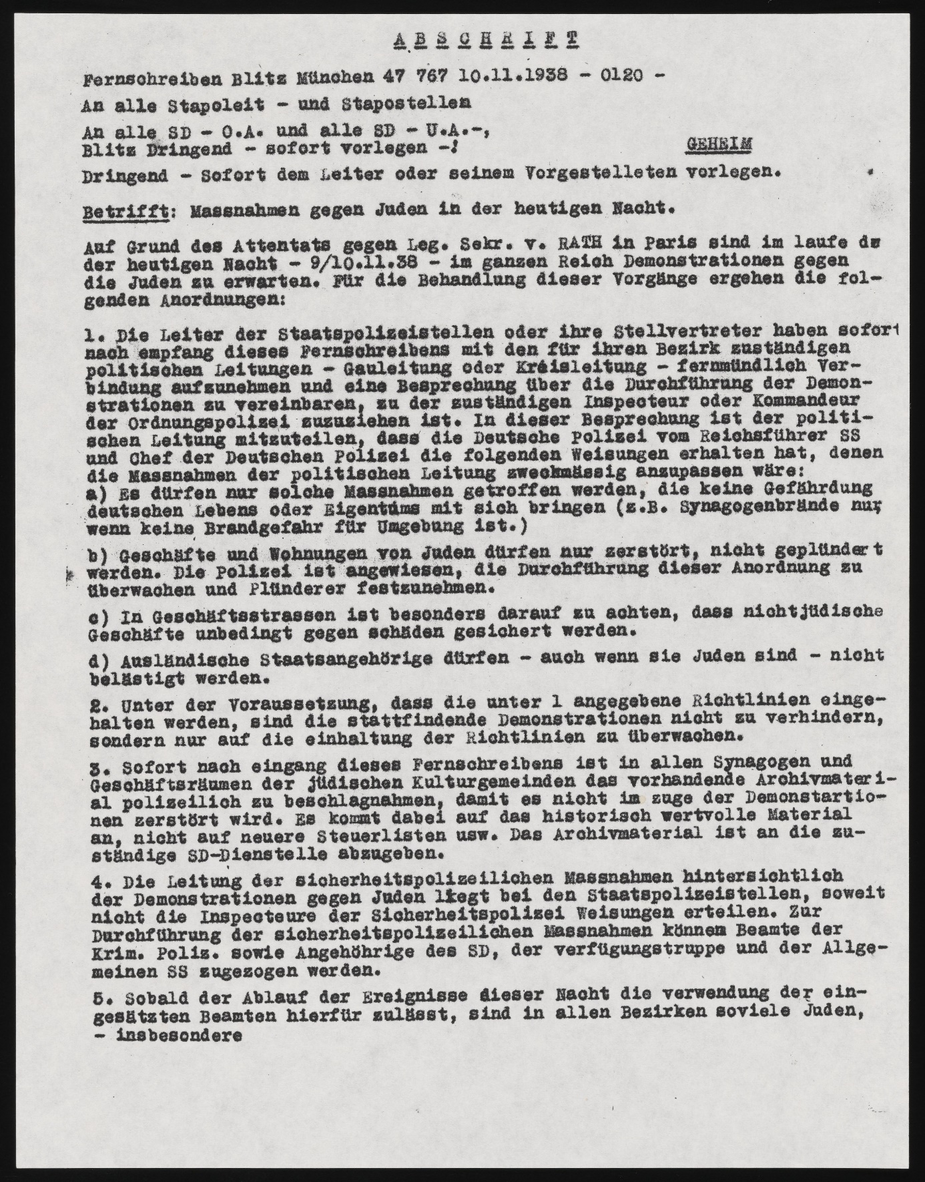
Ref: (USHMM, 2025)
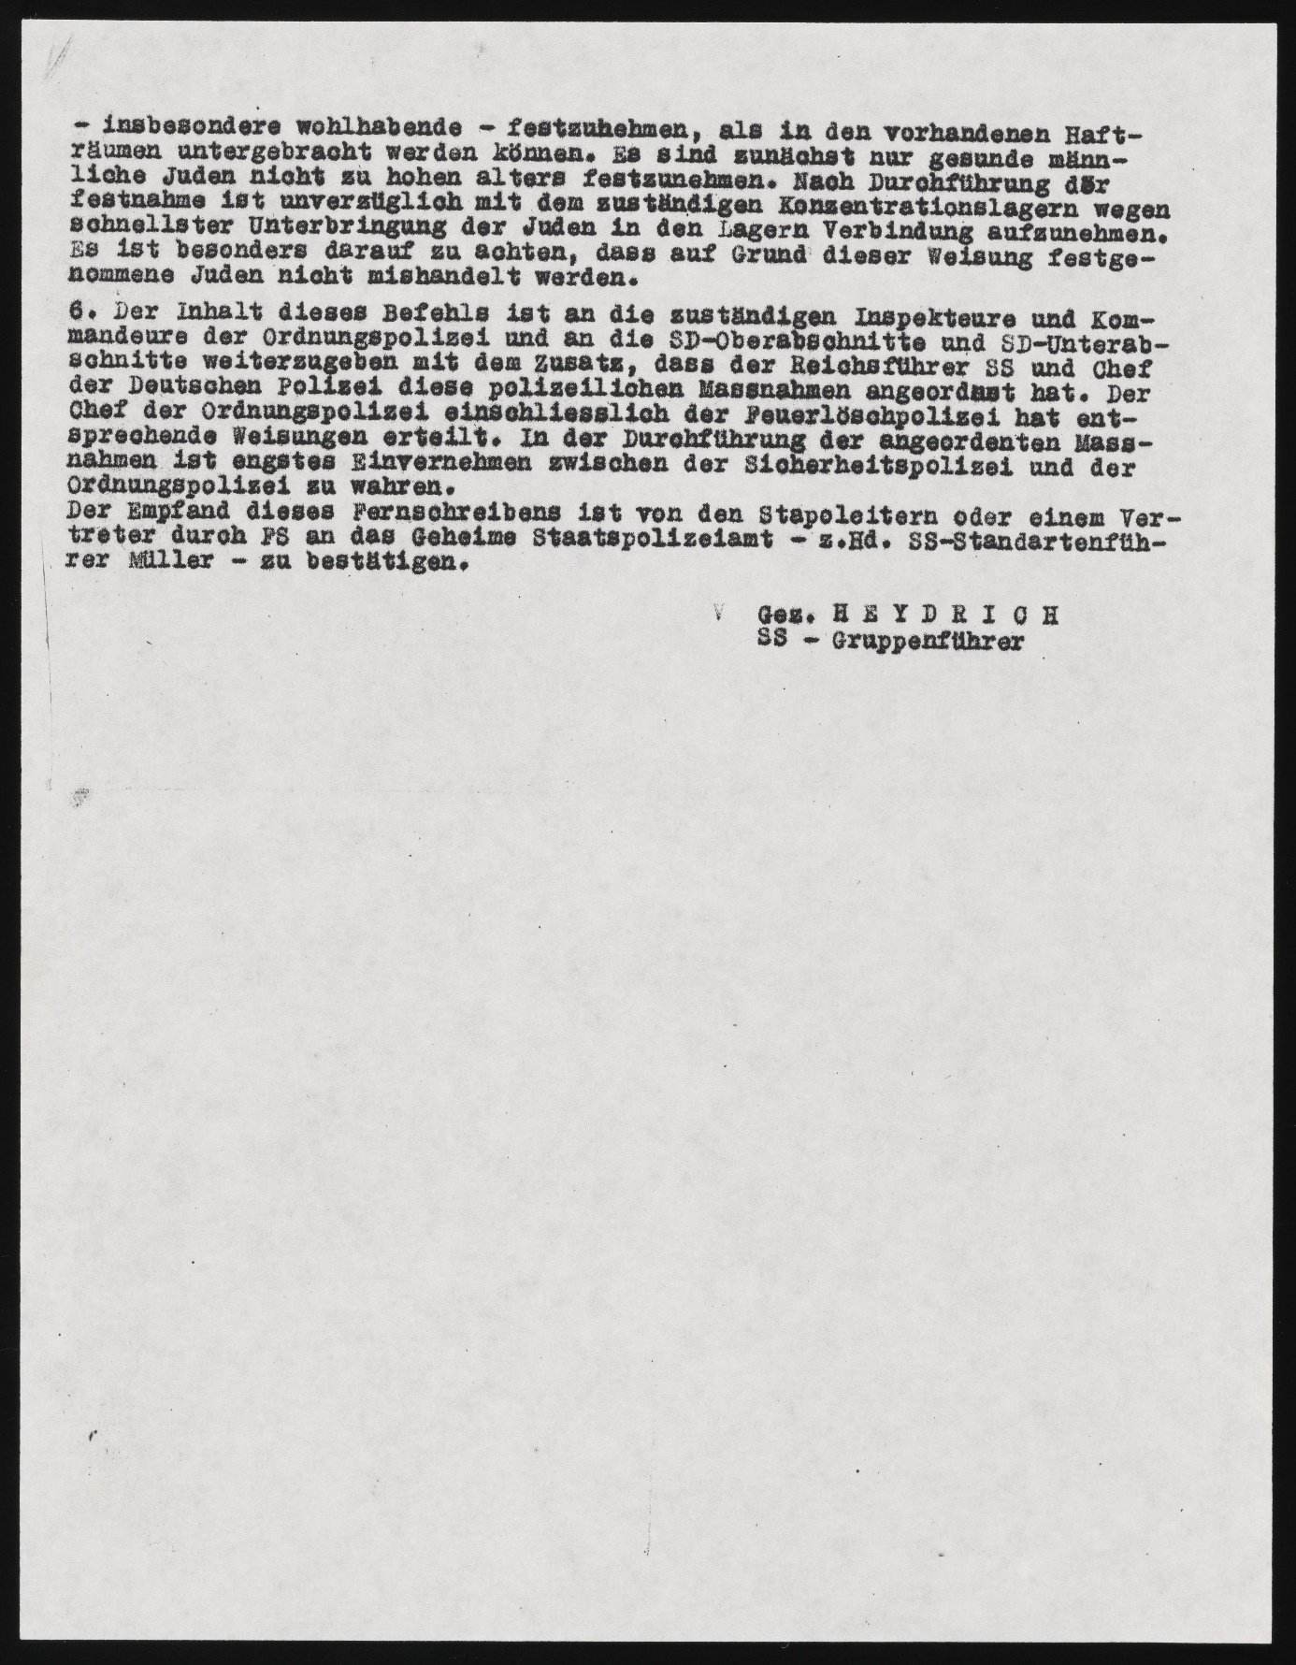
Ref: (USHMM, 2025)

APPENDIX B: Translated text of the Kristallnacht telegram by Reinhard
Heydrich dated 10th November 1938 at 1.20 am.

Copy of Most Urgent telegram from Munich on November 10, 1938, 1:20 a.m.
To all Headquarters and Stations of the State (Political) Police
To all Local and Regional Offices of the Security Service (SD)
Urgent! For immediate attention of Chief and his deputy!

Re: Measures Against the Jews Tonight.

Because of the assassination of Legation Secretary vom Rath in Paris, demonstrations throughout the Reich are to be expected tonight -- November 9 to 10, 1938. The following orders are issued for dealing with these occurrences.

1.) Upon receipt of this telegram, the chiefs of the political police [Gestapo] stations or their deputies must immediately contact the appropriate political authorities for their district [the local Nazi Party leaders]... by telephone to arrange a discussion about the conduct of the demonstrations. This discussion should include the competent Inspector or Commander of the Order Police.

[The local] political authorities are to be informed that the German police have received from the Reichsfuehrer SS and the Chief of the German police the following orders to which the actions of the political authorities should be correspondingly adjusted:

a) Only such actions may be carried out which do not threaten German lives or property (e.g., burning of synagogues only when there is no threat of fire to the surroundings).

b) Stores and residences of Jews may only be destroyed but not looted. The police are instructed to supervise compliance with this order and to arrest looters.

c) Special care is to be taken on commercial streets that non-Jewish businesses are completely secured against damage.

d) Foreign citizens, even if they are Jewish, may not be molested.

2.) Demonstrations in progress should not be prevented by the police but only supervised for compliance with the guidelines.

3.) Existing archival material is to be impounded by the police in all synagogues and offices of the Jewish community centres to prevent its destruction in the course of the demonstrations... [This material] is to be turned over to the... offices of the SD.

4.) The direction of Security Police [both political and criminal divisions] operations relating to the anti-Jewish demonstrations resides with Political Police authorities except when orders are issued by Security Police inspectors. Officials from the Criminal Police as well as members of the Security Service (SD), of the SS para-military units, and of the general SS may be called upon to carry out Security Police operations.

5.) As soon as the course of events during this night allows the assigned police officers to be used for this purpose, as many Jews -- particularly affluent Jews -- are to be arrested in all districts as can be accommodated in existing detention facilities. For the time being, only healthy male Jews, whose age is not too advanced, are to be arrested. Immediately after the arrests have been carried out, the appropriate concentration camps should be contacted to place the Jews into camps as quickly as possible. Special care should be taken that Jews arrested on the basis of this instruction are not mistreated.

6.) The contents of this order are to be passed on to the competent Inspectors and Commanders of the Order Police and to regional and local sectors of the SD....

The chief of the Order Police has issued the corresponding instructions to the Order Police including the fire brigades. Close coordination is to be maintained between the Security Police and the Order Police during the implementation of the ordered actions

signed: [Reinhard] Heydrich
SS-Gruppenführer
[SS-Major General, Nazi Chief of Security Police

Ref: (USHMM, 2025)

