
MARKETING PLAN OF HILTON HOTELS AND PRESENTATION

Student Name: Georgiana Pangonis
Student ID: 2245303
Course Name: BA International Hotel Management
Module title: Marketing Essentials BMIH4005
Lecturer Name: Dale Clarke
Word count: 1216 Component A
397 COMPONENT B

Table of Contents
Introduction 3
Situation analysis 3
Objectives 6
Strategy 7
Tactics 8
Action 9
Control 11
Conclusion 11
References 12
Presentation Introduction 14
Situational analysis 14
Objectives and strategy 14
Tactics 14
Action and control 15
Conclusion 15
References 16

Component A-Marketing Plan

Introduction
The purpose of the marketing plan is to define different strategies to engage the audience for achieving business objectives. The goal of the marketing plan is to ensure marketing activities are relevant, structured, and timely to achieve the desired objectives of the company. The present marketing plan focuses on the Hilton Hotels and the purpose of this marketing plan is to provide an innovative solution for dealing with rapid changes in the market during this post-pandemic period. This marketing plan is to be presented to the board of directors of Hilton Hotels along with the use of the Ansoff matrix, 5 C’s, RACE framework and SWOT analysis.

Situation analysis
5 ‘C’s
Company: SWOT Analysis
Strengths | Weaknesses
- Huge consumer base  - Satisfied employees and a positive workforce | - Bad reviews about the ambience of Hilton Hotels on social media are a major weakness.  - During the technological advancement, Hilton Hotel faced a data breach.
Opportunities | Threats
- Social media marketing  - Expansion to developed countries | - High competition  - Russia-Ukraine Conflict
Customers: Segmentation and targeting
Segmentation
As stated by Dolnicar (2022, p. 862), the four types of segmentation behavioural, demographic, psychographic and geographic help to divide the group of customers as per their attributes. Hilton Hotel follows demographic and psychographic segmentation and divides its customers as per their age, gender, income and lifestyle. Hence, people belong to 25 to 40 with luxurious lifestyles are the target customer of Hilton Hotels
Targeting

Age | 25 to 40 years old
Gender | Male. Female and LGBTQ+
Income | Medium to High
Competitors: Perceptual positioning map
Positioning
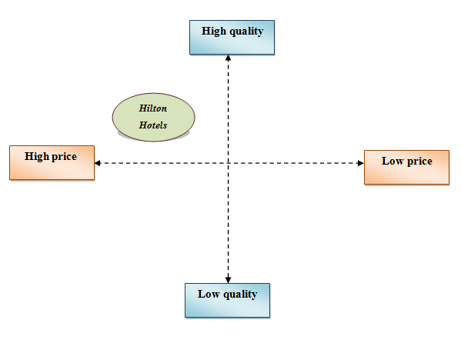
Figure 1: Positioning map
(Source: Developed by the author)
Bowman's strategy clock
As opined by Almutairi (2023, p. 410), Bowman's strategic clock is the marketing positioning of a company as per the inherent approach towards market adaptation. The eight positions of the clock are low-price & value-added, low price, focused differentiation, differentiation, monopoly pricing, risky high margins, hybrid, and loss of market share. Hilton Hotel follows the hybrid approach which allows the company to manage a moderate differentiation from its competitors along with dynamic prices to attract customers.
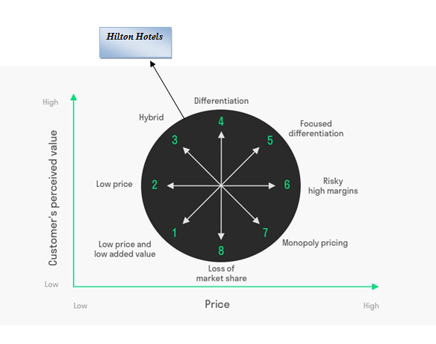
Figure 2: Bowman’s strategic clock
(Source: Developed by the author)
Collaborators: Demonstrations of awareness of your organisation's B2B Relationships, Partnerships, and Franchises
Hilton Hotels manages its operations through collaboration with B2C relationships which refers to the firm directly providing services to the customers. Hilton Hotels also has a partnership with exclusive global sponsor BringMe for operating the business in 122 countries with 7000 properties, (hilton.com, 2023).
Climate: PESTLE
Factors | Description | Impact
Political | Post-Brexit situation | Affect the supply chain relation of Hilton Hotels
Economical | High inflation | Reduce customer numbers
Social | Changing customer trends | Affect the annual income of Hilton Hotels
Technological | Advanced technology | Allow Hilton Hotels to use a digital marketing strategy
Legal | Employee Act 1996 | Satisfy employees need
Environmental | Sustainability | Positive brand image
Marketing Mix
Product | Hospitality service
Price | Competitive Pricing
Place | U.K and 122 countries
Process | Digital media marketing to attract customers
Physical evidence | 7000 properties
Promotion | Social media advertising
People | Knowledgeable and skilled employees

Objectives
Objectives | Specific | Measurable | Attainable | Relevant | Time-bound
To expand the business | Important to increase the sales and income of the business | By analysing the sales margin of the business and the growth process of Hilton Hotels all over the world | By using effective marketing strategy and digital media marketing by using the latest technology and social media platforms | Required for increasing sales and developing brand image | 6 months
To develop a customer base | Important to build a loyal customer base and improve the brand recognition to hold a strong position within the market | Through positive feedback from customers | Improving the services of Hilton Hotels | Needed to gain competitive advantage | 8 months to 1 year

Strategy
Ansoff matrix
As stated by Kurniawan et al., (2020, p. 129), market penetration, product development, market development and diversification are the four factors of the Ansoff Matrix that allow a business to determine the market and product growth strategies. Currently, Hilton Hotels is facing the issues of poor feedback from customers regarding the poor ambience. Hence, market penetration can be the most effective option for Hilton Hotels to improve the ambience and service. As per the views of Clarissia (2020, p. 18), market penetration focuses on expanding sales with the already existing product in the existing market. Therefore, this is the safest option for Hilton Hotels to expand the business with their known product and with a piece of detailed knowledge about the market. This knowledge can help Hilton Hotels to improve their hospitality services and hotel rooms with the help of the latest technologies to satisfy the needs of customers and provide an effective service to them.

Tactics
Hilton Hotels uses different social media platforms such as Facebook, Instagram, Pinterest and Twitter for communicating with its customers. The major issues which have been faced by Hilton Hotels in the present time are the poor reviews of customers regarding the ambience of the hotels. Hence, the application of the RACE model can be used by Hilton Hotels to improve communication with customers.
RACE framework
The four phases of the RACE framework are research, action & planning, communication & relationship building and evaluation, (Rautela, 2021).
Research | In this first stage, Hilton Hotels needs to identify how different social media platforms and other digital platforms can be used effectively to reach customers. The role of AI to build customer relationships can be applied by the firm for recognising customer trends and demands so that by using the latest technology those needs can be satisfied.
Action & Planning | In this phase, Hilton Hotels needs to develop an effective marketing plan by using digital platforms to meet the customer's needs and communicate with them. Different effective strategies can be used in this stage such as discounts, offers and additional customers to attract customers. The firm can also use third parties such as social media influencers for promoting the business on social media.
Communication & Relationship Building | Hilton Hotels can collect data from different sources of social media and identify the trends of customers. This can help the firm to improve the discount and offer strategies more so that they can attract more customers. Along with this, the rooms which are needed by the customers can be also identified in this stage hence Hilton Hotels can provide an outstanding experience to the customers.
Evaluation | In this stage, Hilton Hotels can build a strong customer base by providing them with the required service and achieving the desired goals of the company to get positive feedback about the company in social media platforms.

Action
Activities | Week 1 | Week 2 | Week 3 | Week 4 | Week 5 | Week 6 | Week 8 | Week 9 | Week 10
Conduct market research
Identifying the customer trends
Analysing the resources to choose the required information
Managing and controlling all the marketing activities
Review the activity
The above marketing activities can allow Hilton Hotels to overcome the issues faced by the customers within the specified period and hold a strong position in the market. Different marketing channels such as advertising, social media marketing, email marketing, search engine optimisation, display advertising and influencer marketing can be used for completing the overall task.

Control
Hilton Hotels can follow the below-mentioned metrics for measuring the success of the proposed marketing plan and resolving the issues.
Sales volume | As described by Chaffey and Smith (2022), an increasing sales margin indicates the effectiveness of the marketing strategy of the company that leads the firm to attract customers.
Customer acquisition cost | This allows determining the efforts of Hilton Hotels which are needed to generate customer conversion.
Website traffic generated | Higher traffic generation indicates that the company is aiming to increase market outreach, (Ferrell et al., 2021).
Increase of profit | Positive feedback from customers from different social media channels.
Brand perception | Increasing profit means the firm can meet customer trends.

Conclusion
Thus, it can be concluded that this present marketing plan identifies the contemporary issue which has been faced by Hilton Hotels. The business is currently facing the issues of negative feedback from customers regarding the ambience. Therefore, this marketing plan focuses on overcoming this issue with the application of different tools and techniques. Different models and frameworks are included in this assignment which allows the firm to adopt effective strategies and follow customer trends. The models such as Ansoff matrix, PESTLE and Bowman’s strategic clock have been mentioned in this writing along with the positioning map for the brand to hold a strong position in the market.

References
Books
Chaffey, D. and Smith, P.R., 2022. Digital marketing excellence: planning, optimizing and integrating online marketing. Taylor & Francis.https://books.google.com/books?hl=en&lr=&id=GmmdEAAAQBAJ&oi=fnd&pg=PP1&dq=marketing+plan&ots=aux05CB_i4&sig=GBlyii5-7mApdfO1RC_Qy-w2Eio
Ferrell, O.C., Hartline, M. and Hochstein, B.W., 2021. Marketing strategy. Cengage Learning.https://books.google.com/books?hl=en&lr=&id=SewfEAAAQBAJ&oi=fnd&pg=PP1&dq=marketing+plan&ots=PgWxyCGi65&sig=8w_a7Uz1ckT_rvOs9vdwB_imNcA
PDFs and Journals
Almutairi, M.M.Q., 2023. The Impact Of Market Analysis On The Company Strategy. Journal of Positive School Psychology, pp.401-412.https://www.journalppw.com/index.php/jpsp/article/view/16345
Clarissia, S.M.S., 2020. A study on Ansoff Matrix Technique: As a growth strategy and an adaptive learning technique adopted in the leading brand of products. BIMS Journal of Management, p.18.https://bimskol.org/pdf/E-copy-BIMS-Journal-Management-Kolkata-Vol5-Issue-1-July-2020.pdf#page=26
Dolnicar, S., 2022. Market segmentation for e-tourism. In Handbook of e-Tourism (pp. 849-863). Cham: Springer International Publishing.https://link.springer.com/content/pdf/10.1007/978-3-030-48652-5_53.pdf
Kurniawan, D., Iswahyudin, M.D. and Suciati, T.R., 2020. SWOT Analysis and Ansoff Matrix in Creative Food Industry Business Development: A Study on Creative Food Business “Komala”. Open Access Indonesia Journal of Social Sciences, 3(2), pp.128-136.https://scholar.archive.org/work/zy4ikgnqbnfebmyqiv7orywolm/access/wayback/http://journalsocialsciences.com/index.php/oaijss/article/download/30/28
Rautela, S., 2021. Social Media for New Product Launch: A Study of Social Media Platforms Across the RACE Planning Framework. International Journal of Interactive Mobile Technologies, 15(5).https://pdfs.semanticscholar.org/b954/bb3bba5da4fa65435fd7e2cba4cbd0032bc9.pdf
Websites
hilton.com, 2023: Hotels by Hilton - book the best rates across all brands. Available at: https://www.hilton.com/en/ (Accessed: 19 May 2023).

Component B: Presentation

Introduction
This presentation discusses the marketing plan for Hilton Hotels in detail to overcome the issues of negative feedback from the customers about the ambience of the hotel. The aim of this presentation is to provide an innovative solution for Hilton Hotels to overcome the issue.

Situational analysis
As per the SWOT analysis of Hilton Hotels it has been identified that the major strength of the firm is the high consumer base and the satisfied employees. However, the weaknesses of the brand are poor reviews of the customers and data breach issues. Hilton Hotel currently follows the psychographic and demographic segmentation which allows the firm to divide the customers as per their age, income level and characteristics. The target customers of Hilton Hotels are people from 25 to 40 years both male, female and LGBTQ+ who belong to the medium to high-income group. Therefore, the firm follows high-price and high-quality service. As per Bowman’s strategy clock, it has been suggested that Hilton Hotels can follow the hybrid approach for managing the differentiation within the company to attract customers with dynamic pricing. The PESTLE analysis indicates that the firm is facing issues in this post-pandemic and post-Brexit issue regarding managing its supply chain. As per the marketing mix, the product of Hilton Hotels is its hospitality service and the firm follows a competitive strategy to gain a competitive advantage in the market.

Objectives and strategy
The objectives of Hilton Hotels are to expand the business and build a strong customer base to increase the annual revenue. On the other hand, as per Ansoff Matrix Hilton Hotels can follow the market penetration strategy by improving its existing product in the existing market to meet the customer's needs.

Tactics
As per the views of Sobande (2021, p. 133), the RACE framework includes four stages of action, act, convert and engage for meeting the customer's needs by applying an effective marketing strategy. Hence, in this process, Hilton Hotels can use different social media platforms to identify the needs of customers and improve their services to meet their needs.

Action and control
Hilton Hotel can follow the steps of developing market research, identifying customer needs, analysing resources, and managing, controlling and reviewing the overall marketing activities to overcome the identified issue. By measuring the sales volume, consumer acquisition cost, website traffic generation and increasing profit the overall marketing can be controlled.

Conclusion
Thus, it can be concluded that this presentation describes the marketing plan for Hilton Hotels that can help the company to overcome the issue of negative feedback from the customers. The application of the Ansoff matrix, RACE model, PESTLE and Bowman’s clock model has been discussed in this presentation for implementing the marketing plan successfully.

References
Sobande, F., 2021. Spectacularized and branded digital (re) presentations of black people and blackness. Television & New Media, 22(2), pp.131-146.https://journals.sagepub.com/doi/pdf/10.1177/1527476420983745

