
Research and Case Scenario in Data Security and Compliance
Data Security and Compliance
Computing (Games Development)

William Foot (2405192)
Contents
Zero Trust Architecture: A Critical Analysis 2
Abstract 2
Introduction 2
Principles 2
Implementation 4
Challenges 5
Efficacy Compared to Traditional Models 5
Conclusion 6
Case Scenario 8
Introduction 8
Organisation Structure 8
Policies & Procedures 9
Compliance 10
Governance & Strategy 11
Risk Management 12
Contingency Planning 13
Protection Mechanisms 14
References 16

Zero Trust Architecture: A Critical Analysis

Abstract
This document discusses the Zero Trust Architecture (ZTA) framework and how this approach can address some of the shortcomings of traditional network protection methods. It outlines the core principles of ZTA and the techniques used to enhance an organisation's network security. Strategies for implementing ZTA and the challenges associated with its practical implementation will also be discussed. This document will also compare ZTA to the traditional perimeter protection method, highlighting the benefits and drawbacks of each approach.

Introduction
ZTA is a cybersecurity framework comprising multiple interconnected security components. It uses the principle: never trust, always verify [1]. By default, it treats all devices, users, and applications as potential threats. ZTA constantly authenticates every access request to minimise the attack surface and increase security. Previously, it was thought that everything within the organisation’s network could be considered trusted. The traditional method of protection divided the network into two areas: internal and external. Firewalls and other security controls were deployed to the edge of the network, or perimeter, to separate and secure the internal network from the rest of the internet [2].
With hybrid and remote work becoming increasingly commonplace, allowing employees to work from anywhere, IT systems are no longer confined to a single, protected location. Users and Devices can connect from beyond the firewall, increasing the attack surface of a system and rendering the old method of network security inefficient [1], [2]. ZTA attempts to address this security issue by implementing improved authorisation verification methods, access controls, and algorithms for evaluating trust. The trust of the subject is no longer tied to its physical location, but rather obtained through several authentication methods and context evaluation [3].

Principles
The Zero Trust (ZT) model assumes that all entities are considered untrusted, both internally and externally. An entity must earn the system's trust by proving itself through authentication and authorisation procedures. Enforcing this authentication and authorisation process on every request gives the system more control and security when resources are accessed [1], [2].
ZT is made up of core security principles that will help an organisation approach how it can improve its security, data protection, and network access [1].

Never Trust, Always Verify
At the core of the Zero Trust model is the dismissal of implicit trust. All devices, users, or software are never trusted by default. Every request to access the system must be authenticated regardless of origin. Using this continuous verification process mitigates the risk of a compromised entity moving freely through the system. The verification of a trusted source involves not only authenticating the device but also implementing security policies and requirements. A source may need to meet some minimum security requirements before being allowed access to a resource [1], [2].
Trust can also be lost from sources. If a user or device starts to request resources and data outside of its scope, or there are multiple login attempts in quick succession, the source's level of trust could be reduced. A Multifactor Authentication (MFA) system can be used to establish an initial level of trust and can provide an extra layer of security for any login attempts [2].

Restrict Access
ZTA also uses the least privilege principle, ensuring that users and devices have the minimum level of access necessary [1]. Users and devices can only access the parts of the system that directly relate to their role. The level of access can be decided by two things: identity and role. Authorisation is mapped to a subject’s identity, and access to different resources can be assigned using an Access Control List (ACL). However, this approach lacks scalability for settings where roles can change for individuals or groups, as authorisation would constantly have to be revisited for each identifier when changes are needed. A Role-Based Access Control (RBAC) assigns access to resources through a role and then applies that role to a subject. This allows for the creation of groups where access to resources can be changed for multiple subjects simultaneously. For example, all users with the Finance role could view payroll, whereas users with the Developer role would not [4].

Assume Breach
When using ZTA, you assume that a breach is not a possibility to be avoided; it is an inevitability. Instead of thinking that all threats are external, you presume that attackers may already be within the system. This mentality makes security professionals design tools and controls that contain threats that have already breached the first line of defence. Professionals focus more on monitoring and rapid response to minimise the impact of the breach [1], [5].

Context-Aware Access Policies
The decisions of ZTA are not set in stone; contextual data informs them to provide dynamic responses. Factors such as a user's identity, location, and data requested are all analysed to inform a response. A policy may prohibit a user from accessing sensitive data from a public wifi network or from a non-company-issued device. In this case, the IP address is being used to flag that the user may pose a security risk, even though the entered credentials are correct. [1], [4].

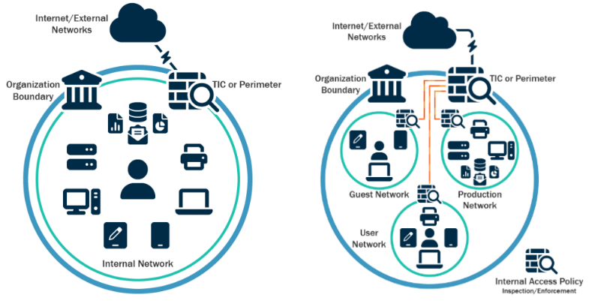
Microsegmentation
Figure 1. An unsegmented network (left) and a segmented network (right) NOTE:add reference #stopRansomeware
Networks can be divided into separate, isolated zones, which can prevent attackers from easily moving across the network, thereby reducing the impact of a breach. It also allows security teams to create resource-specific access policies [1]. Although microsegmentation can help reduce the lateral movement of attackers, it can prove challenging to implement correctly. Improper policies and access rules can lead to misconfiguration. Larger networks with multiple workflows can be complex to segment, as all possible interactions between workflows must be identified and translated into accurate policies. If done incorrectly, it can lead to disruptions in existing workflows [4].

Implementation
Implementing or migrating to a ZTA in a business can be a time-consuming process and presents some challenges [6]. ZTA extends beyond network controls; a layered and incremental approach must be taken to ensure that the key pillars: identity, devices, networks, and data are all secure [1]. The process for implementing a ZT environment is divided into different steps, each of which applies the framework to a different component [6].
The initial step should focus on identifying the protecting surface, mainly the data, assets, applications, devices, and services of the business. All user and machine identities should be managed and tracked; creating a device and user database can help track this information effectively. Then, two methods for identifying the device and the user requesting resources need to be created [2].
Next, implicit trust should be removed from the system. All devices should now be treated as if they are accessing resources from outside the network [2]. Authentication controls should be created to ensure that only authorised entities can access data. Access requests from the application layer should always be verified, and controls should be implemented to prevent unauthorised use. Sensitive data stored on the system should only be accessible by authorised personnel and applications [1], [6].
The network should be segmented, and user management and access should be implemented. The segmentation of the network will restrict the movement of unauthorised entities and allow for the implementation of precise policies for different areas of the network. Then, ZT policies should be created and enforced [1], [6].
Finally, a suitable monitoring and maintenance system should be established to ensure that the new ZTA can effectively protect the system. The continuous monitoring of a network is vital to the proper implementation of a ZTA. It helps to maintain the correct level of trust for each source and detect any inconsistencies in a source’s behaviour, which is necessary information in managing trust levels. Any endpoints or Internet of Things (IoT) devices must be continuously assessed to ensure that they remain uncompromised [1], [2], [6].

Challenges
One of the biggest challenges when implementing ZTA is avoiding disruptions to users during migration and deployment. First, the business would deploy the new ZTA approach and encourage the users to switch to this service. Then, the company should allow some time for users to switch while also imposing restrictions on the old method to encourage users to do so. Finally, the old method should be deprecated and removed, leaving only the new ZTA approach [2]. The business may encounter technical issues during each step, which could result in user disruption at each phase. Depending on the business type, this could impact revenue loss [6].
Older systems, applications, or infrastructure may also pose challenges when migrating to a new ZTA. Additional resources may need to be managed, or, in some cases, the legacy system may require modification or redesign. This will require more time and monetary investment from the business [6].
Some companies may want to restrict access to their systems to only company-owned or managed devices. This allows them to control the types of devices their employees use and the software installed on them. However, this may not work for another company that uses a bring-your-own-device (BYOD) policy, as it creates a privacy issue when the company attempts to install monitoring software on private devices [7].
The creation of a new ZTA introduces additional policies that staff members must now learn and follow. The creation of these new policies can prove a challenge for the business, as they must comply with the intended goal, remain consistent, and avoid introducing redundant policies. These policies must now be enforced and adhered to by the staff for the ZTA to perform to its highest standard. If policies aren't followed, then system security will suffer as a result [7].

Efficacy Compared to Traditional Models
While traditional security methods focused on protecting the system's perimeter, they also trusted internal sources and safeguarded against external threats [8]. With more data being stored in the cloud, hybrid working, and BYOD policies, the perimeter of a system is now too large to rely solely on traditional methods [1]. As a result, the conventional perimeter-based method of protection has become less effective in protecting businesses from cyber threats [6].
The traditional model focuses on preventing threats from entering the system through firewalls, VPNs, and other boundary defences. But once the perimeter is breached, the attackers can move through the system with little resistance. ZT instead focuses on verifying each device, external or internal, and controlling access to resources [5].
Compared to the traditional security model, implementing ZTA into business security offers several benefits:
Improved Security: By enforcing least privilege access and continuous authentication, ZTA reduces the attack surface and prevents unauthorised users from accessing data. Allowing users only to access the data they need with access controls reduces the insider threat [1]. By taking a proactive approach to security, the organisation can reduce the risk of a data breach. ZTA utilises authentication for every request, even if the compromised device is already connected to the network [1], [5].
Improved Visibility, Monitoring, and Response: By utilising continuous monitoring and logging, an organisation can more effectively detect threats or anomalies and respond faster. And with least privilege access, constant monitoring, and behavioural analytics, it is easier to detect and combat insider threats before irreversible damage can be done [1], [5].
Reduced Risk of Advanced Persistent Threats (APTs): By using microsegmentation to isolate network segments and verifying access at each stage, ZTA can minimise the impact of attacks and contain those that attempt to spread to other areas of the system [1]. If an attacker does breach the system, their movements will be monitored, and with a segmented network, the potential damage can be reduced [5].
Scalability: ZTA can be easily scaled to accommodate a large number of devices, users, and applications, allowing businesses of all sizes to take advantage of the enhanced security [1].
Support for Remote Work and Cloud Environments: Traditional perimeter-based security is no longer sufficient for the dynamic environment introduced with cloud computing. The ZTA model offers a flexible framework that can be applied to online workers and cloud environments, such as IoT. Verifying the identity and device before allowing remote access to the system. Ensuring secure access for everyone, not just the on-site workforce. The framework can be adapted to changes in the network, user behaviour, and new threats [1], [5].

Conclusion
The traditional model of perimeter-based security still protects systems from cyber threats, but it lacks the flexibility and proactive approach that a ZT model provides [5]. In the modern work environment, cloud services have become commonplace, with many organisations adopting them. The perimeter of an organisation's network no longer ends at the office door; the introduction of remote work has allowed employees to work from anywhere, providing flexibility for the organisation but posing new security challenges. Transitioning to a ZT model where implicit trust is no longer given to subjects, internal or external, can help improve network security. By adhering to ZTA’s core principles, the organisation can take a more granular, refined, and proactive approach to network security. However, as mentioned, implementing a ZTA can be a time-consuming process. A practical implementation of a ZTA must be thoroughly researched and tailored to suit the organisation's specific needs. Once a ZTA has been created and policies have been outlined, they must be consistently upheld by the staff; otherwise, the system's security will suffer.

Case Scenario

Introduction
Security policies are a crucial part of daily business; they ensure that IT resources comply with data regulations and protect the organisation's data. When expanding a business to a new economic zone, understanding the new data regulations that you will encounter is key. Current policies and procedures must be assessed to ensure they meet the requirements of these new regulations; if not, new policies need to be implemented, or existing ones reevaluated to ensure compliance. This document outlines policies and procedures that can be implemented to comply with the EU's data regulations. It also outlines some of the core principles of DORA and NIS2.

Organisation Structure
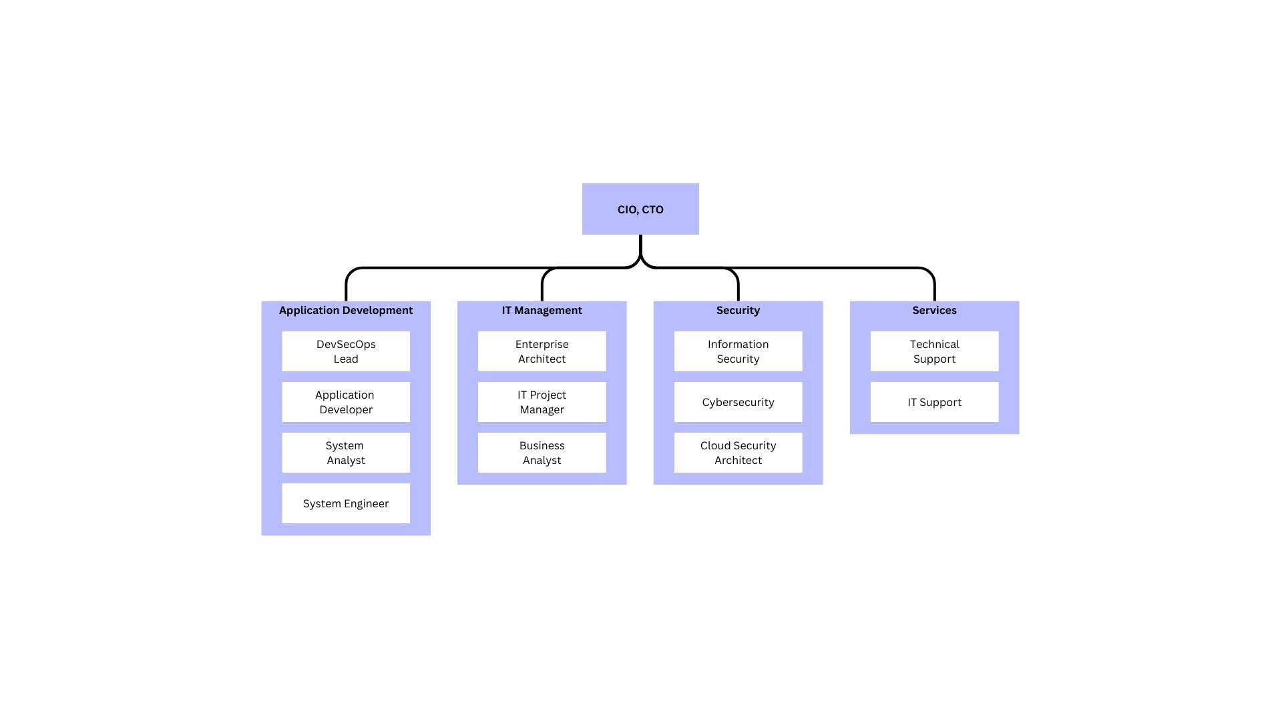
With the additional workload of this expansion, two new roles have been proposed: a Cloud Security Architect and a Development, Security, and Operations (DevSecOps) lead.
Figure 2. Example Organisational Structure

The example above illustrates an organisational structure, and the two proposed roles are added [9].
The DevSecOps Lead will be responsible for collaborating with the development team to integrate security practices throughout the software development lifecycle. They will test new systems and applications to verify that they meet security standards. It is their responsibility to develop security strategies and promote cybersecurity awareness throughout the development process [10]. The role also requires familiarity with automation tools to identify software vulnerabilities. Implementing a DevSecOps Lead into the organisation's structure will help identify security flaws early in an application's development, allowing for quick remediation. They will also help improve the team's security awareness and training, resulting in higher-quality security [11].
With ResilientIntellect’s focus on hybrid work and cloud storage and services, it is essential to introduce a Cloud Security Architect role. They will be responsible for designing, building, and overseeing the implementation of network and cloud security. They will also establish and review security policies and provide training to educate staff on best-practice security protocols. They will also conduct regular system checks to ensure consistent monitoring of cloud systems is achieved. They will work closely with the development team to design and implement effective cloud solutions. Collaboration with the security team will be required to respond to potential threats [12], [13].

Policies & Procedures

AI Usage
AI tools can enhance services by automating tasks and procedures, thereby improving efficiency and productivity. However, they do pose a risk, and employees should have guidelines on how to use these tools responsibly.
The DWP Artificial Intelligence security policy outlines user responsibilities when using AI tools and features, as well as policies that can be adopted [14]. Such as:
- Listing approved AI tools for employee use
- Users must receive approval before entering any personal or sensitive information or code into AI tools
- Listing standards of behaviour for interacting with AI tools
- Ensuring data provided to AI tools is correct
- Output of AI tools must be checked for accuracy and reliability
- Data protection principles must be adhered to when interacting with AI tools

Secure SaaS Configuration
SaaS policies should prioritise access control and encryption to ensure secure access to the public cloud. These tools must encrypt all data that flows through the application. Threats to SaaS are: misconfiguration and data exposure [15], [16], [17]. Policies should be implemented to address these issues.
For example:
- Use Single Sign On (SSO) where possible to increase security
- Use MFA to prevent unauthorised access
- Use the Zero Trust model to always verify logins
- Use least privileged access
- Regular audits to ensure no sensitive data is exposed due to outdated sharing settings
- Sensitive data should be encrypted
- Password security standards should be implemented for all accounts

BYOD
As ResilientIntellect uses a hybrid workforce, some employees will use privately owned devices. Security policies must be established to allow employees to use their personal devices for work purposes. These devices can be vulnerable to loss, theft, and malware; therefore, steps must be taken to mitigate risk when using them.
Purplesec features a BYOD security policy template that outlines many of the necessary policies and procedures that can be used to keep the organisation's data secure [18]. For example:
- Central management of BYOD devices.
- The right to block suspicious devices on the network
- Installing antivirus software on these devices
- Registration of BYOD devices
- Devices must feature an authentication lock, such as a fingerprint or a password that adheres to the password policy
- Immediate reporting of lost or stolen devices

Compliance
When expanding into the EU, the requirements of the Digital Operational Resilience Act (DORA) must be met. A proactive approach must be taken before fully committing to business within the EU to avoid damage to legal status and monetary gain. DORA is a regulation that ensures that “financial entities can withstand, respond to, and recover from ICT disruptions, such as cyberattacks or system failures” [19]. As ResilientIntellect is an ICT service provider, DORA will be applicable. A compliance gap analysis must be done to identify non-compliant areas that should be addressed [20].
To comply with DORA, ResilientIntellect must abide by the five pillars: ICT risk management, incident reporting, digital operational resilience testing, management of third-party risk, and information sharing [21], [22]. Under Chapter II of DORA, ResilientIntellect must take a proactive approach that addresses vulnerabilities before they escalate into serious issues, utilising monitoring of key systems, data, and connections. Under Chapter III, the process of incident reporting must be standardised. Systems should be put in place to monitor and report any ICT incidents to the relevant authorities. ICT systems should undergo regular vulnerability assessments, performance testing, and penetration testing, among other assessments, as outlined in Chapter IV. It is ResilientIntellect’s responsibility to ensure that any third-party systems used also comply with DORA, as covered in Chapter V. Finally, Chapter VI promotes the sharing of threat intelligence to foster a collaborative environment [21], [22], [23], [24].
ResilientIntellect must also comply with NIS 2 reporting obligations. Ensuring that the relevant entities are notified in the event of an incident. Systems should be implemented that can accurately record the severity and impact of the incident, as well as monitoring systems that aid in investigating the root cause [25].

Governance & Strategy
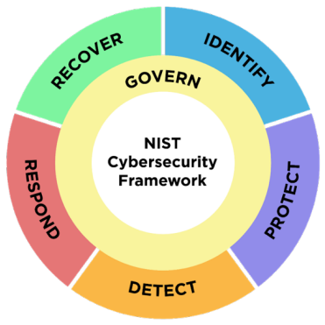
The NIST Cybersecurity Framework (CSF) 2.0 guides organisations to manage cybersecurity risks [26].
Figure 3. NIST Cybersecurity Framework [26]
Using this framework, ResilientIntellect aims to govern the ethical, secure, and compliant use of AI. This includes understanding the values, principles, and techniques to guide conduct in the development of its AI-powered tools [27]. ResilientIntellect also aims to protect customer data by adhering to relevant cybersecurity standards and providing the best possible consultancy services. To do this, a Zero-Trust aligned security program will be implemented to protect both software and customers. Relevant policies will also be implemented in accordance with the Zero Trust Framework. Clear accountability and oversight for cybersecurity will also be outlined.
A governance body will be established to oversee the implementation and compliance with this framework. It will consist of [28]:
- CISO: Addresses protection and threat vectors.
- CPO: Interprets regulatory obligations.
- CDO: Ensures data quality
The sensitive user data, the AI model, and the training data are all assets that need protecting. Backups should be implemented to prevent data loss, and a least-privilege access policy should be established to avoid theft or corruption of sensitive data. The Zero-Trust model can provide a framework for implementing the necessary procedures needed to ensure the protection and security of data. And methods of monitoring network activity to prevent incidents [1], [5].
Recovery plans and network best practices should also be implemented to restore normal operations in the event of a cyberattack quickly. For example, maintaining backup servers that can be used to repair any corrupted or lost data [29].

Risk Management
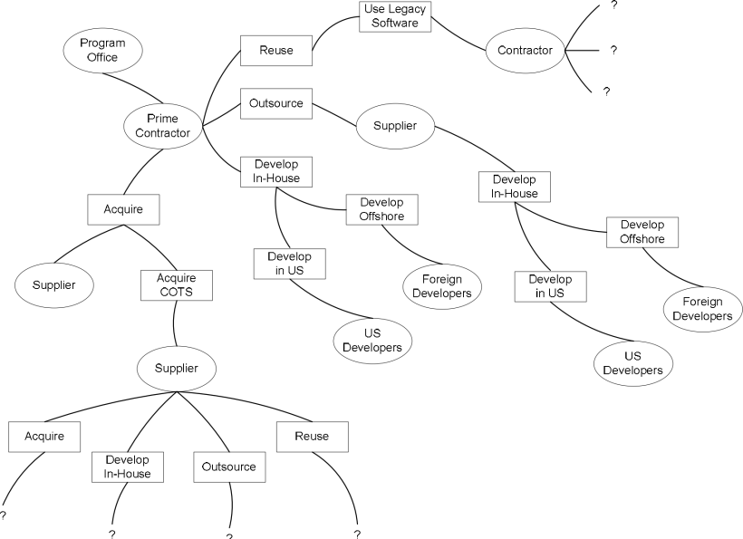
It is ResilientIntellect’s responsibility to maintain a secure software supply chain, ensuring uninterrupted business operations.
Figure 4. A software supply chain NOTE: add reference “A Systemic Approach for Assessing Software Supply-Chain Risk” below

The figure above illustrates the complexity of a software supply chain. Software used by a business can be from multiple organisations in different countries with varying data protection regulations, or open-source, allowing for freely available source code [30].
Threat actors can manipulate software communication to send malicious updates or block patches, allowing them to exploit unpatched vulnerabilities. This could happen to the software and servers we provide or use, resulting in damage to our business and customers. To avoid this, care should be taken when researching new suppliers, and monitoring should be implemented to verify that they are taking the necessary steps to protect their services [31].
As ResilientIntellect’s core software is AI-powered, it must be especially vigilant of AI data poisoning. This is when an attacker manipulates the training data of an AI or machine learning model to produce biased or dangerous results. This can have severe consequences for businesses, especially ResilientIntellect’s threat analysis software, as damaging this could have cascading consequences for all its customers. This type of attack can come from insider threats, supply chain attacks, and unauthorised access. To prevent this, ResilientIntellect should implement data validation and monitoring on training data to identify any malicious data or changes before it is fed to the AI model. A diverse set of data should also be used to avoid bias and reduce the impact of a single corrupt data source. A least privilege access approach should be taken so that only authorised employees have access to the AI model and its training data [32].

Contingency Planning
A ransomware attack has the potential to disable an organisation completely. If the training data or source code for the AI software is stolen and encrypted, the entire business has the potential to fail. A contingency plan must be put in place to minimise downtime caused by an attack.
Three scenarios could occur during a ransomware attack. First, the data could remain unaffected due to security measures, and the only disruption would be caused by disabled computers, which would limit accessibility. Second, data could be disabled but recoverable from an unaffected backup. Finally, the data could be lost permanently [33].
A backup copy of the training data and source code should be regularly maintained and stored on a separate, encrypted offline network. These backup locations should be physically separate from the central server to ensure their protection and reduce the impact of potential data loss [29], [33], [34].
The MS-ISAC #StopRansomeware Guide [29] has a ransomware and data extortion response checklist that has steps to follow in the event of an attack.
The checklist is as follows [29]:
1. Infected systems should be identified and isolated. This includes devices connected to the network. Snapshots of cloud services should be taken for later investigation.
2. Devices that cannot be disconnected should be powered down to reduce further spread.
3. Identify systems for restoration and recovery on a clean network.
4. Examine monitoring systems and logs to identify additional systems or malware used in the attack.
5. Document the initial understanding of the attack based on initial analysis.
6. Begin an investigation to find the source of the attack.
7. Follow notification requirements in relevant cyber incident reporting plans to keep in compliance with data protection regulations if the incident results in a data breach.
8. Take snapshots of affected systems and devices and collect any relevant logs.
When attempting to restore the network after an incident, it is crucial not to re-infect clean systems. If data was lost, use the backup to restore the network. Password resets should be issued for affected users and systems to avoid unauthorised access. Finally, the incident should be fully documented from detection to response to refine policies, plans, and procedures [29].

Protection Mechanisms
New, modern security controls should be implemented to enhance security in the environment and ensure regulatory compliance.

Cloud Security Posture Management (CSPM)
CSPM tools provide automated visibility and continuous monitoring to help detect misconfigurations across cloud resources, thereby reducing the likelihood of breaches. As ResilientIntellect expands to the EU, the use of these tools will also help mitigate compliance violations across the shared cloud environments. The CSPM tools will automatically compare cloud infrastructure with compliance requirements and guide in the event of a violation [35].

Security Information and Event Management (SIEM)
SIEM solutions collect event data from across IT systems, including operating systems, databases, and applications. This can then be used to generate alerts and automated responses to potential security concerns. This tool will help monitor and analyse large volumes of data, allowing for a quicker response. It can also aid security compliance by maintaining data logs for auditing [36].

Endpoint Detection and Response (EDR)
EDR focuses on detecting advanced threats that have successfully entered the environment. Eventually, threats will bypass environmental security, and there must be fallbacks in place to mitigate the damage advanced threats can cause. An EDR can help detect, investigate, and address advanced threats that penetrate traditional perimeter defences, such as ransomware that encrypts data and holds it hostage, which can be particularly devastating [37].

Phishing-Resistant MFA
The most common implementation of phishing-resistant MFA uses a device, like a smartphone, as the token. Registering your device with the account creates a cryptographic key pair. When attempting to access the system from a computer, the authentication device must be connected via USB or NFC, and the user must then provide a biometric scan to verify that the device is still in their possession. The website will now recognise and trust that device, allowing it to connect to the network. No code can be shared with others, making it a much more secure option for MFA [38].

References
[1] ‘What Is Zero Trust Architecture? Key Elements and Use Cases’, Palo Alto Networks. Accessed: Jan. 07, 2026. [Online]. Available: https://www.paloaltonetworks.com/cyberpedia/what-is-a-zero-trust-architecture
[2] S. Teerakanok, T. Uehara, and A. Inomata, ‘Migrating to Zero Trust Architecture: Reviews and Challenges’, Secur. Commun. Netw., vol. 2021, no. 1, p. 9947347, 2021, doi: 10.1155/2021/9947347.
[3] Y. He, D. Huang, L. Chen, Y. Ni, and X. Ma, ‘A Survey on Zero Trust Architecture: Challenges and Future Trends’, Wirel. Commun. Mob. Comput., vol. 2022, no. 1, p. 6476274, 2022, doi: 10.1155/2022/6476274.
[4] N. F. Syed, S. W. Shah, A. Shaghaghi, A. Anwar, Z. Baig, and R. Doss, ‘Zero Trust Architecture (ZTA): A Comprehensive Survey’, IEEE Access, vol. 10, pp. 57143–57179, 2022, doi: 10.1109/ACCESS.2022.3174679.
[5] S. Houghton, ‘Zero Trust vs Traditional Perimeter Security: What’s the Difference?’ Accessed: Jan. 08, 2026. [Online]. Available: https://www.aztechit.co.uk/blog/zero-trust-vs-traditional-perimeter-security
[6] P. Phiayura and S. Teerakanok, ‘A Comprehensive Framework for Migrating to Zero Trust Architecture’, IEEE Access, vol. 11, pp. 19487–19511, 2023, doi: 10.1109/ACCESS.2023.3248622.
[7] E. Bertino, ‘Zero Trust Architecture: Does It Help?’, IEEE Secur. Priv., vol. 19, no. 5, pp. 95–96, Sep. 2021, doi: 10.1109/MSEC.2021.3091195.
[8] P. Dhiman et al., ‘A Review and Comparative Analysis of Relevant Approaches of Zero Trust Network Model’, Sensors, vol. 24, no. 4, Feb. 2024, doi: 10.3390/s24041328.
[9] ‘What is an IT Organization? | Definition TechTarget’, Search CIO. Accessed: Jan. 11, 2026. [Online]. Available: https://www.techtarget.com/searchcio/definition/IT-organization-information-technology-organization
[10] ‘DevSecOps Engineer Roles & Responsibilities’, AI Security Automation. Accessed: Jan. 11, 2026. [Online]. Available: https://swimlane.com/blog/devsecops-roles-responsibilites/
[11] E. Miller, ‘Understanding DevSecOps Roles and Responsibilities’, Invensis Learning Blog. Accessed: Jan. 11, 2026. [Online]. Available: https://www.invensislearning.com/blog/devsecops-engineer-essential-skills-and-qualifications/
[12] R. Guevarra, ‘Security Architect: Roles, Responsibilities, and Distinctions’, Medium. Accessed: Jan. 11, 2026. [Online]. Available: https://medium.com/@raleighguevarra/security-architect-roles-responsibilities-and-distinctions-55bd8fa2260f
[13] A. Chia, ‘The Cloud Architect Role: An Overview of Responsibilities & Skills’, Splunk. Accessed: Jan. 11, 2026. [Online]. Available: https://www.splunk.com/en_us/blog/learn/cloud-architect-role-responsibilities.html
[14] ‘Artificial Intelligence Security Policy’, GOV.UK. Accessed: Jan. 11, 2026. [Online]. Available: https://www.gov.uk/government/publications/dwp-procurement-security-policies-and-standards/artificial-intelligence-security-policy
[15] ‘SaaS Security 101: The Definitive Guide | NordLayer’. Accessed: Jan. 11, 2026. [Online]. Available: https://nordlayer.com/blog/saas-security-guide/
[16] J. Silberman, ‘SaaS Security Best Practices and Strategies for 2025 | Valence Security’. Accessed: Jan. 11, 2026. [Online]. Available: https://www.valencesecurity.com/resources/ saas-security-best-practices-and-strategies-for-2025
[17] ‘Using Software as a Service (SaaS) securely’. Accessed: Jan. 11, 2026. [Online]. Available: https://www.ncsc.gov.uk/collection/cloud/using-cloud-services-securely/using-saas-securely
[18] ‘Information & Cyber Security Policy Templates’, PurpleSec. Accessed: Jan. 11, 2026. [Online]. Available: https://purplesec.us/resources/cyber-security-policy-templates/
[19] ‘Digital Operational Resilience Act (DORA) - European Insurance and Occupational Pensions Authority’. Accessed: Jan. 10, 2026. [Online]. Available: https://www.eiopa.europa.eu/digital-operational-resilience-act-dora_en
[20] ‘PDF’. Accessed: Jan. 10, 2026. [Online]. Available: https://www.theseus.fi/bitstream/handle/10024/805417/Gusiv_Pavel.pdf?sequence=2&isAllowed=y
[21] A. Uberoi, ‘What are the 5 pillars of the EU DORA regulation?’ Accessed: Jan. 10, 2026. [Online]. Available: https://www.cm-alliance.com/cybersecurity-blog/what-are-the-5-pillars-of-the-eu-dora-regulation
[22] C. Amblard-Ladurantie, ‘Digital Operational Resilience Act: DORA The 5 Pillars Explained | Bizzdesign’. Accessed: Jan. 10, 2026. [Online]. Available: https://bizzdesign.com/blog/five-pillars-digital-operational-resilience-act
[23] ‘REGULATION (EU) 2022/2554 OF THE EUROPEAN PARLIAMENT AND OF THE COUNCIL of 14 December 2022’. Accessed: Jan. 10, 2026. [Online]. Available: https://eur-lex.europa.eu/legal-content/EN/TXT/PDF/?uri=CELEX:32022R2554&from=FR
[24] ‘Joint Guidelines on the oversight cooperation and information exchange between the ESAs and the competent authorities under Regulation (EU) 2022/2554’. Accessed: Jan. 10, 2026. [Online]. Available: https://www.eiopa.europa.eu/document/download/243b423e-404d-4a4d-bd2b-b7a0fa4779ed_en?filename=Joint-guidelines-on-oversight-cooperation-and-information-exchange-between-the-ESAs-and-the-competent-authorities-under-DORA_EN.pdf
[25] ‘NIS 2 Directive, Article 23: Reporting obligations’. Accessed: Jan. 10, 2026. [Online]. Available: https://www.nis-2-directive.com/NIS_2_Directive_Article_23.html
[26] National Institute of Standards and Technology, ‘The NIST Cybersecurity Framework (CSF) 2.0’, National Institute of Standards and Technology, Gaithersburg, MD, NIST CSWP 29, Feb. 2024. doi: 10.6028/NIST.CSWP.29.
[27] ‘Understanding artificial intelligence ethics and safety’, GOV.UK. Accessed: Jan. 11, 2026. [Online]. Available: https://www.gov.uk/guidance/understanding-artificial-intelligence-ethics-and-safety
[28] madison, ‘Building a NIST Data Governance Framework’, Congruity 360. Accessed: Jan. 11, 2026. [Online]. Available: https://www.congruity360.com/blog/building-a-nist-data-governance-framework-csf-2-0-dgm-profile/
[29] ‘#StopRansomware Guide’.
[30] C. J. Alberts, A. J. Dorofee, R. Creel, R. J. Ellison, and C. Woody, ‘A Systemic Approach for Assessing Software Supply-Chain Risk’, in 2011 44th Hawaii International Conference on System Sciences, Jan. 2011, pp. 1–8. doi: 10.1109/HICSS.2011.36.
[31] C. S. E. Canada, ‘Protecting your organization from software supply chain threats – ITSM.10.071’, Canadian Centre for Cyber Security. Accessed: Jan. 11, 2026. [Online]. Available: https://www.cyber.gc.ca/en/guidance/protecting-your-organization-software-supply-chain-threats-itsm10071
[32] ‘What is AI data poisoning?’ Accessed: Jan. 11, 2026. [Online]. Available: https://www.cloudflare.com/learning/ai/data-poisoning/
[33] P.-H. Chen, R. Bodak, and N. S. Gandhi, ‘Ransomware Recovery and Imaging Operations: Lessons Learned and Planning Considerations’, J. Digit. Imaging, vol. 34, no. 3, pp. 731–740, Jun. 2021, doi: 10.1007/s10278-021-00466-x.
[34] ‘Joint Cybersecurity Advisory - AA20-302A - Ransomware Activity Targeting the Healthcare and Public Health Sector’. Accessed: Jan. 11, 2026. [Online]. Available: https://www.cisa.gov/sites/default/files/publications/AA20-302A_Ransomware%20_Activity_Targeting_the_Healthcare_and_Public_Health_Sector.pdf
[35] ‘What Is CSPM? | Cloud Security Posture Management Explained’, Palo Alto Networks. Accessed: Jan. 10, 2026. [Online]. Available: https://www.paloaltonetworks.co.uk/cyberpedia/what-is-cloud-security-posture-management
[36] ‘What Is SIEM? - Security Information and Event Management’, Cisco. Accessed: Jan. 10, 2026. [Online]. Available: https://www.cisco.com/site/us/en/learn/topics/security/what-is-siem.html
[37] ‘What Is EDR? - Endpoint Detection and Response’, Cisco. Accessed: Jan. 10, 2026. [Online]. Available: https://www.cisco.com/site/us/en/learn/topics/security/what-is-endpoint-detection-response-edr-medr.html
[38] ‘What is Phishing Resistant MFA?’, SANS Institute. Accessed: Jan. 10, 2026. [Online]. Available: https://www.sans.org/blog/what-is-phishing-resistant-mfa

