Assignment due:

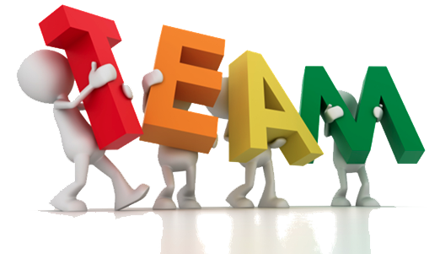
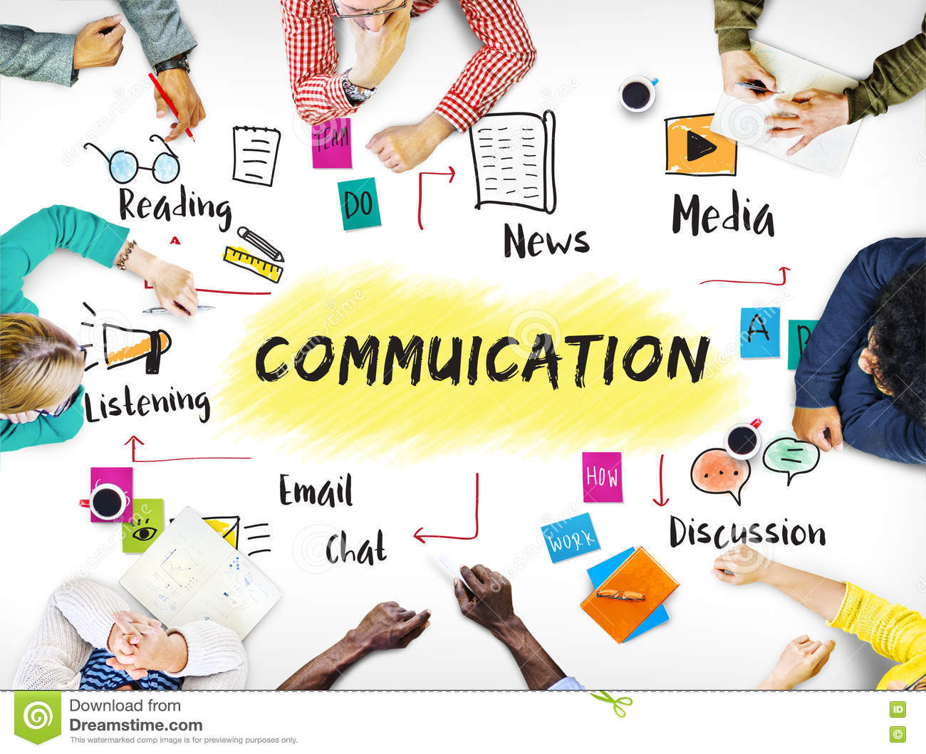
Effective team working and communication (BMS24002_BIRM)
-Shakira Yasmin Akther (2130089)

-Akash Puranik

Table of content:

- Introduction
Definition of team and teamwork
Characteristics of teamwork

- Model of teamwork – How can you develop a team based on the scenario using models –
Identify, discuss, and justify your preferred model then
Identify, discuss, and justify a second model
- Role for creating effective teams
Identify the roles using a theory
What are the roles
Why is it important to consider these roles when selecting a team?
4.0. Impact of effective teamwork on team success
Discuss the advantages of having an effective team
Discuss the barriers to teamwork in the case study
5.0. Conclusion/Recommendation
6.0. Reference List – minimum of 8 references using Harvard referencing style.

Summary
This report will consist of possible solutions for Tom to follow to help him build up his ambitious target of opening up three warehouses in the major cities of Europe. Even though Tom already has a team, his team are not a strong enough team to help achieve the goal he wants, there are many barriers which are stopping the team from progressing forward so we will help and identify the group’s weaknesses to ensure the goal they have set can be achieved in the best way possible. Lastly, we need to ensure the group are willing to put time and effort so that the opening of the warehouses are successful.

Introduction:

In this report we will be discussing how Tom can strengthen his team to make sure they reach the goal of them opening three other warehouses in Europe. We will look at both the teams strengths and weaknesses and see what they already have and what they need to improve on we can identify this by Tuckman’s model which will be expressed further within this report. There are also many other techniques that could be used to recognize any defaults within the group for example: Delphi technique, Nominal technique and Didactic interaction. Some techniques will work better than others and some may not even apply to the problem but that is where we need to see which technique is best to ensure we get the best outcome

Overview of teamwork:

What defines a team?

A team is a group of people who exist to accomplish specific tasks that are related to common goals. (Maund et al 2017).

What contributes to effective teamwork?

There are many factors that contribute to effective teamwork. Effective teamwork gives you the chance to exchange ideas and thoughts by communicating to help expand not only yours but others knowledge. Not every will think the same as you and not everyone will agree with the same idea you come up with and that’s where effective teamwork is involved , sharing and expanding opinions with a wide range of people to get everyone to reach their goals and targets. (Qin , Johnson, and Johnson , 1995) stated that “ individuals who work in teams or groups and learn to cooperate with other increase their chance of solving shared problems and meeting personal needs” this suggests that the more people work as a team or group the more comfortable people feel with solving problems as not only are they working alone but they have others to help and support them with not only their own needs but solving a problem together as a whole team. Another effective factor that contributes towards effective teamwork is agreeing as a group on what needs to be done and who it needs to be done by this is important as it enables the group to be responsible for their own tasks and then this way you can see who genuinely puts in effort and who doesn’t as each member should be doing what they are accountable for and not doing someone else’s tasks for them.

Models of team development:

The team development that could be considered in this problem is Tuckman’s Model 1965. The Tuckman’s Model consist of these stages: Forming , Storming, Norming , Performing and Adjourning

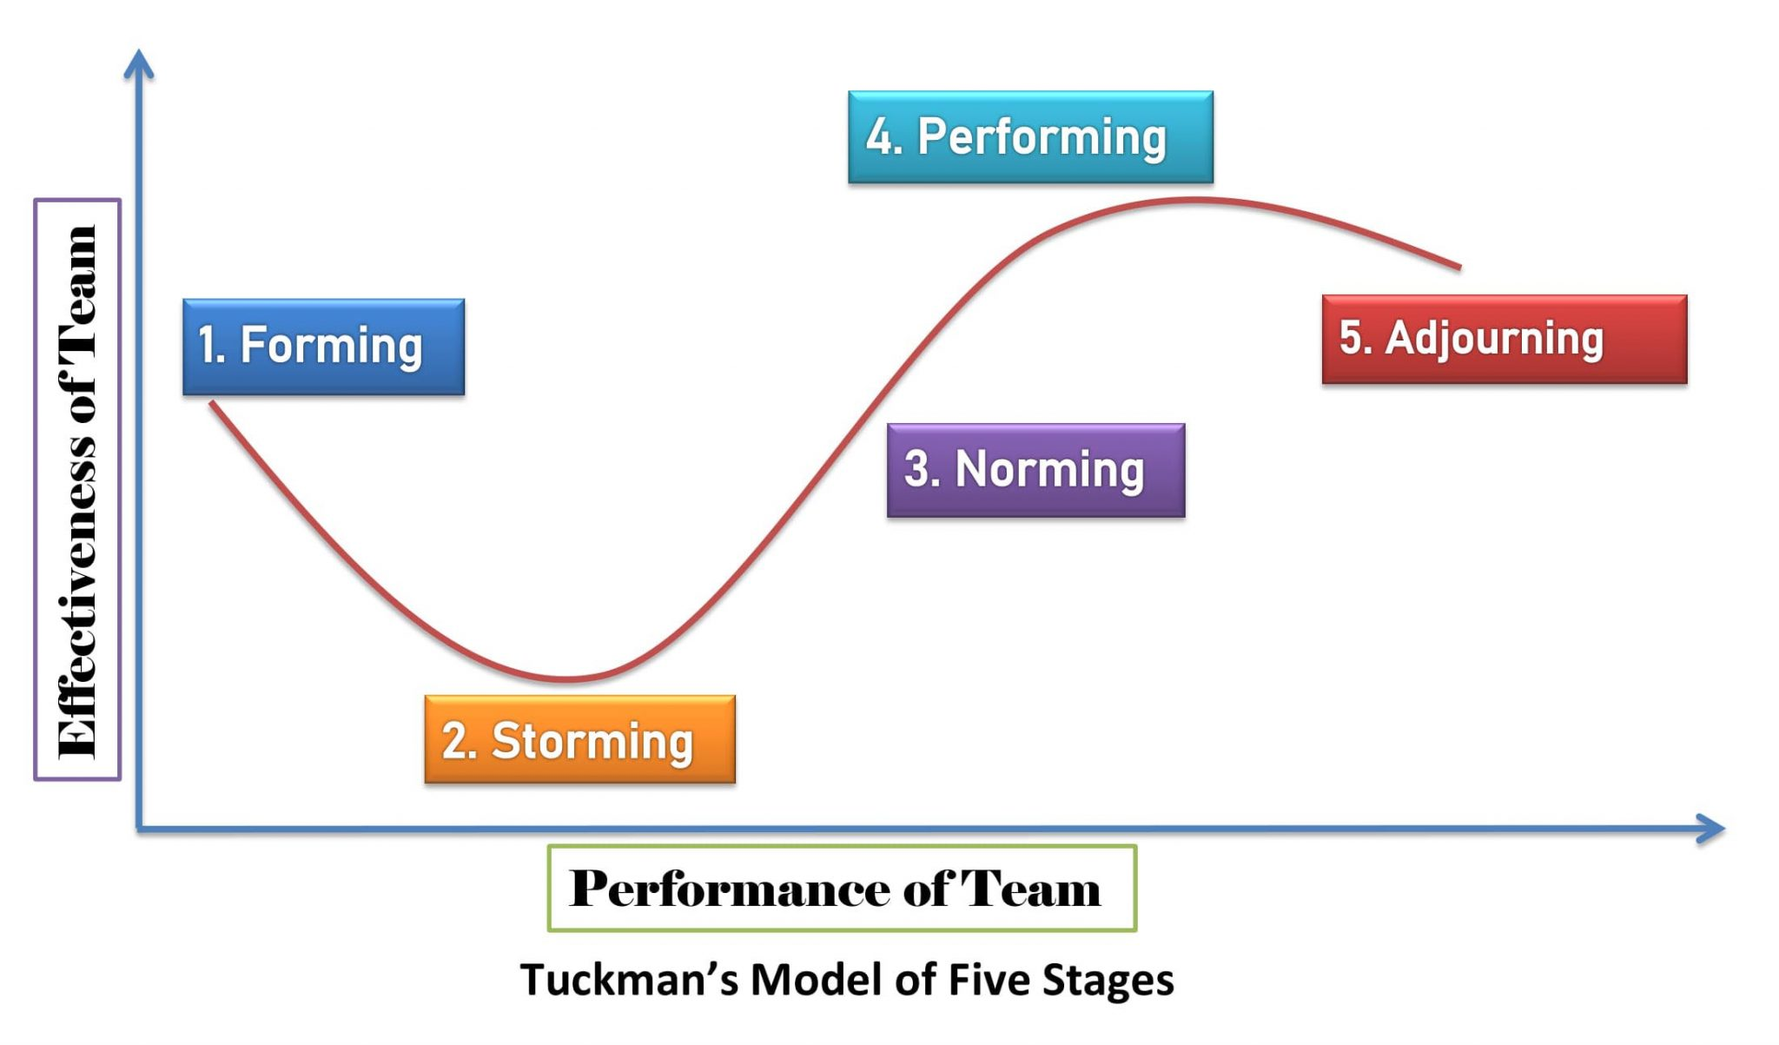 The reason being is that they have already formed their group and are currently on the storming stage. Them being on the storming stage means they are aware of the factors that’s stopping them from proceeding the main reasons are communication , commitment and lack of interest.

There is another model that could possibly use in this problem which is called Wheelan’s Model 2005 this was discovered and developed by Susan Wheelan. This model consists of four different stages:

- Dependency and Inclusion
- Counter-dependency and Fighting
- Trust and Structure
- Work and Productivity

However the best way to solve this problem would be to use the Tuckman’s model this is because the team is quiet small so it gives them the opportunity to get through the stages quicker especially by communicating. Whereas with Wheelan’s model it involves a team leader which could cause more problems and complications which could then also slow down the process. It is also emphasized that groups who function higher at either model tend to be more productive which then leads to more group development (Wheelan), (2009)

Team Roles:

What roles are needed to create a cohesive and effective team?

Belbin (1981) concludes that a team is better when it has a wide range of diversity within the team roles and ensures these qualities are present. Belbin also elaborated that there needs to be a balance of personalities in able to ensure that they are successful. There are nine roles that are split into three different categories.

- Action oriented roles- consists of shaper, implanter and completer/finisher
- People oriented roles- consists of coordinator, team worker and resource investigator
- Thinking oriented roles- consists of plant , monitor- evaluator and specialist.
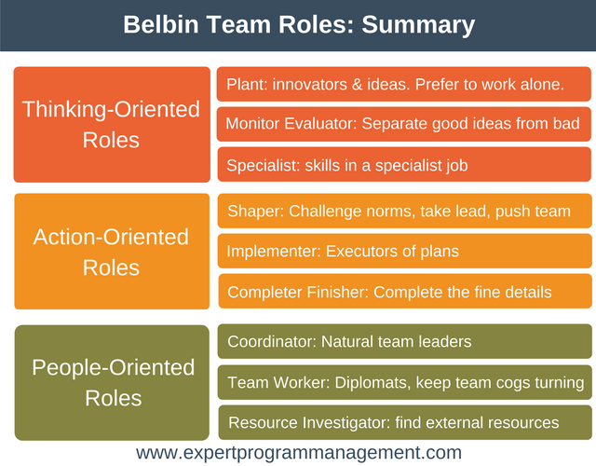

What are the theories relating to this?

The theory behind this team role is that it has been tested that a wide range of team roles and representers are performed better than those teams that have an imbalance of roles because some rules are not exceeded to expectations. Torrington et al., (1985), have suggested that for effective team functioning both task-oriented, and social or emotional oriented people are needed, this indirect that people that are task oriented have a strength of concentrating to get the work done for example gathering necessary information and people that are social or emotional oriented help maintain the team through out the process for example supporting others views and opinions. Senior (1997) carried out a study and it was proven that there is a difference when it comes to a group team role balance and performance. There was a significant positive correlation between the hypothesis and conclusion. Moving forward with the study specific teams were created to determine whether Belbin’s theory was effective, results showed the team with mixed members performed better than the team that had members of the same role type.

Why is it important to consider team roles when selecting team members or recruiting new staff?

There are many reasons as to why it is important to consider team roles when selecting team members or recruiting new staff. Selecting a new team member or staff means you need someone that will benefit you, someone that has a skill or quality that no one else has this is important as you know they will be brining something different to the table to pursue the goal of achieving your target. Individuals with a different mindset to others is required to guarantee tasks will be completed to a high standard enabling the team to succeed and reach the targets set. Tarricone and Luca (2002) carried out research based on personality, team work and design results specified that these key aspects are needed to be considered by both team members and managers when team work is involved. Ochieng and Price (2009) concluded that team members need to have a clear understanding of team goals, effectiveness , responsibility and communication to complete the job as expected. A team should able to work well together to complete the project given and ensured it is done on time with no complications or errors.

Discussion:

What are the advantages of effective team working?

Effective team working has many advantages such as improving your communication skills, this can be done by engaging with your team and exchanging ideas. From the current case study we can see communication is a barrier within this team to help build the effectiveness to this team we need all components to sit down and talk about any issues in regards to the plan of opening three new warehouses. By doing this it enables the team to sort out any conflict between them and gives them the chance to move forward in order to get things done quicker. Following the Culture Code by Coyle it identifies the secrets of a successful group.
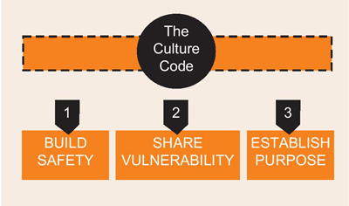

Tom and his group can follow the culture code to make sure he can get the most effective team. Firstly the team need to ensure they are listening to one another’s ideas this could be done by showing interest this involves good use of eye contact and good body language this means you are paying attention to what is being said. The team leader also needs to contribute by asking the team questions for example “is there anything I’ve missed?” this gives the team the chance to speak up and elaborate further. Lastly when feedback is given back by either a team leader or another member be respectful and appreciate the feedback given by simply saying “thank you for letting us know.” In the second stage the team leader needs to question the team regarding their vulnerability so for example “ what is one thing you would like me to carry on doing?”. For team effectiveness always make sure any negative energy or problems is solved face to face as it is much more better as things wont be escalated and you can communicate properly. Another factor that improves a group’s effectiveness is listening this does not mean constant nodding to show you’re listening but instead ask questions that could challenge one another by doing this it also gives you the chance to expand a wider range of ideas. Finally the team need to organize the priorities and things that need to be completed this means set certain targets that need to be done first.

As previously discussed the barriers within this group is lack of communication, interest and stability.

Michael (2012) said “ teams can work faster and more effectively with members working in parallel and independently” this implies that working as a group gets things done quicker as not everyone is doing things individually everyone gets together and does what needs to be done to speed up the process whereas if something was to be done by one person it would take a long time but working as a team means getting the same task done in a short period of time.

Conclusion:

To conclude effective team work requires a lot of communication , trust, effort , commitment and a mindset willing to learn. These factors play a huge role in building and effective team in many different ways. Communication is needed to engage and exchange ideas within the team to ensure everyone ideas and opinions are getting noticed this needs to be ensured as if someone’s ideas and opinions are going by unnoticed a good idea could not be introduced into the group which means both you and the team are losing out. Trust is needed for an effective team as you’re going to have to trust your peers to make sure the work that was allocated to them is done because if the work is not complete then the team will slowly fall apart as it will cause unnecessary stress and problems. Effort is needed within an effective team as it should be an equal project for all members so that means everyone should be giving one hundred percent and not just picking and choosing when they want to do things because it the end it will only cause conflict which will then step back the team. Commitment is needed because things may be difficult and there may be times where the team will have to face challenges and that’s where commitment comes in because no matter how difficult things get everyone needs to have the mentality of getting through the struggles and not giving up easily. Lastly a mindset willing to learn has an affect on effective team work as everyone will be dealing with problems different so they need to be able to learn how others work so that the team is strong also you need a willing to learn mindset as there will be things that you may not know which will then need to be used within the team project to ensure the goal is reached.

Reference List:

Aritzeta A., Swailes S. and Senior B. (2007). Belbin's team role model: Development, validity and application for team building. Journal of Management Studies, 0022-2380.

Belbin, M., (2010), Team Roles at Work, eBook Collection (EBSCOhost), Routledge

Belbin, M. (2016) Team role circle, Available: https://www.belbin.com/media/2302/belbin-team-role-circle.pdf (Accessed: 19 June 2020).

Maund, A. et al. (2017) Certificate in higher education : skills for the workplace student yearbook. London:: Sage.

Ochieng E. G., & Price A. D, (2009). Framework for managing multicultural project teams. Engineering, Construction and Architectural Management, 16(6), 527-543.

Torrington, D., Weightman, J. and Johns, K. (1985), Management Methods, Institute of Personnel Management, London.
Tuckman, 1965
B.W. Tuckman Development sequence in small groups
Psychological Bulletin, 63 (1965), pp. 348-399

West,M.A(2017) Effective Teamwork: Practical Lessons from Organizational Research

