Investigation into modelling of a projectile through a composite:

Contents
Abstract 2
The Johnson Cook Model 3
Assumptions 4
Making the Model 5
Setup of Coarse Mesh 5
Setup of Fine Mesh 8
Testing the model 10
Testing Coarse Mesh 10
Testing Fine Mesh 15
Discussion 19
Conclusion 20

Abstract

This investigation examines several different setups of two types of an armoured plate. It explains how different changes such as mesh density and material choices drastically effect the outcomes of simulations. This investigation attempts to explain how to set up these as well as providing conclusions on the data generated.
This will be principally on:
Meshes:
The matrices that make up an object within Abaqus and how its density effects otherwise identical models.
Changing Material Properties:
How a laminate performs against an equal thickness solid plate, investigating differences in penetration, spalling and damage patterns.

In which it is determined that finer meshes are broadly superiors to a coarse mesh, but have time-related drawbacks. A laminate does not provide similar resistance to a projectile as a homogeneous plate of identical size, however, has less additional negative effects such as spall.

Abaqus, The Johnson Cook Model and Material Properties

In this investigation, Abaqus finite element analysis software was used as the basis for the models. Abaqus allows the user to create models in both 2 dimensions and 3. Abaqus is owned and maintained by Dassault systems [1] and is updated at least once per annum. There are multiple versions available, with each being able to handle more ‘nodes’ than the next, these include a student edition, a teaching edition, and a professional edition.

In order to simulate the model of a projectile through a composite, the properties of all materials involved must be known. This includes the materials density, young’s modulus, melting points/transition temperatures and, most importantly for simulation damage; the Johnson Cook parameters. Abaqus’ own training aids describes the Johnson cook damage initiation parameters as a ‘criterion model for predicting the onset of damage’ [2] and Johnson Cook plasticity as ‘a particular type of Mises plasticity model with analytical forms of the hardening law and rate dependence’ [3]
Johnson-Cook Damage:
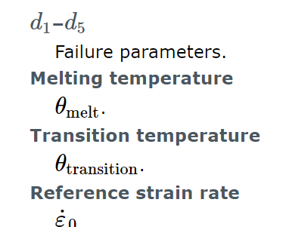
Johnson-Cook Plasticity:
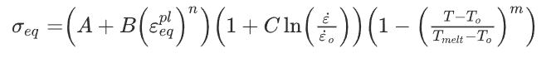
‘Where ε is the equivalent plastic strain, ὲ is the plastic strain rate and ὲ_{o} is a reference strain rate. The parameter A is the initial yield strength of the material at quasi-static strain rate. The parameter B and n represents the flow stress on strain hardening behavior at quasi-static strain rate. And the parameter C represents strain rate effect, and m represents thermal softening effect. T_{melt}, T_{o} each represents melting temperature and references temperature.’ [4]

Assumptions

The First assumption that was made when creating this model is that a material can be modelled using finite points or ‘nodes. This is integral to this model and the computer processing and is what allows us to simulate any model.

The second assumption being made the projectile does not deform in the same way as the target plate. This was changed during the investigation as numerous issues were encountered. This specifically is with the Johnson-Cook damage initiation criterion, when a node’s damage is ‘exceeded’ or in other words has been destroyed, at which point this mass is deleted. This occurs within the target plate and not in the projectile which could cause deviation from what a real trial would look like.
Another assumption being made in this model is that the projectile will always stay perpendicular to the target plate. This is due to the axisymmetric nature of the model – one half will always be ‘fixed’ and only act in a linear direction.

As discussed above the model is axisymmetric, as such it is not modelled in three dimensions, but is extruded from the two-dimensional calculations. This would likely cause significant deviation from a real trial, as materials could deform in different way e.g. along internal microscopic cracks or by the material not being truly homogeneous.

Another potential cause for deviation from reality was altering ‘fracture energy’ while conducting the investigation, on the advice of Professor Kelvin Donne, this was varied from the stated material properties due to critical failures in Abaqus- this caused the simulation stop and the error ‘wave speed ration greater than 1.0’ to appear. The way this was avoided was through using another sub option ‘failure at displacement’ which does not use energy as its metric but rather mechanical movement, upon Professor Donne’s recommendation a ‘nominal value’ was selected, in order for the simulation to complete.
The final assumption I made was that the model had layers of equal thickness. If this was not the case this would have had further implications especially when using the laminate of materials as opposed to a solid plate.

Making the Model

Setup of Coarse Mesh

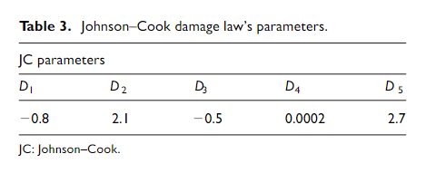
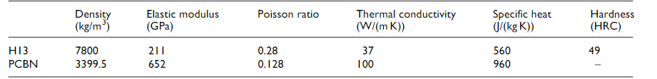
At the beginning of the investigation, the basic model was provided. Professor Donne had created a basic ‘projectile’ and laminated plates. The professor had assigned three different materials to the model. The projectile was made of ‘steel’; the top, middle and bottom plates were a copper and finally the remaining plates were a plastic called polyvinyl butyral (pvb). In the simulation the copper was replaced with H13 Tool Steel, which was selected from several different materials, as its material properties were widely available and researched [5]

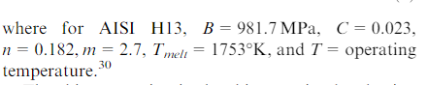

The material properties of the pvb were as follows and were provided by Professor Donne:
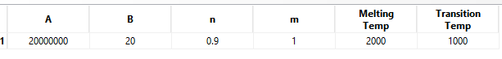
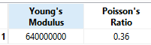

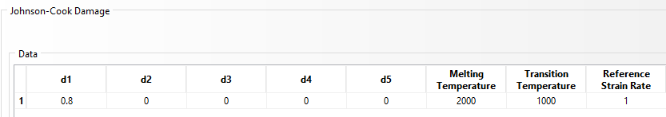

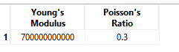
The Final Material used was ‘steel’ it was used for the projectile and again was provided by Professor Donne:

As referred to in the assumptions section, these properties are much reduced that the other materials. This is because the projectile is not destructible in the same way as the target plating. However, the projectile is still able to elastically deform.
There were two planned tests while using the different meshes. For both the fine and the coarse mesh, one simulation would run with the provided ‘laminate’ and another would be done with a single homogenous plate. This was achieved in practice, by ‘repainting’ the plastic material section, with the H13 tool steel.

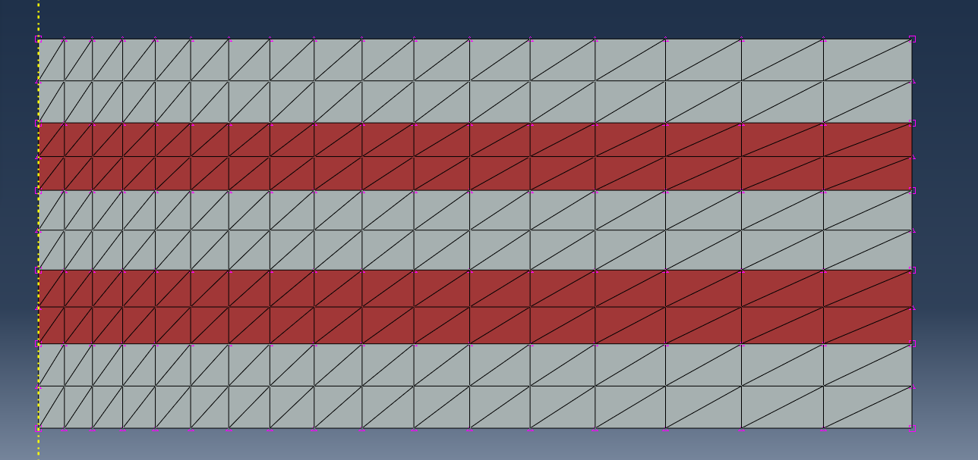
Figure 1 Coarse Laminate
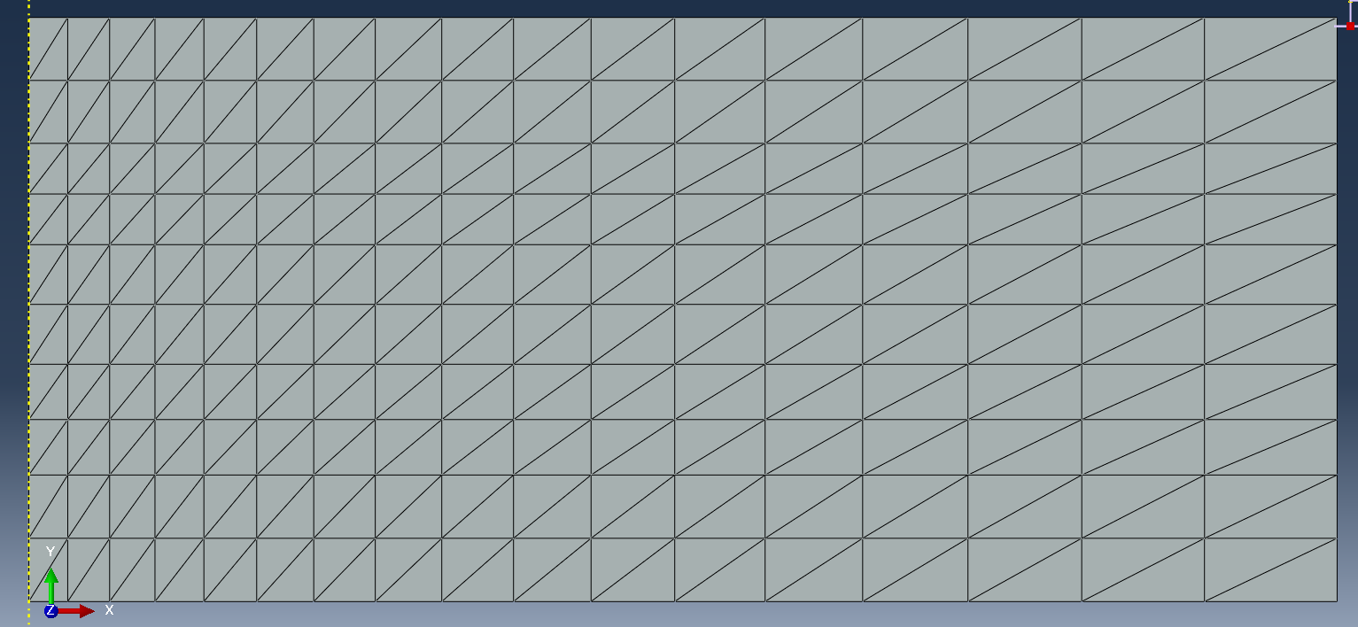
Figure 2 Coarse Solid

Setup of Fine Mesh

To Create the fine mesh, the original coarse mesh had to be deleted. This was immediately followed by deleting the mesh ‘seed. The seeds are what mark out the shape that is to be meshed and allows a ‘bias’ to the mesh. To create a finer mesh, there must be more seeds. This was achieved through the ‘seed edges’ tool. The reseeding was done in two steps, firstly the horizontals were selected, and the bias option was set, this creates a finer mesh around the point of ‘impact’ while also ensuring that processing time does not increase unnecessarily, which becomes a bigger issue as the mesh gets finer as there is exponentially more points and nodes to simulate. Now the vertical edges are seeded, this is not biased as it would affect the vertical movement of them mesh and projectile. One this was done, the mesh itself was generated using the ’mesh part’ button. The final stage of the remeshing is to redefine the interaction. This is done via the interaction menu, and by creating a ‘set’ of nodes that included the likely contact area with the projectile. This was again done to reduce processing time. Using the interaction manager, the surface of the projectile was selected, as was the ‘set’ of nodes.
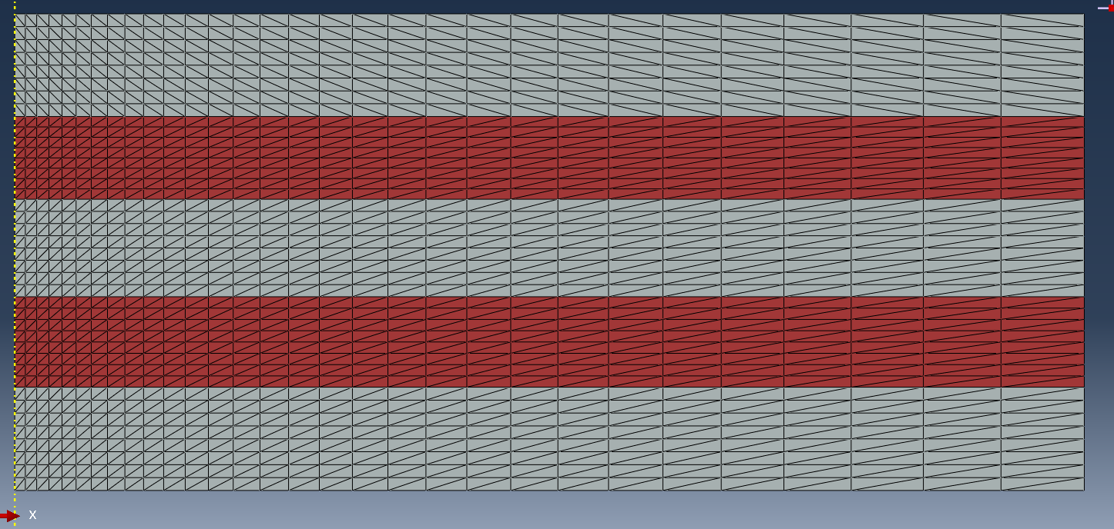
Figure 3 Fine Laminate
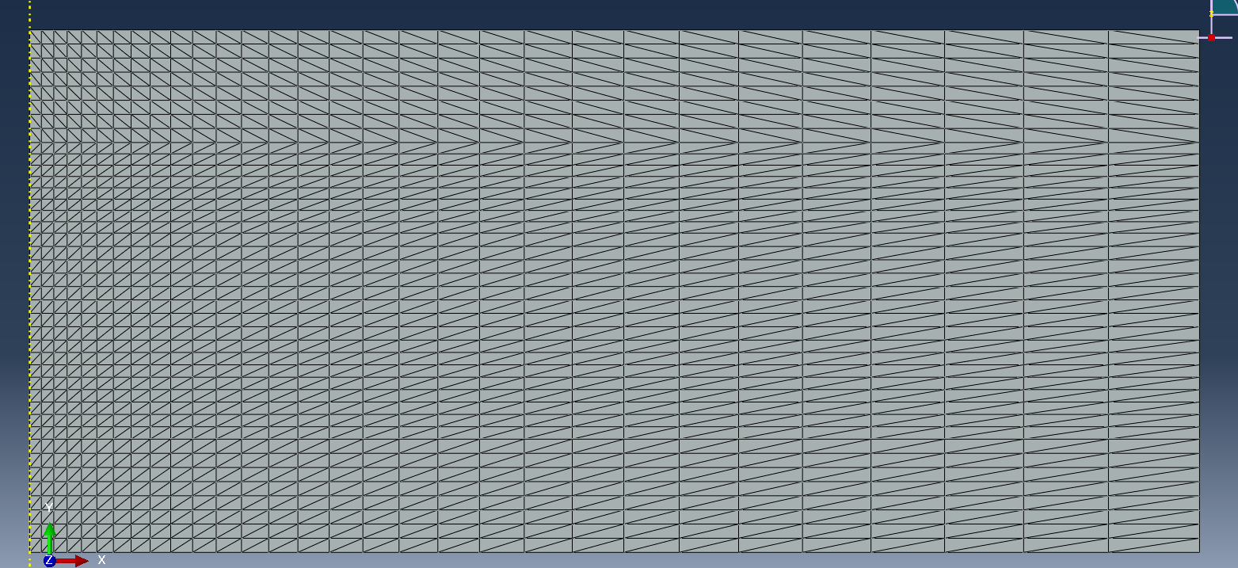
Figure 4 Fine Solid

Testing the model

Testing Coarse Mesh

The first mesh to be tested was the laminated coarse mesh. This ran into issues immediately. When the simulation began, it was aborted almost instantly, when replaying this in the visualisation, it was clear that the error occurred instantly when the projectile contacted the surface. This was fixed by checking the values of by material properties. In this case the fracture energy of H13 which I had found was causing significant problems, on advice of Professor Donne and was changed to failure at displacement. The value of this of 0.0001m and was estimated. This enabled the simulation to run, and the following results were obtained:

Laminate: 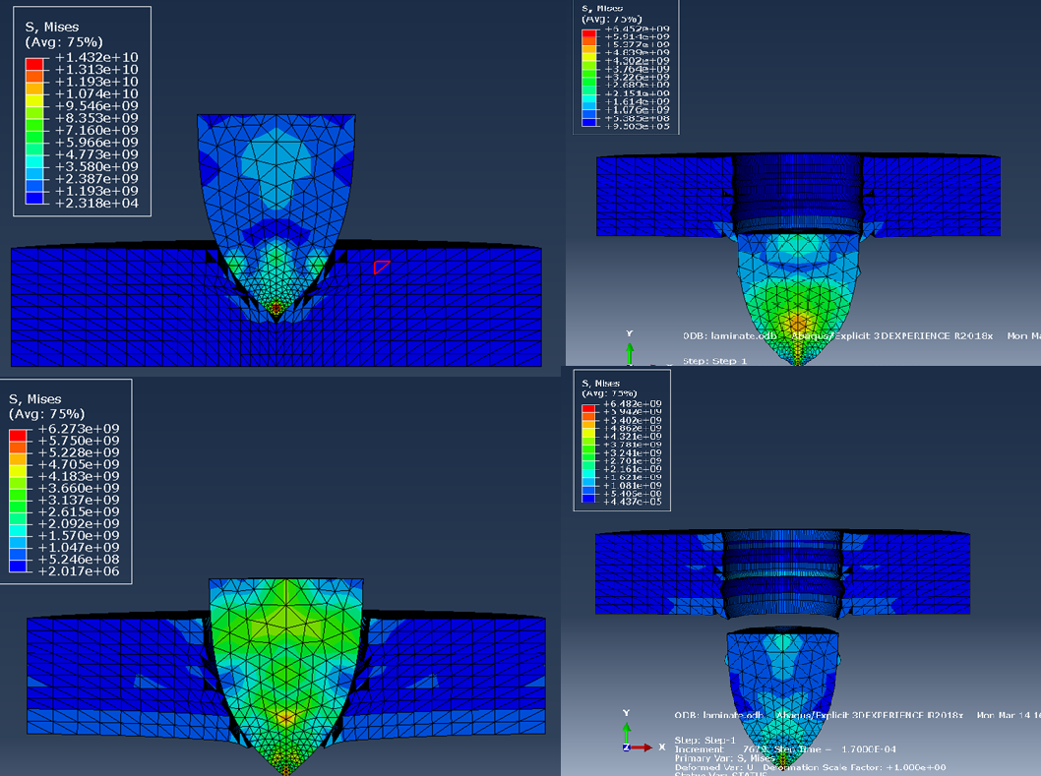

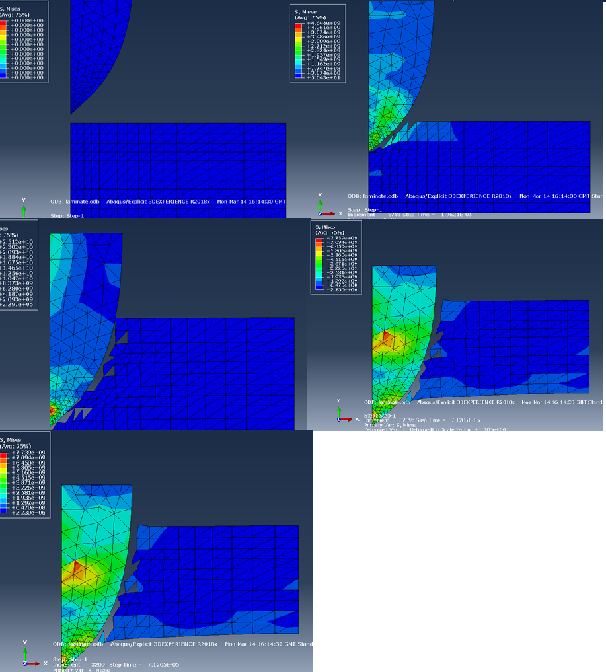

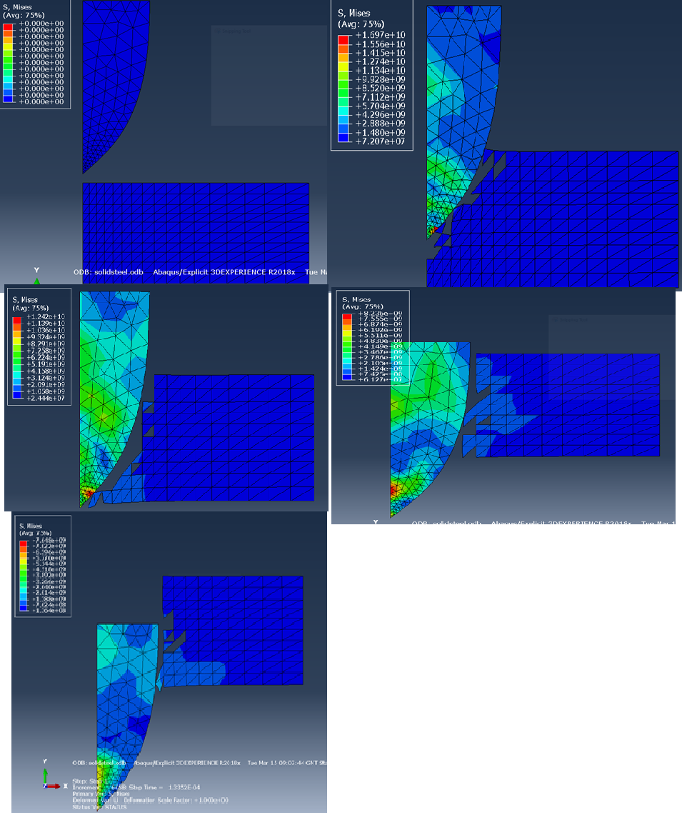
Solid:

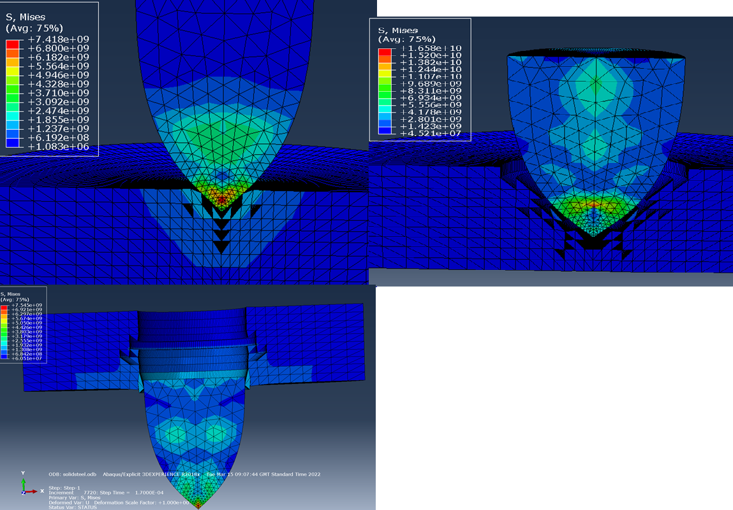

Testing Fine Mesh
After testing both the laminate and solid coarse meshes, the next step was to test the fine meshes. This ran the whole simulation without issue, however, when viewing the simulation, it was realised that the ‘interaction’ had not worked as intended, the project ‘phased through’ the target. This was because under the interaction manager, the new interaction created for the mesh had not been enabled, and the old disabled. This was rectified and the simulation was repeated. This time it ran without issue and yielded the following results:
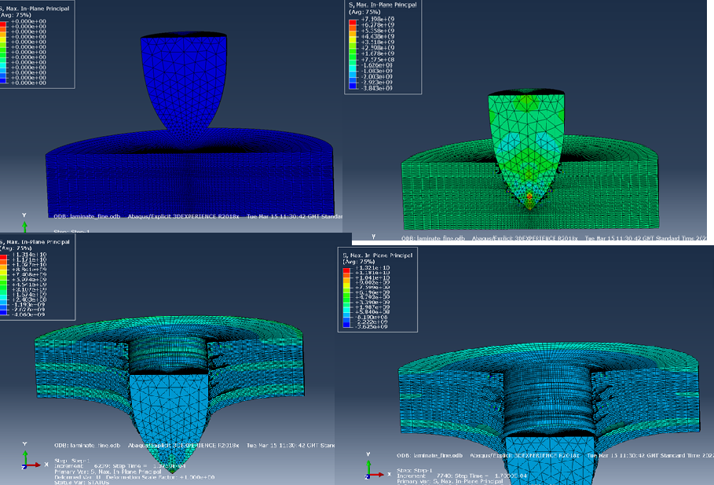
Laminate:

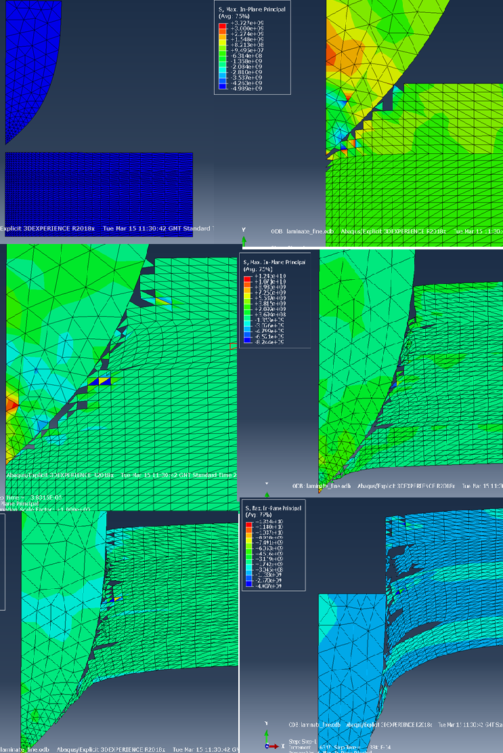
Solid:
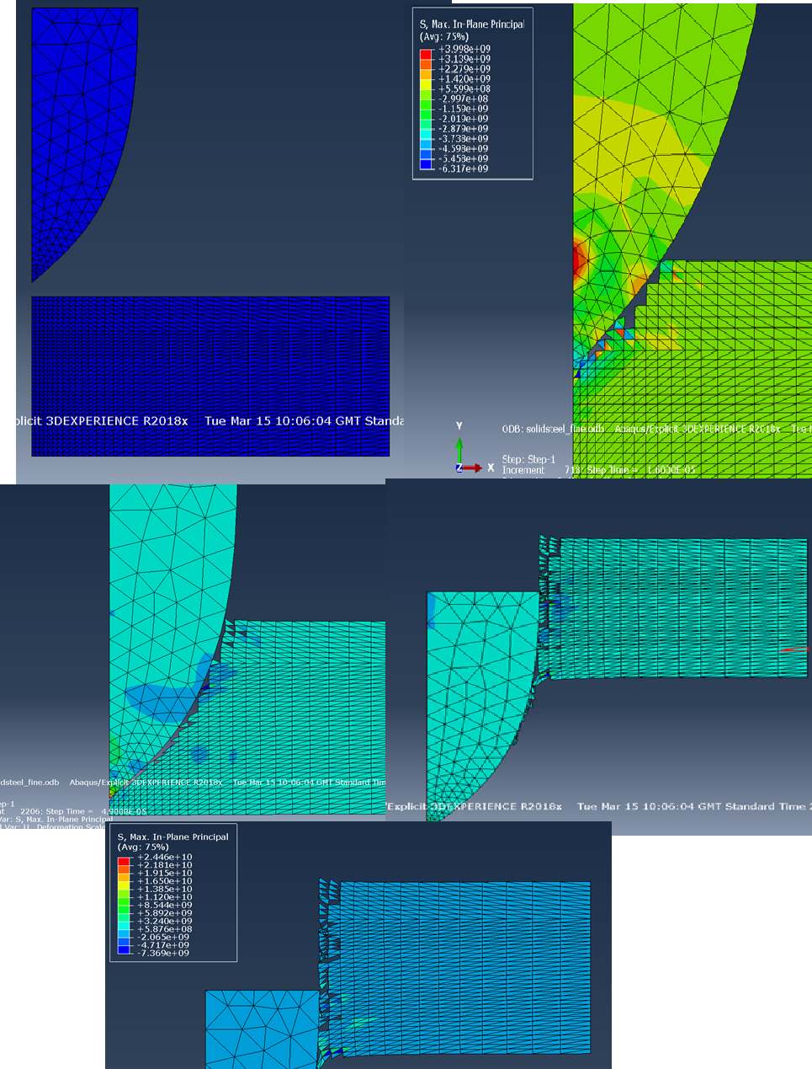

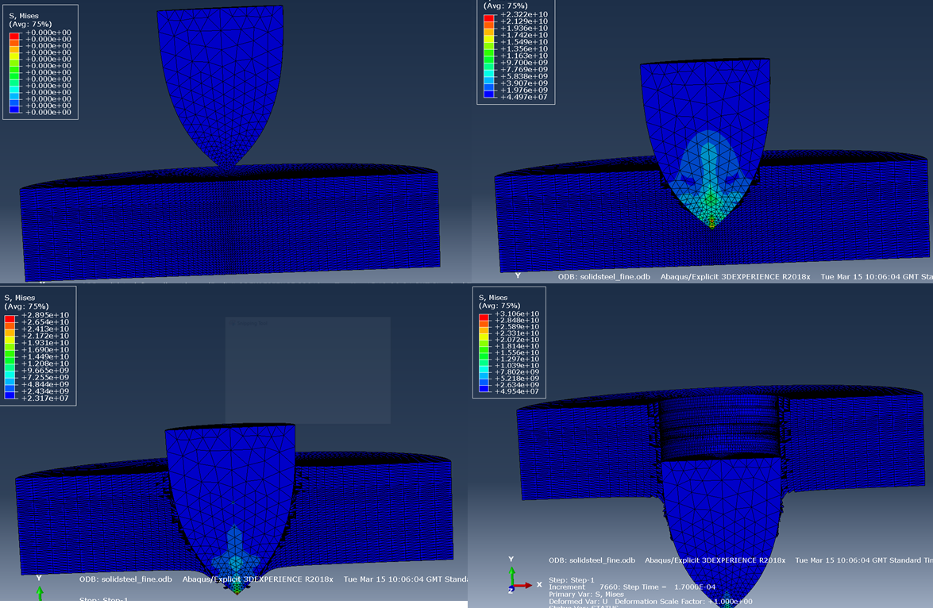

Discussion

All four simulations, seemed to work well and demonstrate broadly similar phenomena. All four simulations show a penetration of the plate by a projectile however each demonstrates slightly different things.

The first comparison is between the finely meshed laminate and the coarse mesh laminate. In the coarse mesh, the triangles of the mesh delete along the border between the steel and plastic layers in a limited way, however in the fine mesh clear delamination is seen very clearly. It is also evident that in the fine mesh there is significantly more flex within the steel layers of the target, this is especially noticeable in the final layer, which appears to have bent to an almost right-angle at its most extreme. It is also noticed in the finer mesh, that as the projectile moved through the plastic, it clearly ‘squashes’ deeper into the armour plate. This does so significantly more than the surrounding steel, which would make sense as it is a significantly ‘softer’ material. This difference is likely aided by the increase in nodes in the laminated plates, the increase in moveable points might allow additional ‘flex’ whereas with the reduced number of nodes, this flex would cause element deletion as rather than multiple nodes moving a small distance, this must move significantly further, causing additional strain on the induvial node, to the point of deletion.
An interesting difference between the fine mesh and coarse is the velocity graph, while all projectiles begin at the same velocity, there is initially greater ‘spikes’ in velocity within the fine mesh, however this soon flips on its head as time progresses; the spikes drastically reduce until forming and almost linear line. In an attempt to create a more useful graph, a trendline was added to the graph. Interestingly the finer mesh appears to slow the projectile substantially more. It is speculated that this is due to the extended contact and deformation of the fine mesh; that the fine mesh target was acting upon the projectile longer than the with the fine mesh; hence it was slowed more than the coarse mesh examples.

In both the fine and coarse mesh, it is evident that the solid steel plates offer significant increase in resistance to the projectile. This can be seen in the projectile velocity graphs, where the in both cases the final velocity is noticeably lower for the solid steel plate than in the laminate. However, something that must be taken into account with this, if the deletion of nodes within the model. It is done in this simulation in order to provide an estimate of a real event and in order to enable a working model. This has an innate problem with the fact that matter does not simply disappear, (conservation of mass laws [6]) this means that, the model is fundamentally flawed and at best can only provide an approximation of reality. In a real setting, the deleted nodes would remain as matter, and given their imparted energy would also travel through the newly formed hole as individual projectiles in their own right. This process is known as ‘Spalling’ and has significant influence on armour technology and design [7].

Conclusion

In Conclusion, there is significant difference between both measured parameters. It is noted that the fine mesh appears drastically more ‘lifelike’ than the alternative coarse mesh in a number of ways as discussed previously. It also noted that this model is not a replacement for real testing as there is several fundamental errors within the simulation, such as the aforementioned conservation of mass laws, assumptions about a material being able to be split into nodes rather than one ‘plate’ and arguably the fact that within this model the projectile cannot deform in the same way as the plate.

However, of the two meshes of models presented here the fine mesh appears to be a better simulation in all ways aside from time. In any future work, if time and computing power allows even finer meshes should be used, as potential phenomena is likely to be missed at these mesh’s resolution. By increasing this, the confidence within the model would also increase drastically.
It is also surmised from the available data that the solid steel plate offers greater resistance to the projectile, however the reduction in elastic deformation would likely create greater quantities of spall is speculated that would cause significant damage alongside the projectile itself. In all four simulations, the projectile fully penetrates the plate and retains significant energy, which would severely damage anything behind the pates, but a caveat must be added that within this model it assumes that the projectile not deformable. In Reality it is likely that the projectile’s profile would significantly change during the impact.

References

[1] | “3ds.com,” Dassault Systems, [Online]. Available: https://www.3ds.com/products-services/simulia/products/abaqus/. [Accessed 20 April 2022].
[2] | “abaquas docs,” [Online]. Available: https://abaqus-docs.mit.edu/2017/English/SIMACAECAERefMap/simacae-t-prpmechanicaldamagejc.htm. [Accessed 20 april 2022].
[3] | “Abaqus docs,” [Online]. Available: https://abaqus-docs.mit.edu/2017/English/SIMACAEMATRefMap/simamat-c-johnsoncook.htm. [Accessed 20 april 2022].
[4] | J. K. J. H. J. K. Y. K. H.S. Nam, “Ductile fracture simulation for A106 Gr.B carbon steel under high strain rate loading condition,,” in Recent Advances in Structural Integrity Analysis - Proceedings of the International Congress (APCF/SIF-2014),, Chosun, 2014.
[5] | M. K. M. J. E. A. Q. A. A.-A. Usama Umer, “Assessment of finite element and smoothed particles hydrodynamics methods for modeling serrated chip formation in hardened steel,” Advances in Mechanical Engineering , no. https://www.researchgate.net/publication/303796656_Assessment_of_finite_element_and_smoothed_particles_hydrodynamics_methods_for_modeling_serrated_chip_formation_in_hardened_steel#pf6, 2016.
[6] | “law-of-conservation-of-mass,” Sciencing , [Online]. Available: https://sciencing.com/law-of-conservation-of-mass-definition-formula-history-w-examples-13720453.html. [Accessed 3 may 2022].
[7] | W. M. Evans, “The Spalling of Armour Plate and the Influence of Backing Liners,” London, 1972.

