

How organisational cultures within Police Forces influence officers’ willingness to seek help.

Katie-Louise Bellew
2319739
Bachelor of Science: Professional Policing Practice

Declaration
This work has not previously been accepted in substance for any degree and is not being concurrently submitted in candidature for any degree.
Signed: K.Bellew
Date: 21/06/2026

Statement 1
This dissertation is being submitted in partial fulfilment of the requirements for the degree of BSc.
Signed: K.Bellew
Date: 21/06/2026

Statement 2
This dissertation is the result of my own independent work/investigation, except where otherwise stated. Other sources are acknowledged by footnotes giving explicit references. A bibliography is appended.
Signed: K.Bellew
Date: 21/06/2026

Statement 3
I hereby give consent for my dissertation, if accepted, to be available for photocopying and for interlibrary loan, and for the title and summary to be made available to outside organisations. Signed: K.Bellew
Date: 21/06/2026

Statement 4
I hereby give consent for my dissertation, if accepted, to be available on the university’s IT system to those who have consent to use the system.
Signed: K.Bellew
Date: 21/06/2026

Acknowledgments
I would like to express my gratitude to my mum, sister and my aunty. Your endless encouragement, patience, belief in me, and constant support throughout this journey have been my biggest motivation. Thank you for always being there, listening and keeping me going when things felt challenging. This achievement is as much yours as it is mine.
To my two children, Freya and Luis: thank you for being my greatest inspiration. Your love, understanding and patience when things get busy gave me the strength to keep going. I hope this work shows you that with determination and the right people around you, you can do anything.
I also wish to extend a sincere thank you to my tutor, Laura, for her valuable guidance and constructive feedback which helped shape and improve my work.
Lastly, I wish to remember and honour, my father who passed away before he was able to see me succeed in joining as a Police Officer and begin my studies. Your influence, pride and lessons you have left me with have carried me every step of the way. I carry you in everything I do, and I hope this achievement makes you proud.

Abstract
Mental health and wellbeing within policing are becoming increasingly prominent issues, with research consistently showing high levels of stress, burnout and officers on the sick. Despite the vast amount of support available to officers, many are reluctant to access them. This dissertation explores how organisational culture within police forces impact police officers’ willingness to seek help. It examines the underlying norms, values and unwritten rules that shape their behaviour within the police service.
Advancing on existing literature and research, this study identifies key barriers including the traditional stigma around mental health, ethos of resilience and concerns around lack of confidentiality. It also considers how positive cultural shifts, such as visible leadership support and normalisation of wellbeing, can encourage help=seeking behaviours. The research analyses the tension between the historic “macho” culture of policing and the modern drive to prioritise officer welfare, questioning whether cultural change alone is sufficient to improve officers seeking support.
The findings reveal that organisational culture acts as both a barrier and an enabler: when officers feel safe and supported by their force, they are more likely to reach out. Conversely, cultures that rewards self-reliance and discourage vulnerability create an environment where help-seeking is viewed as a weakness. This work concludes that for support services to be effective, they must be accompanied by genuine cultural transformation.

Table of Contents

Chapter 1 – Introduction
1.1 Background 6
1.2 Research Rationale 6-7
1.3 Research aims 7
1.4 Conclusion …………………………………………………………………………………………………………7
Chapter 2 – Literature review
2.1 Introduction ……………………………………………………………………………………………………….8
2.2 Objectives 8
2.3 Defining the topic 9
2.4 Help seeking and accepting help ……………………………………………………………………………9
2.5 Wellbeing and mental health in policing …………………………………………………..…………9-10
2.6 Theorectical Frameworks………………………………………………………………………………..10-12
2.7 Conclusion……………………………………………………………………………………………………….13

Chapter 3 – Methodology
3.1 Introduction……………………………………………………………………………………………………..14
3.2 Methodology…………………………………………………………………………………………………….14
3.3 Framework………………………………………………………………………………………………….14-16
3.4 Conclusion………………………………………………………………………………………………………16

Chapter 4 – Analysis of results
4.1 Introduction……………………………………………………………………………………………………..17
4.2 Organisational norms within policing………………………………………………………………17-18
4.3 Mental health climate within policing…………………………………………………………………..18
4.4 Central concerns regarding organisational culture…………………………………………… 18-19
4.5 Stigma and consequences…………………………………………………………………………… 19-20
4.6 Leadership and awareness ……………………………………………………………………………….20
4.7 Conclusion …………………………………………………………………………………………………….21

Chapter 5 – Conclusion and recommendations
5.1 Conclusion and achievement of objectives …………………………………………………….22-23
5.2 Future research ………………………………………………………………………………………………23
5.3 Recommendations ……………………………………………………………………………………..23-24
5.4 Final conclusion ……………………………………………………………………………………………..24

Chapter 6 – Bibliography……………………………………………………………………………………..25-28
Chapter 7- Appendixes
Appendix A- Blank questionnaire………………………………………………………………………… 29-30
Appendix B- Questionnaire information sheet ……………………………………………………….31-33
Appendix C- Participant debrief sheet …………………………………………………………….……33-34

Chapter 1 – Introduction
This purpose of this dissertation is to examine the relationship between organisational culture and police officers’ willingness to seek help when experiencing psychological, emotional or occupational difficulties. The study focuses on understanding how values, norms and beliefs can influence officers’ attitude towards asking or seeking help. While police officers are frequently exposed to traumatic situations, the decision to seek help is often shaped by the environment they work in.
  - – Background
Police officers work within an environment characterised by high levels of responsibility, trauma exposed, unpredictable situations and very demanding on their emotions. The nature of police requires officers to regularly respond to incident that involve violence, accidents and human suffering. These factors can contribute to occupational stress, and mental health issues if appropriate support if not accessed (Oscar Kilo, 2019). Although awareness of mental health within policing has increased, many officers continue to experience barriers when seeking help.
Help seeking behaviours among police officers is an important area of research as early access to support can prevent or minimalize the negative effects of stress and trauma on the officer and improve long-term wellbeing. However, officers are often less likely to seek psychological help compared to other occupational groups (Karaffa and Koch, 2015). The reluctance to seek help has been linked to factors such as fear of judgement, concerns over confidentiality and worries regarding it negatively affecting professional reputation (Haugen et al., 2017).
The culture within policing has often been described as containing strong informal norms that shape officer behaviour and identity. Traditional cultures may encourage officers to form the “macho” identity, where emotional difficulties are minimised or hidden to maintain credibility among their colleagues (Morgan et al., 2004). These expectations can influence officers’ perception on whether seeking help is acceptable or a sign of weakness.

  - – Research Rationale
The rationale for this research is based on the continuing concern that many police officers experience barriers to accessing support despite increased recognition of occupational mental health and wellbeing. Police services have introduced numerous initiatives to promote this, but this does not guarantee that officers will use them. Organisational attitudes and workplace expectations can determine whether officers feel comfortable and supported enough to seek help within the organisation.
This research is significant because improving help-seeking behaviours requires more than just providing wellbeing initiatives and support services. The organisation must understand that the cultures within the organisation can influence officers and educate those from within to change the norms. By examining how the organisational cultures have influence over officers’ willingness to seek help, this dissertation aims to contribute to understanding how policing environments can be improved to support officers efficiently.

  - – Research Aims
The aim of this research is to examine how organisational cultures influence within police forces influence officers’ willingness to seek help. It also aims to provide recommendations to overcome traditional norms and identify strategies to encourage openness.
These aims will be done by completing the following objectives:
- Examine officers’ perceptions on organisational culture and how it impacts their mental health
- Identify what cultural norms are persistent
- Explore recurring experiences between officers to propose recommendations to improve wellbeing and support within the forces.

  - – Conclusion
This introduction has established the importance of examining organisational culture as a factor influencing officers’ willingness to seek help as well as outlined the core aim and objectives. The following chapter will analyse the public academic literature that is already existing and accessible.

Chapter 2 – Literature review
2.1- Introduction
Organisational culture within Police Forces shapes officers’ identities and behaviours, this then has a knock-on effect to officers’ wellbeing. The culture has been defined as the cumulative effect of what people do and how they do it (Cooper, 2024). These cultures that are formed influence not only operational decisions but also officers’ willingness to seek or accept help. This help could either be psychological or organisational (INGRAM, TERRILL and PAOLINE, 2018).
Serving officers, the College of Policing, His Majesty’s Inspectorate of Constabulary (HMIC) and the College of Policing are just of few of that who have voiced concerns surrounding the mental health of officers. Surveys have been carried out which show the ever-growing level of officers suffering from symptoms of anxiety, depression, burnout and Post Traumatic Stress Disorder (PTSD) (Federation, 2022). The findings from surveys show that this is due to the officers experiencing higher workloads, experiencing trauma within the job, and facing intensified public scrutiny. In comparison to the number of reported symptoms of these conditions, the percentage of officers who seek and accept help remains significantly lower (Corrigan, 2004).
Understanding the effects organisational cultures have is therefore essential to improving officer wellbeing which in turn would improve force functioning, and higher levels of public trust.

2.2- Objectives
Overall, this literature review will establish the existing knowledge surrounding the cultures and the affects they have on officers and consider how traditional policing values such as resilience and emotional control may both support effective policing but also create barriers to officers seeking help.
This chapter will explore these issues in depth by analysing literature and supporting evidence. It will begin by defining the key terms and outlining theories that show current understanding of the culture and the lack of help-seeking. It will then include major concepts and debates that have been found within literature including the stigma, masculinity persona, and trust within the organisation. The aim of this is to illustrate how organisational culture shapes serving officers attitude towards accepting help. The chapter will then continue to review the gaps that are found within research and reviewing the research that was found. Lastly, it will conclude by summarising the implications of the issues of organisational cultures and highlight the need for change to allow officers more support and further show improvement in policing.

2.3- Defining the topic: Organisational cultures within UK police forces
The main focus of this chapter is to analyse and review the relationship between cultures within UK forces and officers’ willingness to seek help. Organisational cultures refer to shared norms, values, beliefs behavioural expectations (Rune Glomseth and Bentzen, 2025). These cultures guide officers’ commitments and interactions whilst carrying out their duties. They are often shaped by historical traditions and mindsets, occupational demands and organisational structures (Loftus, 2010).
In the United Kingdom, organisational culture is heavily influenced by the principle of officers’ policing by consent. Loader and Mulachy (2003) show how the tradition of policing with consent shapes officers’ identity and expectations. This has created informal norms such as solidarity, emotional control, risk awareness and creating a cultural environment which influences officers’ willingness to accepting support (Gray, 2013). Whilst Loftus’ (2010) shows how cultural norms that were formed, persist regardless of organisational reform. This shows that organisational culture is historically rooted and difficult to change which leads to a strong influence on officer’s seeking help (Loftus, 2010a).

2.4 Help seeking and accepting help
“Help-seeking” refers to officers recognising and actively pursuing assistance when required, whereas help acceptance refers to officers’ willingness to accept the needed help and support when it is offered to them. In UK policing, there is numerous ways where assistance could be offered which may include consulting occupational health within the force, accessing mental health services or engaging with the forces TRIM processes (College of Policing, 2016). The TRIM process refers to a Trauma Risk Management process, which is a peer-delivered service which aims to signpost those who have been involved in a traumatic incident to the correct support services and coping mechanisms (West Yorkshire Police, 2018).
Studies such as Karaffa and Koch(2015) show that officers are less likely to seek help than employees in comparable high-stress professions (Karaffa and Koch, 2015). In the United Kingdom, Wood and Watson revealed that officers put off help seeking, or help acceptance, until their symptoms or struggles become overwhelming. They referred to the expectation of being tough and being seen as weak and in turn experiencing career repercussions.

2.5 Wellbeing and mental health in policing
Wellbeing refers to the psychological, emotional and occupational health of officers. Officers experience high workloads, high demand and in turn leads to high levels of stress, trauma and burnout. Studies such as Violanti (2014) show that police officers have a high rate recorded for mental health illness than the average civilian yet still have lower rates of engaging with support services (Violanti, 2014).
Specifically in the United Kingdom, Houmont and Elliot-Davies (2016) revealed that stressors within policing such as workload, management and lack of support from management – are more damaging to the officer than physical dangers. This study alone supports that it is important to examine how organisational cultures influence officers’ willingness to accept help (Houdmont and Elliott-Davies, 2017).

2.6 Theoretical frameworks
The Social Identity Theory by Tajfel and Turner (1979) suggests that individuals gain part of their social identity from their peers. This is hugely relevant within policing, and a “Police” social group becomes a norm due to the tightly structured force and the fact the job is based on teamwork. Via social categorisation, officers begin to see officers as one group and the public as outsiders (College of Policing, 2024). Officers begin to accept the “norms” that are created within their group and accept the values of loyalty to the group, solidarity and bravery (Tajfel, 1981). When officers form this “police group”, admitting vulnerabilities may seem as a threat to their status within their group. Research shows that officers do not speak out as they fear being judged and appeared unreliable if disclosing that they have mental health concerns to their group (Waddington, 1999).
Masculinity Theory also assists with evidencing why police officers refuse to seek or accept help by highlighting how they are expected to “be a man” and consider that the things that they are experience should be seen as their normal. Policing has long been paired with “hegemonic masculinity” which is a form of masculinity that holds values of toughness and emotional control (Connell, 2005). Officers learn early on in their career that showing vulnerability goes against the organisational culture of being masculine and strong and that it can be seen as a weakness leading to officers being undermined in relation to their credibility or competence. Studies also show that women officers often feel pressured to adopt masculine traits to feel accepted within forces (Brown and Heidensohn, 2000).
Further to this, due to organisational cultures such as dark humour and downplaying the emotional strain the individual is facing is another way of reinforcing the masculine norms (Lou, 2020). Officers who move away from these norms and are more open fear the stigma of being unreliable which further evidences why officers are less willing to accept help (Silvestri, 2017).
The existing literature surrounding organisational cultures and the influences they have on officers’ willingness to seek help reveals numerous reoccurring themes and debates. These themes relate to one another, and the following sections synthesise parts of the research.
One recurring theme in the research literature is the influence of solidarity and group loyalty within the organisation. Studies show that solidarity within a team provides reassurance and emotional support allowing for a sense of belonging in the group (Sangiovanni, Juri and Juri Viehoff, 2024). On the other hand, this solidarity places a restriction for officer to be able to seek help due to it reinforcing the norm of acting tough (Paoline, Myers and Worden, 2000).
Wood & Watson (2021) show that people disagree on the debate of whether solidarity could be a positive influence through structured support programmes (Heyman and McGeough, 2018) or whether solidarity reinforces secrecy and prevents officers from opening up about their vulnerabilities (Brown, 2024).
Stigma around mental health is one most discussed barrier to individuals seeking or accepting help. Research shows that officers are in fear of being deemed unfit for duty, seen as weak or unstable due to the hegemonic masculinity within the forces (Karaffa and Koch, 2015a). The stigma and masculinity pair together to form a toxic cultural environment where showing signs of vulnerability is discouraged and goes against police norms.
Another recurring theme in the reviewed literature is the impact of trust in the organisation. Hierachy and trust in the organisation officers work within, shapes future communication and help-seeking behaviours. Young (2022) shows that police officers who are reluctant to seek help, fear judgement from their supervisors and believe they will face consequences from being deemed unstable (Charman and Bennett, 2021).
Hierarchy and leadership style shape officers’ perceptions of trust in the organisation and their perception on safety. Hesketh & Tehrani (2019) state that transformational leadership encourages seeking support and coping mechanise whilst Myhill & Bradford (2013) states stricter leadership causing avoidance and reinforces the cultural norms.
Lastly, diversity and inclusion are a further theme that reoccurs. Literature and research show that officers that fit into a minority bracket such as women, ethnic minorities or LGBQT+ officers face increased pressure leading to further barriers in seeking help (Holdaway, 2017). Officers who are a minority experience discrimination from peers, stereotyping or intense pressure to conform to the organisational cultures (Westmarland, 2011). As an example, women who are in a male dominated job role, feel the necessity to act like a male, and be as strong as. This in turn leads to reluctancy to seek help to prove themselves.
Research on the influence organisational cultures have on help seeking behaviours has increased but there are still several gaps that remain. Some literature is under-developed, limited or lack depth and are in need of further research.
Most of the literature and research available is originates in Australia or America, rather than the United Kingdom. Though there are some UK studies such as Loftus, 2010; Wood & Watson, 2021, these are based on The United Kingdom as a whole and do not focus on the issues amongst Welsh Police forces. Wales remained almost fully absent from literature despite having four police forces within. This means there is no analysis on how the Welsh Government has had an impact on policing nor of any influences the Welsh Government’s wellbeing policies (Welsh Government, 2015) have had on policing.
Welsh policing is significantly different to policing around the remaining parts of the United Kingdom due to having its own health care system, own wellbeing legislations, bilingual service delivery requirements and different policing challenges. This therefore does not allow for literature and research to be accurate and be used to analyse the impacts of organisational cultures within Wales.
Another gap in the literature is the representation of minorities and intersectional experiences. Research such as Silvestri (2017) and Holdaway (2017) show that minority officers face increased barriers yet there are little to no studies that focus on intersectional minorities such as black women police officers, of a female officer with a disability.
Further to this there is little to no research on minority officers who are based in a Welsh police force and there are no studies that explore how providing bilingual services affect policing, as some parts of the force have Welsh as their first language, whereas some have English. This gap should be important due to the Welsh Government emphasising equality and inclusion. These gaps highlight the need for research that is Welsh policing specific, intersectional, based on the realities of rural and bilingual policing and focused on organisation trust.
The literature reviewed within this chapter displays a clear demonstration of how organisational culture plays a role in shaping officers’ beliefs and norms, affecting their willingness to accept psychological help. As a nation, police officers are faced with cultural norms such as solidarity, toughness and emotional control (Loftus, 2010). Whilst the literature explains that these norms can be beneficial for officers for resilience and managing risk, it also shows that they cause barriers for officers and prevent individuals from seeking the help they need.
Schein (2010) highlights how informal norms can often influence individuals more so than force policies. The negative influence these cultures cause can then lead to interventions failing, as evidence shows that due to the stigma, individuals fail to engage with wellbeing strategies and peer-support initiatives. Police officers often feel that seeking help goes against anything they have learnt during their time as an officer. They are told to be strong, resilient and brave and it is often thought that admitting to vulnerabilities goes against this which will lead to restricted duties within work and loss of respect from their peers (Cotton and Hart, 2003).
The literature also reveals that with the solidarity expected of officers, comes the belief that distress is normal. Officers are surrounded by negative and traumatic experiences that they are led to believe that it should just be easy to brush off the incident and move on to the next incident without considering their own feelings beforehand (Paoline, 2003).
2,7- Conclusion
In conclusion, the literature strongly supports the argument as to whether organisational cultures affect police officers’ willingness to seek and accept help. These organisational cultures are deep-rooted into the police forces and will continue to undermine support services until there is improvement and addressing the issues requires a change beyond a new policy.
This study has the potential to make a meaningful contribution to both academic research and organisational functioning by addressing the gaps in the existing literature. This research will benefit existing officers and future officers by gaining a theoretical understanding of the issues and creating insights in how to improve the issues. By addressing the issues, it will allow for more effective strategies to be put in place which will in turn improve officer wellbeing, leading to less officers on the sick, lower turnover and improved confidence in policing.
This literature review has examined the existing literature and research surrounding the relationship between organisational culture and police officers’ willingness to seek help. The literature shows that help-seeking behaviour within policing is influenced by a range of organisational factors. Workplace values, expectations and leadership approached all contribute to how officer perceive support and whether they feel comfortable accessing it.
The review has highlighted that the culture within forces often places importance on resilience, emotional control, independence and the ability to remain strong during challenging situations. Whilst these are essential within policing, they can have a negative effect on officers creating barriers to seeking help as they will be seen as weak.
Although previous research has identified many barriers affecting help-seeking behaviours among police officers, aps remain in understanding how specific organisational cultures can influence these behaviours and how changes within the organisation can encourage greater engagement with support services.
This dissertation aims to address this gap by further exploring this subject and the next chapter of the dissertation will look at the methodology which is most appropriate to conduct primary research based upon this.

Chapter 3 – Methodology
3.1 Introduction
The methodology for this dissertation aims to explore how organisational culture affects police officers’ willingness to accept help. The research aims are to understand the organisational cultures within policing that encourage or discourage officers to seek and accept help when experiencing mental health struggles. Policing is a high-pressured career that leads to officers being exposed to traumatic and stressful situations whilst managing high workloads, therefore there are numerous wellbeing services available which intent to lower the burnout rates and number of officers who experience symptoms of mental health issues. Despite the availability of these services, evidence suggests (College of Policing, 2024b) officers are still reluctant to access these services due to the organisational cultures within the police expects officers to remain strong and show resilience.
Organisational cultures refer to the shared values, beliefs and norms and shape officers within the organisation (Huff, 2014). They often include expectations of being tough, showing resilience and being able to manage trauma, which in turn discourages officers from seeking help and showing vulnerability. Being able to understand the influences of the culture within policing requires research that can explore real life experiences and officers’ perceptions of the working environment. This chapter therefore discusses the research strategy needed to study this subject, the methods of data collection and the limitations associated.
3.2 Methodology
Organisational culture within police forces cannot be measured solely though number data as the cultures are often informal and impact officers in different ways. Using a qualitive approach to the research allows for research participants to describe their experiences and provide a real insight into the influences the cultures have. Numerical data alone will produce statically generalised results whereas qualitive research allows for a deeper understanding of the influences and be able to provide improvements.
The primary method that will be used for this subject is a questionnaire which will be distributed to serving police officers in the United Kingdom. Questionnaires will allow for the collection of data regarding the subject and the influences whilst ensuring that each participant is asked the same set of questions to allow for comparisons to be made across the responses. Questionnaires are likely to increase the officers willing to participate due to them being anonymous, which in turn can lead to more honest and open answers. Due to the culture spoken about within this subject, officers may be reluctant to speak around these vulnerabilities so being able to provide an anonymous platform provides reassurance. The questionnaire will include closed questions to measure attitudes towards the cultures, and open-ended questions to allow for officers to elaborate on their responses. The questionnaires allow for a larger number of participants to answer compared to the interview process leading to a broader overview of the issues. It is important that wide research is conducted as well as deep research as it ensures a robust analysis of policing and is cultures. Without breadth, the analysis risks being too narrow and failing to explain how the findings fit into the wider area of policing rather than just localised.
A second method that I will offer is a semi-structured interviews which will allow the officer to discuss their experiences and views in their own words. These interviews were chosen to provide a set of guiding questions based on the subject and the organisational cultures to provide the balance between flexibility and structure. Also, this interview process allows for the officers being interviewed to expand where they feel necessary and ask questions to the interviewer. This process is valuable when a sensitive subject is being research such as mental health.
The target population within this research is serving police officers amongst Welsh Police Forces. Welsh Police forces were specifically chosen as not only do I have an access route to research but also due to the gap in research within Welsh Police forces. The participants within this research will be recruited via the shared server called “The Beat”. The Beat is shared amongst Gwent Police and South Wales Police where you can share updates and posts to reach all serving officers. The sampling strategy aims to include officers from a range of ranks other than student police officers. Organisational cultures can vary between different units and ranks so it is important to have a mixture to broader the research and improve the depth of the findings.
Participants will be provided with an information sheet to explain to them the purpose of the research, how the data will be used and stored and their rights as a participant in the research. Consent will be obtained prior to the research taking place, but participants will be made aware that they are able to withdraw at any point and their responses will remain anonymous.
Quantitively data gathered will be analysed using descriptive statistics to identify patterns in the responses to provide an overview of officers’ perceptions. The open-ended questions will be analysed using thematic analysis to again identify patterns and themes within the data collected (McLeod, 2024). This approach allows for systematically examination of the responses to identify the recurring issues within policing. With a balance between both qualitive and quantitative data, the research can develop an understanding of organisational cultures and the influences they have, which can further provide recommendations for improvement.
One limitation of this research is that involvement in the surveys is voluntary and due to officers already busy work schedule, it may be pushed aside and forgotten about during a busy period. This research being voluntary also could result in only those who are involved in mental health, or the subject itself taking part, meaning the sample may not represent the broader view of the police forces.
Another limitation is that the responses have potential to be influences by social desirability bias, meaning they may respond how they feel they should or how is deemed acceptable rather than their honest beliefs. Although the research sheet expresses that it is anonymous, participants may still be hesitant in being honest.

3.3 Framework
This research is informed by Schien’s (2017) theory of organisational culture, which has provided a framework to allow for understanding on how share values and beliefs within an organisation can influence individuals’ attitudes and behaviours. Shein identified three levels of culture: artefacts, espoused values and underlying assumptions. Within policing organisations, these levels explain how the cultures can influence officers’ perceptions on resilience and vulnerability.
Applying Shein’s framework will allow the research to explore how organisational cultures shape officers. Within the mixed method approach it will allow for data to be collected and be studied to gather both quantitative and qualitative data to provide an insight into the cultures and their influences on officers. Despite the limitations, support will be offered to the participants to minimalize these issues to allow for a broad and honest trend to be found and improve the future in policing.

3.4 Conclusion
This chapter has outlined the research approach used to explore the subject. The chosen methodology provided a suitable framework for examining key factors such as stigma, resilience and support. Ethical considerations were also addressed to ensure the research is conducted responsibly. The next chapter will present the findings and analyse how they relate to the research aim and existing literature.

Chapter 4– Analysis of results
4.1 Introduction
This chapter of the dissertation attempts to present and interpret data collected via research, showing how it related to the research objectives. It will outline key themes that have emerged from the individual participants’ experiences and perceptions and examine how these themes reflect how Organisational Cultures Impact Officers Willingness to Seek Psychological Help. The analysis will connect the data to existing theories and literature, highlighting patterns, contradictions and insights into the factors that influences officers’ decisions.
The questionnaire was created via Microsoft Forms which consisted of 12 relevant questions. A copy of this questionnaire can be found in the appendix in Chapter 7. The questionnaire was placed on a shared resource site between Gwent Police and South Wales police, asking those who are interested in taking part to do so. Over the time frame of it being placed on the site, 40 participants of varied ranks took part in the questionnaire. Within these 40 participants, 25 of them were male, 10 of them were female and 5 of them chose the “prefer not to say” option. The ranks also vary as 31 of the participants were constables, 5 of them were sergeants and 4 were inspectors.
Due to the large number of responses and the limited word count within this chapter, only some of the themes will be analysed. These will be prioritised based on the relevance to the aims and objectives of the project.

4.2 Organisational norms within policing
One of the first charts created for this questionnaire was based on current organisational norms within policing and what the participants agreed or disagreed with based on their experience. The below chart reflects that emotional suppression remains defining feature of organisational culture within policing.
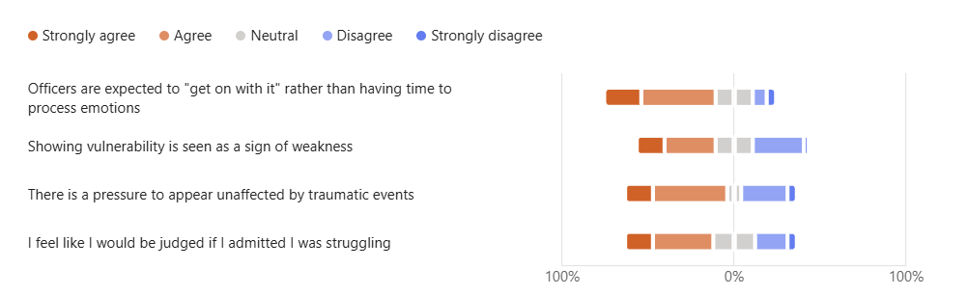
This shows that 64.8% of participants strongly agree or agree that officers are expected to just “get on with it” and 59.4% of those also agreed that there is a pressure to appear unaffected by events within their career. These questions show the “cult of coping” within policing which reflects the argument that Reiner made that those who join the police force are forced into a culture that expects emotional control, detachment and toughness (Reiner, 2010).
Further to this, 45.9% of participants agree that showing vulnerability is a sign of weakness compared to the 32.4% who disagreed. This aligns with research based on stigma and masculinity that prominent in policing and how traditional masculine norms remain present and shaping officers’ behaviour. These norms contribute to the stigma where officers negatively view themselves for experiencing psychological strain and refrain from opening up (Forensic Focus, 2025).

4.3 Mental Health climate within policing
The below chart was created based on questions relating to mental health within policing and the openness that the forces have surrounded this subject.
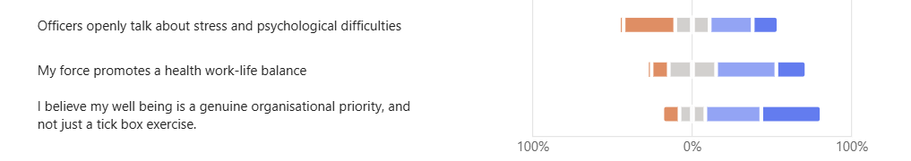
High workloads, unpredictable shifts and emotional labour are just a few things that characterise policing. Studies by Houdmont and Elliott-Davies show that officers frequently report burnout and fatigue, which undermines wellbeing (Officer, 2016). 56.7% of participants from this study, which was placed across two different Welsh Police Forces, state that they disagree that their force promotes a healthy work life balance whilst 13.5% agree.
The key part to this theme is the scepticism surrounding the organisations wellbeing initiatives. 72.9% of the participants in this study feel that officer wellbeing is more of a tick box exercise rather than a genuine priority, whilst 10.8% disagree. Also, 56.7% of participants stated they disagree that their force promotes a healthy work-life balance between professional responsibilities and personal wellbeing. This suggests that operational pressures and workplace expectations may influence officers’ perceptions of how much importance is placed on their wellbeing and in turn see it as a less of a priority.
Overall, this theme demonstrates that despite the increased attention to police wellbeing, police officers are continuing to experience a disconnect between policy and practice. This supports broader literature that suggests genuine change around organisational culture requires not only policy development but structural reform.

4.4 Central concerns regarding organisational culture
The word cloud below highlights how “mental health” is a central concern within policing as the majority of participants have used this phrase to describe their main concerns.
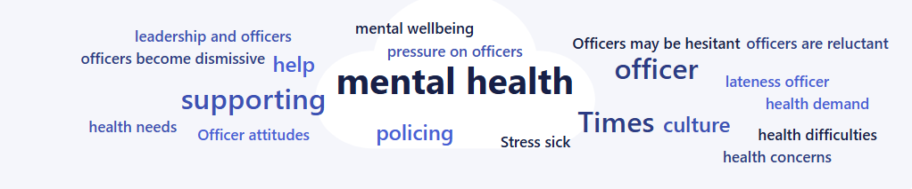
Participants also regularly mentioned phrases such as “hesitant”, “reluctant” and “dismissive” which reflects a culture where the psychological issues faced by officers are often minimised or deprioritised. These findings align with long-standing research that shows occupational culture encourages emotional suppression and discourages help seeking behaviours (Lewsey, 2022).
Further reoccurring phrases are “pressure on officers”, “stress” and “support” indicate that officers are experiencing the significant psychological strain yet may not feel comfortable addressing it. It also suggests that officers recognise the importance of support, but the negative terms imply that accessing the support is complicated by the culture.
The word cloud illustrates a policing environment where mental health issues are widespread, yet the cultural expectations continue to contribute to the hesitation and reluctance to seek support. This theme reinforces that organisational culture remains a powerful determinant of help-seeking behaviour, and that without meaningful change, the toxic environment will remain for officers and officers will not feel supported in addressing the wellbeing issues.

4.5 Stigma and consequences
This chart is based around the stigma and consequences around seeking help, to which there were a mixture of responses.
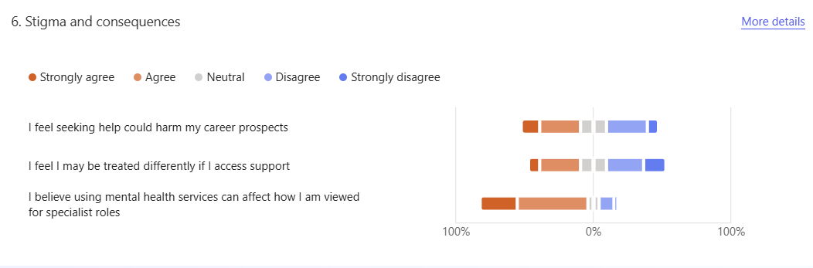
The findings indicate that stigma and perceived consequences remain an important factor in officers being influenced on their perceptions of seeking help. The responses suggest that some officers believe accessing mental health support could negatively affect their professional identity, career progression or how they are generally perceived within the organisation.
The data shows that 43.2% of participants expressed concerns that accepting help may harm their career prospects and result in being treated differently by their peers or supervisors. This suggests that some officers may still be associating help-seeking with negative perceptions, creating barriers to openly accessing the support offered to them. Concerns were also identified around the impact of using mental health services may have on their future career progressions, with 78.4% of participants, agreeing or strongly agreeing that they believe it will affect how they are viewed for specialist roles.
However, the variation in responses indicates that not all participants share the same experiences or beliefs. Some officers disagreed that seeking support would have negative consequences, suggesting that attitudes towards mental health within policing may be changing.

4.6 Leadership and awareness
This chart is based off officers’ perceptions on leadership styles and how these influence officers’ perceptions.
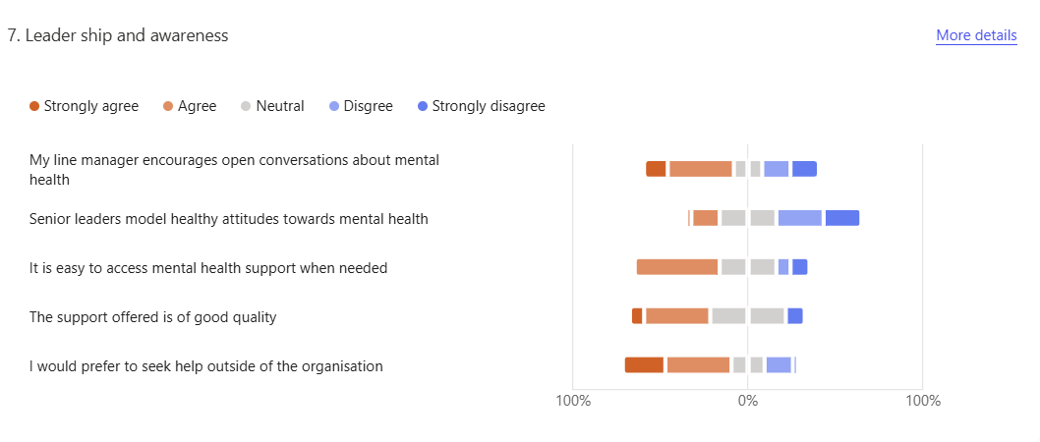
The findings indicate that leadership and organisational awareness play an important role in shaping officers’ perception of mental health support. The results suggest that the participants had mixed views regarding the extend to which leaders encourage openness and demonstrate positive attitudes towards wellbeing.
62.1% of participants stated they agree or strongly agree that they would prefer to seek help from outside of the organisation. This suggests that there is a link to trust and confidence in internal services which may influence whether officers choose to engage with the wellbeing resources. A preference for external support may indicate concerns about confidentiality organisational stigma and peer perception.
48.6% of participants also stated they disagree that senior leader’s model healthy attitudes towards mental health. Whilst some participants agreed, it indicates that there are inconsistencies between organisational expectations and officers’ experiences. This may affect how comfortable officers feel discussing mental health concerns with their supervisors.

4.7 Conclusion
Overall, this chapter demonstrates that organisational culture continues to shape help-seeking behaviour within Welsh Policing. Emotional suppression, stigma regarding mental health, and the expectation to be tough remains embedded leading to officers being discourages from seeking support. Although it appears some cultural change is occurring, the developments are uneven and insufficient to counter the long-standing norms.

Chapter 5 – Conclusion and recommendations
5.1 Conclusion and achievement of objectives
This dissertation successfully addressed the research objectives by examining how organisational culture can influence officers’ willingness to seek help. The findings demonstrated that help-seeking behaviours are shaped by a combination of workplace expectations, leadership practices, stigma and perceptions of organisational support.
The first objective was to examine officers’ perceptions of organisational culture and how it impacts their mental health. This objective was achieved through analysing participants' perceptions on workplace expectations, wellbeing services and access to support. The findings demonstrated that organisational culture has significant influence on officers’ mental health experience. Many participants expressed concerns regarding work life balance and whether wellbeing was genuinely prioritised within their organisation. The perception that wellbeing initiatives could be viewed as a “tick box” exercise suggests that some officers feel there is a difference between organisational messages about wellbeing and their lived experiences.
These findings support Schein’s (2017) theory of organisational culture, which explains that workplace behaviour is influenced by visible practices, stated values and deeper underlying assumptions. While police forces may promote wellbeing through policies and support services, the findings suggest that underlying cultural expectations around resilience, emotional control and maintaining professionalism continue to influence how officers manage mental health issues. This demonstrates that organisational culture can either encourage openness or create barriers to accessing support services.
These findings also echo those of Brown et al who argued that wellbeing programmes in police forces often appear to be performative or compliance driven rather than being embedded in day-to-day practice. When officers perceive wellbeing efforts as tick box exercises, trust in the organisation diminishes meaning they are less likely to seek support from them, this is reflected in Heslin and Kleiner who showed that employees are less likely to access support services when they doubt the sincerity of the interventions (HESLIN, VANDEWALLE and LATHAM, 2006).
The second objective was to identify what cultural norms are persistent within policing environments. This objective was addressed by examining recurring themes surrounding stigma, perceptions of vulnerability, leadership and attitudes towards accessing support. The findings suggest that traditional policing values including strength, self-reliance and the ability to cope under pressure, remain influential within police culture.
Although these characteristics are key to effective policing, the findings indicate that they can also discourage officers from being open about their feelings and struggles, discouraging them form discussing their mental health concerns. Participants reported concerns that seeking help could have a negative effect on their career progression, opportunities for specialist roles or how they are viewed by their peers. This suggests that stigma and fear of judgement remain persistent culture barriers within the organisations. These findings align with Goffman’s (1963) Stigma Theory, as officers may avoid seeking support due to these barriers.
The third objective was to explore recurring experiences between officers to propose recommendations for improving wellbeing and support withing police forces. This objective was achieved by identifying common patterns across participant responses, including concerns around stigma and support services.
The findings suggest that access to support alone does not guarantee that officers will use it. Some participants indicated a preference for seeking outside of the organisation, suggesting concerns about confidentiality, judgement and whether internal support services are trusted. This highlights the importance of creating a culture where wellbeing is integrated into everyday policing rather than treated as a separate initiative.

5.2 Future research
Future research should continue to explore how organisational culture influences help-seeking across different ranks, roles, and police environments. Qualitive research could provide deeper insight into officers lived experiences and the cultural factors that influence their decisions.
Further investigation into how organisational change affects help-seeking behaviours would also be valuable, particularly in identifying which interventions create meaningful improvements.

5.3 Recommendations
Based on these findings, recommendations have been developed on focussing on strengthening leadership approaches, increasing trust and reducing stigma. Improving officer wellbeing requires organisational change that addresses both formal policies and the deeper cultural expectations.
Firstly, organisations should focus on creating a culture where discussions surrounding mental health are normalised rather than treated as an occasional issue. Forces should ensure that wellbeing is embedded into everyday policing practices through regular conversations, supervisor meetings and team discussions. This would help demonstrate that wellbeing is an ongoing priority rather than a policy requirement.
Secondly, there is a need for greater investment in leadership training focused on mental health awareness and supportive management. As leadership was identified as an important factor having influence on officers’ experiences, supervisors should be equipped with the skills to recognise the signs of stress, burnout and emotional difficulties. This links to Psychological Safety Theory (Edmondson, 1999), as supportive leadership can help create environments where officers feel comfortable being honest about their wellbeing.
Another recommendation is that police forces should consider reviewing workload expectations and operational pressures that can contribute to poor work-life balance. The findings showed that concerns regarding whether organisations genuinely supported a healthy balance between work and personal life. Whilst operational demands are an unavoidable aspect of policing, forces should explore ways to improve workload management, ensuring appropriate staffing levels and encourage officers to take adequate rest. Addressing these issues may reduce burnout and demonstrate that wellbeing is valued alongside operational effectiveness.
Overall, these recommendations highlight that improving help-seeking behaviour requires cultural change rather than simply increasing the availability of support services. By strengthening leadership, reduce stigma, improving trust and embedding wellbeing into everyday practice, police organisations can create environments where officers feel valued and supported.

5.4 Final Conclusion
This dissertation demonstrates that organisational culture is a critical factor influencing police officers’ willingness to seek help. The findings show that although wellbeing is increasingly recognised within policing, cultural barriers including stigma, lack of psychological safety and concerns about consequences remain.
Creating healthier policing environments requires a shift from a culture of simply coping, towards a culture of support. Officers should be encouraged to view seeking help as an important aspect of professionalism, resilience and maintaining long term effectiveness.

Chapter 6 – Bibliography
Brown, J. and Heidensohn, F. (2000). Gender and policing : comparative perspectives. Basingstoke: Macmillan.
Brown, K. (2024). Vulnerability and Social Control at the Margins: A Contribution to an Interdisciplinary Trialogue on Vulnerability. Human Studies, 47(2), pp.287–306. doi:https://doi.org/10.1007/s10746-024-09734-5.
Charman, S. and Bennett, S. (2021). Voluntary resignations from the police service: the impact of organisational and occupational stressors on organisational commitment. Policing and Society, [online] 32(2), pp.1–20. Available at: https://www.tandfonline.com/doi/full/10.1080/10439463.2021.1891234 [Accessed 25 Jan. 2026].
College of Policing (2016). Sources of help for those in need of mental and emotional support | College of Policing. [online] College of Policing. Available at: https://www.college.police.uk/app/mental-health/sources-help-those-need-mental-and-emotional-support [Accessed 22 Jan. 2026].
College of Policing (2024a). Collapsing the canteen: Empowering and encouraging police officers to report sexual misconduct among their colleagues | College of Policing. [online] www.college.police.uk. Available at: https://www.college.police.uk/research/projects/collapsing-canteen-empowering-and-encouraging-police-officers-report-sexual-misconduct-among-their-colleagues [Accessed 25 Jan. 2026].
College of Policing (2024b). National policing culture and inclusion strategy 2025 to 2030 | College of Policing. [online] College of Policing. Available at: https://www.college.police.uk/support-forces/diversity-and-inclusion/culture-and-inclusion-strategy [Accessed 8 Mar. 2026].
Connell, R. (2005). Masculinities. 2nd ed. Cambridge Polity.
Cooper, S. (2024). Policing Culture: Definition, Toxic Characteristics and Good Practice |. [online] Rank Success Blog | Free UK Police Promotion Support to Sergeant, Inspector and Beyond. Available at: https://policepromotion.blog/2024/06/23/policing-culture-definition-toxic-characteristics-and-good-practice/ [Accessed 20 Jan. 2026].
Corrigan (2004). APA PsycNet. [online] psycnet.apa.org. Available at: https://psycnet.apa.org/record/2004-19091-003?doi=1 [Accessed 20 Jan. 2026].
Cotton, P. and Hart, P.M. (2003). Occupational Wellbeing and Performance: A Review of Organisational Health Research. Australian Psychologist, [online] 38(2), pp.118–127. doi:https://doi.org/10.1080/00050060310001707117.
Edmondson, A. (1999). Psychological Safety and Learning Behavior in Work Teams. Administrative Science Quarterly, 44(2), pp.350–383. doi:https://doi.org/10.2307/2666999.
Federation, P.F. (2022). The silent crisis killing police officers: more than 100 suicides since 2022. [online] Polfed.org. Available at: https://polfed.org/news/latest-news/2026/the-silent-crisis-killing-police-officers-more-than-100-suicides-since-2022/ [Accessed 20 Jan. 2026].
Forensic Focus (2025). UK Policing On The Edge: Lessons From The 2025 Oscar Kilo Well-Being Survey - Forensic Focus. [online] Forensic Focus. Available at: https://www.forensicfocus.com/articles/uk-policing-on-the-edge-lessons-from-the-2025-oscar-kilo-well-being-survey/ [Accessed 20 Apr. 2026].
Gray, G.C. (2013). Insider Accounts of Institutional Corruption: Examining the Social Organization of Unethical Behaviour. British Journal of Criminology, 53(4), pp.533–551. doi:https://doi.org/10.1093/bjc/azt013.
Haugen, P.T., McCrillis, A.M., Smid, G.E. and Nijdam, M.J. (2017). Mental health stigma and barriers to mental health care for first responders: A systematic review and meta-analysis. Journal of Psychiatric Research, [online] 94(94), pp.218–229. doi:https://doi.org/10.1016/j.jpsychires.2017.08.001.
Hesketh, I. and Tehrani, N. (2018). Psychological Trauma Risk Management in the UK Police Service. Policing: A Journal of Policy and Practice, [online] 13(4). doi:https://doi.org/10.1093/police/pay083.
HESLIN, P.A., VANDEWALLE, D. and LATHAM, G.P. (2006). KEEN TO HELP? MANAGERS’ IMPLICIT PERSON THEORIES AND THEIR SUBSEQUENT EMPLOYEE COACHING. Personnel Psychology, 59(4), pp.871–902. doi:https://doi.org/10.1111/j.1744-6570.2006.00057.x.
Heyman, I. and McGeough, E. (2018). Cross-disciplinary partnerships between police and health services for mental health care. Journal of Psychiatric and Mental Health Nursing, 25(5-6), pp.283–284. doi:https://doi.org/10.1111/jpm.12471.
Holdaway, S. (2017). The re-professionalization of the police in England and Wales. Criminology & Criminal Justice, [online] 17(5), pp.588–604. doi:https://doi.org/10.1177/1748895817690214.
Houdmont, J. and Elliott-Davies, M. (2017). Police Officer Welfare, Demand, and Capacity Survey Inferential Results. [online] Available at: https://polfed.org/media/14062/pfew-inferential-results-report-27-12-17-v10-002.pdf [Accessed 23 Jan. 2026].
Huff, R. (2014). Organizational culture. [online] Encyclopedia Britannica. Available at: https://www.britannica.com/topic/organizational-culture [Accessed 8 Mar. 2026].
INGRAM, J.R., TERRILL, W. and PAOLINE, E.A. (2018). POLICE CULTURE AND OFFICER BEHAVIOR: APPLICATION OF A MULTILEVEL FRAMEWORK. Criminology, 56(4), pp.780–811. doi:https://doi.org/10.1111/1745-9125.12192.
Karaffa, K.M. and Koch, J.M. (2015). Stigma, Pluralistic Ignorance, and Attitudes Toward Seeking Mental Health Services Among Police Officers. Criminal Justice and Behavior, 43(6), pp.759–777. doi:https://doi.org/10.1177/0093854815613103.
Lewsey, F. (2022). UK policing: psychological damage among officers heightened by bad working conditions. [online] University of Cambridge. Available at: https://www.cam.ac.uk/research/news/uk-policing-psychological-damage-among-officers-heightened-by-bad-working-conditions [Accessed 27 Apr. 2026].
Loader, I. and Mulcahy, A. (2003). Policing and the Condition of England : Memory, Politics and Culture. Oxford: Oxford University Press.
Loftus, B. (2010a). Police culture in a changing world. Oxford: Oxford University Press.
Loftus, B. (2010b). Police occupational culture: classic themes, altered times. Policing and Society, [online] 20(1), pp.1–20. doi:https://doi.org/10.1080/10439460903281547.
Lou, N. (2020). Book Review: Police Occupational Culture; Research and Practice. The Police Journal: Theory, Practice and Principles, 20, p.0032258X2093262. doi:https://doi.org/10.1177/0032258x20932627.
McLeod, S. (2024). Thematic Analysis: A Step by Step Guide. [online] SimplyPsychology. Available at: https://www.simplypsychology.org/thematic-analysis.html [Accessed 8 Mar. 2026].
Morgan, C., Mallett, R., Hutchinson, G. and Leff, J. (2004). Negative pathways to psychiatric care and ethnicity: the bridge between social science and psychiatry. Social Science & Medicine, 58(4), pp.739–752. doi:https://doi.org/10.1016/s0277-9536(03)00233-8.
Myhill, A. and Bradford, B. (2013). Overcoming cop culture? Organizational justice and police officers’ attitudes toward the public. Policing: An International Journal of Police Strategies & Management, 36(2), pp.338–356. doi:https://doi.org/10.1108/13639511311329732.
Officer (2016). FOI 00169 - 2016 Officer Demand, Capacity and Welfare Survey report. [online] Polfed.org. Available at: https://polfed.org/resources/access-to-information/disclosure-log/foi-00169-2016-officer-demand-capacity-and-welfare-survey-report/ [Accessed 20 Apr. 2026].
Oscar Kilo (2019). You’re not alone: mental health support for police officers | Oscar Kilo. [online] Oscar Kilo. Available at: https://www.oscarkilo.org.uk/mental-health-support-police-officers [Accessed 21 Jun. 2026].
Paoline, E.A., Myers, S.M. and Worden, R.E. (2000). Police culture, individualism, and Community policing: Evidence from Two Police Departments. Justice Quarterly, [online] 17(3), pp.575–605. doi:https://doi.org/10.1080/07418820000094671.
Reiner, R. (2010). The Politics of the Police. 4th ed. Oxford: Oxford University Press.
Rune Glomseth and Bentzen, T.H. (2025). Police Leadership. Springer.
Sangiovanni, A., Juri, P. and Juri Viehoff (2024). The Virtue of Solidarity. Oxford University Press.
Silvestri, M. (2017). Police Culture and Gender: Revisiting the ‘Cult of Masculinity’. Policing: A Journal of Policy and Practice, [online] 11(3), pp.289–300. doi:https://doi.org/10.1093/police/paw052.
Tajfel, H. (1981). Human groups and social categories: Studies in social psychology. Cambridge Cambridgeshire ; New York: Cambridge University Press.
Violanti, J.M. (2014). DYING FOR THE JOB. Charles C Thomas Publisher.
Waddington, P.A.J. (1999). Discretion, ‘Respectability’ and Institutional Police Racism. Sociological Research Online, 4(1), pp.175–183. doi:https://doi.org/10.5153/sro.243.
Welsh Government (2015). Well-being of Future Generations (Wales) Act 2015: the essentials [HTML]. [online] GOV.WALES. Available at: https://www.gov.wales/well-being-future-generations-act-essentials-html [Accessed 25 Jan. 2026].
West Yorkshire Police (2018). Trauma Risk Management (TRiM) - Force Policy | West Yorkshire Police. [online] West Yorkshire Police. Available at: https://www.westyorkshire.police.uk/about-us/policies-and-procedures/policies/human-resources/trauma-risk-management-trim [Accessed 25 Jan. 2026].
Westmarland, L. (2011). Gender and policing : sex, power and police culture. London ; New York: Routledge.
Wickert, C. (2025). Erving Goffman – Stigma: Notes on the Management of Spoiled Identity (1963) | SozTheo. [online] SozTheo. Available at: https://soztheo.com/criminology/key-works-in-criminology/erving-goffman-stigma-notes-on-the-management-of-spoiled-identity-1963/ [Accessed 22 Jun. 2026].

Chapter 7 – Appendix
Appendix A- Blank interview
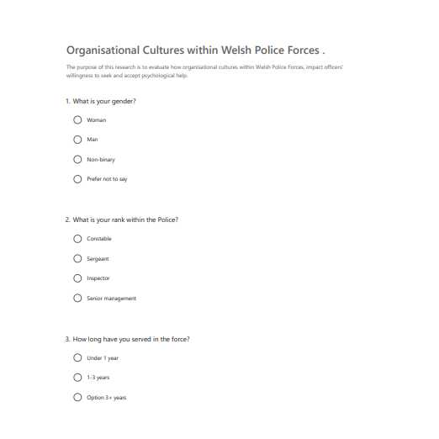

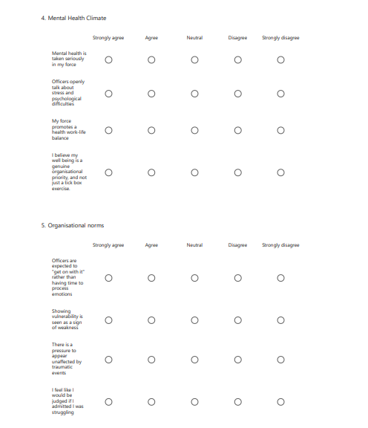

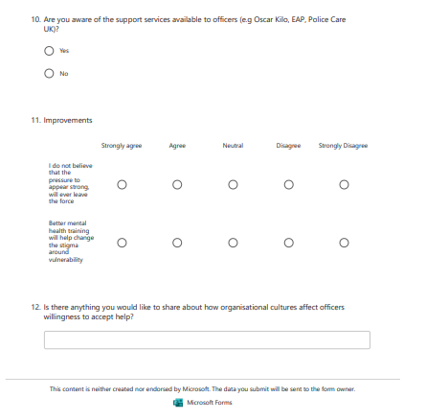
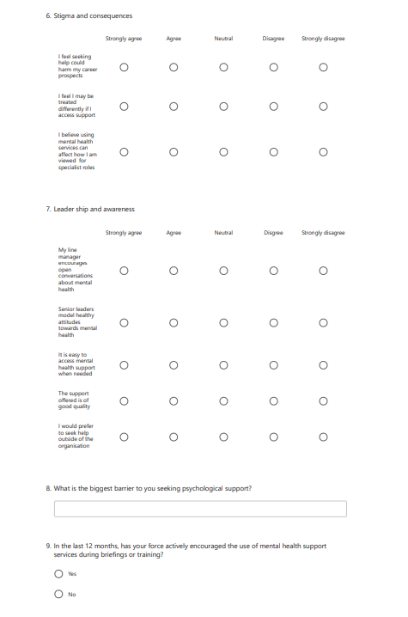

Appendix B- Questionnaire information sheet
Research Title:
How organisational cultures within police forces influence officers’ willingness to seek help.
Introduction
You are invited to participate in a research study exploring how organisational culture influences police officers’ willingness to seek help, particularly in relation to mental health and wellbeing support. Before deciding whether to participate, it is important you understand the purpose of the research, what your participation involves and how the information gathered will be managed.
Please read the following information carefully. If you have any questions before completing the questionnaire, feel free to contact me on 2319739@student.uwtsd.ac.uk.
The purpose of this research is to explore police officers’ perceptions of organisational culture and how workplace expectations, values, and attitudes influence mental health and help-seeking behaviours.
The study aims to examine:
- officers’ experiences and perceptions of organisational culture;
- cultural norms and attitudes that may influence discussions around mental health;
- factors that encourage or discourage officers from accessing support;
- potential improvements that could strengthen wellbeing and support within police organisations.
Your participation will contribute to a better understanding of how police forces can create more supportive environments for officer wellbeing.
What Participation Involves
If you choose to participate, you will be asked to complete a questionnaire containing questions relating to your experiences and perceptions of workplace culture, mental health, wellbeing support, and help-seeking within policing.
The questionnaire should take approximately 10–15 minutes to complete.
Some questions may ask about personal opinions or experiences relating to mental health and workplace support. You do not have to answer any question that you do not feel comfortable responding to.
Voluntary Participation and Right to Withdraw
Your participation in this research is completely voluntary.
You are free to:
- choose whether to participate;
- skip any questions you do not wish to answer;
- withdraw from the study at any time before submitting your responses.
You do not need to provide a reason for withdrawing.
Once submitted, your responses may not be able to be removed if they have been anonymised and combined with other participants’ data.
Confidentiality and Anonymity
All responses provided will remain anonymous.
No identifying information such as your name, workplace location, or any details that could identify you personally will be collected. The information you provide will be analysed collectively with other responses and will only be used for the purposes of this dissertation.
The results will be presented in a way that protects participants’ identities, and no individual participant will be identifiable within the final research report.
Sensitive Nature of the Research
This research involves discussion of mental health, wellbeing, and experiences within policing. Some questions may cause you to reflect on difficult or sensitive experiences.
You are reminded that:
- you do not have to answer any question that causes discomfort;
- you may stop completing the questionnaire at any time.
If completing this questionnaire raises any concerns or you feel that you would benefit from additional support, details of relevant support services will be provided at the end of the questionnaire.
Support Information
Due to the sensitive nature of this research, a list of support services will be provided following completion of the questionnaire. These services are available if you would like to speak to someone about any concerns relating to your wellbeing.
Use of Data
The information collected will be used solely for academic purposes as part of this dissertation. Data will be stored securely and only accessed by the researcher and relevant academic supervisors where required.
The findings may be used to inform discussion around improving wellbeing practices and support systems within policing.
Consent
By continuing to the questionnaire, you confirm that:
- you have read and understood the information provided;
- you understand that participation is voluntary;
- you understand that you may withdraw before submitting your responses;
- you consent to your anonymous responses being used for this research.
Thank you for considering taking part in this study.

Appendix C – Participant debrief sheet
Participant Debrief Information Sheet
Thank You for Your Participation
Thank you for taking the time to complete this questionnaire.
Your contribution is greatly appreciated and will support this research into how organisational culture influences police officers’ willingness to seek help, particularly in relation to mental health and wellbeing support.
The information you have provided will contribute to a greater understanding of officers’ experiences, perceptions, and the factors that may influence decisions around accessing support.
Confidentiality and Use of Your Responses
As explained before participation, your responses will remain anonymous and confidential. No identifying information will be included in the research findings, and your individual responses will not be shared with your organisation or any third party.
The information collected will only be used for the purpose of this dissertation and will be analysed alongside other participants’ responses.
Further Questions or Concerns
If you have any questions about this research, would like further information, or wish to discuss any aspect of your participation, please contact the researcher via email: 2319739@ student.uwtsd.ac.uk
Support Information
Due to the sensitive nature of this research topic, you may have reflected on personal experiences or feelings relating to stress, wellbeing, mental health, or experiences within policing.
If completing this questionnaire has raised any concerns, or if you feel you would benefit from additional support, the following services are available:
Police and Emergency Service Support
Oscar Kilo – National Police Wellbeing Service
Provides wellbeing resources, guidance, and support specifically for police officers and staff, including information on mental health, resilience, and workplace wellbeing.
Website: The National Police Wellbeing Service | Oscar Kilo
Police Care UK
A charity supporting serving and retired police officers, staff, and families affected by physical or psychological challenges connected to policing.
Website: https://www.policecare.org.uk
The Police Treatment Centres
Provides rehabilitation, support, and wellbeing services for serving police officers experiencing physical or psychological difficulties.
Website: https://www.thepolicetreatmentcentres.org
Your Force Occupational Health / Wellbeing Service
Your organisation’s internal wellbeing and occupational health teams can provide confidential advice, support, and referrals where appropriate.
General Mental Health Support
Samaritans
Provides confidential emotional support for anyone experiencing distress or struggling to cope.
Telephone: 116 123
Website: Samaritans | Every life lost to suicide is a tragedy | Here to listen
Mind
Provides information and support relating to mental health and wellbeing.
Website: https://www.mind.org.uk
NHS Mental Health Services
If you feel you need professional support, you can contact your GP or access NHS mental health services.
Website: https://www.nhs.uk/mental-health
Thank You
Thank you again for your time and contribution. Your participation is valuable in helping to improve understanding of wellbeing, organisational culture, and support within policing environments.

