
The change management of British Petroleum (BP)
Yuchi Zhang
2203623
BMMB 7000 Change & stability management

Executive summary
BP (BP) is one of the world's largest private oil companies and one of the world's top ten private conglomerates. In 2020-2022, BP introduced a series of changes due to the impact of the COVID-19 pandemic and the Russia-Ukraine war. This report was written to understand how these changes took place and to assess how effective they really were. The present report analyses the causes of such change, the steps of change management and the ultimate effects, taking into account academic sources and the specific circumstances of the Organization.
Through PESTEL and SWOT analysis, changes in the political and economic environment are identified as the main drivers of change at BP, and BP's corporate leadership is the main force driving these changes. These changes are a emergent change. Combined with Professor Kanter's theory, one conclusion can be concluded that resistance to BP's change management comes mainly from being different, the ripple effect and the actual threat posed by change.
Through incremental execution, BP overcame these resistance and successfully managed change. A Kotter's eight-step change management model can be used to describe how these changes occur. From the results of BP's change, BP's change is undoubtedly effective.
Based on the results of the analysis of change management at BP, three recommendations are proposed to help companies achieve successful change management:
- Develop appropriate change plans, including general change plans and emergency change plans in response to black swan events. Different types of change can refer to the four change approaches model of Deborah Rowland et al.
- Take action to reduce the impact of organizational change, see Kavanaugh & Tarafdar's theory of microchange.
- To integrate a culture of change into your company's culture, Kate Heinz's five-step model for cultural change is a good reference.

Contents

Executive summary 1
Introduction 3
1. The changes British Petroleum experienced in 2020-2022. 4
2. What led to changes at BP 5
2.1. External factors 5
2.2. Internal factors 7
2.3. Resistance of change at BP 8
2.4. Type of changes 9
3. Change management at BP 10
3.1. Kotter’s eight-step model 10
3.2. Step-by-step change management at BP 10
3.3. Change evaluation 14
4. Conclusion 15
Recommendations 15
Recommendation 1 15
Recommendation 2 17
Recommendation 3 18
References: 19

Introduction
British Petroleum (Hereinafter referred to as BP) is a British multinational oil and gas company headquartered in London, England. It is one of the oil and gas "supermajors" and one of the world's largest companies measured by revenues and profits (Reuters, 2008). It is a vertically integrated company operating in all areas of the oil and gas industry, including exploration and extraction, refining, distribution and marketing, power generation, and trading. However, affected by the Covid-19 pandemic that began in late 19 and the Russia-Ukraine conflict in 2022, BP experienced a series of changes in 2020-2022, including the announcement of "accelerate the transition to a lower carbon economy and energy system" (Keown, 2020), the sale of the petrochemical sector, the development of offshore wind in partnership with Equinor, It announced that it will acquire a 50% non-operating stake in the Empire wind farm in New York and Beacon wind offshore wind farm in Massachusetts (Adomaitis, 2020) and announced that it will sell its 19.75% stake in Rosneft (BBC News, 2022), among others.
This report was prepared to analyse the changes BP experienced in 2020-2022, the causes of the changes and to assess the effectiveness of BP's change management. First, this report will summarize the key changes BP underwent in 2020-2022. Second, this report will analyze the causes of change and the drivers of change management from the external and internal environment. This report will then combine models and theories to analyze the key steps of change management in BP, i.e. how change management occurs, and assess the effectiveness of change management in BP. Finally, this report will draw conclusions and make some suggestions based on BP's change management process, and provide thinking and assistance on how to implement change management.

The changes British Petroleum experienced in 2020-2022.
In order to analyze BP's change management in 2020-2022, the changes it underwent in 2020-2022 should first be identified.
During the COVID-19 pandemic, with the lockdown policies of various governments, human social activities have decreased to the lowest level in nearly a century(Ullah, 2020). The decrease in activity led directly to a sharp decline in the demand for fossil fuels in human society, which in turn led to a write-down of US$17.5 billion by BP in the second quarter of 2020 (WSJ, 2020). In June 2020, BP sold its petrochemicals division to INEOS. In September of the same year, BP entered into a partnership with Equinor to co-develop offshore wind and announced that it would acquire a 50% non-operating stake in the Empire wind in New York and the Beacon wind offshore wind farms in Massachusetts (Farmer, 2021). And at the end of 2020, BP acquired a majority stake in Finite Carbon, the largest developer of forest carbon offsets in the United States. These acquisitions all appear to confirm its announcement during the pandemic to "accelerate the transition to a lower carbon economy and energy system."
And during the Russian-Ukrainian war, in response to Russia's invasion of Ukraine in 2022, BP announced that it would sell its 19.75% stake in Rosneft. In October of the same year, BP announced that it would acquire renewable natural gas producer Archaea Energy Inc. (BP, 2022) for $4.1 billion. At the end of 2022, BP again announced the completion of its acquisition of Gula Energy for $3.3 billion. In 2023, BP released its 2022 financial report. As can be seen, BP achieved the highest profit in its 114-year history in 2022 due to energy shortages and soaring international oil prices due to the impact of the Russian-Ukrainian war (Hart, 2023).

What led to changes at BP

External factors
To find the external factors that lead to bp change, a PESTEL model can be used for analysis. The principle of the PESTEL model can be seen in Figure 1.
Politically, the lockdowns of governments around the world during the pandemic have led to a reduction in human activity, which has directly affected BP's reduction in oil production. The decline in human activity has also led to a decrease in the world's demand for oil, which in turn has affected BP's product sales. And during the Russian-Ukrainian war, the organization announced it was giving up its stake in Rosneft after the British government raised concerns about BP's involvement in Russia (The Guardian, 2022), but the energy shortage caused by the war directly led to the growth of the organization's profits.
Economically, the global economic downturn during the pandemic affected BP by laying off its workforce and selling some of its businesses, as did the recession in the pre-Russia-Ukraine conflict, but then took a turn.
Socioculturally, the Western values of traditional British companies influenced BP's judgment in the Russia-Ukraine conflict, indirectly leading it to give up most of its stake and business in Russia (Ron Bousso, 2022).
Figure 1
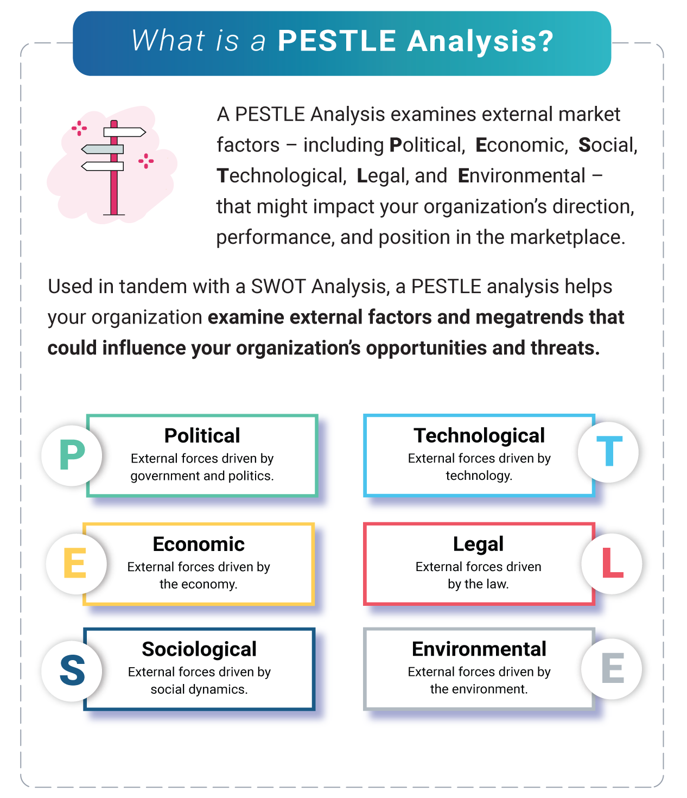
(OnStrategy, 2023)
Enviromentally, the impact of traditional fossil energy on the ecological environment has become increasingly impossible to ignore, which indirectly leads to BP's announcement of a "shift to a low-carbon society and energy system". But on the other hand, industrial production and manufacturing still need the supply of fossil raw materials, and BP's future main business will still be the petrochemical industry.
From the perspective of BP's external environment, the main factors leading to BP's change are political and economic. The attitude of countries and the UK government during the pandemic and the Russian-Ukrainian war has directly or indirectly affected BP's changes.

Internal factors
A SWOT model can be used to analyze the internal factors of BP in the face of change, and the interaction of internal and external factors.The results of the analysis are shown in Figure 2.
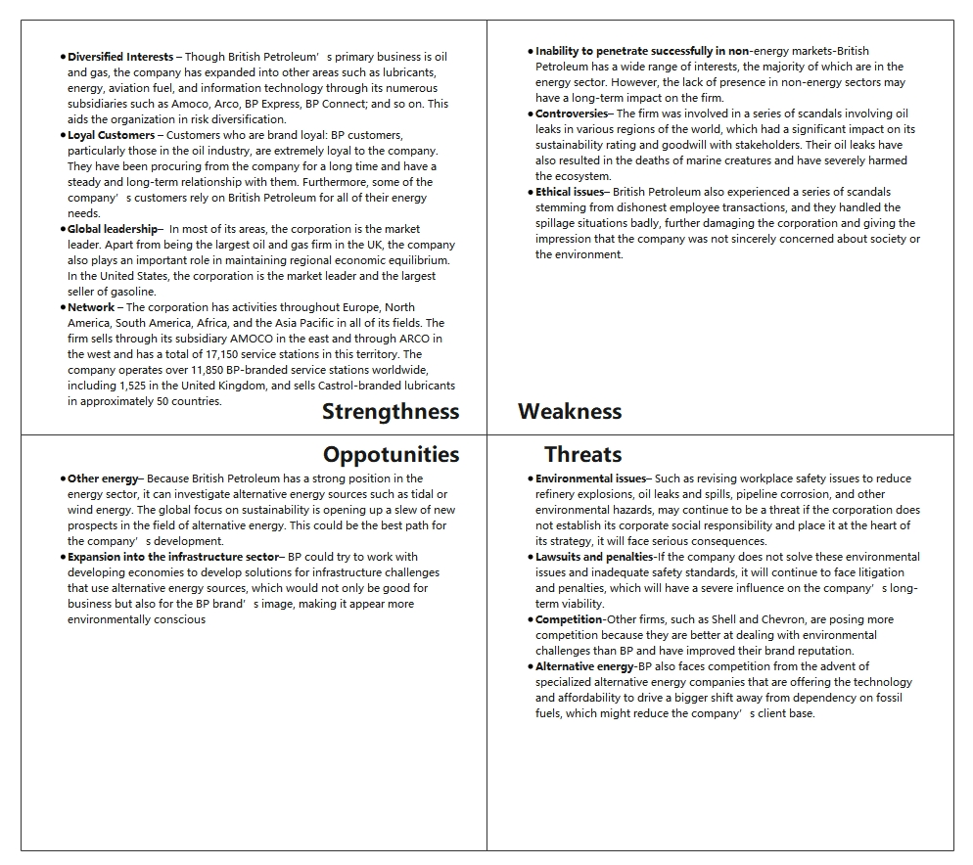
Figure 2
(Adapted from Shastri, 2022)
From the analysis results, it can be seen that BP's profitability mainly depends on fossil energy, so BP will react greatly when the external environment (such as the world's demand for fossil energy, the price of fossil energy, etc.) changes. Just as during the pandemic, the reduction in fuel demand due to reduced human activity directly affected the reduction of BP's profits; During the war in Russia and Ukraine, the shortage of fossil fuels caused by the global energy crisis brought BP high profits. This single profit structure is a weakness, which means that the company is less resilient to risk and change. But the good news is that BP seems to be aware of this and is transitioning from a traditional fossil fuel business to a new energy business. This can be seen in BP's acquisition of clean energy businesses such as wind. This shows that despite the size of BP's business, its managers are actively seeking transformation, which is good for change management.

Resistance of change at BP
Professor Kanter (2018) from Harvard summarized the reasons why people resist change into 10 points: Loss of control, Excess uncertainty, Sudden surprise, Everything seems different, Loss of face, Concerns about competence, More work, Ripple effects, past resentments, and Sometimes the threat is real.
For BP, resistance to change comes from being different, the ripple effect and the actual threat posed by change. The sale of the petrochemical division, layoffs, new divisions and acquisitions of new businesses will inevitably lead to changes in the original working conditions and adjustments in the processing of the original business. BP's approach to this is to make changes gradually. For example, for acquisitions of new energy businesses, BP makes acquisitions every once in a while. Also, at the beginning of the pandemic, BP first announced that there would be no layoffs within 3 months, and then started layoffs 3 months later (Gren, 2020). These incremental steps illustrate that BP's leadership is trying to be as stable as possible in the midst of change, and by slowly changing people, people are more receptive to and familiar with change.

Type of changes
From the above PESTEl and SWOT analysis, it can be seen that in the era of the pandemic and the Russian-Ukrainian conflict, the decisions of leadership directly lead to organizational changes. From announcing accelerated transformation to selling petrochemical divisions, from acquiring offshore power generation to selling Rosneft shares. The leadership's decision allowed BP to survive the pandemic recession and again achieve high profitability after the Russia-Ukraine conflict.Therefore, it can be considered that leadership is the key factor of organizational changes.
The changes that BP experienced in 2020-2022 were more of an emergency change than a planned one. Pandemics and Great Recessions, as well as all-out wars between the two largest economies, tend to be black swan events, i.e. such events are usually sudden and unforeseen (Raikar, 2023). Therefore, BP's change is more like a hedge in the event of an external crisis. These changes were not part of the organization's plan before the crisis, but when the crisis occurred, they followed.

Change management at BP

Kotter’s eight-step model
A Harvard Business School professor and world-renowned change expert, Dr. Kotter describes his eight-step process of change in his book Leading Change (1995). Since then, Kotter's eight-step change model has been widely used in the field of change management. Unlike the traditional cognitive "analyze-think-change" approach, Dr. Kotter believes that "seeing-feeling-changing" is more realistic. Seeing is believing, empathy, and thus creating a constant sense of urgency to drive change to happen. Under this pathway, it can be broken down into eight steps, which are to create a sense of urgency, form a strong guiding alliance, develop a vision and strategy, communicate a vision, remove barriers and empower employees to take action, create short-term wins, consolidate results, and reinforce change through change in anchoring culture. A classic Kotter eight-step change management model can be seen in Figure 3.

Step-by-step change management at BP
The process of change management implemented in BP is almost a standard Kotter eight-step change model.

Figure 3
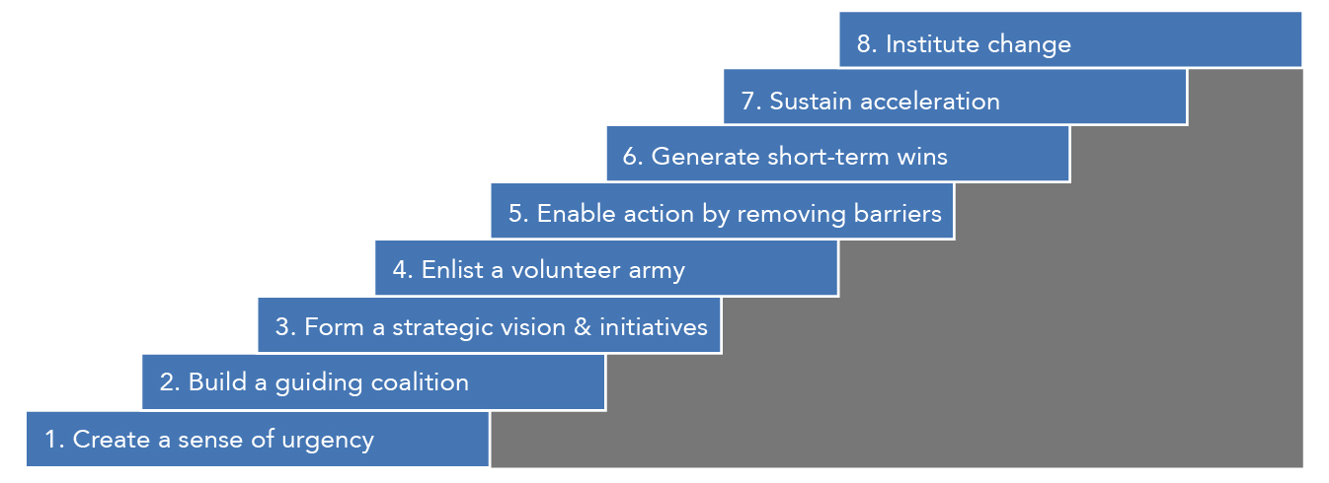
(Kotter, 2023)
Step 1: Create a sense of urgency-When there is a strong demand for change within the enterprise, change will be more likely to occur. So, the first step in driving change is to create a sense of urgency for change within the organization. For the world, the pandemic has already happened. For BP, the decline in staff activity and world energy demand has put the company in an urgent position.
Step 2: Form a strong guiding coalition-For BP, the words of chief executive Bernard Looney are a powerful guide. He noted that BP's main objectives in the context of the pandemic were threescore: protecting people, supporting communities and, most importantly for the company, "strengthening finances"(bp global, 2020). Everything BP has done since then has been guided by these three guidelines.
Step 3: Form a strategic vision & initiatives-In the early stages of a change project, change leaders may have different ideas about how to communicate the purpose and meaning of the change. These good ideas need to be brought together to form a company-wide vision for change. The vision must be clear, short, and powerful, help people quickly understand why change is being made, and inspire people to take concrete action to achieve the goal of change. As described in Step 2, Bernard Looney's three guidelines for BP constitute a vision of a responsible, survival strategy that will help people fight the pandemic together and survive.
Step 4: Communicate the vision-Once a vision for change has been formed, effective communication is key to the success of a change project. In order to distinguish the delivery of the vision of change from the other messages conveyed in the daily work of the company, it is necessary to repeatedly communicate the vision of change to employees in a powerful way and in various appropriate occasions, so that it can be deeply rooted in the hearts of the people. For this reason, BP has specially set up the communication and contact department to realize the internal and external communication of the organization and the transmission of vision (BP global, 2023).
Step 5: Empower others to act on the vision-After presenting the vision, BP will empower people at all levels of the organization to implement them, including the general staff and the finance department.
Step 6: Plan for and create short-term wins-Change leadership teams need to find ways to create tangible results early on in a change project, because nothing motivates people more than sharing the fruits of victory. This would also partially eliminate the negative impact of boycotts. BP's management has outlined a series of plans to meet short-term targets: cutting spending, delaying new exploration, cutting jobs and selling off parts of its business. All this effectively achieves the purpose of "fiscal strengthening
Step 7: Consolidate improvements and produce still more change-According to Kotter, many change projects fail because of premature announcements that change has succeeded. For change to be truly successful, it will involve deeper changes such as processes, systems, etc., and will need to be integrated into the company's culture. So an early victory for change is just a good start. In order to achieve ultimate victory, the change leadership team must continuously follow up and improve. Parts of BP's regime during the pandemic were preserved, and when new situations arose, such as the Russia-Ukraine conflict, BP again proposed new measures to cope with the change.
Step 8: Institutionalize new approaches-Finally, in order to further solidify the results of change, there is a need for sustained efforts to embed change into the corporate culture so that all aspects of the day-to-day operations of the business are aligned with the vision of change. Of course, winning the continued support of business leaders and employees for change is also critical. Otherwise, change may revert to square one. Some of the changes BP introduced during the pandemic have been well preserved, allowing it to cope with the Russia-Ukraine conflict. Such as selling shares and businesses in exchange for the business and survival of the organization.

Change evaluation
As for evaluating the effectiveness of change management in BP, two evaluation methods can be used. The first way to evaluate is to discuss BP itself. For BP, the pandemic-era sale of its petrochemicals division has effectively reduced BP's losses and brought it one step closer to transitioning to a clean energy business. The acquisition of new energy businesses such as wind energy has enriched BP's business structure, enhanced its ability to resist risks and stability of its profit structure, and won BP a good social reputation. The incremental changes also allow BP to still profit from the petrochemical energy business, as it did in 2022. The second way to evaluate BP is to compare BP to companies of the same type, such as Shell. In 2021, Shell announced that its assets had written down $21.7 billion in 2020 due to the pandemic (BBC News, 2021), a figure well above BP's $17.5 billion. This proves that BP's change management has worked so far, and the long-term results of BP's change management remain to be seen.
In terms of evaluating change management steps at BP, Kelsey Miller (2020) from Harvard Business School divides the steps of change management into five parts: Prepare the Organization for Change, Craft a Vision and Plan for Change, Implement the Changes, and Embed Changes Within Company Culture and Practices and Review Progress and Analyze Results. From the degree of completion of these five steps, except for the first and fourth steps, which are relatively lacking, BP completes the other three steps well. The lack of preparation for change may come from the suddenness of change, and the culture of change takes longer to integrate into the culture of the organization.

Conclusion
From the above analysis, it can be concluded that BP has undergone several major changes from 2020 to 2022. In terms of external environmental factors, these changes are most affected by politics and economics. From the perspective of the internal environment, leadership is the key factor and core force that leads to change. The biggest resistance to change comes from the organization's resistance to change, the ripple effects of change, and the real threat. The types of these changes are all emergency changes. Fortunately, BP has reduced these resistance by slowly pushing through change measures, with good results. However, in terms of the change process, BP's change management process still falls short in terms of planning change and integrating the culture of change into the company culture. This means that in the future of work, BP needs to have adequate change plans and better integrate the culture of change into the company's culture.

Recommendations

Recommendation 1
In order to better execute organizational change, the first recommendation is to develop an adequate change plan. Professors Deborah Rowland, Michael Thorley, and Nicole Brauckmann (2023) from Harvard Business School divide organizational change approaches into four categories, namely Directive change, Self-assembly change, Masterful change, and Emergent change. This model of the transformative approach can be seen in Figure 4.
Figure 4
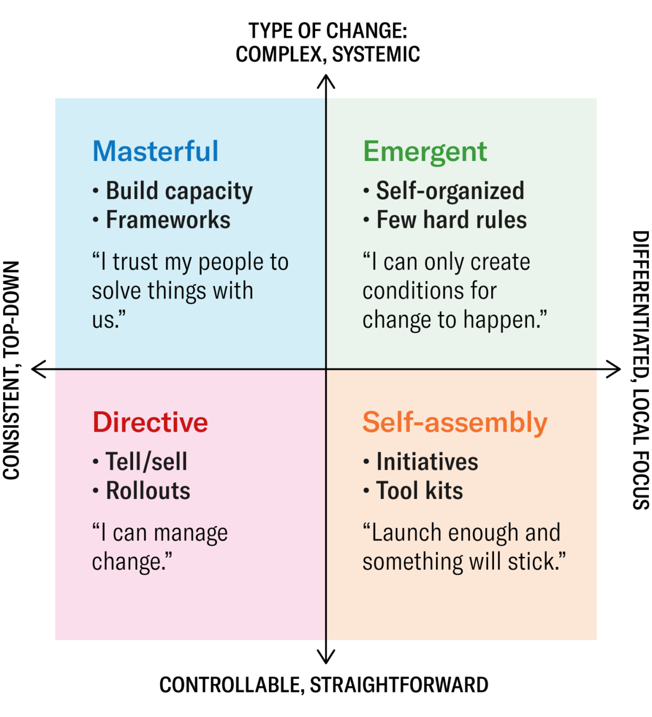
(Adapted from Rowland, D. and Higgs, M. Sustaining change: Leadership that works., 2008)
It's important to note that while emergent change is more urgent than the other three approaches to change, that doesn't mean organizations can't act until a emergent change situation arises. In other words, a well-prepared organization should have contingency plans in place during non-emergency periods to deal with possible emergencies and act according to contingency plans when emergencies arise. This behavior is often referred to as emergency management (Smith, 2017). At present, emergency management in the business field is relatively lacking, in order to deal with possible black swan events, managers need to develop an awareness of emergency management, and make adequate emergency plans in non-emergency situations, so that emergency changes can be made faster and more efficiently when emergencies occur.

Recommendation 2
The second recommendation is to reduce the impact of organizational change, and this recommendation comes from BP's experience of successful change. In BP's change management, every step of change management is trying to neutralize the impact of organizational change, such as starting layoffs after a three-month pause during the pandemic, or announcing the sale of Rosneft's shares during the Russia-Ukraine war without announcing a timetable. Leadership gives the organization ample time to react and familiarize itself with these changes to eliminate the negative impact of sudden changes. In terms of how to eliminate the negative effects of sudden changes, Kavanaugh & Tarafdar's (2021) theory of microchange management can be used as a reference. In this theory, Kavanaugh & Tarafdar proposes three recommendations for change management: Deconstruct big change into small steps, change behavior through small modifications to habits and routines, and Continuously measure, learn. These recommendations have positive implications for how organizations can effectively implement change management and reduce the impact of organizational change.

Recommendation 3
The third recommendation is to take action to integrate a culture of change into the company's culture. In the study of BP and some subjects, it is clear that although these companies have done a good job of the change management steps, few companies have incorporated the culture of change into the corporate culture, although it is part of change management. Prosci (2023) believes that company culture has a very important impact on change management. In order for the organization to better adapt and manage change in the future, managers must integrate the culture of change into the company culture. Lawon and Price (2003) from McKinsey put forward four conditions, including A purpose to believe in, Reinforcement systems, The skills required for change, and Consistent role models. As for how to make this cultural shift, Kate Heinz (2023) proposes five steps, namely Determine your culture goals, Assess your current company culture, Revisit and define core values, Map out a plan with benchmarks, and Evaluate your progress.

References:
- Adomaitis, N. and Bousso, R. (2020) BP enters offshore wind with $1.1 billion Equinor deal, Reuters. Thomson Reuters. Available at: https://www.reuters.com/article/us-equinor-bp-idUSKBN2610OT (Accessed: February 26, 2023).
- Analysis, T.B.- (2008) Oil majors' output growth hinges on strategy shift, Reuters. Thomson Reuters. Available at: https://www.reuters.com/article/us-oilmajors-production-idUSL169721220080801 (Accessed: February 26, 2023).
- BBC News (2021) Royal Dutch Shell sees huge loss as pandemic hits oil demand, BBC News. BBC. Available at: https://www.bbc.com/news/business-55931523 (Accessed: May 4, 2023).
- BP to offload stake in Rosneft amid Ukraine conflict (2022) BBC News. BBC. Available at: https://www.bbc.co.uk/news/business-60548382 (Accessed: February 26, 2023).
- BP's ties to Russia draw UK government 'concern' (2022) The Guardian. Guardian News and Media. Available at: https://www.theguardian.com/business/2022/feb/25/bps-ties-to-russia-draw-uk-government-concern (Accessed: February 27, 2023).
- Communications & External Affairs: Careers: Home (no date) bp global. bp global. Available at: https://www.bp.com/en/global/corporate/careers/professionals/career-areas/communications-and-external-affairs.html (Accessed: February 27, 2023).
- Covid-19 BP response: News and insights: Home (2020) bp global. bp global. Available at: https://www.bp.com/en/global/corporate/news-and-insights/covid-19-bp-response.html (Accessed: February 27, 2023).
- Farmer, M. (2021) Equinor and BP win 2.49GW Offshore Wind contracts in US auction, Power Technology. Available at: https://www.power-technology.com/news/company-news/contract-news/equinor-bp-tender-empire-2-beacon-wind-project-new-york-us-turbine-assembly/ (Accessed: May 3, 2023).
- Gren, C. (2020) BP to make global job cuts mandatory : BP layoffs 2020, Industry Leaders Magazine. Available at: https://www.industryleadersmagazine.com/bp-to-make-global-job-cuts-mandatory/ (Accessed: May 4, 2023).
- Hart, R. (2023) BP boasts record profits as Oil Giants Report historic windfalls, Forbes. Forbes Magazine. Available at: https://www.forbes.com/sites/roberthart/2023/02/07/bp-boasts-record-profits-as-oil-giants-report-historic-windfalls/ (Accessed: May 3, 2023).
- Heinz, K. (2023) How to change your company culture in 5 steps (with examples), Built In. Available at: https://builtin.com/company-culture/how-to-change-company-culture (Accessed: May 5, 2023).
- Kanter, R.M. (2018) Ten reasons people resist change, Harvard Business Review. Available at: https://hbr.org/2012/09/ten-reasons-people-resist-chang (Accessed: May 4, 2023).
- Kavanaugh , J. and Tarafdar, R. (2021) Break down change management into small steps, Harvard Business Review. Available at: https://hbr.org/2021/05/break-down-change-management-into-small-steps (Accessed: May 5, 2023).
- Kenton, W. (2023) SWOT analysis: How to with table and example, Investopedia. Investopedia. Available at: https://www.investopedia.com/terms/s/swot.asp (Accessed: May 3, 2023).
- Keown, C. (2020) BP takes up to $17.5 billion writedown and lowers 30-year oil price forecast. here's what it means, Barron's. Barrons. Available at: https://www.barrons.com/articles/bp-takes-up-to-17-5-billion-writedown-and-lowers-30-year-oil-price-forecast-heres-what-it-means-51592235645 (Accessed: February 26, 2023).
- Kotter, J. (1995) ‘Leading Change: Why Transformation Efforts Fail’, Harvard Business Review, 73(2), pp. 59–67.
- Kotter, J. (2023) The 8-step process for leading change: Dr. John Kotter, Kotter International Inc. Available at: https://www.kotterinc.com/methodology/8-steps/ (Accessed: May 3, 2023).
- Lawson, E. and Price, C. (2003) The Psychology of Change Management, McKinsey & Company. McKinsey & Company. Available at: https://www.mckinsey.com/capabilities/people-and-organizational-performance/our-insights/the-psychology-of-change-management (Accessed: May 5, 2023).
- Miller, K. (2020) 5 critical steps in the Change Management Process: HBS Online, Business Insights Blog. Available at: https://online.hbs.edu/blog/post/change-management-process (Accessed: May 4, 2023).
- Onstrategy (2023) What is a pestle analysis? why do I need it?, OnStrategy. Available at: https://onstrategyhq.com/resources/pestle-analysis/ (Accessed: May 3, 2023).
- Prosci (2023) Culture and change management: The water we swim in, Prosci. Prosci Inc. Available at: https://www.prosci.com/blog/culture-and-change-management-the-water-we-swim-in (Accessed: May 5, 2023).
- Race, M. (2022) BP sees biggest profit in 14 years as energy bills soar, BBC News. BBC. Available at: https://www.bbc.co.uk/news/business-62382624 (Accessed: February 26, 2023).
- Raikar, S.P. (2023) Black Swan event, Encyclopædia Britannica. Encyclopædia Britannica, inc. Available at: https://www.britannica.com/topic/black-swan-event (Accessed: May 3, 2023).
- Ron Bousso, D.Z. (2022) BP quits Russia in up to $25 billion hit after Ukraine invasion, Reuters. Thomson Reuters. Available at: https://www.reuters.com/business/energy/britains-bp-says-exit-stake-russian-oil-giant-rosneft-2022-02-27/ (Accessed: February 27, 2023).
- Rowland, D. and Higgs, M. (2008) Sustaining change: Leadership that works. Chichester, England: Jossey-Bass.
- Rowland, D., Thorley, M. and Brauckmann, N. (2023) The most successful approaches to leading organizational change, Harvard Business Review. Available at: https://hbr.org/2023/04/the-most-successful-approaches-to-leading-organizational-change (Accessed: May 5, 2023).
- Shastri, A. (2022) In-depth SWOT analysis of BP - 2023 update, IIDE. Available at: https://iide.co/case-studies/swot-analysis-of-bp/ (Accessed: May 3, 2023).
- Smith, G.S. (2017) “Emergency business management and internet connectivity,” Business Horizons, 60(3), pp. 353–361. Available at: https://doi.org/10.1016/j.bushor.2017.01.007.
- Ullah, N. (2020) “The world after Covid -19,” COVID-19 Pandemic update 2020, pp. 248–253. Available at: https://doi.org/10.26524/royal.37.25.
- WSJ (2020) BP takes $17.5 billion write-down, expects oil price to stay low, The Wall Street Journal. Dow Jones & Company. Available at: https://www.wsj.com/articles/bp-takes-17-5-billion-write-down-expects-oil-price-to-stay-low-11592211169 (Accessed: May 3, 2023).

