

Certificate of Higher Education in Skills for the Workplace

Task 2
Professional career development report

Student name: Vira Kobzysta
Student ID: 2113831

Module name: Professional Career Development
Module code: (BMSW4005_LON)
Lecturer name: Bianca Sanfilippo
Word count:
Submission date: 06/09/2022

Contents

- Introduction ___________________________________________________________ 3
- Personal reflection on the role play: Recruitment and Selection, Applying Kolb’s (1984) learning cycle _________________________________________________________ 3
- Skills and knowledge which contribute toward working effectively _________________ 5
- My personal strengths and areas for further development _______________________ 6
- SWOT Analysis ________________________________________________________ 7
- My employment goals and my personal career action plan/development plan ________ 8
- My short - medium – long term targets for the development of my own professional career plan _________________________________________________________________ 9
- Conclusion __________________________________________________________ 10
- References __________________________________________________________ 11
- Appendix A - The questions asked as interviewer in the role play (A1) ____________ 12
- Appendix B - Application Form completed as applicant for the role play ___________ 13

Introduction

In this report, I want to describe my personal reflection as an applicant in the job search. I will try to analyze the swarm game step by step using the Gibbs model.
Also, the report will provide as a demonstration of my understanding of the skills and knowledge necessary for us to perform more productively and understand what the employer expects of us. I will do a SWOT analysis of my strengths for career development in the future.
My individual action plan for advancing my career will be discussed in the report. I will also make goals for my future professional development.

Personal reflection on the role play

In this part, I provide my own personal reflection of the role play by using Gibb’s model of reflection.
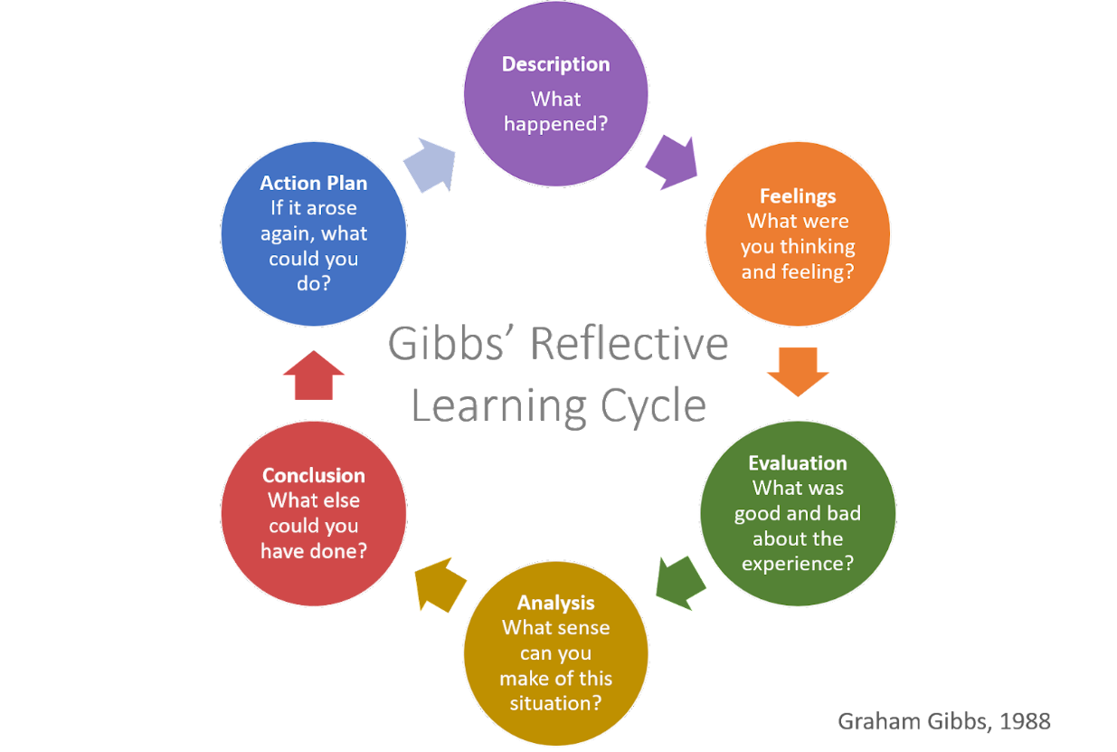
‘It is not sufficient simply to have an experience in order to learn. Without reflecting upon this experience it may quickly be forgotten, or its learning potential lost. It is from the feelings and thoughts emerging from this reflection that generalisations or concepts can be generated and it is generalisations that allow new situations to be tackled effectively.’ (Gibbs 1988)

I will try to identify my strengths, areas for improvement and actions I can take to improve my professional skills using this 6-step Gibbs model. Steps 1-3 discuss what happened during the event, and steps 4-6 discuss how you can improve the experience and outcome in the future.
1. Description
Since I haven't lived in England for so long and have no experience of looking for a job, I started working in a bakery as a pastry chef. But my job does not offer career opportunities, so I decided to apply for the position of Chef de Partie at The Ivy Collection restaurant and try to prove myself there. My role-playing game was built on this basis.
2. Feelings
I felt very confident at the beginning of the game. Before that, I carefully prepared answers to the questions I knew. But when my colleague and I played in public, I started to get a little nervous. I felt like I was at a real interview. The looks and attention of strangers confused me a little.
3. Evaluation
This role play was really great. It gave me my first interview experience. But I realised that I had to act more confidently, because despite my knowledge, I looked nervous. My body language gave me away: I blushed, began to speak more quietly and avoided eye contact. And these are all proofs of lack of confidence. Next time I do this in real life, I will have to make sure my body language is better.
4. Analysis
The more I gave it a thought, the more I understood how crucial body language is. Even if the candidate is extremely intelligent and has excellent knowledge and skills,but if he will be silentesly throughout the interview, avoid making eye contact, and hide his hands because they are shaking. He will never be able to leave a positive impression on his employer.
5. Conclusion
This event taught me what mistakes I made and what I needed to pay attention to in an interview. Next time, I will be more confident in myself, I will smile and look the interlocutor in the eyes. Even if I forget something, I should react more calmly, not be nervous.

6. Action plan
The next time I prepare for an interview, I will start by preparing answers to frequently asked questions. Second, I will repeat my responses aloud in front of the mirror several times. Finally, I will record myself so that I can analyse my body language and try to make it more automatic in order to avoid the problems mentioned above.

Skills and knowledge which contribute toward working effectively

I applied for the position of Chef De Partie in the role-play. In fact, I am seeking for a job in this industry and have investigated the skills and knowledge needed for the job. During the dialogue with my colleague, I focused on skills and knowledge such as: attention to detail, meeting deadlines, working under pressure, ability to learn quickly, and mathematical skills. This is one of the most important skills that contribute to effective work as a Chef De Partie.
Any Chef De Partie must demonstrate the ability to pay attention to detail. You must be exact in this job when following instructions, measuring ingredients, and cooking meals. In order to make your workplace safe and clean, you must also pay particular attention to the small things. (Climbtheladder, 2022).
The ability to meet deadlines is a time-management skill. Every chef should develop and improve this skill to quickly fulfil orders. After all, the high-quality work of a chef is in timely preparing dishes.
A chef must always study and practice. You must spend a lot of time and energy to learning if you want to become an expert in the many cooking techniques. Therefore, you must frequently learn new things if you want to become a professional chef. So one of the skills that contribute to effective work is the ability to quick learning.
Also, chef needs to be mathematically literate. through the using of different recipes, accurate weighing techniques, and routine stocktakes.
Every employment has special knowledge requirements linked to that role and the services offered. Health and safety at work and understanding of the workplace rules are the two fundamental knowledge areas needed to perform my profession as Chef de Partie properly.
The Health and Safety at Work etc Act 1974 is the primary piece of legislation covering occupational health and safety in Great Britain. It is sometimes referred to as HSWA, the HSW Act, the 1974 Act or HASAWA.
It sets out the general duties which:
- employers have towards employees and members of the public
- employees have to themselves and to each other
- certain self-employed have towards themselves and others. (HSE,2019)
Every workplace has certain rules, and it is important to know them. It is particularly important to observe the rules of discipline. For example, going to work on time, reporting illness or the reason for not going to work, not drinking alcohol or drugs at the workplace, and observing hygiene rules.

My personal strengths and areas for further development

I am currently employed as a pastry chef in a bakery. I am searching for employment as a Chef De Partie in a restaurant since I want to advance my profession in the near future. My strong side is culinary skills. Employers want to hire chefs who have experience of making great food. have had prior experience starting from scratch and producing good results when working in a famous bakery. My manager has some good suggestions. I like to make exclusive desserts and good designs on dishes. In the future, I hope to demonstrate my skills in excellent food design and have the opportunity to put my own design ideas into action. With many years of work experience, I have well-developed organisational skills. In the future, I want to demonstrate them because in the position of Chef De Partie, it is very often necessary to do several things at the same time: monitor the remaining ingredients and order them on time; make preparations for the next day; and prepare current orders.

SWOT Analysis

STRENGHTS  - I have working experience.  - The ability to accept criticism and work well under pressure.  - The ability to learn quickly.  - The ability to work well with others.  - To be thorough and pay attention to detail.  - Culinary skills.  - Digital skills and mathematical knowledge.  - Active listening skills.  - A good memory. | WEAKNESSES  - Perfectionism.  - I expect too much from myself.  - I have bad motivation.
OPPORTUNITIES  - Good salary.  - Gain new knowledge and improve skills.  - Ability to grow with the company. | THREATS  - If I devote all my time only to this work, I will not be able to achieve anything else.  - I do not have a certificate of education in the field of food preparation.  - I do not speak English well.  - I have limited time to study.  - I am afraid to be disappointed in the position of Сhef De Partie in a new company.

My employment goals and my personal career action plan/development plan

My professional career pathway is:
I want to become a Chef Departie in a restaurant in the dessert section
What are my current strengths?
I have many years of work experience. I also have all the necessary knowledge and skills for this position.
What are my achievements and areas of success since the beginning of the module/programme.
- I learned how to correctly write a CV according to the profession I am looking for.
- Before the start of the module, I had several interviews, but I did not know how to prepare for them. This module taught me how to prepare questions for an interview.
- The topic of my career development plan played a particularly important role for me. I now know step-by-step what to do in the future.
In what areas do I need to develop?
While completing this module, I realized that I need to develop my public speaking skills, as well as improve my academic writing skills and be more confident.
Why is it important to improve in these areas?
Considering that these are my weaknesses. I want to eliminate them because it will help me develop faster in my career.
Who will help me? What resources will I need?
At the beginning of the course, the teacher helped me by providing a large amount of information. Now I am helped by my friend, who works as a manager in a restaurant. She gives me advice on what skills I need to improve. In addition, I used a lot of University’s resorses in Moodle. Internet resources play a big role.
What are the constraints/ barriers to achieving these key ares and how I will manage these– eg time, resources.
The main barrier is the time limit. because I am currently working. Also, I prefer face-to-face training. At the moment, there is a lot of online training, which is not very suitable for me.
What further action do I need to take now?
- Take a short vacation from your current job.
- Do research for information about my new position.
- Write a CV and prepare a set of answers to interview questions.
- Continue studying at the university.

Actions to be taken – things to do, people to see.
I plan to send my CV to The Ivy Colections restaurant. Meet with the manager of this restaurant and get an interview for the position of Chef de partie.
Time scale – by when.
October 2022

My short - medium – long term targets for the development of my own professional career plan

I established SMART plans for the future, according to the article T.J.Law 2021.
Short-term plan (3 -6 months)
Specific | Complete Uiversity studies level 4
Measurable | Attendance above 70%, submit assignments and achieve a pass.
Agreed | Lecturers, menager from my current job.
Realistic | Yes, as I am completing level 4.
Time-Bound | 10 October 2022
Medium-term plan (1-2 years)
Specific | Work as a Сhef De Partie on the dessert line in a restaurant
Measurable | Full-time employment contract with a reliable income.
Agreed | General manager, family.
Realistic | Yes, I have currently sent my cv to a number of restaurants. I got through one interview.
Time-Bound | 01 September 2023
Long-term plan (2-5 years)
Specific | Work as Chef De Partie on all lines in the restaurant. Become a Senior chef.
Measurable | Full-time employment contract with a reliable income.
Agreed | General manager, team members.
Realistic | Yes
Time-Bound | 01 September 2025
Conclusion

Let's summarise my report. With the help of the Gibbs model, I analysed the role play conducted in the classroom. I drew conclusions for myself about where and how I need to improve.
I made a SWOT analysis of my strengths and weaknesses according to my chosen profession. I analysed it and concluded that it is necessary for me to develop in order to advance in my career.
And at the end of this report, I made my individual and step-by-step action plan for career advancement and the achievement of career goals.
I hope that I managed to make a good report and cover all aspects of career planning and personal development.

References

- ClimbtheLadder. (2022). 14 Chef De Partie Skills for Your Career and Resume. [online] Available at: https://climbtheladder.com/chef-de-partie-skills/#:~:text=Attention%20to%20detail%20is%20a [Accessed 19 Aug. 2022].
- Futures Skills Award (2018). Applying the Gibbs’ Reflective Model. [online] Available at: https://www.mmu.ac.uk/media/mmuacuk/content/documents/careers/Applying-the-Gibbs-Model-2018.pdf [Accessed 23 Aug. 2022].
- Gibbs, G. (1988). Learning by Doing, A Guide to Teaching and Learning Methods. [online] Oxford Brookes University. Oxford Brookes University. Available at: https://thoughtsmostlyaboutlearning.files.wordpress.com/2015/12/learning-by-doing-graham-gibbs.pdf [Accessed 23 Aug. 2022].
- HSE (2019). Health and Safety at Work etc Act 1974. [online] Hse.gov.uk. Available at: https://www.hse.gov.uk/legislation/hswa.htm [Accessed 20 Aug. 2022].
- Law, T.J. (2021). 10 Powerful SMART Goal Examples to Help You Achieve Your Dreams. [online] www.oberlo.co.uksmart-goals-examples. Available at: https://www.oberlo.co.uk/blog/smart-goal-examples [Accessed 23 Aug. 2022].

Appendix A
The questions asked as interviewer in the role play (A1)
1.Why are you interested in the position?
2.What do you know about this role in our company?
3.What are your strengths?
4.Why should we hire you?
5.Where do you see yourself in the next few years?
The question/s asked as interviewee in the role play (A1)
1.When and how will I get an answer about the result of today’s interview?
2. Does the company provide quality training for this vacancy?

Appendix B

Job application form

Application for [job title] – Pastry Chef de Partie

Your details

Name: Vira Kobzysta

Education and training
Please give details:

- Ternopil secondary school N12 (1986-1996)
- Ternopil Volodymyr Hnatiuk National Pedagogical University (1996-2001):
  - Faculty of Physics and Mathematics.
  - Specialty: teacher of physics and informatics.

Qualifications
Please give details:

- Certificates:
Fire Safety Awareness (02/2022-02/2023)
Food Safety Level 2 (VTQ) (03/2022-03/2025)
- University of Wales Trinity Saint David/UK (2021-present)

Employment history

Your current or most recent employer

Name of employer: Paul Rhodes Bakery

Job title: Pastry Chef

Length of time with employer: From September 2021 to present

Reason for leaving: In fact, I am very pleased with my work. I have gained new experience in the food industry. I also took a few courses, such as Food Safety. I am leaving this position to gain an opportunity to advance in my career. I also want to prove myself in the field of restaurant business.

Duties:

- Making handmade cookies that meet the requirements and standards of the company
- Adhering to the specifics of the order
- Meeting deadlines
- Assisting the Head Baker in the production of handmade baked products
- Weighing and measuring ingredients
- Decorate pastries and other desserts using a variety of different sauces, toppings, and other items
- Keeping accurate records
- Operating a variety of kitchen equipment
- Maintaining a clean and hygienic work environment

Previous employers

Please tell us about other jobs you have done and about the skills you used or learned in those jobs.

Name of employer: YUG Contract/Ukraine

Job title: Document management specialist/customer department

Length of time with employer: From May 2012 to February 2018

Reason for leaving: Moving to London.

Duties:
- Receiving and processing orders from clients
- Registration and submission of primary documentation
- Work with a package of documents on legal contracts
- Reconciliations of mutual settlements with clients
- Maintaining customer service records
- Contacting customers with questions and dealing with complaints
Skills:
- Time management
- Multitasking and deal with a lot of information
- Tasks prioritising
- Focus on customer service
- Problem solving
- Critical thinking
- Working under pressure
- Computer literacy (Microsoft Office,1C:etc) and mathematical skills
- Verbal and written communication skills

Supporting statement
Please tell us why you applied for this job and why you think you are the best person for the job.
I will get the chance to work in the restaurant industry after accepting the position from Chef de Partie, and it will also be a chance for me to develop my career. I can demonstrate and develop my skills in the field of food preparation for the final consumer in this position.
You have to hire me because I have most of the skills needed for this role. I always think positively, and I enjoy working in a team. You will be able to confirm that I am a trustworthy and motivated individual by hiring me. I'll handle the duties in a professional manner.

Right to work in the UK
Do you need a work permit to work in the UK? Yes / No
Yes

References
Please give the names and contact details of 2 people who we can ask to give you a reference. We may ask them before an employment offer is made. We will not ask your current employer until we get your permission.

- Andras -Head of Pastry Chefs in Paul Rhodes Bakery
02082690460 hr@paulrhodesbackery.co.uk
- Tatyana – been Main Manager of document and customer department in YUG Contract/Ukraine
+380503128567 (viber)

Declaration
I confirm that to the best of my knowledge the information I have provided on this form is correct and I accept that providing deliberately false information could result in my dismissal.

Name: Vira Kobzysta
Signature: VK
Date: 06/07/2022

