University of Wales Trinity Saint David

Certificate for Higher Education, Skills for the workplace

(Health and Social Care) Group 2. Term 3

BMHP4003_London

08/12/2020

Psychology for Health and Social Care

October 2020. Term 3

Essay 1

Topic: Early Childhood Developmental Psychology

1
Introduction.
Developmental Psychology is a scientific study of how people develop through their life and why. Psychology is a Greek word which is the study of Soul and Mind. It is a practice through observation, measurement, and testing to get to the conclusion that are sound based. It is a scientific methodology. Psychology can be simple, or complex, conscious, or unconscious behaviour done voluntary or involuntary. It can be rational or irrational, practically our thoughts and feelings.
This essay is about developmental psychology in early childhood. The physical aspect, the cognitive aspect, and the psychosocial aspect of psychological development. It was originally concerned with children but now it has broadened over the years and focuses on every stage in human growth. It examines the changes from infancy, adolescence, and adulthood.
Background of Developmental psychology.
Jean- Jacques Rousseau and John B. Watson are placed to provide the basis for contemporary developmental psychology. Watson stressed the need to learn what can be done and anticipate and monitor its goals. According to him much of our behaviour is controlled by unconscious.
Early years: Developmental psychology.
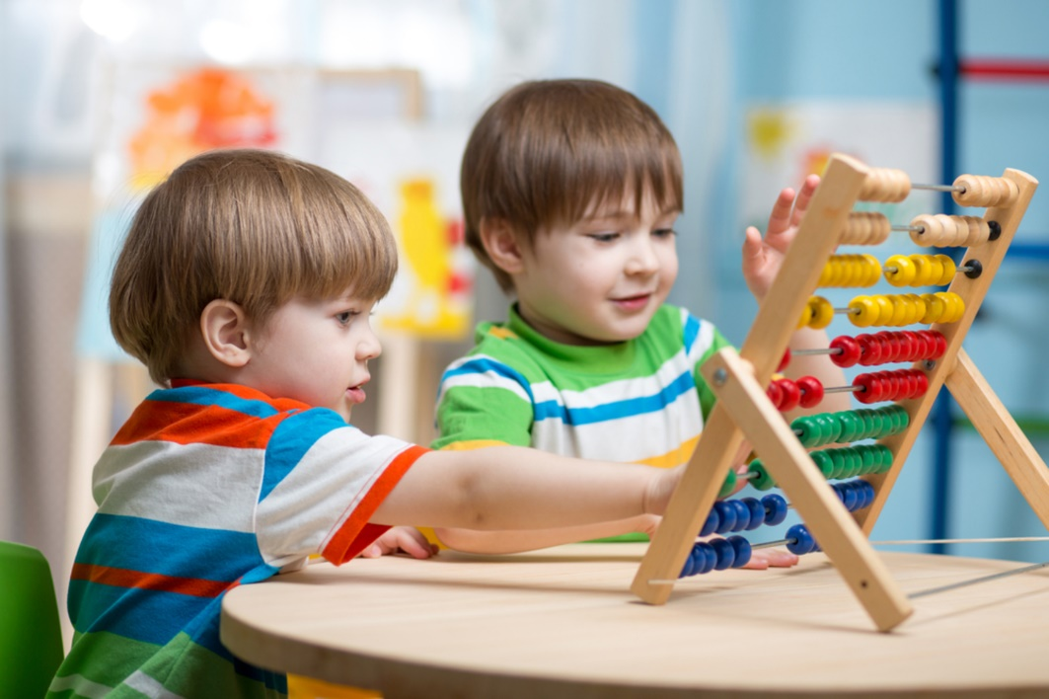
This Photo by Unknown Author is licensed under CC BY-ND.
2
There are some major developmental theories on psychology despite the numerous theories regarding psychology. Sigmund Freud’s psychoanalysis developmental theory, Erik Erikson’s psychosocial theory, and Piaget’s cognitive developmental theory. Early childhood is a period of immense physical cognitive, socio-emotional and language development, typically described as birth to 8 years.
There are two contemporize approach to developmental psychology. Neuroscience assumes that behaviour is a viewpoint of biological functioning that psychodynamic behaviour is driven by an inner, unconscious force that a person has little influence over.
There are three types of human approaches to psychology. The human behaviour which focuses on observation. The cognitive which is about how people relate to the world by their thought and the third one is the Humanistic behaviour focusing on how people can control their behaviour naturally. There is also scientific approach in psychology. Childhood is divided into two groups, the preoperational stage, and the concrete operational stage. (Sanghvi, 2020).
The preoperational stage.
Eye and hand coordination schemas for young children and object performance occur at this age. The pre-operational stage involves the growth of symbolic thinking using language as proof. (KB, 17). The preoperational period starts at 2 and last until age of 7. Memory and imaginings are created by the infant. They assume that the universe is seen by all as they see. (Bashrin, 2015). 2-4 years is when they begin the development of rudimentary concepts and the tendency to see connections between unrelated things. owing to their similarities, they start to identify items in those classes, but because of their definition they make mistakes. 4-7 years is the intuitive thinking age. They solve problems based on their intuition and gain a detailed understanding of the principle. (Bashrin, 2015).
The operational stage.
The concreate operational stage is 7-12 when clear and rational reasoning is demonstrated by the children. They can conduct different mental tasks and reason with concrete logic.
The five developmental stage.
During cognitive developmental stages, children begin to learn and solve problems. The social- emotional developmental stages, the children develop in language. The physical stage is when children develop their fine motor skills using their hands to hold and to manipulates objects. Gross motor skills are developed at this stage and they begin to walk, build stamina, and control their balance.
According to Ivan Pavlov, human behaviour can be innate or learnt through positive or negative reinforcement. (Malti T, 2018). The social learning theory, the classical conditioning of learning. The childhood life span is more related to Piaget’s cognitive development theory.
3
Sigmund Freud’s Psychoanalysis developmental stages.
Freud emphasises that the first five years of life are crucial to adult personality knowledge.
Age | 0-18 months | 18-36 moths | 3-6 years | 6-12 years | 12-
Stage | Oral | Anal | Phallic | Latency | Genital
Pleasures | Mouth sucking, biting, and chewing. | Bowels elimination. demands for control. | Genital copping with incestuous sexual feelings. | Dormant sexual feelings, Gender identification. | Maturation and sexual interest.

The Sigmund Freud theory of psychosexual is about Id- instinct, Ego -reality and Superego- morality. The Id is the primitive and instinctual part of the mind that contains sexual and aggressive drives and hidden memories. According to Freud the Super-ego operates as a moral conscience and the ego is the realistic part that meditates between the desires of the Id and the ego. Freud believes that humans has more than one aspect. In 1923 he emphasis on three developmental stages in human lives. He indicates that they are systems and not part of the brain and they are not physical. He explains that the Id is what we inherit biologically and are with us at birth.
The unconscious mind influences actions and impulses to a greater degree than people expected, according to Fraud. (Singer, 2016) According to Sigmund Freud, the unconscious motive and primitive biological instinct control much of our human actions. Basically, all human beings would like to achieve pleasure and escape pain. Freud’s theory tries to bring psychologist into light making unconscious things conscious. The psychoanalysis stages of Freud are the Oral, Anal, Phallic and Genital.

4
Piaget’s Cognitive Developmental theory.
Jean Piaget brought about the cognitive development. Piaget born 1896-1980 in Switzerland was the first son of Arthur Piaget and Rebecca Jackson. Piaget in childhood period developed some interest in animals and nature. (KB, 2018).He became more interested in how children reasoned during a test and started studying the cognitive development of children. (Sanghvi, 2020). Piaget’s method used were direct observation and he began observing his own children which contributed to the construction of his theory. His studies are believed to be based on case studies and clinical observation rather than scientific experiment, however Piaget’s cognitive developmental theory has remained lasting contribution to development psychology.

Stages of cognitive development.
 | Age | Stages | Motivation skills. |  | Development.
 | 0-2 | Sensorimotor | Coordinates of senses such as waving, sensory like touching, interest about the environment with motor response and vocabulary for demands. |  | Object performance  Stranger anxiety
 | 2-6 | Preparational |  | Convey ideas, symbolic thought, Imagination, imitation and intuition are powerful, but still difficult to complicate abstract ideas. | Ego centrism  Conservation is.  developed
 | 7-11 | Operational |  | The definition of concrete time, space and quantity is known and can be applied, but not as an individual concept. | Conservation  Mathematical  Transformation
 | 12- | Formal operational |  | Strategy and training are becoming possible to apply. Concept learnt in one context to another. | Abstract logic.  Moral  Reasoning.
5
The four stages of Piaget’s schema theory.
The Schemas are the building blocks or the moulding period. They could be established by two phases, Assimilation and Accommodation. Jean Piaget claims that children are going through four stages of mental development. In addition to understanding how children learn information, his theory focuses on understanding the essence of intelligence, Schemas, Adaptation, Assimilation and Accommodation. Although the stages may differ, they all progress through these stages.
Piaget schema theory
Assimilation | Using what they know to learn or adapt new situation. Imagining things according to their knowledge, such as drawing or making funny objects and naming them.
Equilibration | When a child tries what they know and it does not work, they try to accept and try new things. Children master the new challenge, example, repeating and rehearsing new words and short sentences, like rhymes and phrases.
New situation | Children schema can deal with new thoughts or information through assimilation.
Disequilibrium | Disequilibrium is when a child cannot cope with the new information, they are unable to adapt to some situation.
Accommodation | Accommodation is when the child has understood and accept the new idea or concept or mindset of something with new approach. Example a toddler or a baby sees a moving toy for the first time and begin to run. After they understand and probably feel of touch it, they change their mind.

Piaget suggests that each child goes through phases of the same order, and that child development is largely dictated by biological maturation and contact with the environment. According to Piaget, the toddler age is the second stage of development, 1-3 years where they learn to walk and talk. Childhood continues to 12 years. Piaget’s cognitive theory the 0-2 years is the schema age where they are sensorimotor. They experience the world through senses and actions. They also develop by object performance and may have stranger anxiety. The main schemas in child development are connecting, orientation, transporting, trajectory, positioning, rotation. Enveloping, and enclosing
According to Ivan Pavlov, human behaviour can be innate or learnt through positive or negative reinforcement. (Malti T, 2018). The social learning theory, the classical conditioning of learning. The childhood life span is more related to Piaget’s cognitive development theory.

6
Physical Development.
Good eating habits and well supported families can have lower BMI, thus reducing likelihood of overweight and encourages trajectory activities. (Apouey, 2016).
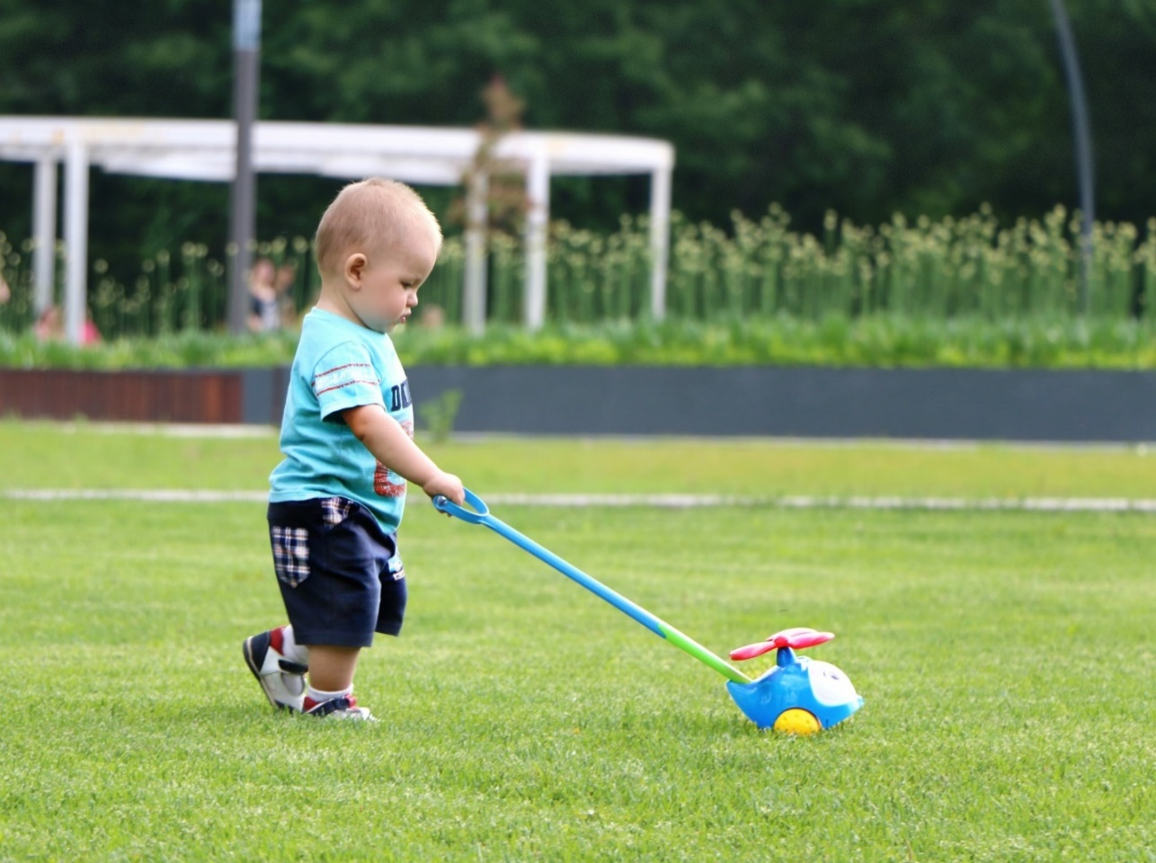
Microsoft Copyrights | Legal Resources.
Cognitive development.
Children cognitive development is when they begin to think, explore, and figure out how things work. They exercise their knowledge, skills and try solving problem offering their toy to another child who is crying to keep them quiet. They develop their brain by trying to understand the world around them. Most children are influence by genes, culture, traits, and environment. (Tetzcher, 2019). They build attachment and bond with parents, carers, teachers, and close relatives. Skills and adaptive behaviours are developed by parental responsiveness. (Galasyuk I N, 2019). Different socioeconomic gradient variables have substantial effect on cognitive growth, with the strongest determinant being maternal schooling. Policies to minimise the detrimental impact of this gradient should be introduced. (Sanitaria, 2020).
7
Emotional and social development.
Children try to understand who they are, what is expected from them. They explore feelings; they try to form relationship and sustain them. At the toddler age of 1-2 they come out with words like ‘’it’s mine, my mum, my dad’. At this stage children build their self-confidence, empathy, and form friendship, bonds, and attachment. (Robinson, 2019). Children at this age are very genuine in their emotions, they build trust and release fear, anxiety, tantrums as they develop. And when they developed, they can withhold tears. (Bridges, 2017). It is crucial to consider the social-emotional growth of the child as it can promote prevention and intervention to meet children’s developmental needs. (Malti T, 2018).
Behaviour.
Toddler behaviour defers, positive behaviour and negative. Behaviour like act of kindness as seen in the picture, illness, and stress behaviour, for instant a child welcomes new-born child into the family can earn the child with a behaviour like withdrawn from touch, food or even sleep. Then behaviours that are destructive, biting, hitting, overturning things.
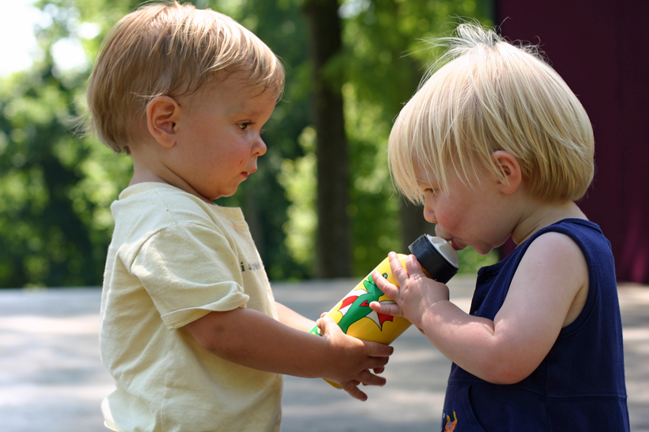Developmental psychology has been the artistic force behind children’s new pictures. (Singer, 2016). According to the report of the research done by the Institute of development studies UK, in relation to Piaget’s theory children’s attitude to other ethnic and racial groups are influenced by their cognitive growth, where children support the in-group to the age of 6-7 and show strong discrimination towards out-groups. (Boun D, 2017).
This Photo by Unknown Author is licensed under CC BY-SA
8
Discussions. /Research articles.
According to Laura, children and adults live in distant sense, a unique mix of personal and environmental conditions that can contribute to various avenues of transition. (Berk, 2018).
A data research by Sarah B Abdallah et al, of the Obsessive -Compulsive Disorder is a neuropsychiatric development with known heritability estimated 3% worldwide, estimates vary from 27%, but this aetiology is poorly known. (Abdallah, 2020).
The impact of Alzheimer’s diseases.
(Bobbie K Burks, 2020).
There is the body of knowledge that indicates that children start to build biases at an early age, but also that values such as fairness, empathy and justice begin to be learned early on. (Douglas Bourn, 2017).

Conclusion.
Professionals and non-professionals, a crossed the globe have tried to understand the human cognitive concept on how it functions in countless context. They believe understanding the functionality will help the process of influencing both the recipients and the helpers. Understanding it can have good impact in professional life. Good observation critical thinking, scientific research and effective analysis can promote the knowledge and insight into developmental psychology.

References.

Abdallah, S. B., 2020. Rare genetic viriation in obsessive-compulsive disoder, New Heaven: Pro-Quest LLc.
Apouey, B., 2016. Child physical development in the UK. Public Health, 04 September, 141(2016), pp. 255-263.
B., D. D. K., 2020. The preoperational stage of children. Different features of pre-operational stage of child cognition and its application, Issue 218.
Bashrin, S., 2015. Child development stages and cognitive Health. Child development stages and cognitive Health, April, Issue 20, p. 12.
B, D. D. K., 2017. Different features of preoperetional stage of child cognition and its application in behaviour mod.. Issue 2018.
Berk, L. E., 2018. Child life span developmental psychology. Seventh ed. Illinos State: Boston ,Pearson.
Bobbie K Burks, A. B.-J. J. M. S. S., 2020. Decision making experince in care givers of mates in later stages of alzheimer's disease. , Capella University Minnesota.: ProQuest LLC.
Boun D, H. F. A. H., 2017. Childhood development stages and learning on global issues, Brigton, London: K4D Helpdesk Report.
Bridges, K., 2017. The social and emotional development of the Pre-school child. s.l.:Google scholar,2017-books.google.com.
Douglas Bourn, F. H. H. A., 2017. Childhood development stages and learning on global issues, London: Education Development Trust.
Galasyuk I N, L. M. A. E. V. ,. K. S. Y., 2019. Parents responsive and its role in neurocognitive and socioemotinal of one year olds. Developmental psychology, 3(12), pp. 6-104.
KB, D., 17. Preoperational stage of young children. University of health science Karnatata, Issue 2018.
KB, D., 2018. Different features of pre-operational stage and its application in behaviou modification. KGV Dental college and hospital.
Malti T, Z. A. N. G. G., 2018. Knowing Every Child. Validation of holistic student assessment/ Prevention science, 08 May, 19(2017), pp. 306-317.
Robinson, L., 2019. Attachment. Electronic books ed. London: Red Globe Press.
Sanghvi, P., 2020. A review of Piaget's theory of cognitive development. Mumbai: Independent -Mental Health Professionals.
Sanitaria, G., 2020. The role of parental social class, education and unemployment on child cognitive development.. The role of parental social class, February, Volume 34, pp. 51-60.
Singer, E., 2016. Child- care and the psychology development. London: Sage.
Tetzcher, S. V., 2019. Typical and Atypical development-Child and adolescent psychology.. Genes, Enviromental and Culture., 26 October.Issue 201.

