  Creativity and Value Creation  University of Wales Trinity Saint David | Darina Tsoneva  2423106

Contents
Task1 1
Task 2: Aim, Objectives & Research Area 2
Aim and Objectives 2
Aim 2
Objectives 3
Research Philosophy 4
Research Tools & Databases 4
Task 3: Research Strategies 5
Validity, Reliability, Generalisability and Ethics 5
Validity 5
Reliability 5
Generalisability 6
Ethical Considerations 6
Research Strategies and Pilot Study 6
Research Design 6
Pilot Data Collection 7
Quantitative and Qualitative Analysis 7
Justification 8
References 8

Task1
This mind map focuses on “Innovation in Computing for Student Wellbeing.” It shows how technology can help improve students’ mental health and academic performance. Key areas include innovation theory, which explains how digital tools like AI are transforming industries, and technology solutions such as chatbots and data analytics that provide support. It also highlights student challenges like stress, anxiety, and lack of resources. The map includes design thinking steps to create effective solutions and suggests project ideas like wellbeing apps. Overall, it demonstrates how computing innovations can address real-world problems and support students through smart, accessible, and user-focused solutions.
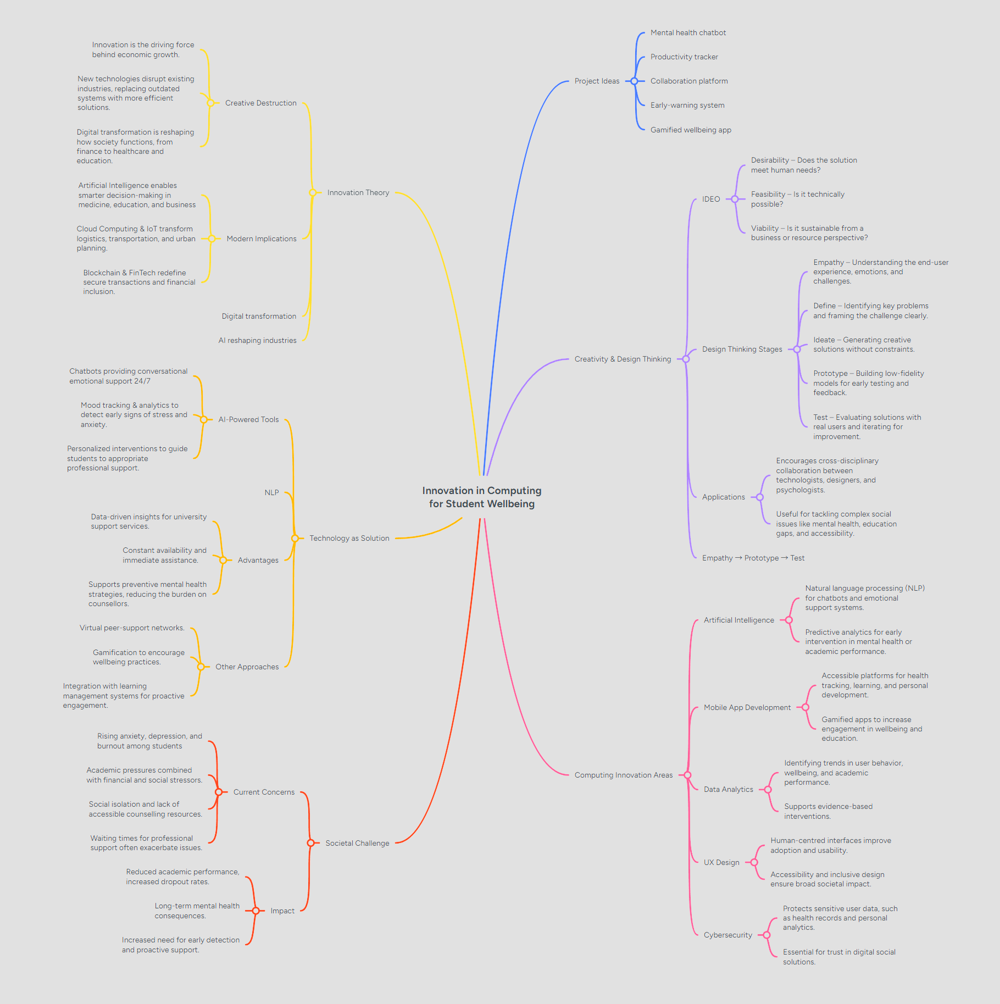

Task 2: Aim, Objectives & Research Area

Aim and Objectives

Aim
The aim of this project is to design and evaluate an AI-powered mobile application that provides early-stage mental wellbeing support for university students through conversational artificial intelligence and mood-tracking analytics. The project seeks to explore how emerging digital technologies can be leveraged to provide accessible, preventative mental health support within higher education settings. The increasing prevalence of anxiety and stress among university students has been widely documented by organisations such as the World Health Organization, highlighting the need for innovative and scalable support mechanisms. Digital mental health tools present an opportunity to complement existing counselling services by offering immediate, low-barrier assistance.

Objectives
To achieve this aim, the project will follow several structured objectives.
First, a comprehensive literature review will be conducted to examine current research on AI-driven mental health applications, particularly chatbot-based systems and emotional analysis technologies. This will establish an academic foundation and identify existing gaps in research. Second, the project will investigate the specific mental health challenges faced by university students. Understanding common stressors, support needs, and user expectations will ensure that the proposed solution is relevant and user-focused. Third, appropriate AI and Natural Language Processing (NLP) frameworks will be identified and evaluated for chatbot implementation. This will involve assessing their technical feasibility, scalability, and ethical considerations. Fourth, the project will design a user-centred mobile interface based on design thinking principles. Organisations such as IDEO emphasise empathy and human-centred innovation, which will guide the design process to ensure the application is intuitive, supportive, and accessible. Fifth, a functional prototype of the application will be developed, integrating conversational AI features with mood-tracking capabilities. Sixth, pilot testing will be conducted with university students to assess usability, engagement, and perceived helpfulness. Finally, the overall effectiveness, usability, and ethical implications of the application will be evaluated. Particular attention will be given to issues such as data privacy, safeguarding, and responsible AI use. Together, these objectives provide a clear progression from research and design to development and evaluation. 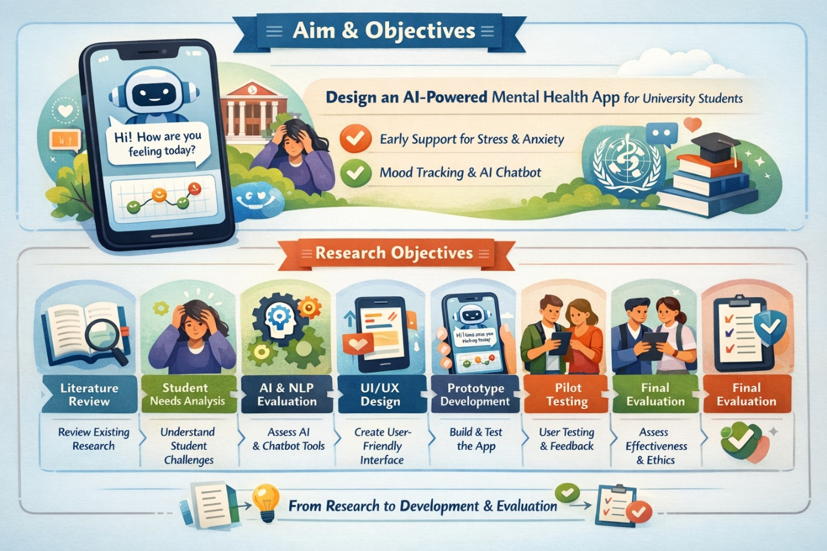

Research Philosophy
The research philosophy guiding this project is Pragmatism. Pragmatism focuses on practical solutions and real-world problem-solving rather than strictly following either quantitative (positivist) or qualitative (interpretivist) traditions. It recognises that different types of data can be combined to better understand and address complex issues. According to John Dewey, knowledge develops through active inquiry and experimentation. This perspective aligns closely with the nature of this project, which aims not only to study student mental health challenges but also to create and test a practical technological solution. The project will therefore adopt a mixed-methods approach. Quantitative data will include usage statistics, mood-tracking scores, and structured survey responses. Qualitative data will include semi-structured interviews and open-ended feedback from participants. By combining measurable data with personal experiences, the research can evaluate both the functional performance of the application and the emotional response of users. Pragmatism is particularly suitable because the project’s primary goal is to produce a working solution that generates social value, rather than to test a purely theoretical model.

Research Tools & Databases
To ensure the research is academically rigorous and evidence-based, several reputable databases and search tools will be used. These include Google Scholar for broad interdisciplinary research, IEEE Xplore Digital Library and ACM Digital Library for computing and AI-related studies, and PubMed for psychological and mental health research. A structured search strategy will be applied using targeted keywords such as “AI mental health chatbot,” “university student wellbeing technology,” “conversational agents in healthcare,” and “NLP emotional analysis.” Boolean operators (AND, OR, NOT) will be used to refine searches and improve relevance. Only peer-reviewed sources published within the last ten years will be included to ensure up-to-date and reliable findings. Studies must be directly relevant to higher education contexts or AI-based mental health technologies.By applying this systematic approach, the research foundation of the project will be both comprehensive and academically credible.

Task 3: Research Strategies
Validity, Reliability, Generalisability and Ethics
Ensuring methodological rigour is essential in evaluating an AI-powered mental wellbeing application, particularly when working with sensitive psychological data. This project therefore places strong emphasis on validity, reliability, generalisability, and ethical responsibility throughout the research process.

Validity
Validity refers to the extent to which the research accurately measures what it intends to measure. In this study, both internal and construct validity will be carefully addressed. Internal validity will be strengthened by pilot testing survey instruments prior to full data collection to identify ambiguous questions or measurement inconsistencies. The use of established and validated mental wellbeing scales, such as the GAD-7 framework, will further enhance measurement accuracy. Employing recognised tools reduces the risk of bias and ensures that anxiety and wellbeing indicators are assessed using reliable psychological standards. Additionally, consistent testing conditions will be maintained across participants, including similar timeframes of app usage and structured evaluation procedures. Construct validity will be ensured by clearly defining the concept of “mental wellbeing support” within the scope of the project. In this context, the term refers specifically to non-clinical, preventative, and early-stage assistance rather than formal diagnosis or therapeutic intervention. By maintaining conceptual clarity, the research avoids overstating the system’s purpose and ensures that outcomes are interpreted within appropriate boundaries.

Reliability
Reliability concerns the consistency and stability of research findings over time. To improve reliability, the study will employ standardised questionnaires for all participants, ensuring uniform data collection. Chatbot scripts and system responses will remain consistent during pilot testing to avoid variation in user experience caused by uncontrolled system changes. Test–retest reliability will be assessed by comparing responses across different time points to determine whether results remain stable. Where possible, testing will also be repeated with small groups of students from different academic cohorts to evaluate whether similar patterns emerge. These measures will increase confidence that the findings are dependable and not the result of random fluctuation.

Generalisability
Generalisability refers to the extent to which research findings can be applied beyond the immediate sample. The pilot sample will include students from different academic disciplines and year groups to capture a range of experiences and perspectives. Although the study may be limited to one institution, efforts will be made to ensure diversity within the participant group in terms of gender, course background, and academic level. While the relatively small sample size restricts broad statistical generalisation, the findings may be transferable to similar UK higher education institutions facing comparable student wellbeing challenges. The aim is not to claim universal applicability, but rather to provide evidence that supports the feasibility and potential scalability of AI-assisted mental wellbeing tools in university contexts.

Ethical Considerations
Ethical considerations are particularly significant in mental health research due to the sensitivity of personal data and the potential vulnerability of participants. This project will adhere strictly to institutional ethical guidelines and data protection regulations. Ethical approval will be sought from the university’s research ethics panel prior to data collection. Participants will receive detailed information sheets outlining the purpose of the study, and informed consent will be obtained before participation. All collected data will be anonymised to protect participant identity, and secure data storage systems will be implemented in accordance with UK GDPR requirements. Only authorised individuals will have access to the data. The application itself will include a clear disclaimer stating that it does not replace professional counselling or clinical treatment. In addition, emergency signposting features will be incorporated to direct users to appropriate crisis services if high-risk responses are detected. Transparency, confidentiality, and participant wellbeing will remain central throughout the research process.

Research Strategies and Pilot Study

Research Design
This study adopts a mixed-method research design, combining quantitative and qualitative approaches to provide a comprehensive evaluation of the application. The quantitative component will include pre- and post-usage wellbeing surveys to measure potential changes in anxiety or mood levels following interaction with the app. Application usage analytics, such as frequency of engagement and duration of sessions, will also be collected to assess behavioural patterns. The qualitative component will involve semi-structured interviews and open-ended feedback surveys. These methods will allow participants to describe their experiences in their own words, providing insight into perceived usefulness, emotional impact, and areas for improvement. Combining numerical trends with subjective reflections ensures a balanced and nuanced understanding of the system’s effectiveness.

Pilot Data Collection
A small-scale pilot study involving approximately five to eight students will be conducted to test the prototype prior to wider implementation. The pilot will focus on evaluating usability, clarity of the mood-tracking interface, and perceived helpfulness of the chatbot responses.
Participants will be asked structured evaluation questions such as rating the ease of use on a five-point scale, assessing whether chatbot responses felt supportive, indicating whether they would use the app again, and providing suggestions for improvement. Feedback gathered during this stage will inform refinements to conversational scripts, user interface design, and the clarity of disclaimers or guidance messages. The pilot phase serves as an essential iterative step, allowing the system to be improved before broader deployment. Supporting documentation, including consent forms and the pilot questionnaire template, will be included in the project appendix.
Quantitative and Qualitative Analysis
Quantitative data will be analysed using descriptive statistics, including measures such as mean, median, and standard deviation to summarise wellbeing scores and usability ratings. Pre- and post-test comparisons will be conducted to explore potential changes in mood indicators following app usage. Correlation analysis may also be performed to examine relationships between usage frequency and reported mood improvement. Analytical tools such as SPSS, Microsoft Excel, or Python libraries (e.g., Pandas and Matplotlib) may be used to process and visualise data. Qualitative data will be analysed using thematic analysis, following the six-phase framework developed by Virginia Braun and Victoria Clarke (2006). This approach involves familiarisation with the data, systematic coding of responses, identification of patterns, development of themes, review and refinement of themes, and finally defining and naming them. Potential themes may include experiences such as “feeling heard,” concerns about privacy, perceptions of ease of use, or levels of trust in AI technology. Thematic analysis enables deeper exploration of user perspectives and provides contextual meaning that numerical data alone cannot capture.

Justification
This project is justified by the increasing mental health challenges faced by university students, including stress, anxiety, and academic pressure. Many students struggle to access timely support due to limited counselling resources and long waiting times. As a result, there is a clear need for innovative and accessible solutions.
The use of Artificial Intelligence (AI) in mental health applications provides an effective way to address this issue. AI-powered chatbots and mood-tracking systems can offer immediate, 24/7 support, helping students manage their wellbeing at an early stage. This reduces pressure on traditional services while improving accessibility.
Additionally, this project is justified from a technological perspective, as it applies modern computing techniques such as Natural Language Processing in a real-world context. It also follows a user-centred design approach to ensure usability and relevance.
Overall, the project is important because it combines technology and research to create a practical solution that supports student wellbeing.

References
[1] V. Braun and V. Clarke, “Using thematic analysis in psychology,” Qualitative Research in Psychology, vol. 3, no. 2, pp. 77–101, 2006.
[2] World Health Organization, Mental health and COVID-19: Early evidence of the pandemic’s impact. Geneva, Switzerland: WHO, 2022.
[3] K. K. Fitzpatrick, A. Darcy, and M. Vierhile, “Delivering cognitive behavior therapy to young adults with symptoms of depression and anxiety using a fully automated conversational agent (Woebot),” JMIR Mental Health, vol. 4, no. 2, 2017.
[4] B. Inkster, S. Sarda, and V. Subramanian, “An empathy-driven, conversational artificial intelligence agent (Wysa),” JMIR mHealth and uHealth, vol. 6, no. 11, 2018.
[5] S. Russell and P. Norvig, Artificial Intelligence: A Modern Approach, 4th ed. Pearson, 2021.
[6] B. Shneiderman et al., Designing the User Interface, 6th ed. Pearson, 2016.
[7] T. Davenport and R. Kalakota, “The potential for artificial intelligence in healthcare,” Future Healthcare Journal, vol. 6, no. 2, pp. 94–98, 2019.
[8] D. D. Luxton, “Artificial intelligence in psychological practice: Current and future applications,” Professional Psychology: Research and Practice, vol. 45, no. 5, pp. 332–339, 2014.
[9] E. Shortliffe and J. Cimino, Biomedical Informatics: Computer Applications in Health Care and Biomedicine, 4th ed. Springer, 2014.
[10] J. Torous, M. Jän Myrick, R. Rauseo-Ricupero, and J. Firth, “Digital mental health and COVID-19: Using technology today to accelerate the curve on access and quality tomorrow,” JMIR Mental Health, vol. 7, no. 3, 2020.
[11] A. Dix, J. Finlay, G. Abowd, and R. Beale, Human-Computer Interaction, 3rd ed. Pearson, 2004.
[12] R. S. Pressman and B. R. Maxim, Software Engineering: A Practitioner’s Approach, 8th ed. McGraw-Hill, 2015.
[13] I. Goodfellow, Y. Bengio, and A. Courville, Deep Learning. MIT Press, 2016.
[14] P. Jain, P. Sharma, and A. Jain, “Role of machine learning in mental health prediction,” International Journal of Computer Applications, vol. 182, no. 44, pp. 1–5, 2019.

