Portfolio
Competencies & Skills linked to Employability Skills.

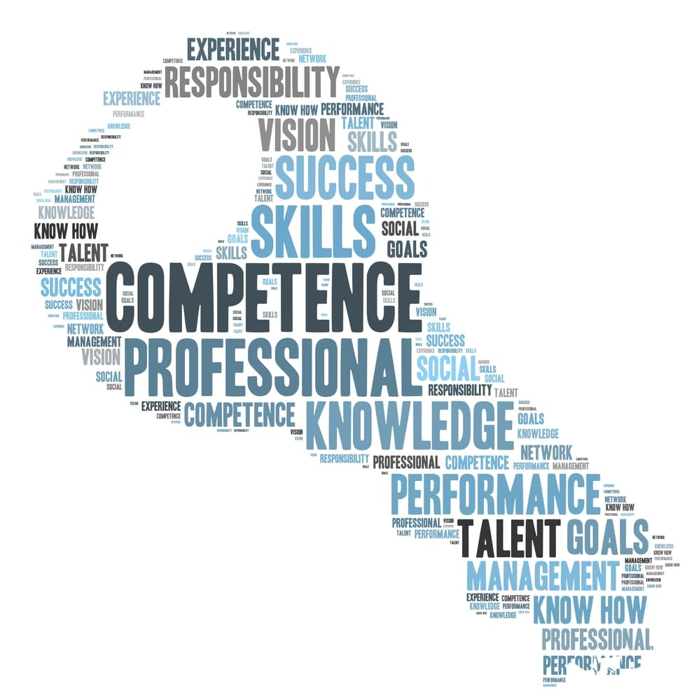

Kaitlyn Hole (1705192)

Contents
Page 3 – CV (Old)
Page 6 – CV (New)
Page 10 – Personal Statement
Page 11 – Reflective Paper
Page 14 – References

Kaitlyn Hole
Tel: 07745709167
Email: kaitlynhole1@hotmail.com
7 Ceiriog Road
Townhill
Swansea
SA1 6NL

Profile
A hardworking, diligent young person with excellent customer service, organisation and communication skills. Works well individually using her initiative as well as being a key team member when working with others, very reliable to work with and always endeavours to complete every task set to the best of her ability.
Currently in University at University of Wales Trinity St David; working hard towards her Education Degree.
Qualifications and skills
Accomplished 13 GCSE’s, are including English, Science and Media studies.
Also accomplished triple distinctions while studying BTEC National Diploma in Child Care, Learning and Development at Gower College Swansea which includes a work placement at various places, e.g. Townhill Primary School.
Participating in various work placements helps to build confidence with communicating with others and personal organisation skills.
Accomplished VTCT Level 2 Certificate in Cosmetic Makeup and Beauty Consultancy at Gower College Swansea.
Also accomplished 2nd Place in Makeup at the Hair and Beauty Championship of Wales in 2016 with Salon Cymru.
Also achieved a place in University of Wales Trinity St David to do A BA (Hons) in Education Studies.

Career Summary
Discount UK, Parc Tawe Retail Park, SA1 Swansea July 2013 – Sept 2013
Cashier / General Sales Assistant
Duties included filling shelves with new stock, as well as helping and servicing customers on a daily basis.
Hours were various shifts including evening and weekends.
Primark, St Mary’s Square, SA1 Swansea Sept 2013 – Jan 2014
General Sales Assistant (Christmas Temp)
Duties included working with customers face to face on a daily basis, ensuring all shop floor was kept tidy to the highest standard, helping customers to make decisions with garments whilst on fitting room duty.
New Look, Morfa Retail Park, Swansea, SA1 7DF April 2015 – April 2016
Sales Assistant.
Working with customers on a daily basis, ensuring that all the shop floor is tidy to the best standard, working well as part of a team, helping customers with their issues to achieve the goals that they want, and also worked well doing stock taking.
I also worked on the till and was able to carry out refunds and exchanges and also with online shopping (click & collect in store) I also helped all the customers with any issues that they had, also with advice on clothes.
I also helped out when any of the team needed help, if there was any new staff that needed guidance, I would help them to the best of my ability.
I am a very hard worker and enjoyed working in retail, helping out customers and working very hard on any task given.
Paradise Nursery, Phoenix Centre, Swansea, SA1 6PH Oct 2016 – Nov 2017
Nursery Nurse.
Working with children up to the age of twelve, ensuring they have a good time in Nursery. Helping out parents requirements that are needed, dealing with the children’s everyday needs and making sure that every child is treated fairly. Communication is to best standard when parents are collecting, dropping off, or explaining what medication needs to be taken.
Making sure every child is included activities, playing with friends. Also making sure that every child is happy when attending Nursery, if any child has an issue; they will be helped to the best of our ability.
Dylan Thomas Community School Nov 2016 – July 2017
Teaching Assistant.
I also worked as a one to one support with a child with additional needs to the best of my ability, worked well as team with the teaching staff at a local comprehensive. Helping the teachers with any tasks given and I also helped all the children in the class with any additional help they needed to achieve the task that the teacher has set out for them.
Maintaining a good relationship with parents to make sure that children with any needs, has the best support possible.
Pandora Swansea Oct 2017 – Jan 2018
Sales Assistant
Worked as a sales assistant, serving customers at a busy time during the Christmas Period; able to work well under pressure and help customers to the best of my ability.
Served the jewellery in a professional manner and helped customers with jewellery they was not sure on buying for family members. Worked hard to keep customers happy and to make sure they leave with a good impression on the service they received by myself.
Was able to work excellently under pressure to bring out products during the Christmas Period and gave the same service to all customers during that time of year.
Benefit Cosmetics Feb 2018 – January 2019
Beauty Advisor
Working as a beauty advisor, making sure all the customers have the best experience when coming into the store. Working hard to the best of my ability and making sure customers felt at ease when trying new make up on.
Serving the makeup in a professional manner and dealing with customers who may have an issue. Make sure all stock is filled and working through busy times of the year. Make sure the customers leave with a good impression of the cosmetics and myself.
Working hard to achieve targets and goals throughout the time of working in Benefit.

Dylan Thomas Community School Feb 2019 – March 2019
Teaching Assistant.
Working with young people with special needs, helping them to the best of my ability and making sure every child can undertake any task given. Working hard with staff members and achieving any task, to the best of my ability. Working with all different age groups and I have got a lot of experience working with teenagers. Maintaining good relationships with staff, children and also the parents of the young people.
References
Available on request.
Availability
Tuesday, Wednesday, Friday, Saturday & Sunday.
Also when needed.

Kaitlyn Hole
Tel Number: 07745709167
Email Address: kaitlynhole1@hotmail.com
7 Ceiriog Road
Townhill
Swansea
SA1 6NL

PROFILE
A hard- working young lady with excellent communication skills, organisation skills and motivated to develop skills further. Works well independently, also developed her team working skills in University with various group projects; very reliable to work with and has developed her stress tolerance accordingly.
Accepting critical feedback from both lecturers and also members of the class. Being able to adapt in situations such as being in part time employment and developing that adaptability to education.
Motivated young lady, working hard towards her Education Degree and also hopeful to have a place on the PGCE for her teaching status, developing her competencies for her Maths GCSE.

QUALIFICATIONS AND SKILLS
Accomplished thirteen GCSE’s which include English, Science and Media Studies.
Motivated to have a developed GCSE in Maths (hardworking towards a B Grade).
Worked hard and confidently achieved Triple Distinctions while studying BTEC National Diploma in Childcare, Learning and Development while attending Gower College Swansea which includes various placements such as Townhill Primary School. While attending Gower College Swansea and also Attending UWTSD – the competencies I have developed were my stress tolerance towards deadlines, part time employment.
Participating in various work placements which helped developed my flexibility skills, enhances my proactive competency and also shows the employers that I have the willingness to achieve future goals.
Gifted VTCT Level Two Certificate in Cosmetic Makeup and Beauty Consultancy at Gower College Swansea; this gave me the confidence to develop my competencies further of working in teams at college, meeting new people and the determination to achieve another goal. I also was awarded Second Place in Makeup at the Hair and Beauty Championship of Wales in 2016 with Salon Cymru – this shows that I am flexible, and this have developed my future life skills to work hard under pressure.
One of my greatest achievements was also having a place at University of Wales Trinity St David where I am developing my future career skills to achieve my dream job. The Competency which is developed and is going to be developing throughout my time of university is having the motivation and the time and planning to achieve a place.

CAREER SUMMARY
Discount UK, Parc Tawe Retail Park, SA1 Swansea July 2013 – Sept 2013
Cashier/ General Sales Assistant
Duties included filling shelves with new stock, developing communication skills with customers, working in a team with my fellow co-workers and also developing my initiative further throughout my time of working. Developing my time and planning – making sure I am on time for work and having various duties such as handling money. Being reliable and being honest. Hours were various shifts which included evenings and weekends. This was when I attended college in 2013; so therefore, had to make sure my organisation skills were developed and continued to develop.
Primark, St Mary’s Square, SA1 Swansea Sept 2013 – Jan 2014
General Sales Assistant (Christmas Temp)
When working in Primark; I used my initiative on a daily basis and ensured that all customers had a great experience when shopping in store. Made sure that the shop floor hygiene was kept tidy to highest standard.
Making sure my listening skills were at the highest and are continuing to develop this competency throughout my time. Motivated and hard working – whether it was in a team or independently. Using communication skills to the best of my ability; whether it was communicating or just making sure I listen effectively to the customers needs; to achieve this I made sure that eye contact was attained, smiling and also being fully engaged.

New Look, Morfa Retail Park, Swansea SA1 7DF April 2015 – April 2016
Sales Assistant
During my time here I was working with customers on a daily basis; making sure I am developing my communication skills with customers and my employers. Ensuring that hygiene is at its best standard. When working in New Look; I wanted the customers to achieve the goal they wanted to achieve – whether it was shopping for themselves or shopping for presents; I was motivated to partake in achieving these goals. Helping customers to their issues, which developed my honesty and integrity competency which I continue to develop throughout my time of employment and education. Helping new staff if they needed guidance on various tasks, becoming adaptable to them situations and also having the listening skills if they find any task hard to begin with.

Paradise Nursery, Phoenix Centre, Swansea SA1 6PH Oct 2016 – Nov 2017
Nursery Nurse.
Working with children up to the age of twelve which developed my adaptable competencies and also developed me becoming a rounded person. Helping out parents with the requirements that their child may need, using my time and planning skills to make sure that every child need was met when attending Nursery; also making sure that every child is treated fairly.
Communication is to best standard when parents are collecting, dropping off, or explaining what medication needs to be taken.
Making sure every child is included in activities, playing with friends. Also make sure every child is happy when attending Nursery.
Building good working relationships with fellow co-workers and employers, making sure I have the best working relationships with the children and their parents – Any conflict with any of these were resolved and maintained as professional as possible.

Dylan Thomas Community School Nov 2016 – July 2017
Teaching Assistant.
Working as a teaching assistant as a one to one support with a child with ALN, making sure the child’s needs were met to the best of my ability; making sure communication skills were developing and continue to develop. Being able to adapt if the child was upset or needed some guidance and being co-operative when working with co-workers and also employers. Helping the teachers with any task given and also helped other children in the class. Maintaining a good working relationship with parents and also the children of the school, being professional as possible. Developing my stress tolerance competency if I am feeling stressed with work or during my time in education.
Pandora Swansea Oct 2017 – Jan 2018
Sales Assistant
Worked hard during my time as a sales assistant, serving customers at a busy time over the Christmas Period; able to work hard under pressure and developing my adaptability skills. Serving jewellery in the professional manner and using my honesty and integrity when it came to customers buying presents for family members. Making sure I left a good impression with customers and the service that was provided.
Was able to develop my stress tolerance by working over the Christmas Period and gave the same service to the customers throughout my time of working in Pandora.
Benefit Cosmetics Swansea Feb 2018 – January 2019
Beauty Advisor.
Working as Beauty Advisor, developing my skills to the best they can be to ensure that the customers had a good experience of when entering the store. Also attending University when working in Benefit – developing my adaptability and time and planning skills. Serving the customers in a professional manner and also dealing with customers who may have an issue which developed my empathy and sympathy competency. Working hard towards targets and having the motivation to achieve them targets when in work. Being reliable in work and coming into work with a positive mental attitude.

Dylan Thomas Community School SA1 Feb 2019 – March 2019
Teaching Assistant
Working hard with young people with special needs, working in a team with the other teaching assistants and also ensuring that every child has the attitude of that they can do anything they set their mind to. Ensuring all children have the motivation; therefore developing my motivation skills and ensuring I am positive when entering the education sector. Maintaining good relationships with the staff, children and also the parents of the young people – developing my communication skills when communicating with my employer or co-workers.

REFERENCES
Available on request.

AVAILABILITY
Monday, Wednesday, Thursday, Saturday & Sunday.
Available when needed.

Personal Statement for PGCE Application

Below I have taken a piece of my Personal Statement from my PGCE application which I recently typed up; even though this was not along ago – I do believe that I can update this further.

“As you can see with my GCSE grades - I have a C in English Language but would like to request for an Equivalency Test, I am resitting my Maths GCSE and undertaking classes in my local College until 2020, where I am going to sit my Maths GCSE and hopefully get a B, I also have a Pass which is a C in Science. I know my grade in Maths is not quite as expected to be for the QTS, but I am working hard to the best of my ability to make sure I have a B before September 2020, I also have a private tutor as well as attending College to make sure I get the grade needed for this course.
In my many years of experience of working in the Education Sector, I have worked with a team and also independently; I do have the abilities and the skills to work in a positive working environment, I have excellent communication skills, fantastic relationships with everyone in and out of a working environment (I know the importance of positive relationships in the workplace) and also I want to develop my skills and abilities further with the help of the QTS course.
I very much understand that there are some challenges that can be faced while teaching but also many, many rewards. Some children may not have the best start in their personal life - at home, so when they come to school; they may not feel motivated to learn, but I want to change that for pupils. I have faced some challenges while working in a local Comprehensive School as a 1:1 support for children with ALN - Some days, they may not be feeling up to the task of learning certain subjects, but having a positive working relationship with pupils overtime, they will feel confident to communicate; so they could have a better start to their day.”

Reflective Paper

This module was created to help and develop my personal skills further; whether it was in the educational sector of me attending University or college, or me working part time. The expectations of the course was very little, I did not know what to expect and I felt like I was not going to achieve much, but throughout my time of taking part in this module – I could see that my competencies are developing and were developing throughout the time of attending university.
From Comprehensive School to University – I have also wanted to become a Primary School Teacher; if it means that I can develop my communication skills for young children and have good working relationships with them and their parents; I am glad that I partake in this module.
I felt very engaged throughout this module, I wanted to achieve the best grades possible and wanted work hard during my time in University – I made sure I attended every session – which was developing my time management skills further without realising.
“Improving your time management can give you a better perspective on forthcoming activities and priorities, more opportunities to be creative, less stress, more leisure time and greater achievement of goals and objectives.” (Fowlie, 2015 ) I do feel like I need to develop my time management skills further – I am willing to work hard to make sure I have more time to do assignments etc. I made sure I was on time to University every time I was there, I engaged in every lesson – communicating well with the lecturers and also other members of the class. I made sure that I was professional throughout and not let personal issues get in the way of my education.
The challenges I would say that I had throughout this module was having the confidence to ensure that I have been working hard in this module – one of the competencies, I need to ensure that I work hard on is stress; I can undermine myself sometimes and feel unworthy, but I am ensuing I have the confidence of achieving excellent grades in this module and also throughout my time of University.

This module has helped me for future employment because I am now going to use my new CV when applying for jobs – I have been made aware of team working skills, how to develop your own initiative, developing working independently, developing my own confidence and also developing my time management skills. This can help me with work because Time Management and working to your own initiative is vital and employers want their employees to have certain competencies and throughout this module, I have worked hard toward achieving and attaining them.

The three components I have chosen was an old CV which I annotated to depict the competencies I have developed throughout this module and work experience. A new CV with the competencies added to the information; about my developmental skills and critically what I need to develop further, and also a Personal Statement which I recently typed up but now have annotated to depict of the developing skills that I have developed in this module.
The reason why I chose an old CV was because I felt that it needed to be updated and throughout this module, you are taught about the various competencies you can develop further and what you have been developing. A demonstration of communication skills for example; are taking part in various classroom talks which can be about anything – listening skills need to be developed further but is developing and achieving the tasks of communicating with the lecturers and fellow students in your course.
When developing certain competencies – it is important that you are aware of the competencies you are developing; for example – you can write down the skills you are attaining.
When thinking critically about the competencies that are being developed – as a student you need to be aware of the ones you need improving on. The ones I need improving on and I am developing is Time Management – developing this and improving on this will help me for prospects, but I am proud that is developing. “As a student, you need to plan your academic workload, employment, social life and domestic commitments so that you allocate the required amount of all your module” (Fowlie, 2015 ) Thinking critically about this – it can sometimes become stressful when you are trying to manage various workloads and social life; but when you become organised, you can develop your time and management better – which is one of the competencies that I do believe I need to improve on further.
These competencies will help me with future job roles as this will get me to analyse what I need to improve on or what I have developed further – whether it is in the educational environment such as University or working part time. Being aware of these competencies; which is vital and certainly an eye opener – you realise what you can achieve and what you have been achieving during your time of further education. Realising about what you need to achieve of working in a team or working to your own initiative, making sure your reliable and having good working relationships with young children and their parents – these are the competencies that students have been developing throughout their time in University or simply having a part time job in a retail environment.

The Reflective Piece that we were introduced to was Gibbs Reflective Piece which down below, you can see an example of: -
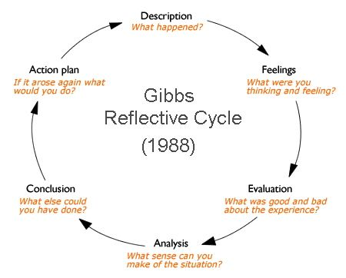

The Gibbs Reflective Cycle cannot only be used in the Education Sector that you are currently in – it can also be used in the workplace environment, this can help you realise what had happened during the occasion, how you are feeling about it, if it was a good or bad experience, what sense can you make of the situation, what else could you have done and also if it arose again what would you do? This is an excellent framework as this can help you to attain your developmental goals of competencies and help you progress them further.
I know that further down the line I will develop and use this reflective cycle, as this will help me develop the ones that need further assistance – such as time management on certain work, the stress – simply breathing in and out and using this cycle, could help me achieve my goals further and prospects further.

References

References
Ashley, R. (n.d.). How to Enhance your Employabiltiy . British Library Cataloguing .
Fowlie, B. S. (2015 ). How to Succed in University 2nd Edition . SAGE Publications LTD .

