
Master of Business Administration
International Business pathway
Master of Business Administration
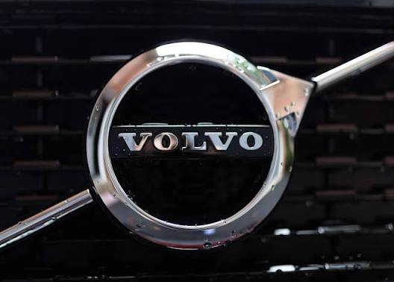
Module name: Strategic Management
Module code: LCMB7003
Lecturer name: Hoang Dang Nguyen

Student name: Mahammad Arsh Mahammadshahin Vhora
Student ID:2519350

Word count: 5091
Submission date: 12/08/2026

AI use acknowledgement
I acknowledge the use of Grammarly (https://www.grammarly.com/) on 11th August,2026 to check grammar. I used the prompt(s):
1. Please check the following text for grammar.
I confirm that I have not presented any AI generated text as my own work. I confirm I have copies of my drafts, notes, and other resources I used before, and after the use of AI tools which I may be asked to provide in evidence.

Strategic Management Analysis of Volvo EX90 in the UK Market: Evaluating Competitive Positioning, Sustainability, and Future Growth

TABLE OF CONTENTS
AI use acknowledgement 2
Section 1 5
1. Organisational Context and Overview 5
2. External and Internal Analysis 6
2.1 External Environment – PESTEL Analysis 6
2.2 Internal Environment – VRIO Analysis 9
2.3 SWOT Analysis 11
3. Comprehensive and holistic view of the organisation 13
3.1 Corporate Social Responsibility (CSR) Strategy and Alignment with business objectives 13
3.2 Balanced Scorecard Analysis 14
4. Strategic Choices and Implementation 17
4.1 Strategic Choices at the Business Level 17
4.2 Validation using Strategic Frameworks. 18
4.3 Delivering Optimum Performance 20
4.4 Implementation Challenges and Mitigation 20
Section 2 23
Reflection 23
Reference list 26

Section 1

1. Organisational Context and Overview
Since 1927, when Volvo Cars was founded in Gothenburg, Sweden, the company has positioned itself as a high-quality car maker noted for its safety, sustainability, and Scandinavian design. The company has a history of delivering products that are safe and reliable, and the Volvo Cars 2026 vision focuses on its role in innovating the future of mobility by driving electrification. Its business model is becoming more reliant on electrification, digitalisation and sustainability as part of the global environmental goals and consumer demand for low-emission vehicles (Volvo Group, 2026). With the introduction of the EX90, the world's first all-electric SUV, this transition will be complete, introducing advanced driver-assistance systems and 800-volt charging technology (Volvo Cars, 2025a).
Volvo car is part of the global automotive sector and operates in the high-end electric vehicle (EV) market. It is an industry in the midst of rapid transformation, due to changing regulatory frameworks, technological progress, and consumer choice for green mobility modes (IEA, 2025). In the UK market, Volvo car will compete against EV giants like Tesla, BMW, Mercedes-Benz and Audi, all set to robustly grow their EV sales in the future (OECD, 2026). What becomes clear about the EX90 through the above is the emphasis Volvo car places on how the car will be manufactured and how it will be designed for sustainability. But Volvo car's differentiation is its reputation for safety and the introduction of cutting-edge safety features, for example, recycled materials and carbon-neutral production plans (Volvo Cars, 2026).
The favourable macroeconomic conditions for the adoption of this vehicle segment by the British market are also reinforced by favourable government policies, in particular, government incentives for EV use and infrastructure investments (GOV.UK, 2026; ONS, 2026). The EX90 is well-suited for these developments, providing a competitive value proposition of luxury, environmental and technological excellence. This would give Volvo car a unique niche due to its trustworthy and safer reputation built from time immemorial but would not overshadow its success in an EV market dominated by Tesla in terms of brand recognition and the availability of charging stations (Porter, 1990). The positioning points to a thoughtful approach to differentiation and sustainability, maintaining resilience amid a competitive and dynamic landscape in the industry.

2. External and Internal Analysis

2.1 External Environment – PESTEL Analysis
Political Factors
Strong acceleration of electrification continues for the UK government. The Zero Emission Vehicle (ZEV) mandate will establish a target of 80% of new car sales as BEVs by 2030. Non-conforming cars will be fined £15,000pm (IndexBox, 2026). Grants are offered for vehicles in 2026 that are as much as £3,750 for EV purchases and £500 for home charger installation (GOV.UK, 2026; Brumble, 2026). Making policies that will incentivise Volvo's EX90, which fits very well with their mission for sustainability. Political risks can be formed by trade blockages on Brexit; regulatory uncertainty could increase the costs of the supply chains.
Economic Factors
The UK economy grew 0.6% in Q1 2026, with inflation at 2.8% and unemployment at 4.9% (ONS, 2026; House of Commons Library, 2026). Although consumer spending is low, EVs have reduced running costs: EV drivers can save up to £1,400 per year on running costs compared with petrol cars (GOV.UK, 2026). The average price of a battery pack in the UK is £95-115/kWh, which remains 10-15% up on Asian benchmarks, due to the UK's reliance on imports (IndexBox, 2026). The EX90 (base price of £89,560) is a premium price, and this will restrict its use by the “value-conscious” segment, but the “top end” segment will be a strong market. A possible decline in demand may be induced by economic uncertainty and high interest rates.
Social Factors
There is a changing attitude among consumers towards EVs In 2025, 473,348 BEVs were registered in the UK, representing 23.4% of market share (CSL Group, 2026). More than 9 out of 10 EV owners (95%) would select electric again, according to Cox Automotive's survey of 2,008 UK drivers in 2026. Younger people (25–34) drive adoption, with 65% of the group owning an electric vehicle. Volvo car fits in well with eco-conscious consumption and social trends toward sustainability. But challenges persist: fear of charging, misconceptions about batteries and cost continue to hinder full-scale market take-up.
Technological Factors
The key to Volvo's EX90 efforts is technological innovation. The model has a 102 kWh usable battery pack, a real range of 295 mi and can be charged to 10-80% in 23 mins at 350 kW DC charging (EV Database, 2026). Architectures are now 800V, with 800V systems becoming the norm for the UK market, which is now moving towards ultra-fast charging and mitigating range anxiety (IndexBox, 2026). Furthermore, technology for connectivity and autonomous driving is in the process of being developed, with the UK's Automated Vehicles Act 2024 provisioning pilot programmes for the year 2026 (CSL Group, 2026). Volvo's legacy of safety and connectedness in the field of ADAS gives them their separation. However, semiconductors and cybersecurity issues continue to pose a threat.
Environmental Factors
The favourable environment is additionally provided by the UK's target to become net zero by 2050 and new regulations limiting the introduction of new ICE cars from 2030 (IndexBox, 2026). Domestic battery recycling schemes have a target to recover at least 95% of batteries by 2030, which falls in line with the principles of the circular economy. Volvo Cars' pledges to become the world's first-ever carbon-neutral carmaker and to use recycled materials in the EX90 reinforce its leadership position (Volvo Cars, 2026). Yet with lithium and graphite volatility and scrutiny of the supply chains for environmental impacts, costs are increasing.
Legal Factors
The UK has very rigid vehicle emissions regulations as well as battery safety certifications (UN38.3) and requirements for extended producer responsibility (EPR) (IndexBox, 2026). Additionally, connected car services are regulated by data protection laws and should comply with GDPR. For Volvo car, being legal is necessary and opens up a new market over others because of their safety reputation. However, the complexity and potential litigation risks of adapting regulations for EVs and the potential risks from many autonomous driving aspects will create a challenge.
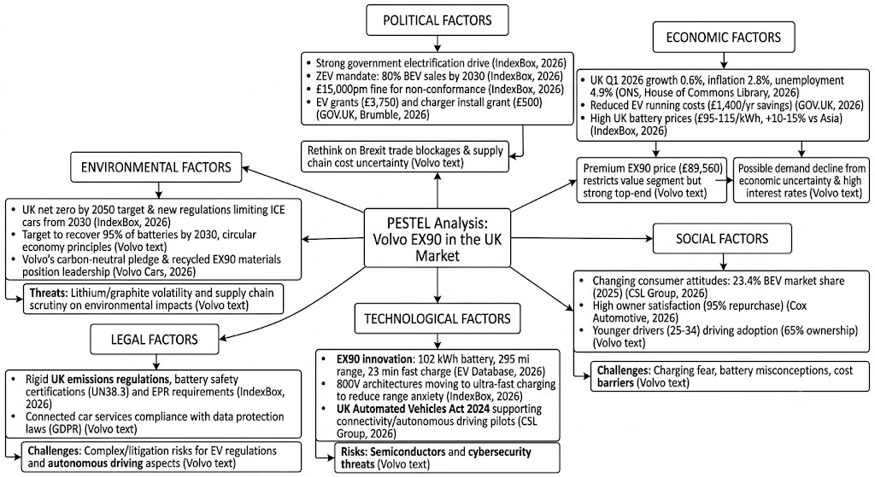
Figure 1: PESTEL analysis
Source: Created by Author
Volvo’s EX90 is positioned to benefit from several opportunities in the UK market. The government offers solid incentives for acquisition and home charging, including grants. Volvo's sustainability policies and net zero commitments are fully aligned to its mission making it a trusted sustainable and safe brand. Eco-conscious buyers, especially younger buyers are pushing for growth within the premium EV market, while Volvo's track record on safety and cutting-edge components such as fast charging and autonomous systems set it apart from the price war.
However, significant threats must be managed. The pressure of inflation and the battery's costs pose risks of reducing margins, impacting the ability to afford. Tesla's and BYD's competitive intensity is threatening to erode Volvo's market share, while problematic infrastructure is causing customer anxiety over charging. Access may be limited due to network dependency, or a premium position. If Volvo car is to be competitive in the long-term, they need to maintain a balance of differentiation with affordability and increase their partnership to reduce the risks to infrastructure.

2.2 Internal Environment – VRIO Analysis
Volvo's VRIO analysis allows an assessment of its resources and capabilities versus the strategic positioning of EX90 within the UK market. We can evaluate Volvo's competitive advantage and how sustainable it is by looking at the resources and how valuable, rare, inimitable, and organised they are.
Valuable
Safety and sustainability are deeply ingrained in the values of Volvo. The EX90 is a culmination of advanced driver-assistance technologies and carbon-neutral production targets, which are in line with current market demand and regulations (Volvo Cars 2026). Thus providing tangible value by mitigating risk and building brand trust. But if there is a high cost of these value-added services, this would restrict accessibility to an otherwise cost-sensitive market. Obviously, resources ought to add value, but they also must represent a competitive advantage, as Barney (1991) also notes, and Volvo car needs to make sure that its value proposition speaks to something more than the affluent consumer.
Rare
Safety innovations are not something which is as common in the car industry as it has been in Volvo car. Volvo car, even in its two latest models, has always been more concerned about safety and environmental responsibility than about performance and luxury, whereas BMW sticks to luxury, and Tesla is more interested in performance. (Johnson et al., 2020) The recycled materials and the incorporation of lidar technology in the EX90 are an accomplishment because it couples the two elements together in an exceptional way. However, as it is being pursued by the growing number of competitors, Volvo car will have to continuously innovate for its sustainability story to maintain uniqueness (Porter, 1990).
Inimitable
Some of the elements of Volvo's brand personality, such as the ethos of Scandinavian design or the company's long heritage of safety, are hard to copy. While the technology can be reproduced, cultural heritage and the consumers' trust dating from several years are not readily translatable (Bartlett & Ghoshal, 1989). This imitatability allows Volvo management to secure a solid competitive edge. But it has not got me my own as there are only a few things that can only be mastered by a vendor that can be delivered by any competitors (IEA, 2025). Volvo car will therefore need to make sure that they invest in intangible heritage as well as tangible innovations to keep their differentiation.
Organised
Volvo Group (Volvo Group, 2026) has aligned with the organisation, with sustainability features in the company's governance and reporting. Electrification, digitalisation, and CSR are already included in its strategy, demonstrating the existence and actualisation of resources. The EX90's mission highlights the preparation of the organisation to make use of these capabilities. However, there are some organisational obstacles to overcome: depending on external charging infrastructure and premium pricing will limit the utilisation of resources, and more partnerships and pricing innovation will be needed (OECD, 2026).
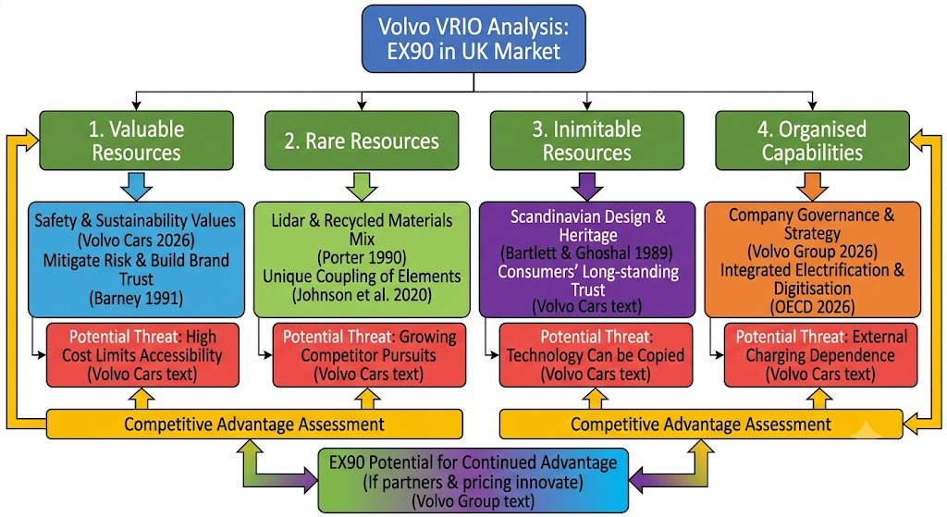
Figure 2: VRIO framework
Source: Created by Author
VRIO shows that Volvo's competitive advantages are as much about their brand heritage and sustainability as well as organisational fit. These are resource-based, limited and highly aspirational, but highly dependent on how they are executed within the organisation. Limits are low cost and dependence on external infrastructure that could be a limitation in otherwise strong resources.
With those unique and inimitably interpreted brand assets coupled with strategic partners and pricing, Volvo's EX90 has the potential for continued competitive advantage; if they do. If not, benefits are at risk of being only temporary, as long as others catch up with technology and social networking.

2.3 SWOT Analysis
The SWOT analysis combines aspects of the external (PESTEL) and internal (VRIO) environments to deliver a comprehensive and rounded SWOT analysis of Volvo's position in the UK market, EX90.
Strengths
Volvo's greatest strength is its reputation for safety and reliability, which continues to be a premium vehicle quality differentiator (Barney, 1991). Following this tradition, the EX90 is equipped with high-tech driver assistance features and a lidar sensor that further safeguards Volvo's brand promise. Its appellation for eco-conscious customers, in addition to sustainability pledges like carbon-neutral production by 2040 and recycled materials, makes it even more enticing. (Volvo Cars, 2026) The alignment and focus on electrification and CSR within the organisation show that Volvo car is ready to make good use of its resources (Volvo Group, 2026).
Weaknesses
While Volvo's opportunities are significant, so are the challenges they have to overcome in terms of affordability. The EX90 offers some high-end features of the R230, but its high price tag may restrict its market to the mainstream purchasing public, especially the cost-conscious UK market (OECD, 2026). Volvo car does not offer its own network of charging stations, a fact which detracts from customer trust. Furthermore, although Volvo's sustainability story is good, other competitors are rapidly following suit, eliminating the differentiation (Johnson et al., 2020).
Opportunities
UK's Regulatory environment presents a huge chance. The government incentives and 2030 targeted ban on new ICE cars are aligned with Volvo's electrification development (GOV.UK, 2026). Consumer demand for EVs is increasing, as Battery Electric Vehicles (BEVs) accounted for almost 25% of new registrations in 2025 (ONS, 2026), giving an expanding market base. Opportunities for innovation in the form of technological solutions, such as 800-volt charging and Autonomous driving legislation (IEA, 2025), will also be presented to Volvo. The alignment with the National Net Zero Targets further solidifies Volvo as a responsible premium brand.
Threats
The threat from competitive intensity is a major threat. However, due to Tesla's market dominance in EV infrastructure and BYD's global expansion, some pressure was put on Volvo's market share (Porter, 1990). Demand for battery park margins and consumer affordability is increasingly under threat by inflationary pressures and high costs of batteries (OECD, 2026). While technology has come a long way, charging anxiety still plays a major role in chilling the uptake of infrastructure, and reliability remains a constant challenge. In addition, the challenge with the regulations of autonomous driving and protection of data may result in compliance risks for Volvo car.
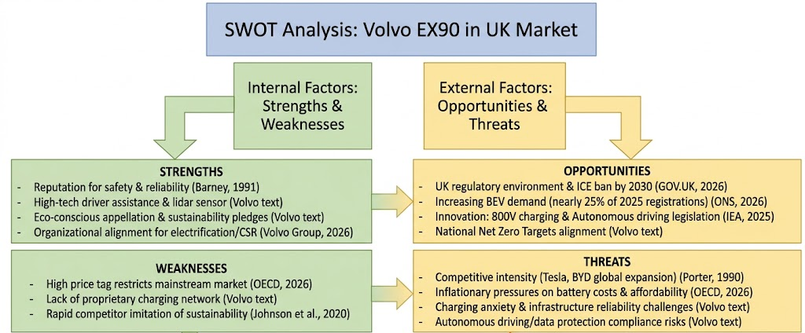
Figure 3: SWOT analysis
Source: Created by Author
The EX90 is a cutting-edge vehicle built to tap into political and environmental trends, and it's designed to prove its worth in the U.K. premium electric car market, thanks to the brand's expertise and focus on safety and sustainability. Long-term success will require fixing problems with reliance on infrastructure and affordability. Enhancing partnerships, proactively building sustainability beyond the sustainability narrative and balancing premium differentiation with accessibility will enable Volvo car to ensure there are current opportunities for future leadership in the UK's dynamic EV marketplace.

3. Comprehensive and holistic view of the organisation

3.1 Corporate Social Responsibility (CSR) Strategy and Alignment with business objectives
More than just a tactic, tracking progress toward annual goals, Volvo's strategies are fully integrated with the mission and vision of the company, which clearly emphasise safety, sustainability and ethical social responsibility for the company and its customers. Volvo car has been an innovator of auto safety features in history, even intentionally not patenting the 3-point safety belt, much to the benefit of all humans ( Johnson et al., 2020). It remains true now with CSR policies aiming towards climate neutrality, circular economy and social responsibility. Volvo car Cars aims to become an all-electric car maker by 2026, and to become carbon neutral throughout its value chain by 2040 (Volvo Cars, 2026).
From the launch of the EX90, alignment of CSR and business objectives is clear. It relies on recycled components, cutting-edge driver-assistance technology and carbon-neutral manufacturing to directly contribute to the company's electrification and sustainability targets. CSR is not viewed and managed as a mere supplementation but as a key competitive tool. Volvo meets regulatory requirements (OECD, 2026) by making CSR an integral part of product innovation; they make their vehicle more attractive to customers, who are concerned about the environment.
However, alignment for CSR is a challenge also. Sustainability will improve brand equity, and premium pricing can make the product inaccessible to those who need it, which can jeopardise the social inclusiveness part of the CSR. Furthermore, other players like Tesla and BMW are positioning themselves in a similar way as sustainable players, which could decrease the differentiation of Volvo car (Porter, 1990). As a result, Volvo's CSR practices need to constantly be adapted in order to be strategically relevant.

3.2 Balanced Scorecard Analysis
The Balanced Scorecard (Kaplan & Norton, 1992) is a structured perspective to assess the operational performance of Volvo car in the following four perspectives: Financial, Customer, Internal Business Processes, and Learning & Growth. The objectives, KPIs, targets, and initiatives are provided for each perspective and aligned with Volvo car in its mission of safety, sustainability and electrification.
Financial Perspective
Goal: Profit-oriented growth based on electrification and sustainability. Key to Volvo’s financial plan is the transformation to electric vehicles without compromising profitability in a competitive marketplace. Costing roughly £89,560 in the UK, the EX90 targets the top-tier EV market (EV Database, 2025).
KPIs include EV sales growth, gross margin and the return on investment made in electrification. Targets: 50% of global sales to be fully electric by 2025, 100% by 2030 (Volvo Cars, 2026). Funding: Focus on batteries, collaborations with renewables, growth in EV manufacturing plants.
The critical reasoning is that a higher price point helps maintain margins but could stunt volume growth due to affordability issues. Volvo car needs to use profits to stay competitive yet be accessible to the public.
Customer Perspective
Objective: Improve Customer Satisfaction and Loyalty on Level of Safety and Sustainability. The Volvo car brand's equity is based on trust, safety, and respect towards the environment. This positioning is in line with the addition of advanced safety technology, such as lidar and driver monitoring systems, to the EX90.
Indicators used: Net Promoter Score (NPS), EV adoption rates, customer retention. Target: 2027 by which time the company achieves top 3 in the country's premium EV customer satisfaction surveys. Activities: Increasing awareness about the advantages of EVs, joint efforts with charging infrastructure companies, and tailored digital services.
More crucially, while Volvo car has a reputation that is difficult to beat and unequalled in the safety world, it must be able to soothe and resolve customer anxieties over administration and costs of charging. Cooperation and interdependence with charging infrastructure is key to maintaining faith and uptake.
Internal Business Processes Perspective
Goal: Increasing the efficiency and sustainability of production. Volvo's CSR approach is focused on carbon-neutral production and circular economy practices. The EX90 is made using recycled materials and will aim at lowering lifecycle emissions (Volvo Group, 2026).
KPIs: Production efficiency, reduction in Carbon Footprint, Defect rates. Targets: carbon neutral manufacturing by 2040 – 40% cut in lifecycle emissions by 2030. Initiatives: Adoption of renewable energies at factory level, digitalisation of supply chains and incorporation of sustainability indicators into performance management.
Critical reasoning is also interesting in pointing out that although the company organises itself to utilise those resources, Volvo car puts a reliance on global value chains, thereby exposing itself to risks from raw material volatility. Improving local sourcing and recycling efforts will improve resilience.
Learning and Growth Perspective
Action Objectives: To encourage innovation and workforce skills in relation to electrification. Volvo car understands that to achieve a lasting competitive edge, learning and innovation are the keys. Don't underestimate the value of organisational learning while picking up the investment in advanced technologies, like the EX90.
Employee training and retention programs are expected to be completed in pharma companies. Initiatives include expanding the development of innovation hubs, University partnerships, and employee involvement in CSR activities, while employees are trained to build sustainability and digital skills and set the 10% target for the annual turnover invested in R&D.
In terms of culture, Volvo's organisational alignment is great, but it's important to balance the development of the culture with the development of the technology to stay in a position of leadership and innovation. Getting the commitment from employees is critical to ensure sustainability and digitalisation become part of an organisation.

Summary Table – Balanced Scorecard for Volvo EX90
Perspective | Objectives | KPIs | Targets | Initiatives
Financial | Profitable growth via electrification | EV sales, margins | 100% EV sales by 2030 | Battery tech investment, renewable partnerships
Customer | Enhance satisfaction & loyalty | NPS, adoption rates | Top-3 UK EV satisfaction by 2027 | Charging partnerships, digital services
Internal Processes | Operational efficiency & sustainability | Carbon footprint, defect rates | Carbon-neutral by 2040 | Renewable energy factories, supply chain digitalisation
Learning & Growth | Innovation & employee capability | Training rates, R&D spend | 10% revenue to R&D | Innovation hubs, CSR engagement

Critical Conclusion
Volvo's CSR strategy and the Balanced Scorecard analysis align well with the ambition for business performance and sustainability. Incorporating CSR into ideas for new products, streamlining operations and customer interaction continues to make Volvo car a differentiator on the premium EV market. But close analysis of the issues of affordability, reliance on infrastructure and competitive intensity has the perception of challenges. For Volvo car to maintain its long-term competitiveness, there needs to be ongoing development of CSR as well as better partnerships and premium differentiation, but not too inaccessible. In doing so, Volvo can become a leader in the new EV marketplace in the UK, building upon its legacy of safety, accountability and responsibility.

4. Strategic Choices and Implementation

4.1 Strategic Choices at the Business Level
With the EX90, Volvo Cars is at a pivotal moment in the UK premium electric vehicle sector. From the business level, the organisation has choices both of cost leadership and differentiation strategies (Porter, 1990). The cost leadership would be to cut down on production and retail prices to rival mass-market EV brands like BYD. This is more difficult to achieve, though, because of Volvo's heritage, positioning and premium pricing. Rather, differentiation – safety, sustainability, Scandinavian design – would better reflect Volvo’s business mission and competitive attributes (Barney 1991).
Utilising the unique and uncommon capabilities that only Volvo car can offer, such as the ability to integrate CSR with safety, has helped the company attract premium-priced, eco-conscious clients. This approach is reflected in the EX90's state-of-the-art driver assistance technology, recycling processes and carbon-neutral production processes (Volvo Cars, 2026). Differentiation thus turns out to be the most suitable strategy as it helps Volvo car maintain its position in the competition in a currently crowded market.

4.2 Validation using Strategic Frameworks.
The decision to differentiate the EX90 for the UK market can be justified using multiple frameworks, all of which provide a different analytical perspective on market dynamics and organisational fit.
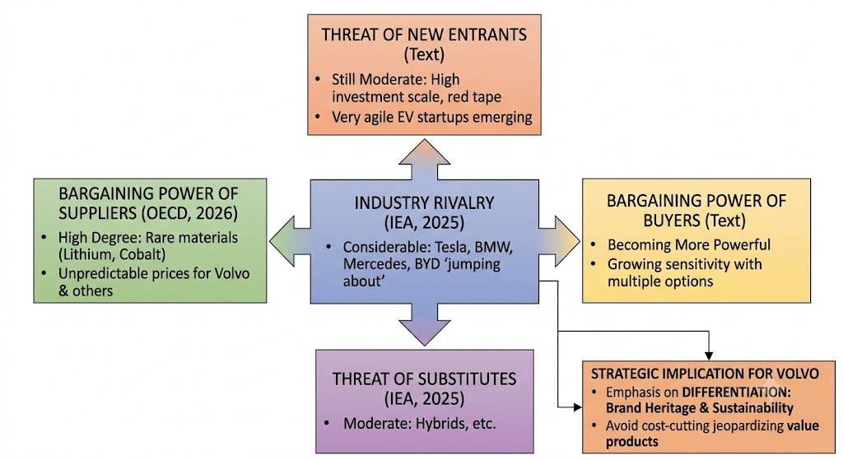
Figure 4: Porter's Five Forces
Source: Created by Author
The insights from Porter's Five Forces certainly bring up the structural pressures that exist in the EV industry. The presence of new players is still moderate, as the scale of investment is large and regulatory red tape prevents many new players, but very agile EV startups are still cropping up. Volvo car and other companies in the industry have a high degree of supplier power, as these raw materials, primarily lithium and cobalt, are rare in nature, causing the supply side to have unpredictable prices (OECD, 2026). The buyer is becoming more powerful, and with multiple options of EVs, buyer sensitivity is growing. Substitutes (hybrids etc.) and industry rivalry are moderate and considerable, with Tesla, BMW, Mercedes and ‘BYD' (Battery yesterday Day after tomorrow) jumping about (IEA, 2025). This competitive environment puts an emphasis on Volvo's differentiation with brand heritage and sustainability, and not in a cost-cutting approach, which would jeopardise its added value products.
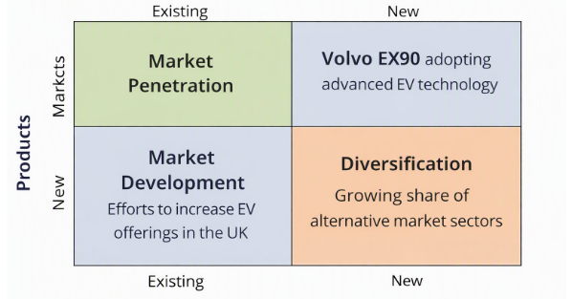
Figure 5: Ansoff's Matrix
Source: Created by Author
The EX90 is also supported by Ansoff's Matrix as being part of two product and market development strategies, which further serves as an endorsement of the power of differentiation. The EX90 is an example of product development considering the adoption of advanced EV technology, accompanied by market development efforts to increase EV offerings in the UK. This is an ‘integrated strategy' that combines government support and growing demand from consumers (GOV.UK, 2026), which dovetails into Volvo's ambitions towards electrification. The matrix reflects that Volvo car isn't just contesting the market they are in, but actually competing to grow share of alternative market sectors.
SAFe (Suitability, Acceptability, and Feasibility) is a way to analyse strategic fit from an overall perspective. Differentiation is appropriate in a context that restricts attention to external drivers like a net zero objective or even customer sustainability preferences. It is good for stakeholders – from customers and regulators to shareholders who appreciate the integration of CSR and Volvo's image as a responsible company. Feasibility is affirmed by Volvo’s organisational setup and financial capabilities, although the cost is an issue (Volvo Group, 2026). This framework represents not only an intelligent approach for differentiation but can also be implemented without difficulty, if Volvo can tackle pricing and infrastructure issues.
Overall, the frameworks illustrate that a strategy for differentiation is most logically via sustainability, safety and innovation, which is the one chosen by Volvo. It enables the company to take advantage of scarce and unique assets, maintain the positioning of the company in the market relative to external forces, and sustain a competitive edge in a highly competitive market. What is key to remember is that differentiation must constantly be reiterated by continually innovating and involving stakeholders under increasing competition.

4.3 Delivering Optimum Performance
Optimised performance can be achieved by differentiation through sustainability and safety, which can build Volvo's brand equity and attract the premium segments. The EX90's advanced technological integration gives rise to a stronger level of customer trust, whereas CSR commitments foster legitimacy (Johnson et al., 2020). Volvo car fully embraces sustainability through operations, not just to comply with regulations but to ensure long-term sustainability.
This is supported by examples from the real world. Ignition's results are an example of a different way to position, through technology and infrastructure, and Tesla's excellent results confirm the feasibility of luxury positioning with BMW. Volvo car has a niche that is provided by its safety and eco-friendliness that gives it an edge to compete without price wars.

4.4 Implementation Challenges and Mitigation
Although there is clarity about the direction and action to be taken, there is a challenge in implementation.
- Risk of Mainstream Buyer Adoption due to Affordability and Market Accessibility Premium Pricing. To maximise mitigation, an effective suite of flexible financing options, resources from governments to improve subsidies, and possibly the deployment of less expensive EV models to increase market access is required (OECD, 2026).
- EV adoption is still hindered by Infrastructure Reliability Charging. If Volvo car do want to adopt a strategy of working with charging providers to increase charging network coverage, they need to find a way to manage the integration of digital solutions that help assuage customer fears around charging availability (IEA, 2025).
- Depending on materials that are hard to come by makes Volvo car vulnerable in its supply chain. Mitigation strategies include diversifying sources, investing in battery recycling, and alternative chemistry (Volvo Group, 2026).
- Tesla and BYD compete with this product for market share. Volvo car always needs to innovate their instigated CSR practices and differentiate itself with intangibles (trust, heritage) (Porter, 1990).
Risk Matrix
Risk Category | Likelihood | Impact | Mitigation Strategy
Affordability | High | High | Flexible financing, subsidies, entry-level EV models
Infrastructure | Medium | High | Partnerships with charging providers, digital reassurance tools
Supply Chain | High | High | Diversification, recycling, alternative battery chemistries
Competitive Intensity | High | Medium | Continuous innovation, CSR differentiation
Regulatory Change | Medium | Medium | Proactive compliance, stakeholder engagement

Critical Conclusion
While offering alternative, elegant fuel-efficient modes of transport will remain central to the big car's efforts in the UK, Volvo's planned approach—the EX90—should focus on differentiation, using the brand's legacy of safety and sustainability to differentiate itself in a premium segment. This is supported by Porter's Five Forces, Ansoff's Matrix, and SAFe, all of which indicated that it was fit and appropriate, acceptable, and feasible. Differentiation can promote a brand's equity, engage with the environmental values of customers and may correspond to regulatory influences to achieve optimum performance.

Section 2

Reflection
The culmination of the research, analysis and development of the strategic decisions and implementation aspect of the assessment has been a great learning experience for me, in both my academic strengths and personal professional development. Gibbs' Reflective Cycle (1988) presents a range of critical examination of the experience in a structure of six stages: description, feelings, evaluation, analysis, conclusion, and action plan.
Description
The assignment was to review Volvo's EX90 strategy in the UK market using certain frameworks like Porter's Five Forces, Ansoff's Matrix and SAFe. Conducted industry research, company information, and a literature search on academics to support the strategy of differentiation. This meant developing a passionate and convincing case based on external pressures, internal resources and a strategic framework, which were synthesised and argued in a coherent manner.
Feelings
At the beginning, I was sure of starting with theories, as I had known other theories from the previous modules, namely that of Porter and Ansoff. I also had some doubt about emphasising the rigour but also practicality of the study. The so-called “luxury EV” segment is changing rapidly, and I didn't want to lose the finer points of the industry. This was done as I moved forward, building confidence in the credibility of the data sources and their integration with Volvo's CSR commitments, which added to the strength of my analysis.
Evaluation
The process had a number of strengths. I was able to use several frameworks to demonstrate specific points in the process of validating differentiation, giving evidence of critical thinking and meeting the academic standard. Porter's Five Forces was used to show the level of competitiveness and Ansoff's Matrix to place the Volvo car strategy of product and market development. SAFe enhanced the ideas by considering suitability, acceptability, and feasibility. However, weaknesses included a lack of consideration for other methods such as cost leadership that could have been considered a balanced comparison. On top of that, I was able to incorporate industry data, but I saw there were not only affordability issues, but also financial issues that needed to be explored more.
Analysis
The model organised by Gibbs highlights the reflection on both positive and negative aspects. I now know that a variety of frameworks add value to strategic evaluation, but descriptive repetition requires critical synthesis skills. For instance, Porter's Five Forces termed the competition as keen, where this insight, when put to Ansoff's product development strategy, revealed how differentiation reduces competitive pressures. Furthermore, the alignment of CSR (embedding sustainability into strategy) was a recurring theme underlining the important role of aligning CSR. This analysis pointed up the interplay between theoretical models and actual organisational goals.
Conclusion
During this reflective process, it has been established that ‘differentiation' is the best approach to the EX90 in the UK; however, issues of implementation must be touched upon. I have come to the conclusion that my capacity to critically analyse theory and practice has grown, though I need to maintain my competency in considering alternative strategies and financial viability. This exercise boosted my confidence in using the academic framework in context, which is of importance to my future job application, specifically in strategic consultancy.
Action Plan
In the future, I will:
- Make more explicit comparisons of a number of strategic choices for the purpose of enhancing critical thinking.
- Integrate financial modelling to evaluate the financial affordability and profitability implications.
- Engage more with specific industry journals to stay informed of EV industry-related facts and dynamics.
- Using reflective frameworks such as Gibbs to further assess the learning process, as well as opportunities for improvement.

Reference list
Ansoff, H.I. (1965) Corporate strategy; an analytic approach to business policy for growth and expansion, Internet Archive. New York : McGraw-Hill. Available at: https://archive.org/details/corporatestrateg0000anso (Accessed: July 28, 2026).
Barney, J. (1991) Firm resources and sustained competitive advantage. S.L.: S.N.
Bartlett, C.A. and Ghoshal, S. (1989) Managing across borders: The transnational solution. Boston, Mass.: Harvard Business School Press.
EV Database (2025) Volvo EX90 twin motor (MY26-27), EV database. Available at: https://ev-database.org/car/3324/Volvo-EX90-Twin-Motor (Accessed: July 28, 2026).
GOV.UK (2026) “Office for Budget responsibility economic and fiscal outlook,” in. Available at: https://assets.publishing.service.gov.uk/media/69a6d7b62e1f4fbda4252208/economic-and-fiscal-outlook-march-2026-web-accessible.pdf (Accessed: July 28, 2026).
Goyal, K., Mukherjee, D. and Kumar, S. (2026) “Corporate reputation and international business: Taking stock and moving forward,” Management international review, 66(3), pp. 527–561. Available at: https://doi.org/10.1007/s11575-026-00629-4.
Hill, C.W.L. and Hult, G.T.M. (2018) International business: Competing in the global marketplace. 12th edn. S.L.: Mcgraw-Hill Education.
IEA (2025) Global EV outlook 2025 – analysis - IEA, IEA. Available at: https://www.iea.org/reports/global-ev-outlook-2025 (Accessed: July 28, 2026).
Johnson, G., Whittington, R. and Scholes, K. (2020) Exploring corporate strategy: Text and cases. 13th edn. Harlow, England: Pearson Education.
Kaplan, R.S. and Norton, D.P. (1992) The balanced scorecard: Measures that drive performance. Boston, Mass.: Harvard Business Review Press, pp. 71–79.
OECD (2026) OECD economic surveys: United kingdom, OECD. Available at: https://www.oecd.org/en/publications/serials/oecd-economic-surveys-united-kingdom_g1gha3fc.html (Accessed: July 28, 2026).
Office for National Statistics (2026) Economic activity and social change in the UK, real-time indicators, Ons.gov.uk. Office for National Statistics. Available at: https://www.ons.gov.uk/economy/economicoutputandproductivity/output/bulletins/economicactivityandsocialchangeintheukrealtimeindicators/23july2026 (Accessed: July 28, 2026).
Porter, M.E. (1990) The competitive advantage of nations. London: Macmillan.
The World Bank (2025) World development report 2025: Standards for development, World Bank. Available at: https://www.worldbank.org/en/publication/wdr2025 (Accessed: July 28, 2026).
Volvo Cars (2023) Side view of the volvo EX90 with open hood, doors, and trunk in a white studio environment., Volvo Cars. Available at: https://www.volvocars.com/uk/cars/ex90-electric/specifications/ (Accessed: July 28, 2026).
Volvo Cars (2025a) The award-winning EX90 just levelled up – with faster charging and new, advanced features, Volvocars.com. Volvo Cars. Available at: https://www.volvocars.com/en-om/news/articles/the-award-winning-ex90-just-levelled-up-with-faster-charging-and-new-advanced-features/ (Accessed: July 28, 2026).
Volvo Cars (2025b) Upgraded EX90 charges even faster and delivers new and improved features | volvo cars media intl, Volvocars.com. Available at: https://www.volvocars.com/intl/media/press-releases/AF327F3DF42E9592/ (Accessed: July 28, 2026).
Volvo Cars (2026) Volvo Car AB (publ.) publishes Annual and Sustainability Report 2025, Volvocars.com. Available at: https://www.volvocars.com/intl/media/press-releases/196E78D5A4E72057/ (Accessed: July 28, 2026).
Volvo Group (2026) Volvo Group Annual Report 2025. Available at: https://www.volvogroup.com/content/dam/volvo-group/markets/master/news/2026/feb/Volvo-Group-Annual-Report-2025.pdf.
Wheelen, T.L. and Hunger, J.D. (2006) Strategic management and business policy. Cases. Upper Saddle River, Nj: Pearson/Prentice Hall.

