Falling water report
Written by Tobi Pratt
2519009
UWTSD
Construction Materials

Table of Contents
- Introduction 1
- About falling water 1
- Falling water – Farming Material analysis 2
- Process 3
- Design 4
- Concretes impacts 4
- Particle size distribution test: 5
- Graph: 6
- References 7
- Figures 8

Introduction
“Concrete is soft and malleable when first mixed then turns out very strong and durable when hardened.” This means its capable of being formed into different shapes and sizes; able to be used for many different structures from bridges high rise buildings while also being able to maintain its strength underwater. The structural strength for concrete is suitable for beams and colours while the hardwearing properties are suitable for floors and roadways! Concrete is a mix of fine coarse aggregate, cement and water. “The properties of the mix must ensure the cement/water paste evenly coats the aggregate and fills all spaces between the grains.” (Pearson Construction student book) With different properties comes multiple mixes, making concrete able to mould and form into almost anything. Creating some breath-taking buildings but the one we’ll be looking at today? Falling water, designed by Frank Write. (See Figure 1)

About falling water
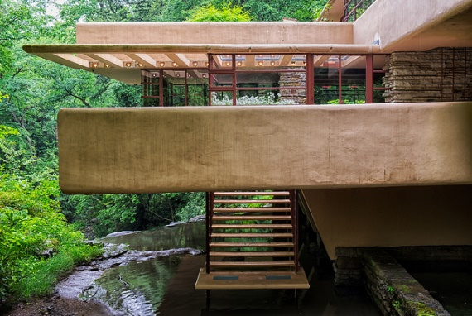
Falling water, a building that utilize a modern material with great structural capabilities. reinforced concrete provides the most preservation challenges to the house, and in the 1950s portions of the reinforced concrete fabric of the house were being reconstructed. “The composition of the concrete used at Fallingwater for the walls was a mixture of cement, sand, and rounded river gravel.” (Preservation History) The use of river gravel enhances strength and stability. When mixed with cement and water “the gravel particles fill holes in the concrete reducing the amount of cement required while maintaining the necessary workability and strength” (The concrete captain). “Within the concrete steel reinforcements long rods of different diameters were added laid in a crossed formation or bent to provide additional strength.” (Preservation History). “The rounded tops of the parapets were formed of a cement and sand blend hand applied after the wall has cured.” (Preservation History). This is known as a cold joint, where two applications meet resulting in irregular cracking that may serve as an entry point for water to seep between the concrete walls.
Figure 1(uchicargo)
This mix of concrete was also used for the trellis, its long expanses suspended over the driveway. The east trellis forming off the living room collapsed in 1953, 1973, and 1982. This was supposably due to falling tree limbs. It has been rebuilt using post-tensioned thread bars. (Preservation History). “Silman installed an electric monitoring system to measure small movements of the terraces and changes in the widths of the existing cracks. After a yearlong study, he determined the terraces were continuing to deflect and began a restoration project that would strengthen the cantilevers.” (waterandlife). In 2001/02 the structural strengthening of the cantilevers was conducted. “University of Virginia graduate student’s thesis research concluded that the terraces had deflected further, one to almost seven inches from its original position.” (Preservation History). This then led to a full structural survey on the site conducted by Robert A. Silman. This analysis highlighted that the concrete and the steel of the terraces was overstressed because of imperfections in the original design of the reinforcement. “In 2011 cracks appeared in the reinforced concrete piers under the house” (Preservation History). Once this was discovered a series of crack tilt meters was installed to oversee the deflection. “A decade after the post-tensioning system was mounted, the terraces have only shown movement to approximately 1/100th of an inch.” (Preservation History)

Falling water – Farming Material analysis
Falling water is built in Pennsylvania, USA. Being in Pennsylvania the climate for materials used is cold. A weather report suggests that per annual the average lowest temp is 4.3* hitting an average hight of 15.2* at its hottest. (Plantmaps). The high humidity in Pennsylvania can cause “materials like wood and plaster to warp, rot, or Mold” (Qnaegine) Materials like concrete, and brick are known to “crack due to shrinkage” in the dry climates, which Pennsylvania does not house meaning concrete is a great material to use for properties. “Materials like steel and iron may rust in damp conditions” (Qnaegine). Falling water is in a damp environment being close to the water with mild rainfall. Whilst the concrete would’ve protected the steel reinforcements from most of the damp, there’s always a chance for ingress to break through the concrete. This could have been the cause of the deflected terraces. In the Pennsylvania winter, concrete can handle freeze thaw stress extremely well. It provides less shifting and little to no gaps for water to seep between individual units. (Yellowdogconcrete). GDI Engineering states “Reinforcement in concrete structures is a crucial aspect of design and engineering. Reinforcement helps to provide additional strength, durability, and stability, making structures more resistant to damage from external forces, such as earthquakes, wind, and water.” (gdiengdesign). Being that there’s a few earthquakes in Pennsylvania the use of reinforced concrete is great for the strength of falling water when these environmental attacks occur “concrete structures are designed to bear weight and resist forces such as wind, earthquakes, and other environmental factors.” (gdiengdesign). Concrete mixes used for structures in Pennsylvania must oblige to the PennDOT concrete standards. Common mixes for this include -
- USA: Class A (3,300psi) – UK: C20/25
- USA: Class AA (3,750psi) – UK: C25/30
- USA: Class AAAP (4,000psi) – UK: C28/35
- USA: Class HES (3,000psi / 3 days) – UK: C20/25
- USA: Rapid Set (1,200psi / 7 hours) – UK: C8/10
- USA: Flowfill Class B (1,25psi max) & C (800psi min) – UK: CLSM (Not structural)
Calculation for PSI to MPa with (Concretemath) 100 PSI = 0.69 MPa.
The below table shows each UK conversion concrete class and what the typical use for each strength class is used for.
Strength Class | Cylinder (MPa) | Cube (MPa) | Typical Use
C8/10 | 8 | 10 | Kerbs, blinding, non-structural work
C12/15 | 12 | 15 | Domestic floors, simple foundations
C20/25 | 20 | 25 | House slabs, driveways, light-duty foundations
C25/30 | 25 | 30 | Structural footings, beams, reinforced slabs
C30/37 | 30 | 37 | Reinforced concrete columns, suspended slabs
C35/45 | 35 | 45 | Heavy-duty reinforced structures
C40/50 | 40 | 50 | High-strength concrete for high-load elements
C50/60+ | 50+ | 60+ | Prestressed members, high-rise construction
Figure 2, Table (constructioncogs)
Whilst there’s no direct information on the class of mixed used for Fallingwater, we can see from this table that a strength class C35/35 or USA class AAAP would be the best class to use for the structure. As the table shows (constructioncogs) states that this class is typically used for Heavy-duty reinforced structures. Though falling water is a excellent structure it has has many defects in the concrete through its time. “antilevered beams were determined to be under-reinforced. This under-reinforcement combined with an ongoing creep condition in the concrete had caused deflections as high as 7 inches on a 15-foot cantilever. Under such conditions, the reinforcing steel was continuing to yield, placing Fallingwater in position of imminent collapse.” (engr.psu.edu) As previously stated these defects were delt with and repaired.

Process
How long does a concrete building like this take?
“Fallingwater began in 1936- Fallingwater was mainly complete in 1937” (Britannica) The whole structure of the property “The main house uses 9,300 square feet of which 4,400 is outdoor terraces, while the guest house totals 4,990 square feet of which 1,950 square feet is outdoor terraces.” (Preservation History). A concrete property of this size regarding it was built in the 1930s “The original estimate for the house was $35,000. The final total cost of construction was approximately $148,000 with an additional $11,300 in architect’s fees.” (Preservation History). Keeping in mine this structures cost, construction period, let’s see how it compares to a steel frame building. There are multiple factors with steel framed buildings, a lot of work goes into the design and fabrication of steel frame. A typical building would take up to 4 years to design and construct. From the information we’ve gathered we can see that falling water with its concrete structure was made a lot quicker than a average steel framed building after all factors are considered. (CollinsonTensile). To construct a medium scale steel building in this day it would cost “From £33,000–£95,000+” Making it significantly less than a concrete structure even built in 1938. (Midbrooksteelbuildings).

Design
While designing falling water “Wright anchored a series of reinforced concrete “trays” to the natural rock. Cantilevered terraces of local sandstone blend harmoniously with the rock formations, appearing to float above the stream below.” (Franklloydwrite). The construction of a building like this is incredibly difficult to achieve “as there was no solid foundation to build from, only water.” (artincontext). Wright was able to overcome this issue by designing trays. These trays were reinforced concrete that mirrored the natural rock of the site. “Terraces of local sandstone were cantilevered to blend with the rock formations.” (artincontext). It was suggested that more reinforcement to the concrete However architect Wright refused. This led to damp and mold ingress from the water. “By 1995 the house was in a very bad state, and on the brink of collapsing.” As previously stated, “In 1997, emergency beams were installed, and the structure was properly restored in 2002.” (artincontext). Being that the building is on top of a water fall it caused many issues in the concrete resulting in repairs “Workers have replaced chunks of damaged concrete, installed waterproof materials beneath terraces and injected almost 12 tons of grout” (smithsonianmag). Falling water has many defects in the concrete, the front elevation holds many cracks on the master terrace “The lines indicate that the cracks on the cantilevered terraces – the issue that launched a massive 2001-02 restoration project” (waterlandlife).
Falling waters complex design has a long preservation concern because of the present structural stress and material aging. These preservation efforts involve “continuous monitoring, periodic repairs, and waterproofing measures to ensure the longevity of this iconic structure.” (architecturelab). The concrete steel terraces were found to be overstressed due to mistake sin the design in reinforcement, meaning they can’t function as designed. In 2011 cracks formed in the reinforced concrete. “In 2013 a series of crack and tilt meters was installed to gauge the deflection, if any, of the terraces” (fallingwater). These cracks are now monitored on a regular basis. There are still many ongoing issues with falling waters structure currently “To stop water from seeping through hairline cracks and mortar joints into those cavities and then into the house, the project team has turned to a waterproofing solution employed by engineers sometimes to stop moisture incursion in stone bridges: injecting grout to fill the cavities or voids in the stone or concrete.” (Canadaconstructconnect). One way to keep concretes strength is by using reinforced steel However, “Once deteriorated concrete was removed, reinforcing steel was coated with a protective coating,” (masonrypresivation). The protective paint is placed on the steel to help prevent it from corrosion among any weathering. “The reason we cover structural steelwork is to protect its integrity. Steel, like many metals, can be affected by elements such as UV rays, wind, water and mould and if exposed to the elements for long periods of time can become rusted and eventually weakened. “(elmbridgeuk).

Concretes impacts
Concrete hands a major environmental impact on the world. The most significant issue being the production. Concrete production comes from cement manufacturing which releases a large amount of carbon dioxide into the word. “The cement sector is the third-largest industrial source of carbon dioxide emissions, accounting for around 7% of global CO₂ emissions” (iea). “Cement emissions remain stubbornly high” (iea). There is preventions in place for us to reach net zero by 2050. However, “The thermal energy intensity of clinker must continue to decrease – expansion of bioenergy and hydrogen will be critical for aligning with the Net Zero by 2050 Scenario” Currently the world is not on track to reaching the net zero goal by 2050 according to (iea). How can we help to prevent this? When it comes to the production of aggregates for concrete a recyclable method can be used known as PFA. PFA or pulverised Fuel Ash is made from “burning pulverised coal in power plants, it replaces a portion of cement. “(concretecaptin) “Using PFA in concrete can enhance strength and durability. Research shows that concrete with 30% PFA can improve resistance to aggressive chemicals” (concretecaptin). Concluding Concrete is servery damaging to the environment especially when compared to steel. “Steel’s recyclability is a cornerstone of its environmental advantage. Unlike many materials that degrade during recycling, steel can be recycled indefinitely without losing quality.” (shunwaste).

Particle size distribution test:
Sieve Size (mm) | Mass(g) | % on sieve | % Passing
125 | 0 | 0 | 100
75 | 0 | 0 | 100
63 | 0 | 0 | 100
37.5 | 120 | 9.6 | 100
20 | 137 | 10.96 | 89.04
10 | 143 | 11.44 | 77.6
6.3 | 105 | 8.4 | 69.2
3.35 | 45 | 3.6 | 65.6
2 | 130 | 10.4 | 55.2
1.18 | 63 | 5.04 | 50.16
0.6 | 105 | 8.4 | 41.76
0.3 | 102 | 8.16 | 33.6
0.212 | 109 | 8.72 | 24.88
0.15 | 98 | 7.84 | 17.04
0.063 | 55 | 4.4 | 12.64

Figure 3

The following particle size distribution was obtained from a sieve analysis on an ‘all-in’ aggregate used for concrete production. The original sample size was 1250g.

Graph:

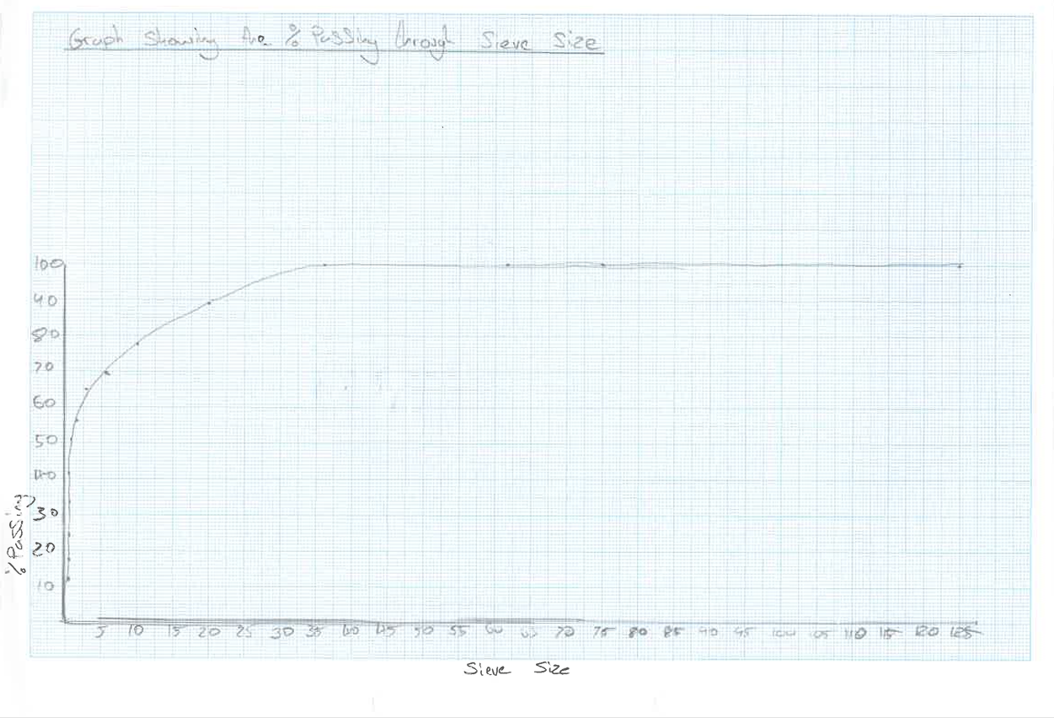
Figure 4
The particle size distribution curve of the aggregate sample shows a poorly graded material, characterized by a steep and narrow grading curve with a rapid drop in percentage passing over a limited sieve range. This indicates that the particles are mostly concentrated within a narrow size range, lacking sufficient intermediate and finer fractions. Such grading contrasts with the well-graded, smooth S-shaped curve preferred for concrete aggregates, which ensures optimal packing density and reduces voids. Consequently, this aggregate is likely to result in poor workability, increased water and cement requirements, and a greater risk of segregation in concrete. Therefore, it is unsuitable for direct use in concrete without modification and should be blended with finer and/or coarser materials to achieve a more continuous grading that meets standard specifications.

References

Bob (2025). What Happens When You Mix Concrete And Gravel: The Key To Strong Foundations - ConcreteCaptain.com. [online] ConcreteCaptain.com.
Available at: What Happens When You Mix Concrete And Gravel: The Key To Strong Foundations - ConcreteCaptain.com [Accessed 15 Feb. 2026].

Fallingwater (n.d.). Preservation History.
[online] Fallingwater. Available at: Preservation History - Fallingwater [Accessed 15 Feb. 2026].

Plantmaps.com (2026). Mill Run Pennsylvania Climate Data - Updated March 2026. [online] Plantmaps.com. Available at: Mill Run Pennsylvania Climate Data - Updated February 2026 [Accessed 15 Feb. 2026].

Yellowdogconcrete.com. (2025). Stamped Concrete vs. Pavers: Which Holds Up Better in Pennsylvania Winters? – Yellow Dog Concrete.
[online] Available at: Stamped Concrete vs. Pavers: Which Holds Up Better in Pennsylvania Winters? – Yellow Dog Concrete [Accessed 15 Feb. 2026].

Concretemath.co.uk. (2025). PSI to MPa Converter | ConcreteMath.co.uk.
[online] Available at: PSI to MPa Converter | ConcreteMath.co.uk [Accessed 15 Feb. 2026].

www.constructioncogs.com. (2025). Concrete Grades Explained For Professionals - Construction Cogs.
[online] Available at: Concrete Grades Explained for Professionals - Construction Cogs [Accessed 17 Feb. 2026].
Psu.edu. (2018). Failures - Fallingwater.
[online] Available at: Failures - Fallingwater [Accessed 17 Feb. 2026].

Collinson, D. (2025). How long does it take to build a steel frame tensile building - Collinson Tensile. [online] Collinson Tensile.
[online] Available at: How long does it take to build a steel frame tensile building - Collinson Tensile [Accessed 17 Feb. 2026].

Olivia (2025). How Much Does a Steel Frame Building Cost in 2025? [online] Midbrook Steel Buildings - industrial steel framed buildings supplier - Steel Buildings with In-House Groundworks, Planning Permission & Turnkey Packages.
Available at: How Much Does a Steel Frame Building Cost in 2025? [Accessed 22 Feb. 2026].

Frank Lloyd Wright Foundation. (2017). Fallingwater - Frank Lloyd Wright Foundation. [online] Available at: Fallingwater - Frank Lloyd Wright Foundation [Accessed 22 Feb. 2026].

Deyzel, K. (2022). Fallingwater House - Discover Frank Lloyd Wright’s Architectural Style. [online] Art in Context.
[online] Available at: Fallingwater House - Discover Frank Lloyd Wright's Architectural Style [Accessed 22 Feb. 2026].

Anderson, S. (2025). Fallingwater’s Roof Is Leaking. Can This $7 Million Renovation Protect Frank Lloyd Wright’s Masterpiece? [online] Smithsonian Magazine.
[online] Available at: Fallingwater's Roof Is Leaking. Can This $7 Million Renovation Protect Frank Lloyd Wright's Masterpiece? [Accessed 22 Feb. 2026].

Architecture Lab. (2024). Fallingwater: An Architectural Landmark To Visit In The USA. [online] Available at: Fallingwater: An Architectural Landmark To Visit In The USA [Accessed 23 Feb. 2026].

IEA (2023). Cement. [online] IEA.
Available at: Cement - IEA [Accessed 09 Mar. 2026].

Shunwaste.com. (2025). Is Steel Eco-Friendly? Exploring Its Environmental Impact And Sustainability | ShunWaste.
[online] Available at: Is Steel Eco-Friendly? Exploring Its Environmental Impact And Sustainability | ShunWaste [Accessed 09 Mar. 2026].

Figures

Figure 1 Voices.uchicago.edu. (n.d.). Concrete – A Dictionary of Modern Architecture.
[online] Available at: Concrete – A Dictionary of Modern Architecture [Accessed 09 Mar. 2026].

Figure 2 www.constructioncogs.com. (2025). Concrete Grades Explained For Professionals - Construction Cogs.
[online] Available at: Concrete Grades Explained for Professionals - Construction Cogs [Accessed 17 Feb. 2026].

Figure 3 Particle size distribution test – table

Figure 4 graph showing % passing through sieve size.

