UNIVERSITY OF WALES
Trinity Saint David
London
MODULE CODE/COD Y MODIWL
LCBB6002

International Financial Management
Assessment 1
Module Lecturer: Zainab Atta
Student name: Neno Dinev
Student ID: 1917135
Table of Contents
Introduction 3
Dividend distribution policy of Unilever PLC 3
Dividend Policy of Unilever: Stable dividend policy 3
Analysis of the efficient market hypothesis in context of Unilever’s operation 4
Market efficiency of Unilever: Weak form 6
Project appraisal method of Unilever PLC 6
Approaches to select better project 7
Risk in the International financial market 7
Conclusion 8

Introduction
To operate an organisation properly in the international market ensuring international financial management is very essential which incorporates the dividend distribution policy, the efficient market hypothesis, the different methods of project appraisal, etc (Njuguna, 2020). These topics are important as they influence the behaviour of the customers in the financial market and helps an organisation to apprise different project based on profitability and period. In this report the dividend distribution policy, the efficient market hypothesis, and the concept of different methods of project appraisal of Unilever PLC will be discussed throughout the next segments.

Dividend distribution policy of Unilever PLC
The dividend policy of an organisation greatly influences the performance of organisation in the financial market. There are four types of dividend policy. These are regular dividend policy, stable dividend policy, irregular dividend policy, and no dividend policy.
In a regular dividend policy, an organisation declares dividends regularly based on the revenue in a specific financial year (Salman, 2021). If the revenue earning is more, the dividend rate becomes more and vice versa. But organisation try to make sure the payment of dividends regularly even though they can’t generate profit which is why a dividend equalisation fund is generated by every organisation. In a stable dividend policy, an organisation gives dividends at a stable rate no matter if there is profit after tax or not. In an irregular dividend policy, an organisation declares dividends irregularly while in no dividend policy organisation never gives a dividend to the investors.

Dividend Policy of Unilever: Stable dividend policy
Unilever is one of the largest multinational organisation in the world with stable financial performance. The revenue of the company has been stable throughout the last decade. In most of the financial year, the company was able to generate more than 50 billion pounds as revenue (Greenwood, 2021). Besides the dividend policy of the company attracts the investor. The company has paid dividends steadily throughout the last 15 years. It declared 32% of the cash dividend on ordinary shares in 2006 while the dividend payment in 2010 was 19.9%. the dividend payment in the last 5 years was 34.3%, 32.76%, 32.98%, 37.6%, and 34.7% respectively which attracts investors (McManus, Gwilym and Thomas, 2021).

Figure 1: Dividend history of Unilever (Mahan, 2021)
Different internal and external factors impact the dividend policy of the company. Even though this factor didn’t work similarly every year but the dividend payment policy of Unilever was similar which signifies a stable dividend payout policy. According to the CEO, the company’s main policy of attracting investors is to give them a return in line with a capital gain.

Analysis of the efficient market hypothesis in the context of Unilever’s operation
Market efficiency can be categorized in three types. These are strong forms of market efficiency, semi-strong forms of market efficiency, and weak forms of market efficiency. Unilever has delivered an unusual number of ugly shocks over the last 5 years. Its market share dropped more than 7% on January 17 in 2022 because of a jumbo deal in over-the-counter medicines (Dobson, 2021). Investors didn’t receive the deal as a positive side which is why the market share was reduced by more than 7% within 1 month. According to Business Insider, the sensitivity of market share ranges from 4.7% to 7.2% which is higher in comparison to its peers (Chen et al., 2022). In 2017 news explored in the market that Craft Heinz wanted to buy the market share of Unilever which is why more than 60% value of its share got decreased. According to Bloomberg from 2017 to 2020 Unilever gave 6 announcements and after every announcements the market share got impacted (Punwasi and Brijlal, 2021).
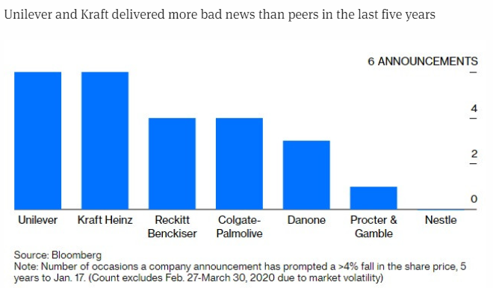
Figure 2: Number of times Unilever’s price changed with the announcement of information (Frith and Done, 2019)
Most of the time when Unilever gave negative warnings in the market its share price decreased sharply. In the first quarter of 2021, the company announced problems regarding collections of raw materials and the efficient running of its supply chain management. For this reason, the market price in the second quarter of 2021 got decreased greatly.
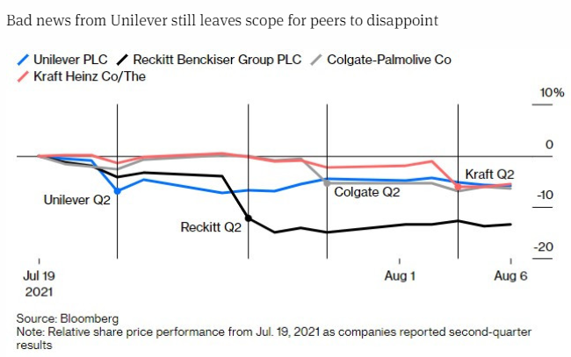
Figure 3: Price response of Unilever and its peers (Dempsey et al., 2014)
The sensitivity of the price of the peer companies can also be found in the graph given below which shows in the efficiency of the market.
Besides in the last 5 years from 2017 to 2021 the valuation of the company changed 18 times based on market data which shows the sensitivity of the valuation of the company in line with the information available in the market (Zack, 2019).
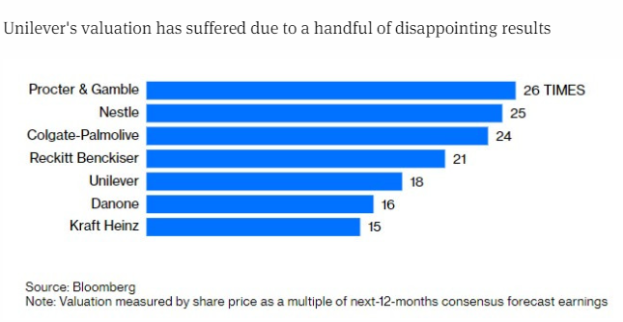
Figure 4: Number of times Unilever’s valuation changed in line with information in the market (Dalton and Crosby, 2017)

Market efficiency of Unilever: Weak form
According to the weak form of efficiency information in the market greatly influences the share price of an organisation. It can be found that in the last 5 years the company gave 6 announcements regarding its operational problem and after every announcement, the share price decreased negatively. Besides the share price also moved with a declaration of dividend and other significant information. Based on this, it can be said that the market efficiency of Unilever is a weak form of efficiency under which the share price moves with the availability of information in the market be it significant or non-significant information.

Project appraisal method of Unilever PLC
Unilever has invested in different projects so far. Before investing in any project it does a rigorous analysis of all the project appraisals which are given below.
Economic analysis: Before looking for the potential of a project it tries to find out the economic condition of the country. To do this it follows the pestle analysis method which helps to understand the external market from a different perspective. If the analysis is positive, it goes for the next appraisal.
Financial analysis: Under the financial analysis the company finds out the necessity of financing for investing in the project. It tries to understand the necessity of fixed investment and variable cost and scrutinize the working capital with ratio analysis. If the demand for variable costs is more, it goes for the next segment of project appraisal.
Life cycle segmentation analysis: In this part, the company tries to find out the introduction of the project industry, its growth potential, maturity, saturation and decline period.
Technical feasibility: Under technical feasibility, the company searches for the availability of land, adequate raw materials, and different kinds of input like power, water, communication, facilities, transportation, etc (Zheng and Zhang, 2021). It also looks for the availability of a licence, support, skilled workforce and availability of servicing facilities like electric repair shops, machines shops, etc.

Approaches to select better project
There may be attractive lots of projects but the company can’t invest in all the projects which are why for better appraisal it does different analyses. First of all, it follows a payback period analysis to understand the return and the time of returning the initial investment. Besides, it looks for the accounting rate of return. It gives a positive sign to those project which takes a lower period and gives a higher accounting return. Besides, when the comparison is much more difficult it tries to find out the net present value (Bilqist, Dachyar and Farizal, 2021). Through this method, Unilever can find out the value a project will give against the stipulated risk. The project with higher NPV are selected.
For example, before starting Hindustan Unilever the company analysed the Indian economy and the policy of the economy. Besides, it looked if the investment in India will meet its goal of reaching the mass market. After rigorous market analysis, it found positive NPV and decided to invest in India which has proved to be one of the best branches of UNILEVER outside of the UK.

Risk in the International financial market
AS UNILEVER is a multinational company it has to face lots of challenges because of the movement of currency in the international market which creates translation risk for the company. Besides the cost of raw materials may get increased as a result of the movement of currency prices against the pound in the home country which creates transaction risk for the company (Miles, 2021). For example, in recent times the currency of Bangladesh got very weak against the dollar and pounds. For this reason, the conversion of Bangladeshi currency to the pound will make less profit at the end of the year which is regarded as a transaction risk for the company.

Conclusion
The movement of currency prices created transaction and translation risk at the end of the financial year. In the international market, the dividend payout policy affects performance which is why it follows a stable dividend payout policy from 2006 to the present. It has been found that in the last five years the valuation of Unilever has changed more than 18 times with the presence of information in the market which signifies a weak form of market efficiency. The main goal of Unilever is to expand its market share and get the mass market of developing countries. That’s why it chooses different projects in developing countries based on economic analysis, market analysis, etc. In the time of choosing the mutual exclusive project, it looks for the payback period, accounting rate of return, NPV analysis, and internal rate of return analysis which helps to choose the best project for investment.

Reference list
Bilqist, R.A., Dachyar, M. and Farizal, F. (2021). Project Valuation in the Geothermal Power Plant Project: A Comparison of Expected Net Present Value and Static Net Present Value Approaches. SSRN Electronic Journal. doi:10.2139/ssrn.3248120.
Chen, H.-C., Chen, S.-S., Huang, C.-W. and Schatzberg, J.D. (2022). Insider Trading and Firm Performance Following Open Market Share Repurchase Announcements. Journal of Business Finance & Accounting, 41(1-2), pp.156–184. doi:10.1111/jbfa.12059.
Dobson, R. (2021). The dividend policy of the MNC’s in the UK. BMJ, 330(7493), p.689.1. doi:10.1136/bmj.330.7493.689.
Greenwood, P. (2021). How Long Can Your Company Go Without Revenue? Entrepreneur and Innovation Exchange. doi:10.32617/539-6025339c0d944.
McManus, I.D., ap Gwilym, O. and Thomas, S.H. (2021). Payment history, past returns and the performance of UK zero dividend stocks. Managerial Finance, 32(6), pp.518–536. doi:10.1108/03074350610666247.
Miles, W. (2021). Has the Euro Common Currency Actually Increased Home Price Co-Movement? SSRN Electronic Journal. doi:10.2139/ssrn.2933852.
Njuguna, J. (2020). Testing the efficient market hypothesis. Investment Management and Financial Innovations, 13(3), pp.75–83. doi:10.21511/imfi.13(3).2016.06.
Punwasi, K. and Brijlal, P. (2021). The market reactions to share repurchase announcements on the JSE: an event study. Investment Management and Financial Innovations, 13(1), pp.191–205. doi:10.21511/imfi.13(1-1).2016.06.
Salman, A. (2021). Determinants of dividend policy. Investment Management and Financial Innovations, 16(1), pp.167–177. doi:10.21511/imfi.16(1).2019.13.
Zack, Y.A. (2019). Company valuation based on discounted financial flows and its residual value under fuzzy data. System research and information technologies, 0(3), pp.43–56. doi:10.20535/srit.2308-8893.2017.3.05.
Zheng, H. and Zhang, Y.D. (2021). Effect of Stability of Soil Water-Stable Aggregates under Different Land Use. Advanced Materials Research, 518-523, pp.4026–4029. doi:10.4028/www.scientific.net/amr.518-523.4026.

