

NAME: Alexander Adeyinka Adesuyi
STUDENTNUMBER:2126827
MODULE: LCMB7003
TITLE: STRATEGIC Management
LECTURER: Dr Hossien
DATE: APRIL 2023
WORD COUNT: 6000

STRATEGIC ANALYSIS OF APPLE COMPANY
Apple a High involvement Brand.


TABLE OF CONTENT

1 INTRODUCTION 3
APPLE BACKGROUND
APPLE MISSION AND OBJECTIVES 3-4
2 MACRO -ENVIRONMENT ANALYSIS OF APPLE 4
PESTLE ANALYSIS 4-7
3 MICRO-ENVIRONMENT ANALYSIS 7
INDUSTRY LIFE CYCLE 7-8
PORTER’S INDUSTRY FIVE FORCES ANALYSIS 8-11
4 INTERNAL ANALYSIS 11
APPLE STRATEGIC RESOURCES AND CAPABILITIES 11-14
VALUE CHAIN ANALYSIS 14-17
PRIMARY ACTIVITIES
SECONDARY ACTIVITIES 17
5 VIRO ANALYSIS OF DISTINCTIVE RESOURCES AND
CAPABILITIES 17-18
6 SWOT ANALYSIS OF APPLE 18-24
7 STRATEGIES TO SUSTAIN COMPETITIVE ADVANTAGE 24-26
8 GROWTH STRATEGIES 26-28
9 GREEN STRATEGY AND CSR 28-31
10 CONCLUSION 31-32
11 RECOMMENDATIONS 32
12 REFERENCES 32-36
13 APPENDIX 37-39
APPENDIX 1
APPENDIX 2

1 INTRODUCTION
Strategic analysis plays an important role in identify opportunities and threat in business environment. The core areas of strategic management including Strategic analysis, Strategic development/choice and Strategic implementation.
This report is based on Apple Company strategic analysis, how they respond to internal and external factors also how they deployed resources and capabilities to achieved competitive advantage within the industry. This report will centre on Ansoff matrix, Porter’s five forces, PESTEL, SWOT analysis, Industry life cycle, VIRO, Value chain Analysis and CSR. At the end of the report, a recommendation on new strategy would base on Ansoff Metric’s model.

APPLE BACKGROUND

Think different, Apple’s Slogan
Apple is electronic consumer company based in California, united states. Apple plc founded on April 1,1976by late Steve Job, Steve Woznak, and Ronald Woznak. The Apple slogan "Think different" is used in marketing promotion and brand proposition (Apple,2017).
Apple design, manufacture and selling consumer electronics and online services. Apple is one of the most valuable brands with market capitalisation of $2tr dollars in united states and by revenue (Totally $394billion in 2022). Apple stock listed on Nasdaq stock market, AAPL. Apple as one of leading consumers electronic and smart technology company. Apple acquired other innovative companies through investments and acquisition such Drive ai, iTunes, Beat Electronics, Beddit, etc. Apple customers are company, student, education institutions, individual consumers, and Non-profit making Organisations.
Mission statement and Objective
Mission statement is summary organisation intension and purpose, whilst provided clarity to staff on what the organisation is trying to accomplish (Whittington et al., 2020).
Apple Mission Statement – Bringing the best user experience to its customers through innovative hardware, software, and services (Apple 2017). According to Apple mission -statement .com, Vision Apple – We believe that we are on the face of the earth to make great quality products, and that is not changing (2017). Apple objective -is to make great products and services that enhance people’s lives and supply an exceptional customer experience so that our users are highly satisfied, loyal, and engaged (Apple,2019).

2 Macro Environment
Macro environmental factors are the 6 factors listed in fig 1, which organisations have no control over it and these factors can impacted business either negatively or positively (Whittington et al., 2020).

PESTLE Analysis is a methodology applied by organisation to analysis those external factors that impacts the business operations (Hooley et al., 2020). Apple pestle analysis are below.

PESTLE Diagram

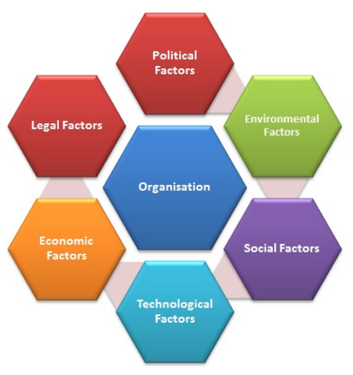
https://research-methodology.net/theory/strategy/7137-2/
Fig 1

Apple PESTEL Analysis
Political Factors
Political factors are government policies such as tax, trade policies, regulations and other international conflicts can result in tariffs, sanctions and other measures that affected business. The major political factor affecting Apple company is change of the US-China trade war which continues to impact Apple supply chain, as well as the global economy due to Russia-Ukraine war. Most of components and chip are manufacturing or outsource from China, and tariffs on these products will lead to higher costs, hence adversely affected Apple turnover (Apple,2022).

Economic Factors

Economic factor are factors that directly influence economy which directly impacted business operations positively or negatively such as inflation, exchange rate, labour market, fluctuating economic growth. Currently global economy is weak, inflation is high, real wages falling (Whittington et al., 2019)). Global economy was badly impacted by the Covid-19 and high inflation due to ongoing Russia -Ukraine war now. The global high energy cost and interest rate. Current global economy adversely impacted consumer spending and affect demand for the Apple products and services, hence affected Apple profit.

Socio/cultural Factors
Socio/Cultural Factor directly influence people behaviour and business. Social trends and changing expectations impact business operation (Morden, 2007). More people are connecting on social media platforms, On-line socialising, stream music and tv through smart technology. Therefore, increase in social networking trend has resulted in increased demand for smart technology. As a result, Apple product also increased the revenue of Apple.

Technological factors
The arrival of 5G network positively impacted Apple company in cloud computing and eco-system, Apple customers are able use seamlessly, fast, better connection more than before. Apple can exploit Internet of Thing (iOT) in other services. Apple spent $26.7m on research and development in the year 2022 report. As a result of advance technology Apple products demand increases more, sales and profit increases (Apple,2022).
Environmental factors
Ecological changed threating production and distribution channel with consequential weather falling (Johnson et al.,2016). Likewise environmental factor creating opportunities for sustainable business and as well protecting earth. The support for green- business are increasing and more people likely to invest their money in eco-friendly investment. Because Apple products are recyclable and more eco-friendly couple with the Apple worldwide environment support and renewable energy. Also, as the company continues its move to all paper packaging, the company are gaining more eco-friendly customers (Apple, 2022). Environmental factors are favourable to Apple.
Legal Factors
Technology industry face intense regulations and media scrutiny in different countries, which exposes tech company to government investigations, and fine. Apple global operations are subject to different and complex laws and regulations in different countries including electronic recycling and climate change regulations, etc (Apple, 2022). For example, Apple facing investigations in relating to App Store terms and conditions in Europe. If finding against Apple resulted in guilty, Apple may need to amend its App Store business or pay penalty. Adverse effect the law will increase costs (Apple,2022), directly impacted Apple annual profit and unfavourable.
Apple company PESTLE analysis are both favourable and unfavourable. Therefore, Apple most act on unfavourable factors for the future growth.

3 Microenvironment Factors are the internal factors that exist within the same industry. which can impact routine activities of the industry or influence business competitive advantage, but business or industry have control over them. The internal factor analysis can be conduct by through Porter’s 5forces, SWOT and Industry cycle.
INDUSTRY LIFE CYCLE
According to fig 2 below, industry life cycle are the business or industry evolution that occur through four stages of introduction, growth, maturity, and decline based on the industry characteristics (Whittington et al., 2020). Industries started when new products developed, with low rivalry, uncertainty regarding market size, high differentiation, and innovation.

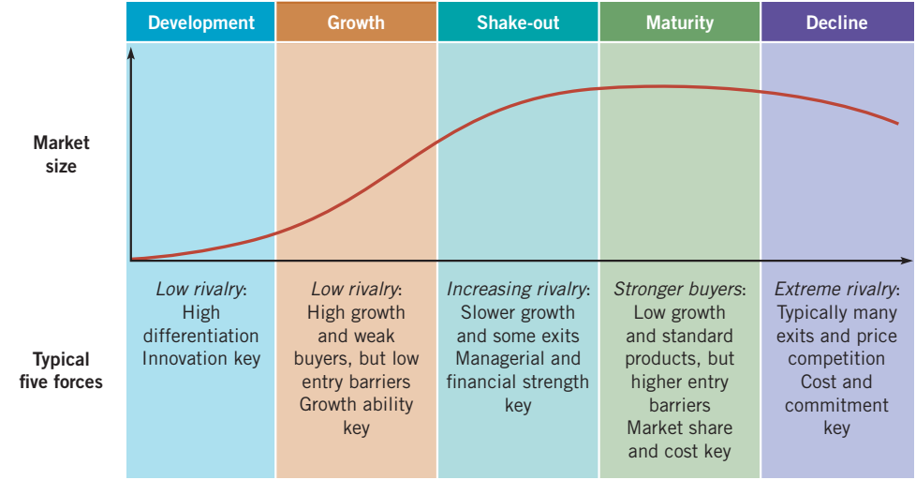
Source: Whittington et al., (2020)
Fig 2

Consumer electronics industry is at growth stage of industrial cycle due to an increase in domestic income, technology change and convergence. Most of the industry products experience several stages in their life cycle due to increasing in customer value and quality push demand and company strategy of acquisition or merger, products extension, and products re-design. Profit is not of important, but company compete to establish a new market share with marketing mix expenditure, research, and development. New products are the engine of growth for consumer electronics. Technological landscape is change and grow due to macro- environment factors such as introduction of 5G networks, the growing demand for smart technology, and the development of augmented, Internet of Things(IoT) and virtual reality has led further growth and demand in the market. With these trends revolutionizing a world which is becoming increasingly digital and connected, the consumer electronics market is bound to profit from this development Lynch (2018).
3.1 Porter’s five forces model are a model used by company to examine the business operating environment, competitiveness, profitability, and attractiveness of industry. The five forces concentrate on five important forces that are part of every organisation and market competition (Morden, 2007). Porter’s 5 forces analysis diagram can be found In Figure 2 below.

Porter’s five forces

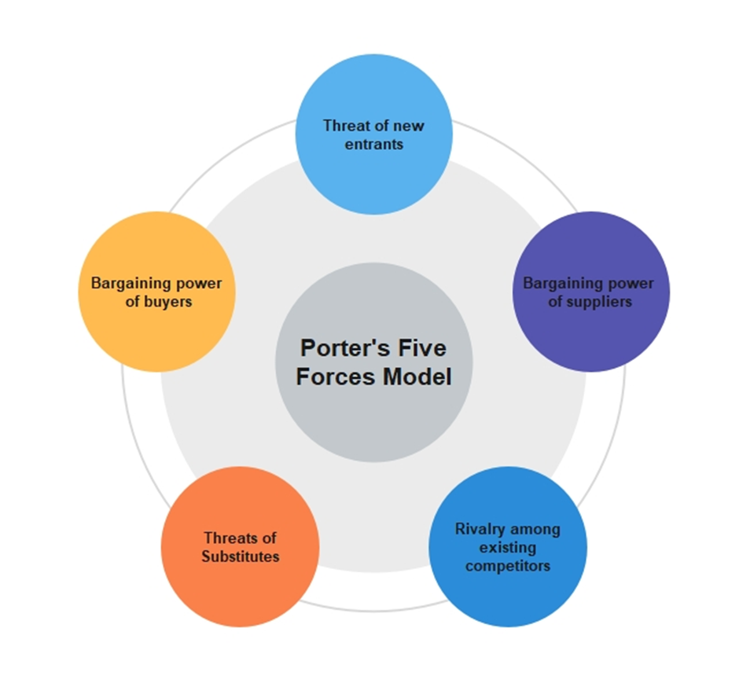

Fig 3
https://www.edrawmind.com/article/porters-five-forces-analysis-definition-and-examples.html

Apple Porter’s 5 forces,
The following Apple Porter’s 5 forces are based on fig 3.
Rivalry
Apple products and services experiencing competition as rivals try to copy the Apple product features, design and applications within their products or offer price that are cheaper than those Apple offer. (Apple,2022) Apple competes with business models that provide content to users for free, smart gadgets and clouds technology such Samsung, Motorola, Nokia, Microsoft, Toshiba, Amazon, etc, Like Apple, the above-mentioned company investing on research and development to meet consumer want and needs changing. The level of rivalry is high and unfavourable to Apple.
Bargaining Buyer’s Power
Individual customers bargaining power is low because of. Apple eco-system, privacy stance and switching cost is high. Apple customers are enjoying Apple’s iOS system which not permitted to use by third parties. Apple customer bargaining power is low but high when considering the collective customer bargaining power, the large market.

New Entrants to Market
Electronic industry entrance barrier is high. Because consumer electronic is huge capital involved, persistent research and development, and enormous brand recognition cost. In 2022, Apple spent $26m on research and development expenses (uk.finance.yahoo.com, 23AD). Apart from this Apple’s repel new entrant with powerful ecosystem, brand image and customers loyalty. Apple make sure that ecosystem of its products does not link to products or services from other brands this mitigate threat.

Suppliers Bargaining Power
Apple reduces the company supplier power through backward integration strategy such as investment in subsidiary or venture company iTunes Apple music, Beddit technology company that support Apple products. Apple is trusted company with numerous suppliers across the continent including China. According to Apple 2021 financial report, 175+ suppliers pledged 100 percent renewable energy transitioning for Apple products. Due to Apple venture, acquisition, large number of suppliers and potential suppliers, the supplier bargaining power are low (Apple,2022).
Threat of Substitution
Apple benefit positioning in the heart of consumers help the company to mitigate this threat. Apple products are expression of authentic, class and quality, The threat of substitution is medium because the possible substitute products capabilities are limited but cheaper in price to Apple products. it difficult for potential consumer to switch because of excitement features and integration between Apple products. For these reason customers are ready to pay high price to Apple product mostly iPhone.

4 INTERNAL ANALYSIS
Internal Analysis is the method used by organisation to assess its internal components such as resources, assets, characteristics, competencies, capabilities, and competitive advantages. Internal analysis tools including Strategy resources and capabilities Evaluation, Value chain, Analysis, VRIO and Core Competencies Analysis.

STRATEGIC RESOURCES AND CAPABILITIES
Organisation resources and capabilities are the long-term continuity and potential that contribute to organisation competitive edge if well employs and deploys. Capabilities are mix of activities, skills and behaviours, tools and organisation that bring about a particular outcome. Resources are the organisation’s asset, knowledge, and skills. Apple resources and capabilities are categories into tangible and non-tangible.

Apple Resources and Capabilities
Apple resources and capabilities that helped the company to build and sustainable competitive edge including the following,

Tangible resources and capabilities are the physical resources of the organisation that contribute to the value added including chief executive officer, Talented Management team, designers, programmers, engineers, hardware, software, suppliers, and retail stores.
Tim Cook has proved to be a good leader after replaced late Steve Job as CEO with an exceptional operational skill. According to Apple ESG report, Apple employees are over 165,000 globally, to conduct its operations and the 3million supply chain staff in 52 countries (Apple,2022). Apple employees are top graduate from university that uphold organisation culture and value. Apple employees ensure that production is surpass customers expectation and at high standard. Also, Apple employees at physical store location participated in in-store marketing and sales.
Apple have exceptional skilful programmers, designers and engineers that developed and produce exceptional operating software system like OS X and A15 Bionic chip. Apple programmer developed over 300,000 applications including entertainment, games, etc (Apple,2010).
Intangible Resources and Capabilities are the resources that we cannot touch physically but benefited by the organisation such as Apple Brand name and image, Knowledge/Skills of employees, Customers loyalty and Database, Marketing, design capability, Research, and Innovation Capability.
Design capability, Apple products design are the same for long time. But Apple constantly change a unique user interface experience by design different screen, battery touch pad and unique functionality in its products. The company’s products redesign has a major positive impact for the company success and for the products to be on top over the competitors. Apple quality and differentiation focus alluring customers.
Research and Development capability, Apple ability to compete in the market depend on R&D, Apple spent $26 billion in research and development in year 2022. Research and development propel Apple to continues design and launch ease to use innovative new products such as iPhone 1 to 14 and iPad. Also, that is why the company in-house hardware, software and operating system are successful (Apple,2022). Another capability of Apple is Artificial Intelligence like Siri along with several functions to help with efficiency.
Innovation Capability, Apple competing strategy also focus innovation from the beginning. For example, Apple transformed Walkman by integrated technological knowledge with selling music online (iTunes). Apple transformed Desktop computer to personal laptop, mp3 to iPod music player and transformed BlackBerry mobile phone to first smart phone.
Brand Image, Apple brand name and image are most recognised in the consumers electronics industry and smart-tech industry. The popularity of Apple products and OS X operating system are undisputable. The transformation and launch of its products such as iPhone helped the company to secure a reputable brand image and customer loyalty. High brand image reflected unique competence that secure the company competitive advantage and loyalty customer.
Differentiation and Product Quality, Apple committed to innovation, unique design and features that differentiate it products from other competitors like Nokia, Motorola, and Samsung, etc. The company produce different exceptional products and services starting from Mac computer to iPhone, iPod, iPad, and Apple pay, iCloud, etc. There are many android system product producers in market but one iOS system and Apple.
Marketing, for years, its unique marketing strategy has helped drive sales and engage customers better. Apple excellent international and marketing strategy are a key source of popularity for the brand. According to Apple annual report 2022, Apple operating in US and 84 stores across nations (Apple 2010 Annual Report). Apple online and physical stores function as an advertisement and revenue location that contributing the success of the company.
Supply chain, Apple backward integration has helped the company to managed supply chain network and availability of quality raw materials. Most of Apple supply chain and assembly functions are site outside America. According to the company ESG report, 1000 of business and facilities support the company worldwide. Quality checks in OEM factories has help the company to managed high quality products and reduce its operational costs by outsourcing manufacturing processes (Apple,2022).
Customer loyalty and Database, Apple build a global customer database and customer loyalty that helps the company secure useful information to support innovation and new product development, as well as marketing strategies and business management and strategic planning. Apple has built ecosystem of related products which has helped the company sustain it retain customer loyalty (Apple ,2022).

VALUE CHAIN ANALYSIS
Value chain is comprising of all the task undertaken by business to provide finished goods and services to the customers (Johnson, et al., 2012).
According to fig 4 below, Apple value chain is divided into primary and supporting activities. The main primary activities including inbound logistics, operations, outbound logistics, marketing and sales, and service. Primaries are activities that deal directly with the production and delivery of product or services. Support activities are technology, personnel management, and procurement. Support activities are the activities that improve the efficiency and effectiveness of primary activities.

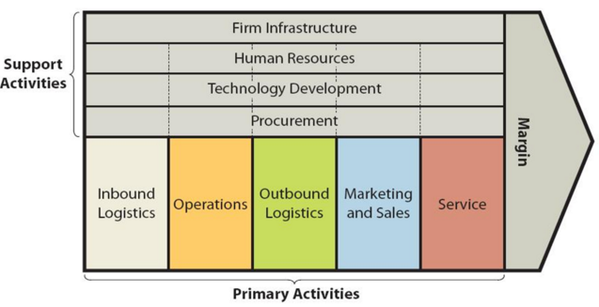
https://research-methodology.net/apple-value-chain-analysis/
Fig 4

PRIMARY ACTIVITIES,

Inbound Logistics:
Apple Inbound are responsible for inventory management, receiving and warehouse management for fast production within a low range of time. Apple receiving raw materials from various countries, while production and assembling takes place in China (Apple,2022).

Operations:
Apple operation function including transforming raw to Apple finished products. Operation also focusses on five segment market areas: America, Europe, Middle East, and Africa. While China sales decline, Japan sales remain constant and possible emerging new potential sector for products sales.

Outbound Logistics:
Apple Outbound logistics focus on shipping final product to warehouse and distributing them to consumers (Wheelan et al., 2015). Because of product short life cycle and shipment costs in China and the Asian region, Apple expand its market penetration around the region. Hence increase in sales and customers loyalty.

Marketing and Sales:
Apple marketing and sales are responsible for integration marketing mix and customers retention. They are using CRM and database to enhance the sales and increases in the company revenue year by year, 2022 revenue increased by7.8% to $394m (Apple ,2022). The company’s generating sale from seven distinguished sectors. These are: Cloud computing, Apple Retail store, Online Stores, Wholesalers, Network providers and Retailers,

Service:

Apple service focus in maintain Apple products and offer best customer experience throughout customer journey. Apple offered customer training to their sales assistants according to 2022 ESG report (Apple,2022). They support customers with the following Including accepting return, refund, customers upgrade and exchange.

.

SECONDARY ACTIVITIES

Apple secondary activities are Support Activities
Apple secondary activities are support activities.

Infrastructure
Apple infrastructure including systems, organisation structure, management, quality control, finance, etc. They are force that propel a company’s success if professionally managed. Apple trained over 15,000 managers as at 2022according to ESG report (Apple,2022)
Human Resource Management
Apple human resource management focus on hiring, retaining and employee’s wellbeing. Apple HRM plays a crucial role in the company. They conducted 175,000 training hours in 2022 according to ESG report (Apple,2022).
Technology Development
Apple’s technological development are one of the points of its distinctive brand image. Apple spent 26 billion dollars (2022) on technology research and development to continuing enjoying unique competitive and growth edge. Apple research and development are using to provide better services, designing and new product range to the customers (Apple, 2022).

Procurement

Apple procurement maintains company source of materials and good relationship with suppliers. Apple invested in some of suppliers through venture finance and acquisition. Hence mitigate short of supply and production disruption all these years (Apple,2022).

5 VIRO ANALYSIS OF DISTINCTIVE RESOURCES AND CAPABILITIES
The VRIO analysis model is a resources-based view that evaluates organisation value, rarity, imitability resources and business capabilities. Distinctive resources and capabilities are the core competencies and resources that guarantees competitive advantages of an organisation (Whittington et al., 2020).

A VRIO Analysis of Apple Inc.
Apple make use of core competencies to achieve long-term competitive edge against aggressive rivals. Apple long-term distinctive and core competencies are the skills, activities, resources, and capabilities that appear in the below table.
Capability | Valuable | Rare | Inimitable | Organized | Result
Brand equity | Yes | Yes | No | Yes | Competitive advantage
Global Presence | Yes | No | Yes | Yes | Temporary advantage
Customer loyalty/Data | Yes | No | Yes | Yes | Temporary advantage
Supply chain | Yes | Yes | No | Yes | Temporary advantage
Premium Product quality /Design | Yes | yes | Yes | Yes | Competitive advantage
Marketing | Yes | Yes | Yes | Yes | Competitive advantage
Research & Innovation | Yes | Yes | N | Yes | Competitive Advantage
Eco-System | yes | Yes | Yes | Yes | Eco-System

From the above VRIO table, Apple globally brand identified as one of core competency and competitive strength because it is valuable, rare, and difficult to imitate. Apple rapid innovation, Research and development is another success factor of the company. These resources/capabilities help the company to maintain a successful rate of innovation especially in software and hardware products and services. From the above VRIO table, supportive ecosystem and Siri artificial intelligence are another Apple’s core competencies and edge. This competency involves products that mutually promote each other. Apple international marketing network and marketing mix also identified as a core competency and distinctive due to global network, strategical location, and authorised distributors. This integrated marketing network organised the Apple strategic plans and efforts in reaching target customers worldwide.

6 SWOT Analysis
SWOT Analysis is strategic model applied by the organisations to spot business competitiveness within the industry. Organisation use strengths and weaknesses to analyse resources and capabilities while opportunities and threats are using to analyse the environment (Whittington et al., 2020)

Apple SWOT Analysis Diagram
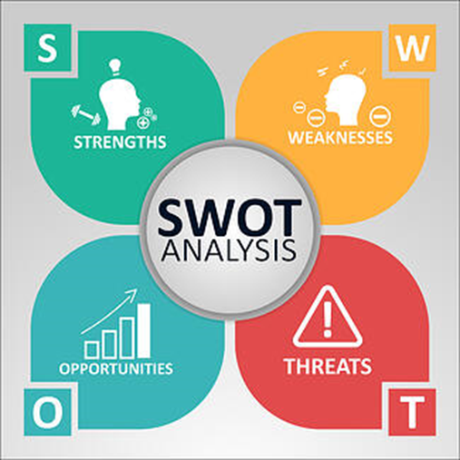
https://www.rhythmsystems.com/hs-fs/hubfs/iStock-1134293632.jpg?width=488&name=iStock-1134293632.jpg
Fig 5

The following are Apple SWOT Analysis is according to the above fig 5.
Strength is the factor that favourable to Apple company because of innovation, research, and development.
Integration, Apple’s vertical and horizontal integration (self-sustainability) give the company competitive edge and influence over suppliers. Apple acquired a lot of company through venture, merger, and acquisition. Which allow the company to expand and grow within the consumer electronics and smart technology company (Apple,2022).

Distribution Channels, Apple applied integrated marketing mix across the globe. Apple distributing its products through indirect and direct channel including physical store, on-line store, and third-party retailers. Apple stores are well located in the high street or mail with simple design that enhance marketing and presentation. Apple physical store sell their product directly to individual, while online store is effective channel for its hardware and software products. Apple third party distributors are the mobile network provider, wholesales, small and medium retailers.

Brand Loyalty. “Once an Apple user, Always an Apple user” which in most cases correct. Apple customer are loyal to the brand because Apple supplies privacy features to a great extent, making its users feel protected secure. The company operating system is different from android system that open to third part companies. The stylish design and simplicity plus fantastic eco-system that is not open to android products.
Technology Wise, Apple is one of dependable company in terms of consumer electronics and smart technology devices. Apple success is because of constant in-house product innovation, research and development that yields a success. Apple transformed Blackberry mobile phone to smart phone by combined iPod with phone together to produce first innovative smart mobile phone(iPhone) that changed the world. According to Apple year 2022 annual report, Apple spent on $26m on research and development an increase of $4billion from its 2021 total (uk.finance.yahoo.com, 23AD)

Design and superior quality Apple offer high quality and superb design products that synonymous with it is slogan “Think different.” The designs, sizes and functions of Apple product are different, made with innovative techniques and software. For example, iPhone have become a symbol of status and class. Apple products and services are support with on-line service platform and dedicated service centre (support.apple.com, 22AD). Apple Service Programs - Apple Support

Strong financial performance, Apple is financial performance improve year by year according to year 2022 annual report and the company market capitalisation is at record of $2tr and its 12 months products and services revenue was $394m and net income of $99m (Apple,2022). Apple sales increase was because of increase in iPhone, Mac, and services Below are Apple iPhone sales from 2008 to 2021.
iPhone annual sales 2008 to 2021 (mm)
Year | Sales (mm)
2008 | 11.6
2009 | 20.7
2010 | 39.9
2011 | 72.3
2012 | 125
2013 | 150.2
2014 | 169.2
2015 | 231.2
2016 | 211.8
2017 | 216.7
2018 | 217.7
2019 | 187.2
2020 | 196.9
2021 | 242
Note: Apple stopped reporting iPhone sales in Q4 2018. All values afterwards are estimates. Sources: Apple, Canalys, CNBC, Gartner, Strategy Analytics

Weakness
1 Limited Advertisement, Apple sees itself as too big to fall because of this, Apple reduces advertisement and sponsorship funding. Must of Apple products advertisement be carryout by whole sellers and indirect retailers. Apple relying on mouth-to-mouth recommendation and its global recognised brand image.
2 Lack of Design and Name, Android product are in different name and range, Apple products name remained the same and series (iPhone 3,4,5,6,7..........14), there no difference in appearance except for size and new features. Apple should produce new products name.
3 Products Price, apple products price is not affordable to some people in developing countries compared to android products at cheaper price. Apple should consider pricing impact on international growth strategy and revenue. The poor and low-class people are price-out in developed countries too.

Opportunities
1 Sponsorship Promotion and social media, Apple customer loyalty will increase if the company can follow the footstep of Coca Cola drink, Visa Card by support global sport event such as World cup, Tennis and Olympic sport.
2 Innovative Capabilities, Apple can use it revolution skills to launching self-drive car and Smart TV. The company enter partnership with Benz AG in year 2022 which is an opportunity to enter automobile industry. Also, the company have opportunity to transform Apple TV and ecosystem to smart television like Sky glass TV. These will generate more revenue.
3 Market Development/Expansion = Apple growth strategy will increase its market share and revenue global. Apple opened new store in South Korea in 2023 and Vancouver in Canada in 2022. These new stores will attract more customers and increase the company products and services sales, hence maximise shareholders returns.

Threats
1 Network Providers. Apple revenue performance from mobile phone, iPad and watch are depends on communication network providers. If network provide fail to retain customers this may affect Apple revenue. According to Apple financial report in 2022, Mobile network provider account for 44% of the company receivable which means that mobile network provider place important role in the company indirect products distribution.
2 Competitors Apple rivalry cut across its products and services. Company such as Google, Sony, Amazon, Microsoft, etc are challenge to Apple market share. Android system products manufacturers are increases and they are competing price and replicate design.

APPLE COMPETITORS
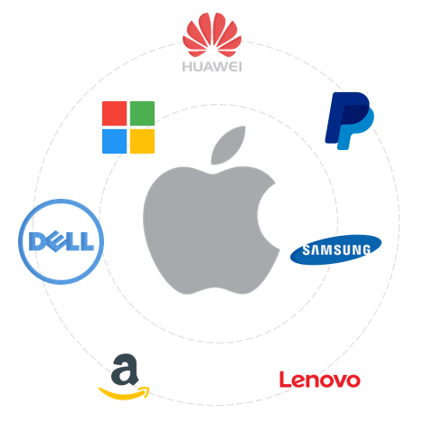
Fig 6
3 Privacy and Security, several attempts have been made to breaches and backdoor to unluck Apple products. individuals or government agencies tried the past to through legal and illegal means to exploit the company product. If bad guy succeeds, then that is the end of Apple competition advantage because privacy that it why many customers loyal and trust Apple products.
4 Changing in needs, from time-to-time consumer needs and want change which impacted consumer electronics life cycle. only company that constant research and develop that will maintain their market share. therefore, research and development cost will continue increasing every year due to dynamic environment.

Apple must use its strength and opportunity to mitigate the weaknesses and threats the company.
The following are the advantages and disadvantages of SWOT analysis.
Advantage and disadvantage
Advantages, with the aid of diagram management can easily understand SWOT analysis. SWOT does not limit by organisation size or capital structure. Disadvantage of SWOT, Data used may be inaccurate as result of subjective decision rather than objective. Sometime Analysis may be inaccurate because of outdated qualitative data.

7 STRATEGIES TO SUSTAIN COMPETITIVE ADVANTAGE
Sustainable competitive advantages comprise of characteristics, capabilities, and asset that organisation explore to meet needs of customers better than its competition over long term (Whittington et al., 2020).
Porter’s generic strategy
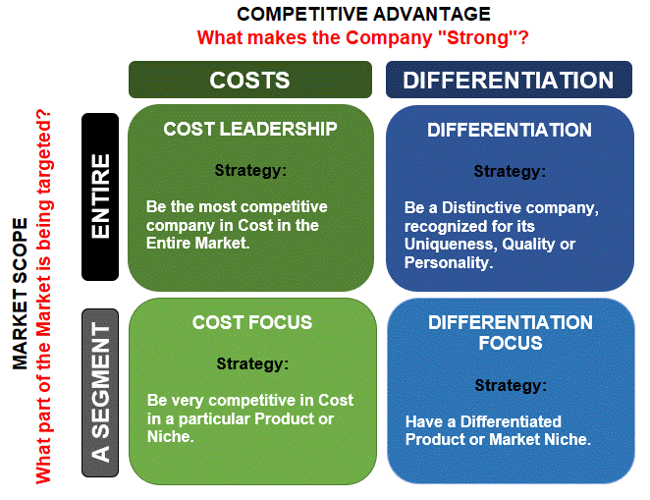
https://www.consuunt.com/porters-generic-strategies/
Fig 7
Porter’s generic strategies describe how an organisation competitive advantage can be achieved across its chosen market scope. Generic strategies formed when two type of basic competitive advantage combined. Apple’s sustainable competitive advantages comprises of Porter’s generic strategy, International and acquisition strategy. Apple applied BCG Matrix Star and differentiation strategies by making the business stand out, synonymously with its slogan THINK DIFFERENT and well fund research and development. Apple distinguishes itself from competition by focus on the following element. Simplicity, Design, and functionality: designs go against the status quo by create more fun and sleeker innovative product with every new roll out. Apple advanced in software and hardware service across all the devices, with the same user interface through ecosystem. For example, Apple's product standout with privacy stance, this is core reason consumers buy their products. There are many Android system products in the market but only one IOS and M1 system. Apple effectively design their product and services differently to protect privacy and security of their customers. The consumers in the Europe and USA are sceptical and cynical when it comes to "privacy" on Chinese-branded smartphones. Apple acquisition and merger, Backward integration has certainly leveraged Apple sustainable competitive advantage. For this reason, competitors cannot take their market share. https://www.apple.com/privacy/.

Apple products
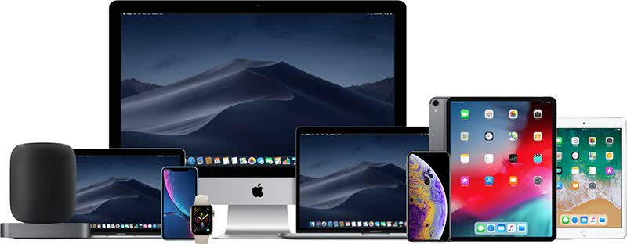
Source: US Economics Review
Fig 8

- GROWTH STRATEGIES

Ansoff Metric’s

Ansoff metric is growth strategy model use by organisation to develop strategies for future growth such as, market penetration, market development, product development, and diversification. Ansoff Matrix was introduced by Igor Ansoff. Technology industry is highly competitive and challenging with innovative brand from other big players. Apple explored international and Ansoff Metric’s strategy to adapt with the dynamic environment, consumer needs and want.

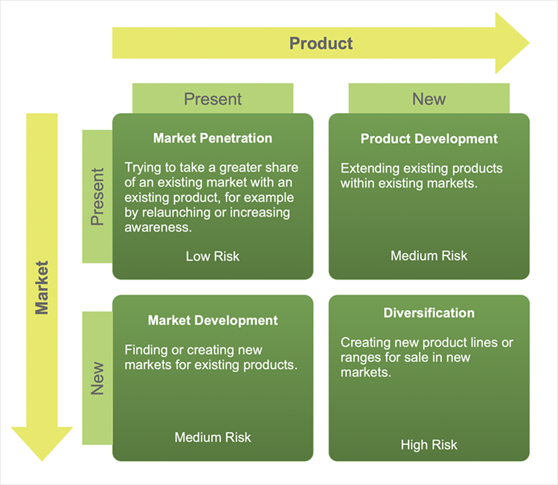
https://www.conceptdraw.com/examples/ansoff-matrix
Fig 9
In line with fig 9 Product development is a means of product line extension within existing markets. Apple constants develop attractive and profitable consumer electronic products to grow market share and business performance. Apple achieved growth strategy by constant innovation, research, and development new product. For example, Apple continues to innovate products like the iPhone 2…….14, Mac, iPad, iPad- mini, and Apple Watch. Apple generic growth strategy by constant technological innovation enhance competitive advantage and profits.
Market Penetration and Global strategies. Apple uses market penetration and global strategy as its second intensive strategy for growth. Apple global and market penetration focus on cost efficient and increase current market share by selling more of the company’s current products. Apple growth strategy increase sales its current markets in North America and new markets. Apple opened an Apple Myeongdong store in South Korea in April 2022 and new store - Apple Al Maryah Island in Abu Dhabi, the UAE in February 2022. In the same month, Apple opened Apple Yas Mall in Abu Dhabi, the UAE(MarketLine). Apple combined Integrated marketing and global strategy to influences the effectiveness of the organization’s competitive advantage and growth (Apple,2022).

9 APPLE GREEN STRATEGY AND CSR

Apple Green and CSR
Green Strategy/Corporate social responsibility is the conscious model applied by organisation to operate in ways that enhance rather than degrade society and the environment. CSR helps to enhance many aspects of society as well as promote a positive brand image of companies. CSR is split into four categories: Environmental, Work/ Ethical responsibility, Human resources, and Community Development.

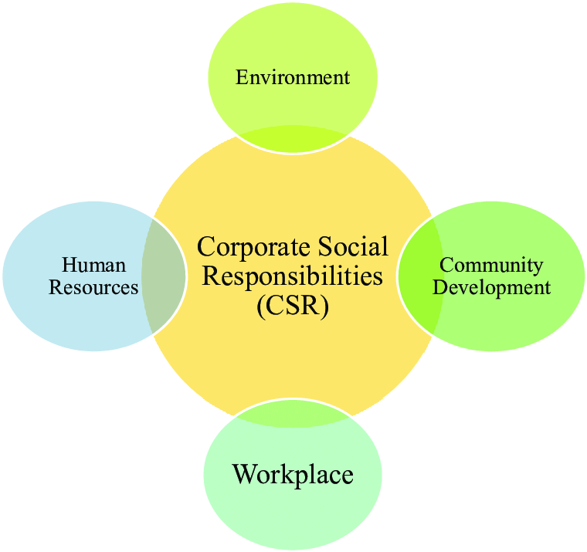

https://www.researchgate.net/figure/Corporate-social-responsibility-CSR_fig2_333660806
Fig 10

From the above diagram, Apple take steps to serve people by designing technology that is accessible to people at the same time protecting the planet by using more recycled materials in its production. Apple take efforts to build inclusive company carbon neutral culture that welcome by employees and supply chain. Apple ESG report comprises of Green Strategy and Corporate Social Responsibility of the company. Apple committed to 2030 environmental goal and serving the communities. For the company to achieve this goal they formed partnership with various organisations and communities worldwide with fund, resources and training, Academy, and educational initiatives across the globe.

On Climate Environment, in line with fig10, since 2020 Apple have been carbon neutral for its corporate operations. Apple reducing emission by 75% compared to year 2015 according to 2022 ESG report. The company design and manufacturing products with less -carbon intensive material and greater energy efficiency. Apple increase facilities and supply chain energy efficient through retrofitting and sourcing 100% renewable energy for offices and stores renewable use. Apple laid ambition and goal to be carbon neutral products by 2030. Apple partnered with The Conservation Fund to protect 36,000 acres of sustainable forest in North Carolina and Maine and more than 13,000 metric tons of wood harvested responsibly. Apple is the only company that awarded with a Clean Energy Index of 100%, according to Greenpeace’s Clicking Clean Report. Apple avoid exposure to chemicals that could be harmful to human health or the environment. At the same time, committed to stewarding water resources and sending zero waste to landfill.
Social
Apple work every day to put people at heart by respecting human right everyone, creating an inclusive and diverse working environment plus equity and opportunity. Apple provided employee benefit and launched a group of health clinics called AC Wellness for its employees and their families. Apple embed human right across the company including privacy, Environmental, health and safety. The company employed more LGBTQ+ Black and Hispanic/Latinx candidate in the past year with 23% offers in US retail leadership roles. Apple support its supply chain by investing in supplier staff training and education ($50m Supplier Employee Development Fund), upholding standards in the sourcing of materials and expectation in accordance with the company supplier code of conduct and responsibility standards. Apple customised it products with advance accessibility features for disabled customers including Voice over recognition, FaceTime, and sound recognition to help them navigate day to day life. Apple support the Black, Hispanic/Latinx communities with economic empowerment and entrepreneur training /investment., donated $24m in May 2022 and £100m in 2020(Apple,2022), acting on racial equity and justice and provide greater access and opportunity to minority and colour children in colleges and universities. Apple launched a 100-kilowatt rooftop solar project at an educational premise for disadvantaged children in Philippines. Also added 50-kilowatt solar power system and a 260-kilowatt-hour battery to supply clean electricity to off-grid fishing community in Thailand.

Governance
Apple embed transparency and accountability at every level of its company. Apple governance and board of directors help the company to make effective corporate decision and strategy that guild the company. The company board run ethnical and honest business and complied with the law and regulations globally including third party compliance, confidentiality, antitrust, health, anti-corruption, export, and sanctions. All suppliers of tin, tantalum, tungsten, gold, and cobalt smelters and refiners participate in third-party audits (Apple,20220.
Carbon Emissions by Apple
As illustrated in figure below.
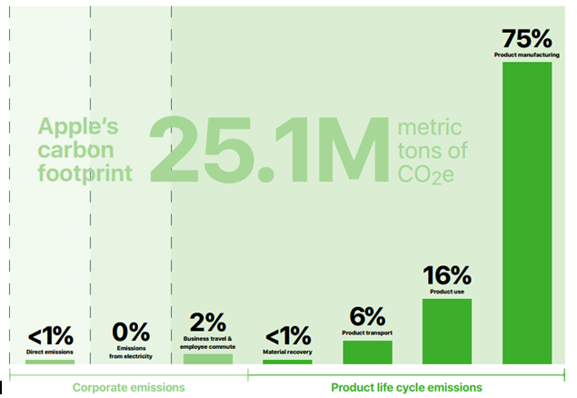

10 Conclusion’
Apple aligns growth strategy with the company’s mission and vision to maximise the organization’s competitive advantages that produced constant business growth and financial performance. According to appendix 1 and 2, Apple maximised shareholder return with basic earning per share of 6.15cent, 5.67 and 3.31 in 2022,2021 and 2020 respectively likewise revenue grow, respectively.
11 Recommendation,
Ansoff Diversification is a riskiest growth strategy due unfamiliar product and market, selling new products to new markets. Diversification would be a useful strategy for Apple Inc. Apple has been brilliant in designing and developing new products. I would be great, if Apple can develop big screen smart LED-TV with built in Apple TV that can be control with iPhone and iWatch. The smart tv integrated in Apple Eco-system. With the artificial intelligence and robotics markets are gaining ground, along with the autonomous and self-driving automobile markets. The core competitive advantage opportunity identified in the VRIO analysis strategically position the business to offer self-driving car like Tesla that will make the corporation a major player early on as these other industries and markets develop.

12 References:
Whittington, R., Regnér, P., Angwin, D., Johnson, G. and Scholes, K. (2020). Exploring strategy. 12th ed. Harlow, England Pearson.
uk.finance.yahoo.com. (23AD). Apple Inc. (AAPL) income statement – Yahoo Finance. [online] Available at: https://uk.finance.yahoo.com/quote/AAPL/financials?p=AAPL.

Hooley, G.J., Nicoulaud, B., Rudd, J.M. and Lee, N. (2020). Marketing strategy & competitive positioning. 7th ed. Harlow; New York: Pearson.
.
Morden, T. (2007). Principles of Strategic Management. 3rd ed. England: Ashgate Publishing Limited.
Kotler, P. (2009) Marketing management. 1st ed. England: Pearson/Prentice Hall.
Doyle, P. and Stern, P. (2006). Marketing management and strategy. 4th ed. Harlow, England; New York: Financial Times Prentice Hall.

Apple (2022) Apple expend the use of recycled materials across its product. https://www.apple.com/newsroom/2022/04/apple-expands-the-use-of-recycled-materials-across-its-products/.
Apple (2022). Apple Store Online. [online] Apple. Available at: https://www.apple.com/store.

Whittington, R., Regner, P., Angwin, D., Johnson, G. and Scholes, K. (2019). Exploring Strategy, text, and Cases. 12th ed. Hoboken: Pearson.
Morden, T. (2007). Principles of Strategic Management. 3rd ed. England: Ashgate Publishing Limited.
Whittington, R., Regner, P., Angwin, D., Johnson, G. and Scholes, K. (2016). Exploring strategy, text, and Cases. 11th ed. Hoboken: Pearson.
Lynch, R. (2018). Strategic Management. 8th ed. Pearson UK.
Johnson, G., Whittington, R. and Kevan Scholes (2012). Fundamentals of strategy. 2nd ed. Harlow, England: New York: Financial Times /Prentice Hall.
Whittington, R., Regner, P., Angwin, D., Johnson, G. and Scholes, K. (2020). Exploring Strategy, Text, and Cases. 12th ed. Harlow: Pearson.

Maverick, J.B. (2022). Analysing Porter’s Five Forces on Apple (AAPL). [online] Investopedia. Available at: https://www.investopedia.com/articles/investing/111015/analyzing-porters-five-forces-apple.asp.
Kolakowski, M. (2021). At $1 Trillion, Apple is Bigger Than These Things. [online] Investopedia. Available at: https://www.investopedia.com/news/apple-now-bigger-these-5-things/.
Apple (2022). Environmental Progress Report. [online] Available at: https://www.apple.com/environment/pdf/Apple_Environmental_Progress_Report_2022.pdf.
Apple Legal. (2021). Legal - Apple Products and Consumer Laws in the United Kingdom - Apple. [online] Available at: https://www.apple.com/uk/legal/statutory-warranty/uk/.
. Apple Inc. (2022). Ethics and Compliance - Apple. [online] Apple Compliance. Available at: https://www.apple.com/compliance/.

Apple Insider(22AD). Apple has more than 1;8b active devices, up150M in the last year. https://appleinsider.com/articles/22/01/27/apple-has-more-than-18b-active-devices-up-150m-in-the-last-year.
Apple (2022). Environmental Social Governance Report. [online] Available at: https://s2.q4cdn.com/470004039/files/doc_downloads/2022/08/2022_Apple_ESG_Report.pd
www.macrotrends.net. (22AD). Apple Research and Development Expenses 2010-2022 | AAPL. [online] Available at: https://www.macrotrends.net/stocks/charts/AAPL/apple/research-development-expenses#:~:text=Apple%20annual%20research%20and%20development.

support.apple.com. (22AD). Apple Service Programs - Apple Support. [online] Available at: https://support.apple.com/service-programs.
www.google.com. (22AD). apple%20retail%20store - Google Search. [online] Available at: https://www.google.com/search?q=apple%20retail%20store&bih=678&biw=1396&hl=en-US&ei=bBKnY5-nNruEhbIP89SImA8&gs_ssp=eJzj4tTP1TcwyigvylFgNGB0YPASSiwoyElVKEotSczMUSguyS9KB [Accessed 24 Dec. 2022].
Peterson, M. (2021). Apple spent $64.8 million on paid search ads in 2020, ranking 12th overall. [online] Apple Insider. Available at: https://appleinsider.com/articles/21/10/26/apple-spent-648-million-on-paid-search-ads-in-2020-ranking-12th-overall.

https://www.apple.com/uk/environment/pdf/GBEN_Apple_Environmental_Progress_Report_2022.pdf

https://research-methodology.net/apple-corporate-social-responsibility-csr

.

APPENDIX
APPENDIX 1
Appendix 2

Apple Income statement
All numbers in thousands
Breakdown

29/09/2022
29/09/2021
29/09/2020
29/09/2019
Total revenue

29/9/2022= $394,328,000
29/9/2021 = $365,817,000
29/9/2020= $274,515,000
29/9//2019 = $ 260,174,000
Cost of revenue

29/9/2022= $223,546,000
29/9/2021= $212,981,000
29/9/2020= $169,559,000
29/9/2019= $161,782,000
Gross profit

29/9/2022= $170,782,000
29/9/2021= $152,836,000
29/9/2020= $104,956,000
29/9/2029= $ 98,392,000
Operating expenses
Research development

29/9/2022= $26,251,000
29/9/2021= $21,914,000
29/9/2020= $18,752,000
29/9/2019= $ 16,217,000
Operating income or loss

29/9/2022= $119,437,000
29/9/2021= $108,949,000
29/9/2020= $ 66,288,000
29/9/2019= $ 63,930,000

Net income Net income available to common shareholders

29/9/2022= $ 99,803,000
29/9/2021= $ 94,680,000
29/9/2020= $ 57,411,000
29/9/2019= $55,256,000

Basic EPS
-
29/9/2022= 6.15
29/9/2021= 5.67
29/9/2020= 3.31
29/9/2019= 2.99
Diluted EPS
-
29/9/2022= 6.11
29/9/2021= 5.61
29/9/2020= 3.28
29/9/2019= 2.97
EBITDA
-
29/9/2022= $130,541,000
29/9/2021= $ 120,233,000
29/9/2020= $ 77,344,000
29/9/2019= $ 76,477,000
https://uk.finance.yahoo.com/quote/AAPL/financials?p=AAPL

