LCHS7009 Digital Health Promotion Blogs (Component 01)
Student name | Md Aktarujjaman
Student number | 2512989
Module code and title | LCHS7009
Lecturer | Dr Besty Jose
Assignment title | Com 1 Blogs (2 entries)
Submission date | 06/03/2026

BLOG 1: Critically discussing an existing digital technology
Mental health self-help apps for anxiety and depression: impact, engagement and governance
Public health problem and why it is a concern
Rampant are anxiety and depression, which may diminish social functioning, productivity and life quality. Barriers to accessing timely assistance, which can be stigma, cost and waiting lists, make low-barrier self-help a more valuable alternative. Digital self-help applications have consequently increased in rapid numbers, providing CBT-based exercises, mindfulness, journaling, mood tracking and signposting. Their promise to the people in terms of health is access and promptness: assistance may be offered when the symptoms appear, not only during the appointment.
How the digital technology is used in health promotion
These apps will help develop coping skills and self-efficacy via repeated practice and behavior change routine in health promotion terms. The NHS-based resources like Every Mind Matters are an addition to this strategy featuring a structured self-help information base and the programme known as the Mind Plan, which proposes specific steps to help alleviate anxiety, stress, sleep better and develop a sense of control (NHS, 2026).
 | 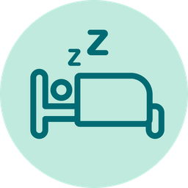 | 
Figure 1: Every Mind Matters Mind Plan icons (NHS self-help entry point).
Source: NHS Every Mind Matters Mind Plan page assets (NHS, 2026).

Evidence that the technology promotes health
There are indications that there are applications that can enhance the results of depression and anxiety in certain users, particularly when the content is evidence-based and individuals utilize it regularly. The gains of systematic review evidence report apply to various types of apps, yet also extensive differences in the quality of the studies and even features of the apps (Wu et al., 2021). The active participation and retention are always pointed out as constraining factors, and a great number of users quit prematurely and, thus, get an inadequate dose of skills practice (Boucher et al., 2024; Smith et al., 2025).
Critical impact: advantages and disadvantages
Privacy, convenience and scalability are its benefits that can aid in early help seeking and managing symptoms. The drawbacks are very high. To begin with, high attrition decreases efficiency in the field. Second, there is a difference in quality of the marketplace and certain products boast of unclear benefits with no clear assessment. Third, confidential information (mood, triggers, usage patterns) is more damaging under the conditions of poor governance. Lastly, the gains might be concentrated on digitally confident users, and the least gains will be enjoyed by those who have little data, are not digitally motivated or have fewer privacy conditions at home (NHS England, 2023).
How shortfalls can be addressed
Certain shortfalls can be minimized through designing to retain (short sessions, explicit progress feedback), enhance crisis and escalation prompts, and implement evidence requirements based on risk with the help of the Evidence Standards Framework developed by NICE (NICE, 2022). The MHRA guidance facilitates the better interpretation of safety expectations of digital mental health technologies (MHRA, 2025). Services must install accommodating routes that have non-digital routes, and supported assistance (NHS England, 2023).

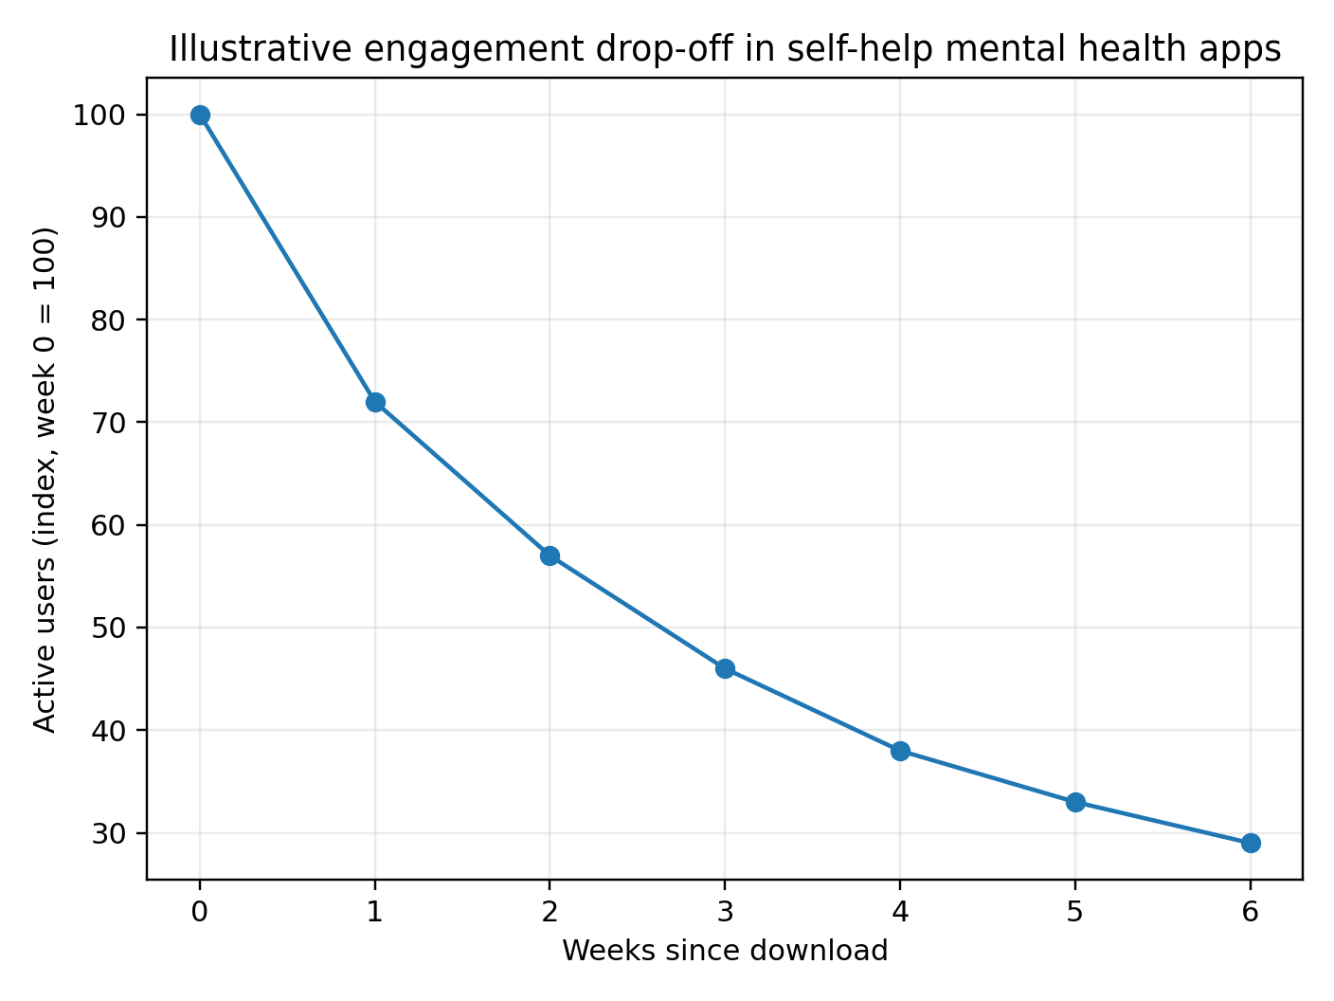
Figure 2: Illustrative engagement drop-off in self-help mental health apps (conceptual chart).
Source basis: engagement and attrition patterns synthesized in Boucher et al. (2024) and Smith et al. (2025).

References
Boucher, E.M. et al. (2024) ‘Engagement and retention in digital mental health interventions’, Discover Mental Health. Available at: https://link.springer.com/article/10.1186/s44247-024-00105-9 (Accessed: 11 February 2026).
Medicines and Healthcare products Regulatory Agency (MHRA) (2025) ‘Digital mental health technologies guidance launched to help manufacturers and safeguard users’. Available at: https://www.gov.uk/government/news/digital-mental-health-technologies-guidance-launched-to-help-manufacturers-and-safeguard-users (Accessed: 11 February 2026).
National Institute for Health and Care Excellence (NICE) (2022) ‘Evidence standards framework (ESF) for digital health technologies: how to meet the standards’. Available at: https://www.nice.org.uk/corporate/ecd7/chapter/how-to-meet-the-standards (Accessed: 11 February 2026).
NHS (2026) ‘Every Mind Matters’. Available at: https://www.nhs.uk/every-mind-matters/ (Accessed: 11 February 2026).
NHS England (2023) ‘Inclusive digital healthcare: a framework for NHS action on digital inclusion’. Available at: https://www.england.nhs.uk/long-read/inclusive-digital-healthcare-a-framework-for-nhs-action-on-digital-inclusion/ (Accessed: 11 February 2026).
Smith, K.A. et al. (2025) ‘Engagement and attrition in digital mental health (consensus and systematic review)’. Available at: https://pmc.ncbi.nlm.nih.gov/articles/PMC12223045/ (Accessed: 11 February 2026).
Wu, A. et al. (2021) ‘Smartphone apps for depression and anxiety: a systematic review’, npj Digital Medicine, 4. Available at: https://www.nature.com/articles/s41746-021-00386-8 (Accessed: 11 February 2026).

BLOG 2: Critically discussing a digital technology
AirGuard Asthma: smart inhaler support with air-quality alerts and community touch points
Public health problem and why it is a concern
Asthma is a chronic disease which may lead to preventable symptoms and severe attacks. According to the World Health Organization, asthma is a significant non communicable disease and that proper control of the disease involves proper medication intake and management of its triggers (World Health Organization, 2024). Controlling factors like air pollution and occurrences of climate are also environmental exposures that can aggravate control and these hazards are usually not equally spread across communities (Canaday et al., 2024).
The designed digital technology
AirGuard Asthma is a developed digital health promotion intervention, which combines a smart inhaler sensor in the form of a clip-on device with a mobile application. It integrates both inhaler-use tracking and air-quality alerts in order to make people take action earlier when the risk increases. A fictitious demonstration page for engagement is included: https://airguard-asthma.health/demo.
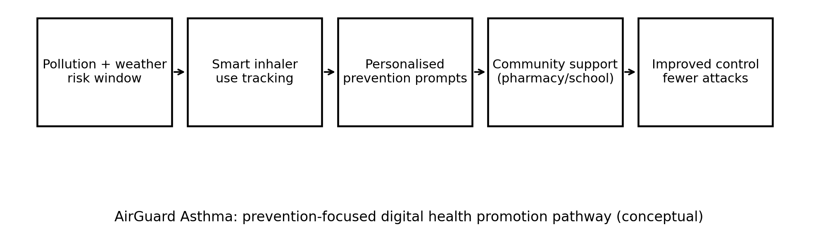
Figure 1: AirGuard concept pathway (designed technology diagram).
Source basis: smart inhaler evidence and environmental trigger rationale (Drummond, 2025; Ologundudu et al., 2025; Canaday et al., 2024).
How the technology will be used in health promotion
The app assists in preventing-based behaviors with brief actionable notifications: reminders to use preventers, technique demonstration videos, and personal guidance when the risks of pollution rise. It also offers community touch points like pharmacy inhaler technique cheques and school support packs to provide support outside of the phone. This is in line with the guideline focus on control and risk mitigation in day-to-day activities (GINA, 2024).
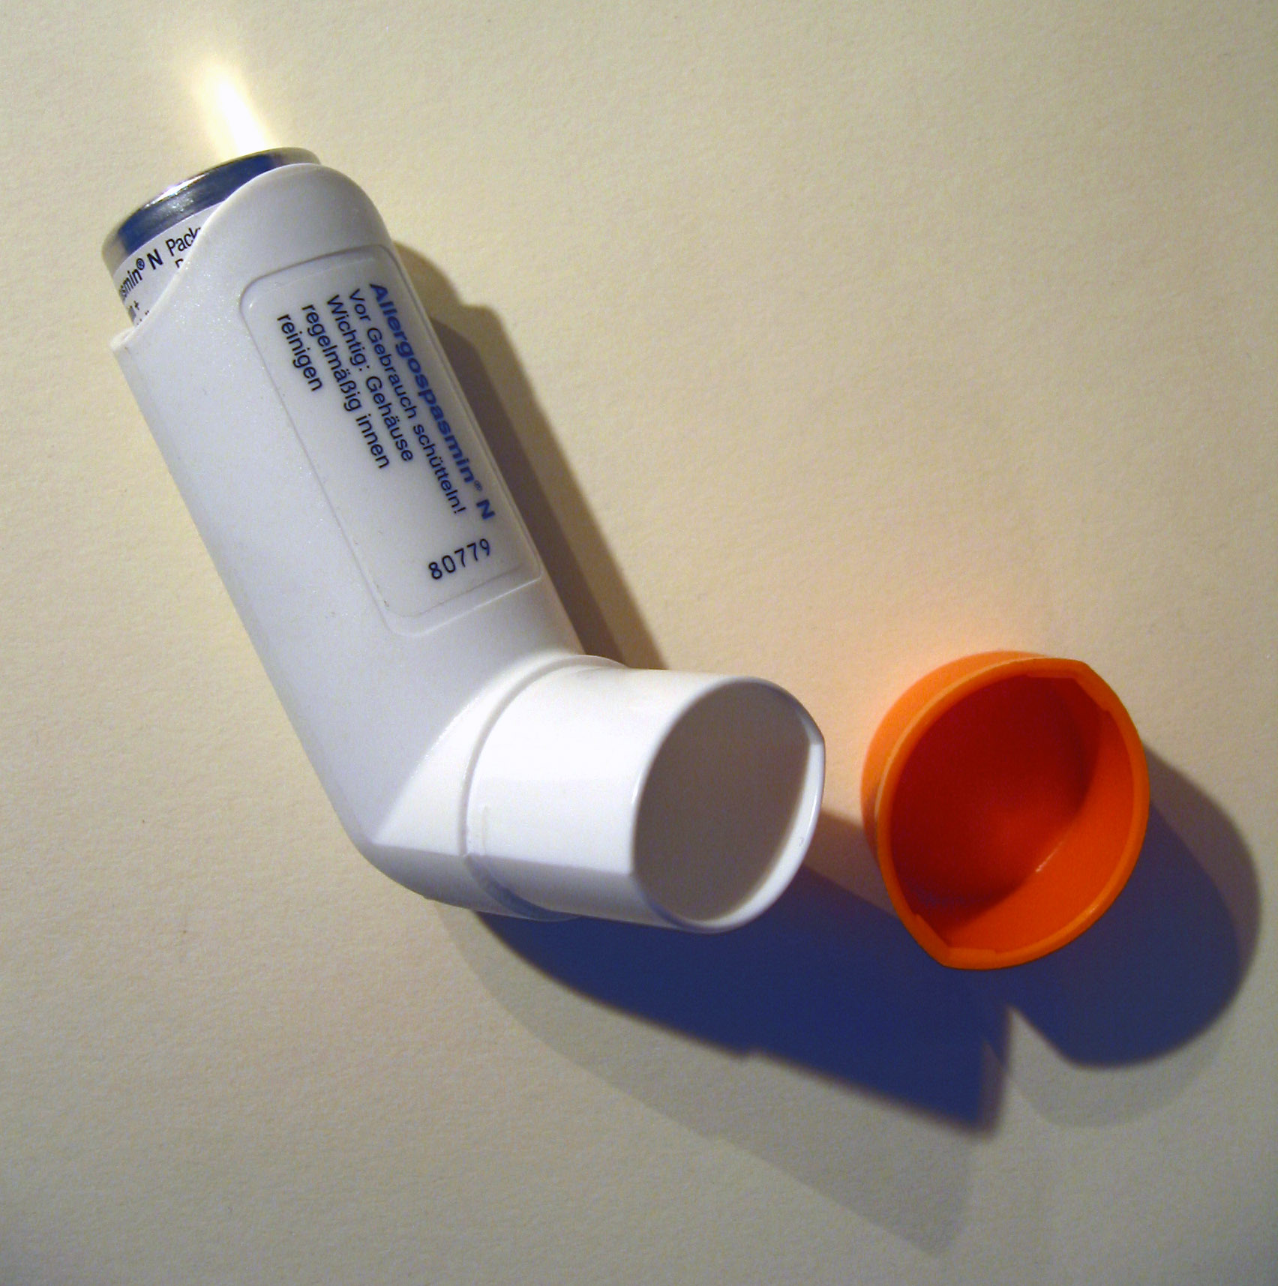
Figure 2: Inhaler device photo (illustrative).
Source: Wikimedia Commons, ‘Inhaler.jpg’ (CC BY-SA). Available at: https://commons.wikimedia.org/wiki/File:Inhaler.jpg (Accessed: 6 March 2026).
Evidence and expected impact
It has been shown that patient-facing digital inhalers have the potential to enhance asthma management and potentially decrease severe exacerbation, but the benefits of the device are constrained by connectivity and engagement (Ologundudu et al., 2025). Pediatric asthma smart inhalers have also been mentioned as the means of closing inhaler usage and compliance gaps (Drummond, 2025). AirGuard takes the next environmental step of converting pollution projections into individualized, time-specific prevention measures.
Critical impact: advantages and disadvantages
The benefits are that it is possible to identify the overuse of relievers earlier, use of personalized prevention prompts and support which can fit everyday life. Limitations contained disadvantages such as alert fatigue, sensor restrictions which record actuation instead of verified inhalation, and inequity in the case the tool requires more advanced phones or data plan. Also of concern are privacy and trust as patterns of inhaler-use can indicate health status.
How shortfalls can be addressed
Personalized thresholds, having quiet hours, and alerting only when there is an indication of an increase in risk of a user can help eliminate alert fatigue. The enhancement of inclusion may be achieved in low-data modes, offline caching, and optional SMS reminders. Endpoints that should be tested to measure include those that are of concern (symptom control, exacerbation, reliever overuse) and differences that can be quantified in high-exposure communities (Canaday et al., 2024; World Health Organization, 2024).
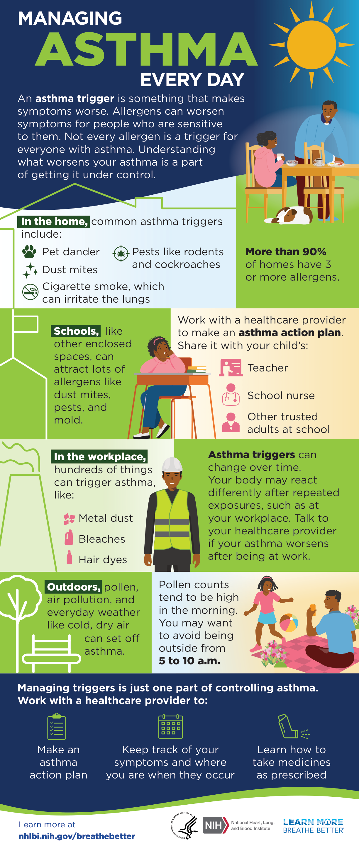
Figure 3: Managing Asthma Every Day infographic (public health education resource).
Source: National Heart, Lung, and Blood Institute (NHLBI) (April 2024) ‘Managing Asthma Every Day’ infographic. Available at: https://www.nhlbi.nih.gov/resources/managing-asthma-every-day-infographic (Accessed: 6 March 2026).
References
Canaday, F.T. et al. (2024) ‘Examining the impact of air pollution, climate change, and social determinants of health on asthma and environmental justice’, Current Opinion in Pulmonary Medicine. Available at: https://pmc.ncbi.nlm.nih.gov/articles/PMC10959677/ (Accessed: 11 February 2026).
Drummond, D. (2025) ‘Smart inhalers in paediatric asthma: bridging the gap between inhaler use and adherence’, Paediatric Respiratory Reviews. Available at: https://pubmed.ncbi.nlm.nih.gov/41047308/ (Accessed: 11 February 2026).
Global Initiative for Asthma (GINA) (2024) Global Strategy for Asthma Management and Prevention (2024 report). Available at: https://ginasthma.org/wp-content/uploads/2024/05/GINA-2024-Strategy-Report-24_05_22_WMS.pdf (Accessed: 11 February 2026).
NHS England (2023) Inclusive digital healthcare: a framework for NHS action on digital inclusion. Available at: https://www.england.nhs.uk/long-read/inclusive-digital-healthcare-a-framework-for-nhs-action-on-digital-inclusion/ (Accessed: 11 February 2026).
Ologundudu, L. et al. (2025) ‘Patient-facing digital inhalers for asthma: a systematic review and meta-analysis’, Journal of Allergy and Clinical Immunology: In Practice. Available at: https://www.jaci-inpractice.org/article/S2213-2198%2825%2900408-8/fulltext (Accessed: 11 February 2026).
World Health Organization (2024) ‘Asthma (Fact sheet)’. Available at: https://www.who.int/news-room/fact-sheets/detail/asthma (Accessed: 11 February 2026).

