

NAME: MARIO NEDYALKOV
STUDENT NUMBER: 1812413
STRUCTURE AND CULTURE – ASSESSMENT 1
LCBB4003: INTRODUCING THE MODERN WORKPLACE
LECTURE NAME: DR. KENNY TANG

INTRODUCING THE MODERN WORKPLACE
Table of content
Introduction 3
Introduction of case study 3
Organisation structure 3
Functional 4
Divisional 4
Matrix 4
Organisation culture 5
Hofstede theory 6
People 7
Maslow’s theory 8
Theory X and theory Y 8
Performances 8
Recommendation 9
Conclusion 9
Reference list 10

Introduction
Organisational structure and culture are considered as backbone for any type of business entity. An organisation structure is defined as the system which outlines ways of performing activities in order to fulfil organisational goals and objectives. On the other hand organisational culture refers to underlying assumptions, beliefs, and values that are being followed which facilitate in contributing positive psychological environment. In today’s business world organisational culture are given utmost importance in order to retain and enhance performance of employees.
This essay will focus on understanding importance of organisational culture with respect to enhance of employee performance. With the application of relevant theories Kellogg’s organisational culture will be analysed in order to gather knowledge related to motivation, culture, leadership, and diversity conserved within the organisation. In addition to this, it will include discussion related to employee’s motivational factors which leads to enhancement and measurement of performances.

Introduction of case study
Kellogg’s company was founded back in 1900s with an aim to provide nutritious foods and dedicated well being. It is one of the biggest multinational food manufacturing company ever existed in United States. With a mind in global expansion currently this company has its base of operations in more than 180 countries around the globe. As per the current financial information, the company was able to generate net revenue of $13547 million with an increase by 5.3% from the previous financial year (Kellogg’s, 2019). The company has showcased a diverse culture with a rich legacy of integrity where employees are able to work in cohesive workplace. Currently, almost 34000 employees across various location works for them. This company is influenced by rigorous innovation in order to facilitate in inventing new cereal so that better food can be provided in the market. Leadership quality portrayed within the management system encourages adequate level of communication through periodically interaction between management and employees. The company is headquartered in Michigan, USA.

Organisation structure
Business organisation requires proper structure to grow within the scope of business environment. As opined by Roome and Louche (2016), organisational structure provides a systematic formation according to which necessary business activities are performed. Basically structure highlights flow of authority as well as leadership so that tasks can be delegated and can be monitored by authoritarian body. Depending upon the business model organisational structure can be decided and formed. Details regarding some common type of structure are provided below.

Functional
This type of structure categorizes an organisation on the basis of specialty. In other words it means that functional organisations has various departments such as sales, finance, marketing, and HR as per which tasks are divided and people are assigned. Main benefit of allowing such type of structure is that it allows maintaining efficiency as employees are directed to perform tasks which they are best at.

Divisional
Divisional structure focuses on dividing functions of organisation into specific divisions. Individual divisions have all the required resources as well as functions in order to facilitate efficient performance. As for example, Gap Company has various divisional units such as banana republic and old navy where each division has functional units such as finance department or marketing department.

Matrix
This type of organisational structure reflects upon making conglomerate of functional and divisional units. As stated by Su et al. (2015), it means that this structure allows employees to have multiple authorities. Integration of this structure will create multiple reporting line and employees will be held responsible for answering to different level of managers. This type of structure is rather complex as compared to other structures.
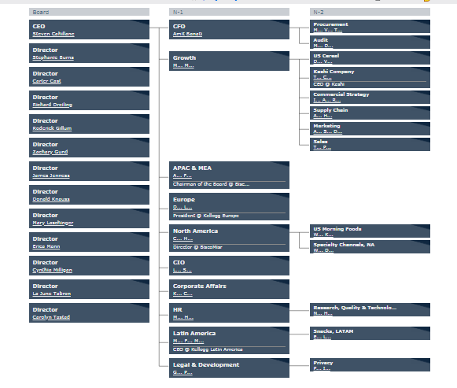
Figure 1: Organisational chart of Kellogg’s company
(Source: Kellogg’s, 2019)

The above figure showcases organisational chart of Kellogg’s company. From the above figure it can be obtained that the company follows functional organisational structure where each specialty department has been formed to address specific tasks or activities. Each department is run by a head of the department and employees are accountable to follow his or her guidelines.

Organisation culture
Organisational culture has emerged as an idea of following some beliefs and assumptions which facilitates in having positive work environment. According to Coccia (2015), culture represents kind of ethics followed by an organisation which indicates high value in corporate governances. It is essential to create a positive corporate or work culture otherwise it leads to affecting employee’s motivational level. Organisational culture can be divided into two segments where one segment is called formal culture and other one is called informal culture. In case of formal culture, activities relating to culture are more of planned activities. It means that formal culture is formed on the basis of schedule and planned activities. As for example, following of a specific business structure becomes a part of culture. In addition to this, required policies as well as operating procedures are also constituted under formal culture. On the other hand informal organisational culture represents casual interaction conducted between management and employees.
It reflects upon the social connection that is being established within an organisation and shared among colleagues (Mohelska and Sokolova, 2015). With respect to organisational culture of Kellogg’s it can be stated that, the company follows both type of cultures within the management system. It has a formal culture where each employee is accountable for working as per outlined procedures and policies (Kellogg’s, 2019). Similarly, employees and managers share a cordial relationship which highlights informal culture of the organisation. This company has multi dimensional culture where employees belonging to various races and backgrounds have come together. As of now there has not been any major issues found as the company encourages idea generation and diversity of though as part of a diverse culture.

Hofstede theory
Hofstede cultural dimensional model showcases changes in values take place due to influence of culture. Professor Hofstede has conducted a research on cultural values of employees belonging to various countries where he introduced six dimensions that addresses each aspect of culture. Six dimensions of this theory include:
- Index of power distance (PDI)
- Individualism vs. collectivism (IDV)
- Masculinity vs. femininity (MAS)
- Index of risk avoidance (UAI)
- Short term vs. long term orientation (LTO)
- Restraint vs. indulgence (IND)
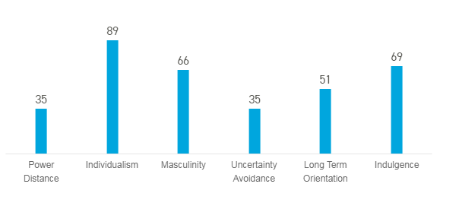
Figure 2: Hofstede six dimensional cultural values in UK
(Source: Hofstede insights, 2019)
The above figure shows various ranges of six dimensions of Hofstede model exited in UK. It can be noted that power distance in UK sits at 35 which indicates that low level of inequalities need to maintained among the people. As opined by Such and Mutrie (2017), next element of Hofsted model represents level of interdependence a society conserves among its people. From the score it can be stated that UK citizen are highly individualistic people with 89 score. They are more prone to think about themselves rather than others. In case of masculinity it can be observed that UK is focused at building a masculinity society where people are highly driven for success and recognition.
Next element of the cultural model emphasizes on dealing of society in terms of being uncertain of future (Lee and Hanna, 2015). In this case UK scored at 35 which mean that they are quite happy about not knowing the future. In case of long and short term orientation UK people have not showcased any dominant preferences which mean that they have equal priorities towards being in a normative society. Indulgence factor of Hofstede model measures the extensity of people towards controlling of own impulses and desires. With a score of 69, people in UK are indulgent and are willing to realize their desires and impulses.

People
People are considered as the most important stakeholders of an organisation who are responsible for operating and directing entity towards success. As stated by Corfield and Paton (2016), it is essential for management to address each motivational segment of employees in order to facilitate sustainability and profitability within a market. People motivation and people engagement are two factors which encourages employees to work efficiently and leading entity towards fulfilling of goals and objectives. In order to measure and indentify people engagement and motivation application of various theories can be used.

Maslow’s theory
This theory of motivation outlines hierarchal needs expected by an employee. At the bottom of pyramid basic physiological needs such as food, clothing, and shelter are mentioned. It has been stated that upon fulfilling of these needs motivations of employees gets changed and they strive for other needs. Maslow suggested that in order to indentify motivational needs of employees it is essential to know employees place within the hierarchy (Taras et al. 2016). With respect to Kellogg’s it can be stated that employees of the company are highly motivated to efficiently complete their work due to managements operation to address each hierarchal needs. As for example, to cater into physiological needs the company pays adequate salaries with the aid of which they can fulfil their basis needs (Osabiya, 2015). Additionally, Cornflex flexible benefits program provided by the company allows choosing any benefits such as life assurance schemes, childcare voucher, and many more. In case of concerning of safety needs the company provides healthy and safe working environment.

Theory X and theory Y
This theory of motivation highlights two different kind of attitude portrayed by employees. As mentioned by Gao (2017), theory X assumes entire negative attitude that is shown by employees such as resistance to change, laid back attitude, disliking towards responsibilities, and many more. On the other hand theory Y assumes positive attitudes shown by employees within a workplace. In case of Kellogg’s it can be noted that employees prefer to bring their positive attitude into the workplace due to facilitation of accurate motivational factors.

Performances
Profitability of an organisation can be obtained through prevalence of high efficient performance. According to Favaretto et al. (2016), performance management assists in facilitating conserving an adequate level of success. Generally performance management can be obtained through consistently monitoring of employee performances and comparing them with desired performance level. In case of Kellogg’s company it can be noted that the company follows highly transparent policy where managers can easily track down performance of each employees. In addition to this, through performance management the company identifies and recognizes potential talent who has demonstrated high capability and growth over a specific period of time. For each department they measure and identify potential talents who can be encouraged to perform consistently by providing them better place within the organisational hierarchy.

Recommendation
Based on the above it can be stated that the company already has earned a high position in the food processing market as well as was recognized as one of the best company to work for. They have showcased a high class leadership quality and were successful at providing adequate encouragement and motivation to employees. However, with the growing change of time competition in the market has grown and it is essential to come up with innovative ideas which can assist in sustainability. Hence it can be recommended that the company need to emphasize more on building innovating products that will help in marinating top notch position in the market.

Conclusion
Thus it can be concluded that in order to enhance and conserve profitability in a market it is essential to support and encourage a positive organizational culture. With the culmination of proper employee management and strategic decisions towards development of employee motivation a successful organisation can be built. In case of Kellogg’s company it has been noted that the company follows a functional organisational structure along with encouragement of formal as well as informal culture. It encourages and supports employee’s performances in order to maintain a cordial relationship within the organisation.

Reference list
Coccia, M., (2015). Structure and organisational behaviour of public research institutions under unstable growth of human resources. Coccia, M.(2014)‘Structure and organisational behaviour of public research institutions under unstable growth of human resources’, Int. J. Services Technology and Management, 20(4/5), pp.6-12.
Corfield, A. and Paton, R., (2016). Investigating knowledge management: can KM really change organisational culture?. Journal of Knowledge Management, 20(1), pp.88-103.
Favaretto, R.M., Dihl, L., Barreto, R. and Musse, S.R., (2016), September. Using group behaviors to detect hofstede cultural dimensions. In 2016 IEEE International Conference on Image Processing (ICIP) (pp. 2936-2940). IEEE.
Gao, Y., (2017). Business leaders’ personal values, organisational culture and market orientation. Journal of Strategic Marketing, 25(1), pp.49-64.
Hofstede insights (2019), United Kingdom, Available at: https://www.hofstede-insights.com/country-comparison/the-uk/, Accessed on [10/08/2019]
Kellogg’s (2019), Ethical performance & culture, Available at: https://www.kelloggcompany.com/en_US/about-ethics.html, Accessed on [10/08/2019]
Kellogg’s (2019), Leadership team, Available at: https://investor.kelloggs.com/CustomPage/Index?KeyGenPage=1073753435, Accessed on [10/08/2019]
Lee, J.M. and Hanna, S.D., (2015). Savings goals and saving behavior from a perspective of Maslow's hierarchy of needs. Journal of Financial Counseling and Planning, 26(2).
Mohelska, H. and Sokolova, M., (2015). Organisational culture and leadership–joint vessels?. Procedia-Social and Behavioral Sciences, 171, pp.1011-1016.
Osabiya, B.J., (2015). The effect of employees motivation on organizational performance. Journal of public administration and policy research, 7(4), pp.62-75.
Roome, N. and Louche, C., (2016). Journeying toward business models for sustainability: A conceptual model found inside the black box of organisational transformation. Organization & Environment, 29(1), pp.11-35.
Su, S., Baird, K. and Schoch, H., (2015). The moderating effect of organisational life cycle stages on the association between the interactive and diagnostic approaches to using controls with organisational performance. Management Accounting Research, 26, pp.40-53.
Such, E. and Mutrie, N., (2017). Using organisational cultural theory to understand workplace interventions to reduce sedentary time. International Journal of Health Promotion and Education, 55(1), pp.18-29.
Taras, V., Steel, P. and Kirkman, B.L., (2016). Does country equate with culture? Beyond geography in the search for cultural boundaries. Management International Review, 56(4), pp.455-487.

