Table of Contents
Executive Summary: 2
Introduction 2
Main Findings Of Strategic Analysis And Critical Evaluation Of The Strategic Options 4
External Analysis (PESTLE): 4
Internal Analysis (SWOT): 6
Critical Evaluation of Strategic Options 8
AI-Enhanced Hyper personalized Care: 8
Omni channel Approach: 10
In-house Talent Development: 12
Key Factors For Shaping And Implementation Of Innovative Strategies 15
Technological Capabilities: 15
Customer Preferences: 16
Employee Skills: 17
Data Privacy Laws: 18
Competition: 19
Global Pandemic Impact 20
Recommendation 22
Conclusion 24
References 25

Executive Summary

This report highlights the need for Amazon, a prominent multinational e-commerce corporation, to reconsider its approach to customer care in response to the prevailing pandemic situation. The recommendation is to adopt a hyper personalized care strategy in order to sustain a competitive advantage. This paper proposes many strategic recommendations based on the examination of SWOT (Strengths, Weaknesses, Opportunities, and Threats) and PESTLE (Political, Economic, Social, Technological, Legal, and Environmental) factors. These recommendations include the enhancement of customer care tools using artificial intelligence, prioritizing critical interactions across multiple channels, and harnessing the expertise of customer care professionals to enhance the organization's overall resilience and customer experience.

Introduction
Established by Jeff Bezos in 1994, Amazon first operated as an internet-based retailer specializing in books. Over time, the company has seen significant expansion and diversification, evolving into a worldwide corporation with a broad presence across several industries. Consequently, Amazon has emerged as a very important entity, exerting substantial economic and cultural influence on a global scale. The entity in question has gained recognition for its ability to significantly impact existing sectors by using technology advancements and operating on a large scale (Bader Althafairi et al., 2019).

The e-commerce platform operated by Amazon is widely recognized as its most prominent commercial endeavor. The platform offers a wide array of goods, including several categories such as literature, apparel, and technology. It provides expedited delivery options, including one-day and same-day services, for a significant number of its offerings. The adoption of a consumer-centric strategy and the provision of a diverse range of services have positioned it as a preferred choice for online consumers on a worldwide scale (Bansal and DesJardine, 2014).
Amazon Web Services (AWS), the cloud services section of Amazon, plays a substantial role in the company's operations by offering people, corporations, and governmental entities with on-demand cloud computing platforms and application programming interfaces (APIs) on a usage-based payment model. The company has been acknowledged as a trailblazer in the contemporary cloud infrastructure and maintains its dominant position in the market category.
Amazon offers a wide range of digital streaming services, such as Amazon Prime Video and Amazon Music, which provide users the opportunity to access extensive collections of films, television shows, and music. Amazon Prime Video has solidified its presence in the streaming sector with the creation of original content such as 'The Marvelous Mrs. Maisel'.
Amazon's artificial intelligence (AI) initiatives include a wide range of fields. Amazon has successfully created a virtual assistant named Alexa, which has been seamlessly incorporated into its range of Echo devices. These gadgets provide users the convenience of voice-activated services that are powered by artificial intelligence. Furthermore, Amazon actively engages in the development and implementation of machine learning technology across its many enterprises (Barter, 2016).

Main Findings Of Strategic Analysis And Critical Evaluation Of The Strategic Options

The PESTLE research highlights the influence of several external variables, including the political, economic, socio-cultural, technical, legal, and environmental dimensions, on Amazon's customer service approach. One example of a sociocultural aspect that may need Amazon to modify its approach towards using consumer data for personalized offerings is the issue of data privacy concerns.
The SWOT analysis conducted inside Amazon provides valuable insights into the organization's internal factors, including its strengths, weaknesses, opportunities, and threats. The organization's robust technical skills and ample resources provide advantageous prospects for the advancement of artificial intelligence (AI) in the realm of personalized customer care. However, the organization's heavy reliance on AI may be a potential drawback, impeding the provision of customer service that prioritizes human interaction and attention.

External Analysis (PESTLE)
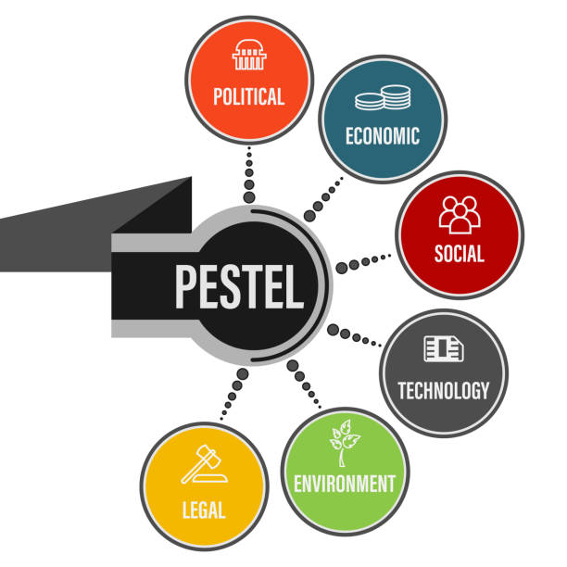
Political: Political aspects include the governmental rules and legal considerations that firms are obligated to adhere to in their operations. Amazon's business operations and image may be impacted by regulatory scrutiny pertaining to antitrust issues, taxes, and labor practices. Amazon must maintain compliance with all legislation and laws in its worldwide markets while simultaneously addressing the demands of their consumers. Potential strategies that might be used including lobbying efforts, activities related to corporate social responsibility and the establishment of comprehensive compliance systems (Yuksel, 2019).
Economic: The commercial operations of Amazon may be influenced by economic factors such as inflation, unemployment, and the general functioning of the economy. The current economic slowdown caused by the continuing pandemic has the potential to influence consumers' disposable income and purchasing ability, hence potentially impacting the sales of Amazon. Potential strategies for addressing this issue may include using various approaches such as providing cost-effective alternatives, giving flexible payment arrangements, or tailoring individualized offers in order to enhance client retention (Němečková, 2017).
Sociocultural: Sociocultural factors, such as shifts in consumer behavior and evolving expectations, have the potential to have a substantial influence on the customer service practices of Amazon. The growing prevalence of digitization in several industries has led to heightened customer apprehension around the protection of their personal data. It is essential for Amazon to establish a customer support system that is characterized by transparency, trustworthiness, and a deep regard for privacy. In addition, it is important for organizations to acknowledge and account for cultural disparities within their international markets, since these variations may significantly influence consumer inclinations and customer service expectations (Duggan et al., 2019).
Technological: The use of technology, namely in the areas of artificial intelligence (AI) and machine learning, presents notable prospects for Amazon to improve its customer care services. These solutions have the potential to enhance customer service by improving efficiency and personalization. Nevertheless, it is important to execute these implementations with careful consideration in order to uphold privacy standards and avoid estranging clients who have a preference for human connection. Amazon should take into account the technical inequalities that exist within its client base, since it cannot assume that all consumers have equal access to or familiarity with digital technology (Lee et al., 2019).
Legal: The legal dimension encompasses the assortment of rules and regulations that have influence on the operational activities of a corporation. Due to its expansive global reach, Amazon is obligated to adhere to diverse consumer protection regulations across several nations, which exhibit significant variations. Errors in compliance may result in financial penalties, harm to one's image, and a decline in consumer confidence. Therefore, it is essential for Amazon to have robust legal teams and processes in each of its operations areas (Benedek, 2012).
Environmental: The expanding worldwide consciousness of environmental concerns has placed a greater demand on corporations to adopt sustainable practices. Amazon's customer service efforts are included inside this. This may include endeavors aimed at diminishing energy consumption in contact centers, guaranteeing the utilization of AI systems powered by renewable energy sources, and offering clients digital alternatives to paper receipts and communications. The implementation of sustainable operations has the potential to enhance Amazon's brand and attract consumers that priorities environmental considerations (Barter, 2016).

Internal Analysis (SWOT)
The internal analysis, often known as SWOT analysis, is a strategic tool used in academia to assess an organization's internal strengths, weaknesses, opportunities, and threats.
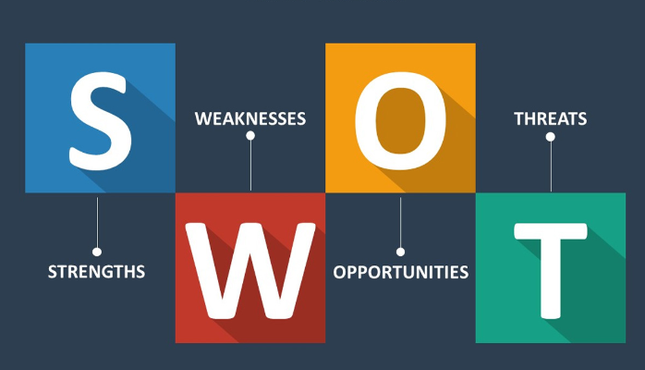
Strengths:
Amazon has a robust worldwide brand reputation that is closely associated with the realm of e-commerce. The establishment of a positive reputation fosters a sense of trust and loyalty among consumers, so creating an opportunity to enhance and advance the customer care experience (Muzumdar, 2019).
Amazon has a robust technical infrastructure that encompasses sophisticated skills in the fields of artificial intelligence (AI) and machine learning. These opportunities may be further used to provide superior and personalized client service (Arabzad, 2020).
Weaknesses:
The increasing reliance on artificial intelligence (AI) has been accompanied by several benefits, such as enhanced scalability and efficiency. However, it is important to acknowledge that an excessive dependence on AI might potentially lead to the erosion of the personalized aspect of customer service. Certain clients may experience feelings of frustration in situations when they are unable to contact human assistance as required (Bader Althafairi et al., 2019).
Opportunities:
There is potential for Amazon to optimize its AI technologies in order to provide a higher level of personalized and proactive customer care. One such approach is using machine learning algorithms to forecast client requirements or apprehensions by analyzing their purchasing behaviors (Bansal and DesJardine, 2014).
Leveraging big data for anticipatory customer service: Amazon has vast quantities of customer data that may be subjected to analysis in order to proactively identify and address potential consumer concerns prior to their manifestation.
Leveraging workers' insights for enhancement: Customer service personnel engage in regular interactions with customers, therefore acquiring significant knowledge on customer requirements and areas of dissatisfaction. The aforementioned observations may be methodically gathered and used to enhance the quality of customer service (Pereira and Frazzon, 2020).
Threats:
The e-commerce industry is experiencing significant growth and is characterized by a multitude of participants, leading to heightened rivalry. Rival entities have the potential to provide customer care services of higher quality, hence potentially luring consumers away from Amazon.
The current market demands a high level of customer service that is outstanding and tailored to individual needs. Customers have come to anticipate personalized care of superior quality as the norm. Failure to achieve these expectations by Amazon may result in the potential loss of consumer loyalty and a decline in market share. The aforementioned need will persistently undergo transformation, necessitating Amazon's proactive measures to remain at the forefront of these developments in order to sustain its competitive advantage (Parkinson et al., 2017).

Critical Evaluation of Strategic Options

The strategy solutions evaluated by our team included AI-Enhanced Hyper personalized Care, Omni channel Approach, and In-house Talent Development. We conducted a thorough assessment of these alternatives, taking into account their prospective advantages, drawbacks, and difficulties in execution, considering prevailing concerns in strategic management such as data protection, growing consumer expectations, and the need of personal interaction in digital services Bansal and DesJardine (2014).

AI-Enhanced Hyper personalized Care
The concept of AI-enhanced hyper personalized care refers to the use of artificial intelligence technologies to provide highly individualized and tailored healthcare services.
Pros:
24/7 customer service: The use of artificial intelligence (AI) enables the provision of customer care on a 24/7 basis, therefore catering to the demands of clients without being constrained by time zones or traditional working hours. As a result, there is a decrease in response time and an improvement in client satisfaction (Grant and Baden-Fuller, 2018).
Efficiency and scale: The use of artificial intelligence technologies, such as catboats, enables the simultaneous handling of a substantial number of inquiries, hence augmenting the efficiency of service provision.
Personalization: The use of machine learning techniques enables the analysis of client data for the purpose of tailoring replies and services to individual preferences. This has the potential to augment client loyalty and happiness via fostering a sense of comprehension and appreciation among consumers (Kumar et al., 2019).
Cons:
Loss of 'human touch': The excessive dependence on AI may result in a diminished sense of personal connection, hence causing dissatisfaction among consumers who have a preference for human interactions. The maintenance of a harmonious equilibrium between the use of artificial intelligence and human engagement in the realm of customer service is of paramount importance (Müller et al., 2016).
Privacy and ethical concerns: Privacy and ethical considerations arise from the use of AI and machine learning, since they necessitate the gathering and examination of client data, hence giving rise to issues over privacy. It is essential for Amazon to priorities the implementation of transparent and ethical data practices (Greenleaf, 2021).
Limited problem-solving ability: Although artificial intelligence demonstrates proficiency in addressing uncomplicated inquiries, it may encounter difficulties when confronted with intricate problems that want human discernment, subtlety, and emotional comprehension (Zuiderveen Borgesius and Poort, 2017).
Evaluation:
Notwithstanding the inherent disadvantages, the integration of artificial intelligence in customer service has the capacity to greatly boost efficiency and personalization, provided that it is applied in a well-considered manner. Achieving a harmonious integration of artificial intelligence (AI) and human engagement, while giving utmost importance to ethical and transparent data practices, is crucial. By effectively integrating technology and human interaction, this approach has the potential to revolutionize Amazon's customer service, therefore augmenting client contentment and fostering long-term loyalty (Dong et al., 2017).

Omni channel Approach
The Omni channel approach refers to a strategic approach that organizations use to provide a seamless and integrated customer experience across several channels, including
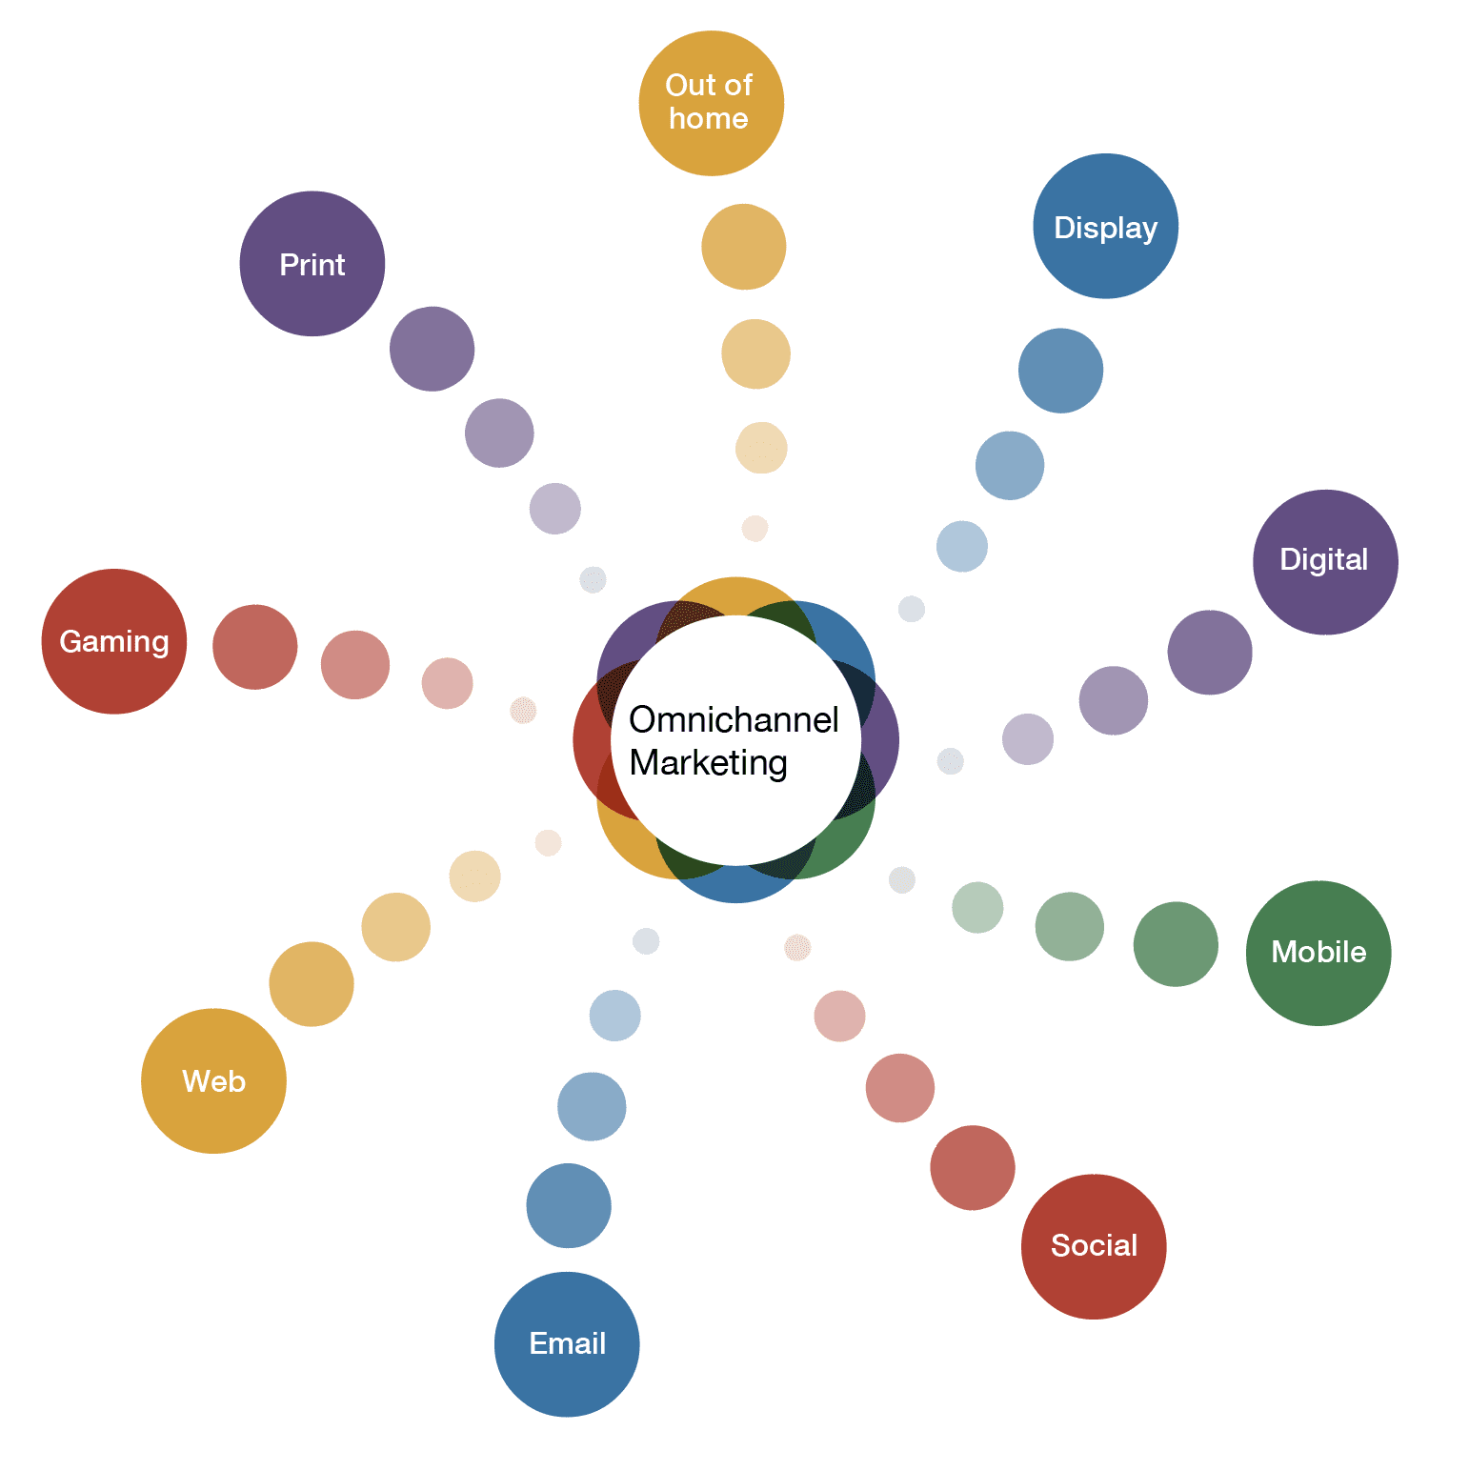
Pros:
Enhancing customer experiences: By prioritizing critical customer engagement points, Amazon can effectively guarantee that these touch points provide exceptional service, hence resulting in enhanced customer experiences and heightened satisfaction levels (Cummins, Peltier and Dixon, 2016).
Consistent and seamless service: The use of an Omni channel strategy ensures the maintenance of consistent and uninterrupted service across several channels, including in-app customer assistance as well as social media involvement. The integration of this seamless experience has the potential to augment brand loyalty and bolster client happiness (Hajdas, Radomska and Silva, 2020).
Cons:
Potential oversight of issues: One potential concern that should be considered is the possibility of overlooking some problems. Focusing only on the most frequently used channels may inadvertently result in disregarding less popular ones. Consequently, customers who rely on these less popular channels may experience discontent if their concerns are not swiftly addressed on these platforms (Lee, 2020).
Varied importance across customer segments: The significance of channels may exhibit considerable variation among different client categories. For example, it is possible that younger consumers may exhibit a preference for social media platforms, whilst older customers may have a predilection for using phone or email channels for obtaining service. The task of recognizing and accommodating these preferences might provide difficulties (Momen and Torabi, 2021).
Evaluation:
The use of an Omni channel strategy has the potential to significantly enhance the consistency and quality of customer service, despite the inherent challenges it may provide. By prioritizing key points of connection and implementing measures to provide high-quality service across these channels, Amazon has the potential to augment consumer pleasure. Nevertheless, it is important to avoid disregarding less prominent communication channels or client segments that exhibit distinct channel preferences. By implementing a proficient Omni channel approach, Amazon has the capability to provide a customer service experience that is both smooth and of superior quality. This, in turn, has the potential to cultivate client loyalty and enhance Amazon's competitive standing (Pereira and Frazzon, 2020).

In-house Talent Development:
The concept of in-house talent development refers to the practice of nurturing and enhancing the skills and abilities of employees inside an organization.
Pros:
Practical insights: As a result of their regular encounters with customers, customer service representatives are privy to invaluable information about the needs, worries, and perspectives of those they serve. By putting this data to use, services might be made more user-friendly and cost-effective (Dong et al., 2017).
Employee motivation and retention: Employee enthusiasm and loyalty can be increased by giving workers access to learning opportunities and a clear path for job growth. This method could make people happier at work, get them more motivated, and keep them there longer. It could also make employees more interested and improve their general success.
Cons:
Resource-intensive: The establishment and maintenance of comprehensive training and development programmers need significant allocation of time, financial resources, and other necessary assets. Nevertheless, this perspective might be seen as a strategic allocation of resources aimed at fostering the sustained prosperity of the organization (Simon, van den Driest and Wilms, 2016).
Not suitable for all employees: While some customer service personnel may get satisfaction from the prospect of growth and assuming more responsibilities, others may find contentment in their existing jobs or lack the necessary competencies or aspirations to transition into other domains.
Evaluation:
Notwithstanding the possible obstacles, the allocation of resources towards the cultivation of internal talent has the capacity to substantially augment the quality of client service and foster enduring staff contentment. Through meticulous preparation, effective execution, and continuous support, this strategic approach has the potential to transform customer service personnel into invaluable assets for the broader organization. Moreover, this practice has the potential to result in increased rates of employee retention and foster a staff that is more engaged and dedicated.
The suggested approaches for customer care, which include the integration of AI technology to improve personalized service, prioritizing important channels within an Omni channel framework, and cultivating internal expertise, will undoubtedly have broader ramifications across the Amazon Corporation. Let us engage in a discourse pertaining to the consequences inside many significant domains (Simon, van den Driest and Wilms, 2016).
Data Management and IT: The successful integration of artificial intelligence (AI) and machine learning (ML) technologies necessitates the establishment of a comprehensive data management framework. The efficient functioning of these technologies requires a substantial volume of data, hence requiring Amazon to optimize and maybe expand its data management systems. Likewise, the IT infrastructure must possess the capability to effectively accommodate these modern technologies, which may result in heightened expenditure on IT systems and data protection (Flyverbom, Deibert and Matten, 2017).
Human Resources: The emphasis on cultivating internal talent necessitates the pivotal involvement of the Human Resources department. The development and implementation of new training programmers may need the allocation of further resources. Furthermore, the proliferation of digitalization may lead to an escalation in the need for certain abilities, necessitating adaptations in recruiting tactics and, perhaps, alterations in job positions within the organizational structure (Tambe, Cappelli and Yakubovich, 2019).
Marketing and Sales: The implementation of enhanced customer care practices may have a substantial impact on the customer experience, hence yielding favorable outcomes for marketing and sales efforts. Customers who are content with their experience are more inclined to exhibit loyalty towards the business, perhaps transforming into advocates who actively engage in word-of-mouth marketing. Additionally, the knowledge acquired through enhanced customer service encounters has the potential to shape marketing plans and sales methodologies (Bansal and DesJardine, 2014).
Legal and Compliance: The legal and compliance departments must priorities the adherence to international, national, and regional rules in order to address the growing concern around data privacy in data-driven projects. This might potentially need enhanced communication between the aforementioned departments and the individuals directly engaged in customer service.
Operations: The operations department may have a potential influence as a result of changes in client expectations and feedback. The acquisition of knowledge and understanding via client interactions has the potential to drive enhancements in products or services (Benedek, 2012).

Key Factors For Shaping And Implementation Of Innovative Strategies

Comprehending and effectively dealing with the primary determinants that impact strategic innovation are of paramount importance in the process of altering Amazon's customer service strategy.

Technological Capabilities:
Amazon has advanced technical capabilities, namely in the fields of artificial intelligence (AI) and machine learning (ML), which provide it a substantial advantage in providing highly customized care. These technological advancements allow Amazon to efficiently analyses large quantities of consumer data in real-time, enabling a degree of personalization that was previously unachievable (Artificial Intelligence Tools for Enhancing Customer Experience, 2019).
For example, artificial intelligence (AI) has the capability to identify patterns and preferences shown by customers, so enabling Amazon to anticipate their requirements, provide personalized suggestions, and proactively resolve any concerns that may arise. Machine learning algorithms provide the capability to enhance the precision of these insights via feedback and continuous client interactions, therefore facilitating a service experience that is always adapting and reacting.
The use of these technical capabilities requires a careful and intricate balancing process. Although artificial intelligence (AI) has the capability to automate repetitive operations and provide prompt, tailored replies, it is unable to fully substitute the intricate comprehension, empathy, and problem-solving skills shown by human customer care personnel. Excessive dependence on artificial intelligence (AI) may result in consumer interactions that are seen as lacking personalization and exhibiting a mechanical nature, ultimately resulting in customer discontentment (Flyverbom, Deibert and Matten, 2017).
Hence, it is advisable for Amazon to adopt a strategic approach that leverages artificial intelligence (AI) as a means of enhancing human talents, rather than seeking to replace them entirely. This is using artificial intelligence (AI) to manage mundane inquiries and activities, while directing intricate problems or circumstances necessitating empathy and nuanced comprehension to human agents.

Customer Preferences:
The current worldwide inclination towards digitization, which has been expedited by the pandemic, has resulted in a noteworthy alteration in client preferences. Contemporary customers has a strong inclination towards and hold a certain level of anticipation for a cohesive, superior, and tailored experience across many platforms, including online retail, customer assistance, and digital media consumption.
An Omni channel approach is deemed essential in addressing this problem. This method incorporates several client touch points, resulting in a cohesive and standardized experience regardless of the channel or device used by the consumer. This facilitates a seamless consumer experience in which every encounter contributes to the previous one, so assuring convenience and preserving contextual relevance (Virtual Technologies, 2016).
In order to effectively deploy an Omni channel strategy, Amazon must possess a comprehensive comprehension of client preferences. Customer expectations may exhibit variability due to a diverse range of characteristics, including but not limited to age, geographical area, cultural background, prior experiences, and more influences. For instance, it is plausible that younger clientele may exhibit a preference for self-service alternatives and catboats, whilst elderly clientele may have a predilection for a direct communication channel with a person representative. Certain clients may place a higher importance on expeditious remedies, whilst others may priorities empathic and tailored service (Němečková, 2017).
It should be noted that client preferences are not fixed but rather subject to change over time, influenced by several factors such as market dynamics, technological advancements, and cultural shifts. It is essential for Amazon to consistently analyses and adjusts to these evolving consumer preferences. This objective may be accomplished by consistently soliciting client input, doing comprehensive market research, and conducting rigorous data analysis.

Employee Skills:
The customer care specialists employed by Amazon play a crucial role in shaping the overall consumer experience. They engage in direct interactions with clients, resolving their issues, and observing their responses. The direct involvement in these experiences makes them a great repository of client information. These insights have the potential to enhance Amazon's comprehension of consumer demands, challenges, inclinations, and anticipations (Baugh, Ben-David and Park, 2019).
Nevertheless, the use of this knowledge extends beyond the mere acquisition and examination of data. The focus of this study is on the cultivation and use of the proficiencies and knowledge possessed by customer service representatives, with the aim of augmenting the quality of service provision and the holistic client encounter (Dong et al., 2017).
In order to address this issue, it is recommended that Amazon allocate resources towards the implementation of talent development initiatives aimed at enhancing the skills and capabilities of its workforce. This may include the implementation of training programmers aimed at augmenting abilities, mentoring efforts designed to facilitate information sharing, and career development opportunities intended to inspire and retain talented individuals. The training programmer should include a comprehensive range of competencies, including both technical proficiencies such as the utilization of AI tools and the comprehension of data analytics, as well as soft skills like effective communication, empathy, problem-solving abilities, and flexibility (Němečková, 2017).

Data Privacy Laws:
In the contemporary digital landscape, data assumes a position of immense value and significance. The use of customer data may provide valuable insights that contribute to the enhancement of service quality, the facilitation of personalized experiences, and the promotion of company expansion. With the aim of enhancing customer service, Amazon is preparing to integrate artificial intelligence (AI) and machine learning technologies into its operations. Consequently, there will be a natural rise in the utilization of client data (Greenleaf, 2021).
The use of a data-driven methodology has a paramount obligation, which is the safeguarding of consumer data. The ethical commitment in question encompasses not just the realm of corporate responsibility, but also has significance as a legal imperative. There is variation in data privacy regulations across different nations. The General Data Protection Regulation (GDPR) inside the European Union establishes stringent guidelines governing the manner in which firms are permitted to manage client data. The California Consumer Privacy Act (CCPA) offers comparable safeguards inside the state of California. Various governments have established their own legal frameworks, while numerous others are contemplating the adoption of similar legislation. Due to its worldwide presence, Amazon operates inside several countries, necessitating adherence to a diverse array of data privacy regulations (R Rizvi et al., 2018).

Competition:
In the contemporary retail environment, characterized by its fluidity and constant change, a highly competitive atmosphere prevails. Amazon, a prominent player in the e-commerce industry, finds itself engaged in strong rivalry not only with other major online retailers but also with conventional brick-and-mortar establishments that are increasingly venturing into the online realm. Hence, a crucial aspect of formulating Amazon's novel approach to customer service is comprehending the competitive landscape and delineating a distinctive value proposition that maintains the company's competitive advantage over its counterparts (Grant and Baden-Fuller, 2018).
The provision of personalized, high-quality customer service that Amazon is actively pursuing is a significant distinguishing factor that has the potential to establish a competitive advantage over other market players. The provision of customer service that is of superior quality and characterized by prompt responsiveness has the potential to augment client loyalty and foster the occurrence of repeat purchases, so establishing a lasting competitive advantage. With an increasing awareness of the significance of customer service, there is a growing competition among firms to provide superior and highly tailored service (Schlosser and Boissier, 2018).

Global Pandemic Impact

The current global pandemic has had a significant impact on the corporate environment, leading to notable changes in consumer expectations and behaviors. The current trend towards digital commerce and the growing need for tailored, streamlined customer interactions provide Amazon potential avenues to establish a lasting edge over its competitors. The relationship between each learning result and this topic may be described as follows:
Synthesize the Relationship between External and Internal Contexts: Against the background of the ongoing epidemic, the external setting encompasses heightened digital contacts and apprehensions around safety and privacy. Amazon's own technology infrastructure and ample resources allow the corporation to effectively address these ever-changing demands. By integrating these many settings, Amazon has the potential to better its online shopping experience by optimizing product suggestions, search tools, and customer support, so offering a unique value proposition that surpasses that of its rivals (Dameron, Lê and LeBaron, 2015).
Critically Evaluate Competitive Strategies: A critical evaluation of competitive strategies reveals that Amazon has the potential to differentiate itself from its rivals via the provision of exceptional customer service. Utilizing artificial intelligence (AI) to enhance personalized service, prioritizing essential channels to provide high-quality experiences, and harnessing workers' customer insights represent creative strategies to surpass competition, especially in the context of a pandemic when exceptional online customer service assumes paramount importance (Schoemaker, Heaton and Teece, 2018).
Assess Key Factors for Strategy Implementation: This paper aims to evaluate the critical factors that contribute to the successful implementation of strategies. The achievement of effective implementation requires a comprehensive comprehension of the requisite technology capacities, consumer preferences for personalized and seamless experiences, staff skills and insights, data protection legislation, and competitive activities. Against the background of the ongoing epidemic, each of these factors assumes a pivotal role in building a strategy that is not only effective but also resilient (Salguero-Caparrós et al., 2020).
Explore Management Response to Ethical Challenges: The use of artificial intelligence (AI) and consumer data poses ethical dilemmas that need attention from organizational leadership. In the context of a global epidemic, where the establishment of trust is of utmost importance, the transparent and ethical management of consumer data by Amazon may serve to bolster its reputation and foster customer trust, therefore creating a durable competitive edge (Benedek, 2012).
Understand the Strategic Management Process: To comprehend the strategic management process, it is essential for Amazon to consistently monitor the dynamic pandemic scenario, evaluate its consequences, formulate plans to tackle new difficulties and opportunities, and execute these strategies with efficacy. The comprehension of the strategic management process allows Amazon to effectively adjust and prosper in an unpredictable business landscape, resulting in the establishment of a lasting competitive edge.

Recommendation

Based on the conducted study, it is recommended that Amazon consider implementing the following suggestions using the McKinsey 7S model. This model places emphasis on the interdependencies between strategy, structure, systems, shared values, style, personnel, and skills (Liu, 2020).
Strategy: The proposed approach involves the use of AI-driven hyper personalization in customer service, with the retention of human touch points specifically for addressing intricate consumer concerns. Concurrently, priorities prominent channels to provide an efficient Omni channel experience (Bansal and DesJardine, 2014).
Structure: It is recommended to establish a specialized team that will assume the responsibility of supervising and executing the personalized customer service strategy. The composition of this team need to include individuals from many areas, including IT, Marketing, and Human Resources (Barter, 2016).
Systems: The use of artificial intelligence (AI) and machine learning (ML) technology may be utilized to provide individualized treatment in various systems. This proposal aims to design and implement technologies that enable the real-time gathering, analysis, and utilization of client data in order to provide tailored experiences (Shukla, 2015).
Shared Values: The objective is to create a corporate environment that prioritizes customer-centricity as a core value. Ensuring trust and openness with clients necessitates the adoption of ethical data management practices as a fundamental objective.
Style: It is essential for leadership to proactively endorse and facilitate innovation and experimentation within the realm of customer service. It is advisable to promote open lines of communication and feedback between customer service staff and the management team in order to support continuous development (Momen and Torabi, 2021).
Staff: Staff could consider investing in talent development efforts aimed at enhancing the skills of customer service personnel. This would enable them to properly address increasingly intricate enquiries and use artificial intelligence products proficiently. Promote and foster their active engagement in activities aimed at enhancing service quality and effectiveness.
Skills: The objective is to foster the development of skills in the domains of artificial intelligence (AI) technology, data analytics, and customer relationship management (CRM). Promote the establishment of a conducive learning environment that facilitates the ongoing adaptation to the ever-changing requirements of customer service.
When these ideas are applied in a comprehensive manner, Amazon can effectively sustain its position as a market leader and provide exceptional customer experiences, even under the challenging circumstances of a pandemic (Virtual Technologies, 2016).

Conclusion

In summary, the pandemic-induced changes in the business environment provide a favorable occasion for Amazon to reevaluate its approach to customer service. Through the use of its extensive technical infrastructure and abundant resources, Amazon has the capability to provide a service that is improved by artificial intelligence and tailored to meet the ever-changing tastes of individual customers (Bader Althafairi et al., 2019).
Adopting an Omni channel strategy that prioritizes the most influential customer contacts has the potential to improve the customer experience without depleting resources excessively. The inclusion of customer service employees' ideas and knowledge offers a distinct opportunity for enhancing service quality, as it introduces a human element to the AI-driven systems. It is essential for the plan to effectively tackle possible obstacles, including but not limited to issues pertaining to data privacy and competitiveness. Maintaining Amazon's economic advantage and fostering consumer trust will need the adoption of a robust ethical framework for data management, with a commitment to ongoing innovation (R Rizvi et al., 2018).
In general, the proposed approach offers Amazon a comprehensive plan for effectively navigating the customer care environment in the aftermath of the pandemic. This plan has the potential to enhance the customer experience, optimize operational efficiency, and establish a durable competitive edge (R Rizvi et al., 2018).

References

Artificial Intelligence Tools for Enhancing Customer Experience. (2019). International Journal of Recent Technology and Engineering, 8(2S3), pp.700–706. doi:https://doi.org/10.35940/ijrte.b1130.0782s319.
Bader Althafairi, Noura Alhoumaida, Muskan Saxena and Zahraa Almsri (2019). Case study - AMAZON. Journal of the community development in Asia, [online] 2(2). doi:https://doi.org/10.32535/jcda.v2i2.517.
Bansal, P. and DesJardine, M.R. (2014). Business sustainability: It is about time. Strategic Organization, [online] 12(1), pp.70–78. doi:https://doi.org/10.1177/1476127013520265.
Barter, N. (2016). Strategy Textbooks and the Environment Construct. Organization & Environment, 29(3), pp.332–366. doi:https://doi.org/10.1177/1086026616638130.
Baugh, B., Ben-David, I. and Park, H. (2019). The ‘Amazon Tax’: Empirical Evidence from Amazon and Main Street Retailers. SSRN Electronic Journal. doi:https://doi.org/10.2139/ssrn.2422403.
Benedek, P. (2012). Compliance Management - a New Response to Legal and Business Challenges.
Parkinson, S., Ward, P., Wilson, K. and Miller, J. (2017). Cyber Threats Facing Autonomous and Connected Vehicles: Future Challenges. IEEE Transactions on Intelligent Transportation Systems, 18(11), pp.2898–2915. doi:https://doi.org/10.1109/tits.2017.2665968.
Chen, L., Mislove, A. and Wilson, C. (2016). An Empirical Analysis of Algorithmic Pricing on Amazon Marketplace. Proceedings of the 25th International Conference on World Wide Web - WWW ’16. [online] doi:https://doi.org/10.1145/2872427.2883089.
Comparison of Ensemble Classification Techniques and Single Classifiers Performance for Customer Credit Assessment. (2016). Modeling of Artificial Intelligence, 11(3). doi:https://doi.org/10.13187/mai.2016.11.140.
Cummins, S., Peltier, J.W. and Dixon, A. (2016). Omni-channel research framework in the context of personal selling and sales management. Journal of Research in Interactive Marketing, 10(1), pp.2–16. doi:https://doi.org/10.1108/jrim-12-2015-0094.
Cuzzolin, F., Morelli, A., Cîrstea, B. and Sahakian, B.J. (2020). Knowing me, knowing you: theory of mind in AI. Psychological Medicine, 50(7), pp.1057–1061. doi:https://doi.org/10.1017/s0033291720000835.
Dameron, S., Lê, J.K. and LeBaron, C. (2015). Materializing Strategy and Strategizing Material: Why Matter Matters. British Journal of Management, 26, pp.S1–S12. doi:https://doi.org/10.1111/1467-8551.12084.
Daqar, M.A.M.A. and Smoudy, A.K.A. (2019). THE ROLE OF ARTIFICIAL INTELLIGENCE ON ENHANCING CUSTOMER EXPERIENCE. International Review of Management and Marketing, 9(4), pp.22–31. doi:https://doi.org/10.32479/irmm.8166.
Dong, Y., Bartol, K.M., Zhang, Z.-X. and Li, C. (2017). Enhancing employee creativity via individual skill development and team knowledge sharing: Influences of dual-focused transformational leadership. Journal of Organizational Behavior, 38(3), pp.439–458.
Fan, B., Ji, H., Wei, J. and Lambert, S. (2018). Development of tactical solutions for the e-credit card issuing industry. International Journal of Accounting & Information Management, 26(1), pp.115–131. doi:https://doi.org/10.1108/ijaim-02-2017-0014.
Fedirko, R. and Campo, S. (2018). Leadership in IT, employees’ motivation and retention.
Flyverbom, M., Deibert, R. and Matten, D. (2017). The Governance of Digital Technology, Big Data, and the Internet: New Roles and Responsibilities for Business. Business & Society, 58(1), pp.3–19. doi:https://doi.org/10.1177/0007650317727540.
Grant, R.M. (2019). The Resource-Based Theory of Competitive Advantage: Implications for Strategy Formulation. California Management Review, 33(3), pp.114–135.
Grant, R.M. and Baden-Fuller, C. (2018). How to Develop Strategic Management Competency: Reconsidering the Learning Goals and Knowledge Requirements of the Core Strategy Course. Academy of Management Learning & Education, 17(3), pp.322–338. doi:https://doi.org/10.5465/amle.2017.0126.
Greenleaf, G. (2021). Global Tables of Data Privacy Laws and Bills (7th Ed, January 2021). SSRN Electronic Journal. doi:https://doi.org/10.2139/ssrn.3836261.
Hajdas, M., Radomska, J. and Silva, S.C. (2020). The omni-channel approach: A utopia for companies? Journal of Retailing and Consumer Services, 65, p.102131. doi:https://doi.org/10.1016/j.jretconser.2020.102131.
Hashemipour, S. and Ali, M. (2020). Amazon Web Services (AWS) – An Overview of the On-Demand Cloud Computing Platform. Lecture Notes of the Institute for Computer Sciences, Social Informatics and Telecommunications Engineering, pp.40–47. doi:https://doi.org/10.1007/978-3-030-60036-5_3.
Huang, M.-H. and Rust, R.T. (2018). Artificial Intelligence in Service. Journal of Service Research, 21(2), pp.155–172. doi:https://doi.org/10.1177/1094670517752459.
Impact of Artificial Intelligence on Customer Experience. (2020). Regular, 9(2), pp.1237–1242. doi:https://doi.org/10.35940/ijrte.b3727.079220.
Jacquemart, Q., Vitali, A.A. and Guillaume Urvoy-Keller (2019). Measuring the Amazon Web Services (AWS) WAN Infrastructure.
Kumar, V., Rajan, B., Venkatesan, R. and Lecinski, J. (2019). Understanding the Role of Artificial Intelligence in Personalized Engagement Marketing. California Management Review, [online] 61(4), pp.135–155. doi:https://doi.org/10.1177/0008125619859317.
Lee, J., Suh, T., Roy, D. and Baucus, M. (2019). Emerging Technology and Business Model Innovation: The Case of Artificial Intelligence. Journal of Open Innovation: Technology, Market, and Complexity, 5(3), p.44.
Lee, M.K. (2018). Understanding perception of algorithmic decisions: Fairness, trust, and emotion in response to algorithmic management. Big Data & Society, 5(1), p.205395171875668. doi:https://doi.org/10.1177/2053951718756684.
Lee, W. (2020). Unravelling Consumer Responses to Omni-Channel Approach. Journal of theoretical and applied electronic commerce research, 15(3), pp.37–49. doi:https://doi.org/10.4067/s0718-18762020000300104.
Momen, S. and Torabi, S.A. (2021). Omni-channel retailing: A data-driven distributionally robust approach for integrated fulfillment services under competition with traditional and online retailers. Computers & Industrial Engineering, 157, p.107353. doi:https://doi.org/10.1016/j.cie.2021.107353.
Motamarri, S., Akter, S. and Yanamandram, V. (2017). Does big data analytics influence frontline employees in services marketing? Business Process Management Journal, 23(3), pp.623–644. doi:https://doi.org/10.1108/bpmj-12-2015-0182.
Müller, O., Junglas, I., Brocke, J. vom and Debortoli, S. (2016). Utilizing big data analytics for information systems research: challenges, promises and guidelines. European Journal of Information Systems, 25(4), pp.289–302. doi:https://doi.org/10.1057/ejis.2016.2.
Němečková, I. (2017). The role of benefits in employee motivation and retention in the financial sector of the Czech Republic. Economic Research-Ekonomska Istraživanja, [online] 30(1), pp.694–704. doi:https://doi.org/10.1080/1331677x.2017.1314827.
Newell, S. and Marabelli, M. (2015). Strategic opportunities (and challenges) of algorithmic decision-making: A call for action on the long-term societal effects of ‘datification’. The Journal of Strategic Information Systems, [online] 24(1), pp.3–14. doi:https://doi.org/10.1016/j.jsis.2015.02.001.
Palmatier, R.W., Sivadas, E., Stern, L.W. and El-Ansary, A.I. (2019). Marketing Channel Strategy : An Omni-Channel Approach.
Pereira, M.M. and Frazzon, E.M. (2020). A data-driven approach to adaptive synchronization of demand and supply in omni-channel retail supply chains. International Journal of Information Management, 57, p.102165. doi:https://doi.org/10.1016/j.ijinfomgt.2020.102165.
R Rizvi, S., Killough, B., Cherry, A. and Gowda, S. (2018). Lessons Learned and Cost Analysis of Hosting a Full Stack Open Data Cube (ODC) Application on the Amazon Web Services (AWS). [online] IEEE Xplore. doi:https://doi.org/10.1109/IGARSS.2018.8518084.
Salguero-Caparrós, F., Pardo-Ferreira, M.C., Martínez-Rojas, M. and Rubio-Romero, J.C. (2020). Management of legal compliance in occupational health and safety. A literature review. Safety Science, [online] 121(1), pp.111–118. doi:https://doi.org/10.1016/j.ssci.2019.08.033.
Schaltegger, S. and Wagner, M. eds., (2017). Managing the Business Case for Sustainability. Routledge. doi:https://doi.org/10.4324/9781351280525.
Schlosser, R. and Boissier, M. (2018). Dynamic Pricing under Competition on Online Marketplaces. Proceedings of the 24th ACM SIGKDD International Conference on Knowledge Discovery & Data Mining. doi:https://doi.org/10.1145/3219819.3219833.
Schoemaker, P.J.H., Heaton, S. and Teece, D. (2018). Innovation, Dynamic Capabilities, and Leadership. California Management Review, [online] 61(1), pp.15–42. doi:https://doi.org/10.1177/0008125618790246.
Shah, M. and Asad, M. (2018). Effect of Motivation on Employee Retention: Mediating Role of Perceived Organizational Support. 7(2), pp.511–520.
Hayes, J., (2014), The Theory and Practice of Change Management 4th edition, Palgrave
Garner, J., Stead, W., Stead, E., (2014), Sustainable Strategic Management 2nd edition, London: England: Greenleaf Pub.
Dess, G. G., Eisner, A., McNamara, G., (2016), Strategic Management: Texts and Cases, McGraw-Hill
Simon, M., van den Driest, F. and Wilms, T. (2016). Driving Customer-Centric Growth: A Practical Roadmap for Brand Marketing: The Pivotal Role of Insights and Analytics in the Customer-Centric Organization. Journal of Advertising Research, 56(2), p.159. doi:https://doi.org/10.2501/jar-2016-029.
Tambe, P., Cappelli, P. and Yakubovich, V. (2019). Artificial Intelligence in Human Resources Management: Challenges and a Path Forward. California Management Review, [online] 61(4), pp.15–42. doi:https://doi.org/10.1177/0008125619867910.
van Hoek, R., Sankararaman, V., Udesen, T., Geurts, T. and Palumbo-Miele, D. (2020). Where we are heading and the research that can help us get there – Executive perspectives on the anniversary of the Journal of Purchasing and Supply Management. Journal of Purchasing and Supply Management, 26(3), p.100621. doi:https://doi.org/10.1016/j.pursup.2020.100621.
Virtual Technologies. (2016). Modeling of Artificial Intelligence, 9(1). doi:https://doi.org/10.13187/mai.2016.9.33.
Wang, X., Tajvidi, M., Lin, X. and Hajli, N. (2019). Towards an Ethical and Trustworthy Social Commerce Community for Brand Value Co-creation: A trust-Commitment Perspective. Journal of Business Ethics, 167(1). doi:https://doi.org/10.1007/s10551-019-04182-z.
Muzumdar, P. (2019). Business Model Development Through Corporate Strategy Design: IBM SWOT Analysis. SSRN Electronic Journal.
Yuksel, I. (2019). Developing a Multi-Criteria Decision Making Model for PESTEL Analysis. International Journal of Business and Management, 7(24), pp.52–66.
Zuiderveen Borgesius, F. and Poort, J. (2017). Online Price Discrimination and EU Data Privacy Law. Journal of Consumer Policy, [online] 40(3), pp.347–366. doi:https://doi.org/10.1007/s10603-017-9354-z.
Lynch, R., (2015), Strategic Management 7th edition, Pearson: Harlow.
Liu, H. (2020). Research on Library Data Management Reform : Discussion on McKinsey 7S System Thinking Model. 2020 6th International Conference on Information Management (ICIM). doi:https://doi.org/10.1109/icim49319.2020.244714.

