HNC / BEng (Hons) Advanced Manufacturing Operations

University Of Wales Trinity Saint David
Quality & Business Improvements

HNC / BEng (Hons) Advanced Manufacturing Operations

L4 – Quality & Business Improvements

Assignment 2

Task Description: You are required to select either option “A” or option “B”. Option B is intended to be an effective route for those individuals who do not, currently have readily available access to data and/or information in their workplace. Please do not attempt both options.
Option I have taken: A
You are tasked with developing a, data-informed, improvement plan for an operation or application within your place of work. The following steps should be documented:
• Problem identification/problem statement
• Data collection
• Data analysis
• Root Cause Analysis
• Action Plan

Contents
Quality & Business Improvements 0
L4 – Quality & Business Improvements 1
Assignment 2 1
The Problem 2
Data Collection 3
Pareto Analysis V1 4
Pareto Analysis V2 4
General Pareto 4
Severity measurement 5
Weekly track 5
Weekly Comparisons 5
Root cause analysis 6
Action plan 1 6
Little Motivation 6
Action plan 2 6
Accuracy of system 6
Conclusion 6

The Issue
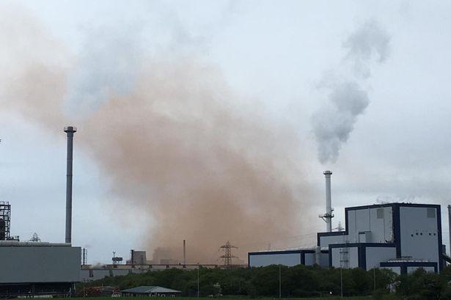
This is what we know as a air quality breach, this breach is a slop which has occurred during the blowing in the vessel, this is where iron is converted into steel. The process is carried out by an operator, there are many reasons that can lead to a slop such as too much gas added, or low ore temperature these are closely measured and tracked but I though the data collection and analysis was not good enough so I made a matrix to present the data in a more appropriate way.
When I first started doing working around the slopping in the area the method for data entry was slow and didn’t always come out with the correct answers, noticing this is decided to change the method of how data is entered by creating a new matrix for entering data, which would be effective and efficient and would always give the correct information and insure it is presented in the correct manor.
The process produces a orange smoke cloud which can be visible from outside the plant it also falls outside the plant and can leave an orange stain on the surrounding area which can involve big pay outs by the company in repair costs, this results in lots of negative complaints which we respond to, this can prove difficult with some people having very strong opinions against the steel works and they will report this to the council putting more pressure on us. This is why I start this new matrix to help reduce and track these issues.

Data Collection
The initial collection is collected by the engineers on plant, it is then given to the fire and environment manager, it is then given to me to analysis and put in to graphical presentation which is then displayed in weekly meetings. We do this because this gas causes damage to the surrounding area and creates compliments from the local residence. This is the matrix I created. This has been passed on to other areas to be copied as they wish so. From the first day I started using this system I had positive feedback of the new layout by the higher managers this give me positive reinforcement to continue work like this.
This the chart where the data has to be physically entered this then filters automatically into the smaller charts which creates the graphs which are reviewed.

Graph Analysis
Here are the smaller graphs which are made from the raw data this is what shows the data in a on graphical form, these are given out in an email weekly along with the graphs, this data automatically updates graphs, here are the graphs that it creates. These are the graphs which are given out in the weekly meetings to discuss the issues around slopping.

Pareto Analysis V1
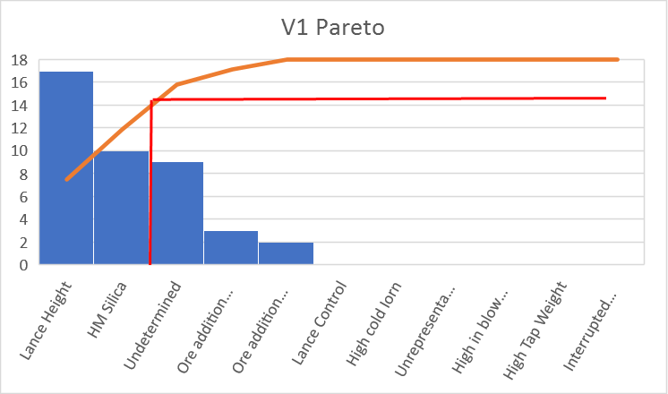
This graph shows the root cause analysis on vessel one, it follows the principle that 80% of the issues lay within 20% of the causes. This shows that we will need to focus on reducing the lance height and the amount of Hm silica because these are the main causes of issues. This graph is tracked weekly and reviewed in weekly meetings by the managers of the area.

Pareto Analysis V2
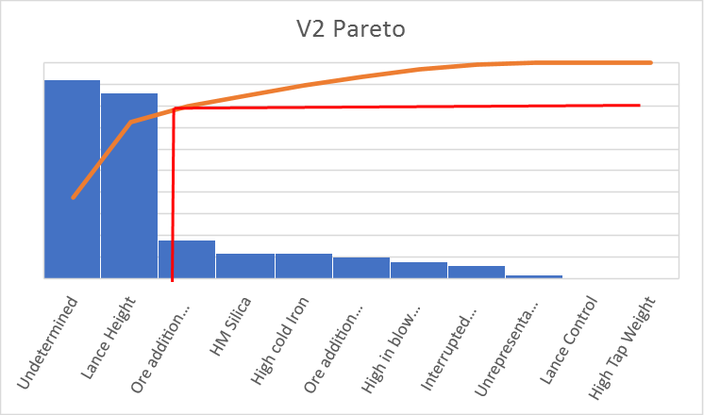
This type of graph is the same as vessel 1 but shows slightly different data, for example on vessel 1 lance height is the largest issue where as on this vessel it is an undetermined issue this means that research will need to be launched to discover the issue. It also shows there are 3 issues out of the 11 rather than 2 unlike vessel 1

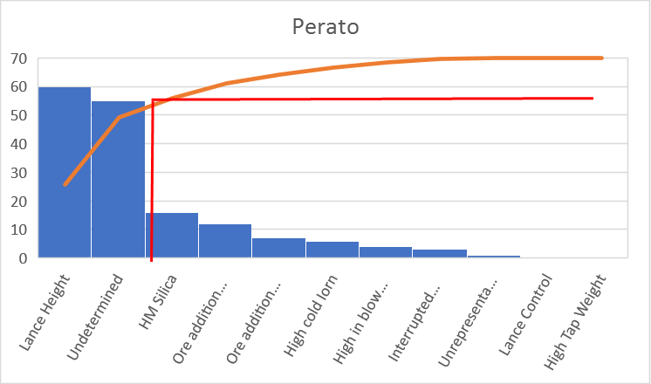
General Pareto
This is an pareto analysis of both vessels this is the graph which is reviewed the most, this shows where the engineers will need to focus the work to reduces these issues, this is explained by myself and the environmental manager in weekly meetings

Severity measurement
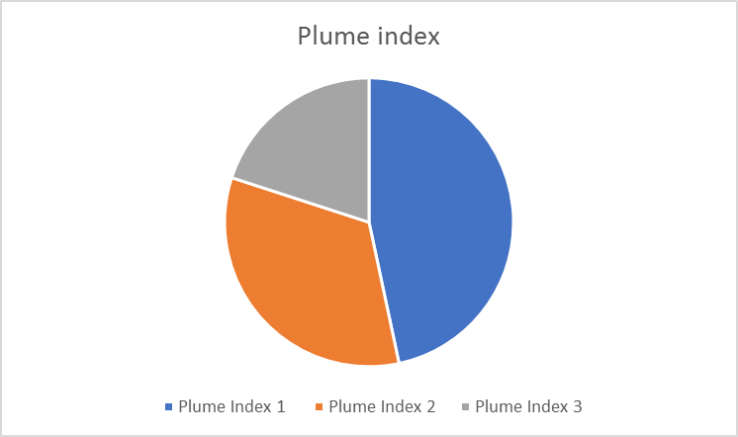
I also track the severity of the slop this is measured in Plume with 3 being the most damaging, this is tracked on a weekly basses and also reviewed in weekly meetings if we can see that index 3 is increasing over a few week research will be launched in an act o reduce the amount of bad slops we have.

Weekly track
This is a track over the year starting with the first working week of the year, this is a simple graph but shows us where we need to apply are focus to decrease the amount of slops

Weekly Comparisons
I can also create comparisons between different weeks, these are not given out in the meetings but can be given out on request, I try to compare the weeks ageist the best week and worst week to create and aim/ target for the operators to reach. Praises would be given if the targets are reached and could create motivation to decrease the amount of issues.

Root cause analysis
From looking at the pareto graphs it is clear that the lance height is the biggest issue when slopping occurs, this is what I will be root causing in the diagram if we could reduce this it could affect 50% of the stats.
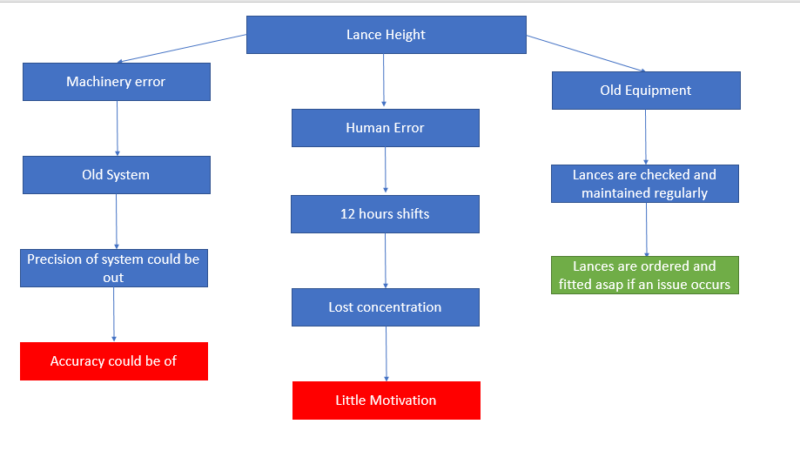
This Is the root cause analysis I have created it shows two possible areas where the issue of the lance height could be resolved, these are little motivation and the accuracy of the system could be off not allowing the lance height to be lowered correctly, I will look into methods of how a plan could be put in place to correct this issue.

Action plan 1

Little Motivation
The workers that control the lance height are shift workers who work 4, 12 hour shifts a week this consists of 2 days and 2 nights. People can start to loose motivation when sticking to this pattern, I would introduce and incentive scheme to help reduce the amount of slops, I would track how many slops occur on each rota per month and give a reward to the rota which has the least amount of issues this could be an inexpensive method to fix this issue and also give motivation to the workers in the areas, I believe months after this started it would start to become a competition between shifts, this could further reduce the amount of slops per year. Hence reducing the amount of complements we get from the local area. And reducing the amount of air breaches we have

Action plan 2

Accuracy of system
To resolve this issue I would like to launch an investigation into the system that we use and look at how accurate it is, if we find and issue with the accuracy this could be fixed by the engineers and help resolve the issue of slopping in are area. This would also aid the workers controlling the lance height, they could have more control over that piece of equipment and be able to give more accurate readings which are reported on a weekly bases.

Conclusion
I have created a new matrix to enter data for an issue on site which is slopping this new system has helped us track the issue of slopping closer than before but has not lead us to an answer. That is why I created an root causes analysis to pin point where the issues are. I discovered two issues that could be the cause of slopping and created an action plan for both showing method of improvement and the benefits of carrying out this action plan. I hope these will be carried out in my area and the amount of slopping is vastly reduced creating less air breaches and a cleaner plant and local area.

