Abstract
The aim for this research study is to explore and demonstrate the importance of public confidence to the police, the importance of the relationship between the police and the public, and how offending police officers can damage the confidence and relationship between the police and the public. To do so, this research consists of three objectives and has used both secondary and primary data. This research study also used a questionnaire and has also used a mixed- methods approach to gain further insight for the findings.
Police officers as offenders: How damaging is this to public confidence in the police?
By Emma Haggett

Contents
Acknowledgements 2
Declarations 3
3
1. Introduction 4
2. Literature Review 8
2.1 Identify the importance of public confidence in the police in the UK. 8
2.2 Explore the prevalence of serving police officers who have been convicted of criminal offences in England and Wales. 10
3. Methodology 14
3. 1 Research Methodology 14
3. 2 Research Onion 15
3. 3 Research Philosophy 15
3. 4 Research Approach 16
3. 5 Research Strategy 16
3. 6 Methodological Choice 16
3. 7 Time Horizon 17
3. 8 Techniques 17
3. 9 Thematic Analysis 18
3. 10 Limitations 18
4. Analysis 20
4.1 Objective one: 20
4. 2 Objective two and three: 27
5. Conclusion 30
5.1 Objective one findings: 30
5. 2 Objective two findings: 31
5. 3 Objective three findings: 32
5. 4 Limitations 33
5. 5 Conclusion 33
Reference list 35
Appendix 44

Acknowledgements
I want to thank my supervisor, Laura, who has helped and supported me throughout this individual project and has helped me throughout my time studying at the University of Wales Trinity Saint David. I also want to thank my parents and my sister for always supporting and encouraging me to work my hardest in and outside of education and who have always supported me.

Declarations
This work has not previously been accepted in substance for any degree and is not being concurrently submitted in candidature for any degree.
STATEMENT 1
This dissertation is being submitted in partial fulfilment of the requirements for the degree of BA/BSc.
STATEMENT 2
This dissertation is the result of my own independent work/investigation, except where otherwise stated.
Other sources are acknowledged in the Reference Section.
STATEMENT 3
I hereby give consent for my dissertation, if accepted, to be available for photocopying and for interlibrary loan, and for the title and summary to be made available to outside organisations.
STATEMENT 4
I hereby give consent for my dissertation, if accepted, to be available on the university’s IT system to those who have consent to use the system.

Student’s Name: Emma Haggett

Signed:

Introduction
Objective one: Identify the importance of public confidence in the police in the UK.
Objective two: Explore the prevalence of serving police officers who have been convicted of criminal offences in England and Wales.
Objective three: Evaluate the impact that convicting police officers has on public confidence in the police.

According to the College of Policing (2023), the role of a Police Constable is to prevent and detect crime and to work with other agencies to do so. Police Constables also "reduce the fear of crime, provide reassurance, and build confidence" to the public. The police use the National Decision Model and Code of Ethics to make autonomous and professional decisions (College of Policing, 2023). The role of the police is to engage with victims of crime, witnesses, and suspects, and those who are vulnerable and must do so using equality, diversity and must consider human rights. Police Officers respond to emergency calls from the public, investigate crimes, make arrests, provide evidence in court, and much more. Police officers ensure law and order in society, investigate crimes, and aim to prevent crime (National Careers Service, 2018).
The police must work with honesty and integrity and when making decisions or actions, the police will follow and use 9 principles to police effectively (Northamptonshire Police, 2023). The 9 Principles of Policing also known as Peel's principles are the "origins of modern policing, law enforcement" and are principles contemporary policing still use (Lentz et al., 2007: p. 69). The Principles of Policing include the prevention of crime, the emphasis on gaining and maintain public confidence and respect, to use physical force as a last resort, to maintain a relationship with the public and to focus more on crime prevention (Watts, 2023).
According to Misconduct999 (2021- 2023) 97 police officers were given a custodial sentence in England and Wales and had a combined sentence of 378 years, 8 months, and 4 days. The offences range from misconduct in Public Office, making and owning indecent images of children, causing a child to engage in a sexual act, sexual assault, rape and more. Hargreaves (2023) reported that in 43 police forces in England and Wales, 67% of misconduct meetings were due to police complaints, 60% were due to conduct, and 40% were "recordable conduct matters”.
According to Goodier (2023), over 90 police officers and staff were found guilty of a range of crimes following investigations of complaints and conduct. These included sexual offences, violent crimes, and corruption. In March 2022, there were 115, 235 complaints made against 76, 831 police officers (Goodier, 2023).
The support of the public and community is essential when "providing an effective Police Service" (O'Dowd, 1999: p. 3). Policing by consent is dependent on the public's confidence and trust of the police. The number of police officers as offenders can seriously harm the relationship between the public and the police and the police's reputation can be significantly damaged when police officers do not behave to the correct and appropriate manner and expectation (O'Dowd, 1999: p. 3). When an officer abuses their power and trust of the public, the police's image is completely damaged, therefore, it is vital that any issues surrounding the police is addressed to restore the reputation of the police as well as the relationship between the police and the public. It is essential for the police to maintain high levels of integrity and the maintenance of the trust between the police and community is vital for policing to maintain mutual respect between the police and the public. The behaviour of the police is of vital importance to ensure that officers act in the correct manner and to police effectively. To do so, officers act in line with the values of the Code of Ethics to better the reputation of the public they serve through their actions and behaviours. They must be transparent, respectful and stay impartial (College of Policing, 2023).

The main aim of this research proposal is to understand the importance of the public’s confidence in the police, and how damaging offending police can be to the public’s confidence and trust of the police. To answer this aim, this research will use three objectives: objective one is to identify the importance of public confidence in the police in England and Wales, objective two is to explore the prevalence of serving police officers who have been convicted of criminal offences in England and Wales, and objective three is to evaluate the impact that convicting police officers has on public confidence in the police. The research found for each objective will allow to answer the main aim as it will outline the importance of public confidence to policing and how the public's perceptions of the police and their confidence within the police can be damaged due to negative stories of the police, especially that of officers who have been convicted. This will also emphasise the importance of the public's confidence and trust in the police as community engagement and the public is vital for the police to operate. By highlighting the importance of negative reports and media of convicted police officers, hopefully more can be done when recruiting officers to maintain the public's confidence in the police and for the police to maintain a positive reputation.
For objective three, a questionnaire will be used to retrieve information to fully answer this objective. According to Jones et al. (2013), a questionnaire allows many participants to take part with "relative ease". By having a large number of participants to take part in the questionnaire, this allows participants to share the questionnaire and can be quickly and easily distributed.
The general population will be the participants who take part in the questionnaire for the research proposal. A target of 100- 150 participants will be required for this research to ensure there is a variety of answers and perspectives. Moreover, it is more representative of the general population and ensures the validity of the research and its findings (Keyes et al., 2018).
Up- to- date and relevant information and statistics using recent and up-to-date sources will be used throughout this research. According to Pontis et al. (2015: p. 22), "conducting and delivering up-to- date research is key" when it comes to academic writing, therefore, to ensure the inclusion of relevant and up-to- date information, the research will primarily use sources from present time to the maximum of five years ago. Moreover, planning ahead and setting a timescale for this research is essential to succeed. According to the University of Sheffield (2023), to succeed the research project, it is important to invest time in planning and organising the research proposal and it is important to set realistic deadlines, therefore by breaking down and setting timescales for each specific task of the individual project, this will be significantly beneficial when completing the research proposal. The timescale for this research will go as follows; proposal and ethics will take place in October, the literature review will be done between November to December, the methodology will be between December to February, analysis will be completed between February to March, the conclusion will be done in April and the final completion of the research project will be done in May of 2024.
This research proposal is important for several reasons, by aiming to get to the core route of why there are many stories and bad media based on offending police officers, this could have the potential to prevent or decrease the number of convicted police officers in England and Wales and to ensure the reputation and relationship between the police and the public stays intact.

2. Literature Review

2.1 Identify the importance of public confidence in the police in the UK.

According to Schaap (2023: p. 306), the public’s confidence in the police is vital for the police to do an effective job and by gaining and maintaining public confidence, this will improve the legitimacy of the police as “authority cannot be legitimate without trust” and legitimacy is an expectation of the police force and its officers.
By providing more positive interactions with the public, this has found to significantly improve the public’s confidence and trust, the police’s legitimacy, and makes the public more likely to cooperate with the police (Peyton et al., 2019). Peyton et al. (2019) reported that if the police are lacking in just policing and legitimacy, this decreases public confidence and makes the police less likely to cooperate with the police. Moreover, Peyton et al. (2019) also reported that there has been more of a focus on Community- Oriented policing to improve the public’s confidence in the police and the police’s legitimacy. Examples of Community- Orientated Policing include foot patrols (College of Policing, 2013). Finally, by having more positive interactions between the police and the public, this will make the public have more positive attitudes towards the police and improve the public’s confidence in the police (Peyton et al., 2019).
According to Sindall et al. (2012: p. 744), evidence found that the public had increasingly less confidence in the police and in response, a “citizen focused policing strategy” was implemented to put more focus on the public. Moreover, a lack of public confidence and trust in the police could mean that individuals may rebel against the police, may not abide to the law, may not report crime, or provide evidence to the police. Sindall et al. (2012) also stated that public confidence in the police could be argued as the most important factor of policing and has been seen as more important than the prevention of crime. The police aim to prevent crime and ensure that community morals and values are protected and met, however it is believed that the negative attitudes of the public towards the police is due to lack of social cohesion or control. Moreover, it is also believed that the lack of public confidence in the police is due to ineffective policing and because of increasing crime levels (Sindall, et al., 2012).
According to the Home office (2023), the Strategic Policing Requirement (SPR) was developed by the Home Secretary to lower the number of crime rates and provide public safety which can again be seen by the Home Office (2023) who reported that public confidence in policing would seriously improve their response to tackling violence against women and girls (Home Office, 2023).
Police forces throughout England and Wales, use Policing by Consent as a model of policing to police effectively (Hobbs et al., 2023). According to the College of Policing (2023), Policing by Consent has the focus that the police can be successful at policing only with the public’s support and their cooperation. Hobbs et al. (2023) stated that if the police show that they act with fairness and integrity as well as effectively, this means the public will have a positive perspective of the police and are more likely to have trust and confidence in the police. However, the trust and confidence of the public can vary due to experiences with the police, police performance, and coverage of the police in the media. The police can improve public confidence and the relationship with the public by improving their interactions with the public and having more community engagement (Hobbs et al., 2023). According to Hobbs et al. (2023), it has been found that trust and confidence levels in the police differ depending on ethnicity and gender.
Tudor (2023) reported that in March of 2022, 73% of individuals had trust in the police, compared to March 2021, where 80% of individuals had trust in the police. In addition, it was reported that 49% had confidence in the police and believed that the police in their community area were doing a good job. Tudor (2023) also reported that evidence also found that in 2022, 73% of the public had trust in the police and 62% believed that the police treated everyone fairly. However, as of 2023, 43% of individuals “thought more negatively” of the Metropolitan Police and 73% believed that the force treated people differently to others.
Furthermore, The Officer for National Statistics (2020) found that 75% of individuals over the age of 16 across England and Wales had confidence in the police and that 79% of Asian individuals and 75% of White individuals had confidence in the police, compared to 70% of Black individuals and 68% of individuals with mixed ethnicity. However, it was found that a higher number of women, apart from women with mixed ethnicity (68% of women and 71% of men) had confidence in their local police (Office for National Statistics, 2020).
According to the Independent Office for Police Conduct (2023), to improve the public’s confidence of the police, surveys are used to gain the public’s perception of the police and to gain feedback from the public in order to understand how the police can improve their policing and how the police can improve the public’s confidence. The Independent Office for Police Conduct (2023) stated that the feedback from the public gives the police further insight into the perceptions of the public and allows them to understand how to improve and change their methods of policing, it also allows the police to provide effective and just policing. One way the police do this, is by using the Public Perceptions Tracker which is a survey for the public to give their views and feedback to the police. The data allows the police to track the public’s confidence and how impactful and effective the police are (Independent Office for Police Conduct, 2023)

2.2 Explore the prevalence of serving police officers who have been convicted of criminal offences in England and Wales.

The offences committed by police officers tend to vary, however, reports show that some crimes that are committed occur regularly by different officers. According to Kersley et al. (2023) as of 2022, 1 in 100 police officers across England and Wales were charged with a criminal offence. It was also found that the Police Federation of England and Wales had represented 140, 000 due to misconduct and criminality. Kersley et al. (2023) also reported that the offences that police officers have committed are misconduct in a public office, offensive messages, assault, sexual offences, and murder. Moreover, 150 police officers were under investigation for sexual misconduct and racism (Kersley et al., 2023).
Moreover, according to Mercer (2020), 200 serving police officers were convicted of a variety of crimes including assault, drug possession, burglary, and animal cruelty. In addition, at least 211 police officers and Police Community support Officers (PCSOs) were employed with criminal convictions. Throughout the UK, there have been many serving police constables and PCSOs who have been employed with criminal convictions and have continued to be employed for the police with these criminal convictions (Mercer, 2020). For example, North Wales Police reported that 20 police officers and five PCSOs had criminal convictions including drug possession and animal cruelty, as well as a sergeant who was convicted of assault (Mercer, 2020).
Between 2021 to 2022, in the Metropolitan Police, 47 officers were criminally charged for violent and sexual offences, furthermore, during 2021- 2022 112 police officers have had a previous conviction, however, this is found to be dependent on the conduct matter and if any misconduct proceedings have not been concluded (Metropolitan Police, 2024).
However, it has also been reported that although complaints and reports have been made about some police officers, they did not face any consequences, as seen by Oppenheim (2023) who reported that between 2022 to 2023, just 24% of police officers across England and Wales who were investigated for domestic abuse, rape, sexual assault and abuse of position were suspended. In addition, 1, 124 officers and staff in 26 forces were accused between 2022 to 2023, however, 269 were just suspended. Furthermore, this number is believed to be higher as not all 43 forces across England and Wales shared this type of information. During this time, the Metropolitan had the highest number as it was reported that 687 staff and officers were accused, however, just 84 of these officers and staff were suspended (Oppenheim, 2024).
According to The Times (2023), as of March 2021, there were 145 convicted police officers found in 34 out of 43 forces across England and Wales; there were 68 sexual offences, 37 misconduct in public office offences, 36 violence against the person offences, and 3 public order offences. However, it was reported that there were 139 convicted male police officers, compared to six convicted female police officers.
As the data shows, it is evident that male police officers are primarily convicted and has been reported that girls and women are victims of these male officers. Davis (2023) reported that as of March 2022, the National Police Chiefs Council reported that there were 653 conduct cases which were related to violence against women and girls. Furthermore, less than 1% of approximately 1, 500 officers and staff had received complaints due to their treatment of women over a six- month period and as a result were fired (Davis, 2023).
Furthermore, female police officers have also been victims of convicted male police officers. According to Matthews (2023), an anonymous female police officer had experienced emotional and financial abuse as well as harassment by her husband who was also a police officer, however, he was arrested but continued to work as a police officer. Moreover, Matthews (2023) also reported that another female police officer was raped by her husband who was also a police officer, and after a 9-month investigation, the male police officer did not receive any consequences in regard to his policing career. It has been found that in many of these cases, the abuser was believed and many of these abusers were able to stay in the police regardless of the reports against them. In addition, Matthews (2023) reported that almost 200 alleged victims contacted the Women’s Centre for Justice due to cases of police domestic abuse.
There have been many cases of convicted police officers, such David Carrick who was jailed for life after admitting to committing over 85 indictable offences and 48 rapes over 17 years while in the police as a firearms officer (Dodd et al., 2023).
Moreover, another notorious case is that of Sarah Everard who was murdered by police officer Wayne Couzens who was found guilty of kidnap, rape and murder after falsely arresting Everard and was sentenced to life in prison (Mercer et al., 2024).
Notorious cases like these tend to have a detrimental impact and influence on individuals’ trust and confidence in the police, which can be seen by End Violence Against Women (2021), who reported that 47% of women and 40% of men reported not having trust in the police following the Sarah Everard case. In addition, 1 in 10 women (10%), reported to be less likely to report cases of sexual assault to the police because of the Sarah Everard case. Following the Everard case, 76% women (71% of all participants) believed that policing needs to change to respond effectively to violence against women and girls. Furthermore, 65% of people believed that the Government needs to do more to prevent and protect victims of violence against women and girls.
In agreement with End Violence Against Women (2021), FiliA (2020) reported that less than 1% of participants were “extremely” or “very confident” in the police and 53% stated that they were “not at all” confident. Moreover, 1% of participants had “a lot” of trust in the police, 55% reported “not a lot” of trust, and 18% had no trust at all. According to FiliA (2020), 10% of participants reported having a positive experience with the police and that positive experiences are vital for the maintenance of confidence in the police. Furthermore, 27% reported that the involvement of the police in high profile incidents had influence whether participants would report to the police, which again is evident in regard to the Sarah Everard case and the findings by End Violence Against Women (2021).

3. Methodology
This chapter focuses on objective three which is to "evaluate the impact that convicting police officers has on public confidence in the police". However, the questions that will be used in the questionnaire will be used to address all three objectives.
As stated in the literature review, Kersley et al. (2023) reported that 1 in 100 police officers across England and Wales were criminally charged in the year 2022, the offences include sending grossly offensive messages, misconduct in public office, and more indictable offences such as assault, sexual offences and murder. Moreover, the relationship between the public and the police and the public's confidence in the police is essential because if neither are present, this could mean that the public may not abide the police and

3. 1 Research Methodology
According to Patel et al. (2019, research methodology is the analysis of methods used in research and often uses quantitative or qualitative techniques. Furthermore, methodology is used to analyse and describe methods in research and show their limitations (Patel et al., 2019).

3. 2 Research Onion
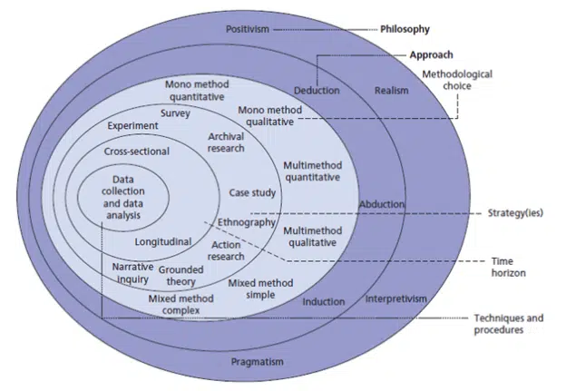

According to Alamgeer (2019) the Research Onion which was created by Saunders et al. (2007). It is a framework for research methodology and includes multiple layers which represent that of an onion. The layers of the onion represent each stage that must be completed in order from the outer layer to the inner layer to ensure that the methodology is effective (Melnikovas, 2018). The layers include Research Philosophy, Research Approach, Research Strategy, Choices, Time Horizon, and Techniques and Procedures.

3. 3 Research Philosophy
The Research Philosophy refers to what is believed to be reality and truth and determines the collected data within research (Ryan, 2018). According to Ryan (2018), interpretivism is knowledge which is gained by retrieving facts and data. Interpretivism is based on an individual's experience, values, and beliefs therefore, an interpretivist approach will be used for the research philosophy which will enable a variety of perspectives and the data being collected will draw on individuals’ experiences and/ or beliefs.

3. 4 Research Approach
Melnikovas (2018) stated that the Research Approach refers to Deduction and Inductive. In this case, the research approach is inductive which initially contains observation and the collection of data which later uses analysis to create a theory, and, in this case, this will be via the use of a questionnaire. The inductive approach uses three stages: observation, observe a pattern, and develop a theory or general conclusion (Streefkerk, 2022). According to the University of Warwick (2016), a conclusion is drawn from an individual's observation and opinions. The University of Warwick (2016) reported that the benefit of using an inductive approach is that it has flexibility and provides knowledge through observation. An inductive approach ensures that all aspects of the collected data are seen. Furthermore, Azungah (2018) stated that the analysis is of data which is based entirely on the participant's own experiences and combines both analysis and literature which is precisely how this research is being conducted, hence why an inductive approach has been used.

3. 5 Research Strategy
Research Strategy refers to how the data is collected, and, in this case, the strategy used will be a questionnaire. According to Jones et al. (2013), a questionnaire is useful as it allows many individuals to take part with ease and is not overly complicated for individuals. Furthermore, Clint (2020b) reported that the advantages of using questionnaires is that the researcher can target specific audiences and retrieve a large number of data in little time and most importantly, participants will be anonymous when they take part in the questionnaire which will encourage them to be more honest in their response increasing the reliability and validity of the data that is collected (Clint, 2020b).

3. 6 Methodological Choice
Methodological Choice refers to qualitative and quantitative methods or both. According to Bhandari (2022) quantitative research involves the collection of non- numerical data and quantitative research is the collection of numerical data and is used to find patters and causal relationships, and to make predictions. For this research, a mixed method approach will be used. According to Clint (2022), by using both a quantitative and qualitative approach this allows the research to be more "holistic and quantifiable" as both complement each other and work significantly well together as they provide further insight. On the contrary, a mixed methods approach can be more complex and may need an individual with more expertise to collect the data and analyse or interpret the results which have been collected compared to if just one method was used. Moreover, combining the two may require more resources and time (Office for Health Improvement and Disparities, 2020). However, the Home Office for Health Improvement and Disparities (2020) stated that individually, quantitative and qualitative data collection can answer different types of questions and when combining the two it can provide an individual with deeper findings and can provide more evidence which is stronger for an individual's research.

3. 7 Time Horizon
Time Horizon refers to the timeframe or length of time dedicated to the research and the timeframe is dependent on the research objectives and the type of research which is conducted (Alamgeer, 2023). According to Connelly (2016: p. 369), Cross- sectional studies take place at a single point in time and over a specific timeframe. A cross- sectional study will be used for this research as they are relatively quick to create and are inexpensive allows individuals to easily access the questionnaire (Wang et al., 2020).

3. 8 Techniques
Techniques refers to data collection, sampling, and the type of data analysis. The data collection is the questionnaire that will be used. Moreover, the sampling of participants refers to the type of individuals who take part. According to Barratt et al. (2009), It is vital to have participants who are representative of the general population to gain a variety of authentic answers and opinions, therefore, a general population sampling will be used. Furthermore, according to Oregon State University (2024) snowball sampling is where the questionnaire will be passed onto other participants to retrieve data from more participants and so on. This will be an effective way for more participants to take part in the research and to retrieve the target number of 100- 150 participants, therefore, snowball sampling will also be used. Kayam et al. (2012) reported that there are many advantages to sharing a questionnaire or survey via social media. For example, time and number of participants is a significant benefit as many participants will be able to access the questionnaire in a relatively short amount of time. Moreover, participants who take part in online studies can directly choose if they want to participate or not in the studies which ensures there is consent on their part (Kayam et al., 2012), therefore, the questionnaire will be posted on social media through existing Instagram, Snap Chat, and Facebook profiles belonging to the researcher.
Throughout this research, both primary and secondary data will be used. For objectives one and two, secondary data will be used, and for objective three, primary data will be used. Primary data has been used as it is specific to the research and is reliable as it is data that collected is data collected from a questionnaire to this specific research. Moreover, the data is accurate and up to date. Secondary data has also been used as it is relatively easy to find (Indeed, 2022). Furthermore, by using Secondary data it improves the efficiency of the research as the secondary data which have been used are credible sources that also makes the research reliable (The Open University, 2019).

3. 9 Thematic Analysis
Furthermore, for this research, thematic analysis will be used. According to Braun et al. (2014), thematic analysis is used as a framework for qualitative data which coincides with an inductive and interpretivist approach which has also been used in this research. Furthermore, thematic analysis will also be used as it can identify patterns throughout the research and can also provide an analysis which is sophisticated for qualitative data.

3. 10 Limitations
However, many limitations can take place during online studies. A limitation that can occur is ethical considerations, specifically consent. According to Roberts et al. (2016), it is vital for participants to provide evidence of consent when taking part in research, therefore, participants will be informed that they do not need to take part if they do not wish to and they have the choice to stop taking part whenever they wish.
However, Clint (2020b) also stated that the disadvantage of questionnaires is that some participants may not be completely honest with their answers and that they may only answer how they think society, or the researcher would want them to answer. To prevent this and to ensure the data collected is accurate and sound, participants will be made aware that they will be completely anonymous and that no private or identifying information will be necessary. Coffelt (2017) stated that both anonymity and confidentiality are vital in research as they protect the privacy of the participants and ensures that participants and comfortable to take part, furthermore, this also ensures that participants are comfortable and confident to answer truthfully and share their opinions and experiences in the questionnaire. Therefore, increasing the reliability and validity of the data collected. Moreover, there is also a risk of unconscientious responses; if the participants do not read the questions properly, they may give inaccurate or false answers which will significantly impact the validity of the collected data. To reduce the risk of this, it is vital to make the questions short and simple (Cint, 2020b).

4. Analysis
The overall aim of this research was to advance an understanding of police officers as offenders and how it can impact public confidence in the police. The research consisted of three objectives which were: to identify the importance of public confidence in the police in England and Wales; to explore the prevalence of serving police officers who have been convicted of criminal offences in England and Wales and to evaluate the impact that convicting police officers has on public confidence in the police. The questionnaire took place on Google Forms. By using Google Forms, this allows data to be easily collected and provides an effective analytical tool for the collected data (Zdraveski et al., 2020).
According to Saldaña (2014), coding is the function of classifying and organising data into categories to analyse. Coding was used to better analyse the data that was collected. The questions were organised based on all three objectives. Questions 1- 14 are based on objective one and questions 15- 18 are based on objective two and three.

4. 1 Objective one:
Question 1 and 2
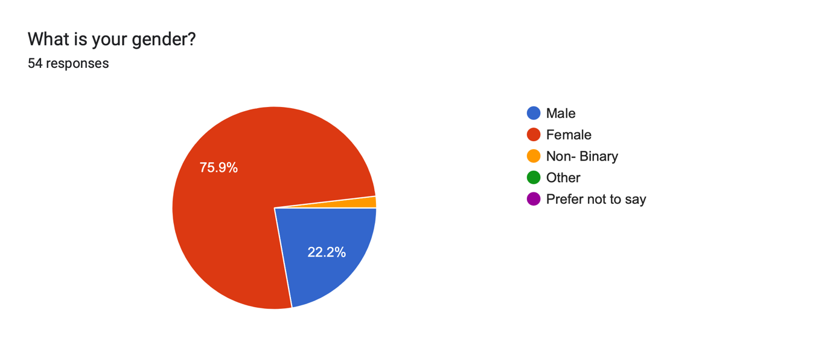

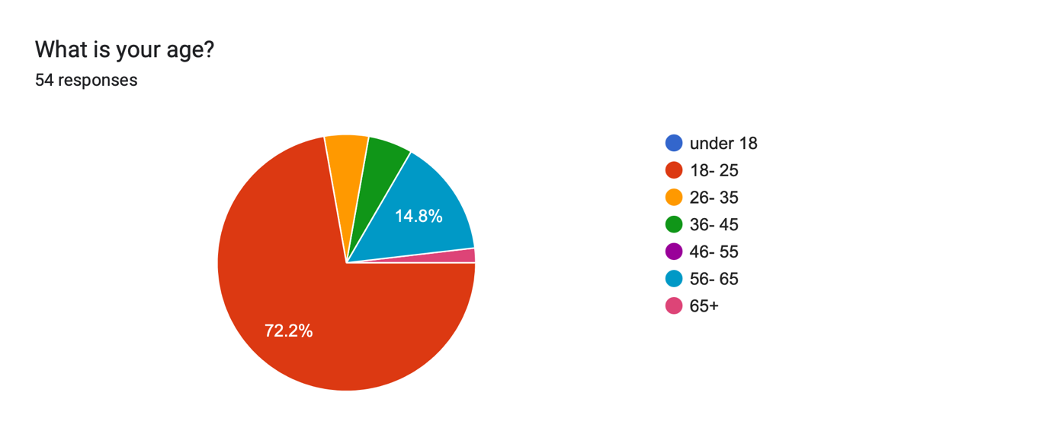In questions one and two, participants were asked for their age and gender. Most participants were female (79%), 22. 2% were male, and 1.9% were non- binary. Moreover, 72. 2% of participants were aged 18- 25, 14. 8% were aged 56- 65, 5. 6% were aged 26- 35 and 36- 45, and 1.9% were aged 65+. Furthermore, in the questionnaire, the role of a police officer was explained to participants, and they were asked if they agreed with the statement; 63% agreed with the statement and 25. 9% strongly agreed, 7. 4% neither agreed or disagreed, 3.7% strongly disagreed and 1. 9% disagreed with the statement.

Question 4
Next, participants were asked what police actions increase their confidence, some responses included showing more empathy and kindness, ensuring that their actions increase public safety, and being sterner with certain crimes such as violent crimes. However, it was found that 34% of respondents believed that more “visibility in our local area” and in the community will improve public confidence, as well utilise more police patrol in public and more engagement and communication with the public will also increase public confidence in the police. This can be supported by Peyton et al. (2019) who reported that more police presence and more engagement with the public increases publics' confidence in the police and increases the likelihood of the public cooperating with the police.

Question 5
The next question asked participants what police actions decrease their confidence, one of the responses included a participant's own experience with the police where they had been in a case for 3 years with no help or support from the police and the case should have taken a considerably shorter period.
Moreover, there was a variety of police actions that participants believed decreases public confidence and trust in the police; 15.09% believed abuse of power decreases public confidence and trust in the police, 16.98% discussed police brutality, and 32% believed that both misconduct and offending police officers decreases public confidence in the police.
There are numerous reports of police officers being investigated or charged for misconduct, corruption, or for offending. As previously stated, Kersley et al. (2023) reported that during 2022, 140, 000 police officers were charged with misconduct and criminal offences including assault, sexual offences, offensive messages, and murder. Moreover, according to Mercer (2020), over 200 serving police officers were convicted of crimes including burglary, animal cruelty, drug possession and assault. From the increasing number of reports of offending police officers, this has therefore supported what police actions decrease the publics’ confidence and trust in the police.

Question 6
Regarding the Code of Ethics, participants were asked if they believed that the police do an effective job at maintaining trust and confidence. Many believed the police do maintain trust and confidence by helping members of the community to the best of their ability and have found police officers to be professional and thorough which increased participant's confidence in them, however, those who said yes also believed that the negative reports from the media also decrease public's confidence as they shed light on the negative aspects of the police and cases of police misconduct which damages the reputation of police officers who are doing an effective job.
On the other hand, participants also believed that the police do an ineffective job at maintaining trust and confidence in the public due to cases of misconduct and cases such as the Sara Everard case. Responses referred to police officers as trying to intimidate the public and one participant discussed their own personal negative experience and because of this negative experience with the police, this has had a negative impact on their trust and confidence in the police. These findings can be supported by Peyton et al (2019) who reported that interactions and experiences with the police can also have a significant impact on the trust and confidence in the police, therefore, to the participant(s) who had a negative experience with the police, this has therefore had a negative impact on their opinions of the police and has significantly decreased their confidence and trust in the police.
Finally, one participant believed that the effectiveness of maintaining trust and confidence by the police is based on the individuals' ethnicity and class and they believed that not everyone is treated equally by the police which again can be supported by Hobbs et al. (2023) who stated that the trust and confidence for the police is dependent on the publics' ethnicity and gender.
The results found in this question can also be supported by Tudor (2023) who reported that 73% had trust in their police and 49% had confidence in their local force and believed they were doing an effective job.

Question 8
As part of objective one, participants were also asked on how they believed the police could improve the relationship between the police and the public. 35. 8% of participants believed that the police need to engage more with the community and communicate more with the community to bond and build trust with the public and build rapport. Moreover, participants believed that more engagement and communication allows the public to “know they (the police) will help” and shows the public that they can trust and confide in the police due to the increase in visibility and engagement with the public. This is again supported by Peyton et al. (2019) who believed that there needs to be more focus on Community- Orientated Policing to improve interactions and engagement with the public to increase the public's confidence and to show their legitimacy. Another response was to create preventative programmes to deter criminals and have more of a focus on prevention strategies which is vital in policing as preventing crime is one of the 9 Principles of Policing (Home Office, 2012).

Question 9
Next, participants were asked whether age, gender, and ethnicity influences public perception of the police. Regarding age, 44. 4% of believed age has a negative impact, 18. 5% believed age has no effect, and 11. 1% believed age has a positive effect.
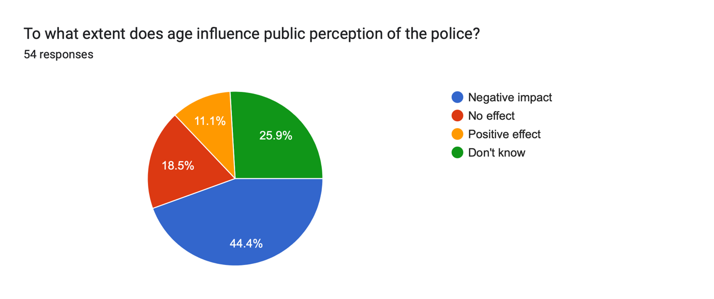
When asked to explain their answer, many believed that youths do not care about the police or have respect towards the police.
Moreover, others also believed that youths may have more of a negative perception of the police due to the negative media of the police. Furthermore, one participant believed that regarding the use of the media, teenagers and adults are more likely to be involved in drug offences, county lines and gang culture, therefore they have a negative attitude towards the police and share this negative attitude online which incriminates the police rather than the individual who has offended.
In addition, only 36% of young black adults and teenagers had trust in the police and 75% of young white adults and teenagers had trust in the police. 28% of Black Caribbean children and young adults had trust in the police and it was also found that there were lower levels of trust in older children and girls, and Black girls had the lowest level of trust at 33%.

Question 10
Regarding gender, 41. 4% believed that gender has a negative impact, 24. 5% believed that gender has no effect, and 3. 8% believed that gender has a positive effect.
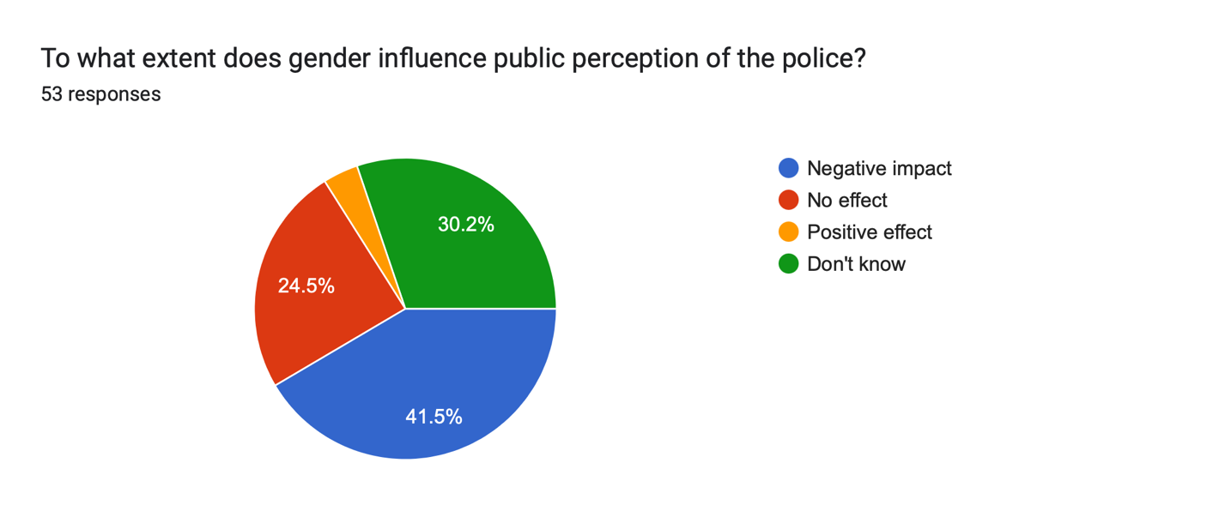
When asked to explain their answer, most responses discussed the lack of trust due to previous cases of misconduct involving offending police officers and believe that male officers are more likely to disregard women.
In addition, a participant shared that she often fears the police due to convicted officers of sexual offences and because of cases like this, this has decreased trust and confidence in the police.
However, other response believed that women are seen at more of an advantage in cases as women are more likely to be believed or sided with than men as men are believed to be instantly blamed due to them “being bigger and stronger thus more powerful”.
Furthermore, one participant believed that both men and women lack trust and confidence in the police; they believed that “men dislike the police because they are taught to and women are taught that the police protect them but do not”, therefore, this influences their confidence and trust in the police and makes them believe that the police may not act effectively.
Moreover, participants also believed that women are less likely to trust and confide in the police due to notorious cases of offending police officers as this creates fear for women and means they are less likely to also report to the police.

Question 11
Finally, participants were asked if they believed ethnicity influenced public perception. 52. 8% believed that ethnicity has a negative impact, 17% believed that ethnicity has no effect, and 5.7 % believed that ethnicity has a positive effect.

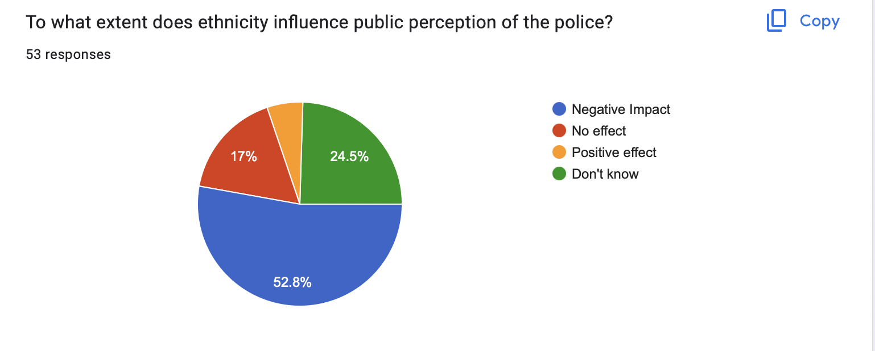
Many participants believed that discrimination on the basis of ethnicity is a big issue for the police and that the police tend to target black individuals or Black, Asian, and minority ethnic (BAME) individuals.
Moreover, participants also believed that the media have an influence on individuals' perceptions of the police. Participants believed that individuals from ethnic minorities have more of a negative perception of the police because of the way they are treated by the police.
Furthermore, a participant also discussed that individuals that they know who BAME have had previous experiences of being stopped by the police either when driving or being stopped and questioned.
Although participants believed that age influences public perception of the police, the Office for National Statistics (2020) reported that 75% of individuals aged 16 and over in England and Wales had confidence in the police. However, Edge Hill University (2023) found that in their survey, 72% of young people do not believe or have trust in the police. Many of the respondents in the survey reported that high profile cases such as David Carrick and Wayne Couzens had “eroded” their trust in the police.
Furthermore, it has also been found that gender, ethnicity, and age all have an influence on public perception of the police. The results found in the questionnaire can further be supported by the Office for National Statistics (2020) who also reported that 79% of Asian individuals and 75% of White individuals had confidence in the police, compared to 70% of Black individuals and 68% of individuals with mixed ethnicity.
Moreover, the London Assembly (2023) reported that 39% of participants who were Black reported that they believed they were treated with respect by the police when they were stopped and searched which has a positive impact on public perception of the police especially that of Black individuals as previous cases of unfair treatment towards Black individuals done by the police has had a negative impact on the reputation of the police, therefore by showing individuals that the police do treat Black individuals with fairness and respect, this provides a positive perception of the police and builds a better relationship and bond with the public, especially BAME individuals.

4. 2 Objective two and three:
Question 12
As part of objective two and three, participants were asked if they had heard or seen reported cases of convicted police officers. 75. 9% said yes, 13% said no, and 9.3% said unsure.
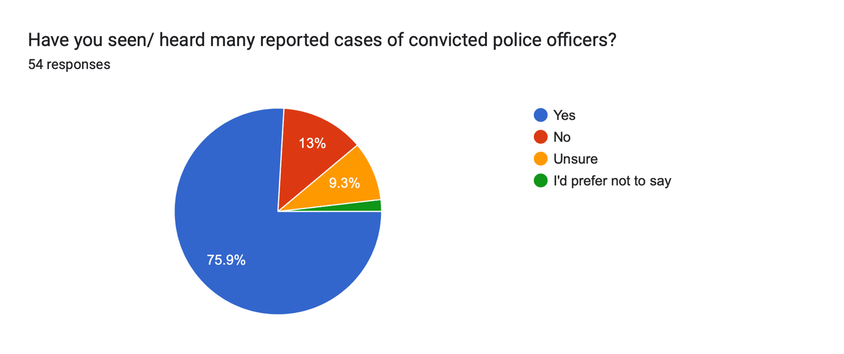

Many of the responses listed notorious cases including the Sarah Everard case, and the David Carrick case. However, other responses included cases of the crimes involved, including sexual abuse or sexual offences, paedophilia, rape, sexual harassment, and a police officer who murdered his pregnant partner. Responses also included lesser-known cases such as the Cliff Mitchell case.

Question 13
Participants were then asked how these cases affected their confidence in the police. Almost all participants believed that it has an impact on the publics' trust and confidence in the police as this creates fear in the public as it could potentially happen to them. Other participants also discussed how it creates fear as a parent that cases that were listed previously may happen to their child or children. However, only a minority of participants stated that these cases have no effect on them because the perpetrator was caught, and it was not in their area.
The findings from this questionnaire can be supported by End Violence Against Women (2021), who reported that 47% of women and 40% of men stated that they did not have trust in the police after the Sarah Everard case. Moreover, (10%) of women reported to be less likely to report sexual assault to the police because of the Sarah Everard case. Furthermore, FiliA (2020) reported that 53% of participants stated that they were "not at all" confident, compared to 1% who were "very confident" in the police. In addition, 27% reported that they had a negative experience with the police and 21% reported that cases of offending police officers had influenced whether they would report to the police. Finally, according to Brown et al. (2023) in 2021, End Violence Against Women surveyed 1,700 adults and found that 47% of women reported that after the case of Sarah Everard, they have less trust in the police.
In conclusion, it is evident that there are many factors involved in the publics’ confidence and trust levels of the police such as age, gender, and ethnicity. However, the main factors that have the most influence on confidence and trust levels are that of individuals’ own experiences, high profile cases of offending police officers, and that of the media. There have been numerous media reports of offending police officers and the negative experiences of the public with the police which then significantly impacts the reputation of the police. Therefore, more needs to be done to show the public that there are in fact good police officers and more needs to be done to aim to ensure there are more positive interactions with the police and the public.

5. Conclusion
The overall aim of this research was to find how damaging offending police officers are to public confidence and trust. To address this aim, three objectives were addressed: to identify the importance of public confidence in the police in England and Wales, to explore the prevalence of serving police officers who have been convicted of criminal offences in England and Wales, and to evaluate the impact convicting police officers has on public confidence in the police.

5.1 Objective one findings:
For objective one, both secondary and primary data were used, however, the secondary data found that by gaining and maintaining public confidence and trust, this allows the police to act effectively and improves the police's legitimacy (Schaap, 2023).
Moreover, according to Peyton et al. (2019), positive community engagement between the public and the police increases the publics' confidence and trust in the police and makes the community more likely to cooperate with the police. In addition, maintaining public confidence is also seen as a base layer for just and fair policing.
Furthermore, the importance of public confidence in the police and cooperation has been further supported by Sindall et al. (2012) who reinforce the idea that public trust in the police can also affect the likelihood of people abiding by the law.
Regarding objective one, participants were asked what police actions increase and decrease their confidence. The police actions listed by participants includes showing more empathy and kindness, ensuring they increase public safety, and having more of a focus on positive interactions and engagement between the police and the public, which again can be supported by Peyton et al. (2019) and by Hobbs et al. (2023) who stated that positive interactions and more positive community engagement can improve public confidence and the relationship between the police and the public. However, most participants stated that having more of a police presence in public and engaging and communicating more with the public increases confidence and trust in the police.
However, regarding what police actions decreases their confidence, a participant's answer included their own negative experience they had with the police where they. These primary findings can be supported by Hobbs et al. (2023) who reported that individuals' confidence and trust in the police can vary depending on their own experiences with the police.

5. 2 Objective two findings:
For objective two, Mercer (2020) reported that over 200 serving police officers were convicted of crimes including assault, burglary, drug possession, and animal cruelty.
Moreover, according to Oppenheim (2023), between 2022- 20223, 24% of police officers in England and Wales were investigated for crimes including sexual assault, domestic abuse, rape, and abuse of position.
Furthermore, as of March 2021, 145 convicted police officers in 34 out of 43 police forces across England and Wales were criminally convicted. There were 68 sexual offences, 37 misconduct in public office, 36 violence against the person, and 3 public order offences. It was also reported that there were 139 convicted male police officers, compared to six convicted female police officers (The Times, 2023).
In addition, notorious cases, such as the Sarah Everard case, which was referred to throughout the questionnaire by participants, have a detrimental impact on the publics' confidence and trust of the police, which can be seen by End Violence Against Women (2021), who reported that 47% of women and 40% of men reported not having trust in the police after the Sarah Everard case and 10% of women reported to be less likely to report sexual assault to the police.
In addition, participants were asked if they had seen or heard of any cases of convicted police officers; 75. 9% said yes, 13% said no, and 9.3% said unsure. Participants were then asked to name these cases, these included Sarah Everard, David Carrick, Cliff Mitchell and also included cases of police officers who were charged for sexual offences, paedophilia, rape, and an officer who murdered his pregnant wife.
Finally, negative personal experiences between the public and the police also have an impact on the publics’ confidence and trust of the police, which can be seen by FiliA (2020), who reported that 21% stated that the involvement of the police in high profile incidents had influenced if they would report to the police, showing the impact of offending officers.

5. 3 Objective three findings:
When asked how these cases had affected their confidence in the police, almost all participants stated it had decreased their confidence as it created the fear that this could potentially happen to themselves or someone they know, especially as a parent. Moreover, it has been found that victims of convicted male police officers are primarily women. This can be seen Matthews (2023) who reported that almost 200 alleged victims contacted the Women's Centre for justice in relation to domestic abuse cases done by male police officers, which again induces fear in the public, mainly that of women and girls.
Finally, negative personal experiences between the public and the police also have a detrimental impact on the publics’ confidence and trust of the police, which can be seen by FiliA (2020), who reported that 27% of respondents reported having a negative experience with the police.
Clint (2020b) reported that the advantages of using questionnaires is that the researcher can target specific audiences and participants will be anonymous when they take part in the questionnaire which makes them more likely to be more honest with their responses increasing the reliability and validity of the data that is collected.
According to Barratt et al. (2009), It is vital to have participants who are representative of the general population to gain a variety of answers and opinions, therefore, a general population sampling was used for the questionnaire.
Furthermore, Health Improvement and Disparities (2020) stated that combining both quantitative and qualitative provided deeper insights on participants' responses and provided further evidence.
In addition, primary and secondary data has been used as it is specific to the research and allows first hand perspectives on the subject matter (Indeed, 2022). Moreover, by using secondary data it improves the efficiency of the research as credible sources were used, also making the research reliable (The Open University, 2019).

5. 4 Limitations
Although secondary and primary data were used, a limitation was the lack of secondary research on convicted female police officers as the sources that were found in the secondary data primarily focused on convicted male police officers. Although one source discussed convicted female police officers, perhaps more research may need to be conducted to retrieve more data to gain further insight into this topic.
was the lack of male participants in the questionnaire. As stated, 79% of participants were female, and 22. 2% were male, therefore the questionnaire may be seen as unrepresentative of the general population and perhaps the results from the questionnaire were not a true reflection of the public's opinions as the findings cannot be generalised to the wider population due to the majority of participants being female.

5. 5 Conclusion
In conclusion, it is evident that many factors take part in the publics’ confidence and trust of the police. As stated by the College of Policing (2023), under the Code of Ethics the police need to prioritise public service, show integrity and accountability, and show respect and empathy. Therefore, more needs to be done to ensure the Code of Ethics is met by Police to ensure the publics’ confidence and trust. As previously stated, victims of convicted male police officers are predominantly women and girls and after the Sarah Everard case, it was reported by End Violence Against Women (2021), 76% of women and 71% of all adult participants believed that policing needs to change to respond effectively to violence against women and girls. Furthermore, 65% of people believe that the Government needs to do more to prevent and protect victims of violence against women and girls, perhaps by working alongside the police and agencies such as victim support charities. By doing so this could potentially increase the publics’ confidence and trust, particularly that of women and girls, and could improve the relationship between the public and the police thus increasing the likelihood that people will engage with the police and abide by the laws they are tasked with upholding.

Reference list
- Alamgeer, Z. (2023) "Time Horizon in Research Onion" The Innovidea. - https://theinnovidea.com/time-horizon-in-research-onion/ (Accessed 05/ 02/ 24)
- Alamgeer, Z. (2023) "Understanding Research Onion for Research Methodology" The Innovidea.- https://theinnovidea.com/understanding-research-onion-for-research-methodology/ (Accessed 15/ 01/ 24)
- Azungah, T. (2018) "Qualitative Research: Deductive and Inductive Approaches to Data Analysis" Vol 18(4): Qualitative Research Journal, pp 383- 400.- https://www.proquest.com/docview/2133411195/fulltextPDF?accountid=130472&parentSessionId=Z%2FIu05tfsqzh0NFuxbMCi3d0SHvd7fDn9CUwd2JC6OU%3D&pq-origsite=primo&sourcetype=Scholarly%20Journals (Accessed 05/ 02/ 24)
- Barratt, H., Shantikumar, S. (2018) "Methods of Sampling From a Population" Health Knowledge: Faculty of Public Health.- https://www.healthknowledge.org.uk/public-health-textbook/research-methods/1a-epidemiology/methods-of-sampling-population (Accessed 08/ 02/ 24)
- Bhandari, P. (2022) "What is Quantitative Research? Definition and Methods" Scribbr.- https://www.scribbr.co.uk/research-methods/introduction-to-quantitative-research/ (Accessed 16/ 01/ 24)
- Braun, V., Clarke, V. (2014) "What can "'hematic Analysis' Offer Health and Wellbeing Researchers?" National Library of Medicine: PubMed Central.- https://www.ncbi.nlm.nih.gov/pmc/articles/PMC4201665/ (09/ 02/ 24)
- Cint. (2020) "What is a Questionnaire and How is it Used in Research?" Cint.- https://www.cint.com/blog/what-is-a-questionnaire-and-how-is-it-used-in-research (Accessed 20/ 01/ 24)
- Cint. (2022) "Using both qualitative and quantitative approaches in your research" Cint: Market Research.- https://www.cint.com/blog/using-both-qualitative-and-quantitative-approaches-in-your-research#:~:text=Quantitative%20and%20qualitative%20research%20are,that%20deliver%20more%20actionable%20insight. (Accessed 20/ 01/ 24) (A)
- Coffelt. A., T. (2017) “Confidentiality and Anonymity of Participants” The SAGE of Communication Research Methods.- https://dr.lib.iastate.edu/server/api/core/bitstreams/c01c71f9-1b9e-4ecd-ae9e-f02e5bc66f8d/content#:~:text=Anonymity%20and%20confidentiality%20are%20important,agree%20to%20participate%20in%20research. (Accessed 09/ 02/ 24)
- College of Policing. (2023) "Building Trust and a Fair Culture" Policing by Consent. - https://www.college.police.uk/about/corporate-strategy-2022-2026/building-trust-and-fair-culture (Accessed 19/ 02/ 24).
- College of Policing. (2023) "Code of Ethics- Have Your Say" College of Policing.- https://www.college.police.uk/article/code-ethics-have-your-say#:~:text=Guidance%20for%20ethical%20and%20professional%20behaviour%20in%20policing&text=The%20guidance%20provides%20practical%20advice,with%20fairness%2C%20dignity%20and%20respect (Accessed 17/ 02/ 24)
- College of Policing. (2023) "Integrity" College of Policing. - https://profdev.college.police.uk/competency-values/integrity/ (Accessed 08/ 11/ 23).
- College of Policing. (2023) "Police Constable" College of Policing.- https://profdev.college.police.uk/professional-profile/police-constable/ (Accessed 24/ 10/ 23).
- College of Policing. (2023) "Police Constable" College of Policing.- https://profdev.college.police.uk/professional-profile/police-constable/ (Accessed 21/ 02/ 24)
- Connelly, L., M. (2016) "Cross- Sectional Survey Research" Vol. 25, No. 5: Understanding Research.- https://www.proquest.com/docview/1827241811?accountid=130472&sourcetype=Scholarly%20Journals (Accessed 05/ 02/ 24)
- Davis, M. (2023) "Fraction of Police Officers and Staff Accused Over Treatment of Women Sacked" Independent.- https://www.independent.co.uk/news/uk/data-wales-england-home-office-metropolitan-police-b2299797.html (Accessed 28/ 12/ 23).
- Dodd, V. (2022) “Police Vetting Failures Have Allowed “Predatory” Officers to Join Up, Watchdog Finds” The Guardian. - https://www.theguardian.com/uk-news/2022/nov/02/prevalent-predatory-misogynistic-culture-in-police-official-report-finds (Accessed 20/ 02/ 24).
- Dodd, V., Sinmaz, E. (2023) "David Carrick Jailed for Life Over Series of Rapes While Met Police Officer" The Guardian.- https://www.theguardian.com/society/2023/feb/07/david-carrick-jailed-life-rapes-met-police-officer (Accessed 29/ 12/ 23).
- Edge Hill University (2023) “Report by Edge Hill University Students Highlights Lack of Trust in Police” Edge Hill University. - https://www.edgehill.ac.uk/news/2023/01/report-by-edge-hill-university-students-highlights-lack-of-trust-in-police/#:~:text=They%20found%20that%2072%25%20of,it%20implement%20correct%20disciplinary%20measures. (Accessed 22/ 03/ 24).
- End Violence Against Women. (2021) "Almost Half of Women Have Less Trust In Police Following Sarah Everard Murder" End Violence Against Women.- https://www.endviolenceagainstwomen.org.uk/almost-half-of-women-have-less-trust-in-police-following-sarah-everard-murder/ (Accessed 26/ 02/ 24).
- FiliA. (2020) "Women's Confidence in Policing" A FiliA Survey.- https://static1.squarespace.com/static/5f0869a15c33825a87fd8c48/t/61dc8184e3b8ad3d3f616338/1641841051710/Women%27s%2BConfidence%2Bin%2BPolicing%2B-%2BA%2BFiLiA%2BSurvey.pdf (Accessed 26/ 02/ 24).
- Goodie, M. (2023) "More than 90 police staff were found guilty of crimes last year, data shows". The Guardian.- https://www.theguardian.com/uk-news/2023/jan/12/more-than-90-police-staff-were-found-guilty-of-crimes-last-year-data-shows#:~:text=The%20figures%2C%20released%20by%20the,well%20as%2025%20police%20staff. (Accessed 05/ 11/ 23).
- Hargreaves, J. (2023) "Police misconduct, England and Wales year ending 31 March 2022" Home Office: Gov. uk.- https://www.gov.uk/government/statistics/police-misconduct-england-and-wales-year-ending-31-march-2022/police-misconduct-england-and-wales-year-ending-31-march-2022 (Accessed 24/ 10/ 23).
- Hobbs, A., Brown, R.(2023) "Trust in the Police" UK Parliament: POST, Crime and Justice.- https://post.parliament.uk/research-briefings/post-pn-0693/ (Accessed 22/ 11/ 23)
- Home Office. (2012) "Definition of Policing by Consent" Gov. UK.- https://www.gov.uk/government/publications/policing-by-consent/definition-of-policing-by-consent (Accessed 22/ 03/ 24).
- Home Office. (2023) "Strategic Policing Requirement (accessible)" Policy Paper- https://www.gov.uk/government/publications/strategic-policing-requirement-2023/strategic-policing-requirement-accessible (Accessed 20/ 11/ 23)
https://assets-hmicfrs.justiceinspectorates.gov.uk/uploads/police-integrity-19990601.pdf (Accessed 05/ 11/ 23).
- Indeed. (2022) "Primary vs. Secondary Data (With Definitions and Benefits" Indeed Careers Guide.- https://ca.indeed.com/career-advice/career-development/primary-vs-secondary-data#:~:text=A%20major%20benefit%20of%20collecting,so%20it%20delivers%20specific%20results. (09/ 02/ 24)
- Independent Office for Police Conduct. (2023) "Public Confidence and Engagement" Police Conduct.- https://www.policeconduct.gov.uk/our-work/research-and-statistics/public-confidence (Accessed 07/ 12/ 23)
- Jones, T, L., Baxter, MAJ., Khanduja, V. (2013) "A quick guide to survey research" Vol. 95, P. 5-7. The Royal College of Surgeons of England: PubMed Central. - https://www.ncbi.nlm.nih.gov/pmc/articles/PMC3964639/ (Accessed 06/ 11/ 23).
- Jones, TL., Baxter, MAJ., Khanduja, V. (2013) "A Quick Guide to Survey Research" PubMed Central, 95 (1): pp. 5-7.- https://www.ncbi.nlm.nih.gov/pmc/articles/PMC3964639/ (Accessed 20/ 01/ 24).
- Kayam, O., Hirsch, T. (2012) "Using Social Media Networks to Conduct Questionnaire Based Research in Social Studies" Vol. 3, No.2: Journal of Sociological Research.- https://citeseerx.ist.psu.edu/document?repid=rep1&type=pdf&doi=fe562a9e2fd55188ce8462efac84855ddd052649 (Accessed 09/ 02/ 24)
- Kersley, A., Townsend, M. (2023) "Revealed: One in 100 Police officers in England and Wales Faced a Criminal Charge Last year" The Guardian.- https://www.theguardian.com/uk-news/2023/feb/25/revealed-one-in-100-uk-police-officers-faced-a-criminal-charge-last-year#:~:text=The%20kind%20of%20criminal%20charges,sexual%20offences%20and%20even%20murder. (Accessed 05/ 12/ 23)
- Keys., M, K. Rutherford, C., Popham, F., Martins. S, S., Gray, L. (2018) "How healthy are survey respondents compared with the general population?" Vol. 2. P. 299- 307, Epidemiology: PubMed Central. - https://www.ncbi.nlm.nih.gov/pmc/articles/PMC5794231/ (Accessed 08/ 11/ 23).
- Lentz, A., S, Chaires, H., R. (2007) "The invention of Peel's principles: A study of policing 'textbook' history" Vol. 35, pp. 69- 79: Journal of criminal justice.- https://www.sciencedirect.com/science/article/pii/S0047235206001449 (Accessed 05/ 11/ 23).
- London Assembly. (2023) "Young People's Trust and Confidence in the Met" London Assembly.- https://www.london.gov.uk/who-we-are/what-london-assembly-does/london-assembly-press-releases/young-peoples-trust-and-confidence-met#:~:text=A%20survey%20of%20young%20people,during%20their%20most%20recent%20interaction. (Accessed 22/ 03/ 24.
- Matthews, J. (2023) "Abuse within Police Force by Male Officers is 'Systemic'" Jordans Solicitors.- https://jordanssolicitors.co.uk/2023/02/abuse-within-police-force-by-male-officers-is-systemic/ (Accessed 29/ 12/ 23).
- Melnikovas, A. (2018) "Towards an Explicit Research Methodology: Adapting Researching Onion Model for Futures Studies" Journal of Future Studies. 23(2): pp. 29-44.- https://jfsdigital.org/wp-content/uploads/2019/01/03-Melnikovas-Onion-Research-Model.pdf (Accessed 16/ 01/ 24)
- Mercer, D. (2020) "Hundreds of UK Police Officers Have Convictions for Crimes Including Assault, Burglary, and Animal Cruelty" Sky News.- https://news.sky.com/story/assault-burglary-and-animal-cruelty-police-officers-convicted-of-crimes-working-for-uk-forces-12024264 (08/ 12/ 23)
- Mercer, D., Whiteside, P., Brunt, M., Hughes, A. (2024) "How Sarah Everard's Killer Was Caught" Sky News.- https://news.sky.com/story/sarah-everard-murder-how-killer-policeman-wayne-couzens-was-caught-and-the-lengths-he-went-to-cover-up-his-crime-12419714 (Accessed 29/ 12/ 23).
- Metropolitan Police. (2024) "Officers Charged/ Convicted for Violence Against The Person or Sexual Offence" The Metropolitan Police.- https://www.met.police.uk/foi-ai/metropolitan-police/d/july-2022/officers-chargedconvicted-for-violence-against-the-person-or-sexual-offences/ (Accessed 02/ 01/ 24).
- Misconduct999. (2021-2023) "Officers who have received custodial sentences" Independent Objective Factual Information about Police Misconduct and Officer- Involved Criminality. - https://misconduct999.com/officers/jailed-officers/ (Accessed 24/ 10/ 23).
- National Careers Service (2018) "Police Officer" OGL: Gov. UK. - https://nationalcareers.service.gov.uk/job-profiles/police-officer (Accessed 07/ 11/ 23).
- Northamptonshire Police. (2023) "Code of Ethics" Police. UK.- https://www.northants.police.uk/police-forces/northamptonshire-police/areas/northamptonshire-force-content/about-us/about-us/our-mission-vision-and-values/code-of-ethics/policing-principles/#:~:text=These%20policing%20principles%20reflect%20the,to%2C%20and%20what%20they%20do (Accessed 09/ 11/ 23).
- O' Dowd, D., J. (1999) "Police Integrity: Securing and maintaining public confidence" Her Majesty's Inspectorate of Constabulary: Home Office Communication Directorate. -
- Office for Health Improvement and Disparities. (2020) "Mixed Methods Study" UK Government .- https://www.gov.uk/guidance/mixed-methods-study (Accessed 20/ 01/ 24)
- Office for National Statistics. (2020) "Confidence in the Local Police" Government. UK.- https://www.ethnicity-facts-figures.service.gov.uk/crime-justice-and-the-law/policing/confidence-in-the-local-police/4.0 (Accessed 22/ 11/ 23)
- Oppenheim, M. (2023) "Britain's New Policing Shame Revealed: Accused of Crimes Against Women- but Still Working" Independent.- https://www.independent.co.uk/news/uk/home-news/police-domestic-abuse-sex-offences-b2394822.html (Accessed 27/ 12/ 23).
- Oregon State University. (2024) "Snowball Sampling" Research Protection Program and Institutional Review Board.- https://research.oregonstate.edu/irb/policies-and-guidance-investigators/guidance/snowball-sampling#:~:text=Snowball%20sampling%20is%20a%20recruitment,in%20identifying%20other%20potential%20subjects. (Accessed 09/ 02/ 24)
- Patel, M., Patel, N. (2019) "Exploring Research Methodology: Review Article" International Journal of Research and Review. Vol. 6: Issue 3, International.- https://www.ijrrjournal.com/IJRR_Vol.6_Issue.3_March2019/IJRR0011.pdf (Accessed 15/ 01/ 24)
- Peyton, K., Arévalo- Sierra, M., Rand G, D. (2019) "A Field Experiment on Community Policing and Police Legitimacy" PNAS: Vol. 116, NO. 40.- https://www.pnas.org/doi/pdf/10.1073/pnas.1910157116 (Accessed 05/ 12/ 23)
- Points, S., Blandford, A., Greifeneder, E., Attalla, H., Neal, D. (2015) "Keeping up to date: An academic researcher's information journey" Vol. 68, pp. 22- 35. Journal of the Association for Information Science and Technology: Wiley Periodicals Inc.- https://asistdl.onlinelibrary.wiley.com/doi/pdf/10.1002/asi.23623 (Accessed 05/ 11/ 23).
- Roberts. D, L., Allen. J., P. (2016) "Exploring Ethical Issues Associated with Using Online Surveys in Educational Research" Curtin University.- https://espace.curtin.edu.au/bitstream/handle/20.500.11937/35494/230826_230826.pdf;jsessionid=9D20D0870004EAA634DB39A41390EC11?sequence=2 (Accessed 09/ 02/ 24)
- Ryan, G. (2018) "Introduction to Positivism, Interpretivism and Critical Theory" Vol 25, No 4: Novice Researchers.- https://journals-rcni-com.ezproxy.uwtsd.ac.uk/doi/pdf/10.7748/nr.2018.e1466 (Accessed 01/ 02/ 24)
- Saldaña, J. (2014) "Coding and Analysis Strategies" The Oxford Handbook of Qualitative Research, 1st Edition. - https://samspo.github.io/Faq/Saldana2014.pdf (Accessed 13/ 03/ 24).
- Schaap, D. (2023) "Police Trust- Building Strategies. A socio- Institutional, Comparative Approach" Policing and Society: Vol. 31, NO. 3, pp. 304- 320.- https://www.tandfonline.com/doi/pdf/10.1080/10439463.2020.1726345?needAccess=true (Accessed 28/ 11/ 23)
- Sindall, K., Sturgis, P., Jennings, W. (2012) "Public Confidence in the Police" Oxford University Press: Centre for Crime and Justice Studies, 52, pp. 744- 764.- https://libkey.io/libraries/1422/openurl?sid=google&auinit=K&aulast=Sindall&atitle=Public+confidence+in+the+police:+A+time-series+analysis&id=doi:10.1093/bjc/azs010&title=B.J.C.&volume=52&issue=4&date=2012&spage=744&issn=0007-0955 (Accessed 20/ 11/ 23)
- Streefkerk, R. (2022) "Inductive vs Deductive Reasoning: Difference & Examples" Scribbr.- https://www.scribbr.co.uk/research-methods/inductive-vs-deductive-reasoning/ (Accessed 01/ 02/ 24)
- The Open University.(2019) "The Advantages and Limitations of Secondary Data" Open Learn.- https://www.open.edu/openlearn/money-business/using-data-aid-organisational-change/content-section-6 (Accessed 09/ 02/ 24)
- The Times. (2023) "Revealed: 145 Police Officers Convicted Since Sarah Everard's Murder" The Times.- https://www.thetimes.co.uk/article/police-officers-convicted-crimes-since-sarah-everard-murder-j90rljkzf#:~:text=There%20are%20145%20officers%20convicted,the%20Ministry%20of%20Defence%20Police. (Accessed 27/ 12/ 23).
- Tudor, S. (2023) "Police Standards and Culture" Restoring Public Trust" House of Lords: UK Parliament.- https://lordslibrary.parliament.uk/police-standards-and-culture-restoring-public-trust/#:~:text=73%25%20had%20trust%20in%20the,to%2070%25%20in%20March%202021 (Accessed 22/ 11/ 23).
- University of Sheffield. (2023) "Dissertation planning" University of Sheffield: 301 Academic Skills Centre- https://www.sheffield.ac.uk/academic-skills/study-skills-online/dissertation-planning
- University of Warwick. (2016) "Inductive or Deductive Approaches" Education Studies.- https://warwick.ac.uk/fac/soc/ces/research/current/socialtheory/maps/when/#:~:text=The%20benefits%20of%20an%20inductive,on%20social%20loss%20as%20example%5D. (01/ 02/ 24)
- Wang, X., Cheng, Z. (2020) "Cross- Sectional Studies: Strengths, Weaknesses, and Recommendations" 158(1): Chest.- https://www.sciencedirect.com/science/article/pii/S0012369220304621 (Accessed 08/ 02/ 24)
- Watts, D. (2023) “What is Policing by Consent?” Ministry of Justice: Law and Justice. - https://ministryofinjustice.co.uk/what-is-policing-by-consent/ (17/ 11/ 23).
- Webster, R. (2022) "Just 36% Black Young People Trust The Police" Russell Webster.- https://www.russellwebster.com/just-36-black-young-people-trust-the-police/ (Accessed 22/ 03/ 24).
- Zdraveski, D., Janeska, M., Sotiroski, K., Maceski, G. (2020) "Student's Perceptions on Benefits and Challenges of Using Google Cloud- Based Tools for E- Learning" Proceedings of the 1st International Conference Economic and Business Trends Shaping the Future. - https://repository.ukim.mk/bitstream/20.500.12188/9710/1/EBTSF-20_paper_45.pdf (Accessed 14/ 03/ 24).

Appendix

https://docs.google.com/forms/d/13dDUelpPvQZ38ACaPgoyd3NM8RqbqJ5vTJfMc2iou68/prefill

