COMPUTER ARCHITECTURE ACCC4003

Student: 1814723 Vlad Maxim
Lecturer: Renuga J.

Table of Contents

Introduction …………………………………………………………3
What is a computer (definition)…………………………..4
Hardware components explained…………………………5
Examples of computer configurations………………….6
References…………………………………………………………..12

Introduction

In this chapter it will be treated as a discussion subject the computer machine – structure of a computer – hardware components from inside – how they are chosen by builder for a good manner of functionality and few examples about hardware configuration in nowadays are made.
In nowadays these machines called computers become powerful and easily accessible for everyone every day with a huge impact on economy and not only.
Every time tomorrow will appear a computer powerful and better than the old one from yesterday and the prices for these machines will never stop to fluctuate in time and space. That’s a reason why I prefer to not use (or to use it in last instance) any currency for any configuration created by me and chose to use monetary unit (u.m) instead.
Thank you for understanding and for your attention.

What is a computer?

A computer is a device that accepts information (in the form of digitalized data) and manipulates it for some result based on a program, software, or sequence of instructions on how the data is to be processed.
This general definition can be found it everywhere on any internet searching engine and anybody know it, but the point is that a computer can replace any of us as a human been if is well instructed.
Let’s see how a computer desktop is look like
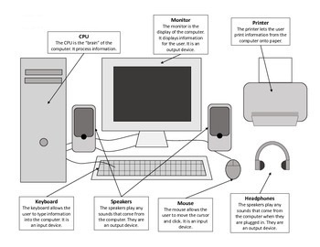

Every component, named peripheral components, from picture above are created to work dependent with Central Unit (C.U).
Let’s go a little bit deeper in C.U to see what can contain that box.
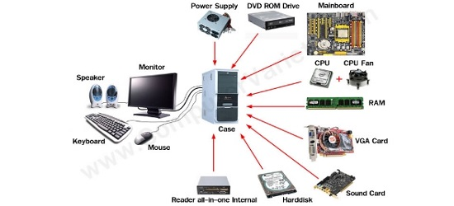

Hope the picture is clear for understand.

1.The first one on top, the power supply, for me is the most important hardware component because protect all internal and peripheric components against electric shockwaves and supply them with the right electric tension.
Can you imagine life without electric energy?

2. Dvd rom drive/CD rom-rw drive…etc, are devices from past. Was created long time ago for reading CD/DVD’s which in nowadays are rear for use. Is replaced by flash memory and after cloud storage (online storage/ server).

3. Motherboard or the board of boards. Is the main board where all the components are linked/connected between them.
Most of motherboards have integrated in their structure a minimum performance videoboard and a sound card plus external slots for future connections as a standard.

4. Processor (CPU) is the brain of the entire unit, with this hardware all the information introduced in the computer must pass through this Control Process Unit.
With this hard work, the CPU is overheating and need an extra source of cooling, usually is made it by a cooling fan.

5. Volatile memory (RAM) called volatile because information stays temporary only, is accessible only on power supply. These little board help the Processor with the flux of information which can be flowed.
The functionality parameters for RAM are directly dependent with the functionality parameters of CPU.

6. HDD (Hard Disk Drive) also called memory unit which can store all type of information processed or not.
Memory unit is a non-volatile type because all information encrypted on Hard disk remain on their position without any electric source and can be accessed in time.

Examples to work on it…
First one.

“An elderly relative wants a low-cost desktop PC with a fairly small form factor but a full-size keyboard and a decent sized monitor to help with their eyesight. They will not be playing any games. They only need to run simple software to perform word-processing functions, check email, surf the net etc, however they do want to be able to watch on line youtube content as well as perform simple skype type video calls with family abroad.”
About this scenario, the first think in “to do list” is to discuss with the person who need this kind of computer and from that discussion you can approximate your calculation about total configuration cost and what kind of properties need to have the hardware and peripheric components have to have.
Second task is to search the components suitable for planed configuration.
- Motherboard
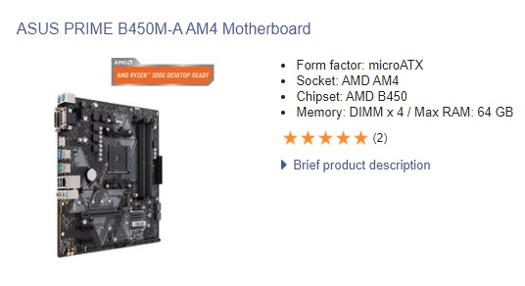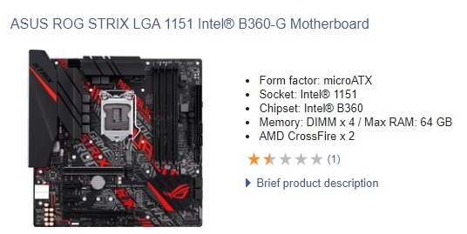
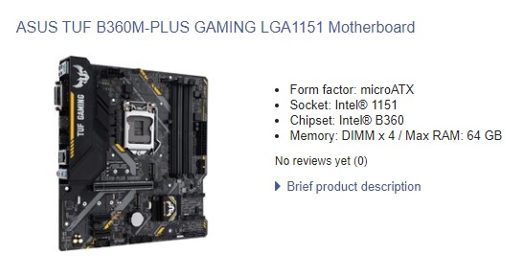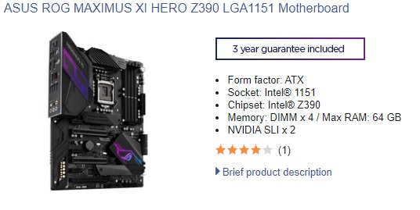

In this case the cheapest option is first motherboard (ASUS Prime B450M model) because can support a configuration more than enough for activities asked for.
Audio and video board are integrated in motherboard and their capacity of functionality are enough for requirements.

2. CPU – processor
Because of the MB (motherboard) chosen before, the CPU should be compatible with, that’s mean should be an AMD socket compatible.
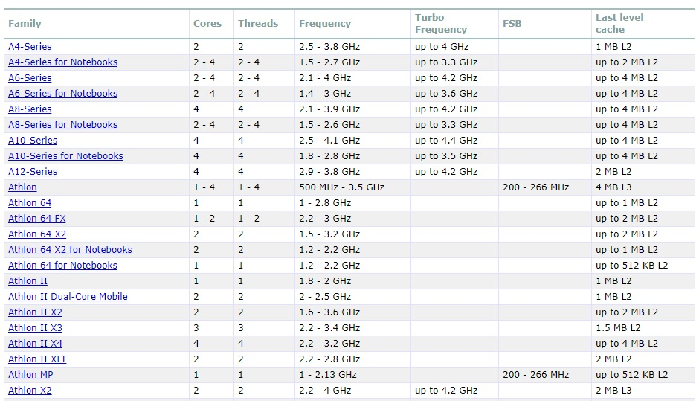
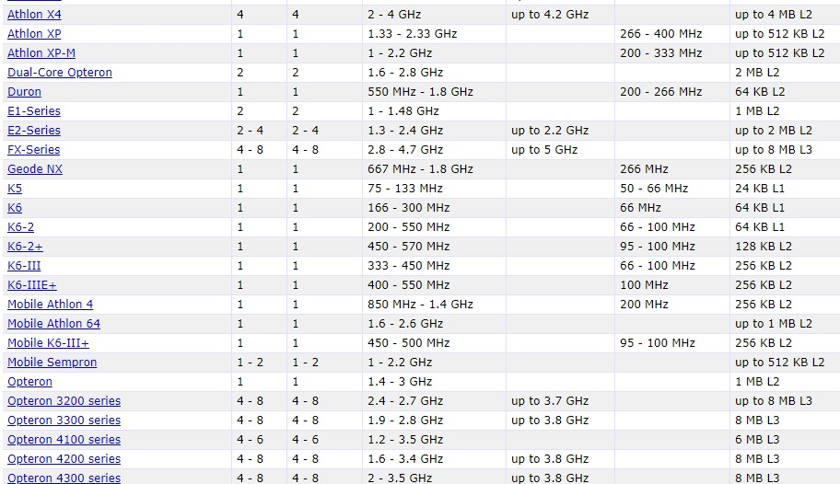
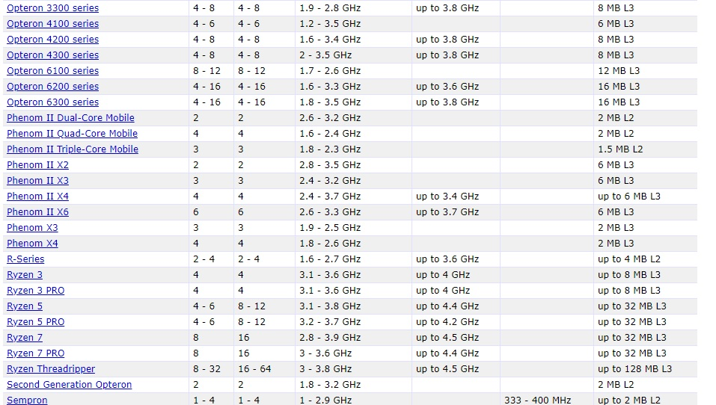
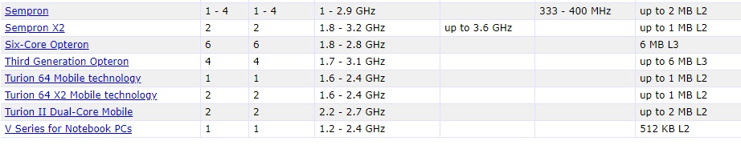
Modest one could be Athlon 3000G, best report between quality, price, and speed of operating.
The cooling fan system is included in AMD price CPU.
3. RAM memory.
Few examples:
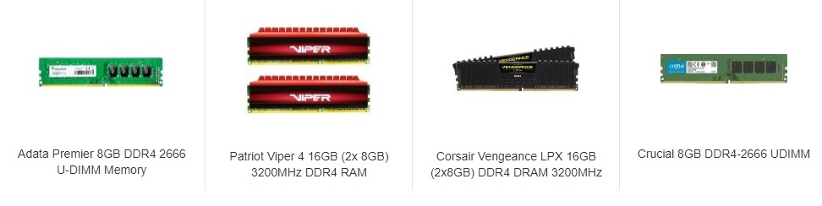
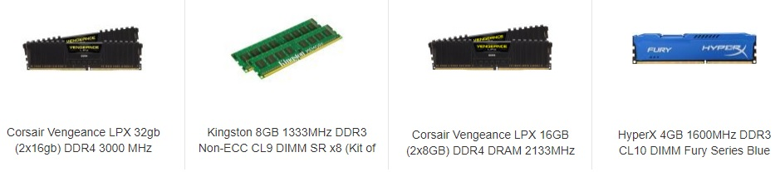
The most important thing when you chose a ramboard is the size of memory and the frequency. The size of memory should be chosen optimal for the processor, in this example must be more than 2 Gb and maximum 10 Gb because like I said before, the quantity of information is set by RAM memory. That’s mean, if is lower than 2 Gb, the speed of action taken by computer will be slower (operation latency), if is bigger than 10 Gb, the quantity of information will be more than processor support and can be physically damaged.
Kingston 8Gb with 2133 Mhz (usual used frequency) on pc4 where pc4 represents the slot/soket type.
DDR1, DDR2, DDR3 slot type was stopped to be produced by many manufacturers for evolution reasons and now are hard to find it and the prices are indirect proportional with the market.

4. HDD (ROM Memory)
Internal storage can be chosen in function with number and size of application what do you prefer to run on computer plus OS (operating system).
The cost of this product increase with the size of storage. The connection with motherboard is not so important in my opinion because the data transferred is the same.
500 Gb HDD is my optimal choice.

5. PC Case
Let’s mount the components somewhere, logical in a PC Case…
Some of cases comes from providers with a standard power source (450W-power) included which is enough for chosen components when we chose the cheap way, also may include all the connection cables from inside, screws and fans.

6. Peripheric components
With peripheric components is usually understand all the devices from outside Central Unit (outside Pc Case) which are necessary for a normal functionality.
- Monitor/ display chosen with a medium size of display and medium pixel rate. (normal 22’ LCD)
- Keyboard, mouse and web camera.

7. OS (operating system) and programs
Not all the time the cheap one can be the best one, but in our case, we can use trial version of all, in fact is for a relate person, we can visit them for this reason. (joke)

Configuration Price list for case 1.:
MB - ASUS Prime B450M-A ... 57 m.u
CPU – AMD Athlon II 3000G…48 m.u
RAM - Kingston 8Gb with 2133 Mhz…38 m.u
HDD – 500 Gb Dell … 20 m.u
Pc case – 450w power source … 30 m.u
Monitor – 22 inch LCD … 60 m.u
Keyboard, mouse and regular webcam can be included in price as gift for new customers.
All prices include VAT.
Total: 253 m.u where 1 m.u can be 1 pound.

For the second example I’ll use information from the first one like tabels and pictures, prices etc.

2.
A graduate youngster needs a computer with a high video configuration and high speed on running graphic applications plus a particular sound transmission. (budget 2500 m.u)
Using most of information from first example, the system configuration can be like next one:
Dell UltraSharp 30’ Monitor with PremierColor: UP3017 – 850 m.u
This monitor model is the optimum chosen product for graphic.
Few of tech Specifications:
Colour Support - 1.07 billion colours
Aspect Ratio - 16:10
Pixel Pitch - 0.251 mm
Contrast Ratio - 1000:1
Energy Consumption per Year - 120 kWh
Vertical Refresh Rate - 50 - 86 Hz
Interfaces:
- DisplayPort (HDCP)
- Mini DisplayPort (HDCP)
- 2 x HDMI (HDCP)
- DisplayPort output (MST)
- 2 x USB 3.0 upstream (Type B)
- 4 x USB 3.0 downstream (Type A)
- Audio line-out
For Central unit I chose a bundle: Intel Core i9 9900K Overclocked Bundle priced at 1045 m.u with next specifications:

Processor | Intel Core i9 9900K "Coffee Lake" Eight Core with HT overclocked to 4.9GHz
Motherboard | ASUS ROG MAXIMUS XI HERO
CPU Cooler | Corsair Hydro H100x
Memory | 32GB Corsair Vengeance LPX 3000MHz DDR4

At this bundle I add a performant video card suitable with monitor technical properties.
GPU (Graphic Process Unit) Nvidia Geforce NTX 2070 with 8Gb memory, running on 256 bits – price 550 m.u
A strong PSU (Power Source Unit) is necessary for this type of configuration:

Seasonic PRIME GX 650 Watt Full Modular 80 cost – 115 m.u
And finaly a Pc case at price of 50 m.u
The total price for configuration satisfying second example is: 2,610 m.u

References
Anon., n.d. Dell. [Online]
Available at: https://www.dell.com/
[Accessed 04 2020].
Anon., n.d. Nvidia. [Online]
Available at: https://www.nvidia.com/
[Accessed 04 2020].
Anon., n.d. SCAN. [Online]
Available at: https://www.scan.co.uk/
[Accessed april 2015].
Štrbáková, V., 2020. Software consultant at Microsoft, s.l.: s.n.

