
Skills for the Workplace
Module Assignment Submission
Student Name: | Bokul Nessa
Student Number: | 1714832
Module No: | BMSK4003
Module Title: | Digital skills and research methods
Lecturer:

Statement of Confirmation of Authenticity
By the act of making this submission, the student declares that this is the work of the student named above. The work has not, in whole or in part, been knowingly presented elsewhere for assessment, or where assessment has been built on a previous assessment, this has been identified. Where materials have been used from other sources it has been properly acknowledged. If this statement is untrue, the student acknowledges that an assessment offence has been committed.
Attention is drawn to the plagiarism and unfair practice policies of both the University and of ILM.

Table of Contents

Introduction 3
Section 1 Search Engines – Google, Yahoo 3
Section 2 Social Media – Facebook, LinkedIn 3
Section 3 E-mail – Google Mail, Outlook 3
Section 4 Storage – Icloud, One Drive 4
Conclusion 5
Bibliography 6

Introduction

This report will be focused on different types of modern technology and social media as a tool in the workplace. Optimisation of search engines, social media, e-mail and online storage systems have become hugely prevalent in recent years. These are just a few examples of the modernisation of technology that has occurred in the upcoming years. Social media can be used as self-promotion when applying for jobs or even for the advertising of events that may be happening at the workplace. It is a means of mass communication that works efficiently in comparison to a text or e-mail. There is always ongoing competition between the best on the market as they have to advertise their product to appeal to the wider majority of the consumer population. As most people now use the internet and social media, with one hundred percent at work definitely doing so, it is only necessary that marketing campaigns are engaging, interesting and appealing. This is because they will have to impress and persuade masses of people to use their system over another. Google has not always been so popular but after years of marketing and promotion, it has been able to overtake Yahoo and claim the title of the best search engine. There is no way to measure what is ultimately the best method of using modern technology to its fullest capacity in the workplace so it is better to weigh up the advantages and disadvantages of each example of technology and social media site. This report will discuss how beneficial the use of modern technology is and whether tools like social media can develop and advance the processes used within the workplace.

Section 1

Google ranks as the number one search engine in the world, above others like Yahoo. This type of modern technology is extremely useful in the workplace as it is consists of every website needed to gather information and has links to further presentations and research. A simple to use and hugely extensive search engine is beneficial as not everyone at the workplace has a high level of knowledge on developed technology. Google works by providing hundreds of thousands of results to whatever you enter to search, using keywords to find the most accurate sites for the consumer to use. Users all over the world prefer a search engine which is able to deliver the most fulfilling and satisfying results for their search queries (purplecowagency). Google is argued to be better than Yahoo as a search engine due to having a better algorithm as well as providing links to all websites as opposed to solely well-established ones. On the other hand, Yahoo does not include as many options as they prefer older sites, they generate more relevant results. There is evidence that users feel Google is more user-friendly as well as more appealing to use compared to Yahoo. Google gives access to various other resources like G-mail and Docs which offer features like building and editing documents in real-time with your colleagues. This is a significant factor which gives Google more appeal in the workplace as Yahoo does not have this, real-time editing alongside work colleagues has satisfied the needs of various companies. A helpful recommendation for Yahoo can be that they generate a similar piece of software to give them more appeal in the workplace. However, even though the younger population prefer Google, people over the age of 45 still stick to Yahoo (purplecowagency). Overall, search engines are still developing and so, can be labelled as modern technology. Google has many features to offer, as does Yahoo but, preference is what determines which a better search engine is.

Section 2

This next section will explore social media as a tool in the workplace. LinkedIn is a social network for professionals (Lifewire, Nations) which is used within the workplace as well as out of it. It is a means of growing your professional career and making further links with others who have the same aspirations as you or has years of experience. LinkedIn provides opportunities for various employers or senior individuals to view your profile online and decide whether they would like to get in contact. Simply, it is a way of ‘showing off’ to potential employers for further work opportunities. As it available for everyone to see, it is highly efficient as the chances of your profile reaching someone who can help you is very likely. The formatting of the site is simple and is similar to other social media sites like Facebook which means it still has an informal feel which can be more appealing to the younger population. This is important as younger individuals just starting their careers are mostly in need of making connections with well-experienced individuals. It has the ability to store all of the people you have connected with on ‘My Network’ which is helpful when referring back to the site. Not only this, there is the option to view job listings which are automatically well-suited to your profile and the connections you have made. Clearly, this is beneficial in the workplace as it allows you to prosper and grow your career which wouldn’t be as possible in the workplace alone with the absence of these professional connections. In comparison to this social media site, Facebook is significantly growing as a social media tool for the workplace. Facebook allows colleagues to easily communicate with each other in large groups and discuss the same topics at the same time. Not only this, they gather information from your search preferences and use this to present job advertisements on your profile. Moreover, there is a large population of older people using the site which shows that with its success with an older population, it is accessible to most people in the workplace and simple to use, like LinkedIn. Facebook has also introduced Facebook workplace which is a collaborative platform run by Facebook. It is used to communicate via groups, to chat with colleagues and offers the social networks features in a corporate environment (Wikipedia). Facebook Workplace is more similar to LinkedIn than Facebook as it focuses solely on professional connections. Both LinkedIn and Facebook act as tools in the workplace allowing the average employee to make professional connections, communicate with others and be exposed to the experiences of others whilst viewing job advertisements.

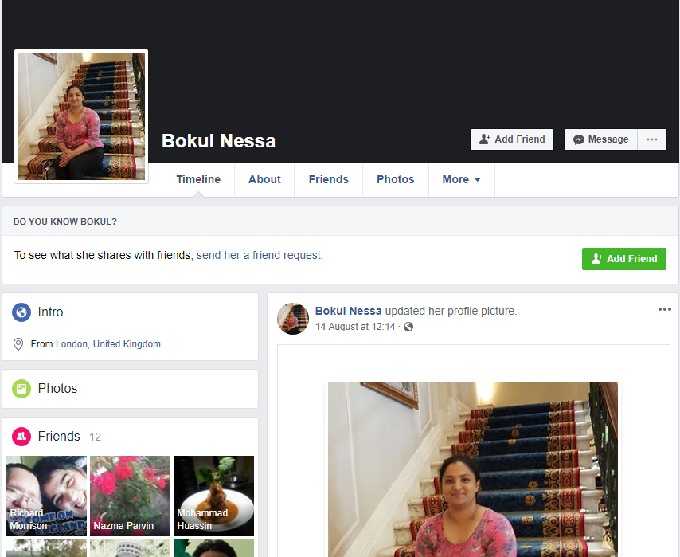

Section 3
Email has been around for more than two decades, and it’s not going anywhere anytime soon. It’s still the quickest and most direct way to reach customers with critical information (uk.marketo). Two of the most popular e-mailing sites are Microsoft Outlook and Google Mail, with Outlook having one of the more cleaner-looking interfaces. Both offer folders and categories to organise emails as well as options to reply to multiple emails at one time. It is important for an e-mailing site to be relevant, conversational, simple, trusted and strategic. Both handle spam emails and are able to filter emails into the relevant folders. For example, Outlook has the folders ‘Focused’ and ‘Other’ which easily organises emails into levels of importance. Some may prefer g-mail to outlook due to their preference of Google in general. Both have a feature that allows users to create documents, Google Docs and Office online. More people enjoy the use of Microsoft documents as it has a simpler layout and is easy to use. However, in terms of the workplace, both sites are equally efficient. More companies use Microsoft Outlook as it is can be customised to fit the company’s needs and security requirements. An advantage that G-mail has is that documents that are shared can be edited on in real-time as aforementioned. Overall, e-mail is still one of the most effective and simple ways of communicating in the workplace as well as after work hours.

Section 4
Another example of modern technology is the type of storage drives used by people in the workplace. The most commonly used ones are iCloud and OneDrive. They are both designed for different device and operating systems. OneDrive is integrated for Microsoft users whilst iCloud is for Apple users. ICloud automatically backs up data whereas this must be done manually for OneDrive. There is competition from storage systems like Dropbox but these remain the best on the market as they are the most intuitive and simple. Security is where these systems differ as OneDrive is unencrypted whereas iCloud is encrypted with SSL transit encryption. OneDrive has the similar advantage to the Icloud system whereby they have reasonably priced plans and great integration with the devices that they are connected with, OneDrive with Windows and Icloud with Apple devices. OneDrive also has the inclusion of Office 365 in higher tiers and great integration with Windows and useful mobile apps, like Outlook. The pros of iCloud is that it is greatly integrated with Apple devices and has growing collaboration features. However, both systems have cons, both do not allow any options for free photo storage. Specifically, one drive has very limited free options. Icloud is restricted in that it is not recommended for non-Apple devices or users which means a huge number of people cannot use it. (Cloudstorageadvice)

Conclusion
To conclude, technology is still undergoing the process of modernisation and technology is still developing but the systems we have in place have proven to be hugely beneficial to the workplace. Google and Yahoo are both highly effective search engines that help the development of knowledge in the workplace with easy access at all times. Moreover, social media as a workplace tool is exemplified through Facebook and LinkedIn as they both help to grow professional connections as well as job opportunities, whilst developing your career. E-mailing systems are now more prevalent than ever with the most common being Google Mail and Outlook from Microsoft, both offering a clean and simple interface with multiple other benefits like google docs and office online, both important in the workplace as everything is now digitally written up and transferred. The final example of modern technology in this day and age is the type of storage system we use as consumers, storage remains a huge issue today we most people prefer to save and keep all of their date backed up rather than deleted. Due to this, no matter how much storage we acquire, it never seems to be enough so we must choose carefully between storage systems as they are incredibly important. Icloud and OneDrive are considered to be the best on the market as of now, they both cater to different audience, Apple users and Microsoft users with various pros and cons to each. Overall, technology has not reached its peak as we still deal with issues like group chat limitations or storage restrictions. As modern technology continues to develop, it is clear that most users will relate and prefer to one type search engine, social media site, e-mail system and storage set-up more than the next best on the market. Everything comes down to preference.

Bibliography

Purplecowagency.com
Lifewire.com
Wikipedia.com
Uk.marketo.com
cloudstorageadvice

