Dawid Trochim (1900457)
Internet technology and security | Cyber security & Networks 05.01.2020
Assignment 1 - kemi

Introduction

This report is going to be showing my journey about making a hand-code responsive website which is made up of five web pages and each web page has its meaning and the reason for being there. This report is going to be showing my website (screenshots), a good introduction and the meaning of the website, I am also going to discuss the purpose and who the main audience is.

Requirements

This section is going to be talking about the requirements which are following:
- Purpose of the website,
- Subject matter,
- Target audience,
- Relevance,
- Describing my website

First of all, my website is called “Xercise4Life” and the reason behind it is its creativity because ExerciseForLife would be boring so I decided to remove “E” and leave “X” as a first letter and also add a number inside the name so it looks creative and it still has the same meaning. The purpose behind this website is to allow people change their lives by letting them attend a very good, big and extremely cheap gym with the highest quality equipment because safety always comes first. The purpose is to allow people to workout and not be insecure about their bodies.
This website is made up of five web pages and is easy to navigate because of a clear navbar, if you want to go to FAQ then you click on it etc. very simple so even old people can navigate around and look for the information that they want. I have a feeling that my main target audience would be people aged from 17-55 so I was trying to make it very easy to use. Gym would be located in the centre of the town which means that anyone can join and still have other shops, restaurants etc. pretty close. I believe that paying $14.99 a month to workout 24 hours a day, 7 days a week, 365 days a year is a good price. My target audience would be pretty much anyone and kids could only workout if they are with their parents. Anyone can workout even old people if they feel that they have enough energy and knowledge to get a good session and not hurt themselves.
The reason why this gym is better than all the others gyms is because of its size, most of the gyms are packed and full and to get the equipment that you want you have to wait quite a long time, whereas my gym is big and has a lot of equipment, especially for compound movement exercises.

Implementation

This section is going to be talking about my actual website and screenshots of my website are going to be shown below. I am also going to validate my HTML code through an online website that is designed to do it. CSS code is also going to be validated. I am going to try to describe every single error if there are any and what I did to fix them.

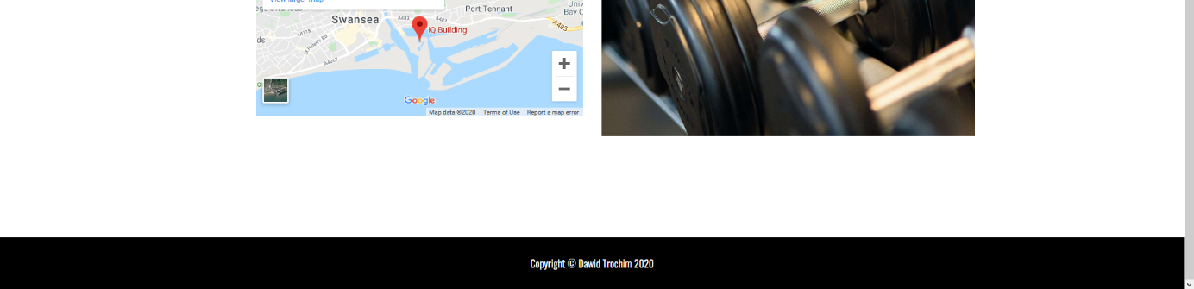
Home page:
This is my homepage which means this website is being displayed first when a user visits my website.

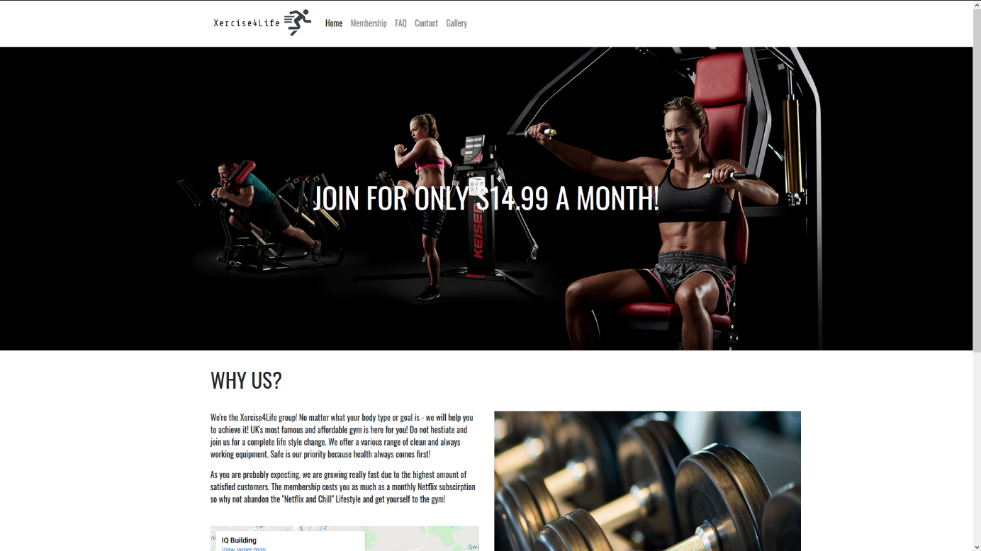
Membership:
This is my membership web page which shows all the available memberships, I tried to make it clear and simple.
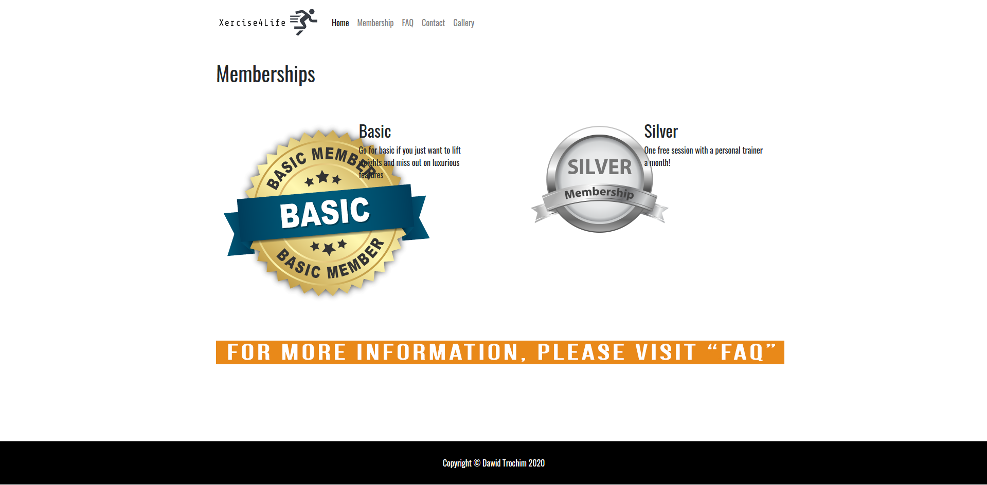

FAQ (Frequently Asked Questions):
Here is my FAQ website which answers most of the questions asked by people.
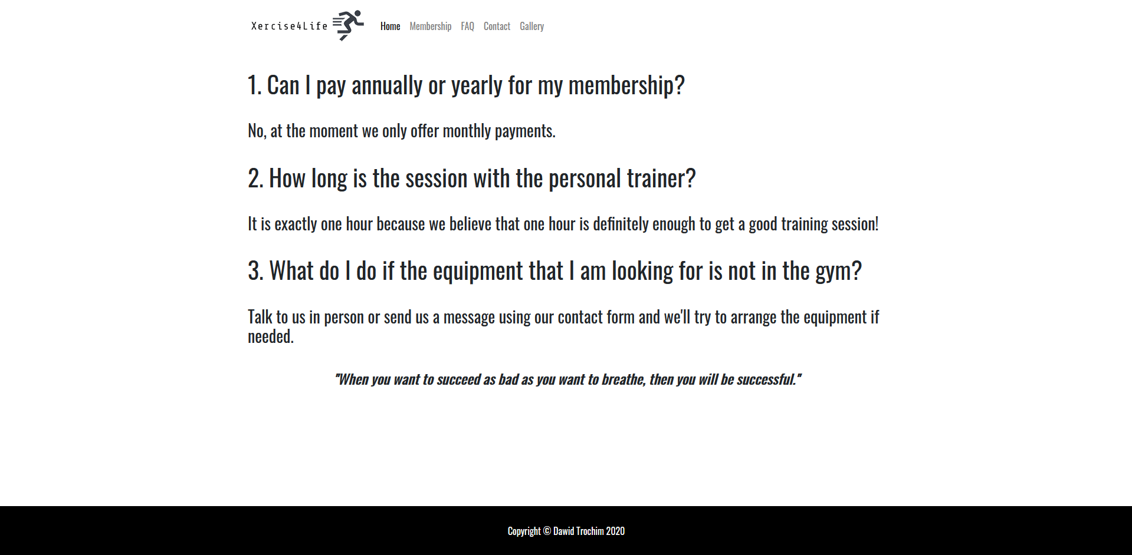

Contact:
Here’s my contact web page and I feel like it is the second most important webpage because people usually have a lot of questions before buying a membership.
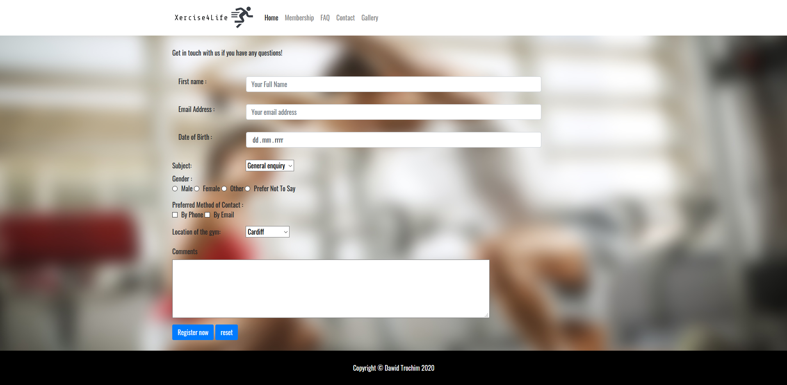

Gallery:
This is a webpage that shows what’s it like inside the gym etc. I created a slideshow made up of three pictures and if we click on the slideshow then it changes, we can also wait about 2-3 seconds for it to change automatically.
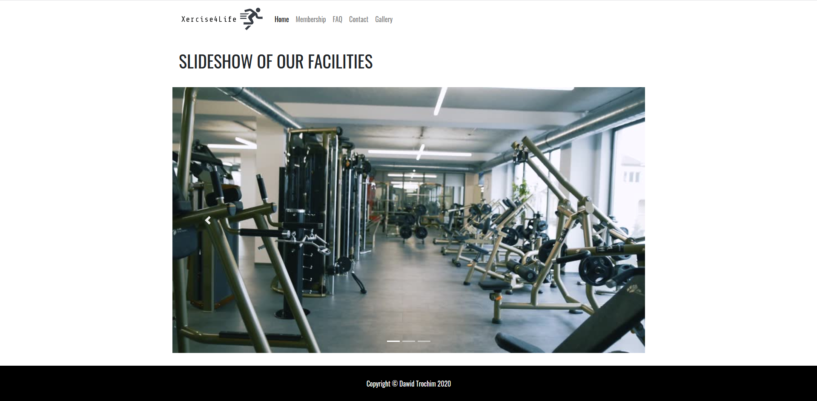

Validating my code

HTML errors:
This is the only error I had and I feel like it is not necessary to fix it because it is iframe which is a map and that code was already premade by Google developers and it is saying that it would be better to put all of that width, height, frameborder etc. in css stylesheet and it works the same.
CSS errors:
No errors were detected in my css code
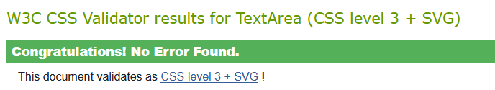

Evaluation

This section is going to be talking about really important aspects of the website and it is accessibility, usability and SEO which stands for Search engine optimisation and it is responsible for our website appearing first in search.

Usability

University of South Florida states that website usability is a term that describes how efficient and good the website is for the user, usability is a different term to describe how good visitors can see the website and its content and the content could be images because it might be easier for someone to understand something just by looking at the image and it should also contain content in form of a text because some people might not like images etc. it should also include a navigation bar which allows users to navigate around from one webpage to a different webpage, it should also contain maps so it is easy for people to find the facility etc. and the aspects that I have mentioned above can really make the usability of our website increase and will definitely provide website owners more income.
There are two types of websites, one of them is when a visitor clicks on our website and the website meet their expectations and allows them to look for the desired information without any problems and that is what most of the websites are like and the other type of website is an “efficient” website and this is basically a much better version of the website that I have mentioned above and an “efficient” website allows visitors to look for the desired information as fast and economically as possible. University of South Florida also states that “the most well-known of the three usability pillars is satisfaction”. So when someone clicks on our website and find out that the website meets every single requirement so it answers every single question that the user has, then it is known as the satisfaction mark. In quick summary, to define how good the usability of our website is, then we need to find out how efficient, satisfying and effective the website is.
[1]

Accessibility

Usability.gov states that accessibility is basically a way of letting disabled people to navigate easier around the website so they do not struggle. Accessibility is a very important aspect when creating our website and should definitely be well-thought by people who are writing CSS to make it easier for example for colour-blind people to navigate without any problems by adjusting the colours.
Accessibility can be done through many ways and of them could be as I said changing colour contrasts for colour-blind people, adding sound button so any information can be read by the narrator if the disabled person has speakers or headset. It is incredibly simple to use accessibility feature because of “point-and-click-interface” and that could be voice-based navigation so the user speaks the instructions for the website, for example go to contact. Accessibility is extremely important because every single person is equal and it is important to allow access disabled people the same kind of information as non-disabled people.
Every single website owner wants to have as many visitors as possible and that is why accessibility is important because we do not want to lose visitors that are disabled and it has been proven that accessible website are achieving much better results than non-accessible website and many other advantages.
Here are some simple ways of making the website accessible:
- Providing transcripts for podcasts
- Images should have alt text when we hover over the picture so if the picture is not displaying or understandable to the user for some reason then the text should replace an image.
- Videos should have captions.
[2]

SEO – Search engine optimisation

IEEE Transactions on Professional Communication and J.B. Killoran are saying that SEO (Search Engine Optimisation) is a process of making the website appear first in search so when someone searches “Best personal trainer Swansea” then we want our name to appear first in search and there are many techniques that people are using in order to make their websites appear first. For example, search engine (for example Google) is a digital library which consist of copies and we are talking about web pages. When we are typing something into the search bar, then the search engine should show us the most relevant and most common phrases typed in by people. It all depends on our settings that we have and also location because search engine is looking for the things or people that are near us. It also depends on the user and the way the phrase is worded because people have different ways of thinking and 10 people can look for the same using different sentences. Pages that are mobile-friendly can get more searches and appear first because high percentage of searches come from tablets, mobile phones etc. and it is 63%. Loading speed is also another factor that can affect the position of our website so having it optimised can increase its position.
[3]

Evaluation of my website

Usefulness (Usability and Utility), I decided to go for basic design when it comes to my website because of my target audience and I mainly expect people aged 17-55 to visit my website so I tried to keep the layout and the design as simple and easy to navigate around as possible. My website is extremely easy to use, if you want to zoom in or check a location on the map that I have inserted on my home page then you just scroll in and that is it, if we want to check membership types then we just click on “membership” webpage which is located on my navbar, if we want to see what are the most commonly asked questions then we also have “FAQ” webpage on the navigation bar, if there is a need to contact with the staff, then there is a “Contact” webpage with a contact form on a navigation bar and someone could be curious about the looks so there is also a Gallery webpage with a slideshow. The content on my website is easy to read and easy to understand, I could keep writing paragraphs on my website but I wanted to keep it as simple and informative and understandable as possible, there are many future improvements that could be implemented and one of them is definitely JavaScript because JavaScript allows us to create amazing effects, and the other thing that could be also considered is dropdown boxes etc. and include some user interaction.
Search Engine Optimisation (SEO), I decided to use some meta tags such as fitness, gym, Swansea, trainer, personal trainer etc. I tried to list the best keywords that are related to exercising, gym, personal trainer etc. so when someone searches “Personal trainer Swansea”, or “cheap gym Swansea” then I want my website to appear first. I have also included many keywords in my paragraphs such as “cheap”, “affordable”, “equipment”, “fitness” etc. My logo also consists of 3 parts that can help me to position my page higher and that is Xercise so Xercise is likely to come up when someone types “Exercise”, I also included number “4” which represents word “for” and a word “life” is widely popular so it could also bring me some visitors that are not even looking to start the gym but might visit my website and change their minds. I tried to remove as much of the unnecessary code as possible to reduce the loading speed because lower loading speed can increase the SEO and also converting my website to mobile-friendly is going to help to position it as well because it has been proven that websites that are mobile-friendly get more visitors.

Accessibility, this is a very important part of any website and should be carefully considered and well-thought my HTML and CSS writers because accessibility can grant us more viewers and better SEO and according to this website - http://contrastchecker.com/ my website’s accessibility is good, colours are good, text is good to read, the size of the text is also properly adjusted.
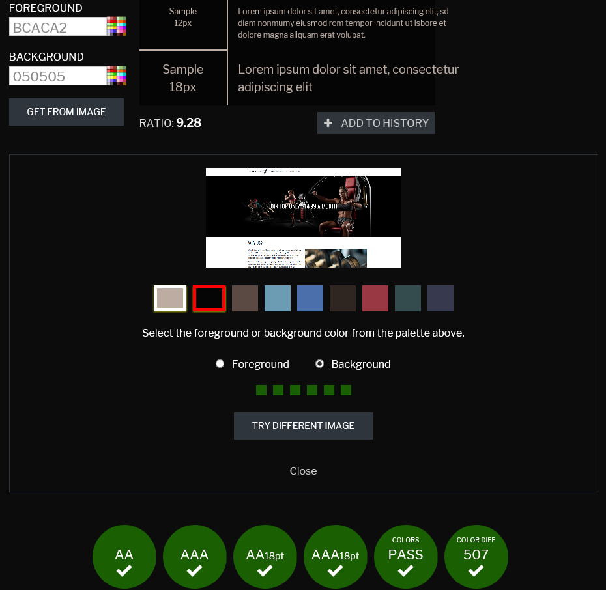

Colour difference is also on point so it would be easy for colour-blind people (colour-blind people are the most common disabled people that are visiting the websites). As we can see my foreground is white whereas background is black so the colour different and contrast is huge and this makes it easy to read and understand.

REFERENCES
Here are my references for pictures and anything used in a process of creating my website.
Gallery webpage:
Slideshow code:
https://getbootstrap.com/docs/4.0/components/carousel/
Slide 1: https://www.google.co.uk/url?sa=i&source=images&cd=&ved=2ahUKEwiXu9Ok8-7mAhVEQBoKHWjSDkIQjRx6BAgBEAQ&url=https%3A%2F%2Fwww.videoblocks.com%2Fvideo%2Fgym-with-various-exercise-machines-in-it-bpwwtevm-j3le8iqv&psig=AOvVaw2T1JS4xvB8XPNj4AOJ3PDz&ust=1578397565931946
Slide 2: https://ak5.picdn.net/shutterstock/videos/27010435/thumb/1.jpg
Slide 3: https://ak4.picdn.net/shutterstock/videos/12609044/thumb/7.jpg?i10c=img.resize(height:160)
Homepage:
Jumbotron: https://www.google.co.uk/url?sa=i&source=images&cd=&ved=2ahUKEwjHkonc8-7mAhUE0BoKHXJbAtEQjRx6BAgBEAQ&url=https%3A%2F%2Fpuresports.hu%2F&psig=AOvVaw2ixRhVEgIyDtPXYSJuTUVw&ust=1578397684612444
Dumbbells webpage: https://www.google.co.uk/url?sa=i&source=images&cd=&ved=2ahUKEwib9aiE9O7mAhWTCWMBHbnPCmoQjRx6BAgBEAQ&url=https%3A%2F%2Fwww.ourdisabilitycommunity.com%2Fnews%2F2019%2F1%2F26%2Fpersonal-trainer-aims-to-tackle-poor-accessible-gym-provision&psig=AOvVaw1AtBl_7EeOqMVq8TGwW0eK&ust=1578397768338638
Membership webpage:
Basic membership:
https://content.web-repository.com/s/84075337756018651/uploads/Images/Basic-Membership.jpg-1324481.png
Silver membership:
https://www.friends1st.co.uk/wp-content/uploads/2018/05/silver-membership.png

