1`1`

SILENCE!!
BREAK THE
CHILDREN’S aloneNSPCC has had 1500 grown-ups call them with respect to the dangers of maltreatment to youngsters who are caught away from public scrutiny where 58% has prompted references that is an ascent of 32% since we went into lockdown. Could you envision the quantity of youngsters actually enduring on the grounds that nobody has seen them be man-handled.
’S
HELP

TAKE ACTION NOW
TAKE ACTION NOW
TAKE ACTION NOW
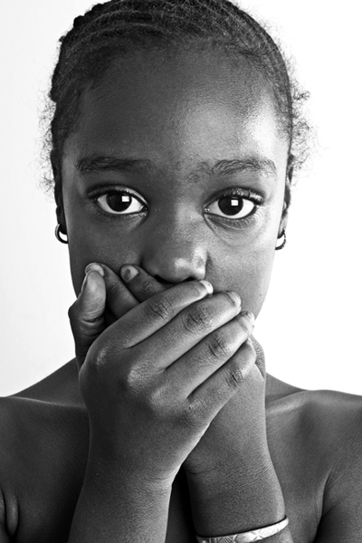



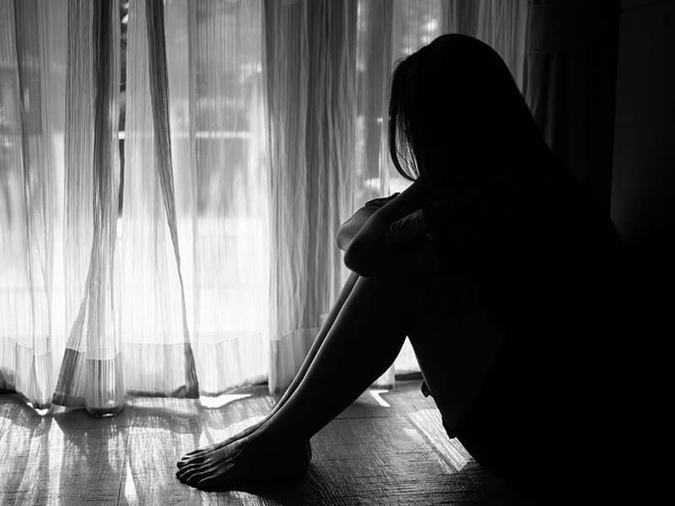
BE APART OF THE CHANGE TO UNSILENCE OUR CHILDREN!!!


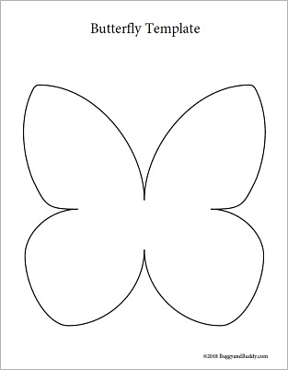
(I Choose to be Silent You Don't Make me be Silent, 2012)
welcome participants in raising awareness of the white butterfly with the bruised emoji/face.

UNSILENCE OUR CHILDREN!!
CONFERENCE ON
MARCH 26TH - 29TH 2021
@ 1PM - 4PM
67 BROADWAY WALK
BANQUETING SUITE
B489TP

(Shhuk, 2021)
(Buggy & Buddy 2018)





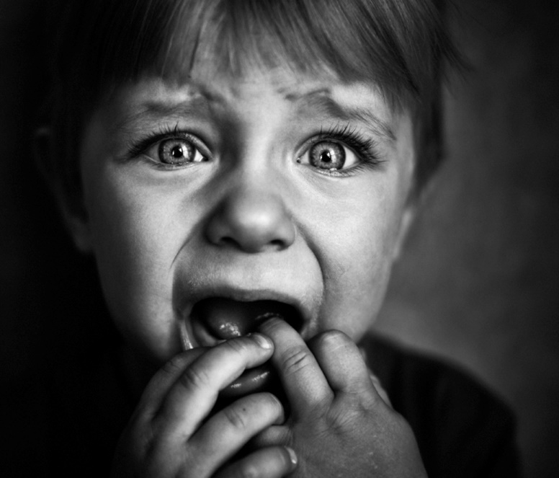
REGISTER @ UNSILENTCHILDRENAWARENESS.COM
- NSPCC HAD 1500 CALLS FROM ADULTS ABOUT CONCERNS OF ABUSE ON CHILDREN IN 2020, CAN YOU IMAGINE HOW MANY MORE CHILDREN GO UN-NOTICED

- HELP THE HIDDEN, AND UNSPOKEN CHILDREN FIND THEIR VOICE.

- HOW MANY MORE CHILDREN COULD BE LIVING HAPPIER LIVES IF THEY WERE ABLE TO SIGNAL FOR HELP

@UNSILENT_CHILDREN
This Photo by Unknown Author is licensed under CC BY-SA
@UNSILENT_CHILDREN
This Photo by Unknown Author is licensed under CC BY-SA
/UNSILENTCHILDREN
(June, S. 2019)
(DOMESTIC VIOLENCE – THE DEATH OF A CHILD, 2013)

LEAFLET/FLYER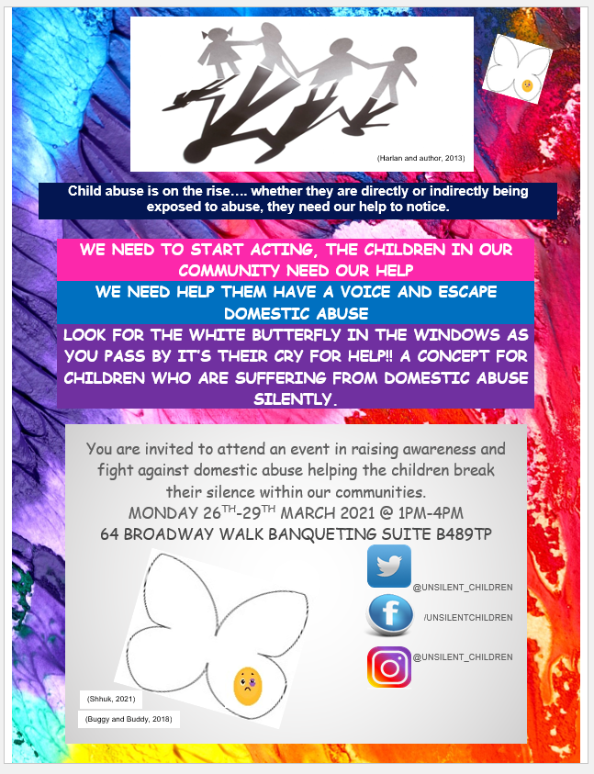
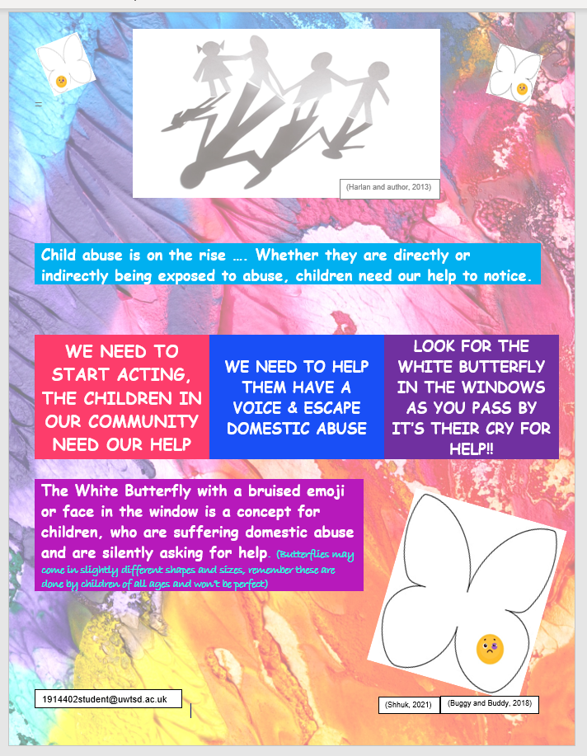
LEAFLET/FLYER

Pitch for the white butterfly with bruised face/emoji for domestic abuse against children

Hello! My name is Chantelle Simmonds and I want to thank you for taking time out, to attend this event about helping to raise awareness about domestic violence against children .
The 2021 Women’s Aid annual audit states that refuge services supported 12,710 children and community-based services supported 124,742 children that were facing domestic abuse. NSPCC had a 32% rise in calls during the early locdown period of 2020. Domestic abuse may be verbal, physical, and emotional. It may not even be directed at them. But the abuse is still real and happening. Being exposed to abuse can have an adverse effect on their well-being, often suffering with mental health and self-confidence issues, they could also end up in abusive relationships or being an abuser.
If adults in this situation find it hard to find a voice and seek help, when their probably able to get access to help, resources and have silent hand gestures, can you imagine how many times harder this is for a child in this situation.
So, bearing this in mind the concept of the white butterfly is for children seeking help from domestic abuse. The idea is that white paper/ envelope would be an easily accessible resource for a child to make a butterfly and draw a bruised emoji/face and place in the window for passer-by to see. White butterflies with the emoji can be already made and accessible for children and young adults to take from their educational centres. (schools, six-form, and colleges) THE WHITE BUTTERFLY CAN EVEN BE SHOWN TO SOMEONE AWAY FROM HOME.
The aim of this, is to make people aware and draw attention to the silent cries of those who are vulnerable and at risk and who are seeking help.

So, I ask of you to join me in creating a way and raising awareness for children to seek help with the butterfly and emoji bruised face.
Once again thank you for your time and I’m open to answer any questions, that you may have.

REFERENCES
Buggy and Buddy. (2018). Make your own galaxy themed butterflies!. [online] Available at: <https://buggyandbuddy.com/galaxy-butterfly-art-project-for-kids/> (Accessed 4 March 2021).
Harlan, S. and author, M., (2013). Behind the Scenes at the Receiving Center for Neglected, Abused Children | San Jose Inside. [online] San Jose Inside. Available at: <https://www.sanjoseinside.com/opinion/2_8_13_juvenile_justice_commissions_inspection_children/> [Accessed 4 March 2021].
Hub, E. and publications, R., 2021. The Domestic Abuse Report - Womens Aid. [online] Womens Aid. Available at: <https://www.womensaid.org.uk/evidence-hub/research-and-publications/the-domestic-abuse-report/> [Accessed 26 March 2021].
Iconarchive.com. 2021. Twitter Icon | iOS7 Style Iconset | iynque. [online] Available at: <https://iconarchive.com/show/ios7-style-icons-by-iynque/Twitter-icon.html> [Accessed 26 March 2021].
June, S. Quinn, A. Lee, L. and Burns, K. (2019).To the Girl Grieving the Loss Of Someone Who Is Still Alive. [online] Her way. Available at: <https://herway.net/life/to-the-girl-grieving-the-loss-of-someone-who-is-still-alive/> (Accessed 07 March 2021).
Lopez, N., 2016. Instagram's new 'Save draft' feature will be a life saver. [online] The Next Web. Available at: <https://thenextweb.com/apps/2016/09/21/instagram-now-lets-everyone-save-drafts/> [Accessed 26 March 2021].
NSPCC. 2021. Calls about domestic abuse highest on record following lockdown increase. [online] Available at: <https://www.nspcc.org.uk/about-us/news-opinion/2020/Calls-about-domestic-abuse-highest-on-record-following-lockdown-increase/> [Accessed 23 March 2021].
Serendipstudio.org.(2012) I Choose to be Silent You Don't Make me be Silent. [online] Available at: <https://serendipstudio.org/exchange/i-choose-be-silent-you-dont-make-me-be-silent> (Accessed 7 March 2021)
Shhuk, p., (2021) Similar Images, Stock Photos & Vectors of emoji sad bruise eyes isolated on white - 1504581434 | Shutterstock. [online] Shutterstock.com. Available at: <https://www.shutterstock.com/search/similar/1504581434> (Accessed 5 March 2021).
Spiritual Side of Domestic Violence.(2013) DOMESTIC VIOLENCE – THE DEATH OF A CHILD. [online] Available at: <https://ssofdv.wordpress.com/2013/04/29/domestic-violence-the-death-of-a-child/> (Accessed 7 March 2021)
ward, s., 2018. Download Icons Wallpaper Desktop Fb Computer Facebook Logo HQ PNG Image | FreePNGImg. [online] FreePNGImg. Available at: <https://www.freepngimg.com/png/65283-icons-wallpaper-desktop-fb-computer-facebook-logo> [Accessed 26 March 2021].
Women’s Aid (2021) The Domestic Abuse Report 2019:The Annual Audit, Bristol: Women’s Aid www.womenaid.org.uk
Womensaid.org.uk. 2021. [online] Available at: <https://www.womensaid.org.uk/wp-content/uploads/2021/01/The-Domestic-Abuse-Report-2021-The-Annual-Audit.pdf> [Accessed 26 March 2021].

